SNR Module Help:

The SNR module is created to compute the SNR for MR sequences based on the difference image method. In this method, two MR images are acquired under identical conditions. These images are then added and subtracted from each other pixel by pixel. In the resulting images, a region of interest is defined and the mean and standard deviation of the ROI is computed. SNR is computed as:

Procedure:

1- Using Slicer, load the two MR images which SNR is measured for.
2- Define an ROI using the Editor tool. The ROI has two labels, with the radius of 40 mm, on two axial slices, separated 50 mm from each other. It does not matter which of the two MR images is used to define the ROI.
- choose PaintEffect, set the radius of the Label to 40 mm, select a slice on the axial window which is located at the edge of the volume and place the label. The slice at the edge of volume is based on the fact that SmartTemplate is placed on the edge of the phantom.
- move the axial slice 50 mm from the selected slice in step 2. (take a note of axial spacing). Define a second label with the same raduis (40mm) on this slice. This creates two labels for the ROI

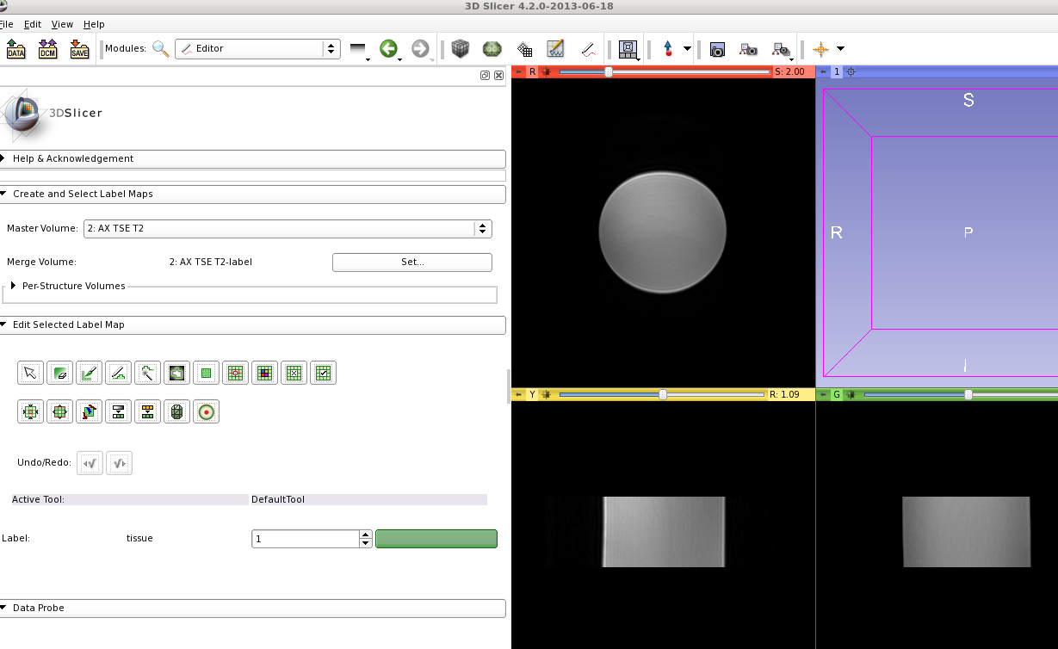

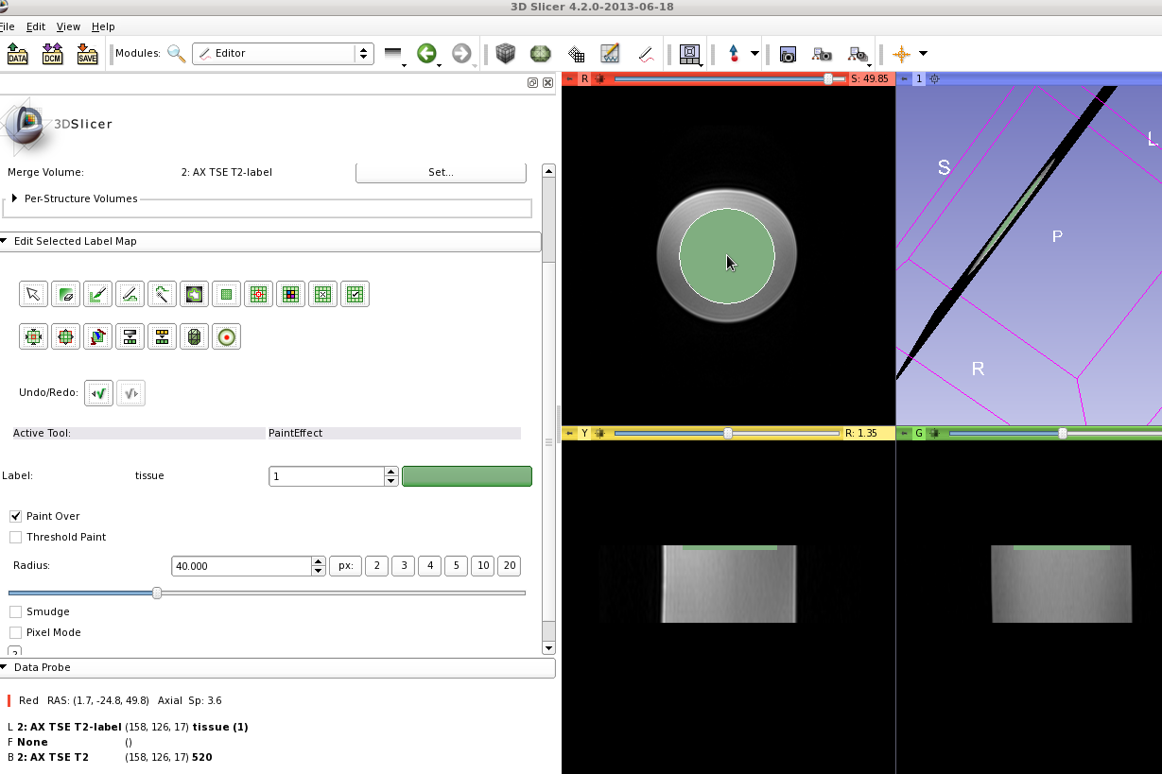

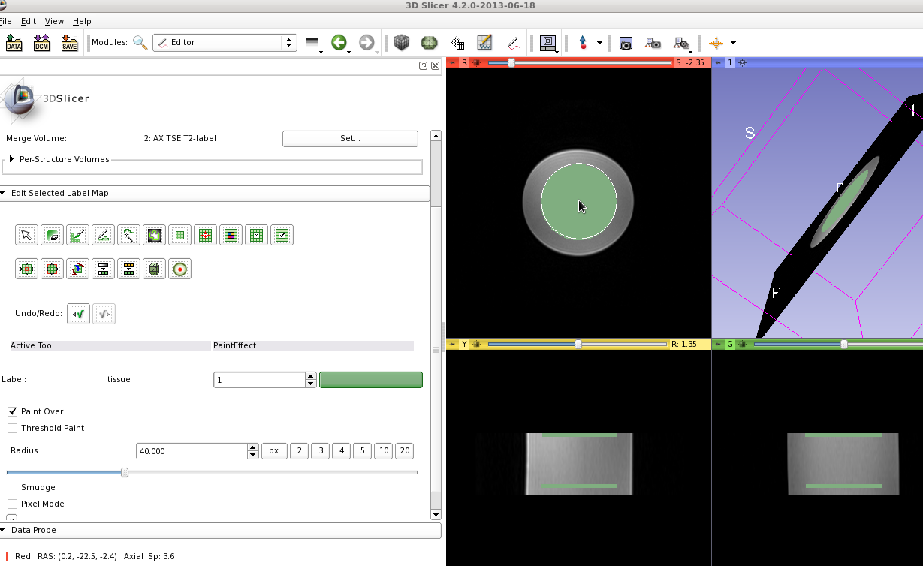
3- Open the SNRMeasurement module.:
- Select the Input Volume 1 as one of the MR image, and Input Volume 2 as the other MR image
- select the Label Map as the ROI which was defined above. Usually it is named “MR image Name”-label.
- Click Apply and it will report the SNR on the terminal:
SNR is :13.5386

If the MR images are the same size, there is no need to define the ROI for every image. Save the ROI as a .nrrd file and load it the next time SNRMeasurement module is needed. However if the sizes of the images are different, which is most of the time, the ROI should be defined.

