Web应用开发结课论文

电商管理系统

**专业**： 软件工程

**学号**： 1804240404

**姓名**： 黄雨薇

**武汉纺织大学**

**计算机与人工智能学院**

**2021年7月**

摘 要

在电商日益发展的今天，良好的电商管理系统有助于提高工作效率以及降低工作成本，所以本次论文我将设计一个电商管理系统。

本次项目就是用vuejs2.0和element-ui 2.x搭建的一个简单的电商管理系统，在VS code平台进行运行，数据库采用了mysql。

目前已经实现了登录、主界面、客服服务商列表、统计列表等简单的功能。

关键词：电商管理; vuejs2.0; element-ui 2.x; mysql

Abstract

With the development of e-commerce, a good e-commerce management system helps to improve work efficiency and reduce work costs, so I will design an e-commerce management system in this paper.

This project is a simple e-commerce management system built with vuejs2.0 and element UI 2. X, which runs on vs Code platform, and the database uses mysql.

At present, it has realized the simple functions of login, main interface, customer service provider list, statistics list and so on.

Key Words: e-commerce management; vuejs2.0 ; element-ui 2.x ; mysql

目 录

1 需求分析 1

1.1用户登陆 1

1.2主页面 1

1.3主要功能 1

1.3.1客服服务商列表 1

1.3.2 统计列表 1

2 系统设计 3

2.1用户用例图 3

2.2 ER图 4

3 系统实现 9

3.1 项目结构 9

3.2 客服服务商列表代码 9

3.3 统计列表代码 10

4 系统总结 14

# 1 需求分析

设计一个电商管理系统，功能有：登录，服务商和客服列表展示、搜索查询、添加服务商和客服列功能以及服务商、客服、订单统计功能。

## 1.1用户登陆

运行程序时，在打开的网页中输入用户名和密码，当用户名及密码不正确时，显示“用户名或密码不正确”，当输入的用户名和密码正确时，直接进入系统，如图1。

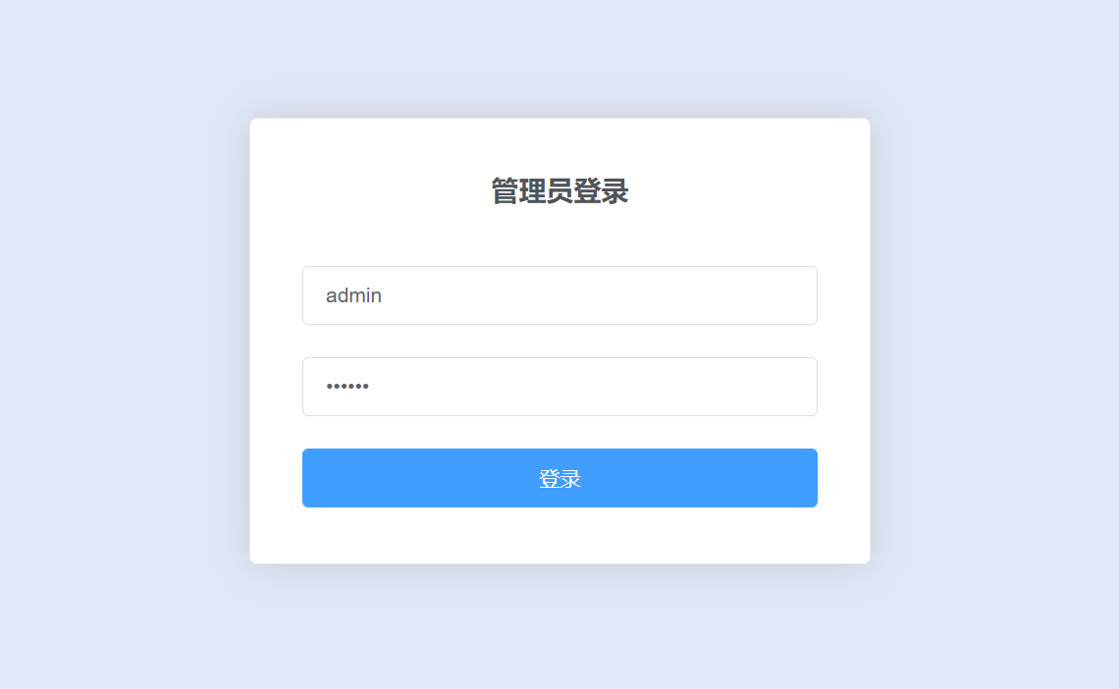

（图1）

## 1.2主页面

系统主界面如图2。

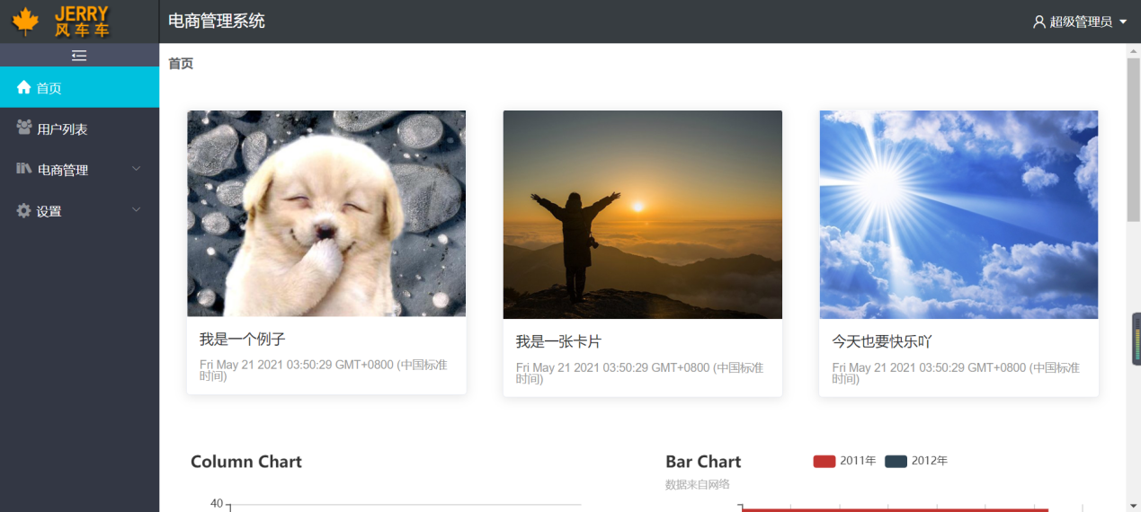

（图2）

## 1.3主要功能

### 1.3.1 客服服务商列表

客服服务商列表包括了服务商和客服列表展示、搜索查询、添加服务商和客服列功能；点击服务商和客服列表就可以看到列表，如图3；在上方工具条有查询和新增按钮，通过输入名称进行查询，点击新增按钮可以增加列表信息，如图4；在每条信息最右边有编辑和删除选项，可以对所在行的数据进行编辑或者删除，如图5。

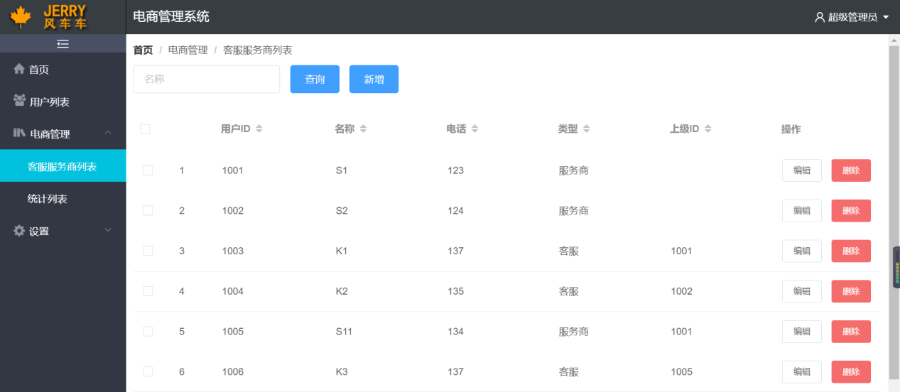

（图3）

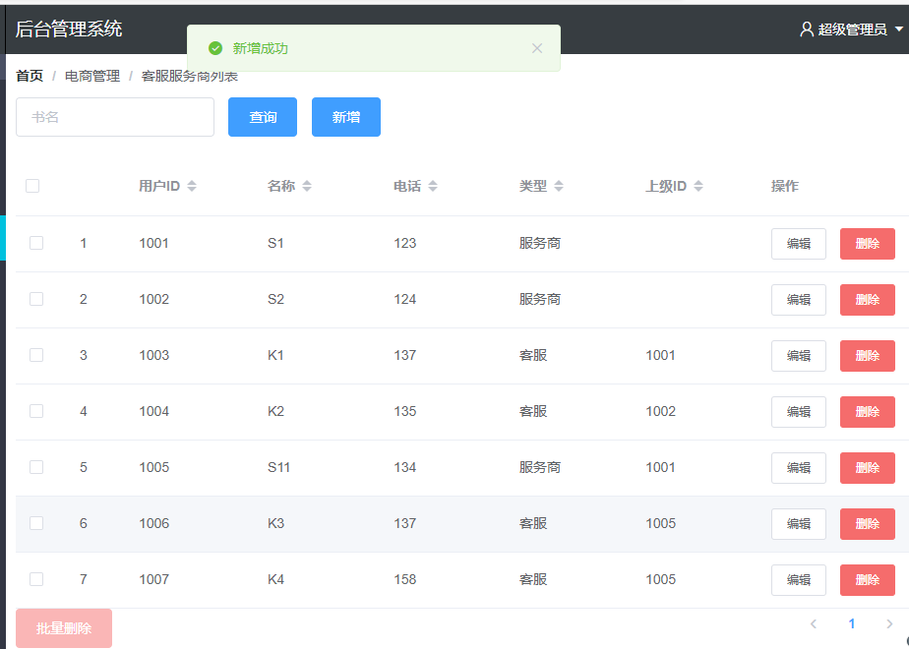

（图4）

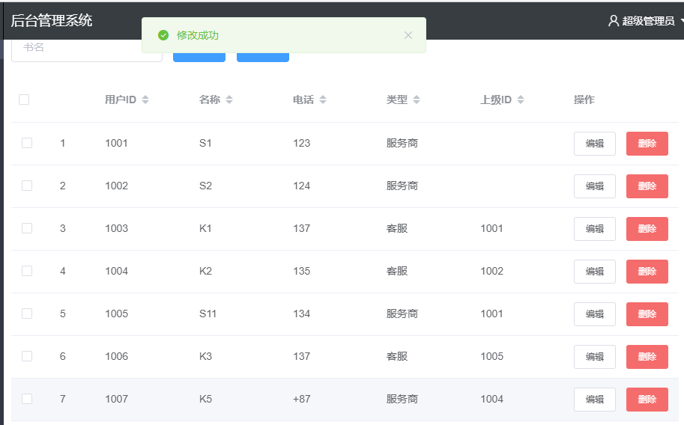

（图5）

### 1.3.2 统计列表

统计列表包括了服务商、客服、订单的统计；点击统计列表就可以展示服务商、客服、订单统计后的内容，如图6。

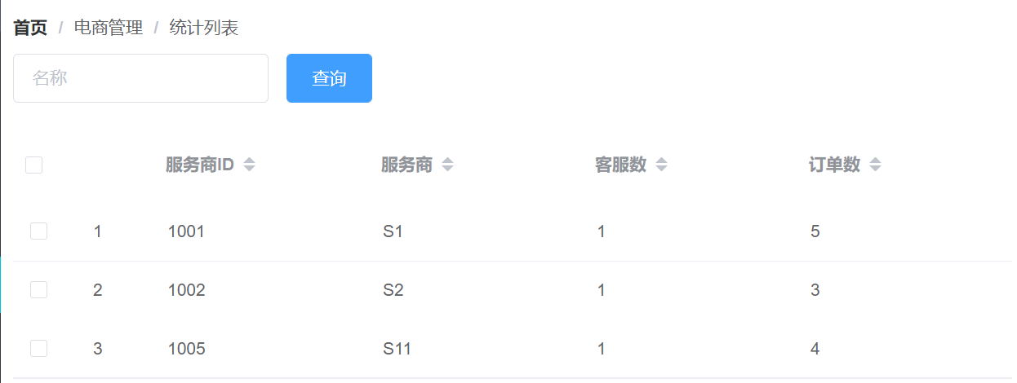

（图6）

# **2 系统设计**

## 2.1用户用例图

用户用例图如图7。

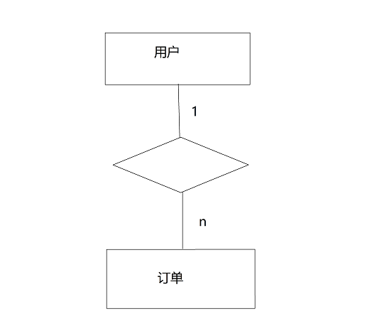

（图7）

## 2.2 ER图

数据库ER图如图8。

%3CmxGraphModel%3E%3Croot%3E%3CmxCell%20id%3D%220%22%2F%3E%3CmxCell%20id%3D%221%22%20parent%3D%220%22%2F%3E%3Cmysql.table%20entity.table.tableName%3D%22uses%22%20label%3D%22uses%22%20id%3D%222%22%3E%3CmxCell%20style%3D%22swimlane%3BfontStyle%3D0%3BchildLayout%3DstackLayout%3Bhorizontal%3D1%3Bhtml%3D1%3BstartSize%3D26%3BfillColor%3D%23b0e3e6%3BhorizontalStack%3D0%3BresizeParent%3D1%3BresizeParentMax%3D0%3BresizeLast%3D0%3Bcollapsible%3D1%3BmarginBottom%3D0%3BswimlaneFillColor%3D%23ffffff%3Balign%3Dcenter%3BfontSize%3D13%3BstrokeColor%3D%230e8088%3Brounded%3D0%3Bshadow%3D1%3Bcomic%3D0%3Bglass%3D0%3BgradientDirection%3Dsouth%3BgradientColor%3D%23ffffff%3B%22%20vertex%3D%221%22%20connectable%3D%220%22%20parent%3D%221%22%3E%3CmxGeometry%20x%3D%2260%22%20y%3D%2250%22%20width%3D%22310%22%20height%3D%22130%22%20as%3D%22geometry%22%2F%3E%3C%2FmxCell%3E%3C%2Fmysql.table%3E%3Cmysql.column%20entity.column.tableName%3D%22uses%22%20entity.column.name%3D%22userName%22%20entity.column.dataType%3D%22VARCHAR%22%20entity.column.PK%3D%22true%22%20label%3D%22%26lt%3Bimg%20title%3D%26quot%3BPrimary%20Key%26quot%3B%20src%3D%26quot%3Bimg%2Fdb%2Fkey1.png%26quot%3B%20width%3D%26quot%3B16%26quot%3B%20height%3D%26quot%3B16%26quot%3B%20align%3D%26quot%3Btop%26quot%3B%26gt%3B%26amp%3Bnbsp%3B%26lt%3Bfont%20size%3D%26quot%3B1%26quot%3B%20face%3D%26quot%3BTahoma%26quot%3B%26gt%3B%26lt%3Bspan%20style%3D%26quot%3Bfont-size%3A%2013px%26quot%3B%26gt%3B%26lt%3Bb%26gt%3Bid%20int%20primary%20key%26lt%3B%2Fb%26gt%3B%26lt%3B%2Fspan%26gt%3B%26lt%3B%2Ffont%26gt%3B%22%20entity.column.oldName%3D%22id%22%20entity.column.datalen%3D%2220%22%20entity.column.decimals%3D%22%22%20entity.column.autoIncreament%3D%22%22%20entity.column.unsigned%3D%22%22%20entity.column.bin%3D%22%22%20entity.column.ascii%3D%22%22%20entity.column.unicode%3D%22%22%20entity.column.unique%3D%22%22%20entity.column.isNotNull%3D%22NOT%20NULL%22%20entity.column.defaultValue%3D%22%22%20entity.column.comment%3D%22%22%20entity.column.enum%3D%22%22%20entity.column.set%3D%22%22%20entity.column.enumSetValue%3D%22%22%20id%3D%223%22%3E%3CmxCell%20style%3D%22text%3Bhtml%3D1%3BstrokeColor%3Dnone%3BfillColor%3Dnone%3BspacingLeft%3D4%3BspacingRight%3D4%3Boverflow%3Dhidden%3Brotatable%3D0%3BportConstraint%3Deastwest%3BfontSize%3D12%3BverticalAlign%3Dmiddle%3B%22%20vertex%3D%221%22%20parent%3D%222%22%3E%3CmxGeometry%20y%3D%2226%22%20width%3D%22310%22%20height%3D%2226%22%20as%3D%22geometry%22%2F%3E%3C%2FmxCell%3E%3C%2Fmysql.column%3E%3Cmysql.column%20entity.column.tableName%3D%22uses%22%20entity.column.name%3D%22chrName%22%20entity.column.datalen%3D%2220%22%20entity.column.dataType%3D%22VARCHAR%22%20label%3D%22%26lt%3Bimg%20title%3D%26quot%3BPrimary%20Key%26quot%3B%20src%3D%26quot%3Bimages%2Fspacer.gif%26quot%3B%20width%3D%26quot%3B16%26quot%3B%20height%3D%26quot%3B16%26quot%3B%20align%3D%26quot%3Btop%26quot%3B%26gt%3B%26amp%3Bnbsp%3B%26lt%3Bfont%20size%3D%26quot%3B1%26quot%3B%20face%3D%26quot%3BTahoma%26quot%3B%26gt%3B%26lt%3Bspan%20style%3D%26quot%3Bfont-size%3A%2013px%26quot%3B%26gt%3B%26lt%3Bb%26gt%3Bname%20varchar(10)%26lt%3B%2Fb%26gt%3B%26lt%3B%2Fspan%26gt%3B%26lt%3B%2Ffont%26gt%3B%22%20entity.column.oldName%3D%22name%22%20entity.column.decimals%3D%22%22%20entity.column.autoIncreament%3D%22%22%20entity.column.unsigned%3D%22%22%20entity.column.bin%3D%22%22%20entity.column.ascii%3D%22%22%20entity.column.unicode%3D%22%22%20entity.column.PK%3D%22false%22%20entity.column.unique%3D%22%22%20entity.column.isNotNull%3D%22%22%20entity.column.defaultValue%3D%22%22%20entity.column.comment%3D%22%22%20entity.column.enum%3D%22%22%20entity.column.set%3D%22%22%20entity.column.enumSetValue%3D%22%22%20id%3D%224%22%3E%3CmxCell%20style%3D%22text%3Bhtml%3D1%3BstrokeColor%3Dnone%3BfillColor%3Dnone%3BspacingLeft%3D4%3BspacingRight%3D4%3Boverflow%3Dhidden%3Brotatable%3D0%3BportConstraint%3Deastwest%3BfontSize%3D12%3BverticalAlign%3Dmiddle%3B%22%20vertex%3D%221%22%20parent%3D%222%22%3E%3CmxGeometry%20y%3D%2252%22%20width%3D%22310%22%20height%3D%2226%22%20as%3D%22geometry%22%2F%3E%3C%2FmxCell%3E%3C%2Fmysql.column%3E%3Cmysql.column%20entity.column.tableName%3D%22uses%22%20entity.column.name%3D%22password%22%20entity.column.datalen%3D%2250%22%20entity.column.dataType%3D%22VARCHAR%22%20label%3D%22%26lt%3Bimg%20title%3D%26quot%3BPrimary%20Key%26quot%3B%20src%3D%26quot%3Bimages%2Fspacer.gif%26quot%3B%20width%3D%26quot%3B16%26quot%3B%20height%3D%26quot%3B16%26quot%3B%20align%3D%26quot%3Btop%26quot%3B%26gt%3B%26amp%3Bnbsp%3B%26lt%3Bfont%20size%3D%26quot%3B1%26quot%3B%20face%3D%26quot%3BTahoma%26quot%3B%26gt%3B%26lt%3Bspan%20style%3D%26quot%3Bfont-size%3A%2013px%26quot%3B%26gt%3B%26lt%3Bb%26gt%3Bname%20varchar(10)%26lt%3B%2Fb%26gt%3B%26lt%3B%2Fspan%26gt%3B%26lt%3B%2Ffont%26gt%3B%22%20entity.column.oldName%3D%22chrName%22%20entity.column.decimals%3D%22%22%20entity.column.autoIncreament%3D%22%22%20entity.column.unsigned%3D%22%22%20entity.column.bin%3D%22%22%20entity.column.ascii%3D%22%22%20entity.column.unicode%3D%22%22%20entity.column.PK%3D%22false%22%20entity.column.unique%3D%22%22%20entity.column.isNotNull%3D%22%22%20entity.column.defaultValue%3D%22%22%20entity.column.comment%3D%22%E5%AF%86%E7%A0%81%22%20entity.column.enum%3D%22%22%20entity.column.set%3D%22%22%20entity.column.enumSetValue%3D%22%22%20id%3D%225%22%3E%3CmxCell%20style%3D%22text%3Bhtml%3D1%3BstrokeColor%3Dnone%3BfillColor%3Dnone%3BspacingLeft%3D4%3BspacingRight%3D4%3Boverflow%3Dhidden%3Brotatable%3D0%3BportConstraint%3Deastwest%3BfontSize%3D12%3BverticalAlign%3Dmiddle%3B%22%20vertex%3D%221%22%20parent%3D%222%22%3E%3CmxGeometry%20y%3D%2278%22%20width%3D%22310%22%20height%3D%2226%22%20as%3D%22geometry%22%2F%3E%3C%2FmxCell%3E%3C%2Fmysql.column%3E%3Cmysql.column%20entity.column.tableName%3D%22uses%22%20entity.column.name%3D%22role%22%20entity.column.datalen%3D%2220%22%20entity.column.dataType%3D%22VARCHAR%22%20label%3D%22%26lt%3Bimg%20title%3D%26quot%3BPrimary%20Key%26quot%3B%20src%3D%26quot%3Bimages%2Fspacer.gif%26quot%3B%20width%3D%26quot%3B16%26quot%3B%20height%3D%26quot%3B16%26quot%3B%20align%3D%26quot%3Btop%26quot%3B%26gt%3B%26amp%3Bnbsp%3B%26lt%3Bfont%20size%3D%26quot%3B1%26quot%3B%20face%3D%26quot%3BTahoma%26quot%3B%26gt%3B%26lt%3Bspan%20style%3D%26quot%3Bfont-size%3A%2013px%26quot%3B%26gt%3B%26lt%3Bb%26gt%3Bname%20varchar(10)%26lt%3B%2Fb%26gt%3B%26lt%3B%2Fspan%26gt%3B%26lt%3B%2Ffont%26gt%3B%22%20entity.column.oldName%3D%22chrName%22%20entity.column.decimals%3D%22%22%20entity.column.autoIncreament%3D%22%22%20entity.column.unsigned%3D%22%22%20entity.column.bin%3D%22%22%20entity.column.ascii%3D%22%22%20entity.column.unicode%3D%22%22%20entity.column.PK%3D%22false%22%20entity.column.unique%3D%22%22%20entity.column.isNotNull%3D%22%22%20entity.column.defaultValue%3D%22%22%20entity.column.comment%3D%22%E8%A7%92%E8%89%B2%22%20entity.column.enum%3D%22%22%20entity.column.set%3D%22%22%20entity.column.enumSetValue%3D%22%22%20id%3D%226%22%3E%3CmxCell%20style%3D%22text%3Bhtml%3D1%3BstrokeColor%3Dnone%3BfillColor%3Dnone%3BspacingLeft%3D4%3BspacingRight%3D4%3Boverflow%3Dhidden%3Brotatable%3D0%3BportConstraint%3Deastwest%3BfontSize%3D12%3BverticalAlign%3Dmiddle%3B%22%20vertex%3D%221%22%20parent%3D%222%22%3E%3CmxGeometry%20y%3D%22104%22%20width%3D%22310%22%20height%3D%2226%22%20as%3D%22geometry%22%2F%3E%3C%2FmxCell%3E%3C%2Fmysql.column%3E%3Cmysql.table%20entity.table.tableName%3D%22product%22%20label%3D%22product%22%20id%3D%227%22%3E%3CmxCell%20style%3D%22swimlane%3BfontStyle%3D0%3BchildLayout%3DstackLayout%3Bhorizontal%3D1%3Bhtml%3D1%3BstartSize%3D26%3BfillColor%3D%23b0e3e6%3BhorizontalStack%3D0%3BresizeParent%3D1%3BresizeParentMax%3D0%3BresizeLast%3D0%3Bcollapsible%3D1%3BmarginBottom%3D0%3BswimlaneFillColor%3D%23ffffff%3Balign%3Dcenter%3BfontSize%3D13%3BstrokeColor%3D%230e8088%3Brounded%3D0%3Bshadow%3D1%3Bcomic%3D0%3Bglass%3D0%3BgradientDirection%3Dsouth%3BgradientColor%3D%23ffffff%3B%22%20vertex%3D%221%22%20connectable%3D%220%22%20parent%3D%221%22%3E%3CmxGeometry%20x%3D%2260%22%20y%3D%22210%22%20width%3D%22310%22%20height%3D%22130%22%20as%3D%22geometry%22%2F%3E%3C%2FmxCell%3E%3C%2Fmysql.table%3E%3Cmysql.column%20entity.column.tableName%3D%22product%22%20entity.column.name%3D%22barcode%22%20entity.column.dataType%3D%22VARCHAR%22%20entity.column.PK%3D%22true%22%20label%3D%22%26lt%3Bimg%20title%3D%26quot%3BPrimary%20Key%26quot%3B%20src%3D%26quot%3Bimg%2Fdb%2Fkey1.png%26quot%3B%20width%3D%26quot%3B16%26quot%3B%20height%3D%26quot%3B16%26quot%3B%20align%3D%26quot%3Btop%26quot%3B%26gt%3B%26amp%3Bnbsp%3B%26lt%3Bfont%20size%3D%26quot%3B1%26quot%3B%20face%3D%26quot%3BTahoma%26quot%3B%26gt%3B%26lt%3Bspan%20style%3D%26quot%3Bfont-size%3A%2013px%26quot%3B%26gt%3B%26lt%3Bb%26gt%3Bid%20int%20primary%20key%26lt%3B%2Fb%26gt%3B%26lt%3B%2Fspan%26gt%3B%26lt%3B%2Ffont%26gt%3B%22%20entity.column.oldName%3D%22id%22%20entity.column.datalen%3D%2210%22%20entity.column.decimals%3D%22%22%20entity.column.autoIncreament%3D%22%22%20entity.column.unsigned%3D%22%22%20entity.column.bin%3D%22%22%20entity.column.ascii%3D%22%22%20entity.column.unicode%3D%22%22%20entity.column.unique%3D%22%22%20entity.column.isNotNull%3D%22NOT%20NULL%22%20entity.column.defaultValue%3D%22%22%20entity.column.comment%3D%22%22%20entity.column.enum%3D%22%22%20entity.column.set%3D%22%22%20entity.column.enumSetValue%3D%22%22%20id%3D%228%22%3E%3CmxCell%20style%3D%22text%3Bhtml%3D1%3BstrokeColor%3Dnone%3BfillColor%3Dnone%3BspacingLeft%3D4%3BspacingRight%3D4%3Boverflow%3Dhidden%3Brotatable%3D0%3BportConstraint%3Deastwest%3BfontSize%3D12%3BverticalAlign%3Dmiddle%3B%22%20vertex%3D%221%22%20parent%3D%227%22%3E%3CmxGeometry%20y%3D%2226%22%20width%3D%22310%22%20height%3D%2226%22%20as%3D%22geometry%22%2F%3E%3C%2FmxCell%3E%3C%2Fmysql.column%3E%3Cmysql.column%20entity.column.tableName%3D%22product%22%20entity.column.name%3D%22productName%22%20entity.column.datalen%3D%2250%22%20entity.column.dataType%3D%22VARCHAR%22%20label%3D%22%26lt%3Bimg%20title%3D%26quot%3BPrimary%20Key%26quot%3B%20src%3D%26quot%3Bimages%2Fspacer.gif%26quot%3B%20width%3D%26quot%3B16%26quot%3B%20height%3D%26quot%3B16%26quot%3B%20align%3D%26quot%3Btop%26quot%3B%26gt%3B%26amp%3Bnbsp%3B%26lt%3Bfont%20size%3D%26quot%3B1%26quot%3B%20face%3D%26quot%3BTahoma%26quot%3B%26gt%3B%26lt%3Bspan%20style%3D%26quot%3Bfont-size%3A%2013px%26quot%3B%26gt%3B%26lt%3Bb%26gt%3Bname%20varchar(10)%26lt%3B%2Fb%26gt%3B%26lt%3B%2Fspan%26gt%3B%26lt%3B%2Ffont%26gt%3B%22%20entity.column.oldName%3D%22name%22%20entity.column.decimals%3D%22%22%20entity.column.autoIncreament%3D%22%22%20entity.column.unsigned%3D%22%22%20entity.column.bin%3D%22%22%20entity.column.ascii%3D%22%22%20entity.column.unicode%3D%22%22%20entity.column.PK%3D%22false%22%20entity.column.unique%3D%22%22%20entity.column.isNotNull%3D%22%22%20entity.column.defaultValue%3D%22%22%20entity.column.comment%3D%22%22%20entity.column.enum%3D%22%22%20entity.column.set%3D%22%22%20entity.column.enumSetValue%3D%22%22%20id%3D%229%22%3E%3CmxCell%20style%3D%22text%3Bhtml%3D1%3BstrokeColor%3Dnone%3BfillColor%3Dnone%3BspacingLeft%3D4%3BspacingRight%3D4%3Boverflow%3Dhidden%3Brotatable%3D0%3BportConstraint%3Deastwest%3BfontSize%3D12%3BverticalAlign%3Dmiddle%3B%22%20vertex%3D%221%22%20parent%3D%227%22%3E%3CmxGeometry%20y%3D%2252%22%20width%3D%22310%22%20height%3D%2226%22%20as%3D%22geometry%22%2F%3E%3C%2FmxCell%3E%3C%2Fmysql.column%3E%3Cmysql.column%20entity.column.tableName%3D%22product%22%20entity.column.name%3D%22price%22%20entity.column.datalen%3D%229%22%20entity.column.dataType%3D%22DECIMAL%22%20label%3D%22%26lt%3Bimg%20title%3D%26quot%3BPrimary%20Key%26quot%3B%20src%3D%26quot%3Bimages%2Fspacer.gif%26quot%3B%20width%3D%26quot%3B16%26quot%3B%20height%3D%26quot%3B16%26quot%3B%20align%3D%26quot%3Btop%26quot%3B%26gt%3B%26amp%3Bnbsp%3B%26lt%3Bfont%20size%3D%26quot%3B1%26quot%3B%20face%3D%26quot%3BTahoma%26quot%3B%26gt%3B%26lt%3Bspan%20style%3D%26quot%3Bfont-size%3A%2013px%26quot%3B%26gt%3B%26lt%3Bb%26gt%3Bname%20varchar(10)%26lt%3B%2Fb%26gt%3B%26lt%3B%2Fspan%26gt%3B%26lt%3B%2Ffont%26gt%3B%22%20entity.column.oldName%3D%22price%22%20entity.column.decimals%3D%222%22%20entity.column.autoIncreament%3D%22%22%20entity.column.unsigned%3D%22%22%20entity.column.bin%3D%22%22%20entity.column.ascii%3D%22%22%20entity.column.unicode%3D%22%22%20entity.column.PK%3D%22false%22%20entity.column.unique%3D%22%22%20entity.column.isNotNull%3D%22%22%20entity.column.defaultValue%3D%22%22%20entity.column.comment%3D%22%22%20entity.column.enum%3D%22%22%20entity.column.set%3D%22%22%20entity.column.enumSetValue%3D%22%22%20id%3D%2210%22%3E%3CmxCell%20style%3D%22text%3Bhtml%3D1%3BstrokeColor%3Dnone%3BfillColor%3Dnone%3BspacingLeft%3D4%3BspacingRight%3D4%3Boverflow%3Dhidden%3Brotatable%3D0%3BportConstraint%3Deastwest%3BfontSize%3D12%3BverticalAlign%3Dmiddle%3B%22%20vertex%3D%221%22%20parent%3D%227%22%3E%3CmxGeometry%20y%3D%2278%22%20width%3D%22310%22%20height%3D%2226%22%20as%3D%22geometry%22%2F%3E%3C%2FmxCell%3E%3C%2Fmysql.column%3E%3Cmysql.column%20entity.column.tableName%3D%22product%22%20entity.column.name%3D%22supply%22%20entity.column.datalen%3D%2220%22%20entity.column.dataType%3D%22VARCHAR%22%20label%3D%22%26lt%3Bimg%20title%3D%26quot%3BPrimary%20Key%26quot%3B%20src%3D%26quot%3Bimages%2Fspacer.gif%26quot%3B%20width%3D%26quot%3B16%26quot%3B%20height%3D%26quot%3B16%26quot%3B%20align%3D%26quot%3Btop%26quot%3B%26gt%3B%26amp%3Bnbsp%3B%26lt%3Bfont%20size%3D%26quot%3B1%26quot%3B%20face%3D%26quot%3BTahoma%26quot%3B%26gt%3B%26lt%3Bspan%20style%3D%26quot%3Bfont-size%3A%2013px%26quot%3B%26gt%3B%26lt%3Bb%26gt%3Bname%20varchar(10)%26lt%3B%2Fb%26gt%3B%26lt%3B%2Fspan%26gt%3B%26lt%3B%2Ffont%26gt%3B%22%20entity.column.oldName%3D%22price%22%20entity.column.decimals%3D%22%22%20entity.column.autoIncreament%3D%22%22%20entity.column.unsigned%3D%22%22%20entity.column.bin%3D%22%22%20entity.column.ascii%3D%22%22%20entity.column.unicode%3D%22%22%20entity.column.PK%3D%22false%22%20entity.column.unique%3D%22%22%20entity.column.isNotNull%3D%22%22%20entity.column.defaultValue%3D%22%22%20entity.column.comment%3D%22%22%20entity.column.enum%3D%22%22%20entity.column.set%3D%22%22%20entity.column.enumSetValue%3D%22%22%20id%3D%2211%22%3E%3CmxCell%20style%3D%22text%3Bhtml%3D1%3BstrokeColor%3Dnone%3BfillColor%3Dnone%3BspacingLeft%3D4%3BspacingRight%3D4%3Boverflow%3Dhidden%3Brotatable%3D0%3BportConstraint%3Deastwest%3BfontSize%3D12%3BverticalAlign%3Dmiddle%3B%22%20vertex%3D%221%22%20parent%3D%227%22%3E%3CmxGeometry%20y%3D%22104%22%20width%3D%22310%22%20height%3D%2226%22%20as%3D%22geometry%22%2F%3E%3C%2FmxCell%3E%3C%2Fmysql.column%3E%3Cmysql.table%20entity.table.tableName%3D%22saleDetail%22%20label%3D%22saleDetail%22%20id%3D%2212%22%3E%3CmxCell%20style%3D%22swimlane%3BfontStyle%3D0%3BchildLayout%3DstackLayout%3Bhorizontal%3D1%3Bhtml%3D1%3BstartSize%3D26%3BfillColor%3D%23b0e3e6%3BhorizontalStack%3D0%3BresizeParent%3D1%3BresizeParentMax%3D0%3BresizeLast%3D0%3Bcollapsible%3D1%3BmarginBottom%3D0%3BswimlaneFillColor%3D%23ffffff%3Balign%3Dcenter%3BfontSize%3D13%3BstrokeColor%3D%230e8088%3Brounded%3D0%3Bshadow%3D1%3Bcomic%3D0%3Bglass%3D0%3BgradientDirection%3Dsouth%3BgradientColor%3D%23ffffff%3B%22%20vertex%3D%221%22%20connectable%3D%220%22%20parent%3D%221%22%3E%3CmxGeometry%20x%3D%22480%22%20y%3D%2280%22%20width%3D%22280%22%20height%3D%22208%22%20as%3D%22geometry%22%2F%3E%3C%2FmxCell%3E%3C%2Fmysql.table%3E%3Cmysql.column%20entity.column.tableName%3D%22saleDetail%22%20entity.column.name%3D%22lsh%22%20entity.column.dataType%3D%22VARCHAR%22%20entity.column.PK%3D%22true%22%20label%3D%22%26lt%3Bimg%20title%3D%26quot%3BPrimary%20Key%26quot%3B%20src%3D%26quot%3Bimg%2Fdb%2Fkey1.png%26quot%3B%20width%3D%26quot%3B16%26quot%3B%20height%3D%26quot%3B16%26quot%3B%20align%3D%26quot%3Btop%26quot%3B%26gt%3B%26amp%3Bnbsp%3B%26lt%3Bfont%20size%3D%26quot%3B1%26quot%3B%20face%3D%26quot%3BTahoma%26quot%3B%26gt%3B%26lt%3Bspan%20style%3D%26quot%3Bfont-size%3A%2013px%26quot%3B%26gt%3B%26lt%3Bb%26gt%3Bid%20int%20primary%20key%26lt%3B%2Fb%26gt%3B%26lt%3B%2Fspan%26gt%3B%26lt%3B%2Ffont%26gt%3B%22%20entity.column.oldName%3D%22id%22%20entity.column.datalen%3D%2220%22%20entity.column.decimals%3D%22%22%20entity.column.autoIncreament%3D%22%22%20entity.column.unsigned%3D%22%22%20entity.column.bin%3D%22%22%20entity.column.ascii%3D%22%22%20entity.column.unicode%3D%22%22%20entity.column.unique%3D%22%22%20entity.column.isNotNull%3D%22NOT%20NULL%22%20entity.column.defaultValue%3D%22%22%20entity.column.comment%3D%22%22%20entity.column.enum%3D%22%22%20entity.column.set%3D%22%22%20entity.column.enumSetValue%3D%22%22%20id%3D%2213%22%3E%3CmxCell%20style%3D%22text%3Bhtml%3D1%3BstrokeColor%3Dnone%3BfillColor%3Dnone%3BspacingLeft%3D4%3BspacingRight%3D4%3Boverflow%3Dhidden%3Brotatable%3D0%3BportConstraint%3Deastwest%3BfontSize%3D12%3BverticalAlign%3Dmiddle%3B%22%20vertex%3D%221%22%20parent%3D%2212%22%3E%3CmxGeometry%20y%3D%2226%22%20width%3D%22280%22%20height%3D%2226%22%20as%3D%22geometry%22%2F%3E%3C%2FmxCell%3E%3C%2Fmysql.column%3E%3Cmysql.column%20entity.column.tableName%3D%22saleDetail%22%20entity.column.name%3D%22barcode%22%20entity.column.datalen%3D%2210%22%20entity.column.dataType%3D%22VARCHAR%22%20label%3D%22%26lt%3Bimg%20title%3D%26quot%3BPrimary%20Key%26quot%3B%20src%3D%26quot%3Bimages%2Fspacer.gif%26quot%3B%20width%3D%26quot%3B16%26quot%3B%20height%3D%26quot%3B16%26quot%3B%20align%3D%26quot%3Btop%26quot%3B%26gt%3B%26amp%3Bnbsp%3B%26lt%3Bfont%20size%3D%26quot%3B1%26quot%3B%20face%3D%26quot%3BTahoma%26quot%3B%26gt%3B%26lt%3Bspan%20style%3D%26quot%3Bfont-size%3A%2013px%26quot%3B%26gt%3B%26lt%3Bb%26gt%3Bname%20varchar(10)%26lt%3B%2Fb%26gt%3B%26lt%3B%2Fspan%26gt%3B%26lt%3B%2Ffont%26gt%3B%22%20entity.column.oldName%3D%22barcode%22%20entity.column.decimals%3D%22%22%20entity.column.autoIncreament%3D%22%22%20entity.column.unsigned%3D%22%22%20entity.column.bin%3D%22%22%20entity.column.ascii%3D%22%22%20entity.column.unicode%3D%22%22%20entity.column.PK%3D%22false%22%20entity.column.unique%3D%22%22%20entity.column.isNotNull%3D%22%22%20entity.column.defaultValue%3D%22%22%20entity.column.comment%3D%22%22%20entity.column.enum%3D%22%22%20entity.column.set%3D%22%22%20entity.column.enumSetValue%3D%22%22%20id%3D%2214%22%3E%3CmxCell%20style%3D%22text%3Bhtml%3D1%3BstrokeColor%3Dnone%3BfillColor%3Dnone%3BspacingLeft%3D4%3BspacingRight%3D4%3Boverflow%3Dhidden%3Brotatable%3D0%3BportConstraint%3Deastwest%3BfontSize%3D12%3BverticalAlign%3Dmiddle%3B%22%20vertex%3D%221%22%20parent%3D%2212%22%3E%3CmxGeometry%20y%3D%2252%22%20width%3D%22280%22%20height%3D%2226%22%20as%3D%22geometry%22%2F%3E%3C%2FmxCell%3E%3C%2Fmysql.column%3E%3Cmysql.column%20entity.column.tableName%3D%22saleDetail%22%20entity.column.name%3D%22productName%22%20entity.column.datalen%3D%2250%22%20entity.column.dataType%3D%22VARCHAR%22%20label%3D%22%26lt%3Bimg%20title%3D%26quot%3BPrimary%20Key%26quot%3B%20src%3D%26quot%3Bimages%2Fspacer.gif%26quot%3B%20width%3D%26quot%3B16%26quot%3B%20height%3D%26quot%3B16%26quot%3B%20align%3D%26quot%3Btop%26quot%3B%26gt%3B%26amp%3Bnbsp%3B%26lt%3Bfont%20size%3D%26quot%3B1%26quot%3B%20face%3D%26quot%3BTahoma%26quot%3B%26gt%3B%26lt%3Bspan%20style%3D%26quot%3Bfont-size%3A%2013px%26quot%3B%26gt%3B%26lt%3Bb%26gt%3Bname%20varchar(10)%26lt%3B%2Fb%26gt%3B%26lt%3B%2Fspan%26gt%3B%26lt%3B%2Ffont%26gt%3B%22%20entity.column.oldName%3D%22productName%22%20entity.column.decimals%3D%22%22%20entity.column.autoIncreament%3D%22%22%20entity.column.unsigned%3D%22%22%20entity.column.bin%3D%22%22%20entity.column.ascii%3D%22%22%20entity.column.unicode%3D%22%22%20entity.column.PK%3D%22false%22%20entity.column.unique%3D%22%22%20entity.column.isNotNull%3D%22%22%20entity.column.defaultValue%3D%22%22%20entity.column.comment%3D%22%22%20entity.column.enum%3D%22%22%20entity.column.set%3D%22%22%20entity.column.enumSetValue%3D%22%22%20id%3D%2215%22%3E%3CmxCell%20style%3D%22text%3Bhtml%3D1%3BstrokeColor%3Dnone%3BfillColor%3Dnone%3BspacingLeft%3D4%3BspacingRight%3D4%3Boverflow%3Dhidden%3Brotatable%3D0%3BportConstraint%3Deastwest%3BfontSize%3D12%3BverticalAlign%3Dmiddle%3B%22%20vertex%3D%221%22%20parent%3D%2212%22%3E%3CmxGeometry%20y%3D%2278%22%20width%3D%22280%22%20height%3D%2226%22%20as%3D%22geometry%22%2F%3E%3C%2FmxCell%3E%3C%2Fmysql.column%3E%3Cmysql.column%20entity.column.tableName%3D%22saleDetail%22%20entity.column.name%3D%22price%22%20entity.column.datalen%3D%229%22%20entity.column.dataType%3D%22DECIMAL%22%20label%3D%22%26lt%3Bimg%20title%3D%26quot%3BPrimary%20Key%26quot%3B%20src%3D%26quot%3Bimages%2Fspacer.gif%26quot%3B%20width%3D%26quot%3B16%26quot%3B%20height%3D%26quot%3B16%26quot%3B%20align%3D%26quot%3Btop%26quot%3B%26gt%3B%26amp%3Bnbsp%3B%26lt%3Bfont%20size%3D%26quot%3B1%26quot%3B%20face%3D%26quot%3BTahoma%26quot%3B%26gt%3B%26lt%3Bspan%20style%3D%26quot%3Bfont-size%3A%2013px%26quot%3B%26gt%3B%26lt%3Bb%26gt%3Bname%20varchar(10)%26lt%3B%2Fb%26gt%3B%26lt%3B%2Fspan%26gt%3B%26lt%3B%2Ffont%26gt%3B%22%20entity.column.oldName%3D%22productName%22%20entity.column.decimals%3D%222%22%20entity.column.autoIncreament%3D%22%22%20entity.column.unsigned%3D%22%22%20entity.column.bin%3D%22%22%20entity.column.ascii%3D%22%22%20entity.column.unicode%3D%22%22%20entity.column.PK%3D%22false%22%20entity.column.unique%3D%22%22%20entity.column.isNotNull%3D%22%22%20entity.column.defaultValue%3D%22%22%20entity.column.comment%3D%22%22%20entity.column.enum%3D%22%22%20entity.column.set%3D%22%22%20entity.column.enumSetValue%3D%22%22%20id%3D%2216%22%3E%3CmxCell%20style%3D%22text%3Bhtml%3D1%3BstrokeColor%3Dnone%3BfillColor%3Dnone%3BspacingLeft%3D4%3BspacingRight%3D4%3Boverflow%3Dhidden%3Brotatable%3D0%3BportConstraint%3Deastwest%3BfontSize%3D12%3BverticalAlign%3Dmiddle%3B%22%20vertex%3D%221%22%20parent%3D%2212%22%3E%3CmxGeometry%20y%3D%22104%22%20width%3D%22280%22%20height%3D%2226%22%20as%3D%22geometry%22%2F%3E%3C%2FmxCell%3E%3C%2Fmysql.column%3E%3Cmysql.column%20entity.column.tableName%3D%22saleDetail%22%20entity.column.name%3D%22count%22%20entity.column.datalen%3D%229%22%20entity.column.dataType%3D%22INT%22%20label%3D%22%26lt%3Bimg%20title%3D%26quot%3BPrimary%20Key%26quot%3B%20src%3D%26quot%3Bimages%2Fspacer.gif%26quot%3B%20width%3D%26quot%3B16%26quot%3B%20height%3D%26quot%3B16%26quot%3B%20align%3D%26quot%3Btop%26quot%3B%26gt%3B%26amp%3Bnbsp%3B%26lt%3Bfont%20size%3D%26quot%3B1%26quot%3B%20face%3D%26quot%3BTahoma%26quot%3B%26gt%3B%26lt%3Bspan%20style%3D%26quot%3Bfont-size%3A%2013px%26quot%3B%26gt%3B%26lt%3Bb%26gt%3Bname%20varchar(10)%26lt%3B%2Fb%26gt%3B%26lt%3B%2Fspan%26gt%3B%26lt%3B%2Ffont%26gt%3B%22%20entity.column.oldName%3D%22price%22%20entity.column.decimals%3D%22%22%20entity.column.autoIncreament%3D%22%22%20entity.column.unsigned%3D%22%22%20entity.column.bin%3D%22%22%20entity.column.ascii%3D%22%22%20entity.column.unicode%3D%22%22%20entity.column.PK%3D%22false%22%20entity.column.unique%3D%22%22%20entity.column.isNotNull%3D%22%22%20entity.column.defaultValue%3D%22%22%20entity.column.comment%3D%22%22%20entity.column.enum%3D%22%22%20entity.column.set%3D%22%22%20entity.column.enumSetValue%3D%22%22%20id%3D%2217%22%3E%3CmxCell%20style%3D%22text%3Bhtml%3D1%3BstrokeColor%3Dnone%3BfillColor%3Dnone%3BspacingLeft%3D4%3BspacingRight%3D4%3Boverflow%3Dhidden%3Brotatable%3D0%3BportConstraint%3Deastwest%3BfontSize%3D12%3BverticalAlign%3Dmiddle%3B%22%20vertex%3D%221%22%20parent%3D%2212%22%3E%3CmxGeometry%20y%3D%22130%22%20width%3D%22280%22%20height%3D%2226%22%20as%3D%22geometry%22%2F%3E%3C%2FmxCell%3E%3C%2Fmysql.column%3E%3Cmysql.column%20entity.column.tableName%3D%22saleDetail%22%20entity.column.name%3D%22operator%22%20entity.column.datalen%3D%2220%22%20entity.column.dataType%3D%22VARCHAR%22%20label%3D%22%26lt%3Bimg%20title%3D%26quot%3BPrimary%20Key%26quot%3B%20src%3D%26quot%3Bimages%2Fspacer.gif%26quot%3B%20width%3D%26quot%3B16%26quot%3B%20height%3D%26quot%3B16%26quot%3B%20align%3D%26quot%3Btop%26quot%3B%26gt%3B%26amp%3Bnbsp%3B%26lt%3Bfont%20size%3D%26quot%3B1%26quot%3B%20face%3D%26quot%3BTahoma%26quot%3B%26gt%3B%26lt%3Bspan%20style%3D%26quot%3Bfont-size%3A%2013px%26quot%3B%26gt%3B%26lt%3Bb%26gt%3Bname%20varchar(10)%26lt%3B%2Fb%26gt%3B%26lt%3B%2Fspan%26gt%3B%26lt%3B%2Ffont%26gt%3B%22%20entity.column.oldName%3D%22count%22%20entity.column.decimals%3D%22%22%20entity.column.autoIncreament%3D%22%22%20entity.column.unsigned%3D%22%22%20entity.column.bin%3D%22%22%20entity.column.ascii%3D%22%22%20entity.column.unicode%3D%22%22%20entity.column.PK%3D%22false%22%20entity.column.unique%3D%22%22%20entity.column.isNotNull%3D%22%22%20entity.column.defaultValue%3D%22%22%20entity.column.comment%3D%22%22%20entity.column.enum%3D%22%22%20entity.column.set%3D%22%22%20entity.column.enumSetValue%3D%22%22%20id%3D%2218%22%3E%3CmxCell%20style%3D%22text%3Bhtml%3D1%3BstrokeColor%3Dnone%3BfillColor%3Dnone%3BspacingLeft%3D4%3BspacingRight%3D4%3Boverflow%3Dhidden%3Brotatable%3D0%3BportConstraint%3Deastwest%3BfontSize%3D12%3BverticalAlign%3Dmiddle%3B%22%20vertex%3D%221%22%20parent%3D%2212%22%3E%3CmxGeometry%20y%3D%22156%22%20width%3D%22280%22%20height%3D%2226%22%20as%3D%22geometry%22%2F%3E%3C%2FmxCell%3E%3C%2Fmysql.column%3E%3Cmysql.column%20entity.column.tableName%3D%22saleDetail%22%20entity.column.name%3D%22saleTime%22%20entity.column.datalen%3D%22%22%20entity.column.dataType%3D%22DATETIME%22%20label%3D%22%26lt%3Bimg%20title%3D%26quot%3BPrimary%20Key%26quot%3B%20src%3D%26quot%3Bimages%2Fspacer.gif%26quot%3B%20width%3D%26quot%3B16%26quot%3B%20height%3D%26quot%3B16%26quot%3B%20align%3D%26quot%3Btop%26quot%3B%26gt%3B%26amp%3Bnbsp%3B%26lt%3Bfont%20size%3D%26quot%3B1%26quot%3B%20face%3D%26quot%3BTahoma%26quot%3B%26gt%3B%26lt%3Bspan%20style%3D%26quot%3Bfont-size%3A%2013px%26quot%3B%26gt%3B%26lt%3Bb%26gt%3Bname%20varchar(10)%26lt%3B%2Fb%26gt%3B%26lt%3B%2Fspan%26gt%3B%26lt%3B%2Ffont%26gt%3B%22%20entity.column.oldName%3D%22count%22%20entity.column.decimals%3D%22%22%20entity.column.autoIncreament%3D%22%22%20entity.column.unsigned%3D%22%22%20entity.column.bin%3D%22%22%20entity.column.ascii%3D%22%22%20entity.column.unicode%3D%22%22%20entity.column.PK%3D%22false%22%20entity.column.unique%3D%22%22%20entity.column.isNotNull%3D%22%22%20entity.column.defaultValue%3D%22%22%20entity.column.comment%3D%22%22%20entity.column.enum%3D%22%22%20entity.column.set%3D%22%22%20entity.column.enumSetValue%3D%22%22%20id%3D%2219%22%3E%3CmxCell%20style%3D%22text%3Bhtml%3D1%3BstrokeColor%3Dnone%3BfillColor%3Dnone%3BspacingLeft%3D4%3BspacingRight%3D4%3Boverflow%3Dhidden%3Brotatable%3D0%3BportConstraint%3Deastwest%3BfontSize%3D12%3BverticalAlign%3Dmiddle%3B%22%20vertex%3D%221%22%20parent%3D%2212%22%3E%3CmxGeometry%20y%3D%22182%22%20width%3D%22280%22%20height%3D%2226%22%20as%3D%22geometry%22%2F%3E%3C%2FmxCell%3E%3C%2Fmysql.column%3E%3CmxCell%20id%3D%2220%22%20value%3D%221..n%22%20style%3D%22edgeStyle%3DentityRelationEdgeStyle%3BfontSize%3D12%3Bhtml%3D1%3BendArrow%3DERoneToMany%3BstrokeWidth%3D2%3BstrokeColor%3D%236c8ebf%3BexitX%3D1%3BexitY%3D0.25%3BentryX%3D0%3BentryY%3D0.5%3B%22%20edge%3D%221%22%20source%3D%224%22%20target%3D%2214%22%20parent%3D%221%22%3E%3CmxGeometry%20relative%3D%221%22%20as%3D%22geometry%22%2F%3E%3C%2FmxCell%3E%3CmxCell%20id%3D%2221%22%20value%3D%221..n%22%20style%3D%22edgeStyle%3DentityRelationEdgeStyle%3BfontSize%3D12%3Bhtml%3D1%3BendArrow%3DERoneToMany%3BstrokeWidth%3D2%3BstrokeColor%3D%236c8ebf%3BexitX%3D1%3BexitY%3D0.5%3BentryX%3D0%3BentryY%3D0.5%3B%22%20edge%3D%221%22%20source%3D%228%22%20target%3D%2216%22%20parent%3D%221%22%3E%3CmxGeometry%20relative%3D%221%22%20as%3D%22geometry%22%2F%3E%3C%2FmxCell%3E%3C%2Froot%3E%3C%2FmxGraphModel%E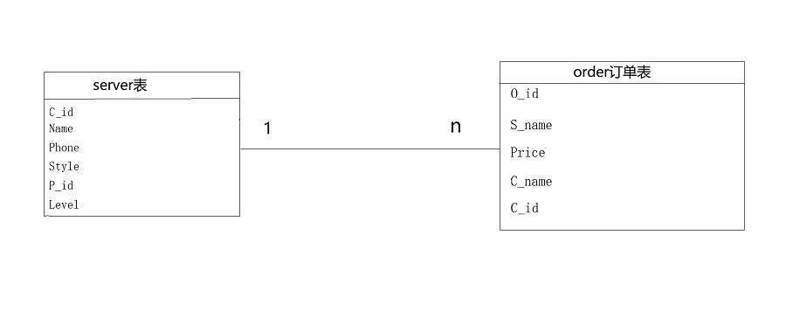

（图8）

# **3 系统实现**

## 3.1 项目结构

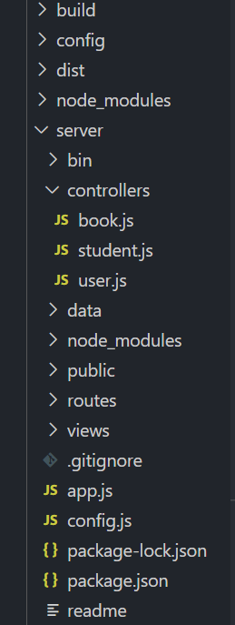

**3.2 客服服务商列表代码**

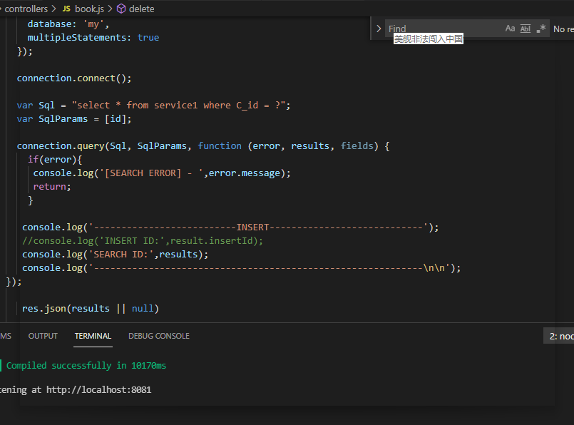

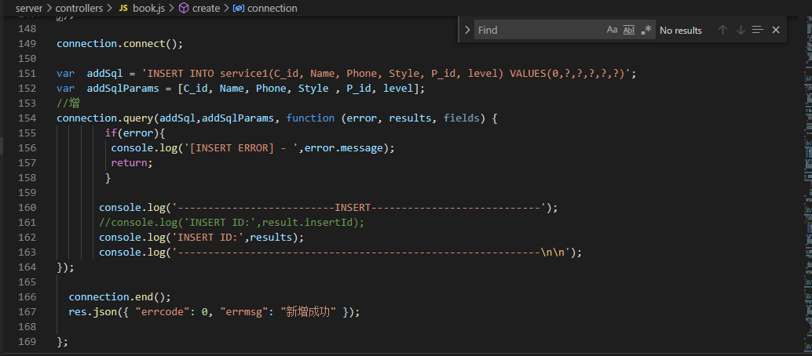

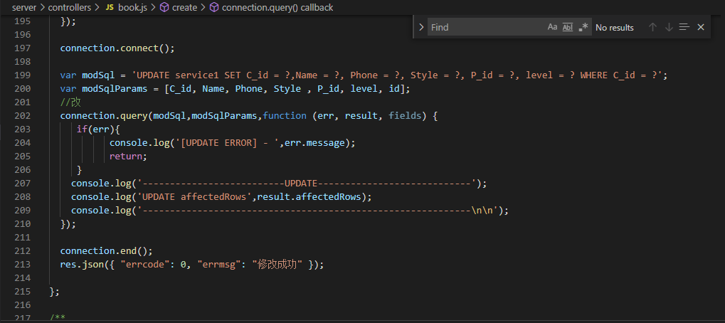

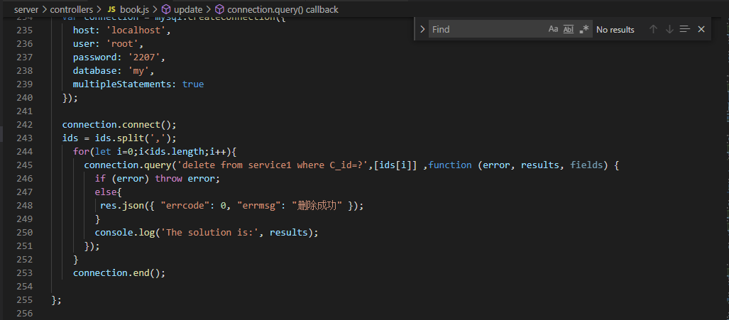

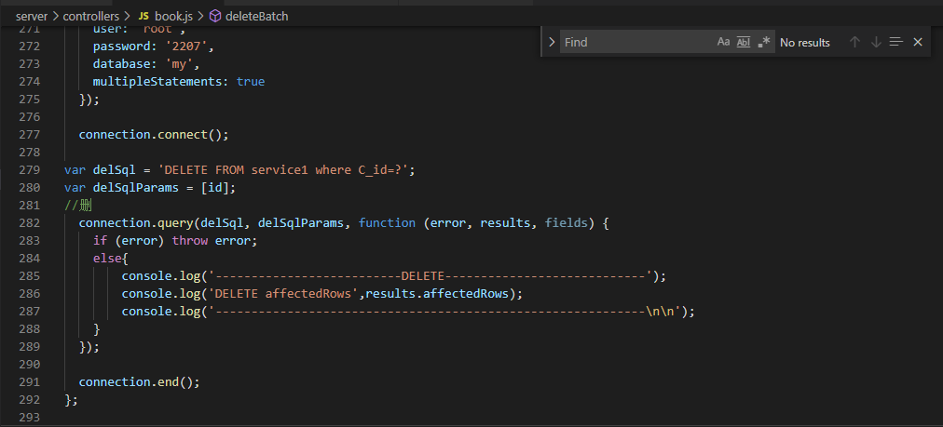

## 3.3 统计列表代码

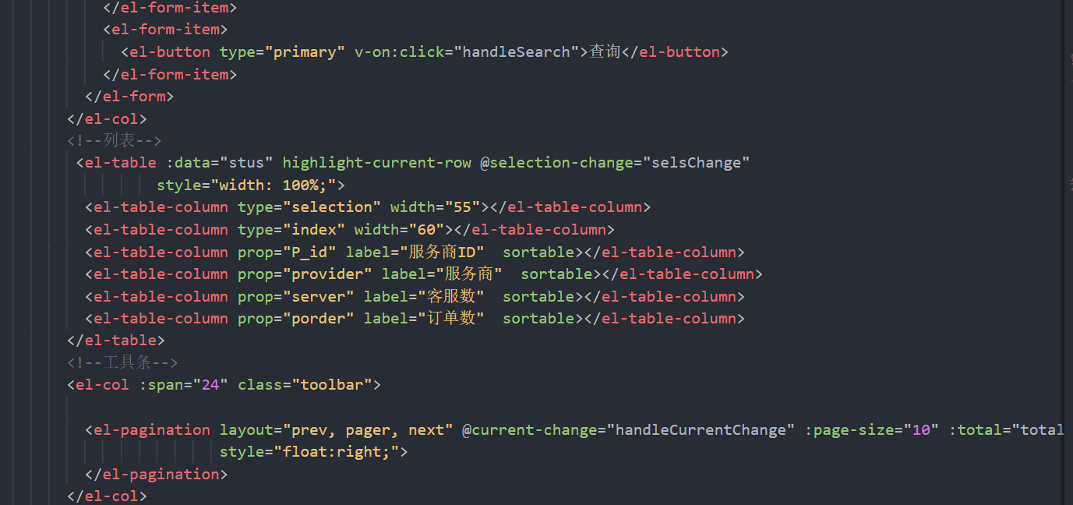

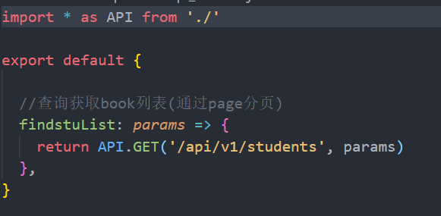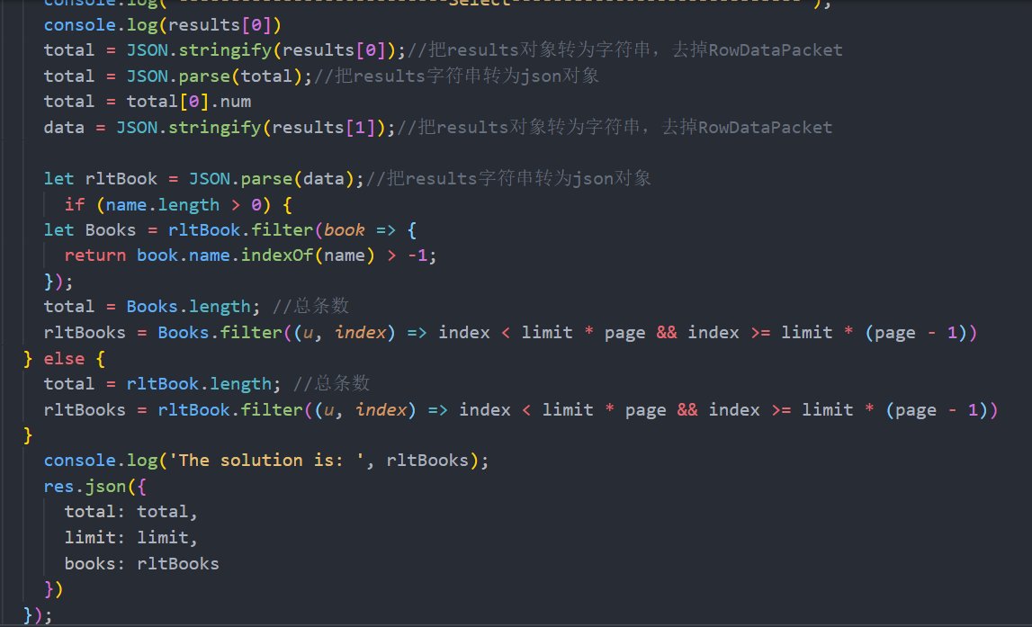

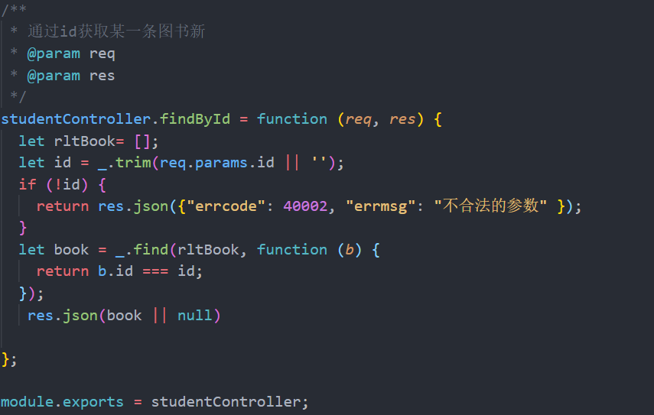

# **4 系统总结**

本次课程设计主要学会了如何做一个比较成熟的系统，更近一步的掌握了之前学过的知识，学会了如何使前端与后端数据连接到一起，在做课程设计中首先就遇到了模板缺失，无法安装成功，百度之后删掉模板之后依旧无法安装成功，后面发现是版本问题，然后重新去官网下载了匹配的版本，然后就是数据库的连接问题，查了很多资料之后问了同学才把数据库和相应的内容匹配，其他的一些小问题就不一一叙述了，这门课程学到了一些前端的知识，粗略的知道了Ajax，maven，spring等，学到了很多之前不知道的东西，收获很大。