CONTENTS
1 | AIM | 3
2 | OBJECTIVE | 3
2.1 | Areas of Research | 3
3 | LITERATURE SURVEY | 4
3.1 | Augmented Reality | 4
3.2 | The history of Augmented Reality | 4
3.3 | Applications | 6
3.4 | Potential Advancements | 6
4 | MINIMUM SYSTEM REQUIREMENTS | 6
4.1 | Hardware Requirements | 7
4.2 | Software Requirements (Windows) | 7
4.3 | Software Requirements (Linux) | 7
4.4 | Other Requirements | 7
5 | DESIGN | 8
5.1 | Algorithm for pattern matching | 9
5.2 | Tools Used | 10
6 | IMPLEMENTATION | 11
6.1 | Design Layout | 11
6.2 | Class Hierarchy | 13
6.3 | Coordinate Transformations | 15
6.4 | Force Accumulator Model | 16
6.5 | Real Time Collision Detection and Resolving | 17
6.6 | Calculation of Reaction force and Impulse | 18
7 | RESULTS | 20
7.1 | Performance Analysis | 20
8 | FUTURE WORK | 21
9 | REFERENCES | 22

1 AIM
The aim of this project is to devise and develop a method of physical interaction with virtual objects in augmented reality systems.
2 OBJECTIVE
This project is mainly carried out with the intension of breaking new ground in the field of augmented reality.
2.1 Areas of Research in this project:
- Attributing physical properties to virtual objects: In order to create a physically active virtual object we have to extract enough information from the scene. Firstly we require the orientation of the camera and scene as a whole with respect to the ground in order to determine the direction of the gravitational force. The information regarding the camera parameters can be obtained as a 3x4 camera matrix using markers of known dimensions. Next we have to calculate the surface normal at each sampled point of the objects in the scene along with their relative positions. This together with the specified material properties can be used to define the virtual objects.
- Resolving real time collision between real and virtual objects: An event driven mechanism can be employed to constantly listen for collision events detected using conventional methods.
- Resolving depth conflicts in an augmented reality scene: Since markers determine the orientation and positional information of the camera, it is crucial that this information is saved or obtained relative to them even if they are occluded or obscured. If this is successfully done it is possible to find relative depths.
- Using hand gestures as a method of direct interaction with virtual objects: Detecting hand gestures and assigning them to corresponding operations is a non trivial problem that must be solved using image processing concepts.
3 LITERATURE SURVEY
3.1 Augmented Reality (AR):
Augmented Reality is a concept involving the combination of the real world with virtual components to produce a composite reality. This kind of a merger results in a more straightforward interaction with the virtual realm. Unlike the conventional methods of human computer interaction where a medium such as a pointing device is required, augmented reality systems allow users to “touch” and interact with virtual objects in ways not possible before. This aspect of straightforward interaction is the key area of research in this project.
3.2 The History of Augmented Reality:
In the original paper by Wellner et al (1993) which coined the term, Augmented Reality (abbr. AR) was described as the opposite of Virtual Reality where the user is immersed into a completely synthesized environment. Augmented reality on the other hand focuses on extracting information from the real world and embedding the same into virtual objects to create a cohesive display.
The Timeline ^{[1]}
1957-62: Morton Heilig, a cinematographer, creates and patents a simulator called Sensorama with visuals, sound, vibration, and smell. ^{[2]}
1966: Ivan Sutherland invents the head-mounted display suggesting it was a window into a virtual world.
1975: Myron Krueger creates Videoplace that allows users to interact with virtual objects for the first time.
1989: Jaron Lanier coins the phrase Virtual Reality and creates the first commercial business around virtual worlds.
1992: Tom Caudell coins the phrase Augmented Reality while at Boeing helping workers assemble cables into aircraft.
1992: L.B. Rosenberg developes one of the first functioning AR systems, called VIRTUAL FIXTURES, at the U.S. Air Force Armstrong Labs, and demonstrates benefit on human performance. ^{[3] [4]}
1992: Steven Feiner, Blair MacIntyre and Doree Seligmann present first major paper on an AR system prototype, KARMA, at the Graphics Interface conference. Widely cited version of the paper is published in Communications of the ACM next year.
1999: Hirokazu Kato develops ARToolKit at the HITLab and it is demonstrated at SIGGRAPH that year.
2000: Bruce H. Thomas develops ARQuake, the first outdoor mobile AR game, and is demonstrated in the International Symposium on Wearable Computers.
2003: GeoVector along with partners Vodafone, HP, Microsoft, Virtual Spectator and Animation Research Ltd showcase Actual Spectator Augmented Reality App at America's Cup Sailing Races in Auckland, New Zealand.
2008: Wikitude AR Travel Guide launches on Oct. 20, 2008 with the G1 Android phone.
2009: AR Toolkit is ported to Adobe Flash (FLARToolkit) by Saqoosha, bringing augmented reality to the web browser.
2009: Wikitude Drive - AR Navigation System launches on Oct. 28, 2009 for the Android platform.

3.3 Applications:
- Interactive 3-D maps that could be collaboratively modified and analyzed.
- Television broadcasts in which virtual markers point out the positions of fielders in a cricket match, or the puck in an ice hockey game and so on.
- Visualizations of hidden objects: doctors can see the fetus in a mother’s womb.
- Assisting difficult tasks: A system could label the parts of a complex machine while a mechanic was at work.
- Interactive games.
- Holographic displays at museums.
- Mounted or projected Heads up displays (Hud) where vital information is shown during a critical process.

3.4 Potential Advancements:
Until now AR has been extensively used in aspects of presentation and display of information. One potential application of Augmented Reality is to mould a virtual object into reality, complete with appropriate physical properties so that it can pose as a real object itself. Such an object will be capable of interacting with other real objects in real time. For instance a collision with a real object can be resolved with the obtained information of the relative velocities and centers of mass. Virtual objects can be given material properties such that they can influence the way that they interact with incident light. With the increasing computing power in today’s CPUs and GPUs high fidelity interactions are made possible.

4 MINIMUM SYSTEM REQUIREMENTS
4.1 Hardware Requirements
- A 1.6 GHz processor or higher.
- 1 GB RAM
- Graphics Card with at least 64MB video memory.
- A Digital Camera.
4.2.1 Software Requirements (Windows)
- Windows XP/ Windows Vista/ Windows 7.
- Direct X runtime.
- OpenGL runtime.
- DSVideoLib runtime.
- VFW Driver for the digital camera.
4.2.2 Software Requirements (Linux)
- Linux 2.6 kernel.
- V4L Driver for the digital camera.
4.3 Other Requirements
- Detectable Pattern cards of known dimensions.

5 DESIGN
This project is modularized in order to reduce complexity and allow ease of maintenance or debugging. Apart from this a spiral model is adopted for the software development process. This allows for iterative development and a recurrent testing phase after every sub-version is implemented. Due to the time constraints this process model proves much effective.
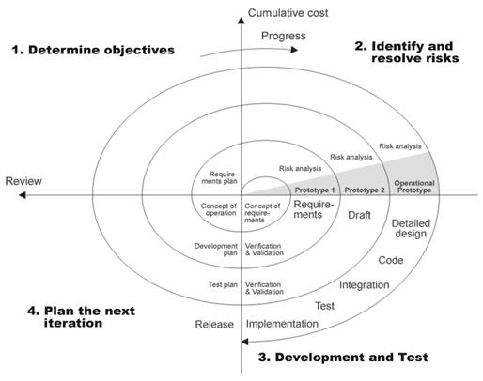
Fig 5.1 - The Spiral model of software development process.
The actual system on the other hand has certain prerequisites that have to be fulfilled. Being a real time system the inputs must be optimally handled and the data flow must be made efficient right from the input stage to the final output. Since a optimal solution for the underlying image processing problems must be found it is desirable that this step be accelerated using a GPU device wherever necessary and available.
5.1 Algorithm
- Begin
- Initialize the input video stream;
- char esc_listener;
- Image *img;
- While ( esc_listener != _EXIT_EVENT_ )
- Image = frame(video) //Grab a frame from the video sequentially.
- For ( every pixel row in the image)
- For (every pixel in the row)
- Int avg = (image->red + image->green + image->blue) / 3;
- Image.red = image.blue = inage->green = avg; // Convert to grayscale.
- End for <8>
- End for <7>
- Image = adaptiveThreshold(image); // Convert to binary image using adaptive thresholding.
- Detect pattern in image;
- Obtain camera parameters;
- Convert camera parameters to OpenGL format;
- Initialize OpenGL projection matrix;
- Initialize OpenGL modelview matrix;
- Draw virtual objects;
- Display Frame buffer;
- End while <5>
- End <1>
5.2 Tools Used
- ARToolKit 2.65 ( Open Source rapid AR application prototyping library )
- OpenCV 1.0 ( Open Source Image Processing Library )
- Microsoft Visual Studio 2005. ( C++ IDE for Windows )
- OpenGL 3.2 ( Open Source graphics library)
- DSVideoLib 0.8 ( Open Source Video Manipulation library )
- GNUC Compiler ( C++ compiler for Linux )
- Nvidia CUDA Toolkit/SDK. ( GPU programming model )

6 IMPLEMENTATION
6.1 Design Layout:
This Project is maintained as a hierarchy in order to abstract the complexities within. The basic elements in the demo are the ball and the maze, which are rendered based on the pattern detected. The first occurrence of the pattern is taken as the reference which is parallel to the ground. This reference is used to calculate the gravity vector in the camera coordinate system.
Timiing is kept with according to clock ticks elsapsed since the start of the program. This way the duration between consequtive frames is maintained and the postion and velocity of the ball are integrated. During each time frame the ball is checked for collisions with all the walls and each of these collisions is resolved by applying the necessary impulses and reaction forces.
The flow chart of the process is shown in the following page.
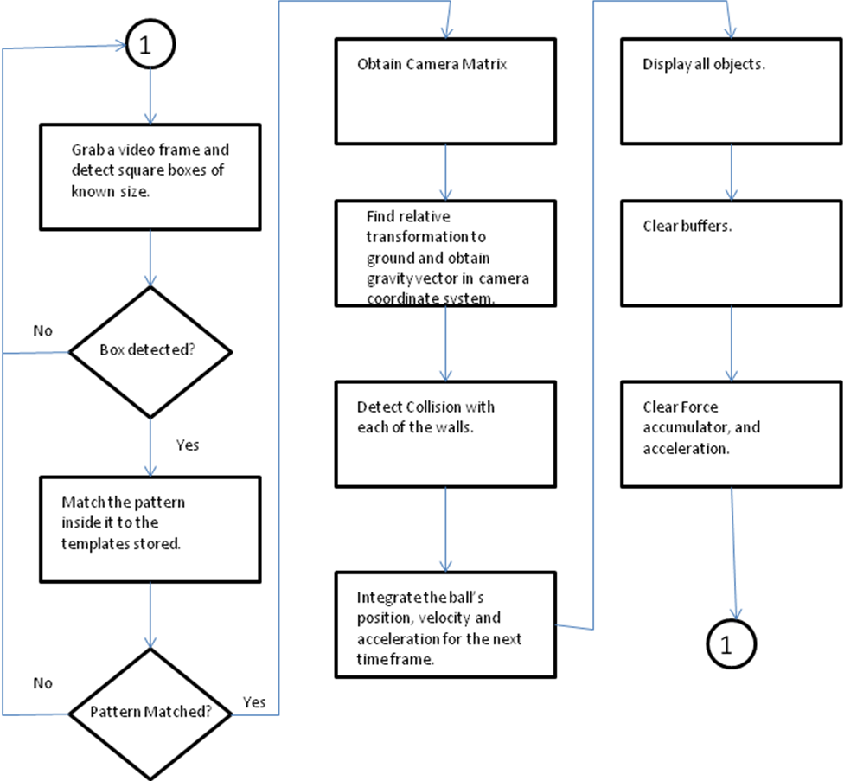
Fig 1.1: Flow chart of the process.

6.2 Class Hierarchy:
All the objects in the game are derived from the Object class. The object class holds information common to all the objects. Like rigidity, solidity and mass etc.
The Wall class holds the properties and methods that pertain to each wall in the maze like the surface normal, The equation of the plane of the wall (stored as an offset value which represents the distance of the plane from the origin), its vertices and collision parameters.
The Maze class is stores the collection of walls that make up the maze, along with methods to calculate the surface normals of each of its walls. The maze is loaded from a maze file with the help of a loader routine.
The most complex and important class is the ball class as most operations are performed on the ball object. The ball class consists of members to store the radius, the number of stacks and slices used to render the ball, the balls force accumulator, parameters like position, velocity, acceleration, the mass and its inverse mass.
The class diagram is shown in the following page.
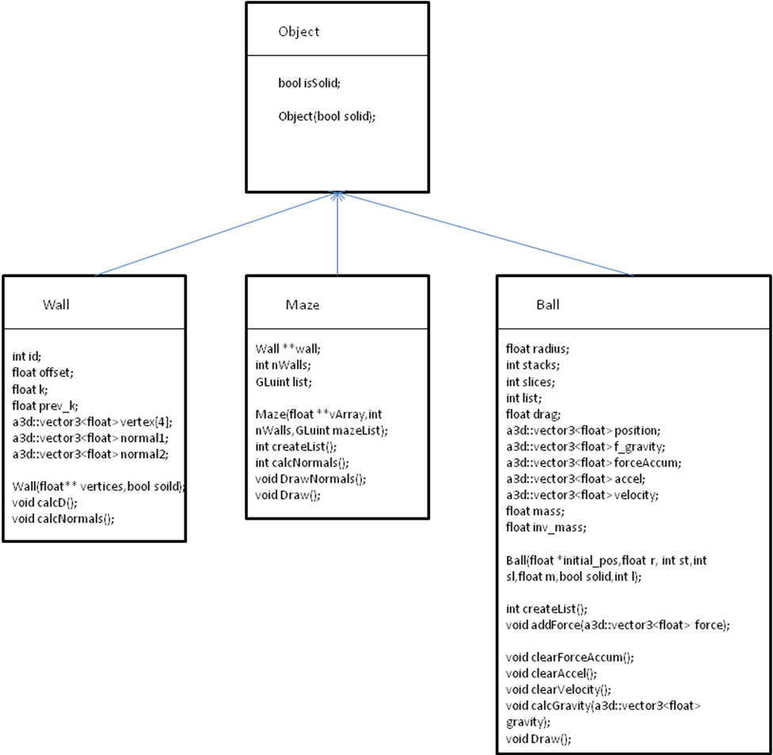
Fig 1.2 Class Diagram.

6.3 Coordinate Transformations
The user initially calibrates the system in order to store the reference coordinate system that is suitably aligned with the ground. The user keeps the pattern in a position that is approximately parallel to the ground or in a direction perpendicular to the gravity vector he desires to generate. This is done by positioning the pattern accordingly and pressing “c”.
Once this is done the reference pattern is stored in a 3 x 4 matrix. The subsequent camera matrices that are obtained will be the ones used to draw the objects in the scene. The corresponding gravity vector is obtained however, is obtained performing the following operations.
Where
T is the resultant transformation matrix,
C is the Camera matrix.
R is the Reference matrix.
The resultant gravity vector in the camera matrix coordinates is obtained by
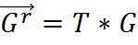
Where
G^{r} is the resultant gravity vector
T is the transformation matrix 3 x 4
G is the gravity vector in the reference coordinate system.

6.4 The Force Accumulator model:
The force accumulator model as the name suggests involves calculating the resultant force in each of the time frames. The D’Alembert’s principle is applied in order to do this. Any event that generates a force adds it to the corresponding object’s force accumulator. In this respect we can visualize a collision as a force generating event. During a collision the immovable walls exert an impulse on the ball. This impulse is added to the balls force accumulator. At any given time frame the resultant force is calculated as follows.
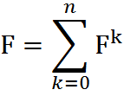
Once this is done the resultant acceleration is calculated as :
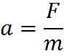
This acceleration is used along with the time duration between two frames (represented as t ) to integrate to find the position and velocity of the ball as follows.

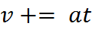
And
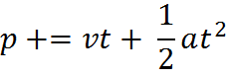
This is done by the integrator that runs in each frame.

6.5 Real Time Collision Detection and Resolving:
Since the only objects between which a collision is possible are a wall and the ball, which necessarily are a plane and a sphere respectively the collision detection is quite trivial. But in order to achieve this we need to know the equations of the planes of which the walls are a part of. The vector equation of a plane is
Where
r is the position vector of any point on the plane.
p is a point on the plane
n is the unit normal vector to the plane.
Translating this equation to 3D coordinates we get the equation as:
Where
which is the distance of the plane from the origin.
It is sufficient to store the value of d for our computations. Once d is known it is just a matter of basic inequality to determine whether a collision occurred between the ball and the wall. We can definitely say that the ball has collided with the wall If the distance between the ball and the wall is less than or equal to the radius of the ball.
i.e
Where
Where
c is the position vector of the balls centre.

6.6 Calculation of Reaction Force and Impulse:
Reaction force is the force that is exerted by any surface along its normal the object is in contact with to nullify any opposing force. The magnitude of the Reaction force is equal to the magnitude to the component of force that is along the negative normal of the surface. The following equation governs the reaction force.
Where
F^{R} is the reaction force
F^{n} is the component of the resultant force that is normal to the surface.
It is this reaction force that keeps objects from passing through each other.

Impulses on the other hand are forces applied in for infinitesimal time duration and produce great accelerations. Since its is not possible to integrate over such small time durations due to constraints on the frame rate of the video and the resolution of the internal clock, impulses are calculated using a different method.
Firstly the component of velocity along the normal of the surface is determined.
Where
v^{c} is the velocity component along the normal to the surface.
v is the velocity vector.
n is the unit normal vector to the plane.
After this the impulse is obtained by reversing the velocity component along the normal and applying a sufficient damping to it. This damping is applied to account for the energy losses incurred during the collision.

7 RESULTS
7.1 Performance Analysis:
Efficiency:
To achieve a smooth output the application has to maintain a reasonable frame rate of 30fps. Moreover the frame rate must not fluctuate. The program was run at a stretch for a period of half an hour and it was found that the frame rates were maintained at an average of 31.7fps. The maximum and minimum frame rates being 34fps and 29.3fps respectively. This indicates that there has been a significantly constant frame rate.
Maintaining a constant frame rate at 31.7fps requires much optimization. The operations between two consecutive frames must be very efficient and kept to a minimum. On an average it is observed that 160 clock ticks elapsed between two consecutive frames.
Scalability:
Considering the amount of processing that goes into the pattern recognition, physics calculation and rendering each frame, scalability is definitely an issue. The program runs smooth at 31.7fps at a resolution of 320 x 240. However at higher resolutions the frame rate drops drastically, making it infeasible to run.
This is due to the tremendous increase in the number of pixels to be processed at higher resolutions.

8 FUTURE WORK
So far augmented reality has been achieved with the use of markers and patterns of known dimensions. This method has certain drawbacks. Firstly the markers must me contained within the scene at all times to render virtual objects. Secondly a big amount of per frame computation is performed for marker detection, recognition and calculation of the camera matrix. Augmented reality systems can be made more efficient and scalable without markers. However this calls for some novel method of obtaining the camera matrix, which is the first step towards performing augmented reality.
In this respect one method is to identify the major plane in the scene and initialize a coordinate system on it to perform AR. This analogous to obtaining a camera matrix, but without the tedious computation required for markers.

9 REFERENCES
[1] Wikipedia – The history of Augmented Reality.
[2] http://www.google.com/patents?q=3050870
[3] L. B. Rosenberg. The Use of Virtual Fixtures As Perceptual Overlays to Enhance Operator Performance in Remote Environments. Technical Report AL-TR-0089, USAF Armstrong Laboratory, Wright-Patterson AFB OH, 1992.
[4] L. B. Rosenberg, "The Use of Virtual Fixtures to Enhance Operator Performance in Telepresence Environments" SPIE Telemanipulator Technology, 1993.

