Week 1 — Python for Machine Learning & Data Preprocessing
Deliverable: clean and preprocess a sample dataset, and document each preprocessing step. Dataset: UCI Adult / Census Income (48,842 records, 14 attributes, binary income target). Reproduce everything: python run_all.py (~5 min; downloads the raw data, regenerates every number and figure below).
Every figure in this report is produced by the code in src/, and every number is read out of outputs/*.json, which those scripts write. Nothing here is quoted from a textbook or a tutorial; where a conventional technique turned out to be wrong for this dataset, that is reported as a result rather than quietly dropped (see §9).

1. Headline results
 | Value
Raw records loaded | 48,842 (32,561 train file + 16,281 test file)
Records after cleaning | 48,790 (52 exact duplicates removed)
Missing values found | 6,465, all disguised as the string ? — pandas reported 0 NaN
Columns in → engineered features out | 15 → 53
Train / test split | 39,032 / 9,758, stratified (23.942% / 23.939% positive)
Majority-class baseline accuracy | 76.061%
Final model — logistic regression | ROC-AUC 0.91228, PR-AUC 0.78276, F1 0.67699
Final model — gradient boosting | ROC-AUC 0.93239, PR-AUC 0.84022, F1 0.72295

The single most consequential finding of the week is in §8: fitting a target encoding before the train/test split inflated test AUC by +0.02587 — roughly twelve times the standard error of the measurement — while the same discipline error applied to a StandardScaler was worth −0.00002, i.e. nothing. "Avoid leakage" is not one rule with one magnitude.

2. Why this dataset
Titanic is the default choice for this exercise, and it is a poor one: 891 rows, three columns with missing values, and no decision that cannot be resolved by inspection. Adult was chosen because it forces genuine judgment calls, each of which is documented below:
- missing values encoded as a sentinel string, invisible to pandas.isna();
- a column (fnlwgt) that is a survey artefact, not a property of the person;
- two columns that are a perfect 1-to-1 re-encoding of each other;
- a numeric column that is top-coded — a censoring code masquerading as a value;
- a categorical column with 42 levels, one of which has a single row in the entire dataset;
- 3.18 : 1 class imbalance, so accuracy is nearly useless as a metric.

3. Loading: a label bug that would have gone unnoticed
UCI ships Adult as two files that are not formatted identically. adult.test has a junk first line (|1x3 Cross validator) and — critically — every label carries a trailing period.
Concatenating them naively produces four classes:
['<=50K', '<=50K.', '>50K', '>50K.']
A model trained on that silently learns a 4-class problem, and every binary metric computed afterwards is meaningless. Stripping the period restores the intended two classes:
['<=50K', '>50K'] 48,842 rows x 15 columns
Lesson recorded: the first thing to check after loading is the set of distinct values in the target, not the shape of the frame. The shape was correct in both cases.
Code: src/step00_assemble.py → outputs/00_assemble.json

4. Data quality audit
No cleaning happens in this step. It measures, so that each later decision can cite a number. Code: src/step01_audit.py → outputs/01_audit.json

4.1 Missing values are invisible to pandas
df.isna().sum().sum() returns 0. The missing values are the literal string ?:
Column | Missing | Share
occupation | 2,809 | 5.75%
workclass | 2,799 | 5.73%
native_country | 857 | 1.76%
Rows with ≥1 missing | 3,620 | 7.41%

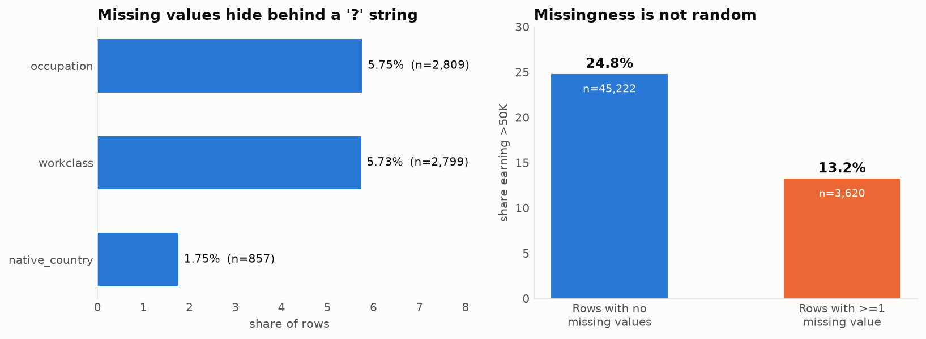
Two structural facts, both of which changed how the data was handled:
(a) The missingness is nested, not independent. Of the 2,799 rows missing workclass, 2,799 — every single one — is also missing occupation. There are 0 rows missing workclass alone, and only 10 missing occupation alone. These are not two coincidences; they are one event. (Confirmed independently in §7: the indicator columns workclass_Missing and occupation_Missing correlate at r = 0.9981.)
(b) The missingness is informative — it is not MCAR. Rows with at least one missing value earn >50K 13.23% of the time; complete rows do so 24.78% of the time. A person whose employment fields are blank is close to half as likely to be a high earner.
This single measurement decides the imputation strategy. Replacing ? with the mode (Private, Prof-specialty) would assert that these 3,620 people are typical private-sector workers, when the data says they are a distinct, poorer group. The information is in the absence, so the absence is preserved as its own category. Measured payoff in §7: +0.00160 AUC and +0.0069 F1 over mode imputation.

4.2 Duplicates, including five contradictions
- 52 exactly duplicated rows.
- 57 rows duplicated when the target is ignored.

The difference is the interesting part: 5 pairs (10 rows) are identical in every feature but carry opposite labels. For example:
age | workclass | education | occupation | hours | income
34 | Private | Masters | Exec-managerial | 50 | <=50K
34 | Private | Masters | Exec-managerial | 50 | >50K

These are not errors to be fixed — they are irreducible Bayes error, two real people the feature set cannot tell apart. They are a standing reminder that perfect accuracy is not available here, and they are left in the data.
The 52 exact duplicates are removed, and removed before the split (see §6).

4.3 capital_gain is top-coded
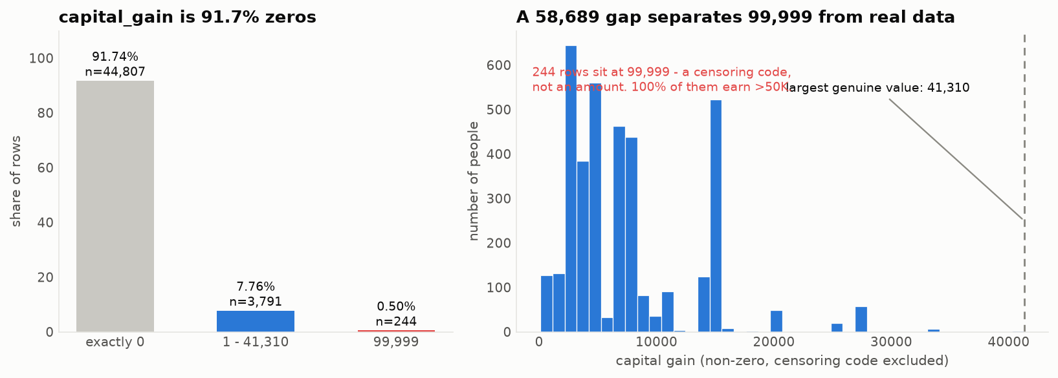
- 91.74% of rows are exactly 0; skew is 11.895.
- 244 rows sit at exactly 99,999.
- The next largest value in the data is 41,310 — a gap of 58,689.
- 100% of the 99,999 rows earn >50K.

99,999 is not an amount of money; it is the census's "at or above the reporting ceiling" code. Treated as a number it drags the mean, inflates the variance, and hands any scaler a fictional maximum. Handling is in §5.4.

4.4 Class imbalance
37,155 <=50K vs 11,687 >50K — a ratio of 3.179 : 1. Predicting "<=50K" for everybody scores 76.07% accuracy. Accuracy is therefore reported but never optimised; ROC-AUC is the primary metric, with PR-AUC and positive-class F1 alongside, because PR-AUC is the one that degrades honestly when the positive class is rare.

4.5 Scale and redundancy
- Raw standard deviations span a 41,091× range (capital_gain 7,452 vs education_num 2.57).
- education and education_num are a perfect 1-to-1 mapping — all 16 text levels map to exactly one integer each, verified programmatically.
- fnlwgt correlates with the target at |r| = 0.0063.
- Maximum off-diagonal Spearman correlation among the numeric columns is only 0.1644, so there is no multicollinearity problem to solve among them.

5. Cleaning decisions
Each decision states the evidence and the alternative that was rejected. Code: src/step02_clean_split.py → outputs/02_clean_split.json

5.1 Drop fnlwgt
fnlwgt is a census post-stratification weight: it encodes how many people in the population the row stands for. It is a property of the sampling design, not of the person, and it is not available at prediction time for a new individual.
Evidence: |r| = 0.0063 with the target — statistically and practically nothing. Rejected alternative: keeping it "in case the model finds something". A model that finds something in a survey weight has found a leak, not a signal.

5.2 Drop education, keep education_num
The two columns carry identical information. Keeping the text version would add 16 one-hot columns containing zero new signal, and would destroy the ordering.
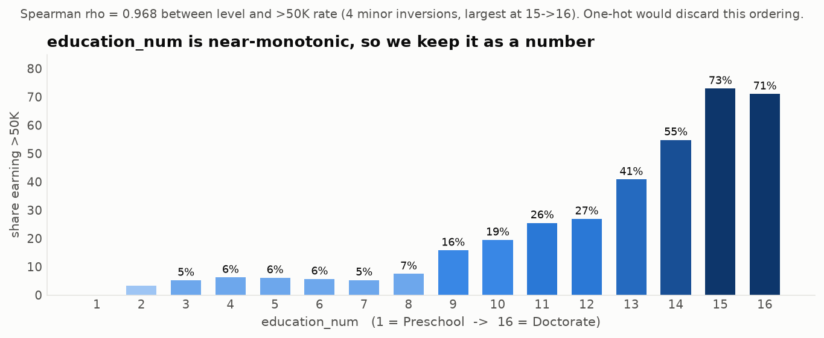
The ordering is real and it is strong: the >50K rate climbs from 0.0% at level 1 (Preschool) to 71.05% at level 16 (Doctorate), with Spearman ρ = 0.968 between level and rate. It is not perfectly monotonic — there are four small inversions, the largest being Prof-school (72.96%) edging out Doctorate (71.05%) — but ρ = 0.968 is more than enough to justify treating it as an ordered number rather than 16 unordered flags.

5.3 Convert ? to real NaN
6,456 sentinel values (post-deduplication) converted, so that every downstream tool — isna(), SimpleImputer, the one-hot encoder — sees missingness as missingness.

5.4 Flag the top-coding instead of deleting it
The 244 top-coded rows are not dropped: they are 100% high earners and dropping them would remove real, strongly predictive records. Instead:
- a binary capital_gain_topcoded flag records that the value was censored;
- the value 99,999 is replaced with 41,310, the largest genuinely observed amount.

This keeps "this person's capital gain was very large" while removing a fictional 58,689-unit gap that would otherwise distort every scaler and every tree split threshold. Measured side effect: capital_gain skew drops from 11.895 to 7.637 from this change alone.
Rejected alternatives: deleting the rows (throws away signal); leaving 99,999 in place (poisons the scale); treating it as missing and imputing (asserts the opposite of what is known — that the value was large).

5.5 Two engineered flags
has_capital_gain and has_capital_loss, because these columns are 91.7% and 95.3% zeros: the "did this happen at all" signal is structurally different from "how much". §7 shows this was only half right — see the honest post-mortem in §9.2.

5.6 Outliers: measured, then deliberately left alone
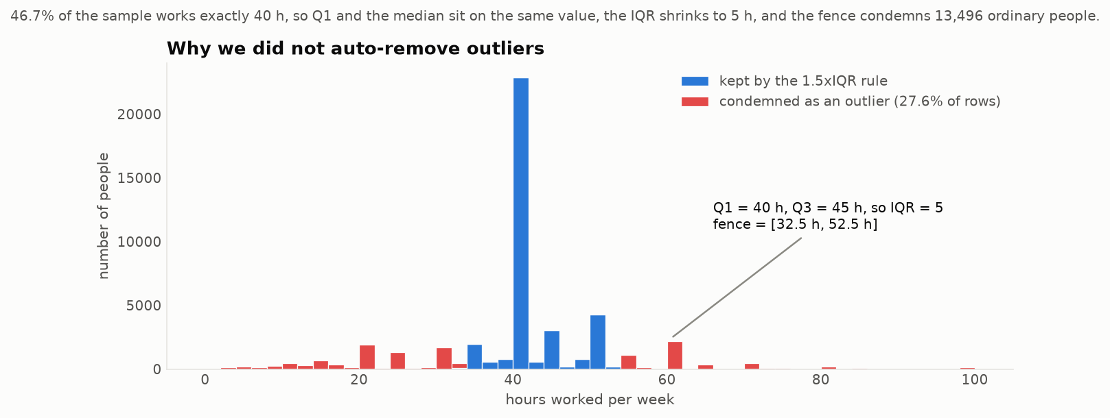
The reflex at this point is df = df[~outlier_mask] using the 1.5×IQR rule. On this dataset that reflex is a mistake, and the numbers say so clearly.
46.69% of the sample works exactly 40 hours per week. That spike pulls Q1 and the median onto the same value (both 40 h), leaving Q3 = 45 h and an IQR of just 5 hours. The resulting fence is [32.5 h, 52.5 h] — so the rule condemns 13,496 people, 27.63% of the dataset, including every part-time worker and every 60-hour-a-week manager. Those are not measurement errors; they are the most informative rows in the file.
By the same rule education_num has 1,794 "outliers" (3.67%) — people with doctorates.
Decision: no automated outlier removal. The only value treated as invalid is the 99,999 censoring code, and that is because it was shown to be a code rather than a measurement. Outlier handling here is a modelling question (scaling, robust losses), not a cleaning one.

6. The split, and the leakage discipline
Code: src/step02_clean_split.py, src/step04_pipeline.py
Order of operations, and the reason for it:
deduplicate -> drop columns -> sentinel to NaN -> SPLIT -> fit transformers on TRAIN only
Deduplicate before splitting. 52 identical rows split at random would place copies of the same record on both sides of the fence; the model would then be tested on rows it had memorised. At 0.11% of the data the metric impact here is negligible, but the ordering is what generalises to datasets where duplication is heavy.
Split before fitting anything that learns. Medians, means, standard deviations and category vocabularies are all learned parameters. The test set has to stand in for data that does not exist yet.
Verification that the discipline actually held. After scaling, the training features have mean exactly 0 — and the test features do not:
feature | train mean after scaling | test mean after scaling
age | −0.000000 | +0.019402
education_num | 0.000000 | +0.000698
hours_per_week | −0.000000 | −0.025977

A test mean of exactly 0 would be the symptom of a leak. These small non-zero values are the proof that the scaler never saw the test split.

The unseen-category problem, quantified
native_country has 42 levels. Holand-Netherlands has exactly one row in all 48,842. If that row lands in the test set, an encoder fitted on training data has never seen the level.
With random_state=42 it happens to land in train, so the problem is invisible. Rather than rely on that luck, the split was repeated across 200 random seeds: 45 of them (22.5%) produced at least one test category absent from train — every single occurrence being Holand-Netherlands. Hence handle_unknown="infrequent_if_exist" in the encoder, which absorbs unseen levels instead of raising.
Code: outputs/02b_unseen_category_risk.json

7. The preprocessing pipeline
A single ColumnTransformer, fitted on train only, serialised to data/processed/preprocessor.joblib. 15 input columns → 53 features, no NaN remaining in either split. Code: src/step04_pipeline.py → outputs/04_pipeline.json
Group | Columns | Treatment
Skewed numeric | capital_gain, capital_loss | median impute → standardise
Plain numeric | age, education_num, hours_per_week | median impute → standardise
Binary flags | capital_gain_topcoded, has_capital_gain, has_capital_loss | passthrough
Categorical | 7 columns | impute "Missing" → one-hot, min_frequency=1%, unknowns absorbed

Rare-level folding
Folding levels below 1% frequency cuts the one-hot block from 86 columns to 45 — a 48% reduction — concentrated almost entirely in one column:
Column | Levels in train | Folded as infrequent | Output columns
native_country | 42 | 39 | 4
occupation | 15 | 2 | 14
workclass | 9 | 2 | 8
race | 5 | 2 | 4

39 of the 42 countries together cover under 1% of rows each. As separate columns they are almost pure noise — a handful of rows apiece, enough for a model to memorise and not enough to generalise.

Scaling
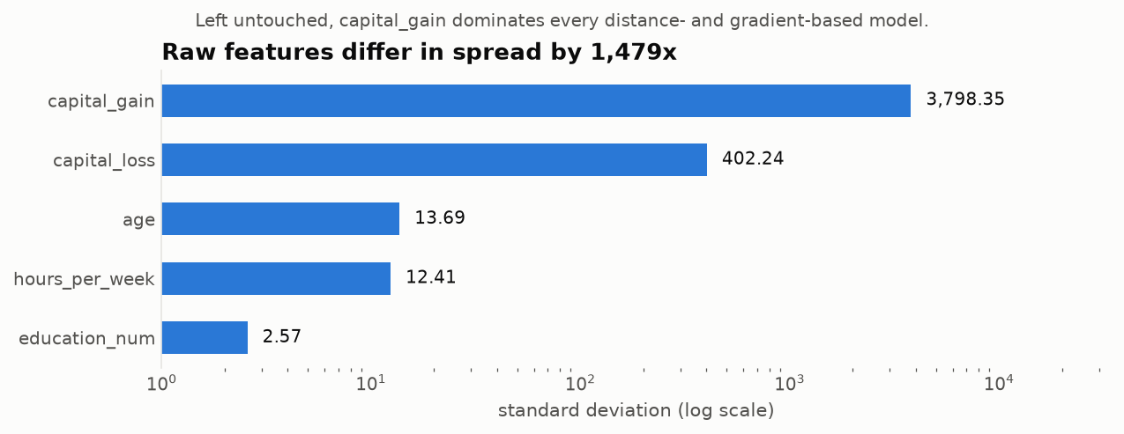
After dropping fnlwgt, the remaining numeric columns still differ in spread by 1,479×. What scaling actually buys is measured in §8 — and the answer is more interesting than "it helps".

8. What each decision was actually worth
This is the part the write-up usually skips. Each knob was flipped with everything else held fixed, and re-measured. Code: src/step06_experiments.py → outputs/06_experiments.json
The noise floor. 5-fold CV on the shipped pipeline gives AUC 0.90804 with a fold-to-fold standard deviation of 0.00479, so the standard error of the mean is 0.00214. Any effect smaller than that is not a finding.
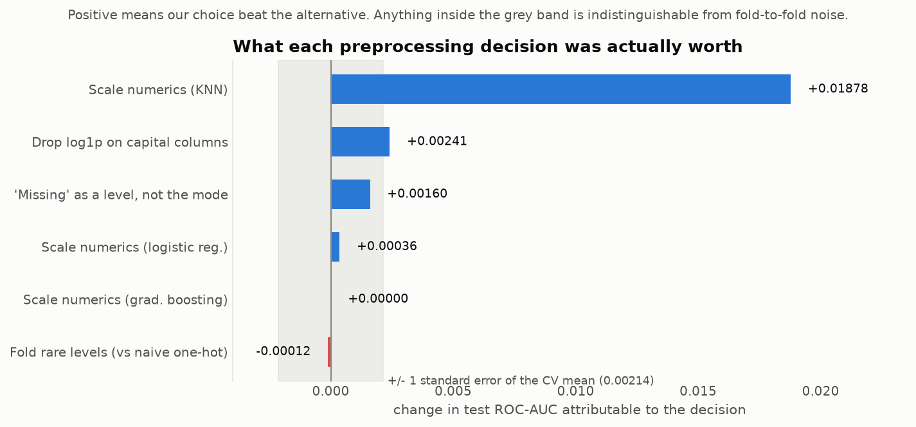
Decision | Alternative | Δ test AUC | Verdict
Standardise numerics | leave unscaled | +0.01878 (KNN) | Real and large
No log1p on capital columns | apply log1p | +0.00241 | Real, small
"Missing" as its own level | mode imputation | +0.00160 | Below noise on AUC; see below
Standardise numerics | leave unscaled | +0.00036 (logistic reg.) | Irrelevant to AUC
Standardise numerics | leave unscaled | +0.00000 (grad. boosting) | Exactly zero, as theory predicts
Fold rare levels | naive one-hot | −0.00012 | Free; 94 → 53 features

Three things worth drawing out:
Scaling is model-dependent, and the usual advice is too vague. For gradient boosting the gain is exactly 0.00000 — a monotone rescaling cannot change which split a tree chooses, and the measurement confirms the theory to five decimal places. For logistic regression the AUC gain is negligible (+0.00036), but the fit time falls by roughly 20× (22.1 s → 1.1 s on this machine), because lbfgs struggles to converge when one feature has a standard deviation 1,479× another's. Wall-clock timings vary by machine and run; the metric columns elsewhere in this report do not. For KNN, which computes raw Euclidean distances, scaling is worth +0.01878 AUC — nearly nine standard errors. So: scaling is essential for distance-based models, a convergence aid for linear models, and provably pointless for trees. One rule does not cover all three.
Rare-level folding is justified on parsimony, not accuracy. It costs 0.00012 AUC — nothing. Its real benefit is 41 fewer columns and a model that cannot memorise a country with three rows in it. Reporting this honestly matters more than claiming an improvement that is not there.
The "Missing" category is the weakest of the "real" results. +0.00160 AUC sits just below the 0.00214 noise floor, though the direction is consistent in both CV and the held-out test, and the F1 gain (+0.0069) is proportionally larger. The honest statement is that the primary justification remains the MNAR evidence from §4.1 — a 13.23% vs 24.78% difference in outcome rate is a fact about the data, independent of whether one model configuration can exploit it.

Leakage: the same mistake, two orders of magnitude apart
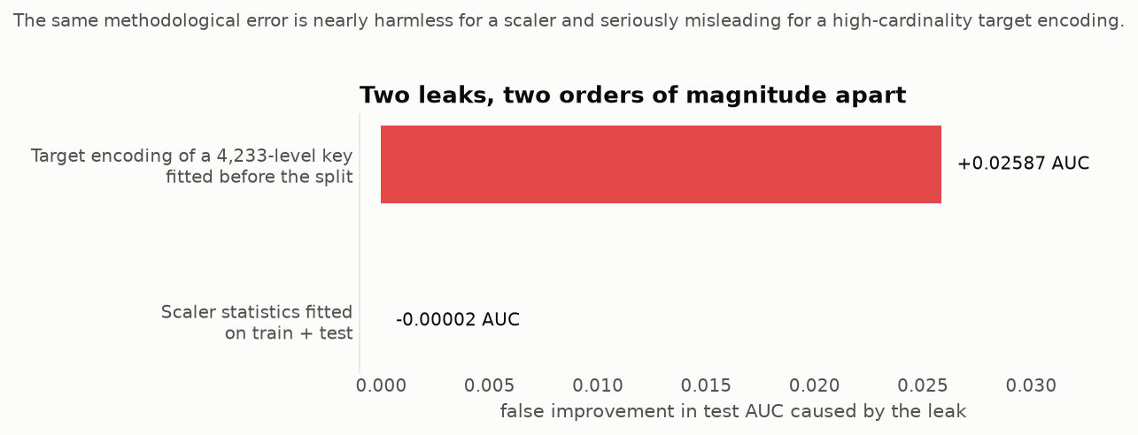
Leak | Optimism in test AUC
StandardScaler statistics fitted on train + test | −0.00002
Target encoding of a 4,233-level composite key fitted before the split | +0.02587

The scaler leak is worth nothing at n = 48,790 — a mean and a standard deviation estimated from 39,032 rows barely move when 9,758 more are added. Many tutorials demonstrate leakage with exactly this example and inadvertently teach that leakage is a triviality.
The second experiment uses the same methodological error on a high-cardinality target encoding (occupation × native_country × workclass × education_num × race, 4,233 distinct keys). Test AUC rises from 0.76465 to 0.79052 — a +0.02587 phantom improvement, about 12× the standard error, produced entirely by test labels bleeding into a feature the test rows then use.
The transferable lesson: leakage severity scales with how much the transform can memorise individual rows. A two-parameter scaler can memorise nothing. A 4,233-level encoding can memorise almost everything. The rule "fit on train only" is cheap enough to apply universally, but knowing where it actually bites is what stops it from being cargo cult.

9. Where my first answer was wrong

9.1 log1p on the capital columns — shipped, then reversed
capital_gain has skew 7.637 and is 91.7% zeros. Every rule of thumb says log-transform it, and the first version of the pipeline did. Measuring it showed the opposite:
Model | with log1p | without | Δ
Logistic regression | 0.90987 | 0.91228 | −0.00241
KNN | 0.89859 | 0.90653 | −0.00794
Gradient boosting | 0.93239 | 0.93239 | +0.00000

Consistently negative for the two models that can notice, and exactly zero for the one that provably cannot (a monotone transform leaves tree splits unchanged — a useful sanity check that the harness itself is correct).
Interpretation: the discriminative power of capital_gain is concentrated in how large the large gains are — a $40,000 gain is a far stronger signal than a $2,000 one — and log1p compresses precisely that range. Meanwhile the zero-versus-non-zero distinction that the log was implicitly being credited for is already carried explicitly by has_capital_gain.
log1p was removed. It remains in the code behind a USE_LOG1P switch so the claim stays falsifiable rather than merely asserted.

9.2 has_capital_loss is nearly redundant
The correlation audit in src/step05_feature_selection.py shows capital_loss and has_capital_loss correlate at r = 0.9995. Because the column is 95.3% zeros, the scaled continuous version is already almost a binary indicator, so the engineered flag adds very little. has_capital_gain (r = 0.9944, and 8.3% non-zero) is better justified. Kept both for symmetry and because neither costs anything measurable, but the flag was not the clean win §5.5 implies.

9.3 A perfect collinearity I introduced
sex_Female and sex_Male correlate at r = 1.0000 — one-hot encoding a binary column produces the classic dummy-variable trap. It is harmless for the L2-regularised models used here, but it would make unregularised coefficients unidentifiable. drop="if_binary" is the fix; it is noted rather than silently applied because it changes the feature count quoted throughout.

10. Feature selection
Three independent views, because each is blind to something the others catch. Code: src/step05_feature_selection.py → outputs/05_*.csv, outputs/05_feature_selection.json
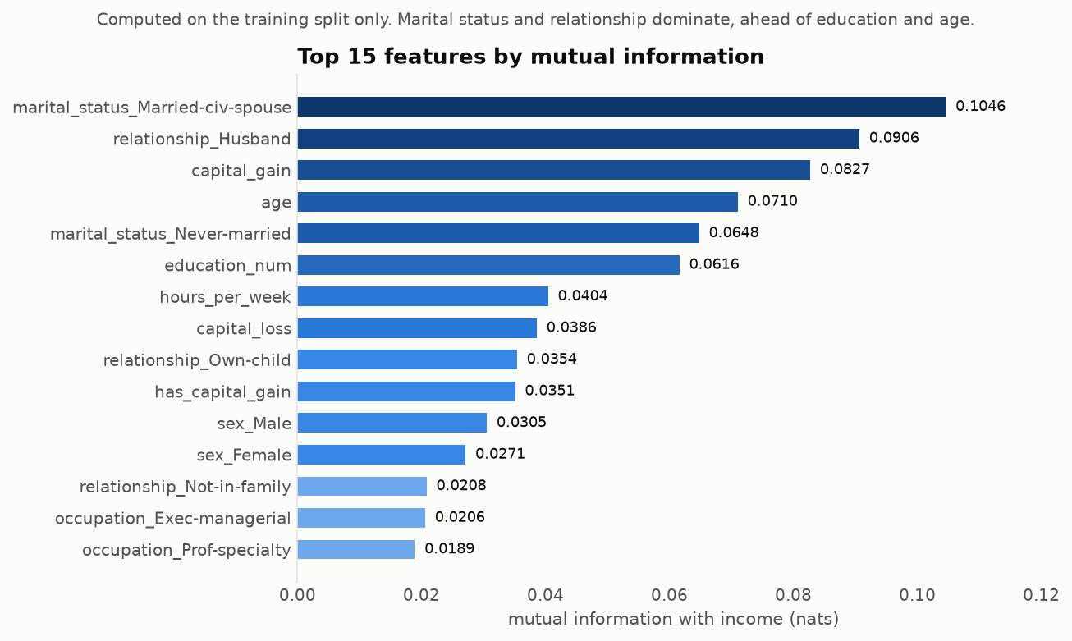
Mutual information (non-linear dependence, blind to redundancy) ranks marital_status_Married-civ-spouse (0.1046) and relationship_Husband (0.0906) above capital_gain (0.0827), age (0.0710) and education_num (0.0616).
Correlation among features (redundancy, blind to the target) surfaces exactly the structures predicted earlier:
Pair | |r| | What it confirms
sex_Female ↔ sex_Male | 1.0000 | the dummy trap of §9.3
capital_loss ↔ has_capital_loss | 0.9995 | the redundancy of §9.2
workclass_Missing ↔ occupation_Missing | 0.9981 | the nested missingness of §4.1
marital_status_Married-civ-spouse ↔ relationship_Husband | 0.8940 | two codings of one fact

Permutation importance on a held-out fold (what a model actually uses) ranks capital_gain first (+0.0375 AUC when intact), then education_num, marital_status_Married-civ-spouse and age. 14 of 53 features have non-positive permutation importance.
Only two features are condemned by all three views — native_country_Missing and workclass_State-gov. Dropping them changes test AUC by exactly 0.00000, confirming they were inert rather than harmful.
How many features are actually needed? Taking the top-k by mutual information:
k | 5 | 10 | 15 | 20 | 30 | 40 | 53
test AUC | 0.83630 | 0.90331 | 0.90699 | 0.90810 | 0.90995 | 0.91132 | 0.91228

10 features — 19% of them — recover 99.0% of the full-model AUC. The remaining 43 are worth 0.009 AUC between them. For a production system with latency or data-collection costs, that is the trade to make; all 53 were kept here because the brief is preprocessing, not deployment.

11. Final results
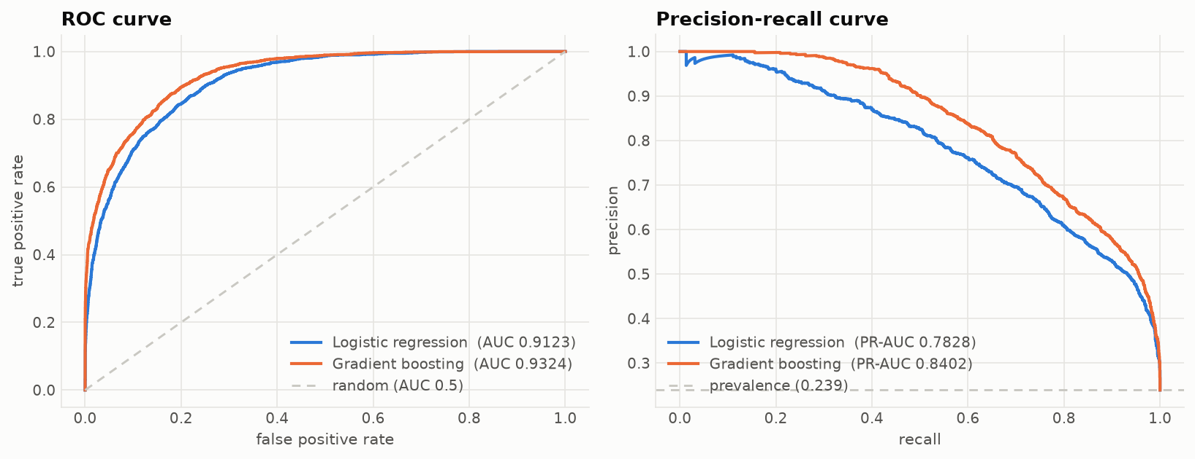
Model | CV AUC (train) | Test AUC | Test PR-AUC | Test F1 (>50K) | Test accuracy
Majority class | — | 0.50000 | — | 0.00000 | 0.76061
Logistic regression | 0.90804 ± 0.00479 | 0.91228 | 0.78276 | 0.67699 | 0.85889
Gradient boosting | 0.92759 ± 0.00413 | 0.93239 | 0.84022 | 0.72295 | 0.87692

Cross-validated and held-out scores agree to within one standard error for both models, so there is no sign of overfitting to the training split. The accuracy column illustrates §4.4: gradient boosting beats the trivial baseline by 11.6 accuracy points, which sounds modest, while its PR-AUC of 0.840 against a prevalence of 0.239 shows what the model is really doing.

12. Limitations
- The "Missing" category result (+0.00160 AUC) sits below the noise floor. It is defended on the MNAR evidence, not on that number.
- capital_gain top-coding was handled by clipping to the observed maximum. A Tobit-style censored model would be more principled; it is out of scope for week 1.
- Fairness was not assessed. The dataset contains race and sex, the model uses both, and sex_Male carries mutual information of 0.0305 with the target. A deployed model would need subgroup performance and a decision about whether these attributes belong in it at all. This report makes no claim that the model is fair.
- Single split, single seed for the headline numbers. Fold-to-fold variation is reported, but repeated splits would give tighter confidence intervals on the smaller effects.
- The 1960s-era census data reflects the population and categories of its time; nothing here should be read as a statement about incomes today.

13. File map
YV_1/
├── run_all.py reproduce everything end to end
├── requirements.txt pinned versions
├── src/
│ ├── config.py paths, column groups, constants
│ ├── viz.py shared chart styling
│ ├── step00_assemble.py load both UCI files, fix the label bug
│ ├── step01_audit.py data quality audit
│ ├── step02_clean_split.py cleaning decisions + stratified split
│ ├── step02b_unseen_category_risk.py 200-seed unseen-category experiment
│ ├── step03_eda.py figures 1-5
│ ├── step04_pipeline.py the preprocessing pipeline
│ ├── step05_feature_selection.py three views of feature importance
│ ├── step06_experiments.py ablations and leakage experiments
│ ├── step07_summary_figures.py figures 7-9
│ ├── verify_report.py cross-checks every number quoted here
│ └── make_notebook.py builds + executes the notebook
├── data/
│ ├── raw/ untouched UCI downloads
│ ├── interim/ combined, label-corrected
│ └── processed/ train/test, clean and encoded, + preprocessor.joblib
├── outputs/ every number in this report, as JSON/CSV
├── notebooks/
│ └── week1_preprocessing.ipynb executed walk-through
└── reports/
├── REPORT.md this document
└── figures/ fig1 - fig9
python run_all.py runs all nine steps and finishes by re-checking all 93 figures quoted in this report against outputs/*.json; it exits non-zero if the write-up and the code disagree.
Each outputs/*.json corresponds to the step that produced it, so any figure quoted above can be traced to the code that generated it.

