**Experiment No :4**

**Aim: Familiarisation of Linux Commands**

**Procedure :**

1. **cut –** cut by bit position.

$ cut -b1 file1.txt

**Output:**

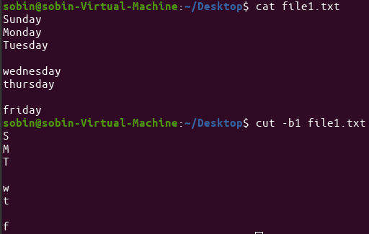

1. **cut -c3 –** To Cut by character

$ cat -c3 file1.txt

**Output:**

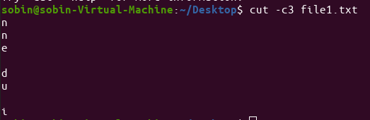

1. **cut -d** To cut by Delimeter

$cut -d y - f1 file1.txt

**Output:**

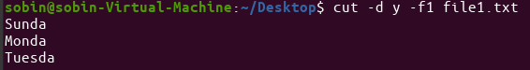

1. **paste** to read all files given as arguments and horizontally merge the corresponding lines of the files, separated by space

$paste file1.txt file2.txt

**Output:**

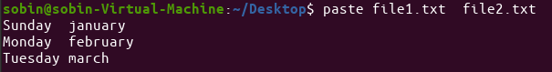

1. **paste file1 file 2> file3** To Store read all files given as arguments and horizontally merge the corresponding lines of the files, separated by space

$ paste file1.txt file2.txt >file3.txt

$cat file3.txt

**Output:**

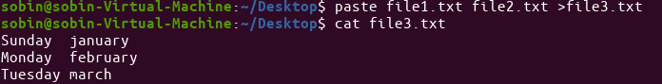

1. **paste -d % file1 file2**  This option allows you to specify a list of characters to be used as delimiters instead of the default TAB separator.

$ paste -d % file1.txt file2.txt

**Output:**

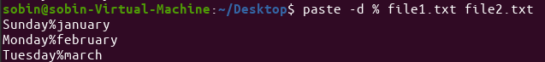

1. **paste -s** Displaying the content of file in single line

$paste -s file1.txt

**Output:**



1. **Cp**  -To copy the file from current working folder.

$cp file1.txt filebackup.txt

**Output:**

