**Experiment No :4**

**Aim: Familiarisation of Linux Commands**

**Co2: Perform system administration Task**

**Procedure :**

1. wc – To print newline ,word and byte count for each file

$wc profile

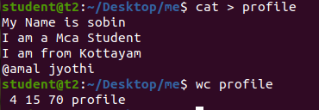

1. wc-c -To display the byte counts in a file

$wc -c profile



1. wc-m -To display the character count in a file

$wc -m profile



1. wc -l - To display the number of lines

$wc -l profile



1. wc -w -To display the number of word

$wc -w profile



1. wc – L – To Display the length of Longest Line in file

$wc -L profile



1. read – Read the content of one line of input into variable

$read

My name is sobin

$ echo $REPLY

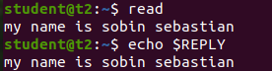

1. read - Read the Content of one line of input into variable

$read var1 var2 var3

My name is sobin

$echo “[$var1][$var2][$var3]”



1. read input \ -To read input in multiple line

$read

My\

Name\

Is\

Sobin

$echo $REPLY

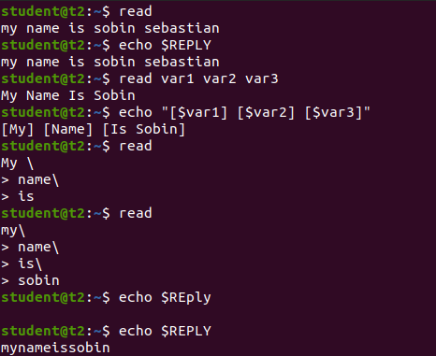

1. read -p – To Read input with prompt text

$read -p “Enter your Name :-”

$echo “My name is $REPLY”

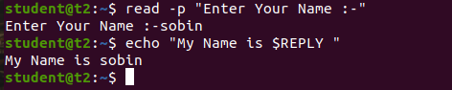

1. read -n -To set Characters limit to the input

$read -n 8 -p “Enter 8 Character only -”



1. read -s -To read input with security

$read -s -p “Enter your password ”

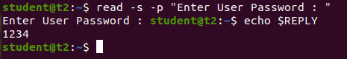

1. More – The more command is similar to cat to display the content the only difference that in case of layer file of file cat command output scroll off user more Command display output one screen full at command display output one screen full at a time

$more hello .txt

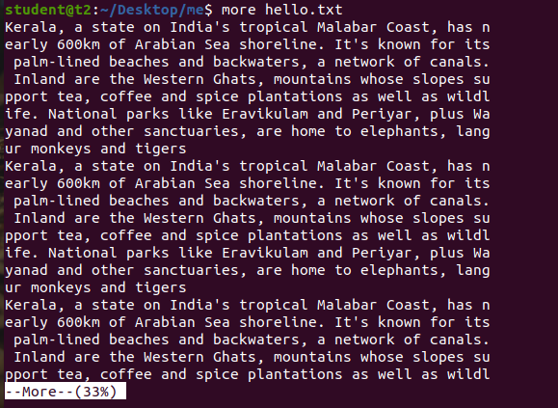

1. more +5 hello.txt – To display the content after the specified number of lines

$ more +5 hello.txt

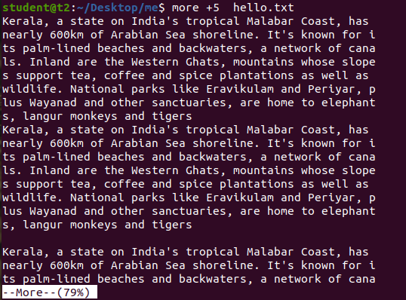

1. more +/pattern -This option is used search string inside your text document you can all the instance by navigation through the result.

more -d -it helps used to navigate according to the instruction space – continue q-to quit

