**Experiment No :6 DATE:14/03/2023**

**Aim: Familiarisation of Linux Commands**

**Co2: Perform system administration Task**

**Procedure :**

1. **Grep** - filter searches a file for a particular pattern of characters, and displays all lines that contain that pattern.

$grep amal hello.txt

Output:

https://lh3.googleusercontent.com/oq3eCHUOW65F-Lfg_NqUC9coufjcne581oxEJPlo-n7FISpzofcoDzLlqWjEBAl5CzBurG3I-FCx5FciPVhA7dqcXpTccheuby0k7TWeAjtZNXwXgcoj_ic7toy1hjt1z4DIQnVL1_arqqzS2bOzQ-g

1. Grep -i -To perform case insensitive  search

$grep -i 78 hello.txt

Output:

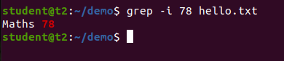

1. Grep -b -to display all content except the secarched content

$grep -b 78 hello.txt

Output:

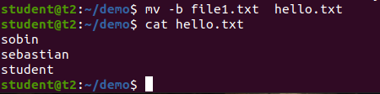

1. Grep -A1- To view  the  content searched along with one line after

$grep -A1  math hello.txt

Output:

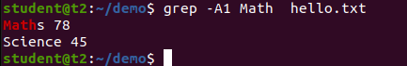

1. Grep -B1 -To view  the  content searched along with one line Before

$grep -B1  math hello.txt

Output:

https://lh3.googleusercontent.com/tusBZR2l7PfVL1HTwkcgilMghcdWlEvl4JWlxdedvGjMIjeiSs2WishJ7pPypdwUOYmtWxagkIfTeliUZcWX503ZXAqflvaf-jXh_twVx0NaSxMeX1njVMkfkQNOpSVx01Je7QrtDwWZ5QmohdPMn2k

1. Grep -C1 -To view  the  content searched along with one line after & Before

$grep -C1  math hello.txt

Output:

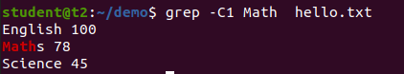

1. Head - To display  the first lines of files . By default, it shows the first 10  lines

$head  file1.txt

Output:

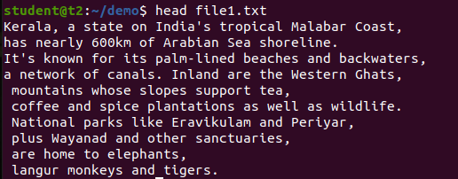

1. Head -number -To display  the first n number of lines of files

$head  -5 file1.txt

Output:

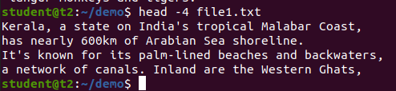

1. Tail -To display  the last  lines of files . By default, it shows the first 10  lines

$tail hello.txt

Output:

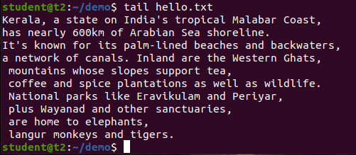

1. Tail -n - To display  last  n number of lines of files

$tail -5 hello.txt

Output:

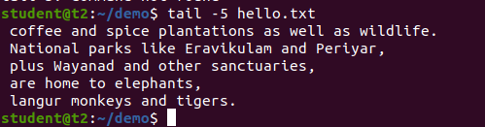

1. Mv -**mv** stands for move. **mv** is used to move one or more files or directories from one place to another

$mv

output:

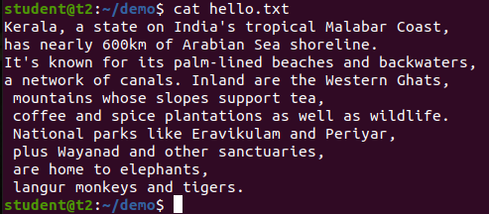

1. Mv -b -to create  backup while moving file

$mv -b

output:



1. Mv i -to display the prompt Warning message

$mv - i file.txt hello.txt

output:

