**Experiment No :8 DATE:21/03/2023**

**Aim: Familiarisation of Linux Commands**

**Co2: Perform system administration Task**

**Procedure :**

1. **Ip** addr : To Get the ip address of system

$ ip addr

**Output:-**

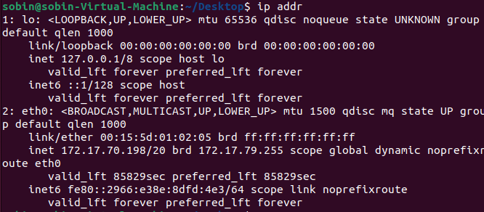

1. **Ssh** stands for secure shell

SSH ("Secure SHell") is a protocol for securely accessing one computer from another. Despite the name, SSH allows you to run command line and graphical programs, transfer files, and even create secure virtual private networks over the Internet.

$ ssh mca@192.168.6.36

**Output:-**

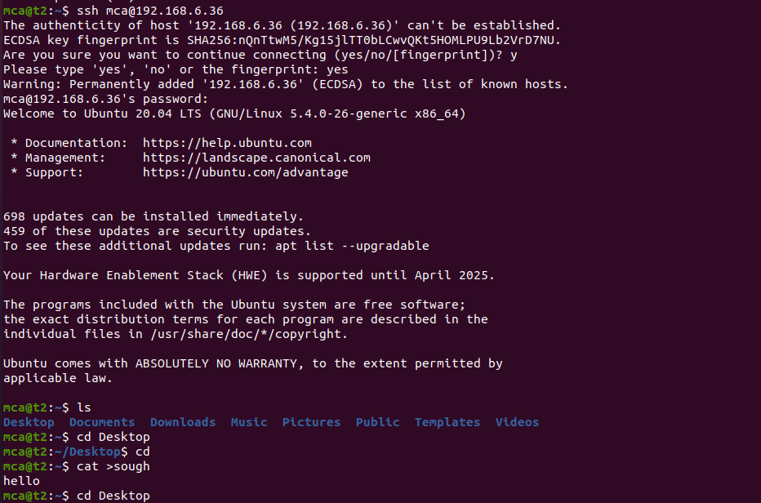

1. **Ssh-keygen** : generate a key for ssh

used to generate a public key pair for use when authenticating with a remote server

$ ssh-keygen

**Output:-**

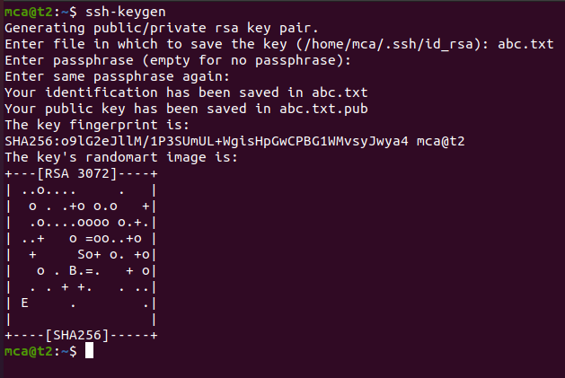

1. **Ps** : currently running program

$ps

**Output:-**

