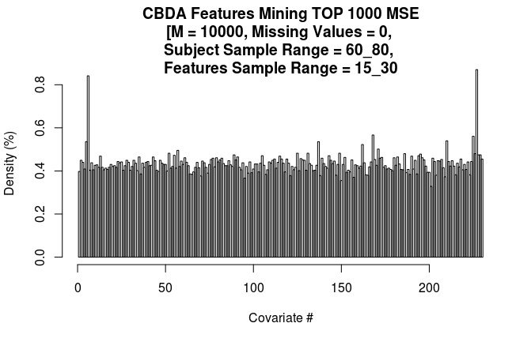
TOP 6 FEATURES IN THE HISTOGRAM ABOVE
Name | Position | Freq
Value_FD_53_END | 227 | 453
CSFV | 6 | 438
Value_CV_50_END | 168 | 295
Value_FD_51_END | 225 | 292
Value_FD_36_END | 210 | 281
WMV | 5 | 279

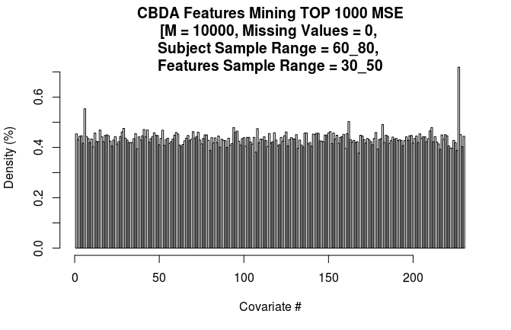

TOP 6 FEATURES IN THE HISTOGRAM ABOVE
Name | Position | Freq
Value_FD_53_END | 227 | 665
CSFV | 6 | 512
Value_CV_44_END | 162 | 465
Value_FD_8_END | 182 | 454
Value_SI_32_END | 94 | 443
Value_FD_37_END | 211 | 443

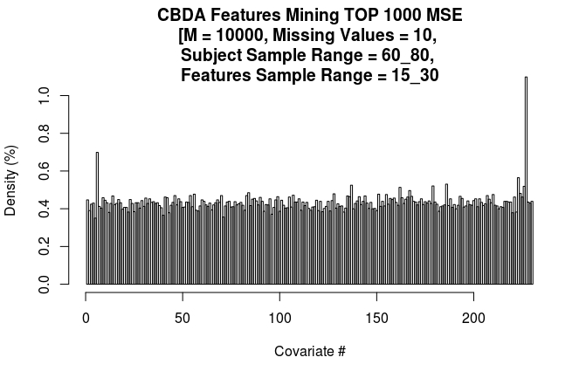

TOP 6 FEATURES IN THE HISTOGRAM ABOVE
Name | Position | Freq
Value_FD_53_END | 227 | 580
CSFV | 6 | 369
Value_FD_49_END | 223 | 298
Value_FD_12_END | 186 | 280
Value_CV_19_END | 137 | 277
Value_FD_5_END | 179 | 275

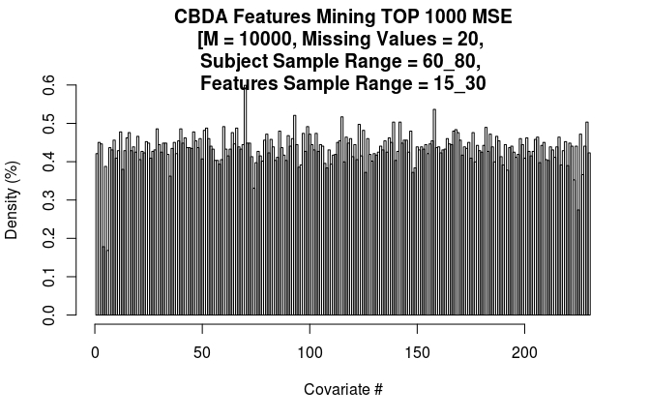

TOP 6 FEATURES IN THE HISTOGRAM ABOVE
Name | Position | Freq
Value_SI_8_END | 70 | 306
Value_CV_40_END | 158 | 274
Value_SI_31_END | 93 | 266
Value_SI_53_END | 115 | 264
Value_CV_21_END | 139 | 257
Value_CV_24_END | 142 | 257

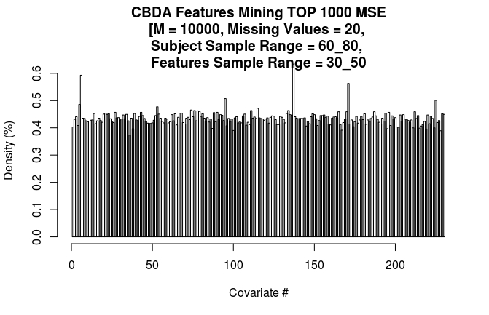

TOP 6 FEATURES IN THE HISTOGRAM ABOVE
Name | Position | Freq
Value_CV_19_END | 137 | 591
CSFV | 6 | 553
Value_CV_53_END | 171 | 525
Value_SI_33_END | 95 | 473
Value_FD_51_END | 225 | 467
WMV | 5 | 453

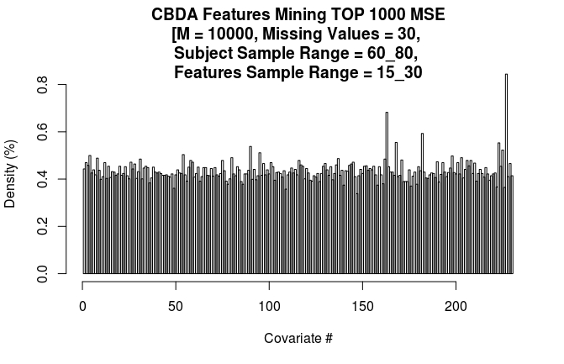

TOP 6 FEATURES IN THE HISTOGRAM ABOVE
Name | Position | Freq
Value_FD_53_END | 227 | 444
Value_CV_45_END | 163 | 359
Value_FD_8_END | 182 | 312
Value_CV_50_END | 168 | 292
Value_FD_49_END | 223 | 291
Value_SI_28_END | 90 | 283

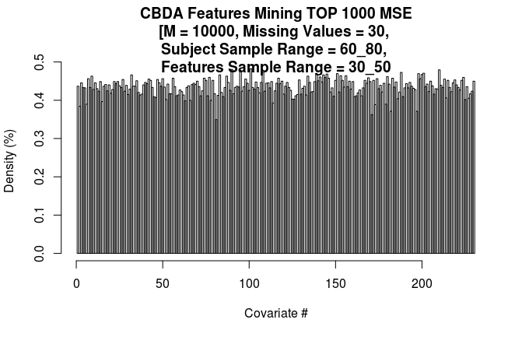

TOP 6 FEATURES IN THE HISTOGRAM ABOVE
Name | Position | Freq
Value_SI_39_END | 101 | 442
Value_SI_28_END | 90 | 440
Value_FD_36_END | 210 | 439
Value_SI_33_END | 95 | 437
Value_SI_46_END | 108 | 433
Value_FD_14_END | 188 | 433

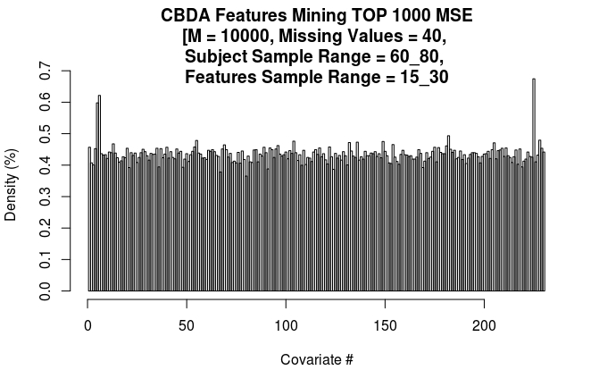

TOP 6 FEATURES IN THE HISTOGRAM ABOVE
Name | Position | Freq
Value_FD_51_END | 225 | 626
CSFV | 6 | 577
WMV | 5 | 555
Value_FD_8_END | 182 | 458
Value_FD_54_END | 228 | 445
Value_SA_49_END | 55 | 444

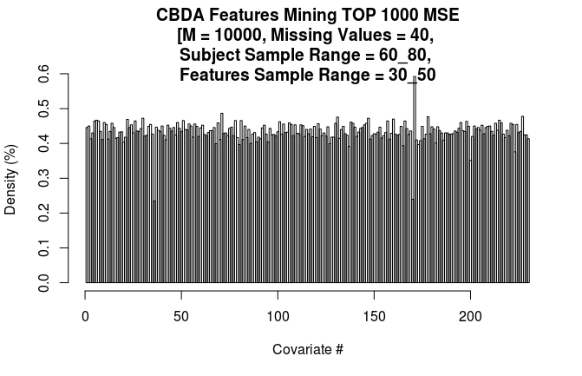

TOP 6 FEATURES IN THE HISTOGRAM ABOVE
Name | Position | Freq
Value_CV_53_END | 171 | 534
Value_SI_9_END | 71 | 439
Value_FD_53_END | 227 | 431
Value_FD_4_END | 178 | 430
Value_CV_13_END | 131 | 429
Value_SA_24_END | 30 | 426

Feature | Position | Freq
CSFV | 6 | 2449
Value_FD_53_END | 227 | 2005
Value_FD_51_END | 225 | 1339
Value_FD_8_END | 182 | 1312
WMV | 5 | 1171
Value_SI_33_END | 95 | 873
Value_CV_53_END | 171 | 817
Value_CV_50_END | 168 | 817
Value_FD_49_END | 223 | 714
Value_FD_36_END | 210 | 714
Value_SI_28_END | 90 | 566
Value_CV_19_END | 137 | 514
Value_CV_44_END | 162 | 465
Value_FD_54_END | 228 | 445
Value_SA_49_END | 55 | 444
Value_FD_37_END | 211 | 443
Value_SI_32_END | 94 | 443
Value_SI_39_END | 101 | 442
Value_SI_9_END | 71 | 439
Value_FD_14_END | 188 | 433
Value_SI_46_END | 108 | 433
Value_FD_4_END | 178 | 430
Value_CV_13_END | 131 | 429
Value_SA_24_END | 30 | 426
Value_CV_45_END | 163 | 359
Value_SI_8_END | 70 | 306
Value_FD_12_END | 186 | 280
Value_FD_5_END | 179 | 275
Value_CV_40_END | 158 | 274
Value_SI_31_END | 93 | 266
Value_SI_53_END | 115 | 264
Value_CV_21_END | 139 | 257
Value_CV_24_END | 142 | 257

