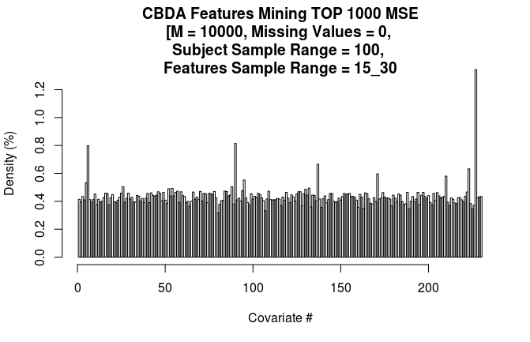
TOP 10 FEATURES IN THE HISTOGRAM ABOVE
Name | Position | Freq
Value_FD_53_END | 227 | 671
Value_SI_28_END | 90 | 407
CSFV | 6 | 399
Value_CV_19_END | 137 | 333
Value_FD_49_END | 223 | 316
Value_CV_53_END | 171 | 298
Value_FD_36_END | 210 | 290
Value_SI_33_END | 95 | 276
WMV | 5 | 266
Value_SA_20_END | 26 | 252

TOP 6 FEATURES WITH 60-80% SUBJECTS SAMPLING RANGE
Name | Position | Freq
Value_FD_53_END | 227 | 453
CSFV | 6 | 438
Value_CV_50_END | 168 | 295
Value_FD_51_END | 225 | 292
Value_FD_36_END | 210 | 281
WMV | 5 | 279

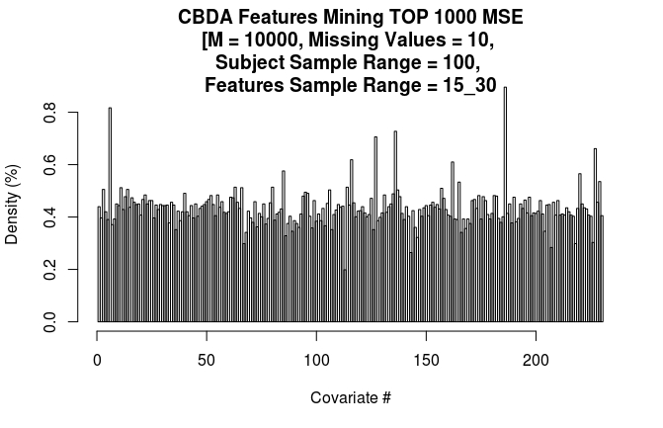
TOP 10 FEATURES IN THE HISTOGRAM ABOVE
Name | Position | Freq
Value_FD_12_END | 186 | 420
CSFV | 6 | 383
Value_CV_18_END | 136 | 341
Value_CV_9_END | 127 | 331
Value_FD_53_END | 227 | 310
Value_SI_54_END | 116 | 290
Value_CV_44_END | 162 | 286
Value_SI_23_END | 85 | 270
Value_FD_46_END | 220 | 265
Value_FD_55_END | 229 | 251

TOP 6 FEATURES WITH 60-80% SUBJECTS SAMPLING RANGE
Name | Position | Freq
Value_FD_53_END | 227 | 580
CSFV | 6 | 369
Value_FD_49_END | 223 | 298
Value_FD_12_END | 186 | 280
Value_CV_19_END | 137 | 277
Value_FD_5_END | 179 | 275

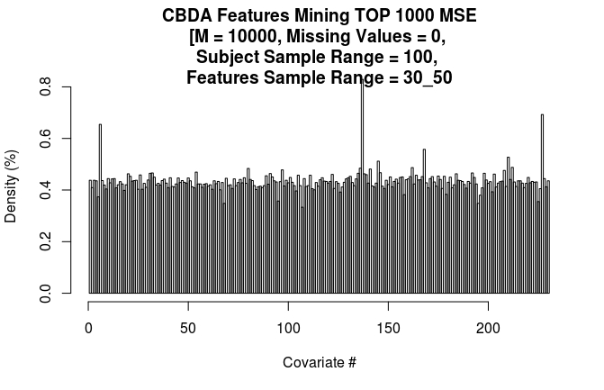

TOP 10 FEATURES IN THE HISTOGRAM ABOVE
Name | Position | Freq
Value_CV_19_END | 137 | 761
Value_FD_53_END | 227 | 636
CSFV | 6 | 601
Value_CV_50_END | 168 | 512
Value_FD_36_END | 210 | 484
Value_CV_27_END | 145 | 470
Value_FD_38_END | 212 | 448
Value_CV_44_END | 162 | 447
Value_CV_18_END | 136 | 445
Value_SI_18_END | 80 | 444

TOP 6 FEATURES WITH 60-80% SUBJECTS SAMPLING RANGE
Name | Position | Freq
Value_FD_53_END | 227 | 665
CSFV | 6 | 512
Value_CV_44_END | 162 | 465
Value_FD_8_END | 182 | 454
Value_SI_32_END | 94 | 443
Value_FD_37_END | 211 | 443

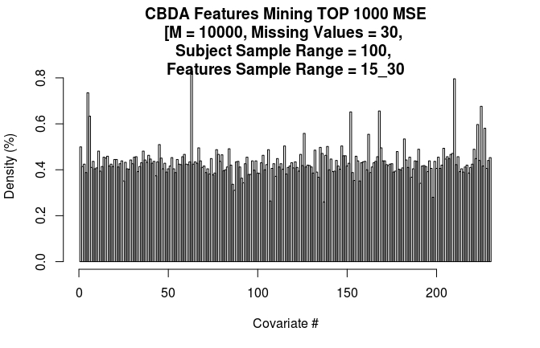TOP 10 FEATURES IN THE HISTOGRAM ABOVE
Name | Position | Freq
Value_SI_1_END | 63 | 409
Value_FD_36_END | 210 | 392
WMV | 5 | 362
Value_FD_51_END | 225 | 333
Value_CV_50_END | 168 | 323
Value_CV_34_END | 152 | 321
CSFV | 6 | 312
Value_FD_49_END | 223 | 294
Value_FD_53_END | 227 | 286
Value_FD_53_END | 126 | 275

TOP 6 FEATURES WITH 60-80% SUBJECTS SAMPLING RANGE
Name | Position | Freq
Value_FD_53_END | 227 | 444
Value_CV_45_END | 163 | 359
Value_FD_8_END | 182 | 312
Value_CV_50_END | 168 | 292
Value_FD_49_END | 223 | 291
Value_SI_28_END | 90 | 283

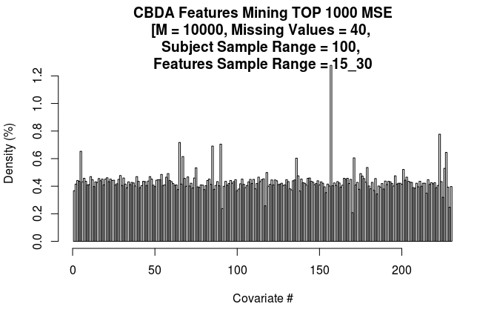

TOP 10 FEATURES IN THE HISTOGRAM ABOVE
Name | Position | Freq
Value_CV_39_END | 157 | 639
Value_FD_49_END | 223 | 389
Value_SI_3_END | 65 | 359
Value_SI_28_END | 90 | 353
Value_SI_23_END | 85 | 346
WMV | 5 | 327
Value_FD_53_END | 227 | 323
Value_SI_5_END | 67 | 308
Value_CV_53_END | 171 | 303
Value_CV_18_END | 136 | 302

TOP 6 FEATURES WITH 60-80% SUBJECTS SAMPLING RANGE
Name | Position | Freq
Value_FD_51_END | 225 | 626
CSFV | 6 | 577
WMV | 5 | 555
Value_FD_8_END | 182 | 458
Value_FD_54_END | 228 | 445
Value_SA_49_END | 55 | 444

List of all the previous experiments combined (10 experiments total)
Specifications
SSR = 60-80%,
Missing Values % = 0%, 10%, 20%, 30% and 40%
i) 5 experiments with FSR=15-30%
ii) 5 experiments with FSR=30-50%
Feature | Position | Freq
CSFV | 6 | 2449
Value_FD_53_END | 227 | 2005
Value_FD_51_END | 225 | 1339
Value_FD_8_END | 182 | 1312
WMV | 5 | 1171
Value_SI_33_END | 95 | 873
Value_CV_53_END | 171 | 817
Value_CV_50_END | 168 | 817
Value_FD_49_END | 223 | 714
Value_FD_36_END | 210 | 714
Value_SI_28_END | 90 | 566
Value_CV_19_END | 137 | 514
Value_CV_44_END | 162 | 465
Value_FD_54_END | 228 | 445
Value_SA_49_END | 55 | 444
Value_FD_37_END | 211 | 443
Value_SI_32_END | 94 | 443
Value_SI_39_END | 101 | 442
Value_SI_9_END | 71 | 439
Value_FD_14_END | 188 | 433
Value_SI_46_END | 108 | 433
Value_FD_4_END | 178 | 430
Value_CV_13_END | 131 | 429
Value_SA_24_END | 30 | 426
Value_CV_45_END | 163 | 359
Value_SI_8_END | 70 | 306
Value_FD_12_END | 186 | 280
Value_FD_5_END | 179 | 275
Value_CV_40_END | 158 | 274
Value_SI_31_END | 93 | 266
Value_SI_53_END | 115 | 264
Value_CV_21_END | 139 | 257
Value_CV_24_END | 142 | 257

