Introduction to the Udall website

Here are some instructions to get you started on the Udall website

## Login to the website

1. Goto the website to login:  
   <http://udallpd.umich.edu/wp-login.php> (after we switch the domains)  
   [http://udall.nursing.umich.edu/wp-login.php](http://udall.nursing.umich.edu/wp-login.php*) (currently use this domain)
2. Login with your uniqname and kerberos password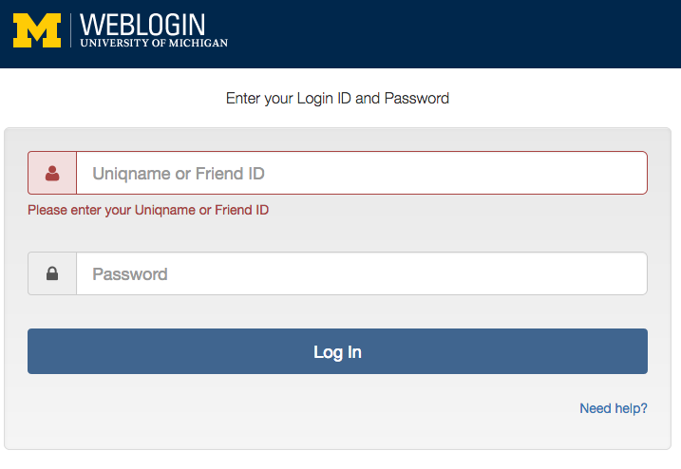

## Setup User Accounts

1. Go to “Users” to create new accounts  
   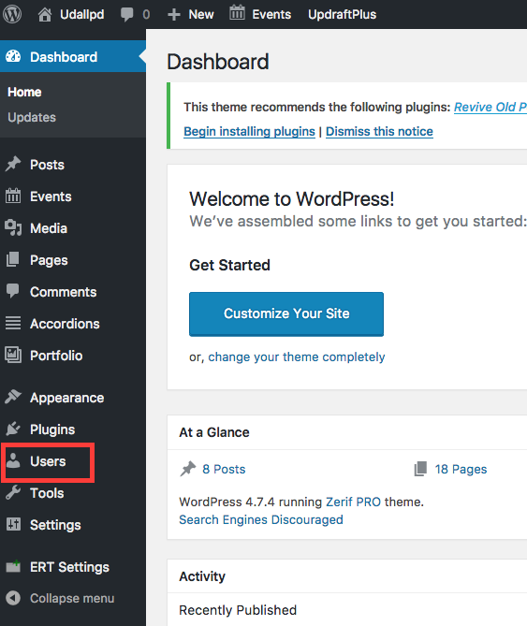
2. Click on “add new” to add more users  
   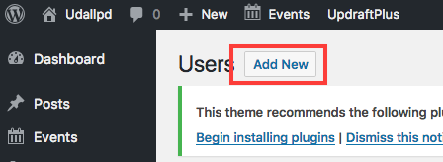
3. The following fields are required:  
   Username: use uniqname  
   Email: use uniqname@umich.edu  
   First Name: User’s first name  
   Last Name: User’s last name  
     
   Finally pick a “Role” for the user.
   * Administrator – Has access to all administrative options and features.
   * **Editor** – Can manage and publish posts. (most common permission you will assign to people managing the content on the website)
   * Author – Can publish their own posts when they wish.
   * Contributor – Can write posts but cannot publish them.

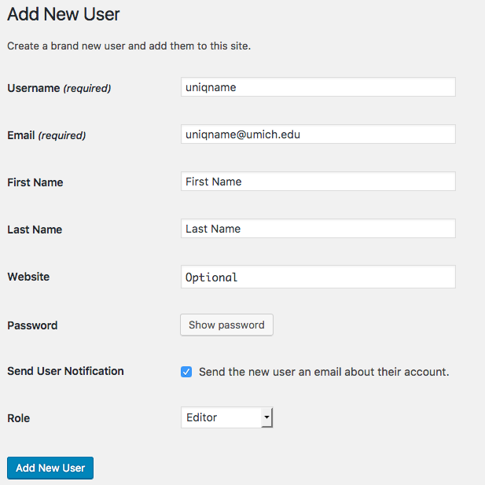

1. Instruct each user to log into the website by going to:  
   <http://udallpd.umich.edu/wp-login.php> (after we switch the domains)  
   [http://udall.nursing.umich.edu/wp-login.php](http://udall.nursing.umich.edu/wp-login.php*) (currently use this domain)

## Website Content

1. You will be primarily spending your time in “Posts”, “Events”, and “pages”  
   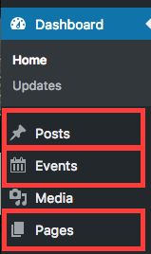
2. Website is divided into 3 types of content
   * Posts- new articles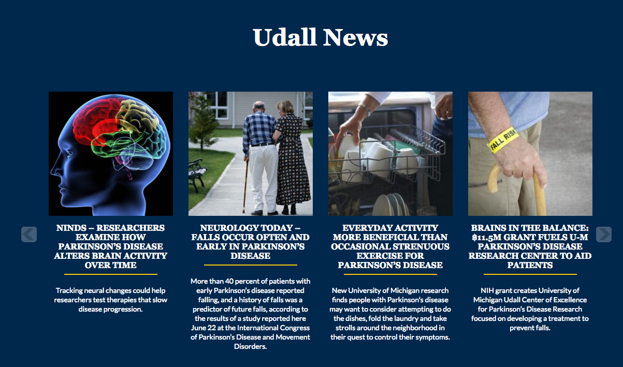
   * Events - calendar events  
     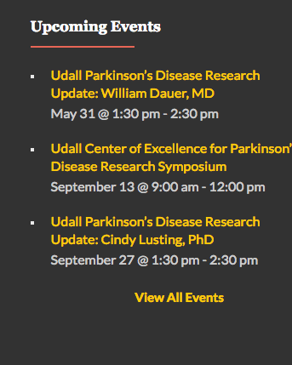
   * Pages - each of the pages in the menu  
     