Conditional Complexity

**Before Refaction**

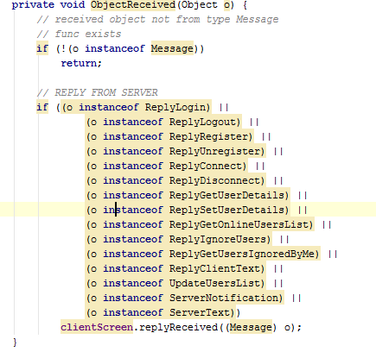

Example from:

* ays.com.javachat.client.manager
  + ClientManager.java
    - lines 42 -65

**Refactoring:**

* Consolidate Conditional Expression
* Remove Control Flag

**After refaction**

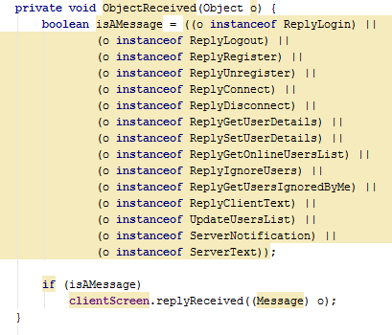

OnlineList.java

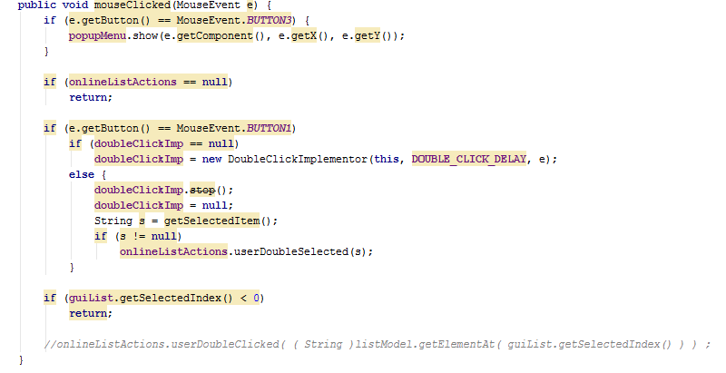

Example from:

* ays.javachat.com.client.screen
  + OnlieList.java
    - lines 122 – 145

**Refactoring**

* Consolidate Conditional Expression
* Consolidate Duplicate Conditional Fragments

**After Refactoring**

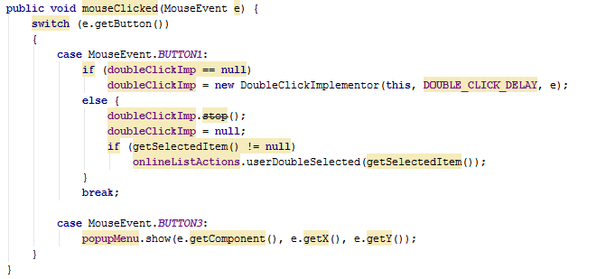

UserDetails.java

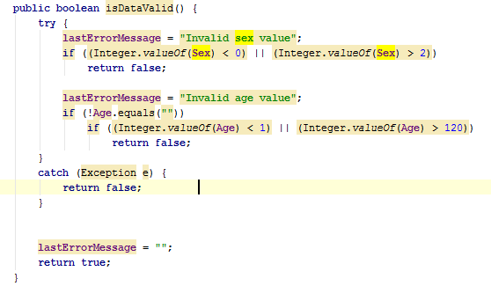

Example from

* com.ays.javachat.common.datatypes
  + UserDetails.java
    - lines 42 - 60

**Refactoring**

* Simplifying Conditional Expressions

**After refactoring**

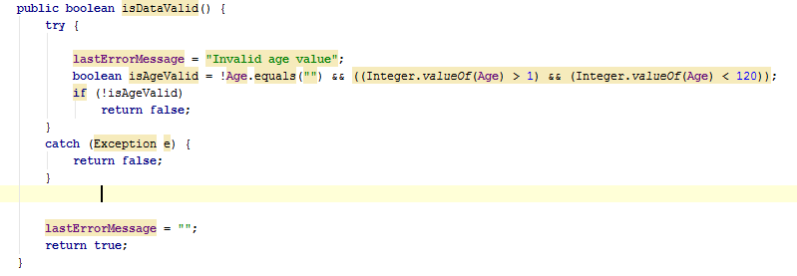

*NOTE: The sex validation is irrelevant since it’s hardcoded to be in range and there is no need to confirm it.

Rooms.java

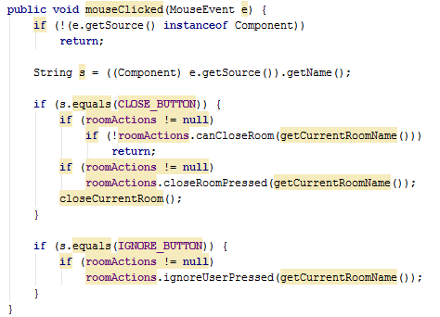

Example from:

* com.ays.javachat.client.screen
  + Rooms.java
    - lines 223 – 242

**Refactoring**

* Simplifying Conditional Expresions

**After Refactoring**

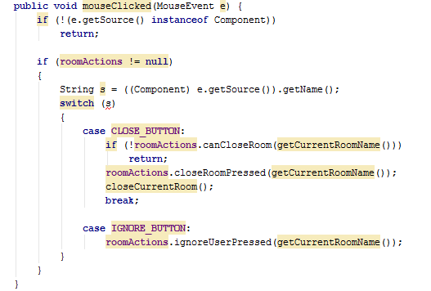

NOTE1: This runs fine in Eclipse, even if IntelliJ shows an error. Switch accepts strings on Java 1.7, but not in lower.

NOTE2: It’s not fully tested due to being unable to create a room. I think this is speculative generality but I have no idea how to explore that.

Speculative Generality

ScreenCallback.java interface



ClientManager.java



Example from:

* com.ays.javachat.client.interfaces
  + ScreenCallback.java
    - line 32
* com.ays.javachat.client.manager
  + ClientManager.java
    - line 32

**Refactoring**

* Erase Method

ClientScreen.java

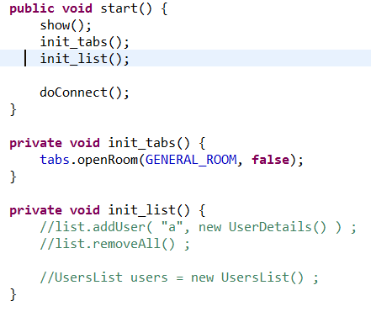

Location:

* com.ays.javachat.client.screen
  + ClientScreen.java
    - lines 102, 111 – 117

**Refactoring**

* Delete Method

Rooms.java

Location:

* ays.com.java.client.screen
  + Rooms.java lines
    - 73 – 86: commented out code
    - 96 – 101: commented out code
    - 117 – 120: commented out code
    - 143 – 147: empty methods

**Refactoring**

* Eliminate method