**Installation**

1. Install ANACONDA by following the steps here: <https://docs.anaconda.com/anaconda/install/windows/>
2. Install PyGMT by following the steps here: <https://www.pygmt.org/latest/install.html>
3. Install PyPDF2 by entering: *conda install PyPDF2* in your anaconda prompt. Make sure you are in the *base* environment.

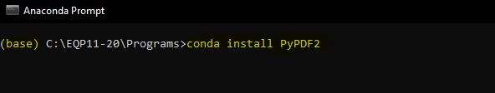

1. Install *vincenty* in your *pygmt* environment

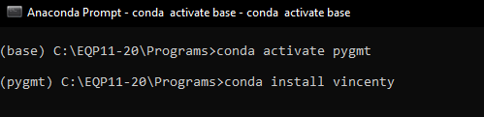

1. Navigate to *C:\Users\USERPROFILE\Anaconda3\envs\pygmt\Lib\site-packages\vincenty* and replace *__init__.py* by the *__init__.py* found [here](https://drive.google.com/drive/folders/1TFVV_mdakPqWt8XRYMu7s9vnZSis69XC?usp=sharing).
2. Copy the following files from [here](https://drive.google.com/drive/folders/1zlRUGZmbb2J94dfeT3NRcxZvo7fyWS_T?usp=sharing) to *C:\EQP11-20\Programs*:

* PLOT_STATIONS_PYTHON.py
* pdf_merge.py
* PYTHON_PLOTTER_VINCENTY_base.exe
* PYTHON_PLOTTER_base.exe
* PLOT_STATIONS.bat

1. Rename PYTHON_PLOTTER_VINCENTY_base.exe to PLOTTER1.exe if you want to use Vincenty formula as the method to compute distances between points. If you want to use the same method as the one used in the FORTRAN version of the plotter to compute distances, rename PYTHON_PLOTTER_base.exe instead. Both executables’ outputs are rounded to 4 decimal places.