**Part 1**

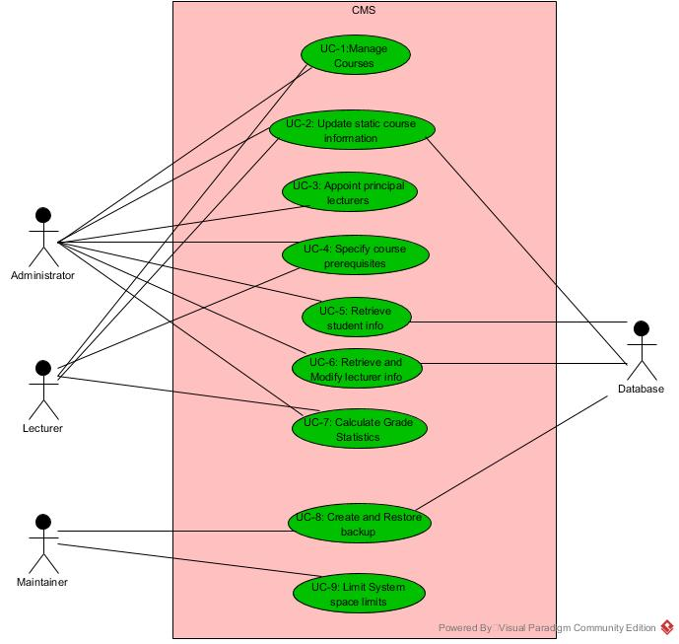

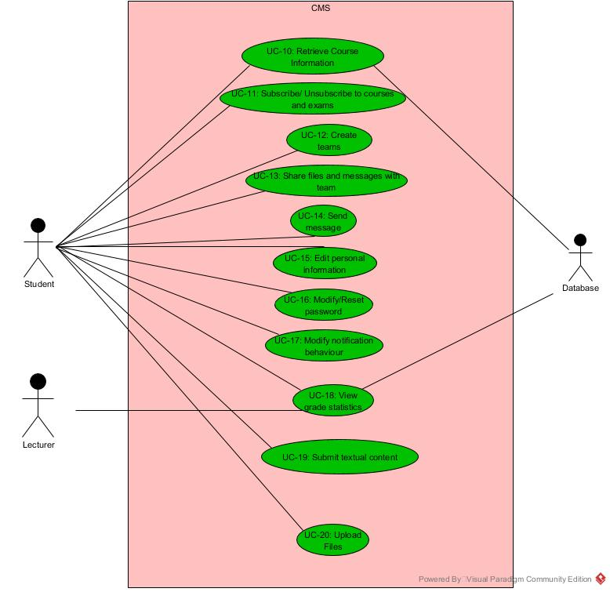

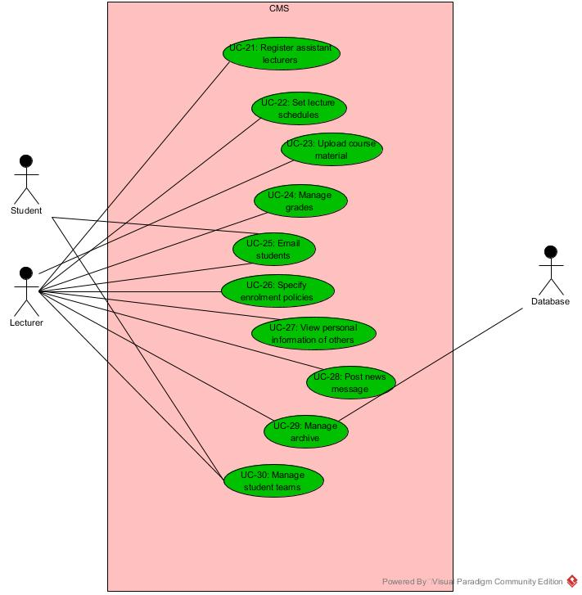

**Quality Attributes (QAs)**

|  |  |  |  |
| --- | --- | --- | --- |
| **ID** | **Quality Attribute** | **Scenario** | **Associated Use Case** |
| QA1 | Privacy | Prevent students from viewing grades of others. Provide a user-customizable visibility policy for personal information | UC15 ,16, 27 |
| QA2 | Availability | No unexpected downtime/ expected downtime to be announced at 48 hours in advance. Downtime only during low-intensity hours, at most 4hours/month | ALL |
| QA3 | User friendliness | Bilingual support. Max 3 click to reach content. Single login to access all content. Intuitive, descriptive, consistent UI. | ALL |
| QA4 | Accessibility | Accessible by blind users. | ALL |
| QA5 | Security | Allow only students to change study information of others.  Allow lecturers to view dynamic course information by other lecturers, manage dynamic content visibility. Allow lecturers to view grade of all students. Students can only view own grades. | UC1, 5, 18, 24 |
| QA6 | Interoperability | Export to commonly used calendar formats.  Import BOZ roster info into course roster. System to be interoperable with secondary uni systems | UC11, 1, 2 |
| QA7 | Extensibility/Evolvability | Easily extensible, evolvable. Allow admin to make exceptions to student enrolment | UC8, 9, 5, 6 |
| QA8 | Testability | Easily testable | UC8, 9 |
| QA9 | Scalability | scalable | UC8, 9 |
| QA10 | Maintainability | Easily maintainable | UC 8,9 |

**Constraints (CON)**

|  |  |
| --- | --- |
| **CON-1** | A minimum of 200 simultaneous users must be supported. |
| **CON-2** | All course information since the start must be stored. |
| **CON-3** | System must be backed up every 24hours |
| **CON-4** | System must be accessed through a web browser (Chrome, Firefox, IE, Safari) on different platforms: Windows, OSX and Linux |