SOFIA Cookbook Recipe: How to view GREAT spectra using CLASS

# Date: 6 Apr 2018

# Introduction

This recipe is a beginner’s introduction to plotting GREAT spectra using the class utility, which is part of the GILDAS package developed by IRAM and now the standard for single-dish heterodyne spectroscopy data reduction. The goal is to take you from finding a sample data set through modifying the baseline fit, averaging, and saving the result in a fits file.

# Ingredients

1. Download and install class from the IRAM GILDAS homepage <https://www.iram.fr/IRAMFR/GILDAS/>
2. Open the class manual in a browser tab. Also, get this useful set of tips on using class for reference: <http://www.iram.fr/~gildas/demos/class/class-tutorial.pdf>
3. Find the data: [see screenshot of archive interface]

* 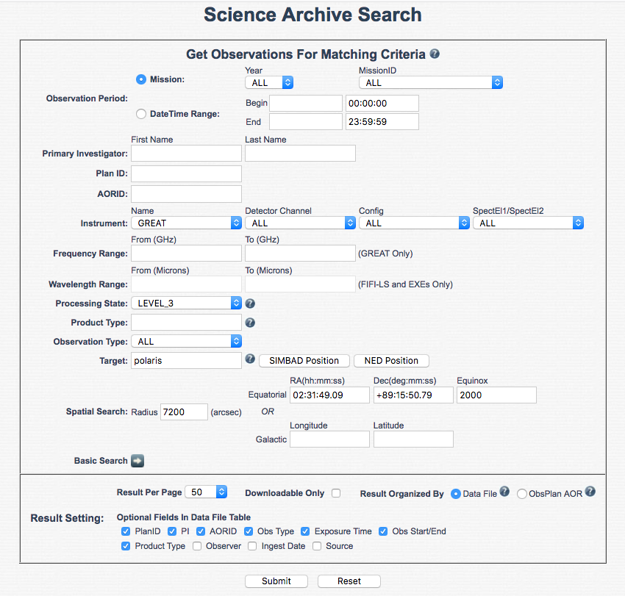Go to DCS archive, <https://dcs.sofia.usra.edu/> and log in
* Click “[Search Science Archive](https://dcs.sofia.usra.edu/dataRetrieval/SearchScienceArchiveInfoBasic.jsp)”
* Click “Advanced search”
* Enter 75_0020 in “Plan ID”
* Use the “Instrument” pulldown menu to select “GREAT”
* Enter “Polaris” in the “target” text field, press “SIMBAD Position”
* Enter “7200” in the “search radius” text field
* Press <submit>

1. Select and download the data [see screenshot of archive search results]

* There are 4 entries returned. Looking at the “Frequency” column of the output, you can see two are for the CII line (1900.53 GHz) and two are for OI (4744.78 GHz).
* Check the box at the left for the two that are on the CII line.
* Press <Get Selected Data in Current Page>
* Watch for an email from “The SOFIA Data Cycle System”, then click the link in the email to save the ZIP file with your data
* Move the zip file to a working directory and Unzip it

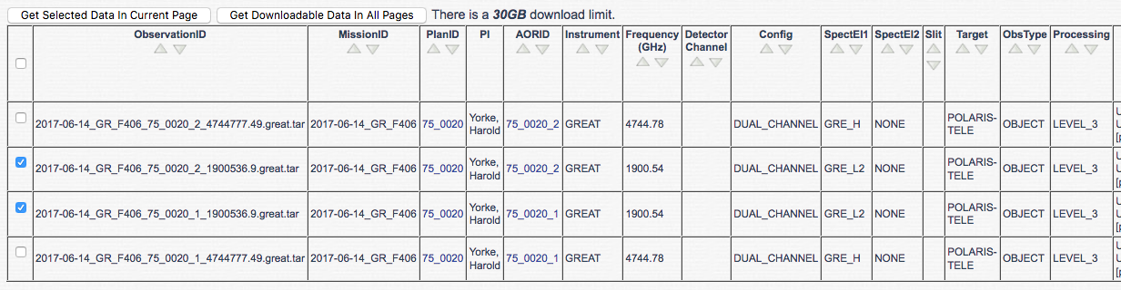

# Procedure

1. Load data into CLASS

* Go to the directory where you put the zip file
* Go to the directory where the unzipped data are:

cd sofia_2017-06-14_GR_F406/p4897/2017-06-14_GR_F406_75_0020_2_1900536.9

* Start class

class

1. Open the file with calibrated main-beam temperature spectra and list them:

LAS> file in 2017-06-14_GR_F406_75_0020_2_1900536.9_Tmb.great

LAS> lis in

Input index contains:

 N;V Source       Line         Telescope      Lambda     Beta Sys  Sca Sub

 1;4 POLARIS-TELE CII_U        SOF-LFAH_0_S    +28.1   +152.3 Eq 20588 2

 2;4 POLARIS-TELE CII_U        SOF-LFAH_0_S    +28.1   +152.3 Eq 20588 6

 3;4 POLARIS-TELE CII_U        SOF-LFAH_0_S    +28.1   +152.3 Eq 20588 10

 4;4 POLARIS-TELE CII_U        SOF-LFAH_0_S    +28.1   +152.3 Eq 20588 14

etc.

1. Get the spectra of the central pixel (0):

LAS> set tel *0*

LAS> fin

I-FIND,  20 observations found

LAS> lis

Current index contains:

N;V Source       Line         Telescope      Lambda     Beta Sys  Sca Sub

1;4 POLARIS-TELE CII_U        SOF-LFAH_0_S    +28.1   +152.3 Eq 20588 2

2;4 POLARIS-TELE CII_U        SOF-LFAH_0_S    +28.1   +152.3 Eq 20588 6

3;4 POLARIS-TELE CII_U        SOF-LFAH_0_S    +28.1   +152.3 Eq 20588 10

4;4 POLARIS-TELE CII_U        SOF-LFAH_0_S    +28.1   +152.3 Eq 20588 14

5;4 POLARIS-TELE CII_U        SOF-LFAH_0_S    +28.1   +152.3 Eq 20588 18

6;4 POLARIS-TELE CII_U        SOF-LFAH_0_S    +28.1   +152.3 Eq 20590 2

7;4 POLARIS-TELE CII_U        SOF-LFAH_0_S    +28.1   +152.3 Eq 20590 6

8;4 POLARIS-TELE CII_U        SOF-LFAH_0_S    +28.1   +152.3 Eq 20590 10

9;4 POLARIS-TELE CII_U        SOF-LFAH_0_S    +28.2   +152.4 Eq 20590 14

10;4 POLARIS-TELE CII_U        SOF-LFAH_0_S    +28.2   +152.4 Eq 20590 18

71;4 POLARIS-TELE CII_U        SOF-LFAV_0_S    +26.8   +150.8 Eq 20588 2

72;4 POLARIS-TELE CII_U        SOF-LFAV_0_S    +26.8   +150.8 Eq 20588 6

73;4 POLARIS-TELE CII_U        SOF-LFAV_0_S    +26.8   +150.8 Eq 20588 10

74;4 POLARIS-TELE CII_U        SOF-LFAV_0_S    +26.8   +150.8 Eq 20588 14

75;4 POLARIS-TELE CII_U        SOF-LFAV_0_S    +26.8   +150.8 Eq 20588 18

76;4 POLARIS-TELE CII_U        SOF-LFAV_0_S    +26.8   +150.8 Eq 20590 2

77;4 POLARIS-TELE CII_U        SOF-LFAV_0_S    +26.8   +150.8 Eq 20590 6

78;4 POLARIS-TELE CII_U        SOF-LFAV_0_S    +26.8   +150.8 Eq 20590 10

79;4 POLARIS-TELE CII_U        SOF-LFAV_0_S    +26.9   +150.9 Eq 20590 14

80;4 POLARIS-TELE CII_U        SOF-LFAV_0_S    +26.9   +150.9 Eq 20590 18

1. Plot the first individual spectrum that was found for the central pixel. You will see the entire passband, which likely includes much more than you need to see.

LAS> get first

I-GET,  Observation 1; Vers 4 Scan 20588

LAS> plot

1. Narrow to the center of the passband near the central velocity of cloud, smooth to 0.5 km/s, and plot again. The data are now acceptable gridded and reveal the approximate range and sensitivity expected for observations of Galactic sources. The keyword “Time” in the header shows 0.28 for this individual spectrum.

LAS> get first

I-GET,  Observation 1; Vers 4 Scan 20588

LAS> set unit v f

LAS> set mode x -50 50

LAS> pl

LAS> smo gau 0.5

LAS> pl

1. Set up baseline fitting. We will do first order excluding the central portion where there could be a line.

LAS> ge fi

LAS> set window -50 -30 30 50

LAS> plot

LAS> draw win

LAS> base /plot

1. Write baseline-subtracted spectra to new file

LAS> file out bsub.dat single /over

I-FILE,  File is version 2 (record length: 1024 words)

I-NEWPUT,  bsub.dat initialized

LAS> write

LAS> for j 2 to found

LAS: get next

LAS: plot; base /plot; draw win

LAS: write

LAS: next j

1. Average the baseline-subtracted spectra from the new file, get the rms

LAS> file in bsub.dat

LAS> fin /all

LAS> average /resample /nocheck cal

LAS> smoo gau 0.5

LAS> plot

LAS> rms /nocheck

1. Write final spectrum to FITS file

LAS> fits write bsub.fits /mode spectrum

# Cleaning up

Now that you have cooked this simple recipe, you should be able to expand and make the spectra you and your colleagues have been dreaming of. To get some more ideas, look at the class script in the tar file for the full reduction script that was used in generating the products and for comments and examples of how to do things with GREAT data in class.