System Validation Report
for
Student Attendance Management System (SAMS)
Version: 1.0
Date: 06-11-2026
Team 1
Name | SRN
Cheethirala Sai Santosh | PES1UG24CS127
Deepak B | PES1UG24CS143
Epari Subhransi | PES1UG24CS161
Gyaan S Shetty | PES1UG24CS178

1. Introduction
This report gives the results of system testing of SAMS against the test cases TC-01 to TC-17 and the security checks in section 5.1 of the Software Test Plan. Each test case was run end to end through the web interface in a browser, the same way a user would use it, and the result was checked on screen and in the database.

2. Test Environment
Item | Details
Build | main at commit c1edd6d (all Sprint 1 and Sprint 2 stories merged)
Server | Django development server, SQLite database, console email backend (mails printed to the server log)
Browser | Chromium (headless), 1280 x 800, driven by a Playwright script that clicks through each test case and saves a screenshot
Test data | 1 admin, 1 faculty (Ravi Kumar), class CSE 5 C with the 4 team members, class CSE 5 D with 70 students, subject UE24CS341A, 3 days of earlier attendance
Date run | 02-11-2026

3. Summary
Test cases | Passed | Failed | Not run
17 | 17 | 0 | 0

Security checks (Test Plan 5.1) | Passed
9 | 9

4. Test Case Results
TC | Req | Test | Expected | Actual result | Result
TC-01 | REQ-1 | Login with valid ID and password | Dashboard opens | Redirected to /accounts/dashboard/ with faculty dashboard | Pass
TC-02 | REQ-1 | Login with wrong password | "Invalid username or password" shown | Stayed on login page, message 'Invalid username or password.' shown | Pass
TC-03 | REQ-2, NFR-7 | Student tries to open admin page | 403 Forbidden | Student opening admin upload page got HTTP 403 | Pass
TC-04 | REQ-4 | Upload Excel with 10 students (2 without SRN) | 8 added, 2 rejected with reason | 8 student(s) added, 2 row(s) rejected; rejected rows listed with reason | Pass
TC-05 | REQ-5, REQ-6 | Admin adds subject and class | Saved and listed | Admin added subject UE24CS342A through /admin, it is listed | Pass
TC-06 | REQ-8 | Mark attendance with 3 absentees | Records saved, confirmation | Class of 70 students: 67 Present, 3 Absent saved, confirmation shown | Pass
TC-07 | REQ-9 | Mark same subject, date and hour again | "Attendance already marked" | Warning 'Attendance already marked for this subject, date and hour.' shown, no new rows | Pass
TC-08 | REQ-10 | Edit attendance within 3 days and after 3 days | Within: saved and logged; after: blocked | Same-day edit saved and logged (1 log row); record marked 4 days ago blocked for faculty | Pass
TC-09 | REQ-11 | % after 3 of 4 classes attended | 75.0% shown | Santosh attended 3 of 4 classes (one edited to Absent in TC-08): 75.0% shown | Pass
TC-10 | REQ-12, NFR-8 | Student views own attendance, tries other pages | Own data only; others 403 | /reports/my/ shows only own subjects (no student id in URL); class report HTTP 403, shortage list HTTP 403 for student | Pass
TC-11 | REQ-13, REQ-14 | Report for date range, PDF and Excel | Report shown, both files download | Report shown for date range; downloaded attendance_UE24CS341A_20261003_20261102.pdf (2 KB), attendance_UE24CS341A_20261003_20261102.xlsx (5 KB) | Pass
TC-12 | REQ-15 | Shortage list | Only students below 75% listed | Subhransi (below 75%) listed; Gyaan (100%) not listed | Pass
TC-13 | REQ-16 | Attendance drops below 75% | Shortage email sent | 4 'Attendance shortage' mails printed by the console email backend right after attendance was saved, to: pes1ug24cs161@sams.local, s0@sams.local, s1@sams.local, s2@sams.local. No mail to students at or above 75% | Pass
TC-14 | REQ-17 to 19 | Apply leave, faculty approves | Approved; days marked Leave; % updated | Request Pending -> Approved; 2 absent days set to Leave; Subhransi % 50.0 -> 100.0 | Pass
TC-15 | NFR-1, NFR-2, NFR-3 | Timing of page load, save and report | < 3 s, < 2 s, < 5 s | Load class list (70): 0.13s; save 70 students: 0.25s; dashboard: 0.05s; semester report: 0.07s (single user, local) | Pass
TC-16 | NFR-6 | Password stored in database | Hashed, not plain text | accounts_user.password = 'pbkdf2_sha256$600000$Dp3jnum...' (hashed, not plain text) | Pass
TC-17 | NFR-9 | Idle for 31 minutes | Session expired, back to login | SESSION_COOKIE_AGE = 1800 s (30 min), saved on every request. Session expiry moved into the past to simulate 31 min idle; next request redirected to login | Pass

5. Security Validation (Test Plan 5.1)
Check | How it was tested | Result
Password hashing (NFR-6) | Read accounts_user.password from the database (TC-16) | Pass
Role based access (NFR-7) | Student on admin page, faculty on student page, student on faculty reports | Pass
Student data privacy (NFR-8) | Student pages use the logged in user only; other report pages return 403 (TC-10) | Pass
Session timeout (NFR-9) | Session expired after idle time, redirected to login (TC-17) | Pass
CSRF protection (NFR-10) | Login form submitted with a wrong CSRF token | Pass
SQL injection (NFR-10) | Entered ' OR 1=1 -- as username and password | Pass
Admin site access | Faculty opening /admin/ is sent to the admin login (not staff) | Pass
Audit log (NFR-11) | Edit of a record created an AttendanceLog row with user and time (TC-08) | Pass
Sensitive data in logs (SO-3) | Searched the server log for the test passwords - none found | Pass

6. Performance (NFR-1 to NFR-3)
Measurement | Result | Limit | Result
Single user timings (TC-15) | Load class list (70): 0.13s; save 70 students: 0.25s; dashboard: 0.05s; semester report: 0.07s (single user, local) | 3 s / 2 s / 5 s | Pass
100 users at the same time (NFR-1) | 100 concurrent logged-in requests to /reports/my/: 100 OK, median 0.67s, 95th 1.08s, max 1.21s | 3 s per page | Pass

Note: measured on a laptop with the Django development server and SQLite, not a production server. Numbers are well inside the limits but should be read as indicative.

7. Defects
No defects were found during system testing. Defects found earlier (D-1 to D-4, see Unit Test Report section 5) were fixed in PR #36 and retested here (TC-03, TC-05, TC-12, TC-13 pass).

Appendix A: Screenshots
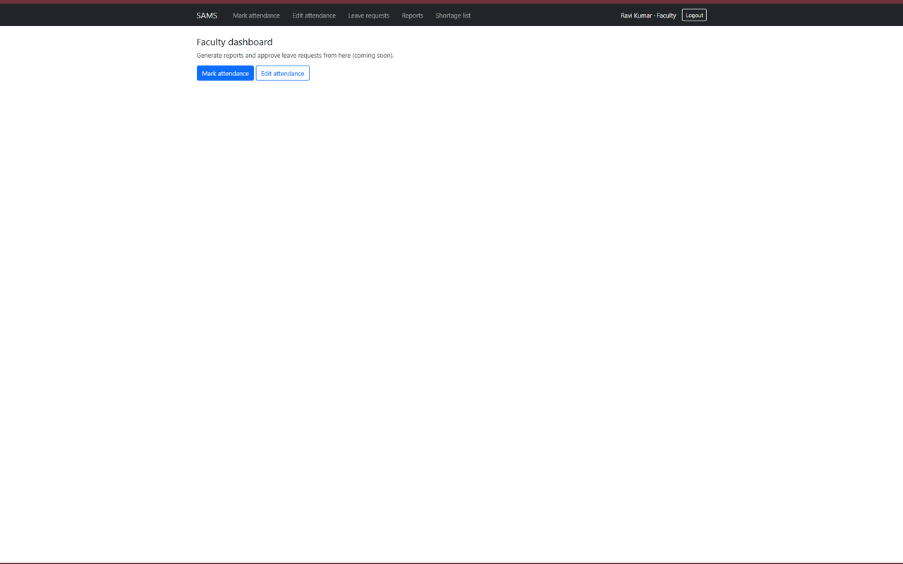
Figure: TC-01 Faculty dashboard after login
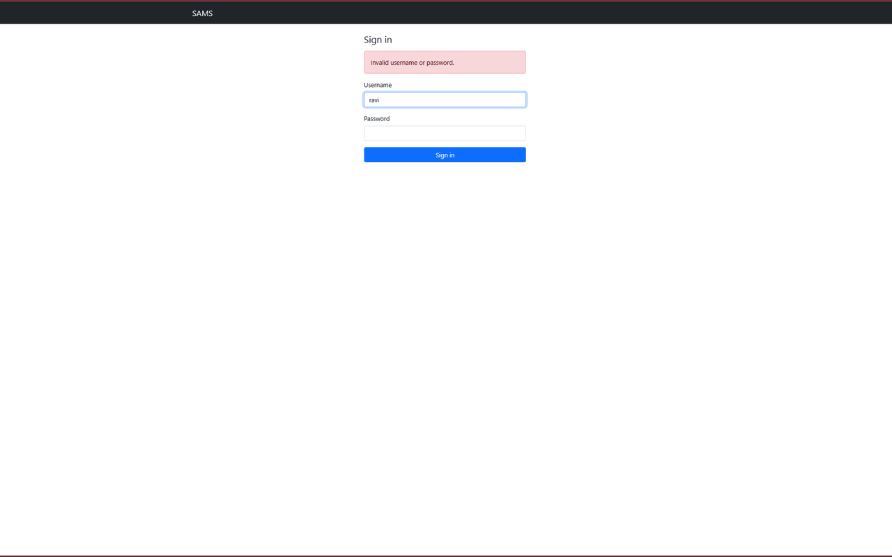
Figure: TC-02 Wrong password
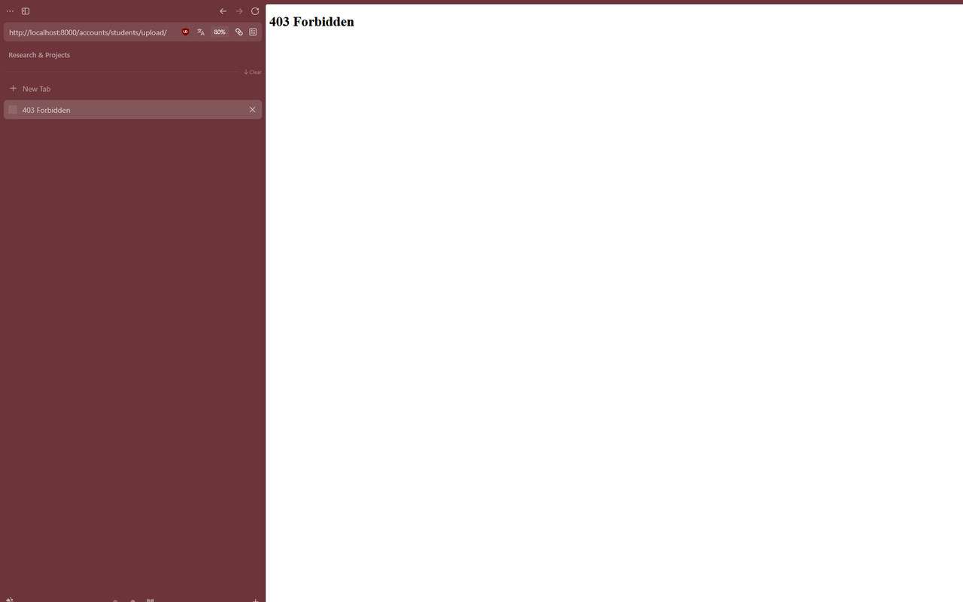
Figure: TC-03 Student blocked from admin page
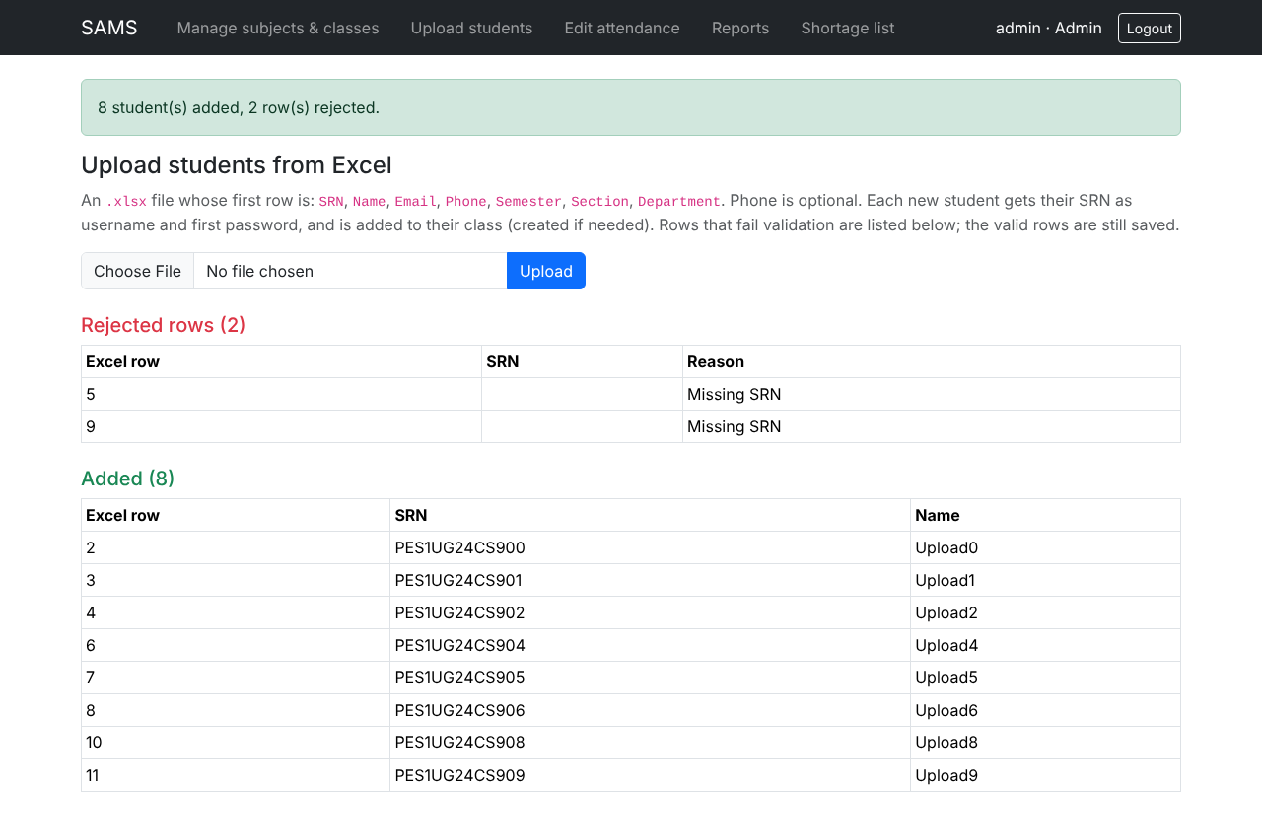
Figure: TC-04 Excel upload result
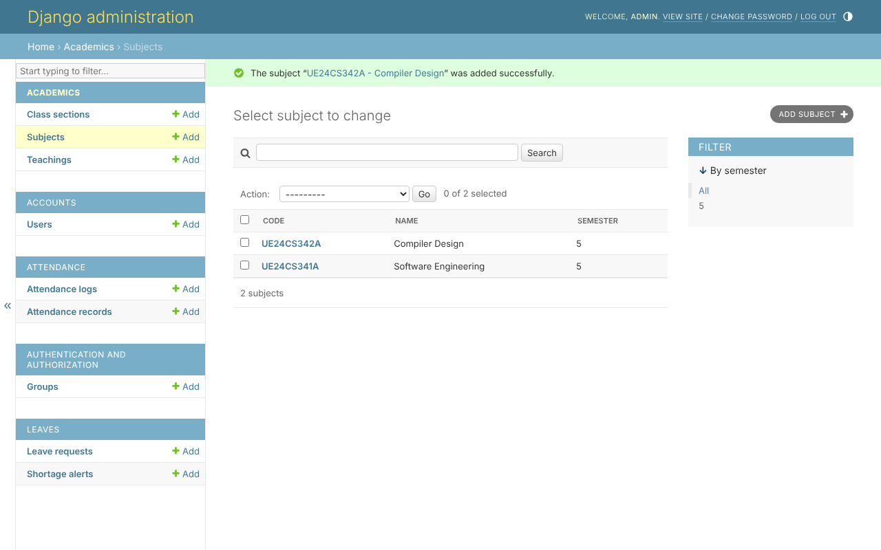
Figure: TC-05 Subject added in admin
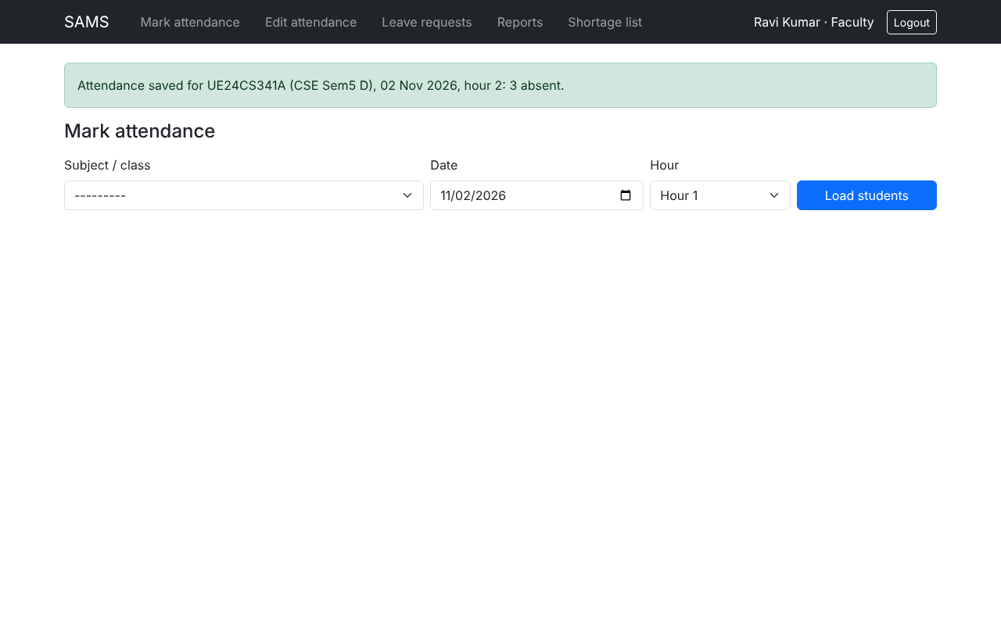
Figure: TC-06 Attendance saved for 70 students
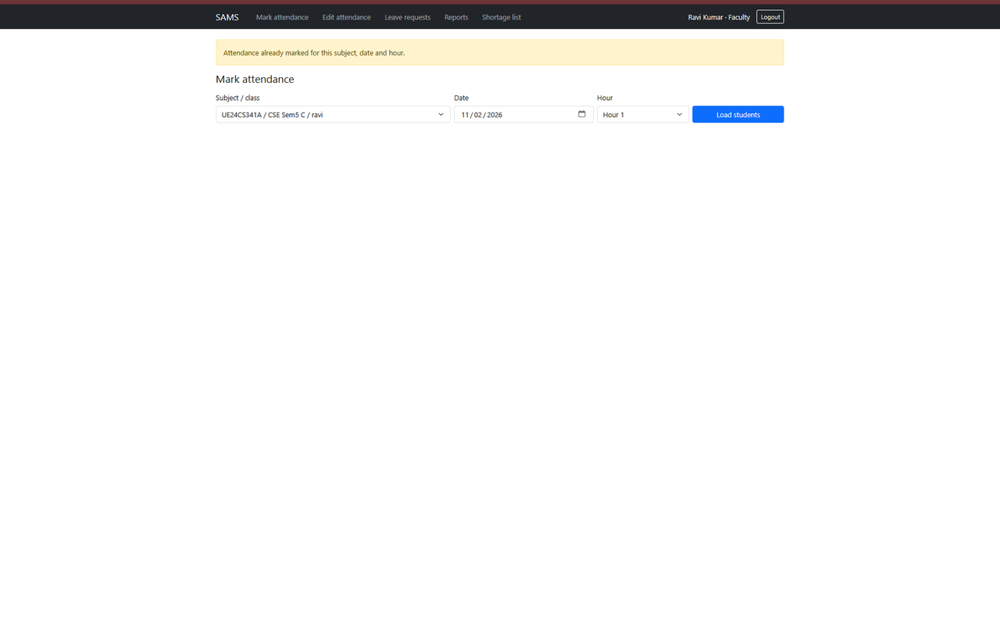
Figure: TC-07 Duplicate marking blocked
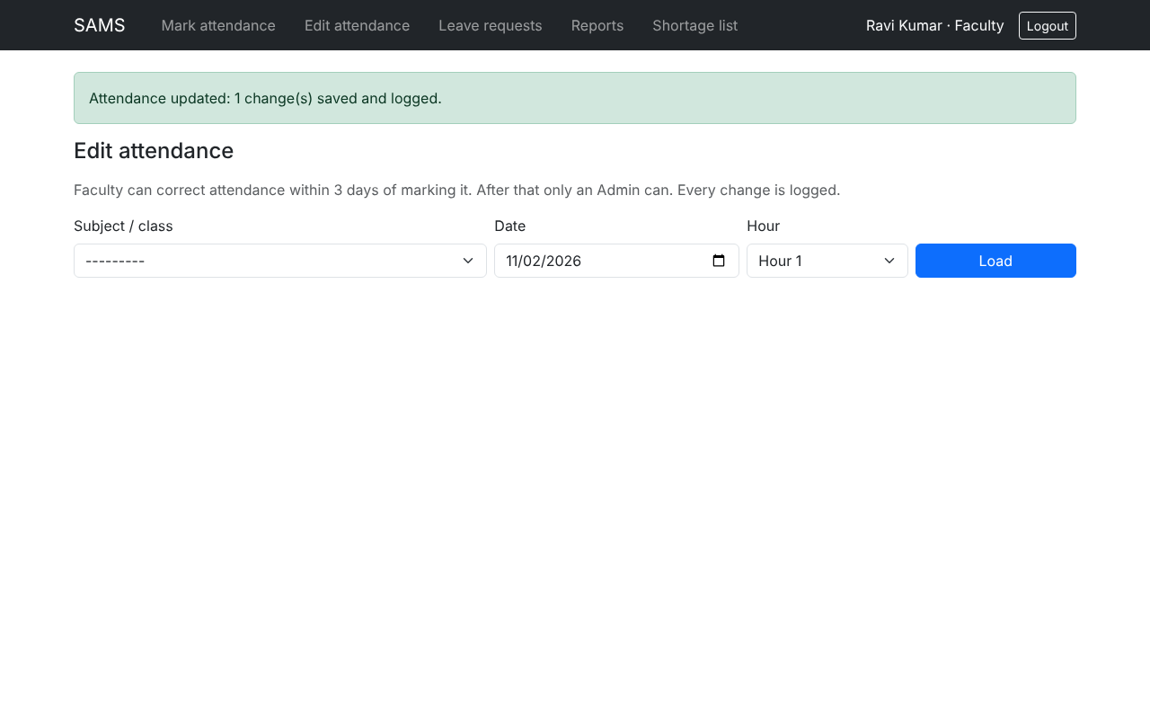
Figure: TC-08 Edit within 3 days saved
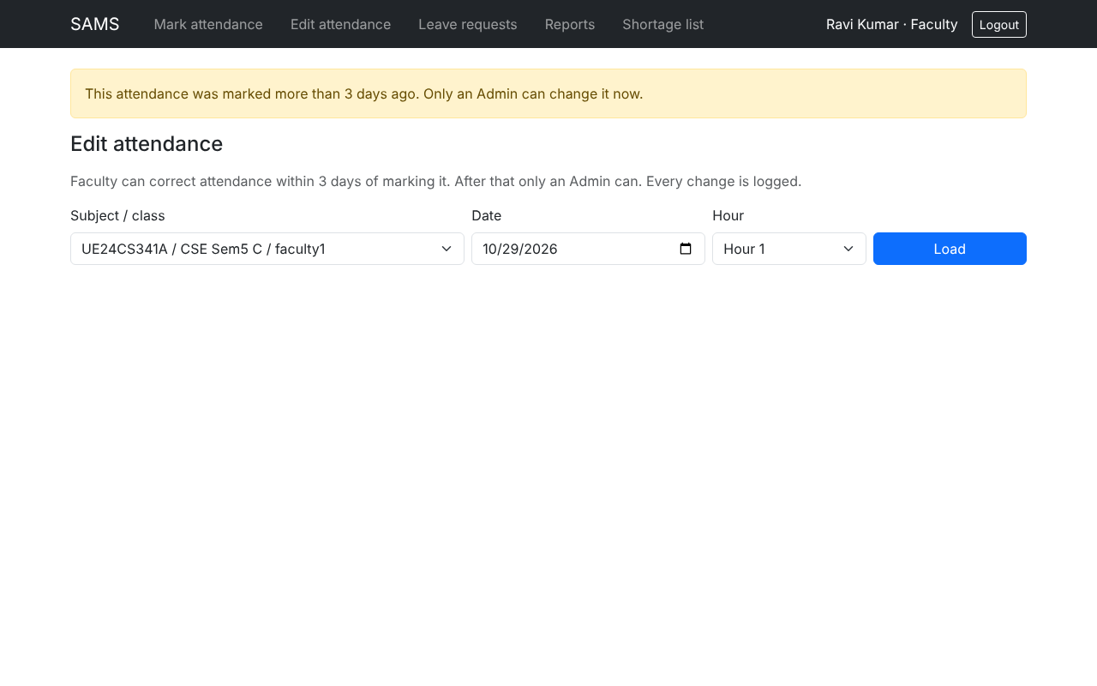
Figure: TC-08 Edit after 3 days blocked
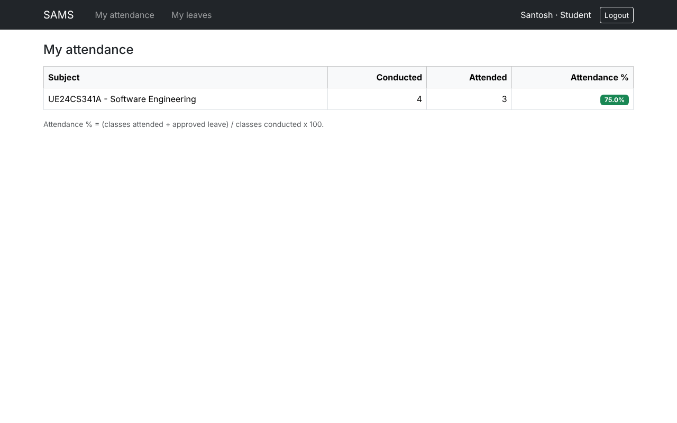
Figure: TC-09 Student percentage 75.0%
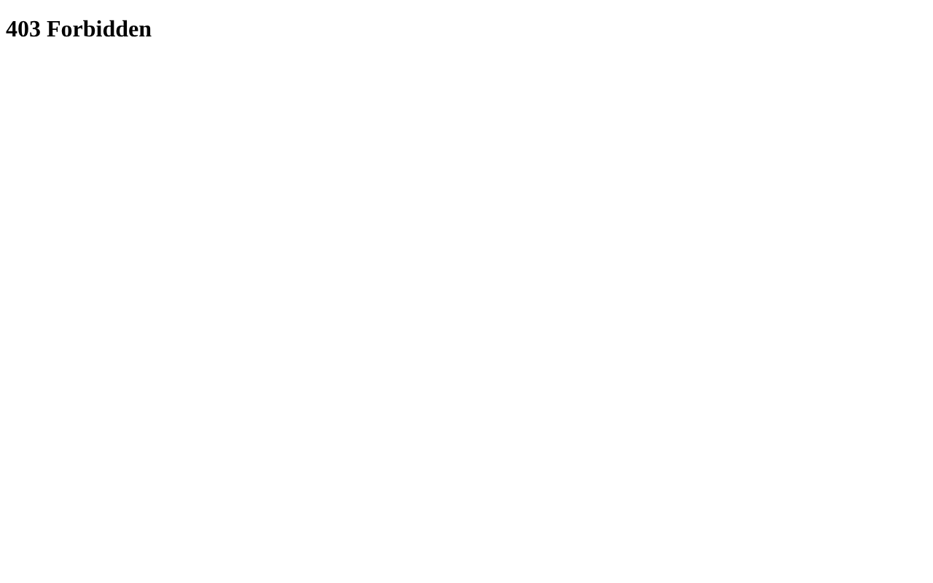
Figure: TC-10 Student blocked from faculty report
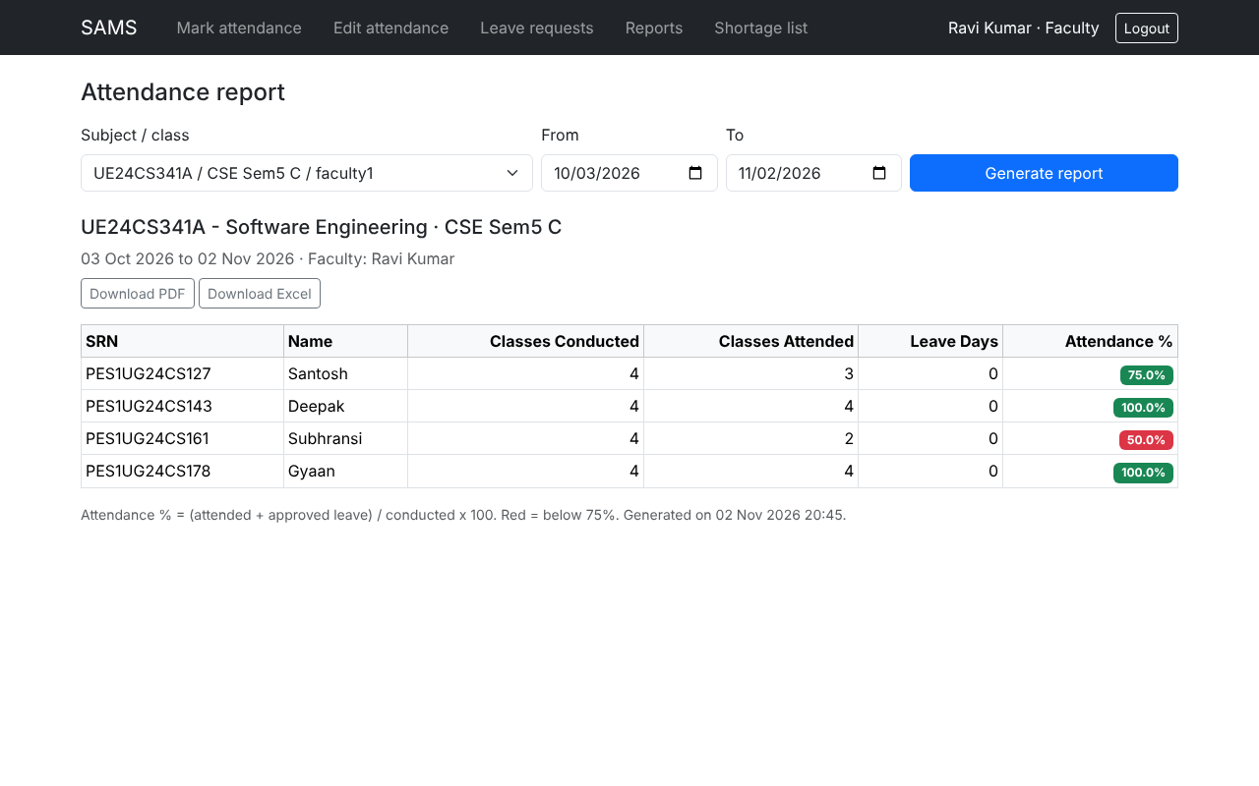
Figure: TC-11 Class report with export buttons
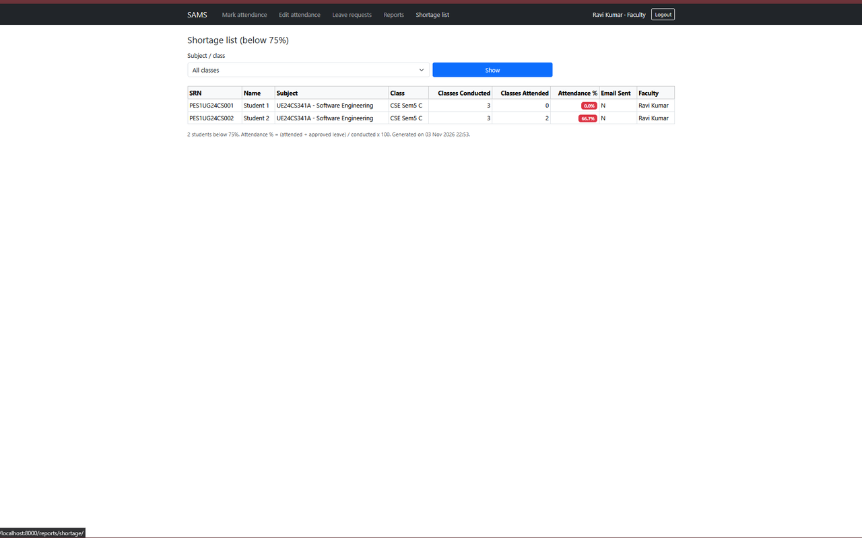
Figure: TC-12 Shortage list
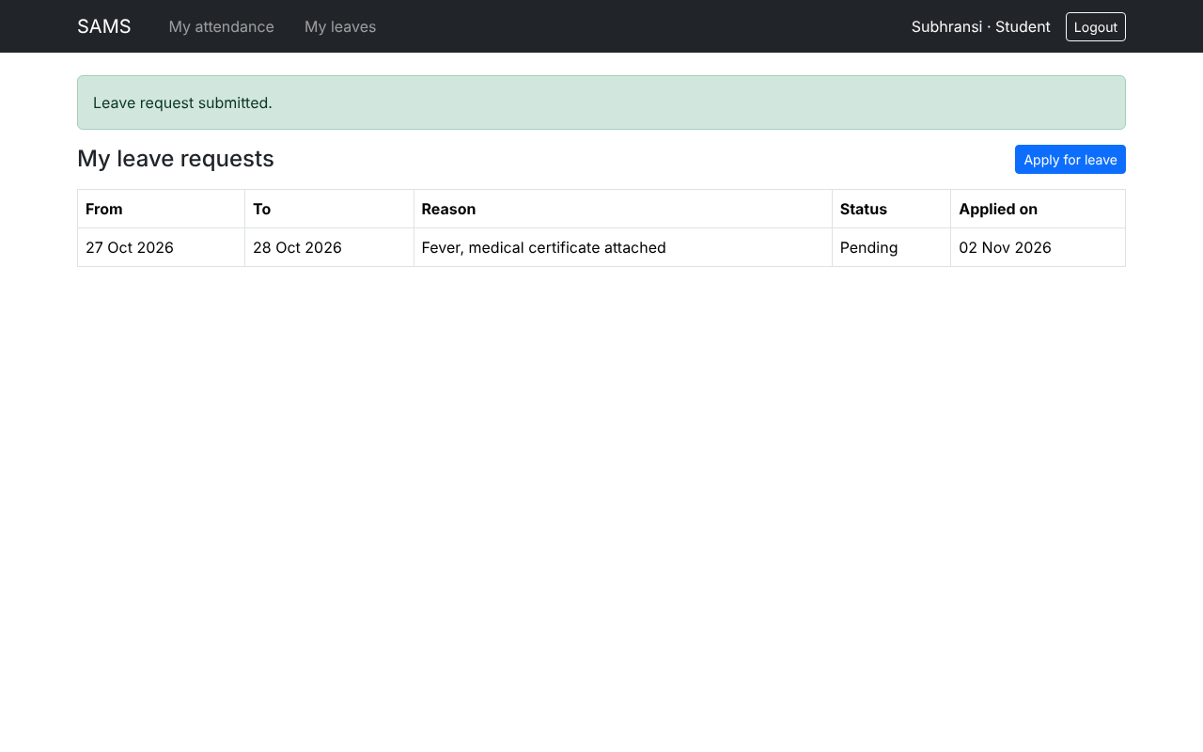
Figure: TC-14 Leave applied
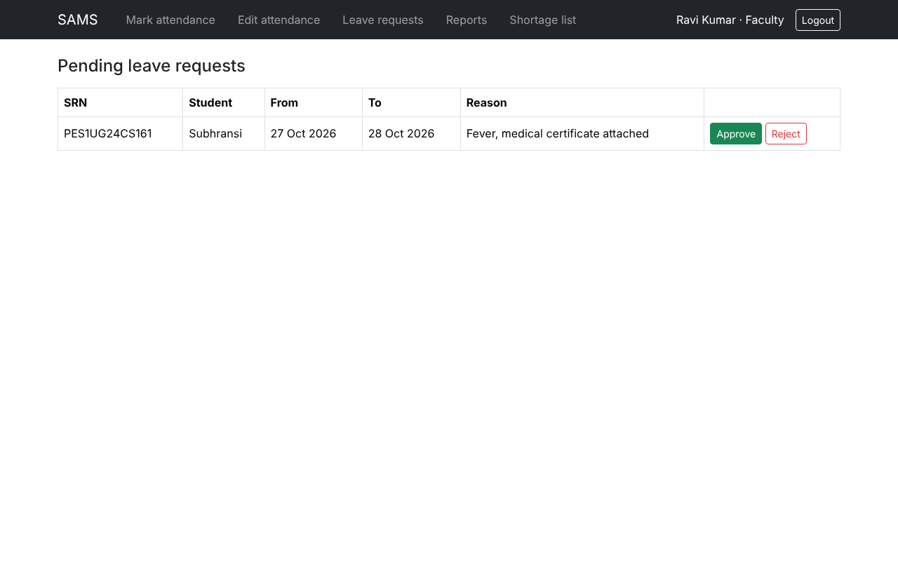
Figure: TC-14 Pending request (faculty)
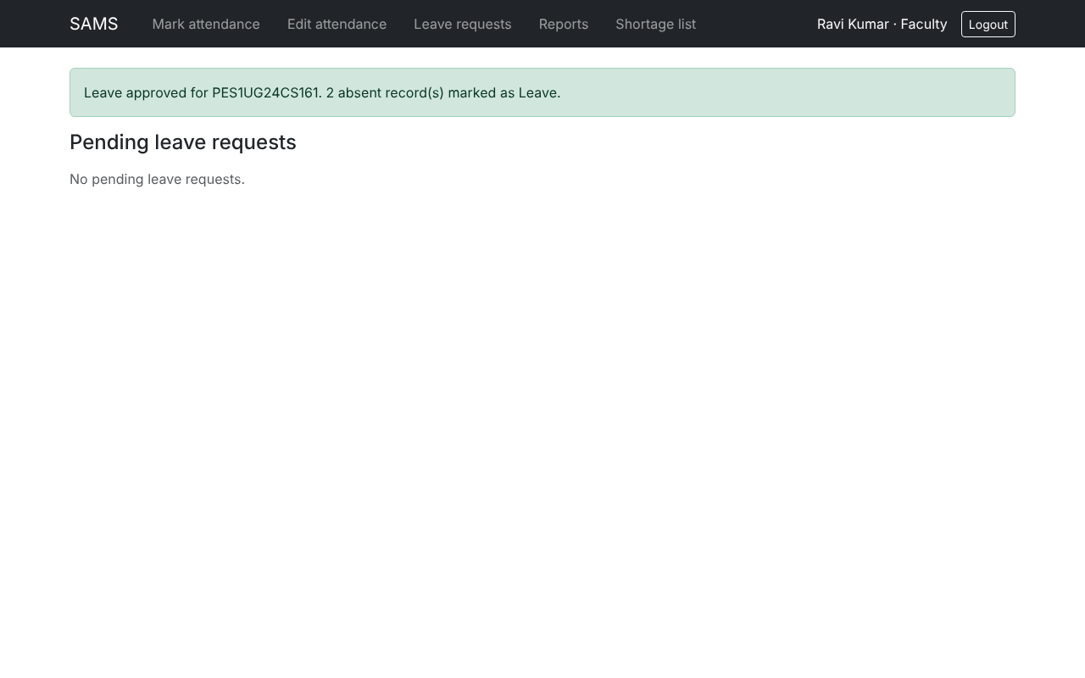
Figure: TC-14 Leave approved
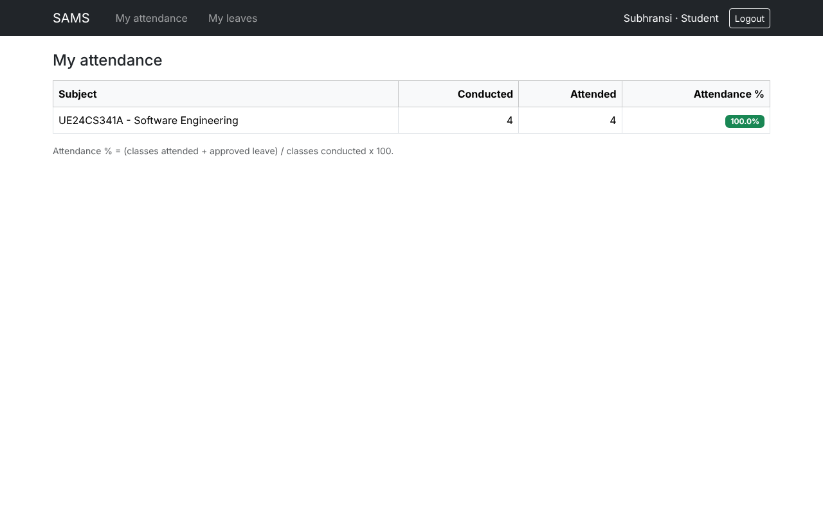
Figure: TC-14 Student percentage after approval
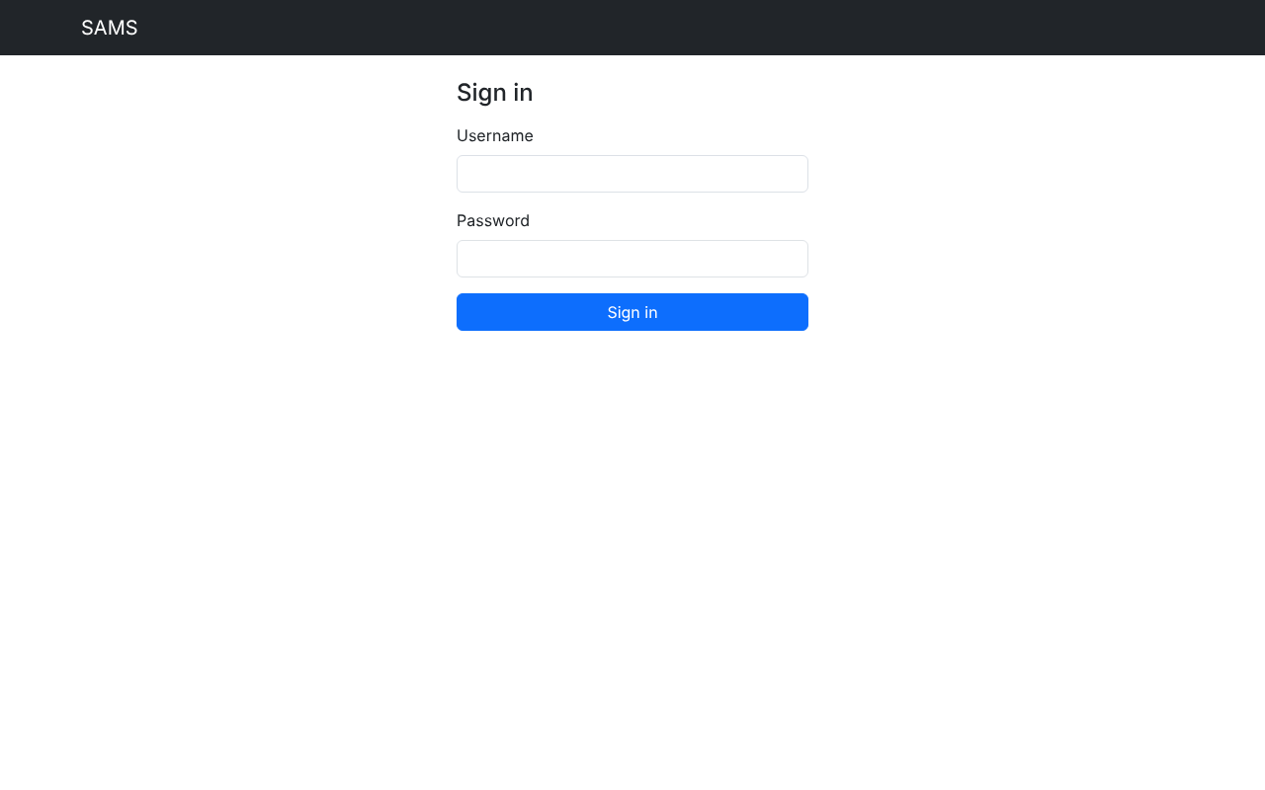
Figure: TC-17 Session expired, login page
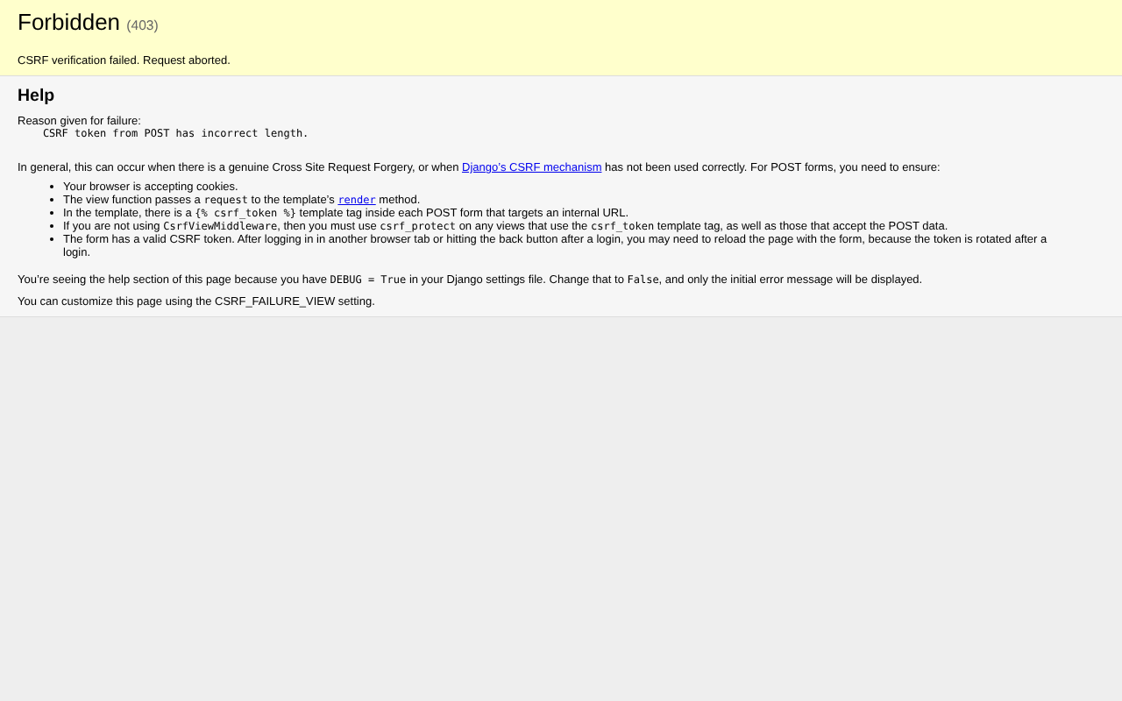
Figure: Security: wrong CSRF token rejected

