Software Architecture and Design Specification
for
Student Attendance Management System (SAMS)
Version: 1.1
Status: Draft
Date: 29-10-2026
Authors: Team 1
Name | SRN
Cheethirala Sai Santosh | PES1UG24CS127
Deepak B | PES1UG24CS143
Epari Subhransi | PES1UG24CS161
Gyaan S Shetty | PES1UG24CS178

Revision History
Version | Date | Author | Change Summary
1.0 | 05-10-2026 | Team 1 | Initial version
1.1 | 29-10-2026 | Team 1 | Data model and API updated to match implementation

Approvals
Role | Name | Signature/Date
Team Lead | Gyaan S Shetty
Developer | Cheethirala Sai Santosh
Developer | Deepak B
Tester | Epari Subhransi
Faculty Guide

1. Introduction

1.1 Purpose
This document describes the architecture and design of the Student Attendance Management System (SAMS) version 1.0. It explains how the requirements in the SRS will be implemented.

1.2 Scope
Covers all modules of SAMS: user login and management, subject and class management, attendance marking, reports, shortage email and leave requests.

1.3 Audience
Developers and testers in Team 1, the faculty evaluator, and anyone who maintains the system later.

1.4 Definitions
Term | Meaning
SAMS | Student Attendance Management System
MVT | Model View Template (Django pattern)
ORM | Object Relational Mapping
CSRF | Cross Site Request Forgery
STRIDE | Spoofing, Tampering, Repudiation, Information disclosure, Denial of service, Elevation of privilege
SMTP | Simple Mail Transfer Protocol

2. Document Overview

2.1 How to use this document
Section 3 gives the architecture - components, pattern, technology, risks, traceability and security. Section 4 gives the design - sequence diagrams, API, error handling and UI. Requirement IDs (REQ-x, NFR-x) refer to the SRS.

2.2 Related Documents
- Software Requirements Specification (SRS) v1.0
- Software Test Plan (STP) v1.0
- Requirement Traceability Matrix (SRS Appendix C)

3. Architecture

3.1 Goals & Constraints
Goals:
- Pages load within 3 seconds for upto 100 users (NFR-1)
- Attendance for 70 students saved in under 2 seconds (NFR-2)
- Only authorised users can access data (SO-1)
- Easy to maintain - each module is a seperate Django app
Constraints:
- Python and Django must be used
- MySQL database
- Web application only
- Team of 4, one semester

3.2 Stakeholders & Concerns
Stakeholder | Concerns
Students | Correct attendance, privacy of thier data
Faculty | Fast and easy attendance marking, reports
Admin | Correct data, control over users and subjects
Developers | Modularity, easy to work in parallel
Evaluator | Traceability, security, documentation

3.3 Component (UML) Diagram
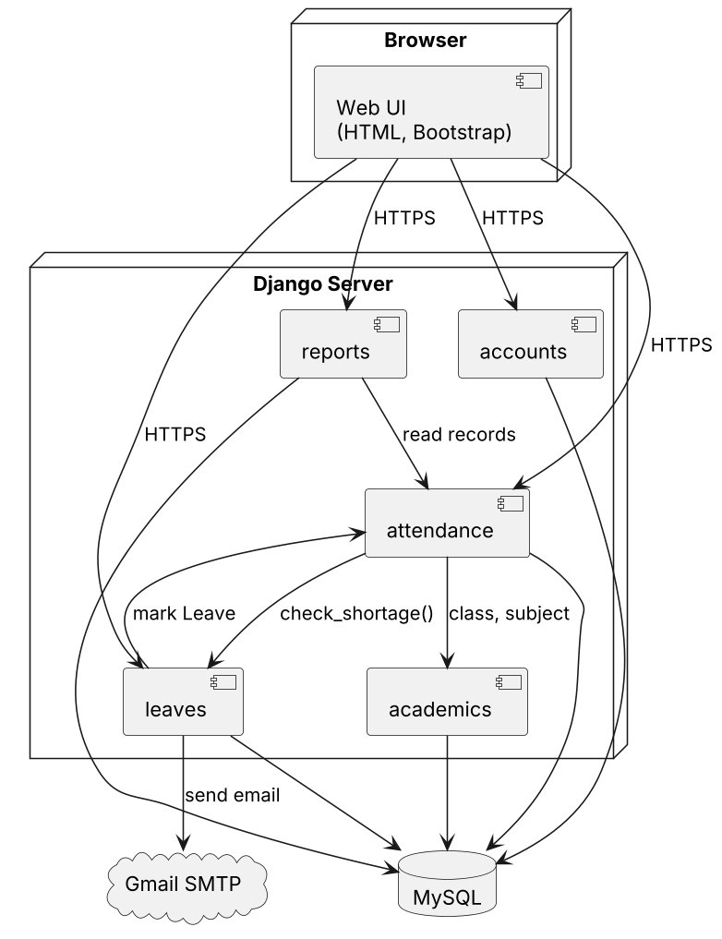
Figure 1: Component diagram of SAMS

3.4 Component Descriptions
Component | Responsibility | Owner
Web UI | HTML pages with Bootstrap, shown in the browser | All
accounts | Login, logout, roles, add/edit/delete users, Excel upload | Santosh
academics | Subjects, classes, enrolment, faculty assignment | Deepak
attendance | Mark and update attendance, calculate percentage, change log | Deepak
reports | Student attendance view, PDF/Excel reports, shortage list | Subhransi
leaves | Leave requests, approval, shortage email | Gyaan
MySQL | Stores all data | -
Gmail SMTP | External server used to send emails | -

3.5 Chosen Architecture Pattern and Rationale
We are using a Layered architecture with Django's MVT (Model-View-Template) pattern.
Layer | Django part | Job
Presentation | Templates | Show pages to the user
Business logic | Views | Handle requests, apply rules
Data | Models + ORM | Read/write MySQL

Why:
- Django already follows this pattern so it is easy to implement
- Each module is a seperate Django app, so each team member can work on thier own app
- Easy to test each layer
Rejected:
- Microservices - too complex for a small college system and a 4 person team
- React SPA + REST API - more front end work, server side templates are enough

3.6 Technology Stack & Data Stores
Layer | Technology
Front end | HTML, CSS, Bootstrap 5
Back end | Python 3.10, Django 4.2
Database | MySQL 8.0 (SQLite for local testing and CI)
Reports | reportlab (PDF), openpyxl (Excel)
Email | Gmail SMTP
Tools | GitHub, JIRA, VS Code

Main tables:
Table | Main Fields
User | id, username, password (hashed), name, email, role
Subject | code, name, semester
ClassSection | department, semester, section, students
Teaching | faculty, subject, class_section (which faculty teaches what)
AttendanceRecord | student, subject, class, date, hour, status (P/A/L), marked_by
AttendanceLog | record, changed_by, old_status, new_status, time
LeaveRequest | student, from_date, to_date, reason, status
ShortageAlert | student, subject, percent, sent_at (shortage mails sent)

3.7 Risks & Mitigations
Risk | Mitigation
Data loss if server crashes | Daily database backup (NFR-4)
Faculty marks attendance twice | Unique check on subject + class + date + hour (REQ-9)
Email not sent (Gmail limit / network) | Log failure and show on admin dashboard
Team members code conflicts | Each person works in own app and git branch, merge after review

3.8 Traceability to Requirements
Requirement | Component
REQ-1 to REQ-4 | accounts
REQ-5 to REQ-7 | academics
REQ-8 to REQ-11 | attendance
REQ-12 to REQ-15 | reports
REQ-16 to REQ-19 | leaves
NFR-6, NFR-7, NFR-9 | accounts
NFR-8 | reports
NFR-10 | All (Django CSRF + ORM)
NFR-11 | attendance (AttendanceLog)

3.9 Security Architecture
Threat modeling done using STRIDE:
Threat | Example in SAMS | Mitigation
Spoofing | Someone logs in as another user | Hashed passwords, session timeout 30 min
Tampering | Student changes attendance | Only faculty of that subject can edit, role check on every view
Repudiation | Faculty says they did not change a record | AttendanceLog stores who changed what and when
Information disclosure | Student sees others attendance | Student can only query own records, HTTPS
Denial of service | Too many login attempts | Limit login attempts
Elevation of privilege | Student opens admin pages | @login_required and role decorators on all views

4. Design

4.1 Design Overview
Each Django app has the same structure:
File | Contents
models.py | Database tables
views.py | Request handling and business rules
urls.py | URL routes
forms.py | Input forms and validation
templates/ | HTML pages
tests.py | Unit tests

4.2 UML Sequence Diagrams
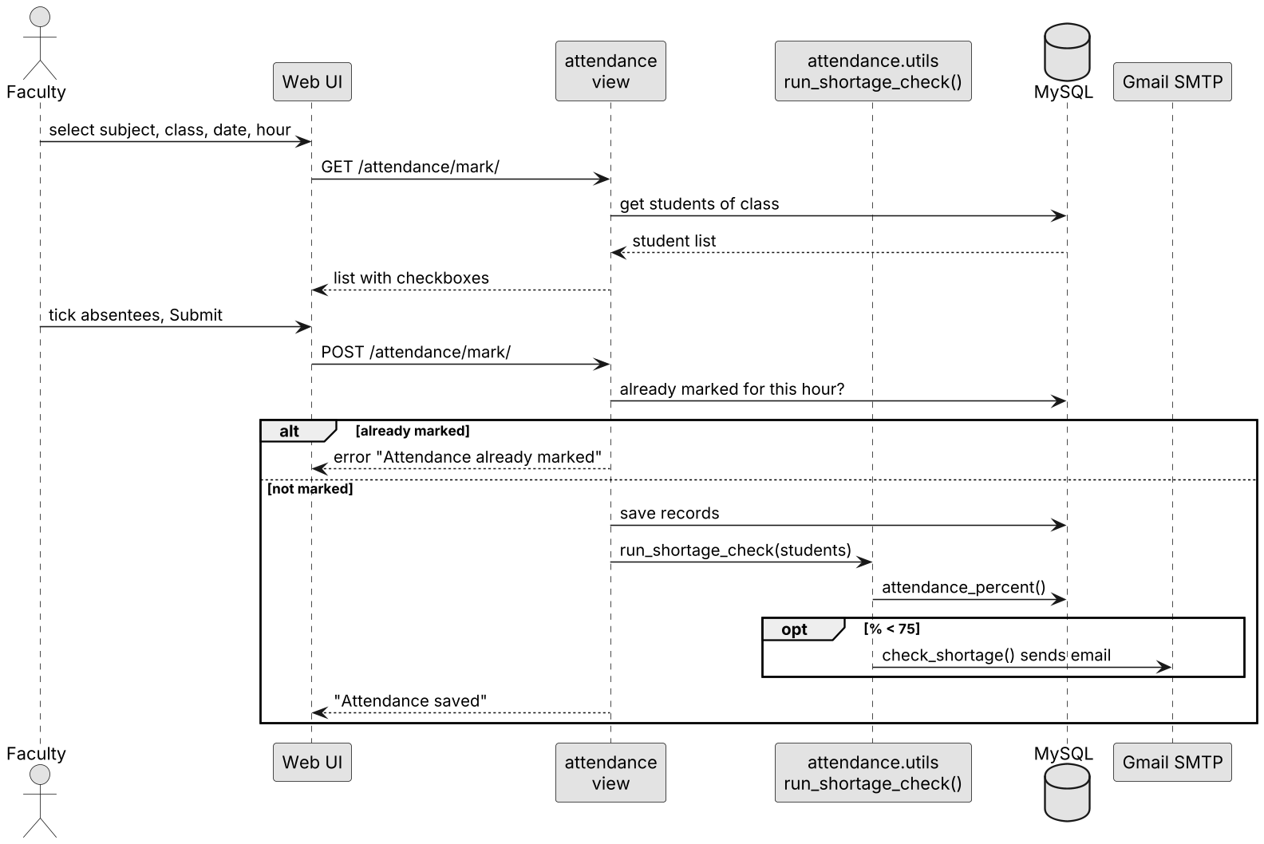
Figure 2: Faculty marks attendance (REQ-8, REQ-9, REQ-16)
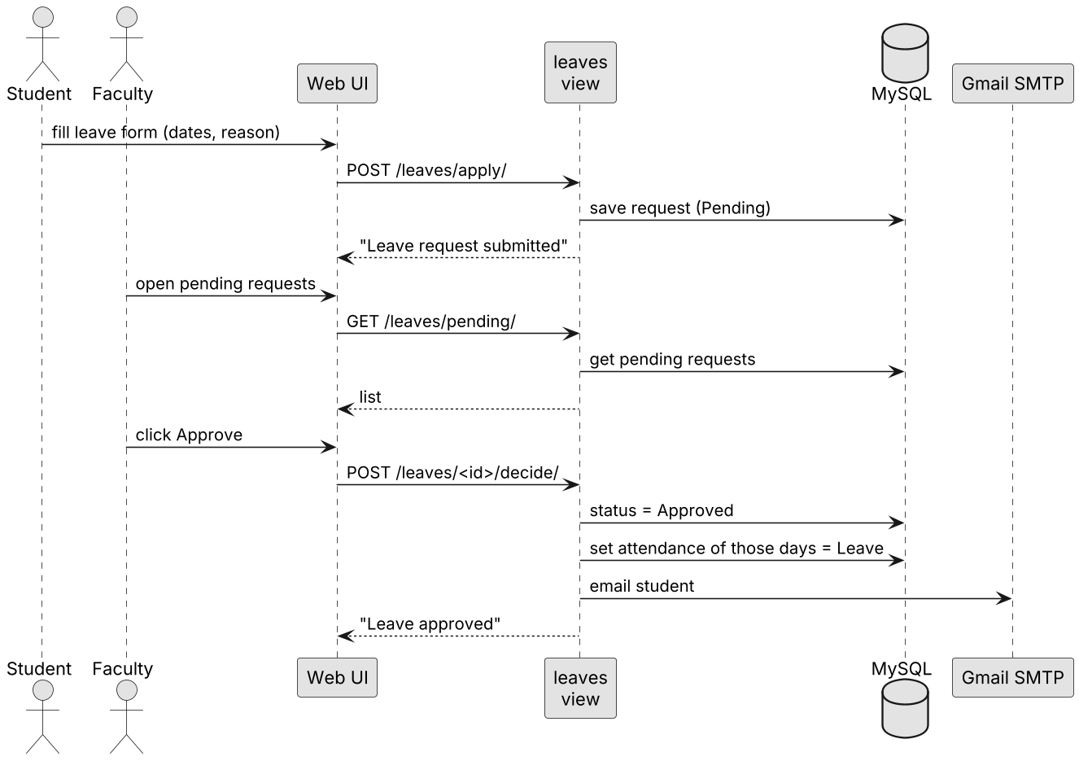
Figure 3: Student applies for leave and faculty approves (REQ-17 to REQ-19)

4.3 API Design
Interface definitions for the attendance and leaves components. All endpoints need login.
Attendance component
Endpoint | Type | Request | Response | Errors
/attendance/mark/ | GET | teaching, date, hour | Student list page | not your class - not listed
/attendance/mark/ | POST | teaching, date, hour, absent[] | Redirect + "Attendance saved" | "Attendance already marked"; future date
/attendance/edit/ | POST | teaching, date, hour, status per student | "Attendance updated" | more than 3 days old (faculty)

Leaves component
Endpoint | Type | Request | Response | Errors
/leaves/apply/ | POST | from_date, to_date, reason | "Leave request submitted" | invalid / overlapping dates
/leaves/pending/ | GET | - | List of pending requests | 403 not faculty
/leaves/my/ | GET | - | Own leave requests | 403 not student
/leaves/<id>/decide/ | POST | decision (approve / reject) | "Leave approved / rejected" | 403 not faculty; 404 not found

Reports component
Endpoint | Type | Request | Response | Errors
/reports/my/ | GET | - | Subject wise % of logged in student | 403 not student
/reports/class/ | GET | teaching, start, end | Class report with % | invalid dates; 403 student
/reports/shortage/ | GET | teaching (optional) | Students below 75% | 403 student

Accounts component
Endpoint | Type | Request | Response | Errors
/accounts/students/upload/ | POST | .xlsx file | Rows added + rejected rows with reason | wrong file / header; 403 not admin

4.4 Error Handling, Logging & Monitoring
- Form errors shown next to the field (Django forms)
- Custom 403, 404 and 500 pages with simple messages
- Database saves done in a transaction so partial data is not saved
- Python logging used for errors - passwords and personal data are never logged
- Failed emails logged and shown to admin
- Admin dashboard shows count of failed logins and failed emails

4.5 UX Design
- Simple Bootstrap layout, works on mobile and laptop
- Dashboard according to role after login
- Attendance page - all students present by default, faculty ticks only absentees
- Attendance % shown with label "Shortage" if below 75%
- Clear success and error messages after every action

4.6 Open Issues & Next Steps
- QR code based attendance
- SMS alerts along with email
- Integration with university ERP

5. Appendices

5.1 Glossary
See Section 1.4 and SRS Appendix A.

5.2 References
- IEEE 42010 - Architecture Description
- IEEE 1016 - Software Design Descriptions
- OWASP Top 10
- Django Documentation

5.3 Tools
- PlantUML (diagrams)
- GitHub
- JIRA
- VS Code

