1. What are comments and what is the importance if commenting in any

code?

In computer programming, a comment is a programmer-readable explanation or annotation in the source code of a computer program. They are added with the purpose of making the source code easier for humans to understand, and are generally ignored by compilers and interpreters.

2.What is Call Statement and when do you use this statement?

The CALL statement transfers control from one object program to another within the run unit.

Use the CALL statement to transfer program control from the calling program to an external subroutine or program that has been compiled and cataloged.

Locally cataloged subroutines can be called directly.

3. How do you compile a code in VBA? What are some of the problem that you might face when you don’t compile a code?

You can compile your VBA code by clicking Debug Menu → Compile VBA Project. A compile error for a missing “End if” part of an IF statement. Every individual line in the code is correct, but together, they don't represent a complete IF statement

**Example 1**

A compile error for a missing “End if” part of an IF statement. Every individual line in the code is correct, but together, they don’t represent a complete IF statement.

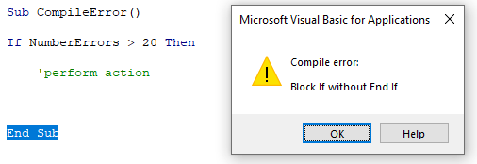

**Example 2**

In this example, the VBA compile process has detected a syntax error, highlighted in red. VBA indicates that the code below is missing a closing bracket on the function.

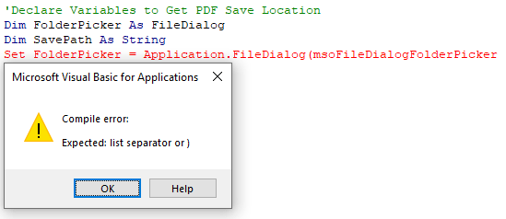

**Example 3**

Compile errors are common when using Option Explicit and occur when a variable has not been explicitly defined. With Option Explicit activated, a Dim statement is required to declare all variables before they can be used in your code.

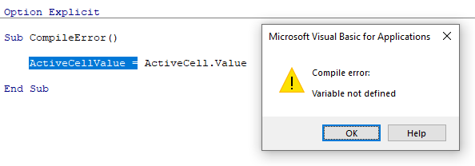

4. What are hot keys in VBA? How can you create your own hot keys?

### Creating a keyboard shortcut by customizing the Quick Access Toolbar

* To customize the Quick Access Toolbar and create keyboard shortcuts:
* Click the File tab in the Ribbon and then click on Options.
* Click the Quick Access Toolbar category on the left.
* From the drop-down menu under Choose commands from, select All Commands.
* Click the button you want to add.
* Click Add.
* Continue adding buttons.
* If you want to re-order buttons, click the button in the Customize Quick Access toolbar pane on the right and click the Move Up or Move Down arrow buttons.
* Click Close.
* Commands appear in the Excel Options dialog box:
* [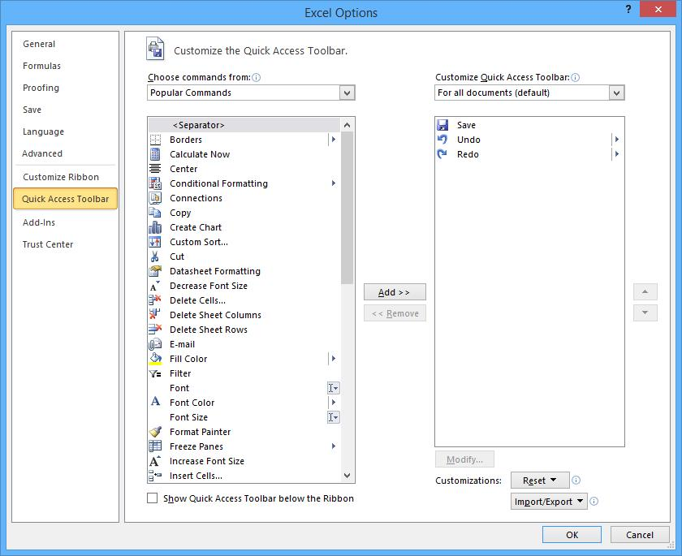](https://www.avantixlearning.ca/wp-content/uploads/2015/04/ExcelCutomizeQuickAccessToolbar.jpg)
* Once you have added the desired buttons, Excel assigns keyboard shortcuts automatically to the buttons based on the order in the Quick Access Toolbar. For example, the first button can be accessed by pressing Alt and then 1, the second button by pressing Alt and then 2 and so on.

### Creating a macro with a keyboard shortcut using the Macro Recorder

* You can also add a keyboard shortcut by recording a macro. In Excel, you can record a macro to automate specific actions and you can assign a keyboard shortcut to the macro. To keep things simple, we'll use the Record Macro button on the View tab in the Ribbon.
* You'll be using the Record Macro dialog (below) to create keyboard shortcuts:
* [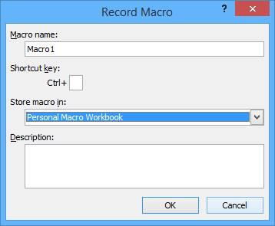](https://www.avantixlearning.ca/wp-content/uploads/2015/04/MacroRecordMacroDialogBox.jpg)
* To create a macro and assign a keyboard shortcut:
* Open the file you want to use or create a new workbook.
* Click the View tab in the Ribbon.
* Click Macros and select Record Macro. A dialog box appears.
* Under Macro Name, name the macro (no more than 255 characters and do not include spaces or begin with a number or an underscore).
* Under Shortcut key, enter a keyboard shortcut. For example, type Shift + H (this would assign Control + Shift + H as the shortcut). By adding Shift, you are less likely to create the same shortcut as a built-in Excel shortcut.
* Under Store macro in, choose This Workbook, New Workbook or Personal Macro Workbook. For global shortcuts, save the macro in the Personal Macro Workbook which is launched on startup and is hidden by default. If you store a macro in another workbook, it will need to be open to run the macro.
* Under Description, you can enter a description.
* Click OK.
* Perform the actions you want to record. For example, click Paste on the Home tab, choose Paste Special and then click on Values in the dialog box. All of your actions are being recorded.
* Click the View tab, click on Macros and then select Stop Recording.
* Try pressing the keyboard shortcut combination that you assigned to run the macro.
* When you use the Macro Recorder, Excel writes the code for the macro using VBA (Visual Basic for Applications). If a macro you created in the Personal Macro Workbook doesn't work as expected, you will probably want to delete it.
* To delete a macro that is stored in the Personal Macro Workbook, you will need to unhide the workbook first. To unhide the Personal Macro Workbook, click Unhide on the View tab, click Personal and click OK. To delete a macro, click Macros on the View tab and choose View Macros. Click on the macro you want to delete and click Delete. Be sure to hide the Personal Macro Workbook again using Hide on the View tab.
* If you have displayed the Developer tab in the Ribbon, Record Macro as well as other useful buttons appear in this tab as well.

6. What are the shortcut keys used to

a. Run the code- **Ctrl + Alt + N**

b. Step into the code- **Shift+F8**

c. Step out of code- Shift+F11

d. Reset the code- **Alt + F4**