1. What are the various elements of the Excel interface? Describe how

they're used.

* The following are the basic parts of the Microsoft Excel Window:
* Quick Access Toolbar
* File Tab
* Title Bar
* Control Buttons
* Menu Bar
* Ribbon/Toolbar
* Dialog Box Launcher
* Name Box
* Formula Bar
* Scroll Bars
* Spreadsheet Area
* Leaf Bar
* Column Bar
* Row Bar Cells
* Cells
* Status Bar
* View Buttons
* Zoom control

2. Write down the various applications of Excel in the industry.

**The main uses of Excel include:**

* Data entry.
* Data management.
* Accounting.
* Financial analysis.
* Charting and graphing.
* Programming.
* Time management.
* Task management.

3. On the ribbon, make a new tab. Add some different groups, insert

commands in the groups and name them according to their commands

added. Copy and paste the screenshot of the steps you followed.

Rename ribbon tabs, groups and commands

In addition to giving your own names to custom tabs and groups that you create, Excel allows you to rename the built-in tabs and groups. However, you cannot change names of the inbuilt commands, only commands added to custom groups can be renamed.

To rename a tab, group or custom command, carry out these steps:

* On the right side of the *Customize the Ribbon*window, click on the item you want to rename.
* Click the **Rename** button below the list if tabs.
* In the *Display name* box, type the name you want, and click *OK*.
* Click *OK* to close the *Excel Options* window and view your changes.

For **groups** and **commands**, you can also select an icon from the Symbol box, like shown in the screenshot below:

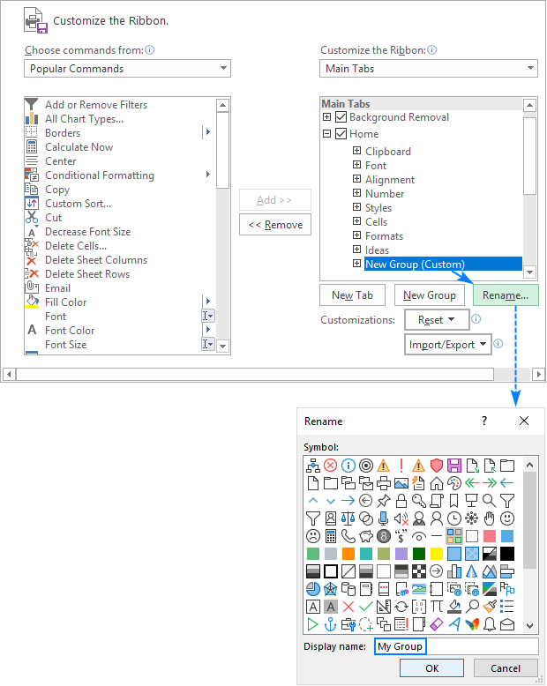

**Note.** You can change the name of any custom and build-in tab, except the *File* tab that cannot be renamed.

Move tabs, groups and commands on the ribbon

To know exactly where everything is located on your Excel ribbon, you can put tabs and groups in the most convenient places. However, the build-in commands cannot be moved, you can only change order of commands in custom groups.

To rearrange items on the ribbon, this is what you need to do:

* In the list under *Customize the Ribbon*, click on the tab, group, or command in a custom group that you wish to move.
* Click the Up or Down arrow to move the selected item left or right on the ribbon, respectively.
* When the desired order is set, click *OK* to save the changes.

The screenshot below shows how to move a custom tab to the left end of the

ribbon.

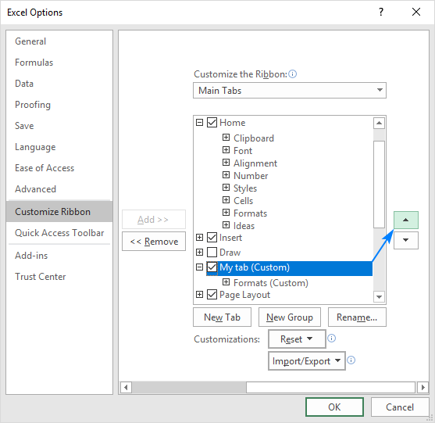

**Note.** You can change the placement of any build-in tab such as *Home*, *Insert*, *Formulas*, *Data*, and others, except the *File* tab that cannot be moved.

Remove groups, custom tabs and commands

While you can remove both default and custom groups, only custom tabs and custom commands can be removed. The build-in tabs can be [hidden](https://www.ablebits.com/office-addins-blog/customize-ribbon-excel/#hide-and-show-tabs); built-in commands can nether be removed nor hidden.

To remove a group, a custom tab or command, do the following:

* In the list under *Customize the Ribbon*, select the item to be removed.
* Click the **Remove** button.
* Click *OK*to save the changes.

For example, this is how we remove a custom command from the ribbon:

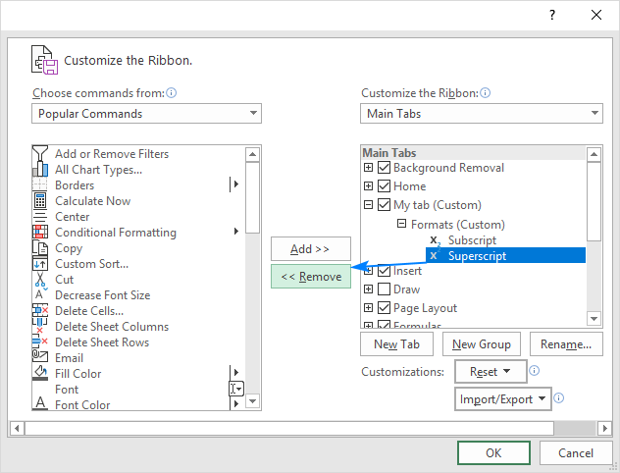

**Tip.** It is not possible to remove a command from a built-in group. However, you can make a custom group with the commands you need, and then remove the entire built-in group.

4. Make a list of different shortcut keys that are only connected to

formatting with their functions.

Ctrl + R: Aligns the line or selected text to the right of the screen. Ctrl + M: Indent the paragraph. Ctrl + Shift + F: Change the font. Ctrl + Shift + >: Increase selected font +1pts up to 12pt and then increases font +2pts,

5.What distinguishes Excel from other analytical tools?

he excel spreadsheet displays financial information in an organized manner. The information could be related to the sales, management department, HR or the marketing. Most of the businesses are dependent on IT sector and therefore excel is a vital tool to run a business. Read on to learn about the topmost features of this software.

* It builds the charts
* It makes use of conditional formatting
* It helps to organize the data
* It will identify trends
* It provides online access

Excel will use range of formulas to unlock the potential of data. You have to insert data in individual cells of columns and rows. In this way, data will be filtered and sorted and hence displayed in a presentable manner. Different types of charts like clustered columns, graphs and pie chart provide great visual presentation. It puts more emphasis to marketing material and business reports. Excel is a wonderful tool to represent data on X and Y axis.

**Why not other applications?**

The worst thing about expensive applications is they do not deliver results at times. If you are a startup or a small business owner you might find it difficult to manage this software. In case you are stuck using the modified PDF converter, clear instructions are mentioned on the tab. Hence, even if you are not well versed in the technology, you can still use this application.

6.Create a table and add a custom header and footer to your table.

* Go to **Insert** > **Header** or **Footer**.
* Choose the header style you want to use.
* **Tip:**Some built-in header and footer designs include page numbers.
* Add or change text for the header or footer. For more info on things you can do with headers, see [Edit your existing headers and footers](https://support.microsoft.com/en-us/office/edit-your-existing-headers-and-footers-490423a3-3e5b-4080-aff0-c429ab5d6708). To edit a header or footer that's been already created, double-click on it.
* To eliminate a header--like deleting it on the title page--select it and then check the **Different First Page** box.
* Select **Close Header and Footer** or press Esc to exit.

To delete, select **Insert**> **Header** (or **Footer**) > **Remove Header** (or **Remove Footer**).