1.What is a Macro? How is it useful in excel or in your daily work?

A macro is a set of instructions used to execute repetitive tasks. You can record a set of commands and then play them back with one or two keystrokes.

That means that you can save A LOT of time when doing routine and repetitive tasks.

2. What is VBA? Write its full form and briefly explain why VBA is used in

excel?

Visual Basic for Applications is a computer programming language developed and owned by Microsoft. With VBA you can create macros to automate repetitive word- and data-processing functions, and generate custom forms, graphs, and reports. VBA functions within MS Office applications; it is not a stand-alone product.

3. How do you record a macro? Write detailed steps to create a macro to

automatically make the following table in bold and to create borders for

it in excel.

Let’s record a very simple macro – one that selects a cell and enters the text ‘Excel’ in it. I am using the text ‘Excel’ while recording this macro, but feel free to enter your name or any other text that you like.

Here are the steps to record this macro:

* Click the Developer tab.
* In the Code group, click on the Macro button. This will open the ‘Record Macro’ dialog box.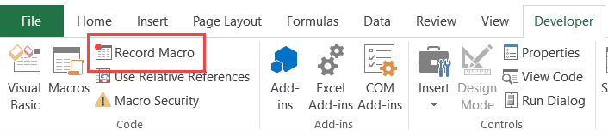
* In the Record Macro dialog box, enter a name for your macro. I am using the name **Enter Text**. There are some naming conditions that you need to follow when naming a macro. For example, you can not use spaces in between. I usually prefer to keep my macro names as a single word, with different parts with a capitalized first alphabet. You can also use underscore to separate two words – such as Enter_Text.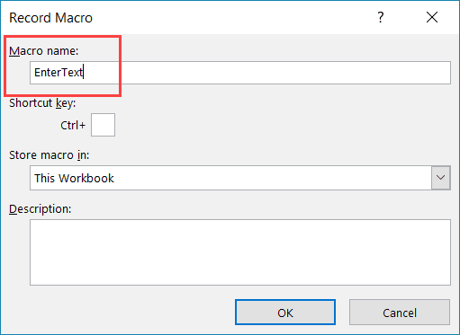
* (Optional Step) You can assign a keyboard shortcut if you want. In this case, we will use the shortcut Control + Shift + N. Remember that the shortcut you assign here would override any existing shortcuts in your workbook. For example, if you assign the shortcut Control + S, you will not be able to use this for saving the workbook (instead, every time you use it, it will execute the macro).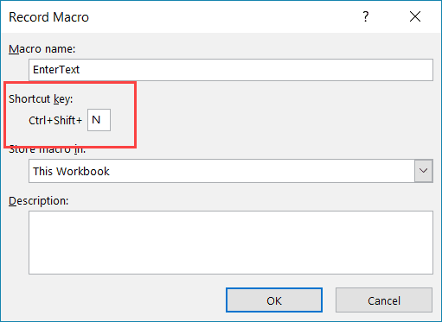
* In the ‘Store macro in’ option, make sure ‘This Workbook’ is selected. This step ensures that the macro is a part of the workbook. It will be there when you save it and reopen again, or even if you share it with someone.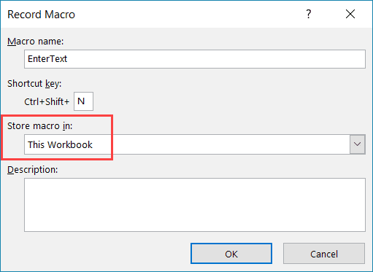
* (Optional Step) Enter a description. I usually don’t do this, but if you’re extremely organized, you may want to add what the macro is about.
* Click OK. As soon as you click OK, it starts to record your actions in Excel. You can see the ‘Stop recording’ button in the Developer tab, which indicates that the macro recording is in progress.
* Select cell A2.
* Enter the text **Excel**(or you can use your name).
* Hit the Enter key. This will select cell A3.
* Click on the Stop Recording button the Developer tab.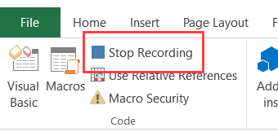
* Congratulations!
* You have just recorded your first macro in Excel. You’re no longer a macro virgin.
* While the macro doesn’t do anything useful, it’ll serve its purpose in explaining how a macro recorder works in Excel.
* Now let’s go ahead and test this macro.
* Follow the steps below to test the macro:
* Delete the text in cell A2. This is to test if the macro inserts the text in cell A2 or not.
* Select any cell – other than A2. This is to test whether the macro selects cell A2 or not.
* Click the Developer tab.
* In the Code group, click the Macros button.
* In the Macro dialog box, click on the macro Name – Enter Text.
* Click the Run button.

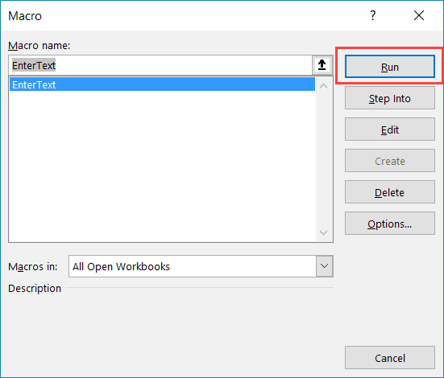

You will notice that as soon as you click the Run button, the text ‘Excel’ gets inserted into cell A2 and cell A3 gets selected.

Now, this may all happen in a split second, but in reality, the macro  – just like an obedient elf – followed the exact steps you showed it while recording the macro.

So the macro first selects the cell A2, then enters the text **Excel** in it, and then selects the cell A3.

4. What do you mean when we say VBA Editor?

Microsoft Visual Basic for Applications (VBA) enables non-programmers to record, create, and edit macros that can automate tasks in Office applications.

5. Briefly describe the interface of a VBA editor? What is properties

window? And what is watch window? How do you display these

windows?

The Properties window lists the [design-time](https://learn.microsoft.com/en-us/office/vba/language/glossary/vbe-glossary#design-time) [properties](https://learn.microsoft.com/en-us/office/vba/language/glossary/vbe-glossary#property) for selected objects and their current settings. You can change these properties at design time. When you select multiple controls, the Properties window contains a list of the properties common to all the selected controls.

**To navigate the Properties window**

* From the **View** menu of the Visual Basic Editor, choose Properties window (F4).
* Select the object whose properties you want to display. You can either use the mouse to select the object or use the **Project Explorer** to choose from a list.
* Click the **Alphabetic** tab to display properties in alphabetic order, or choose the **Categorized** tab to display object properties by category.
* **To change a property's value**
* Select the property in the left column.
* Change the property's value in the right column

6.What is an immediate Window and what is it used for?

The Immediate window displays information resulting from debugging statements in your code or from commands typed directly into the window. From the View menu, choose Immediate window (CTRL+G)