**Tasks:**

(a) Answer to questions

1. At 5V at terminal A the voltage at terminal B is **0V**. The LED **doesn’t glow**.
2. At 0V at terminal A the voltage at terminal B is **1.95V**. The LED **glows**.
3. When the **input goes from high voltage to low voltage** (output goes from low voltage to high voltage) the propagation delay is **3.8 microseconds**.

Similarly, when the input goes from low voltage to high voltage (the output goes from high voltage to low voltage) the propagation delay is **2.4 microseconds**.

1. When the **input goes from high voltage to low voltage** (output goes from low voltage to high voltage) the propagation delay is **2.540 microseconds**.

Similarly, when the input goes from low voltage to high voltage (the output goes from high voltage to low voltage) the propagation delay is **3.060 microseconds**.

1. By increasing frequency the parasitic capacitance increases due to not having proper time to charge and discharge therefore distorting the output and increasing the propagation delay.

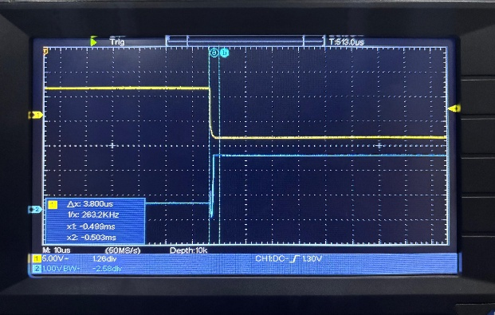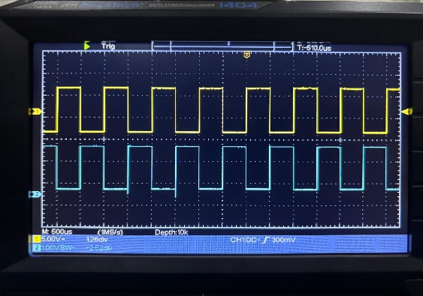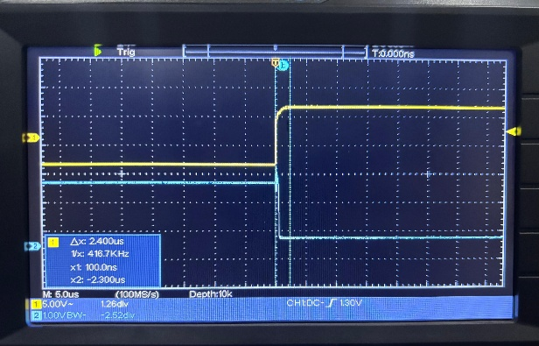(b) Input-output waveform with propagation delay.

(a) (b) (c)

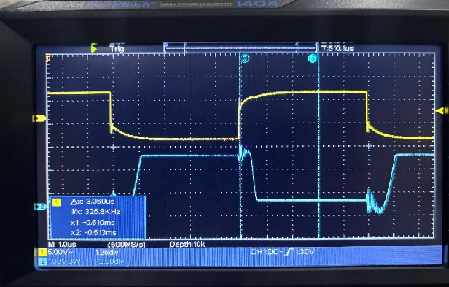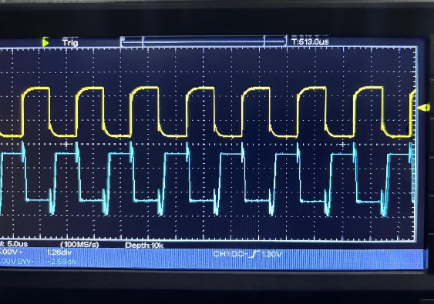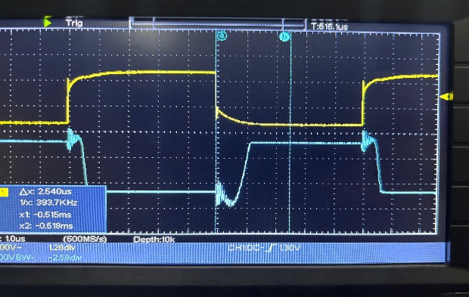Fig 1. Waveforms at 1 KHz (a) Input-Output Waveform (b) Propagation delay when input goes from low to high (c) Propagation delay when input goes from high to low

(a) (b) (c)

Fig 2. Waveforms at 100 KHz (a) Input-Output Waveform (b) Propagation delay when input goes from low to high (c) Propagation delay when input goes from high to low

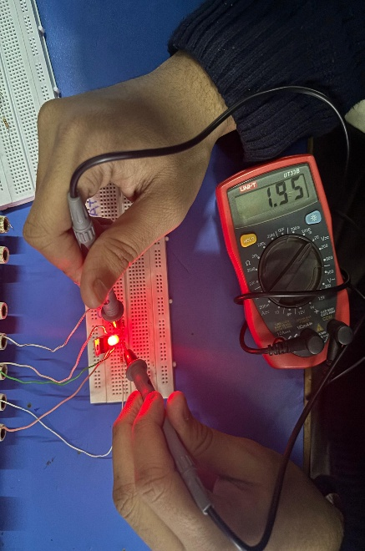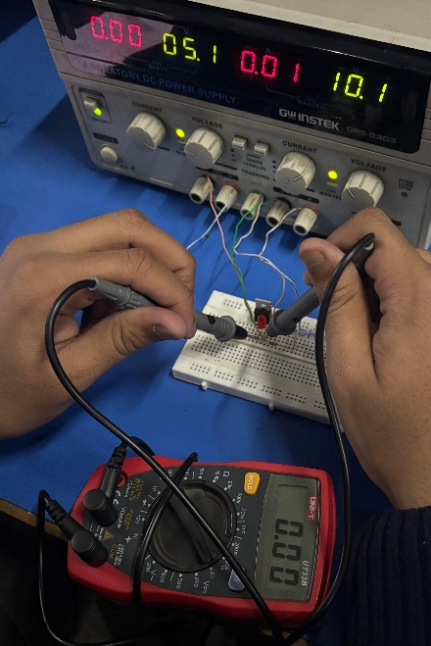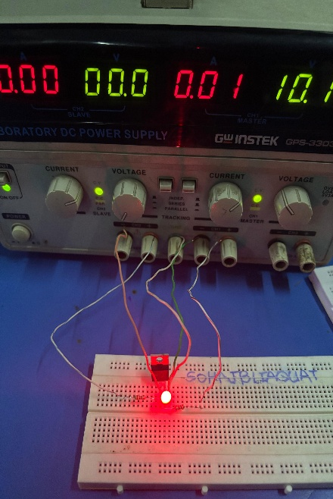**Appendix:**

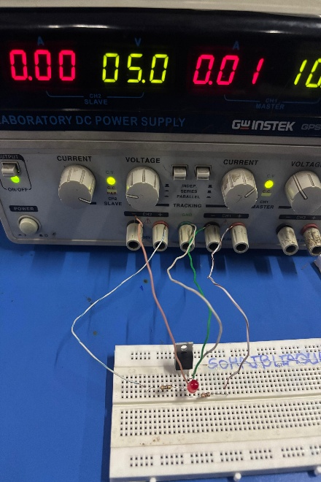

Fig 3. Task a and b; Testing LED at 0V and 5V at terminal A

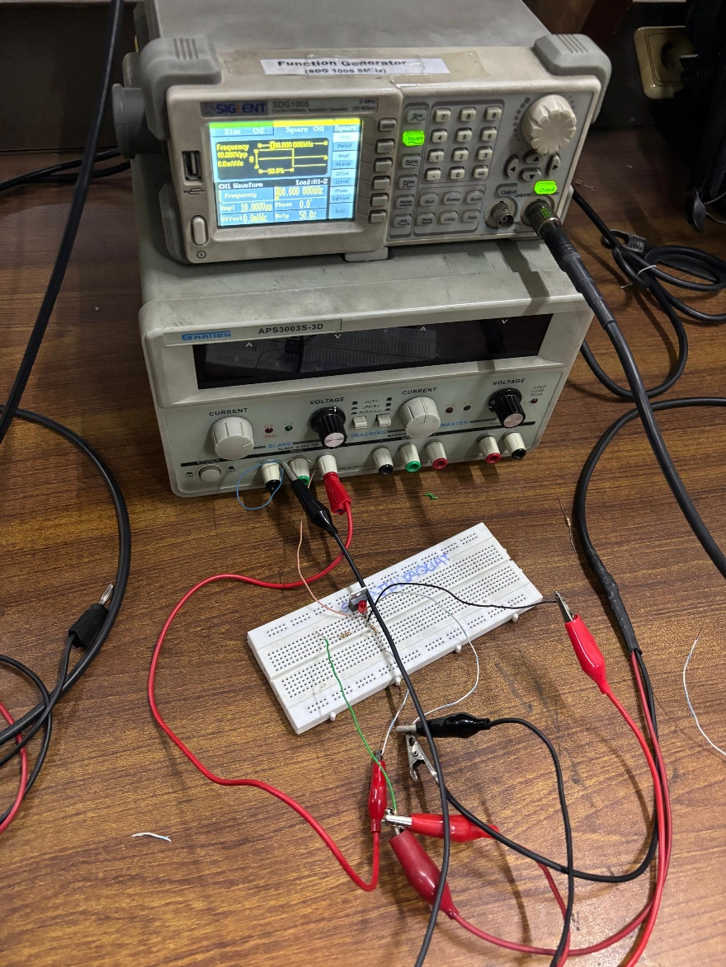

Fig 4. Task c; Circuit for input-output waveform