|  |  |
| --- | --- |
| Name: Sohaib Liaquat | EE-272L Digital Systems Design |
| Reg. No.: 2023-EE-061 | Marks Obtained: ____________ |

**Lab Manual 3**

|  |  |  |  |  |  |
| --- | --- | --- | --- | --- | --- |
| **DSD Lab Manual Evaluation Rubrics** | | | | | |
|  |  |  |  |  |  |
| **Assessment** | **Total Marks** | **Marks Obtained** | **0-30%** | **30-60%** | **70-100%** |
| Code Organization (CLO1) | 3 |  | No Proper Indentation and descriptive naming, no code organization.  Zero to Some understanding but not working | Proper Indentation or descriptive naming or code organization.  Mild to Complete understanding but not working | Proper Indentation and descriptive naming, code organization.  Complete understanding, and proper working |
| Simulation (CLO2) | 5 |  | Simulation not done or incorrect, without any understanding of waveforms | Working simulation with errors, don't cares's(x) and high impedance(z), partial understanding of waveforms | Working simulation without any errors, etc and complete understanding of waveforms |
| FPGA (CLO2) | 2 |  | Not implemented on FPGA and questions related to synthesis and implementation not answered. | Correctly Implemented on FPGA or questions related to synthesis and implementation answered. | Correctly Implemented on FPGA and questions related to synthesis and implementation answered. |

**Tasks:**

(a) Truth table of circuit:

Table 1. Expanded truth table of the circuit

|  |  |  |  |  |  |  |  |  |
| --- | --- | --- | --- | --- | --- | --- | --- | --- |
| Input | Input | Input | NOT | OR 1,2 | NAND | XOR 1 (Output) | XOR 2 | AND (Output) |
| $$a$$ | $$b$$ | $$c$$ | $$\overline{c}$$ | $$a+b$$ | $$\overline{a.b}$$ | $$x=\overline{c}⊕(a+b)$$ | ( $\overline{a.b})⊕(a+b)$ | $$y=(a+b).((\overline{a.b})⊕\left(a+b\right))$$ |
| 0 | 0 | 0 | 1 | 0 | 1 | 1 | 1 | 0 |
| 0 | 0 | 1 | 0 | 0 | 1 | 0 | 1 | 0 |
| 0 | 1 | 0 | 1 | 1 | 1 | 0 | 0 | 0 |
| 0 | 1 | 1 | 0 | 1 | 1 | 1 | 0 | 0 |
| 1 | 0 | 0 | 1 | 1 | 1 | 0 | 0 | 0 |
| 1 | 0 | 1 | 0 | 1 | 1 | 1 | 0 | 0 |
| 1 | 1 | 0 | 1 | 1 | 0 | 0 | 1 | 1 |
| 1 | 1 | 1 | 0 | 1 | 0 | 1 | 1 | 1 |

Table 2. Truth table of the circuit

|  |  |  |  |  |
| --- | --- | --- | --- | --- |
| $$a$$ | $$b$$ | $$c$$ | $$x$$ | $$y$$ |
| 0 | 0 | 0 | 1 | 0 |
| 0 | 0 | 1 | 0 | 0 |
| 0 | 1 | 0 | 0 | 0 |
| 0 | 1 | 1 | 1 | 0 |
| 1 | 0 | 0 | 0 | 0 |
| 1 | 0 | 1 | 1 | 0 |
| 1 | 1 | 0 | 0 | 1 |
| 1 | 1 | 1 | 1 | 1 |

(b) Maximum combinational delay in Synthesis:

Path 1 from ‘a’ to ‘y’ has the maximum delay i.e. **6.850 ns**.

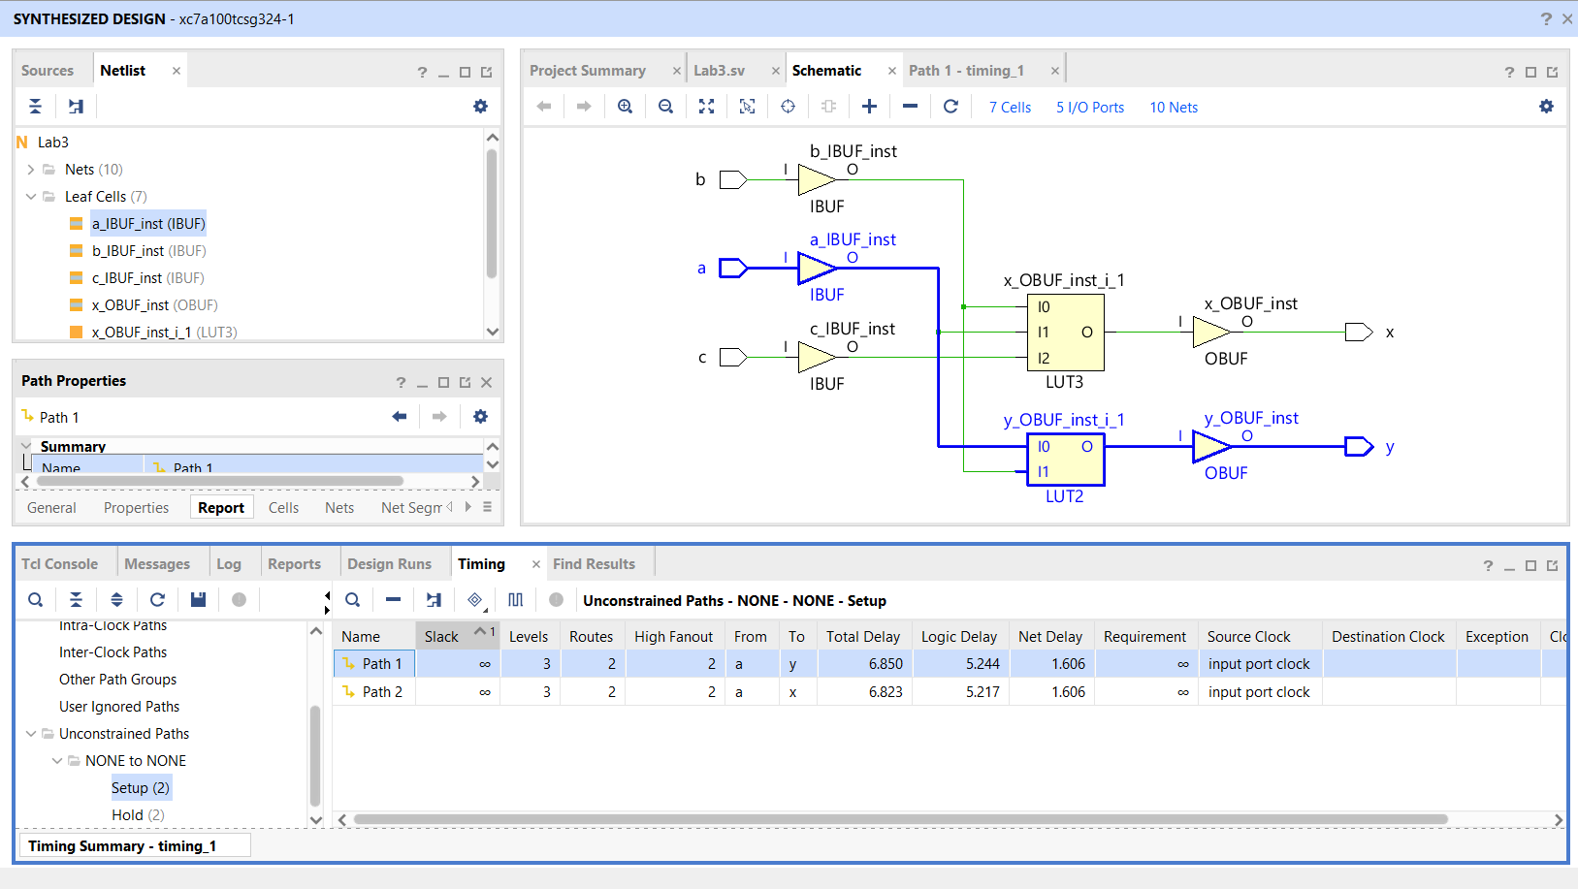

Fig 1. Maximum combinational delay in synthesis

(c) Resource Utilization:

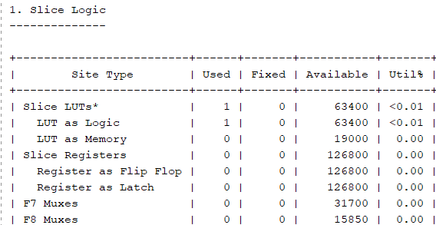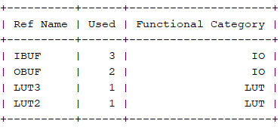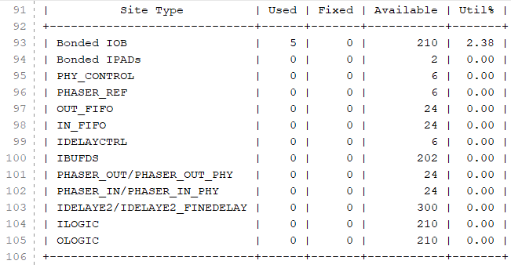

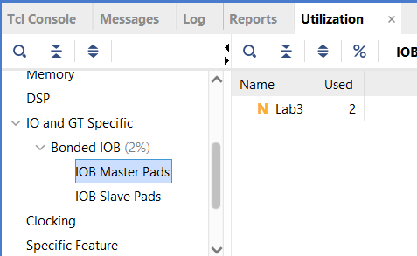

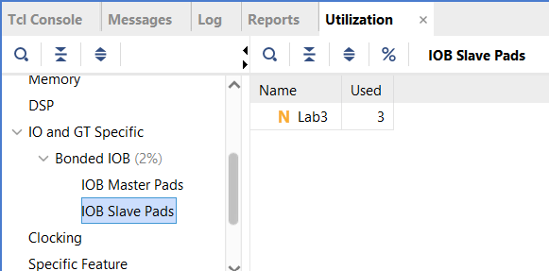

Fig 2. Resource utilization. Look up tables, input, and output ports

**APPENDIX**

* System Verilog Code:

module Lab3(

    input  logic a,

    input  logic b,

    input  logic c,

    output logic x,

    output logic y

    );

    //-----Local Signals-----//

    logic not_out;

    logic or_1_out;

    logic nand_out;

    logic or_2_out;

    logic xor_out;

    //-----Circuit Description-----//

    assign not_out = ~c;

    assign or_1_out = a | b;

    assign nand_out = ~(a & b);

    assign or_2_out = a | b;

    assign xor_out = nand_out ^ or_2_out;

    //-----Output Signals-----//

    assign x = not_out ^ or_1_out;

    assign y = or_1_out & xor_out;

endmodule

* Constraint file Code:

# Outputs (LEDs)

set_property -dict { PACKAGE_PIN V12 IOSTANDARD LVCMOS33 } [get_ports { y }]; #IO_L20N_T3_A07_D23_14 Sch=led[14]

set_property -dict { PACKAGE_PIN V11 IOSTANDARD LVCMOS33 } [get_ports { x }]; #IO_L21N_T3_DQS_A06_D22_14 Sch=led[15]

# Inputs (Switches)

set_property -dict { PACKAGE_PIN V10 IOSTANDARD LVCMOS33 } [get_ports { a }]; #IO_L21P_T3_DQS_14 Sch=sw[15]

set_property -dict { PACKAGE_PIN U11 IOSTANDARD LVCMOS33 } [get_ports { b }]; #IO_L19N_T3_A09_D25_VREF_14 Sch=sw[14]

set_property -dict { PACKAGE_PIN U12 IOSTANDARD LVCMOS33 } [get_ports { c }]; #IO_L20P_T3_A08_D24_14 Sch=sw[13]

* 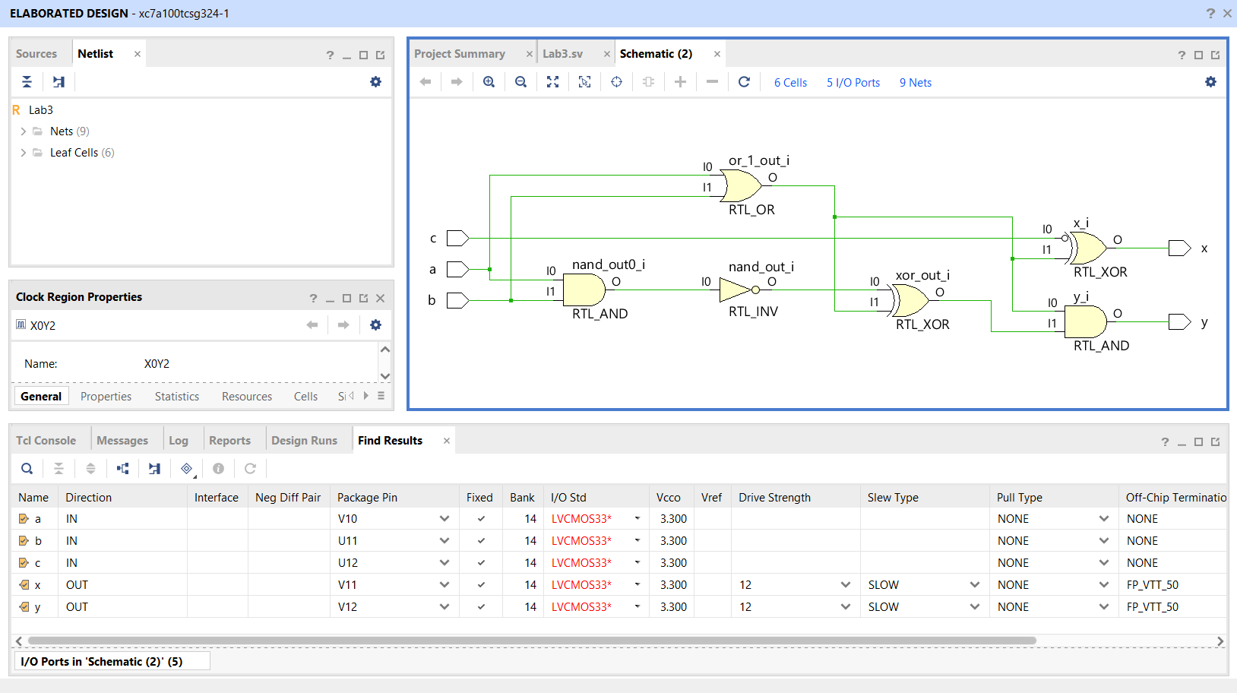RTL schematic:

Fig 3. RTL Schematic for the given circuit.