**Kinrtic energy01:**

using System;

using System.Collections.Generic;

using System.Linq;

using System.Text;

using System.Threading.Tasks;

namespace ConsoleApp2

{

class Program

{

static void Main(string[] args)

{

Console.WriteLine("KINETIC ENERGY CALCULATION");

Console.WriteLine("Enter Velocity:");

double v = Convert.ToInt32(Console.ReadLine());

Console.WriteLine("Enter Mass:");

int m = Convert.ToInt32(Console.ReadLine());

double KE = (m * v * v) / 2;

Console.WriteLine("The Kinetic energy is:");

Console.WriteLine(KE);

Console.ReadLine();

}

}

}

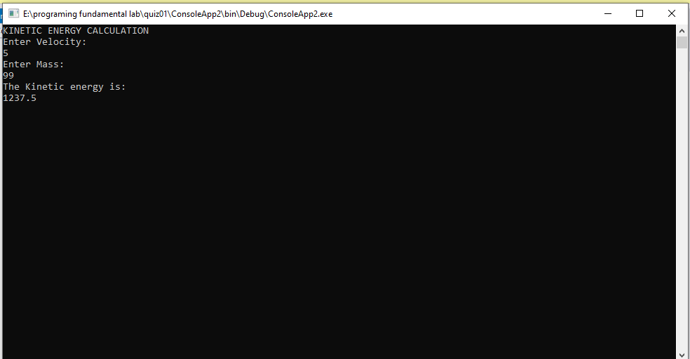

**Distance 02**

using System;

using System.Collections.Generic;

using System.Linq;

using System.Text;

using System.Threading.Tasks;

namespace ConsoleApp2

{

class Program

{

static void Main(string[] args)

{

Console.WriteLine("AVERAGE VELOCITY CALCULATION");

Console.WriteLine("Enter Initial Velocity:");

int Vi = Convert.ToInt32(Console.ReadLine());

Console.WriteLine("Enter Acceleration:");

int a = Convert.ToInt32(Console.ReadLine());

Console.WriteLine("Enter Time:");

int t = Convert.ToInt32(Console.ReadLine());

int d = (Vi * t) + ((a) * (t * t)) / 2;

Console.WriteLine("The distance is :");

Console.WriteLine(d+“m”);

Console.ReadLine();

}

}

}

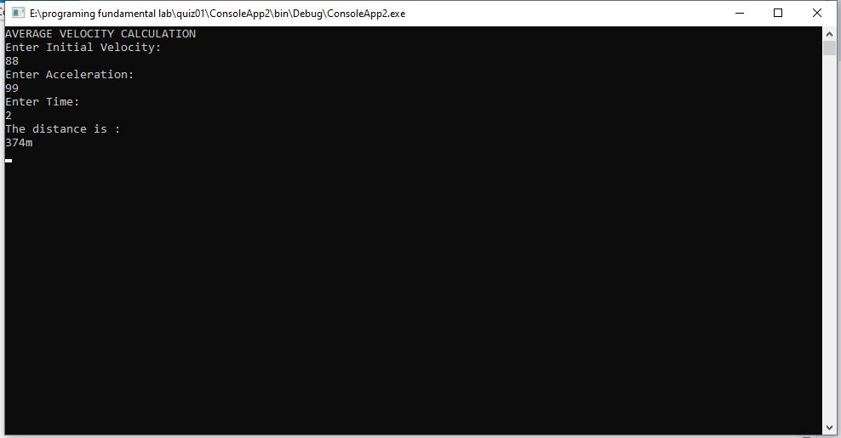

**Average velocity03:**

using System;

using System.Collections.Generic;

using System.Linq;

using System.Text;

using System.Threading.Tasks;

namespace ConsoleApp2

{

class Program

{

static void Main(string[] args)

{

Console.WriteLine("Enter Initial Velocity:");

int Vi = Convert.ToInt32(Console.ReadLine());

Console.WriteLine("Enter Final Velocity:");

int Vf = Convert.ToInt32(Console.ReadLine());

int Avg_V = (Vi + Vf) / 2;

Console.WriteLine("The Average velocity is :");

Console.WriteLine(Avg_V);

Console.ReadLine();

}

}

}

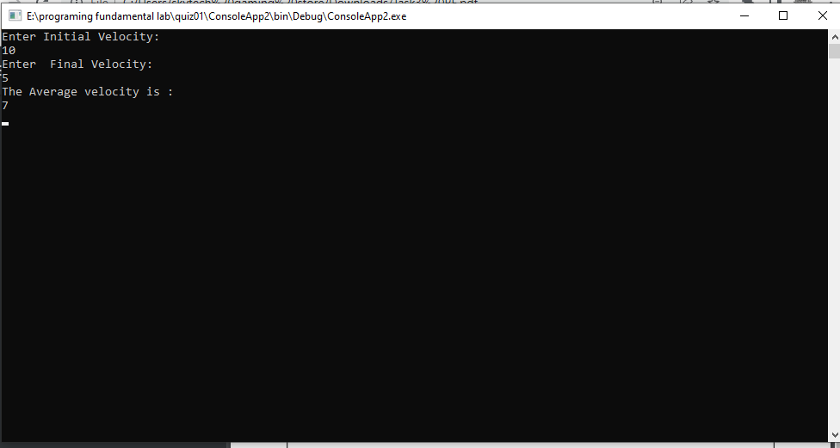

Mass problem 04:

using System;

using System.Collections.Generic;

using System.Linq;

using System.Text;

using System.Threading.Tasks;

namespace ConsoleApp2

{

class Program

{

static void Main(string[] args)

{

Console.WriteLine("Enter value of m1:");

int m1 = Convert.ToInt32(Console.ReadLine());

Console.WriteLine("Enter value of m2:");

int m2 = Convert.ToInt32(Console.ReadLine());

int Rm = (m1 * m2) / (m1 + m2);

Console.WriteLine("The Valuse of reduced mass is:");

Console.WriteLine(Rm);

Console.ReadLine();

}

}

}

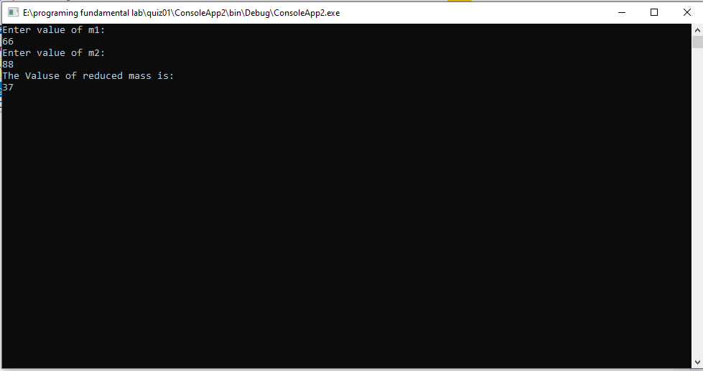

Farenhiet 05:

using System;

using System.Collections.Generic;

using System.Linq;

using System.Text;

using System.Threading.Tasks;

namespace ConsoleApp2

{

class Program

{

static void Main(string[] args)

{

Console.WriteLine("Enter Farenhiet: ");

double Fahrenheit = Convert.ToInt32(Console.ReadLine());

double Celsius = (Fahrenheit - 32) * 5 / 9;

Console.WriteLine("The value of Temperature in Celsius :");

Console.WriteLine(Celsius+"C");

Console.ReadLine();

}

}

}

