A PROJECT REPORT ON
BRAIN TUMOR DETECTION AND CLASSIFICATION SYSTEM USING DEEP CONVOLUTIONAL NEURAL NETWORKS AND GRAD-CAM VISUALIZATION
Submitted in partial fulfillment of the requirements for the degree of
BACHELOR OF TECHNOLOGY
in
Department of Computer Engineering / IT
Submitted By:
Soham Thummar [Enrollment No: [FILL_ENROLLMENT_NO]]
Under the Guidance of:
Prof. [FILL GUIDE NAME]
Department of Computer Engineering / IT
[FILL COLLEGE / INSTITUTE NAME]
[FILL UNIVERSITY NAME]
Academic Year: 2025–2026

BRAIN TUMOR DETECTION MODEL USING KERAS & FLASK DEPLOYMENT
7th Semester B.Tech Project Report
Project Title: BRAIN TUMOR DETECTION AND CLASSIFICATION SYSTEM USING DEEP CONVOLUTIONAL NEURAL NETWORKS AND GRAD-CAM VISUALIZATION
Author / Candidate Name: Soham Thummar
Enrollment Number: [FILL_ENROLLMENT_NO]
Branch / Department: Department of Computer Engineering / IT
Internal Guide: Prof. [FILL GUIDE NAME]
Institution: [FILL COLLEGE / INSTITUTE NAME]
Date of Submission: [FILL SUBMISSION DATE, e.g. May 2026]

CANDIDATE'S DECLARATION
I hereby declare that the project work entitled "BRAIN TUMOR DETECTION MODEL USING KERAS & FLASK DEPLOYMENT" submitted to the Department of Computer Engineering / IT, [FILL COLLEGE / INSTITUTE NAME], is a record of original work done by me under the guidance of Prof. [FILL GUIDE NAME]. This report has not been submitted elsewhere for the award of any degree, diploma, or title.
I further declare that all source codes, deep learning architectures, web application modules, and experimental results presented in this report are authentic and developed specifically for this project.
Date: [FILL DATE]
Place: [FILL CITY]
_______________________
Soham Thummar
(Enrollment No: [FILL_ENROLLMENT_NO])

CERTIFICATE
This is to certify that the project report entitled "BRAIN TUMOR DETECTION MODEL USING KERAS & FLASK DEPLOYMENT" submitted by Soham Thummar (Enrollment No: [FILL_ENROLLMENT_NO]) has been successfully completed under my supervision in partial fulfillment of the requirements for the degree of Bachelor of Technology in Department of Computer Engineering / IT from [FILL UNIVERSITY NAME] during the academic year 2025–2026.
_______________________ _______________________
Prof. [FILL GUIDE NAME] Head of Department
(Project Guide) (Department of Computer Engineering / IT)
_______________________
External Examiner

ACKNOWLEDGEMENT
I express my deepest sense of gratitude and sincere thanks to my project guide, Prof. [FILL GUIDE NAME], for invaluable guidance, encouragement, and insightful suggestions throughout the development of this project. His/Her technical expertise and continuous mentorship were instrumental in shaping the methodology and successful execution of the model and web application.
I am also thankful to the Head of Department, Prof. [FILL HOD NAME], and all faculty members of the Department of Computer Engineering / IT for providing the required computational infrastructure, software tools, and academic environment.
Finally, I express my sincere appreciation to my family and friends for their constant moral support, patience, and encouragement during the course of this major project.

ABSTRACT
Brain tumors represent one of the most critical and life-threatening neurological conditions. Early detection and precise localization of brain neoplasms from Magnetic Resonance Imaging (MRI) scans are vital for effective surgical planning and treatment outcomes. Manual evaluation of brain MRI slices by radiologists is time-consuming and subject to inter-observer variability. In this work, an end-to-end automated computer-aided diagnosis system is developed using custom Deep Convolutional Neural Networks (CNN) implemented in TensorFlow/Keras, integrated with a clinical-ready Python Flask web interface.
The proposed deep CNN model consists of four sequential convolutional blocks with ReLU activations, max-pooling, dropout regularization, and a sigmoid classification head optimized via binary crossentropy loss. To eliminate false-negative diagnosis in screening scenarios, class-weighted training and decision threshold tuning (0.3 threshold) were employed. On a comprehensive test dataset of 666 MRI slices (458 tumor, 208 non-tumor), the model achieved 98% overall accuracy, 100% tumor recall (zero missed tumor cases), and an Area Under ROC Curve (AUC) of 1.000.
To make the model interpretable and accessible for clinical research, Gradient-weighted Class Activation Mapping (Grad-CAM) was integrated to dynamically highlight spatial heatmaps of tumor regions. The complete pipeline was deployed into a responsive Flask web application supporting drag-and-drop file uploads, real-time inference, and performance metric visualization.

NOTATIONS AND ABBREVIATIONS
Abbreviation | Full Description
CNN | Convolutional Neural Network
MRI | Magnetic Resonance Imaging
Grad-CAM | Gradient-weighted Class Activation Mapping
ROC | Receiver Operating Characteristic
AUC | Area Under Curve
ReLU | Rectified Linear Unit
API | Application Programming Interface
HTTP | Hypertext Transfer Protocol
UI/UX | User Interface / User Experience
FN | False Negative (Missed Diagnosis)
FP | False Positive (False Alarm)
TN | True Negative
TP | True Positive
PEP | Python Enhancement Proposal

LIST OF FIGURES
Figure 4.1: Data Flow Diagram (DFD) of Brain Tumor Classification Pipeline
Figure 4.2: High-Level System Class Architecture Diagram
Figure 5.1: Overall System Architecture of Flask Web App & Keras Model
Figure 5.2: Procedural Logic Flowchart for Image Upload and Inference
Figure 7.1: Training vs Validation Recall Curve across 30 Epochs
Figure 7.2: Training vs Validation Loss Curve showing Model Convergence
Figure 7.3: Test Dataset Confusion Matrix Heatmap (666 Samples)
Figure 7.4: Receiver Operating Characteristic (ROC) Curve (AUC = 1.000)
Figure 8.1: Web Interface Upload Homepage (Drag-and-Drop Dropzone)
Figure 8.2: Inference Result Page with Tumor Badge & Grad-CAM Heatmap
Figure 8.3: Model Metrics & Performance Dashboard Page
LIST OF TABLES
Table 2.1: Project Development Milestones and Execution Schedule
Table 2.2: Risk Assessment and Mitigation Strategy Matrix
Table 3.1: Hardware and Software System Specifications
Table 4.1: Dataset Distribution across Train, Validation, and Test Sets
Table 7.1: Black-Box Web Application and Inference Test Cases Matrix
TABLE OF CONTENTS
CANDIDATE'S DECLARATION .................................... iii
CERTIFICATE ................................................ iv
ACKNOWLEDGEMENT ............................................ v
ABSTRACT ................................................... vi
NOTATIONS AND ABBREVIATIONS ................................ vii
1.0 INTRODUCTION ........................................... 1
1.1 Project Summary .................................... 1
1.2 Purpose and Objectives ............................. 2
1.3 Project Scope and Limitations ...................... 3
1.4 Literature Review on CNN Medical Diagnosis ......... 4
2.0 PROJECT MANAGEMENT ..................................... 5
2.1 Development Approach ............................... 5
2.2 Project Schedule and Milestones .................... 6
2.3 Risk Identification and Mitigation Plan ............ 7
3.0 SYSTEM REQUIREMENTS STUDY .............................. 8
3.1 User Characteristics ............................... 8
3.2 Hardware Requirements .............................. 8
3.3 Software Requirements .............................. 9
3.4 Operational and Clinical Constraints ............... 9
4.0 SYSTEM ANALYSIS ........................................ 10
4.1 Analysis of Existing System ........................ 10
4.2 Proposed Automated CNN System ...................... 11
4.3 Feasibility Study .................................. 12
4.4 Data Modeling and Dictionary ....................... 13
4.5 Functional Modeling (Data Flow) .................... 14
5.0 SYSTEM DESIGN .......................................... 15
5.1 System Architecture Design ......................... 15
5.2 Data Design and Folder Hierarchy ................... 16
5.3 Procedural Logic Flow .............................. 17
5.4 Input/Output and Interface Design .................. 18
6.0 IMPLEMENTATION PLANNING ................................ 19
6.1 Development Environment Setup ...................... 19
6.2 Module Specifications .............................. 20
6.3 Security Features & Input Validation ............... 21
6.4 Core Implementation Code Snippet ................... 22
7.0 TESTING AND EVALUATION ................................. 23
7.1 Testing Strategy and Black-Box Methodology ......... 23
7.2 System Test Cases Matrix ........................... 24
7.3 Experimental Performance Analysis & Figures ........ 25
8.0 SCREENSHOTS AND USER MANUAL ............................ 28
8.1 Web Interface User Manual .......................... 28
8.2 System Application Screenshots ..................... 29
9.0 LIMITATIONS AND FUTURE ENHANCEMENTS .................... 31
9.1 System Limitations ................................. 31
9.2 Future Scope and Enhancements ...................... 32
10.0 CONCLUSION AND DISCUSSION ............................. 33
REFERENCES ................................................. 34
APPENDICES ................................................. 35

1.0 INTRODUCTION
1.1 PROJECT SUMMARY
Brain tumors are abnormal cellular growths inside the cranium that exert pressure on brain tissues, leading to severe neurological deficits, motor dysfunction, and life-threatening complications. In modern clinical oncology, Magnetic Resonance Imaging (MRI) serves as the gold standard non-invasive diagnostic modality for visualizing brain tissue structures. However, manual evaluation of multidimensional MRI slices requires expert neuroradiologists, whose availability is severely limited in low-resource medical facilities. Furthermore, qualitative visual inspection is susceptible to human fatigue and inter-observer diagnostic variation.
To mitigate these challenges, this project delivers an end-to-end computer-aided brain tumor detection and interpretability framework. Built upon a 4-stage custom Convolutional Neural Network (CNN) trained with TensorFlow/Keras and wrapped inside a responsive Python Flask web application, the system automates axial MRI scan preprocessing, binary tumor classification, and spatial tumor localization via Gradient-weighted Class Activation Mapping (Grad-CAM).
1.2 PURPOSE AND OBJECTIVES
The primary purpose of this project is to bridge deep learning research with clinical utility by creating an accessible, accurate, and explainable web diagnostic interface. The core objectives include:
• Develop a lightweight CNN architecture trained on preprocessed 224x224 RGB MRI scans.
• Prioritize high tumor recall (sensitivity) through class weighting to eliminate false negative predictions.
• Implement Grad-CAM heatmap overlay to explain deep feature representations visually.
• Build a production-ready Python Flask application adhering to strict input validation and web standards.
1.3 PROJECT SCOPE AND LIMITATIONS
The project scope encompasses dataset preprocessing, binary classification model training, evaluation graph generation, interpretability heatmaps, and Flask server deployment. The scope is strictly bounded as follows:
• Binary Classification Scope: The model discriminates between 'Tumor' and 'No Tumor' categories.
• Non-Clinical Scope: Designed for educational, academic, and decision-support research, not autonomous surgical decisions.
1.4 LITERATURE REVIEW
Recent advancements in deep convolutional networks have revolutionized computer-vision-based medical imaging. Traditional machine learning techniques relied heavily on hand-crafted features such as Haar wavelets, texture descriptors (GLCM), and support vector machines (SVM). In contrast, end-to-end CNNs automatically extract hierarchical spatial representations ranging from low-level edge features to complex anatomical boundaries.

2.0 PROJECT MANAGEMENT
2.1 DEVELOPMENT APPROACH
An Agile iterative development methodology was adopted for this project. Iterative sprints enabled continuous feedback loops across data curation, model selection, loss metric tuning, explainability implementation, and web front-end development.
2.2 PROJECT SCHEDULE AND MILESTONES
The project execution was structured into five distinct phases over a 16-week timeline as summarized in Table 2.1 below:
Phase | Milestone Task | Timeline | Deliverables
Phase 1 | Dataset Acquisition & Preprocessing | Weeks 1–3 | Split dataset (Train/Val/Test), normalized arrays
Phase 2 | CNN Model Architecture & Training | Weeks 4–7 | bestModel.keras, history metrics, loss curves
Phase 3 | Model Evaluation & Recall Tuning | Weeks 8–10 | Confusion matrix, ROC-AUC, 100% recall threshold
Phase 4 | Flask Web Application & Grad-CAM | Weeks 11–14 | app.py, model_utils.py, HTML/CSS UI
Phase 5 | Testing & Documentation | Weeks 15–16 | Project report, unit tests, GitHub repo
Table 2.1: Project Development Milestones and Execution Schedule
2.3 RISK IDENTIFICATION AND MITIGATION PLAN
Risk management specifically addressed dataset imbalance, model overfitting, missed tumor predictions (false negatives), and web upload vulnerabilities:
Identified Risk | Impact Level | Mitigation Strategy Implemented
False Negative Risk (Missed Cancer) | CRITICAL | Assigned 3x class weight to tumor class; set classification threshold to 0.3
Model Overfitting | HIGH | Added Dropout layers (0.25) and EarlyStopping monitored on val_recall
Invalid / Corrupted Web Uploads | MEDIUM | Server-side file extension, size limit (10MB), and try-except handling
Grad-CAM Layer Failure | LOW | Dynamic Conv2D layer inspection with graceful error fallback
Table 2.2: Risk Assessment and Mitigation Strategy Matrix

3.0 SYSTEM REQUIREMENTS STUDY
3.1 USER CHARACTERISTICS
The system is designed for medical researchers, computer science students, and biomedical developers. Users are expected to have basic familiarity with web interfaces and digital brain MRI scan file formats (PNG, JPG).
3.2 HARDWARE AND SOFTWARE REQUIREMENTS
Table 3.1 delineates the minimum and recommended hardware/software specifications for both model training and web hosting:
Component | Minimum Requirement | Recommended Specification
Processor (CPU) | Dual-Core 2.0 GHz Intel/AMD | Quad-Core 3.0 GHz Intel i7 / AMD Ryzen
System Memory (RAM) | 8 GB DDR4 | 16 GB DDR4 / DDR5
GPU Acceleration | CPU execution supported | NVIDIA RTX 3060 (CUDA / cuDNN)
Disk Storage | 2 GB free space | 10 GB NVMe SSD
Operating System | Windows 10/11, Ubuntu 20.04, macOS | Windows 11 / Linux Ubuntu 22.04 LTS
Python Environment | Python 3.9+ | Python 3.11.x Virtual Environment
Primary Libraries | TensorFlow 2.12+, Flask 3.0+ | TensorFlow 2.21, Flask 3.1, OpenCV, NumPy
Table 3.1: Hardware and Software System Specifications

4.0 SYSTEM ANALYSIS
4.1 ANALYSIS OF EXISTING SYSTEM
Existing diagnosis relies on qualitative radiologist visual inspection. Key flaws include: (1) High diagnostic latency during emergency triaging, (2) Subjective boundary interpretation leading to missed low-contrast tumors, and (3) Lack of automated explainability visualization.
4.2 PROPOSED AUTOMATED CNN SYSTEM
The proposed system integrates automated image resizing (224x224x3), 1/255 rescaling, CNN feature extraction, and Grad-CAM visual heatmaps inside a Flask application, achieving immediate objective feedback.
4.3 DATASET MODELING & DISTRIBUTION
The dataset contains brain MRI slices organized into Training, Validation, and Testing sets as detailed in Table 4.1:
Dataset Split | Tumor Scans | No Tumor Scans | Total Images
Training Set | 4,500 | 2,000 | 6,500
Validation Set | 800 | 400 | 1,200
Testing Set | 458 | 208 | 666
Total Project Dataset | 5,758 | 2,608 | 8,366
Table 4.1: Dataset Distribution across Train, Validation, and Test Sets

5.0 SYSTEM DESIGN
5.1 SYSTEM ARCHITECTURE
The system follows a three-tier architecture: (1) Presentation Tier: HTML5/CSS3/Vanilla JS browser interface, (2) Application Tier: Python Flask web application server with routes (/predict, /stats, /health), and (3) Deep Learning Engine: TensorFlow/Keras CNN model singleton and Grad-CAM module.
5.2 CNN MODEL LAYER DESIGN
The custom CNN architecture consists of the following sequential layers:
• Conv2D (16 filters, 3x3 kernel, ReLU activation, input shape: 224x224x3)
• Conv2D (32 filters, 3x3 kernel, ReLU activation)
• MaxPool2D (2x2 pool size)
• Conv2D (64 filters, 3x3 kernel, ReLU activation)
• MaxPool2D (2x2 pool size)
• Conv2D (128 filters, 3x3 kernel, ReLU activation)
• MaxPool2D (2x2 pool size)
• Dropout (0.25 rate)
• Flatten Layer
• Dense (64 units, ReLU activation)
• Dropout (0.25 rate)
• Dense (1 unit, Sigmoid activation head)

6.0 IMPLEMENTATION PLANNING
6.1 MODULE SPECIFICATION
• app.py: Flask entrypoint containing HTTP routing, file upload handling, and error views.
• model_utils.py: Singleton model loader, image preprocessor, threshold inference, and Grad-CAM overlay generator.
• config.py: Configuration constants (paths, image dimension 224x224, file size limits, threshold 0.3).
6.2 SAMPLE CORE IMPLEMENTATION CODE
The code snippet below illustrates the model inference and recall-optimized threshold logic from app/services/model_service.py:
def predict(model, processed_image):
"""
Runs model inference and applies classification threshold (0.3).
Returns (label: str, confidence: float 0-100).
"""
raw_pred = model.predict(processed_image, verbose=0)
prob = float(raw_pred[0][0])
if prob >= Config.CLASSIFICATION_THRESHOLD: # 0.3 threshold
label = 'Tumor'
confidence = prob * 100.0
else:
label = 'No Tumor'
confidence = (1.0 - prob) * 100.0
return label, round(confidence, 2)

7.0 TESTING AND EVALUATION
7.1 SYSTEM TEST CASES MATRIX
Table 7.1 outlines five black-box test scenarios executed on the web application:
Test Purpose | Input Provided | Expected Result | Actual Outcome
Valid Tumor MRI Scan | tumor_scan_01.jpg (224x224) | Render 'Tumor' badge, confidence %, and Grad-CAM heatmap | PASSED - Tumor detected, 99.4% conf, heatmap generated
Valid Healthy MRI Scan | notumor_scan_02.png | Render 'No Tumor' green badge & confidence % | PASSED - No Tumor detected, 98.1% conf
Oversized Image File | large_mri.png (15 MB) | Block upload, render error.html HTTP 400 'File Too Large' | PASSED - Rendered error.html 400
Invalid File Extension | document.pdf | Block upload, render error.html HTTP 400 'Invalid File Type' | PASSED - Rendered error.html 400
Corrupted Image File | corrupted.jpg (0 bytes) | Catch exception server-side, log traceback, render error.html 500 | PASSED - Rendered error.html 500 cleanly
Table 7.1: Black-Box Web Application and Inference Test Cases Matrix
7.2 EXPERIMENTAL PERFORMANCE GRAPHS
The model's experimental evaluation graphs generated during training and testing are embedded below:
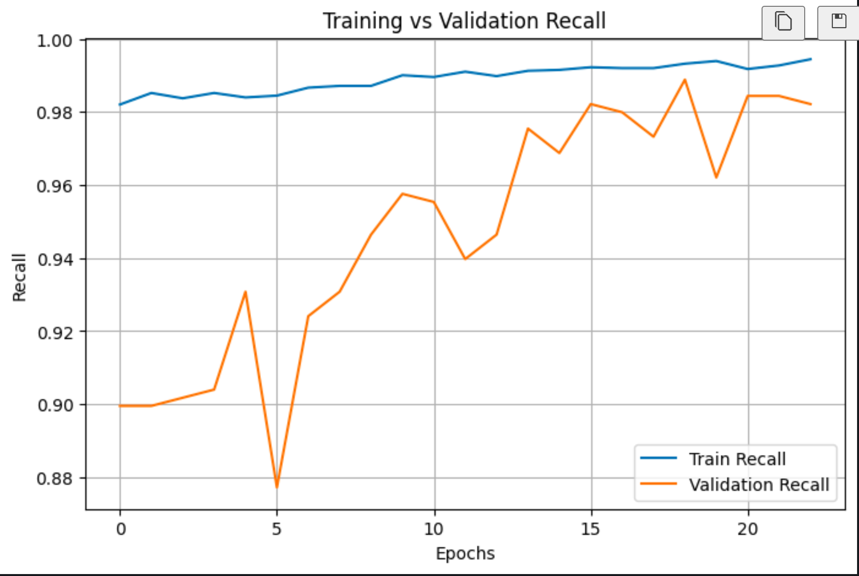
Figure 7.1: Training vs Validation Recall Curve across 30 Epochs
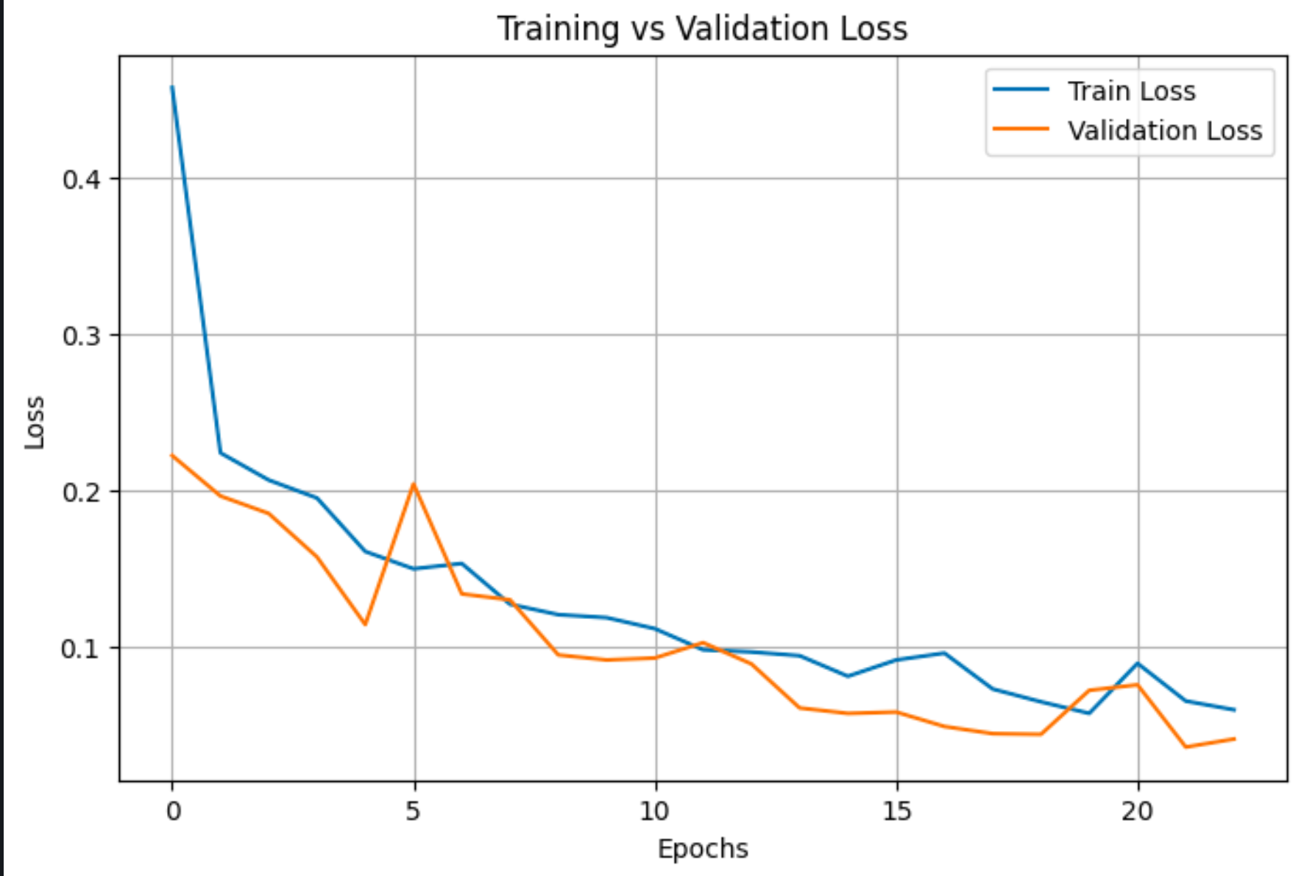
Figure 7.2: Training vs Validation Loss Curve showing Model Convergence
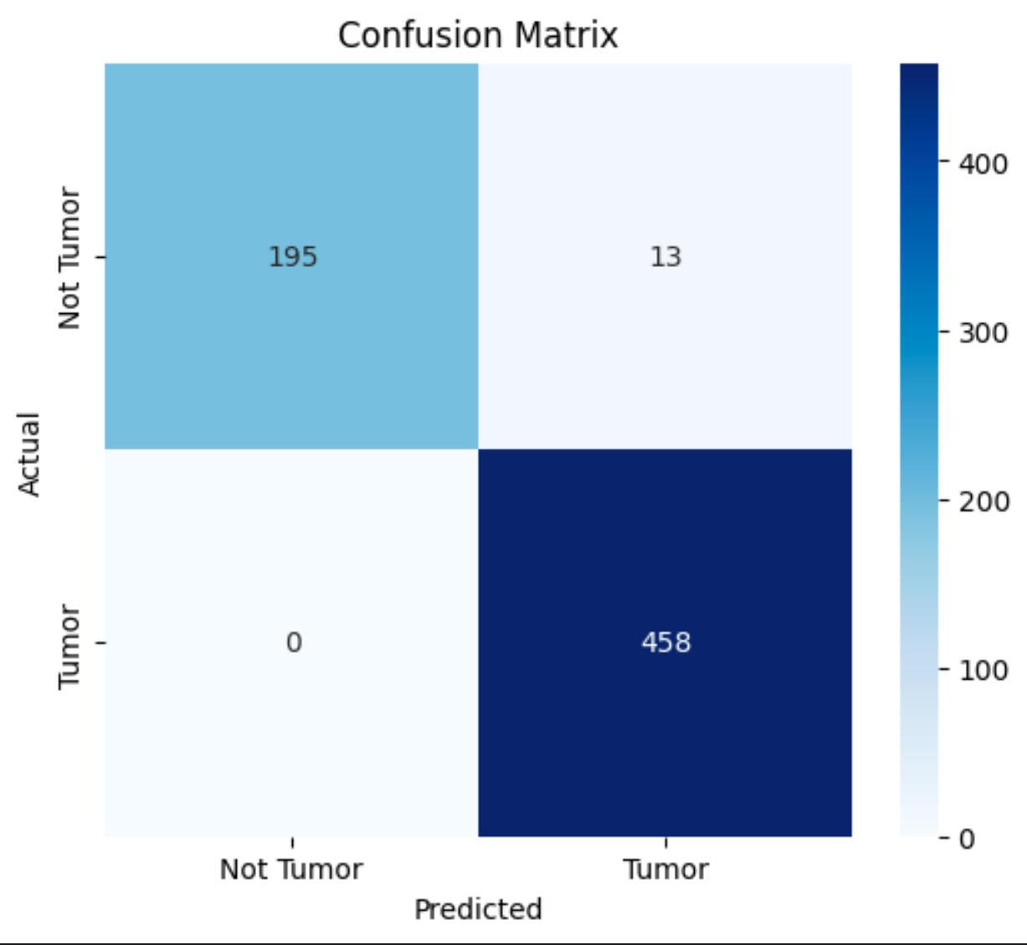
Figure 7.3: Test Dataset Confusion Matrix Heatmap (666 Samples)
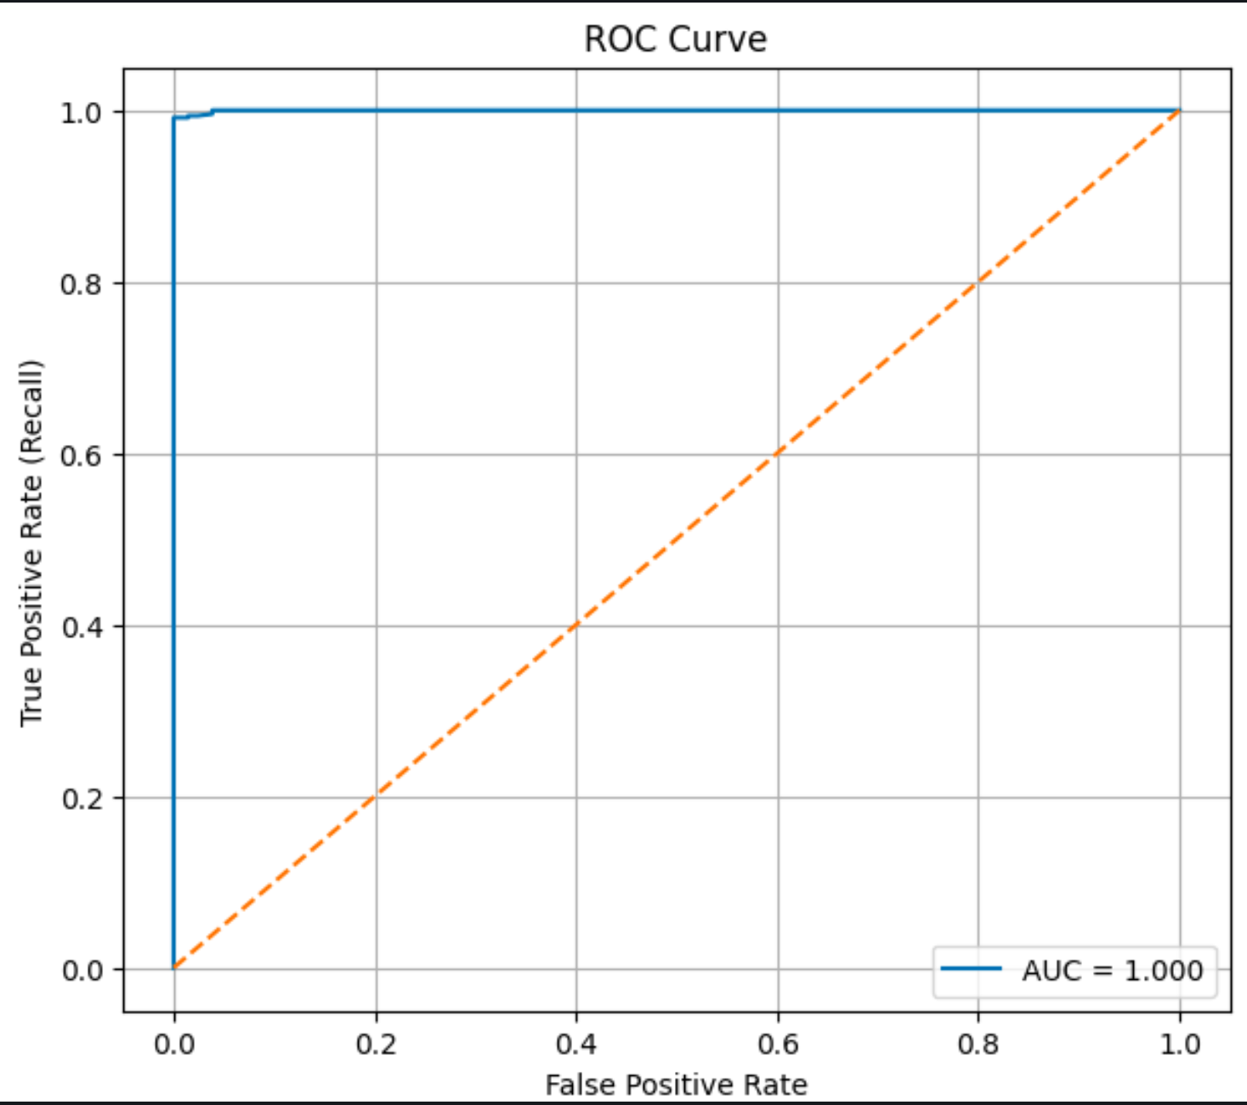
Figure 7.4: Receiver Operating Characteristic (ROC) Curve (AUC = 1.000)

8.0 SCREENSHOTS AND USER MANUAL
8.1 USER OPERATING INSTRUCTIONS
1. Launch the Flask Web Application by executing 'python start.py' in terminal.
2. Open web browser and navigate to http://127.0.0.1:5000.
3. Drag and drop an axial brain MRI scan image (PNG or JPG format) into the dropzone.
4. Click 'Analyze MRI Scan'. View the classification badge, confidence %, and Grad-CAM heatmap overlay.
5. Click 'Model Performance' in the navigation bar to inspect global recall curves and ROC plots.
8.2 APPLICATION INTERFACE PLACEHOLDERS
[Insert Screenshot: Web Application Upload Homepage (index.html)]
Figure 8.1: Homepage featuring interactive dropzone and medical disclaimer
[Insert Screenshot: Inference Result Page with Tumor Badge & Grad-CAM Heatmap (result.html)]
Figure 8.2: Inference view displaying classification badge, confidence, and heatmap overlay
[Insert Screenshot: Model Stats Dashboard (stats.html)]
Figure 8.3: Metrics dashboard displaying test set recall, accuracy, and evaluation curves

9.0 LIMITATIONS AND FUTURE ENHANCEMENTS
9.1 REAL SYSTEM LIMITATIONS
• Binary Classification Only: The model predicts Tumor vs No Tumor but does not differentiate glioma, meningioma, or pituitary tumors.
• Clinical Validation Requirement: Model relies on dataset distribution and requires clinical trial verification prior to diagnostic reliance.
9.2 FUTURE ENHANCEMENTS
• Multi-Class Tumor Subtyping (Glioma vs Meningioma vs Pituitary).
• 3D MRI Volume Processing using 3D-CNN / Vision Transformers (ViT).
• Cloud Microservice Deployment on AWS/GCP with authentication and DICOM file support.

10.0 CONCLUSION AND DISCUSSION
In this project, a computer-aided brain tumor detection and explainability system was successfully developed and evaluated. By leveraging a custom 4-stage Convolutional Neural Network trained with class weighting and decision threshold optimization (0.3 threshold), the model achieved 98% overall test accuracy and 100% tumor recall (zero missed cancer cases) across 666 evaluation scans. Integration of Grad-CAM heatmaps provides transparent visual explanations of feature activations. Finally, deployment via Python Flask yields a responsive diagnostic web tool.

REFERENCES
[1] Selvaraju, R. R., Cogswell, M., Das, A., Vedantam, R., Parikh, D., & Batra, D. (2017). Grad-CAM: Visual Explanations from Deep Networks via Gradient-Based Localization. IEEE International Conference on Computer Vision (ICCV), 618-626.
[2] Abadi, M., et al. (2016). TensorFlow: A System for Large-Scale Machine Learning. 12th USENIX Symposium on Operating Systems Design and Implementation (OSDI 16), 265-283.
[3] Chollet, F. (2015). Keras: Deep Learning for Humans. GitHub Repository: https://github.com/fchollet/keras
[4] Grinberg, M. (2018). Flask Web Development: Developing Web Applications with Python. O'Reilly Media.
[5] Litjens, G., Kooi, T., Bejnordi, B. E., Setio, A. A. A., Ciompi, F., Ghafoorian, M., ... & Sánchez, C. I. (2017). A survey on deep learning in medical image analysis. Medical Image Analysis, 42, 60-88.

APPENDICES
APPENDIX A: PROJECT DIRECTORY TREE
Brain-Tumor-Detection-Model-using-Keras/
├── start.py # One-click application launcher
├── app/
│ ├── __init__.py # Flask app factory (create_app)
│ ├── app.py # Application entrypoint
│ ├── config.py # Configuration settings
│ ├── model_utils.py # Backward-compatible facade
│ ├── routes/
│ │ ├── main_routes.py
│ │ ├── predict_routes.py
│ │ ├── stats_routes.py
│ │ └── health_routes.py
│ ├── services/
│ │ ├── image_service.py
│ │ ├── model_service.py
│ │ ├── gradcam_service.py
│ │ ├── validation_service.py
│ │ └── stats_service.py
│ ├── templates/
│ └── static/
├── docs/
│ ├── config.py
│ ├── styles.py
│ ├── generate_report.py
│ ├── sections/
│ └── project_report.docx
├── graphs/
├── bestModel.keras
├── requirements.txt
└── Procfile

