Music Store SQL Analysis Project
Submitted By
Soham Shukla
Project Overview
This project focuses on analyzing a Music Store database using SQL. The objective is to extract meaningful business insights related to customers, sales, invoices, music genres, artists, and employee information. Various SQL concepts such as filtering, sorting, aggregation, joins, subqueries, Common Table Expressions (CTEs), and window functions are used to answer business questions.
Objectives
- Analyze customer purchasing behavior.
- Identify top customers and spending patterns.
- Determine the most popular music genres and artists.
- Analyze invoice and sales trends across countries and cities.
- Apply advanced SQL techniques such as CTEs and window functions.
- Generate business insights that can support decision-making.
Tools Used
- MySQL 8.0
- MySQL Workbench
- Microsoft Excel (for CSV files)
- Microsoft Word (for report preparation)
Dataset
The dataset consists of multiple tables including Employee, Customer, Invoice, Invoice_Line, Track, Album, Artist, Genre, Playlist, Playlist_Track, and Media_Type.
Database Schema and Table Description
The Music Store database is a relational database designed to manage information about customers, employees, invoices, artists, albums, tracks, genres, and playlists. Relationships between tables enable detailed analysis of sales and customer behavior.
Tables Used
Employee
Stores employee information including employee ID, name, designation, reporting manager, and seniority level.
Customer
Contains customer details such as name, email, country, city, and support representative.
Invoice
Stores invoice information including invoice date, billing details, and total amount.
Invoice_Line
Contains detailed purchase records for each invoice, including track purchased, quantity, and price.
Artist
Stores information about music artists.
Album
Contains album details and links each album to an artist.
Track
Stores information about songs/tracks including genre, album, duration, and price.
Genre
Contains music genre information such as Rock, Jazz, Blues, etc.
Playlist
Stores playlist names.
Playlist_Track
Acts as a bridge table connecting playlists and tracks.
Media_Type
Contains information about track media formats.
Entity Relationship Diagram
(Insert the database schema image provided in the project here.)

Relationships
- One Artist can have many Albums.
- One Album can contain many Tracks.
- One Genre can be associated with many Tracks.
- One Customer can have many Invoices.
- One Invoice can contain multiple Invoice Line items.
- Invoice Line connects purchased Tracks to Invoices.
This schema enables comprehensive analysis of sales, customer preferences, artist popularity, and genre trends.
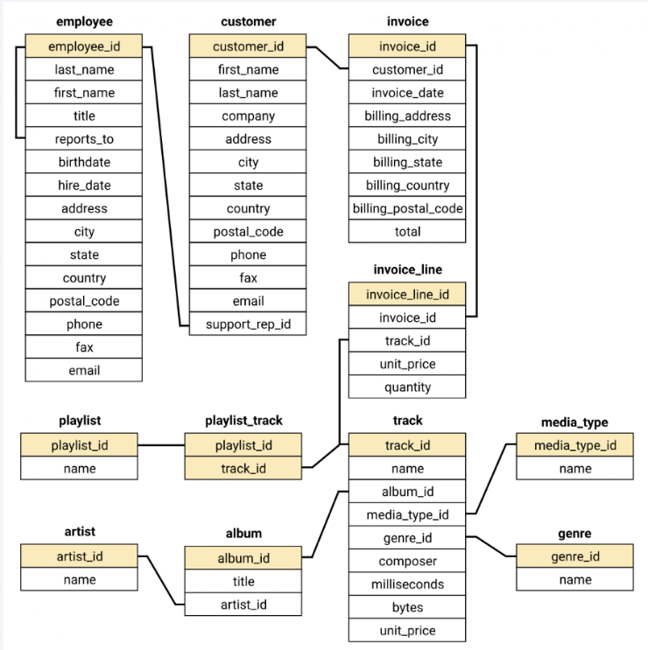

Question: Find the most senior employee based on job title.
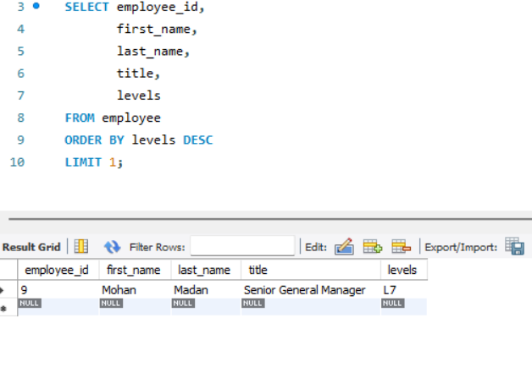
Question: Determine which countries have the most invoices.
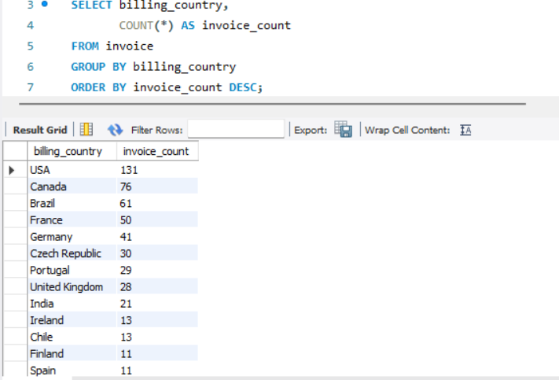
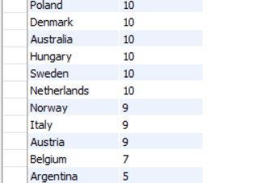

Question: Identify the top 3 invoice totals.
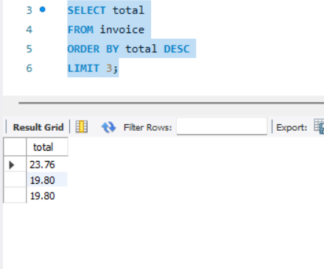
Question: Find the city with the highest total invoice amount to determine the best location for a promotional event.
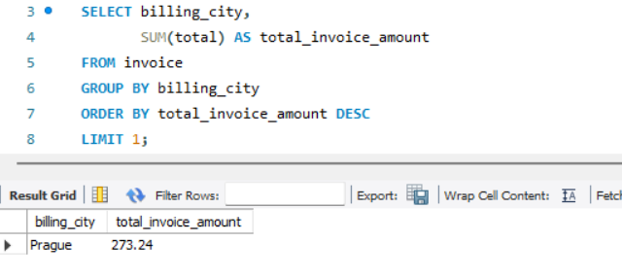
Question: Identify the customer who has spent the most money.
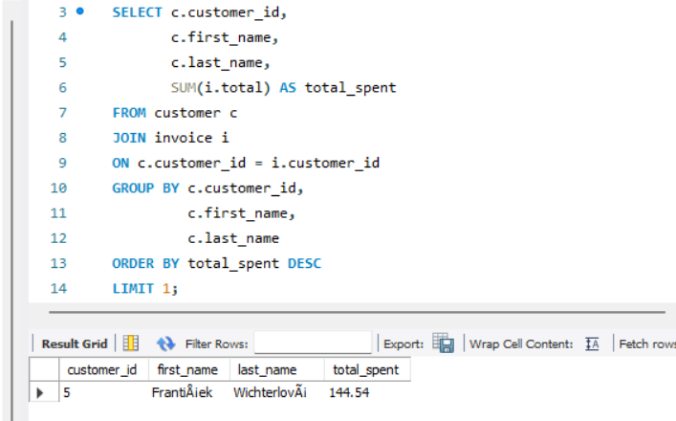
Question: Find the email, first name, and last name of customers who listen to Rock music.
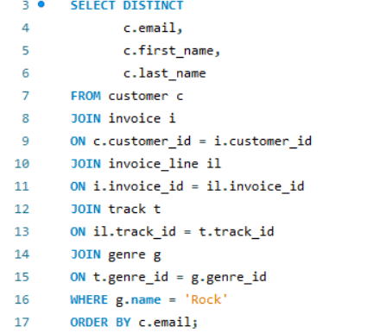
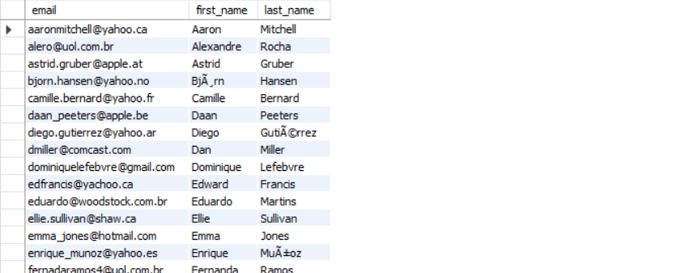
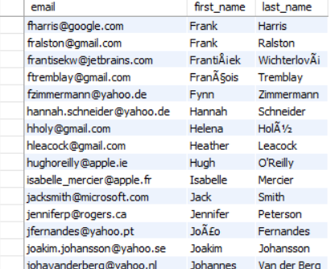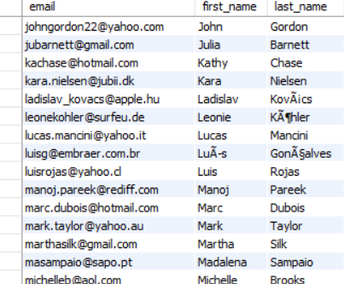
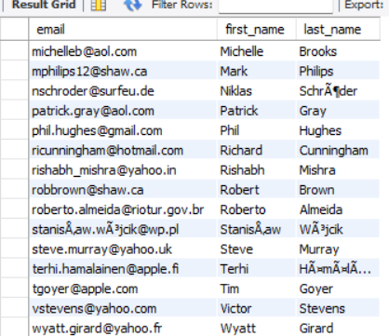
Question: Identify the top 10 rock artists based on track count.
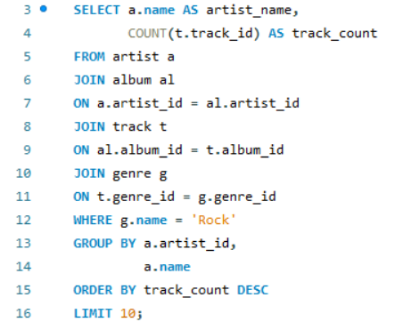
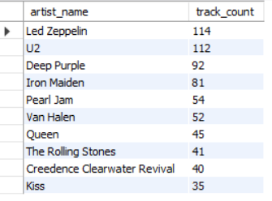
Question: Find all track names that are longer than the average track length.
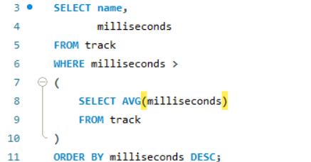
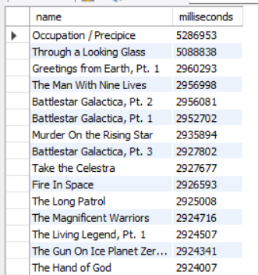
Question: Calculate how much each customer has spent on each artist.
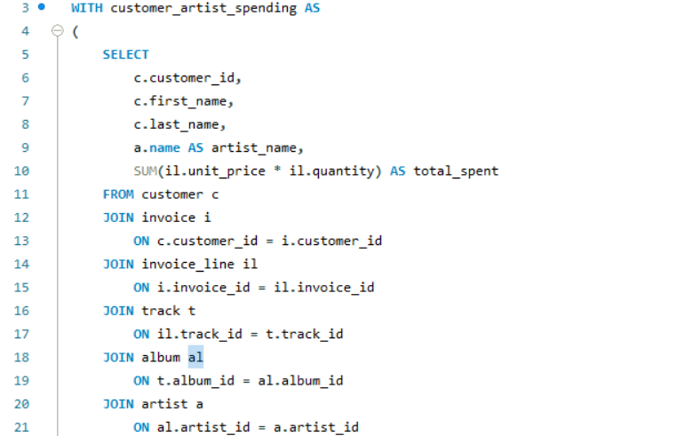
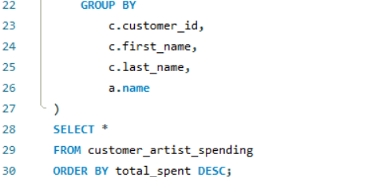
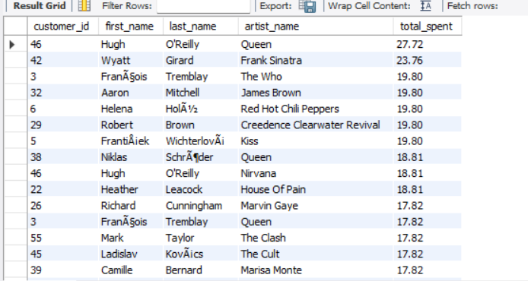
Question: Determine the most popular music genre for each country based on purchases.
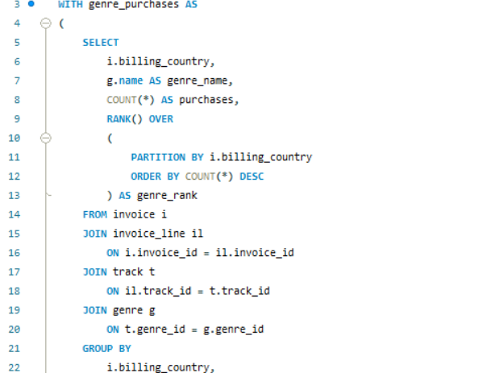
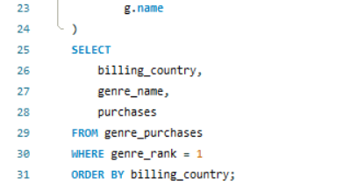
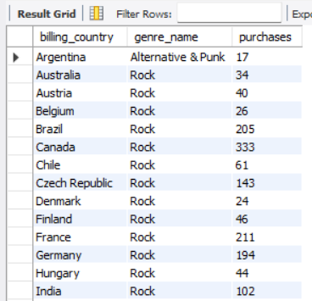
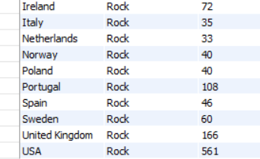
Question: Identify the top-spending customer for each country.
