COVID-19 DATA ANALYSIS USING PYTHON
Project Report
Submitted By:
Soham Shukla
Course:
CSE
College/Institute:
THAKUR COLLEGE OF ENGINEERING AND TECHNOLOGY
Subject:
Data Analysis / Python Project
Tools Used:
Python, Pandas, NumPy, Matplotlib, Seaborn, Google Colab
Submission Date:
July 2026

Project Objective
The objective of this project is to analyze global COVID-19 confirmed case data using Python-based data analysis techniques. The project aims to study the spread of COVID-19 across different countries, identify infection trends over time, compare the most affected countries, and generate meaningful insights through Exploratory Data Analysis (EDA) and data visualization. The analysis helps understand the progression of the pandemic and demonstrates the practical application of data analytics in public health.

COVID-19 DATA ANALYSIS USING PYTHON
Introduction
The COVID-19 pandemic affected millions of people worldwide and created significant challenges for healthcare systems and governments. Data analysis played an important role in tracking the spread of the virus, monitoring infection rates, and supporting decision-making during the pandemic.
This project uses the Johns Hopkins University COVID-19 dataset to analyze confirmed COVID-19 cases across different countries. Using Python libraries such as Pandas, NumPy, Matplotlib, and Seaborn, the project performs Exploratory Data Analysis (EDA), visualizes global trends, and identifies the countries with the highest number of confirmed cases.

Objective
The main objectives of this project are:
- To analyze global COVID-19 confirmed case data.
- To perform data cleaning and preprocessing.
- To study worldwide COVID-19 growth trends.
- To identify the countries with the highest confirmed cases.
- To create meaningful visualizations using Python.
- To generate insights regarding the spread of COVID-19.

Tools and Technologies Used
- Python
- Google Colab
- Pandas
- NumPy
- Matplotlib
- Seaborn

Dataset Description
The project uses the Johns Hopkins University COVID-19 Global Time Series Dataset, which contains country-wise cumulative confirmed COVID-19 cases recorded daily.
The dataset includes:
- Province/State
- Country/Region
- Latitude
- Longitude
- Daily confirmed cases (from January 2020 onwards)
The dataset contains approximately 289 countries/regions and several hundred daily observations representing cumulative confirmed COVID-19 cases.

Data Loading and Exploration
The dataset was imported into Google Colab using the Pandas read_csv() function. Initial exploration was performed using head(), info(), shape, columns, and describe() to understand the dataset structure and identify available variables.
Screenshot:
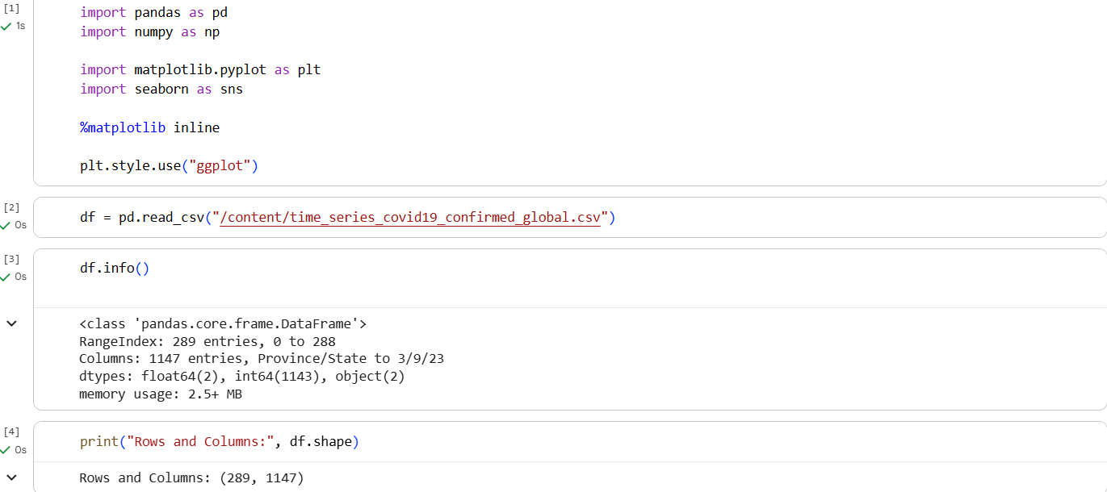

Data Cleaning
The dataset was checked for missing values and unnecessary columns.
The following preprocessing steps were performed:
- Checked missing values using isnull().sum()
- Filled missing values in the Province/State column
- Removed Latitude and Longitude columns
- Grouped data by Country/Region
- Converted date columns into DateTime format for time-series analysis
Screenshot:
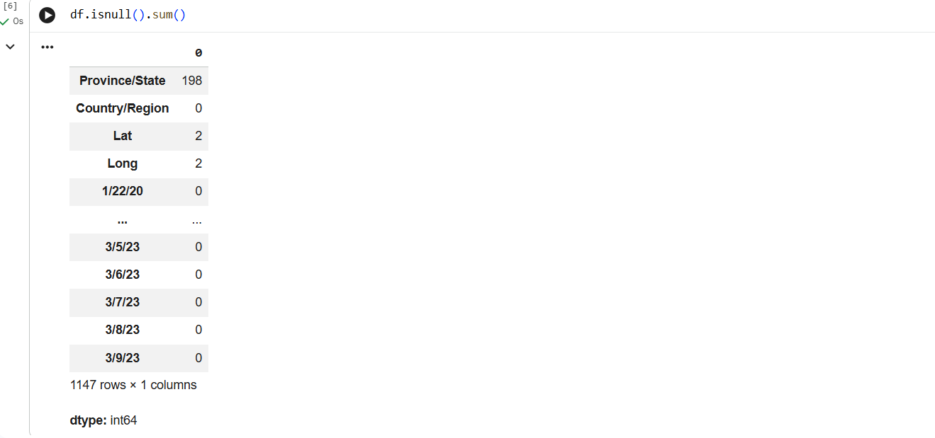
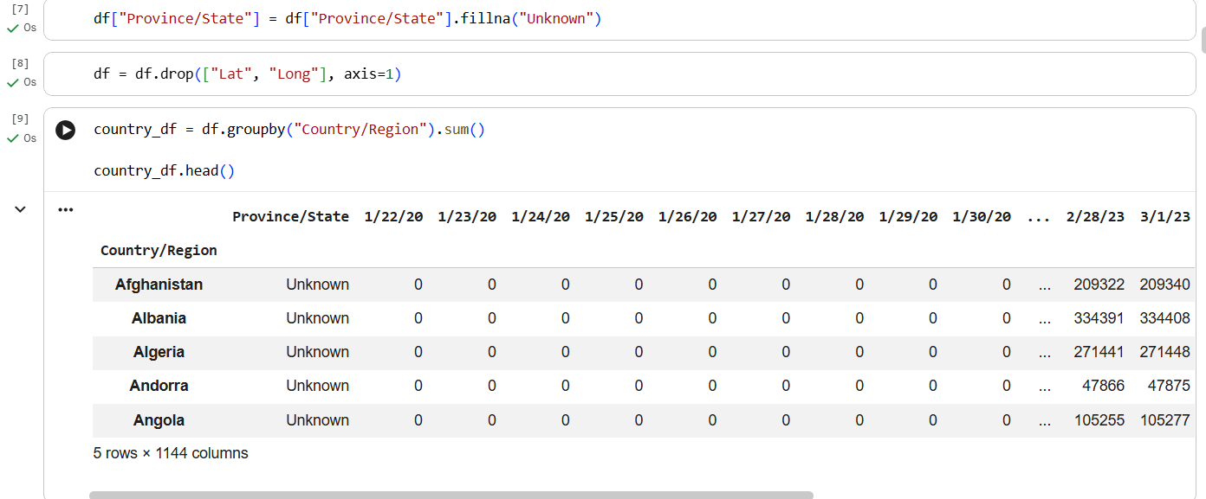
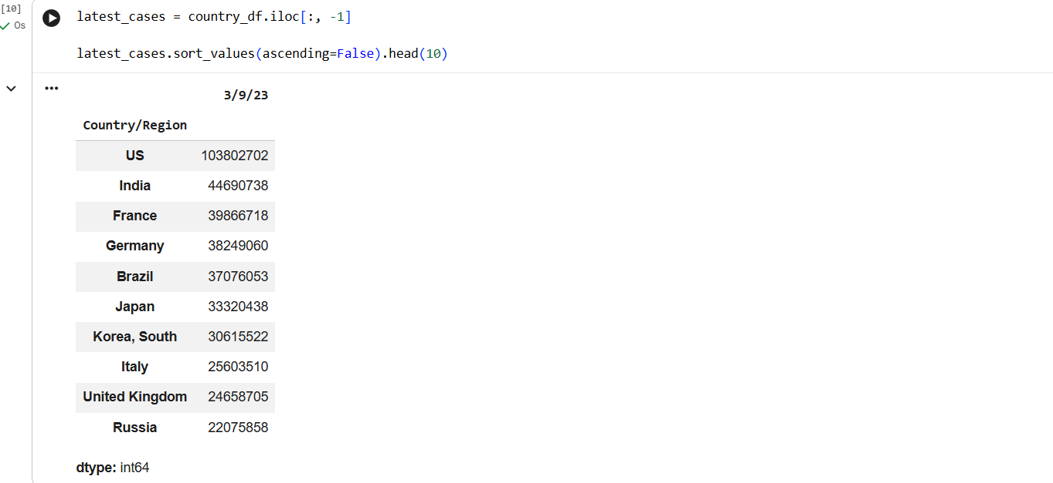
Observation
- Only a few missing values were found in the Province/State column.
- Missing values were replaced successfully.
- Latitude and Longitude columns were removed because they were not required for trend analysis.
- Country-wise cumulative data was successfully generated.

Analysis 1: Top 10 Countries by Confirmed COVID-19 Cases
A horizontal bar chart was created to visualize the top ten countries with the highest cumulative confirmed COVID-19 cases.
Screenshot:
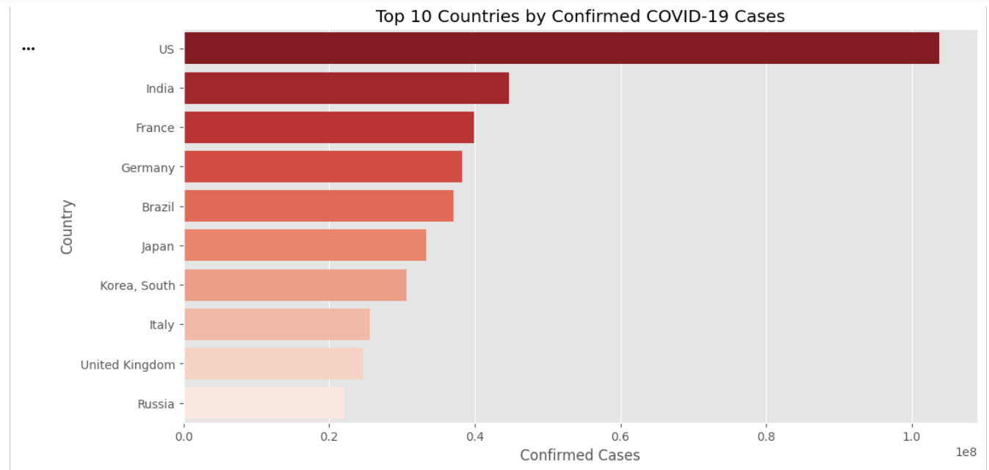Observation
The United States reported the highest number of confirmed COVID-19 cases, followed by India, France, Germany, and Brazil.
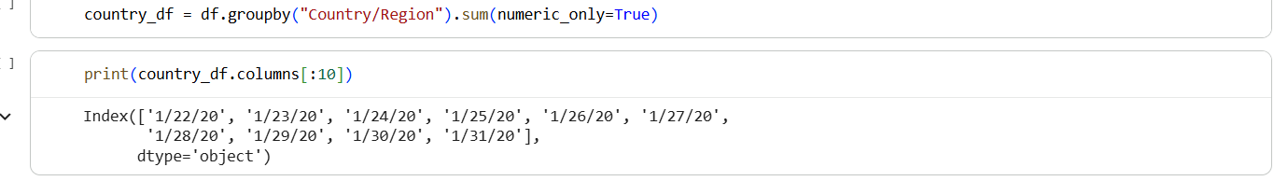
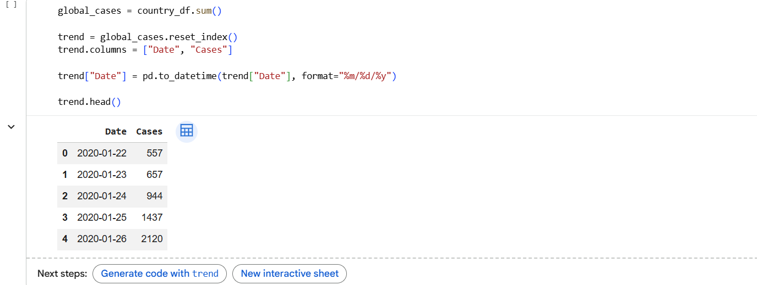
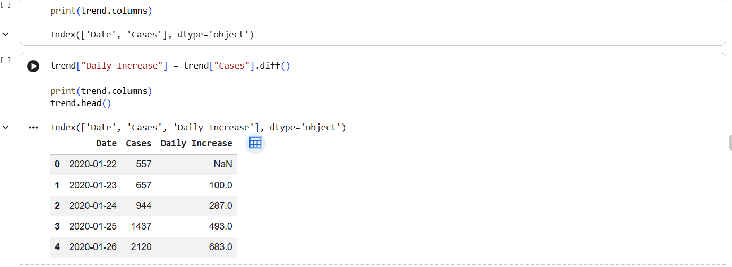

Analysis 2: Global COVID-19 Growth Trend
A line chart was generated to visualize the worldwide increase in confirmed COVID-19 cases over time.
Screenshot:
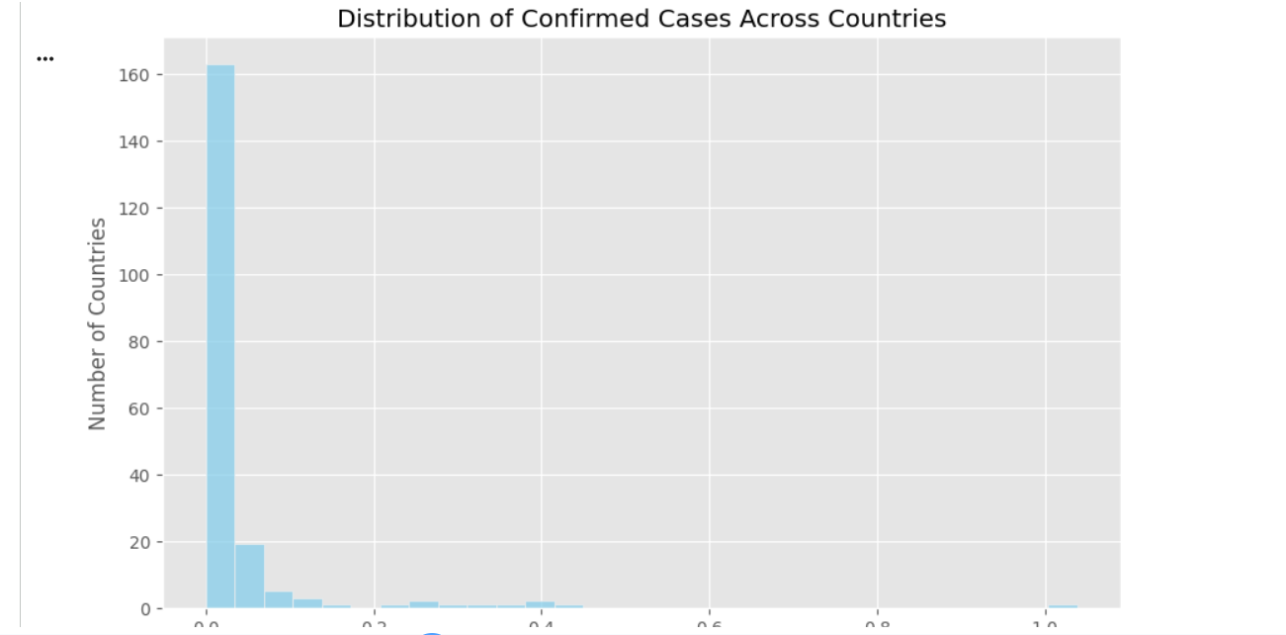
Observation
The number of confirmed COVID-19 cases increased rapidly throughout the pandemic, demonstrating a strong upward global trend.

Analysis 3: Daily Increase in COVID-19 Cases
The daily increase in confirmed cases was calculated using the difference between consecutive cumulative values.
Screenshot:
(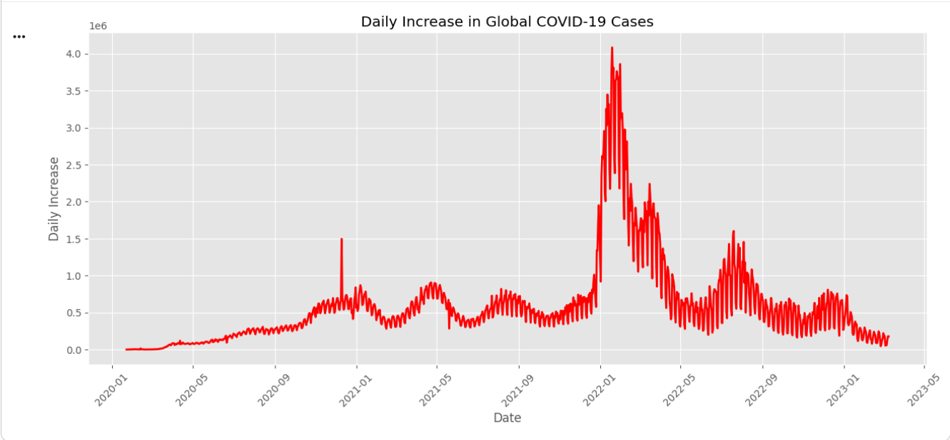Observation
Several significant peaks were observed, indicating major waves of COVID-19 infections across the world.

Analysis 4: Top 20 Countries by Confirmed Cases
A bar chart was created to compare the twenty most affected countries.
Screenshot:
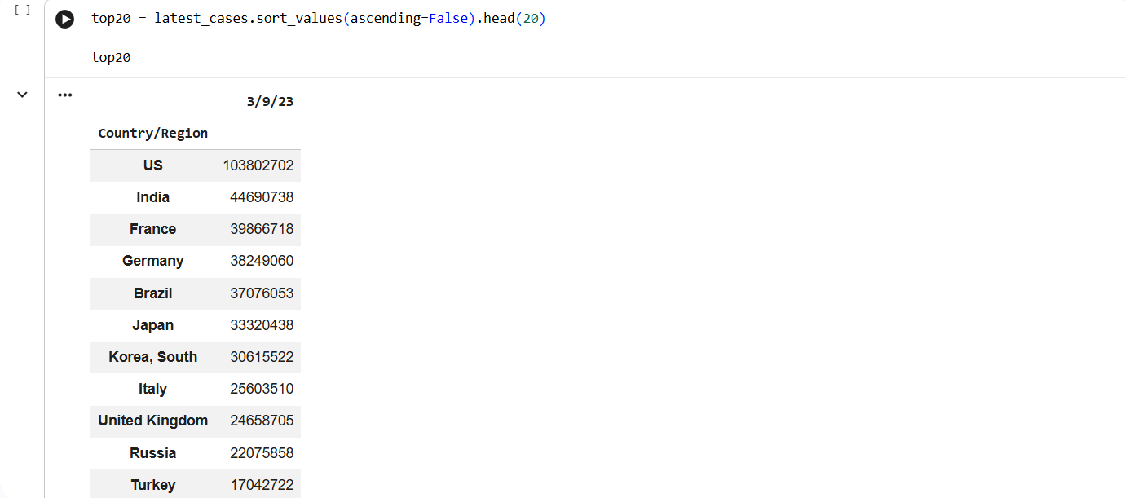
Observation
Most confirmed cases were concentrated in a relatively small number of countries, while many countries reported comparatively lower totals.

Analysis 5: Distribution of Confirmed Cases
A histogram was generated to examine how confirmed COVID-19 cases are distributed among countries.
Screenshot:
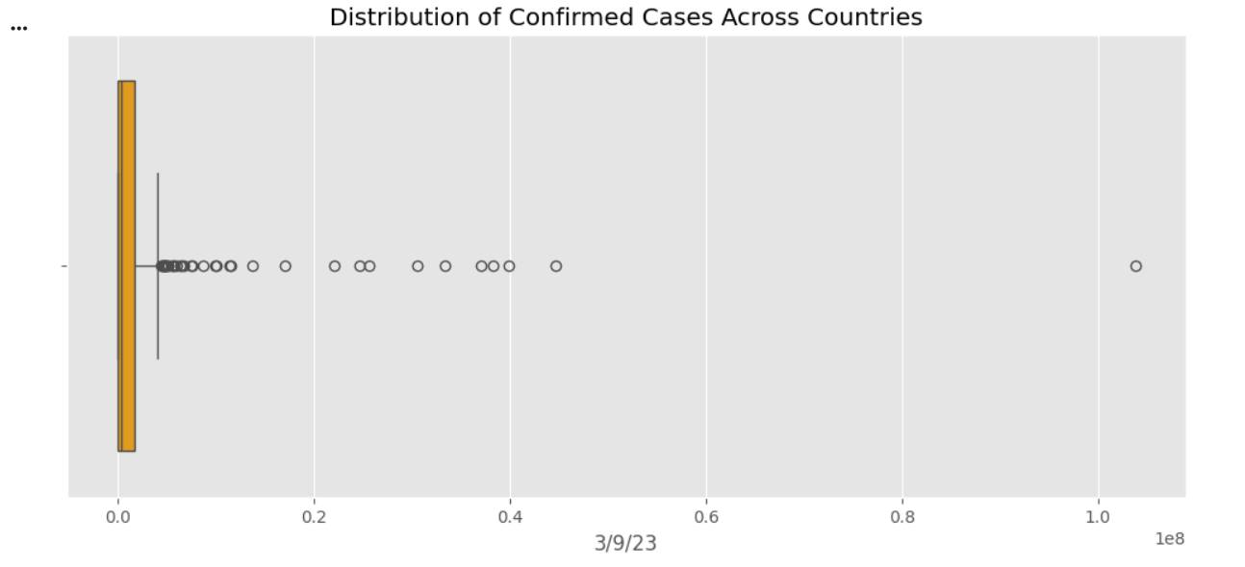Observation
The distribution is highly skewed, indicating that only a few countries experienced extremely high case counts.

Analysis 6: Box Plot of Confirmed Cases
A box plot was used to identify the spread and presence of outliers within the confirmed case data.
Screenshot:
Observation
Several countries appeared as extreme outliers due to exceptionally large numbers of confirmed COVID-19 cases.

Analysis 7: Heatmap of COVID-19 Cases
A heatmap was created to visualize the confirmed COVID-19 cases for the top affected countries over the last 30 days in the dataset.
Screenshot:
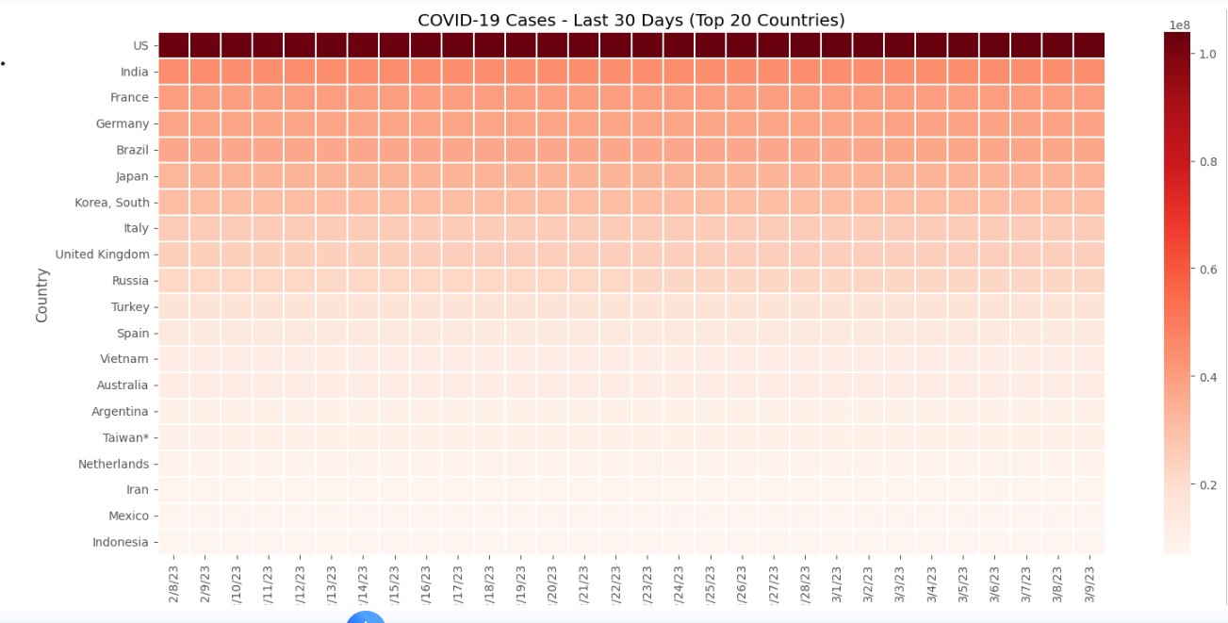
Observation
The heatmap clearly highlights sustained high infection counts among the most affected countries during the later stages of the pandemic.

Summary Statistics
Descriptive statistics were calculated to summarize the dataset.
The analysis included:
- Total number of countries
- Country with highest confirmed cases
- Highest number of confirmed cases
- Average confirmed cases
- Median confirmed cases
Screenshot:
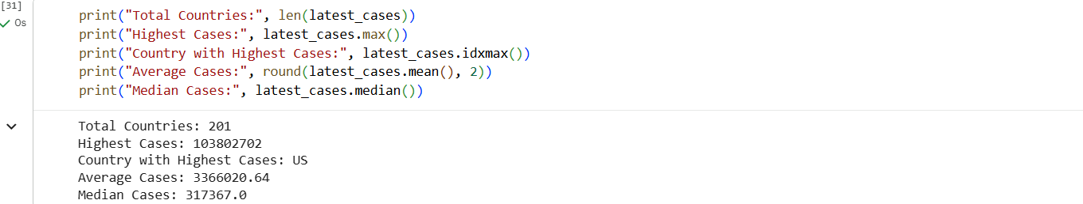
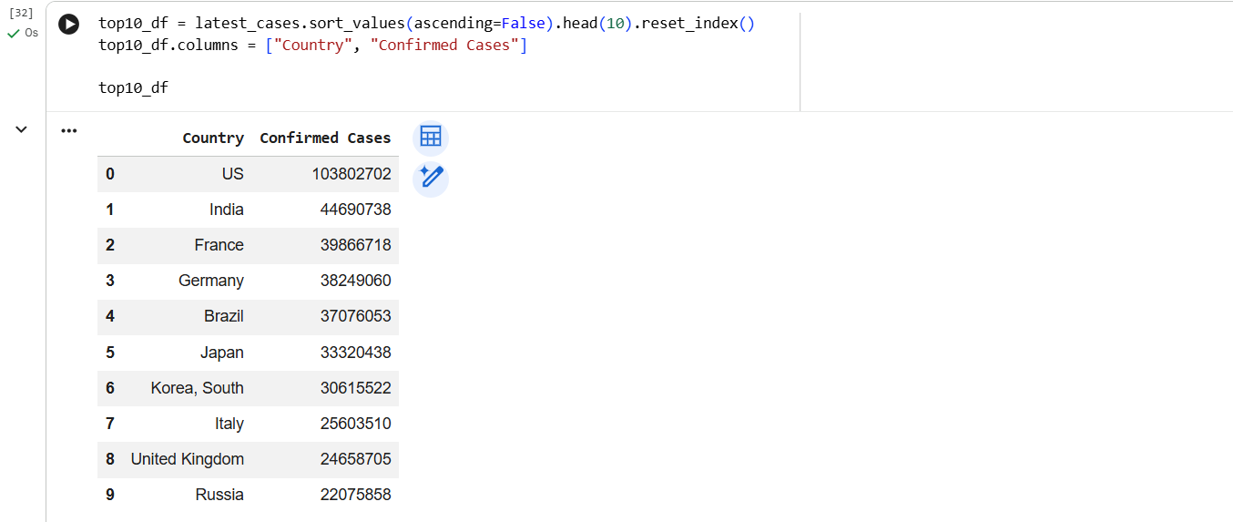

Key Insights
- The United States recorded the highest cumulative confirmed COVID-19 cases.
- India ranked second among the most affected countries.
- Global confirmed cases increased rapidly throughout the pandemic.
- Daily case growth showed multiple infection waves.
- A small number of countries accounted for a large proportion of global COVID-19 cases.
- The histogram and box plot revealed a highly uneven distribution of confirmed cases across countries.
- Heatmap analysis highlighted consistently high infection levels among the most affected countries.

Conclusion
The COVID-19 Data Analysis project successfully explored worldwide confirmed COVID-19 case data using Python-based data analysis techniques. Exploratory Data Analysis (EDA) provided valuable insights into global infection trends, country-wise case distribution, and the progression of the pandemic over time.
Various visualizations including bar charts, line charts, histograms, box plots, and heatmaps helped identify the countries most severely affected by COVID-19 and illustrated the rapid growth of confirmed cases during different phases of the pandemic.
This project demonstrates the practical application of Python, data analytics, and visualization techniques in analyzing real-world public health data. The findings can support researchers, policymakers, and healthcare professionals in understanding historical pandemic trends and highlight the importance of data-driven decision-making in managing global health crises.

