HR ANALYTICS – EMPLOYEE ATTRITION PREDICTION
Project Report
Submitted By:
Soham Shukla
Course:
CSE
College/Institute:
THAKUR COLLEGE OF ENGINEERING AND TECHNOLOGY
Subject:
Data Analysis / Python Project
Tools Used:
Python, Pandas, NumPy, Matplotlib, Seaborn, Scikit-learn, Google Colab
Submission Date:
June 2026

Project Objective
The objective of this project is to analyze employee data and predict employee attrition using machine learning techniques. The analysis aims to identify the key factors influencing employee turnover, such as age, job role, monthly income, overtime, job satisfaction, and work-life balance. By performing Exploratory Data Analysis (EDA) and building a Random Forest Classification model, the project provides valuable insights that can help organizations improve employee retention strategies, enhance workplace satisfaction, and support data-driven Human Resource decision-making.

HR ANALYTICS – EMPLOYEE ATTRITION PREDICTION USING PYTHON
Introduction
Employee attrition is one of the most significant challenges faced by organizations as it directly impacts productivity, recruitment costs, employee morale, and business performance. Human Resource (HR) Analytics uses data analysis and machine learning techniques to understand employee behavior and identify the key factors contributing to employee attrition. This project utilizes Python libraries such as Pandas, NumPy, Matplotlib, Seaborn, and Scikit-learn to perform Exploratory Data Analysis (EDA) and build a predictive machine learning model using the IBM HR Analytics Employee Attrition dataset.
Objective
The main objectives of this project are:
- To analyze employee demographic and work-related data.
- To identify the major factors affecting employee attrition.
- To perform exploratory data analysis using visualization techniques.
- To preprocess the dataset for machine learning.
- To build a Random Forest Classification model for attrition prediction.
- To evaluate model performance and identify the most important features influencing employee attrition.

Tools and Technologies Used
- Python
- Google Colab
- Pandas
- NumPy
- Matplotlib
- Seaborn
- Scikit-learn

Dataset Description
The project uses the IBM HR Analytics Employee Attrition Dataset, which contains employee-related information used to predict whether an employee is likely to leave the organization.
The dataset consists of 1470 employee records and 35 columns, including:
- Age
- Attrition
- Business Travel
- Daily Rate
- Department
- Distance From Home
- Education
- Education Field
- Environment Satisfaction
- Gender
- Job Role
- Job Satisfaction
- Monthly Income
- Overtime
- Total Working Years
- Work-Life Balance
- Years at Company
- Years in Current Role
- Years Since Last Promotion
- Years With Current Manager
The target variable is Attrition, which indicates whether an employee has left the organization ("Yes") or remained ("No").

Data Loading and Exploration
The dataset was loaded into a Pandas DataFrame using the read_csv() function. Initial exploration was performed using the head(), info(), describe(), and columns functions to understand the structure and characteristics of the dataset.
Screenshot:
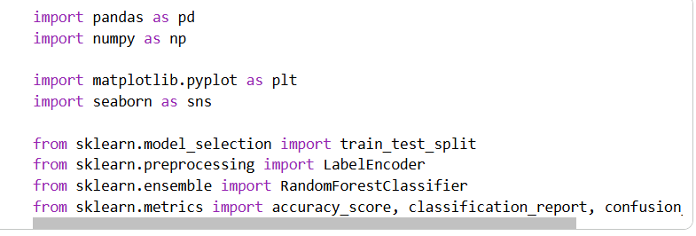
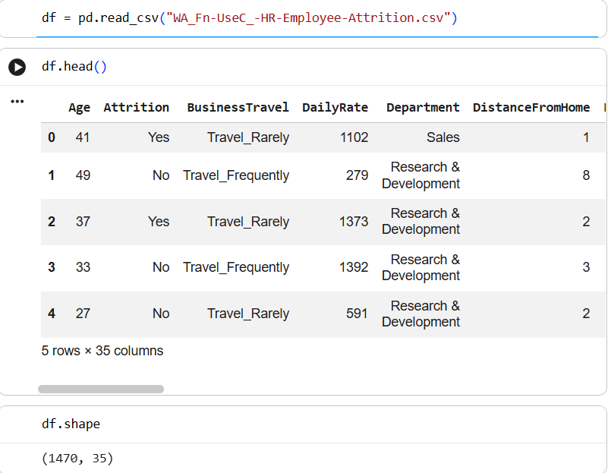
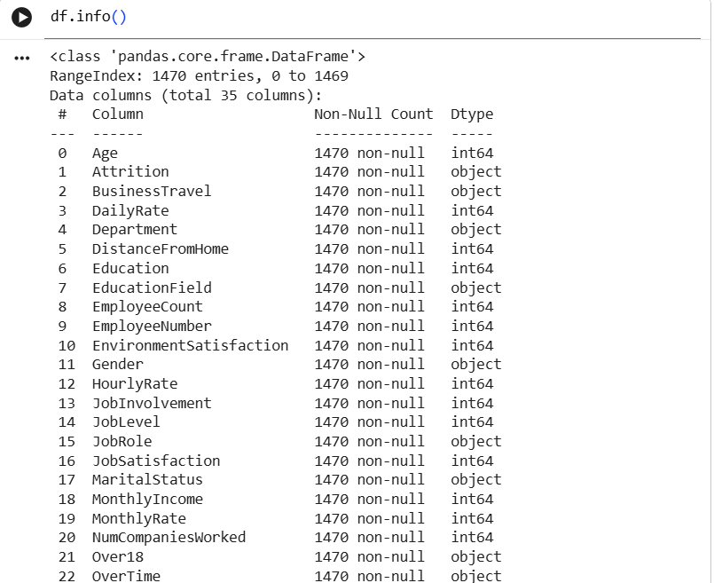
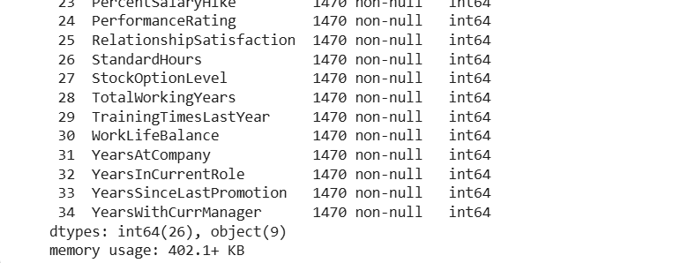
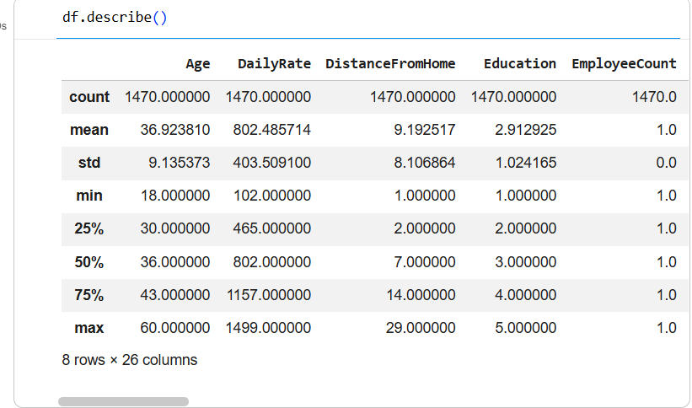
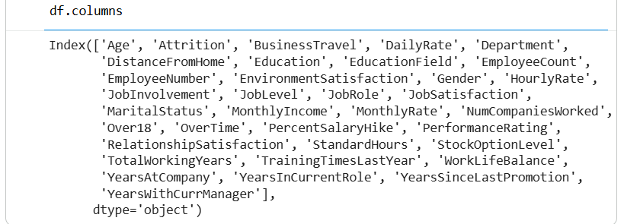
Data Cleaning
The dataset was examined for missing values and duplicate records. Since the IBM HR Analytics dataset is already well-structured, no missing values were found. Duplicate records were checked and removed if present.
Categorical columns such as Attrition, Department, Gender, Job Role, and OverTime were converted into numerical values using Label Encoding to prepare the dataset for machine learning.
Screenshot:
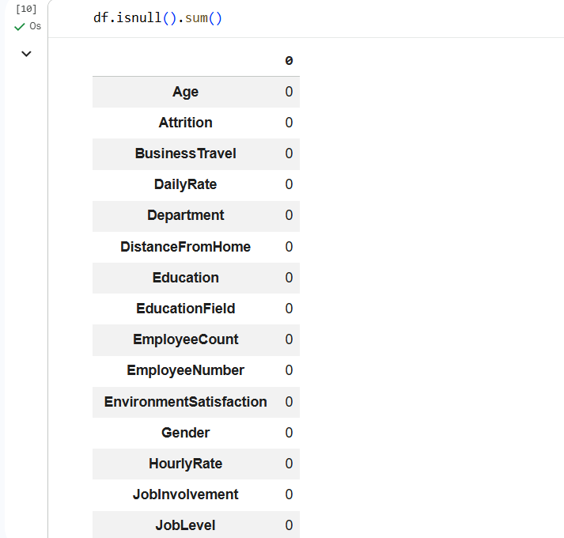
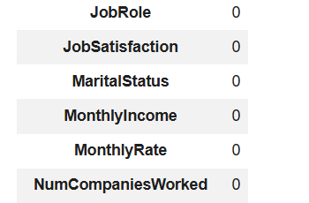
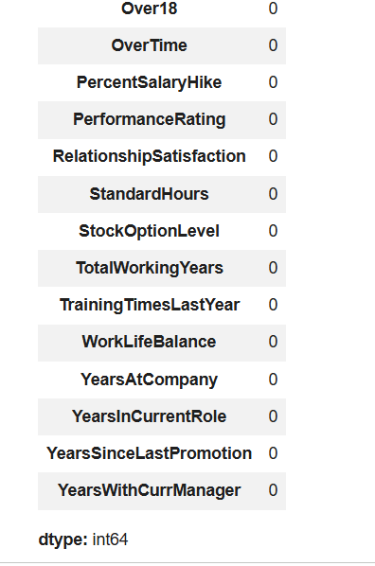
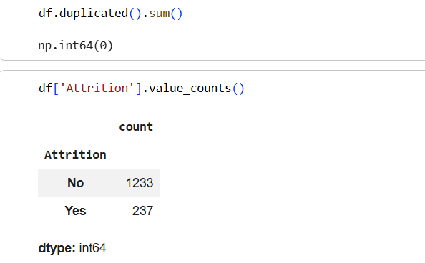
Observation
No missing values were found in the dataset. The categorical variables were successfully encoded for further analysis.
Analysis 1: Employee Attrition Distribution
A count plot was created to visualize the number of employees who stayed and those who left the organization.
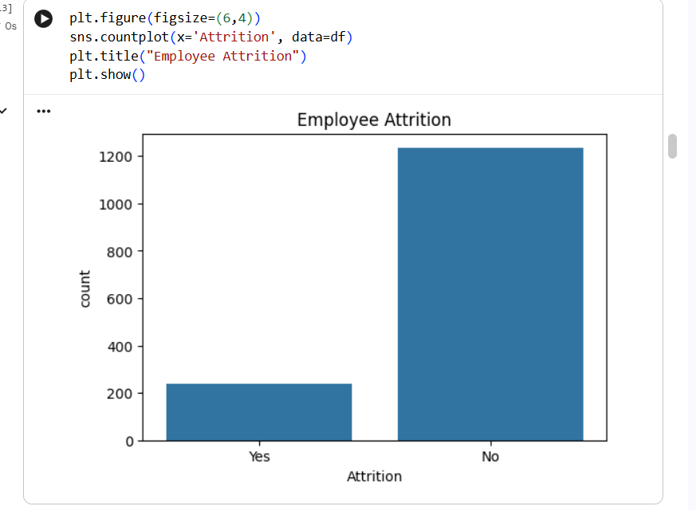
Observation
Most employees remained with the organization, while a smaller proportion left, indicating an imbalanced dataset.

Analysis 2: Age Distribution
A histogram was used to analyze the age distribution of employees.
Screenshot:
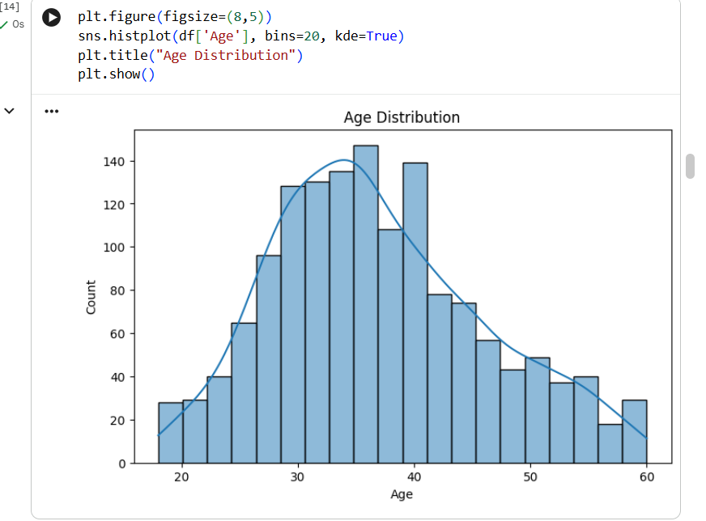
Observation
The majority of employees fall within the age group of 30 to 40 years, indicating that the workforce primarily consists of experienced professionals.
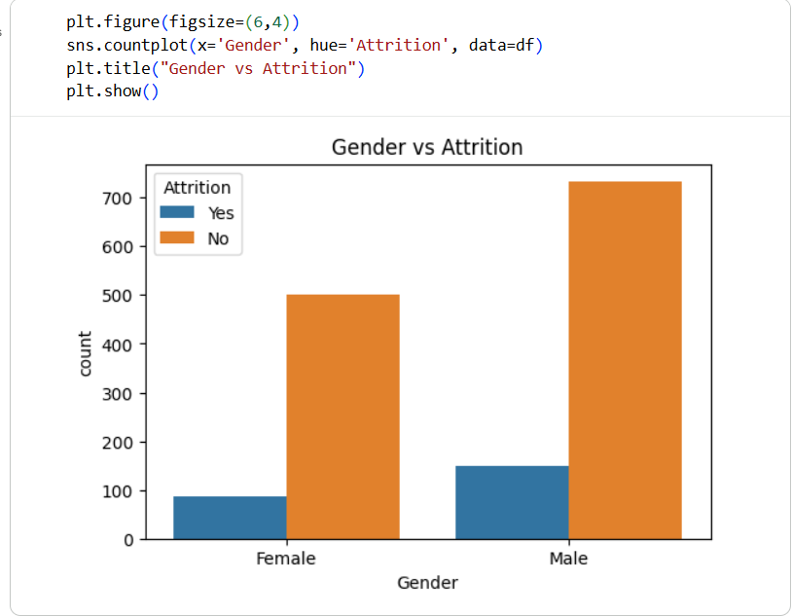
Analysis 3: Department-wise Attrition
A count plot was used to compare employee attrition across different departments.
Screenshot:
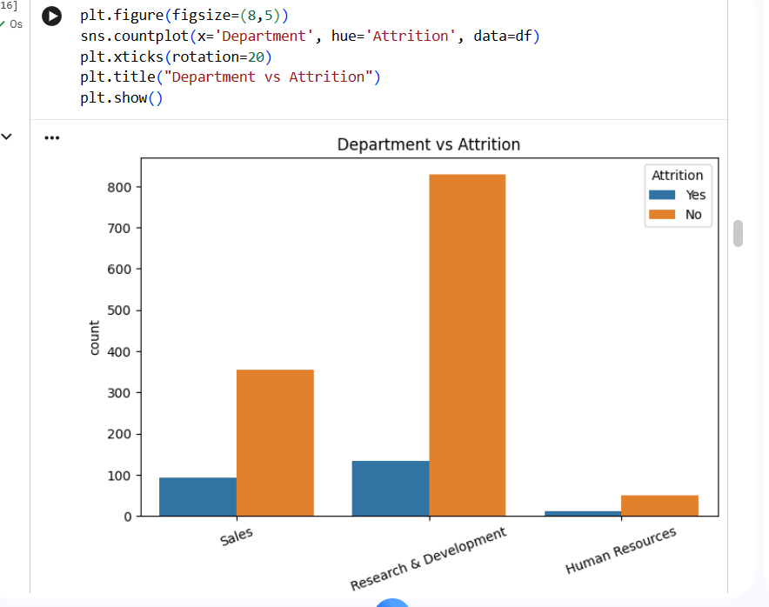
Observation
The Sales department experienced comparatively higher attrition than the other departments.
Analysis 4: Job Role vs Attrition
A count plot was created to analyze employee attrition across different job roles.
Screenshot:
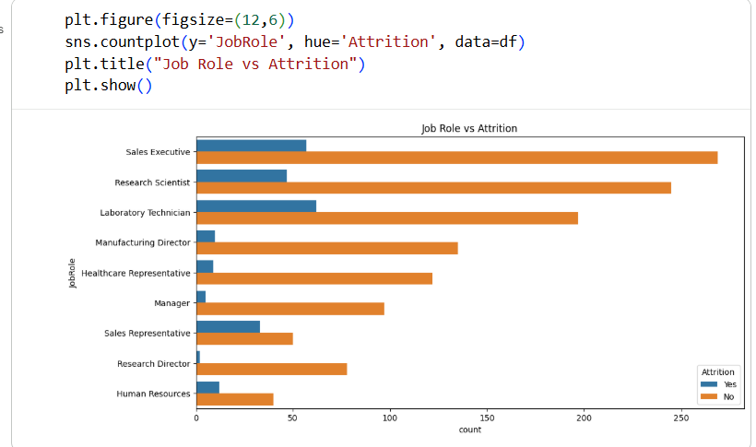

Observation
Certain job roles such as Sales Executive and Laboratory Technician showed relatively higher employee attrition.
Analysis 5: Monthly Income Analysis
A histogram and box plot were used to study employee monthly income and compare income distributions between employees who stayed and those who left.
Screenshot:
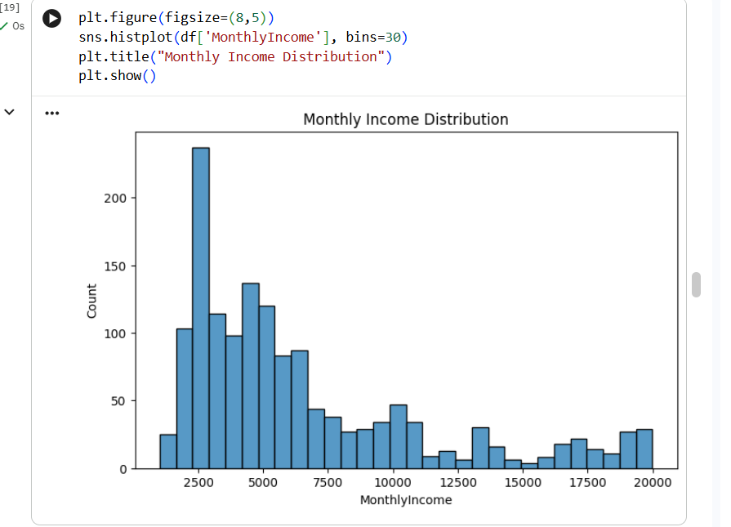
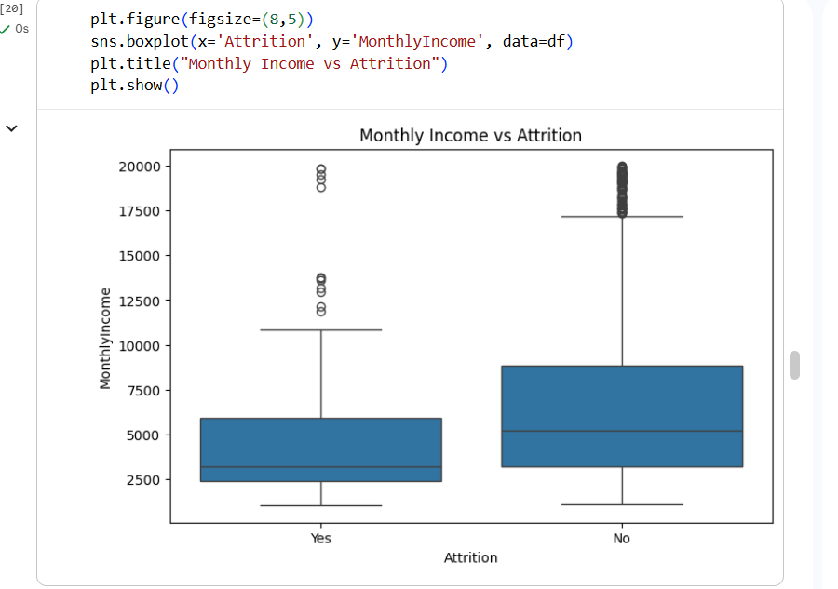

Observation
Employees with lower monthly income exhibited a higher likelihood of attrition compared to employees earning higher salaries.

Analysis 6: Overtime vs Attrition
A count plot was created to examine the relationship between overtime work and employee attrition.
Screenshot:
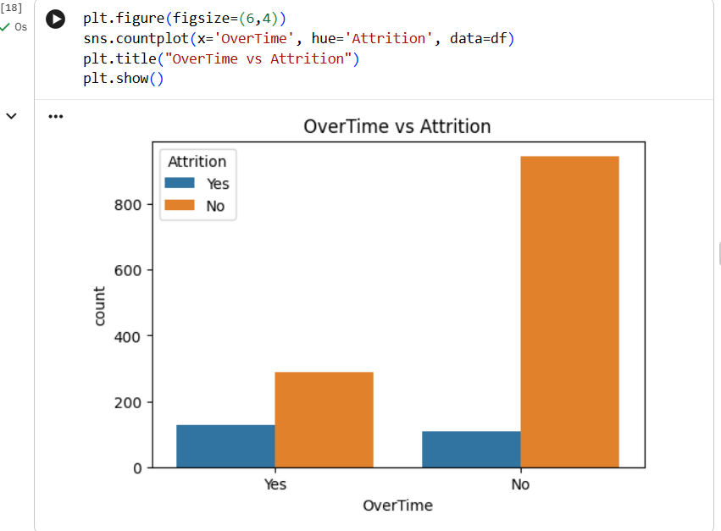
Observation
Employees who frequently worked overtime were more likely to leave the organization.

Analysis 7: Job Satisfaction
A count plot was used to analyze employee attrition based on job satisfaction levels.
Screenshot:
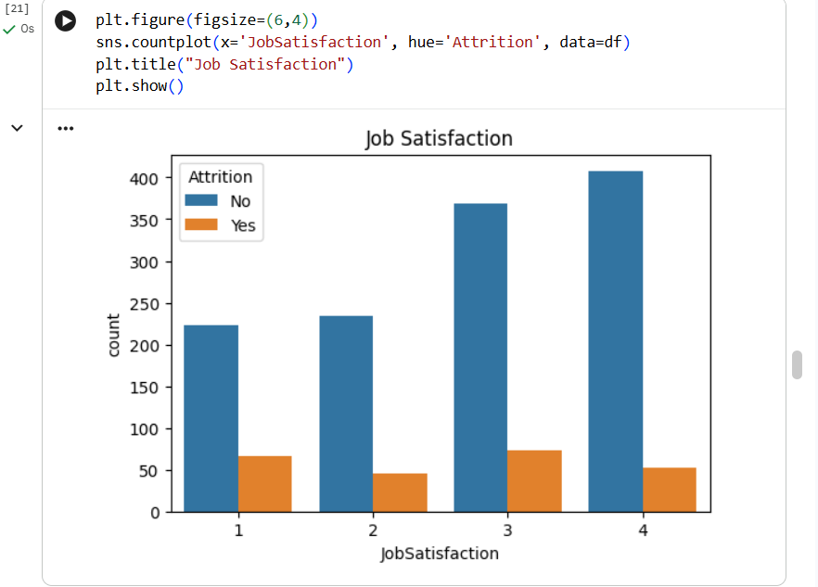
Observation
Lower job satisfaction levels were associated with a higher employee attrition rate.

Analysis 8: Work-Life Balance
A count plot was generated to study the relationship between work-life balance and employee attrition.
Screenshot:
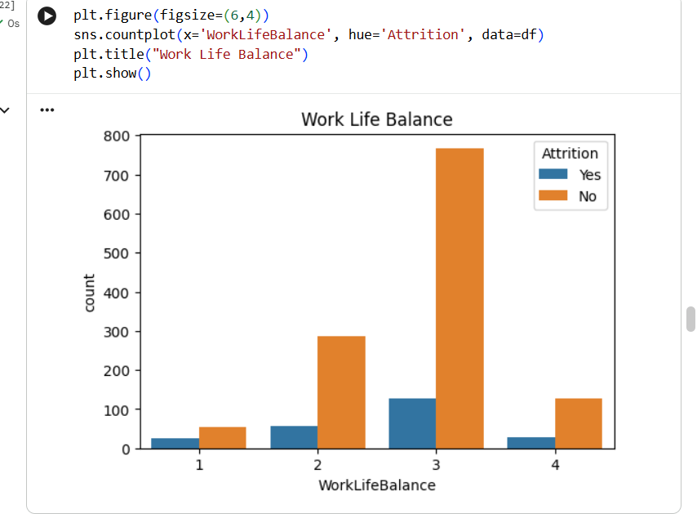
Observation
Employees reporting poor work-life balance showed a greater tendency to leave the organization.
Analysis 9: Correlation Heatmap
A correlation heatmap was generated to identify relationships among numerical features.
Screenshot:
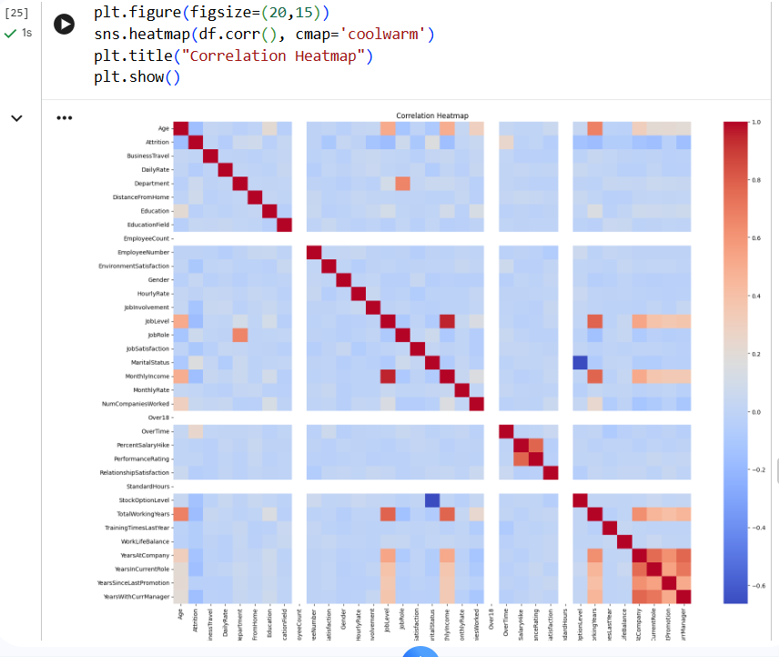
Observation
Several employee-related variables showed meaningful relationships with attrition and other organizational factors.
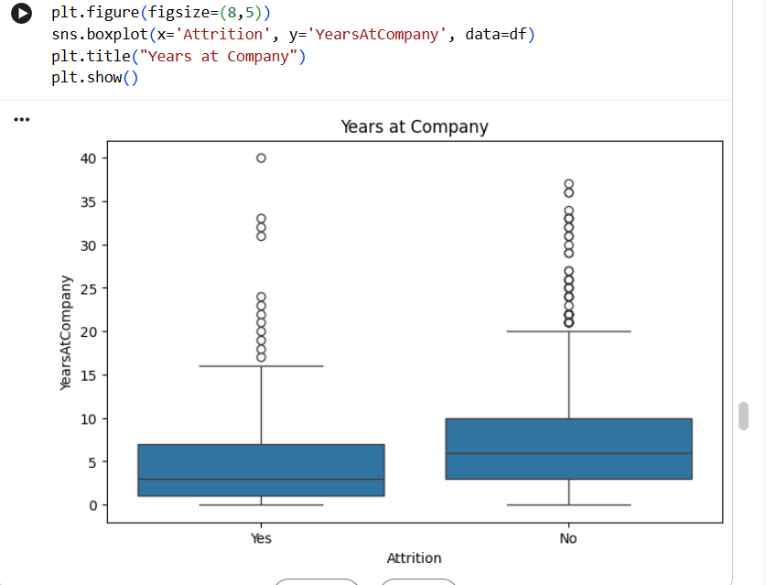
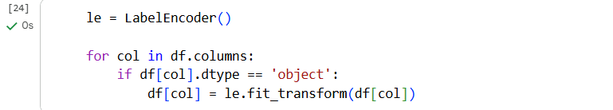
Machine Learning Model
The dataset was divided into training and testing sets using an 80:20 ratio.
A Random Forest Classifier was trained to predict employee attrition.
The model performance was evaluated using:
- Accuracy Score
- Classification Report
- Confusion Matrix
Screenshot:
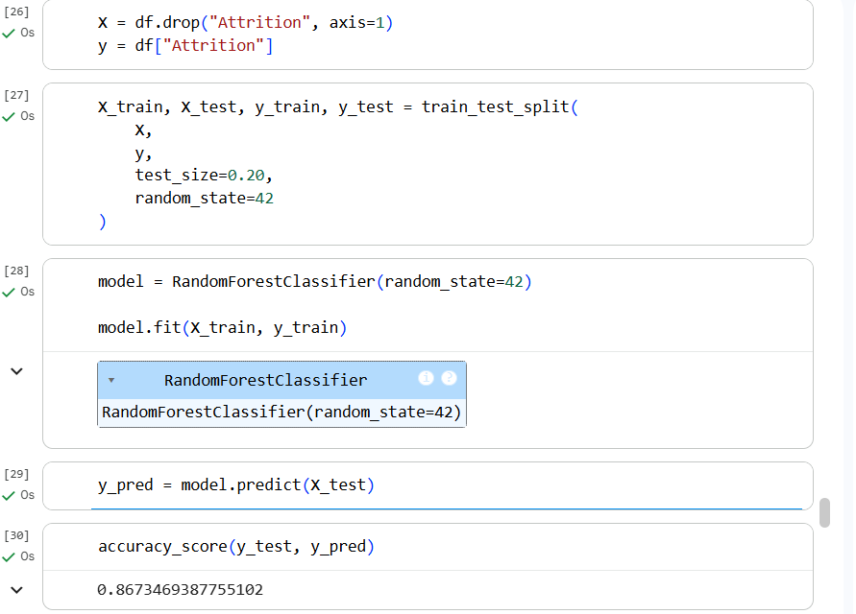
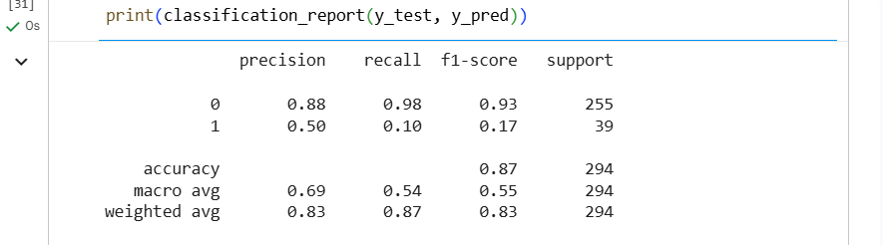
Screenshot:
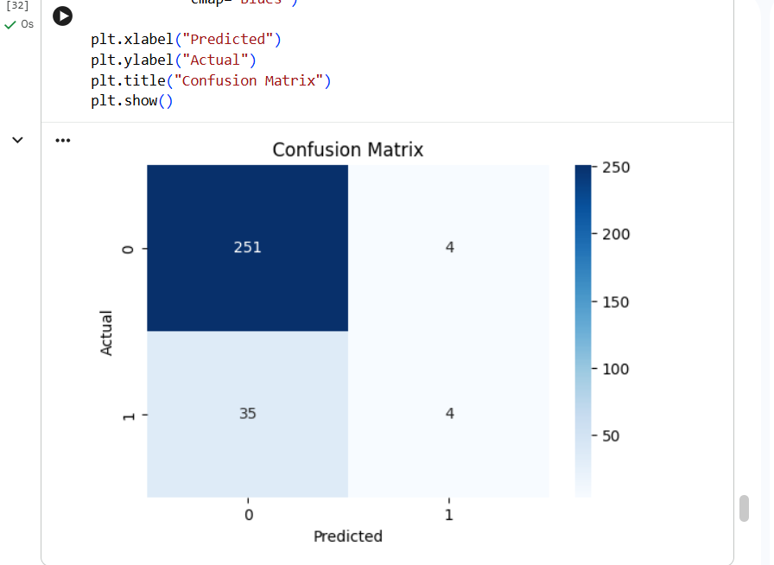
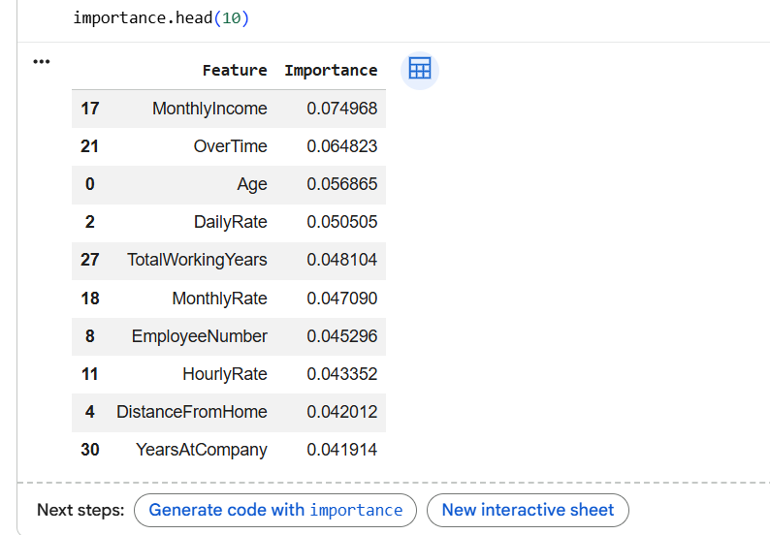

Feature Importance
Feature importance analysis was performed using the Random Forest model to identify the variables that contribute most to predicting employee attrition.
Screenshot:
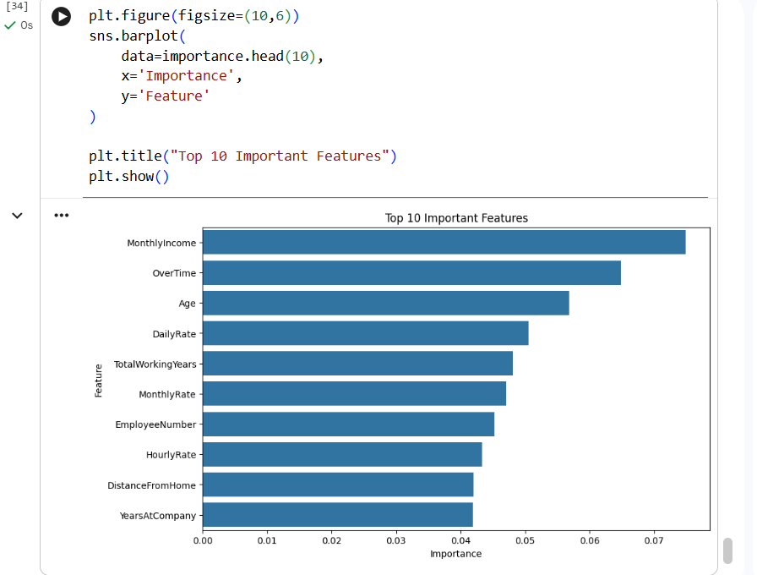
Observation
The most influential features included:
- OverTime
- Monthly Income
- Age
- Total Working Years
- Job Satisfaction
- Years at Company
- Job Level
- Stock Option Level
- Distance From Home
- Work-Life Balance

Key Insights
- Most employees remained with the company, while a smaller proportion experienced attrition.
- Employees working overtime showed a significantly higher likelihood of leaving the organization.
- Lower monthly income was strongly associated with employee attrition.
- Poor job satisfaction contributed to higher resignation rates.
- Employees with poor work-life balance were more likely to leave.
- Sales-related job roles experienced comparatively higher attrition.
- Feature importance analysis identified OverTime, Monthly Income, Age, and Job Satisfaction as the strongest predictors of employee attrition.

Conclusion
The HR Analytics Employee Attrition Prediction project successfully explored employee-related data using Python-based data analysis and machine learning techniques. Exploratory Data Analysis revealed several factors contributing to employee attrition, including overtime, monthly income, job satisfaction, work-life balance, and years at the company. A Random Forest Classifier was developed to predict employee attrition with good accuracy, providing valuable insights for HR departments. The findings can assist organizations in designing effective employee retention strategies, improving workplace satisfaction, and reducing turnover. This project demonstrates the practical application of data analytics and machine learning in solving real-world Human Resource management problems.

