HYDROCLEAR:
A Hydraulic Canal Waste Collection System
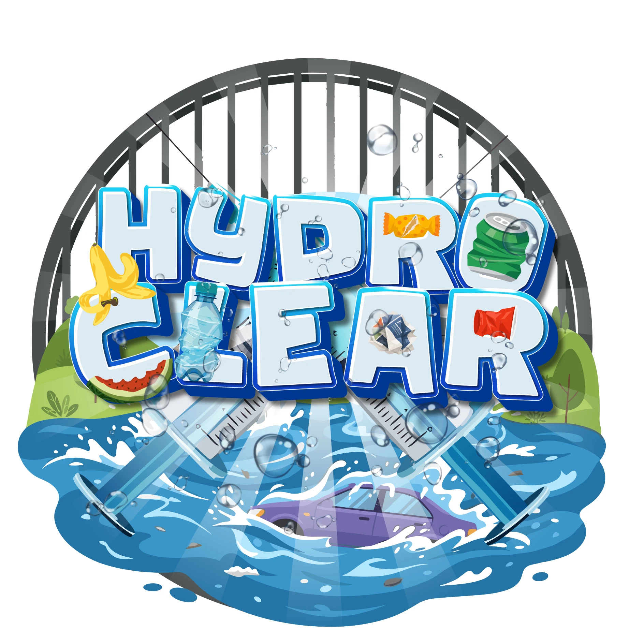
In Partial Fulfillment of the Requirements for General Physics 1
Balanon, Princess Angeli O.
Bano, Matthew Angelo D.
Canlas, Rinoa Heart J.
Flores, Chase Jarish C.
Guevarra, Rhianna J.
Ocampo, Michan Calyx S.
Regala, Leon Vito S.
Sazon, Michelle Anne J.
Sumang, Wohan Jace P.

