PERFORMANCE CHECK 2
I. INTRODUCTION
Flooding is a common problem in many communities, especially during periods of heavy rain. While several factors can contribute to flooding, the accumulation of waste in canals and other waterways can interfere with the normal flow of water. Plastic bags, food wrappers, leaves, and other debris may collect along the sides or become trapped in certain sections of a waterway, particularly in roadside canals and drainage areas. During heavy rainfall, this buildup may further restrict the passage of water and contribute to flooding. Situations like these led us to focus on one specific and manageable aspect of the problem: the collection and removal of waste from canals before it becomes a larger obstruction.
Evidence and Testimonials: Waste-Clogged Waterways Worsen Flooding
Global Evidence
Around the world, poorly managed garbage is a recognized cause of urban flooding. The World Bank estimated that the world produced 2.01 billion tonnes of municipal solid waste in 2016 and projected that this would reach 3.40 billion tonnes by 2050 (Kaza et al., 2018). Waste that is not collected properly ends up in drains and waterways, where it blocks the flow of water.
Some countries have changed their laws because of this problem. Bangladesh became the first country in the world to ban thin plastic bags after it was found that they "played a key role in clogging drainage systems during disastrous flooding" (United Nations Environment Programme [UNEP], 2021). In Accra, Ghana, at least 150 people died during the flood of June 3, 2015, when a fire broke out in the flooded city, and witnesses afterward described "clogged drains filled with plastic waste, household refuse, and debris" (Darkwah, 2026).
The problem is especially serious for the Philippines. A global study of river plastic estimated that Philippine rivers carry about 356,371 metric tons of plastic into the ocean every year, roughly 36% of the world's riverine plastic emissions and the largest share of any country (Meijer et al., 2021). Much of this plastic passes through canals and drains on its way to the sea.
Local Evidence
In July 2025, continuous rain flooded 223 barangays across 18 local government units in Pampanga and affected 527,648 residents, including families in Guagua, Bacolor, Sasmuan, Candaba, and the City of San Fernando (GMA Regional TV News, 2025b). In the same month, the Metropolitan Manila Development Authority (MMDA) collected 603 tons of garbage from 71 pumping stations and flooded areas in just five days, and identified 49 areas where flooding was caused by garbage-clogged drainage ("MMDA: Over 600 Tons," 2025).
"Our drainage system is antiquated, more than 50 years old. So these drainage systems cannot accommodate sofas, refrigerators and other big garbage." "Addressing the flood problem is not the responsibility of the government alone. We have to work together, we need the participation of everybody, especially on the aspect of garbage disposal."
Don Artes, MMDA Chairman ("MMDA: Over 600 Tons," 2025)
Closer to home, heavy rain and piled-up garbage blocked a National Irrigation Administration (NIA) floodgate at Matubig Creek in Santa Ana, Pampanga, on September 1, 2025. The creek overflowed, broke the slope protection of its earth dike, and flooded nearby villages and rice fields. The municipal disaster office reported that about 30 truckloads of garbage had to be removed before the water returned to normal (GMA Regional TV News, 2025a).
Santa Ana Mayor Dinan Labung recalled that once the slope protection broke, water rushed into the rice fields, and the damage reached as far as San Pablo, which went underwater. Vice Governor Dennis Pineda pointed out that people often forget whose duty it is to look after the creek's check gates, and suggested meeting with the mayors and the NIA to assign that duty at the barangay and municipal levels.
Testimonies translated from Filipino and paraphrased (GMA Regional TV News, 2025a)
A 2025 study of the canals along Lazatin Boulevard in the City of San Fernando, Pampanga, found that waste washed into the canals took up about 20% of their drainage volume, and that their capacity to carry water dropped sharply as clogging increased. The researchers concluded that waste accumulation significantly affects the drainage system along the boulevard and leads to clogging and possible flooding (Gob et al., 2025). Large sums have also been spent on flood control, yet when government teams validated the first 8,000 flood control projects in 2025, 421 of them turned out to be "ghost" projects (Mangaluz, 2025). These findings show why communities need practical solutions they can build and maintain themselves.
Our project, HYDROCLEAR, is a hydraulic canal waste collection system presented through a roadside diorama. A bar screen is positioned across the canal to catch floating debris while letting the flow pass through. Once the waste has collected against the screen, two hydraulic mechanisms work in sequence to remove it. The first mechanism, a toothed rake, lifts the collected waste up the face of the screen to its top, while the second, a pusher, sweeps it from the top of the screen into the cargo bed of a waste collection truck that backs up beside the screen. Once loaded, the truck carries the waste away so it can be shipped for proper disposal.
The system operates through two separate hydraulic circuits made from syringes and clear tubing, each sealed with air inside. When a master syringe is pressed, the pressure exerted on the enclosed air is transferred through the tubing to its corresponding slave syringe, causing the plunger to extend. One circuit controls the lifting mechanism, while the other controls the pushing mechanism. This allows the collected waste to be transferred from the canal to the truck through manual hydraulic control.
The prototype applies two physics concepts in a practical application: Pascal's Principle, which explains how pressure applied to the enclosed air in one syringe is transmitted to the other, and Work, which describes the force and distance involved as the rake and pusher move the waste. Rather than addressing flooding as a whole, the project focuses on waste accumulation in waterways as one factor that can be addressed through mechanical collection. Through this project, we aim to show that addressing environmental problems does not always require expensive or complicated technology. By developing a low-cost and manually operated prototype, we hope to demonstrate a simple approach to reducing waste buildup in canals and explore how small-scale innovations can contribute to efforts toward reducing flooding in communities.
II. PRESENTATION OF THE PROTOTYPE
The final output is a roadside diorama depicting a canal-side street. A modeled canal runs alongside the road, holding floating trash against a bar screen. The scene includes terrain, roadside elements, and infographic panels presenting the social issue. Beside the canal sits the hydraulic mechanism, operated through a labeled control panel marked LIFT and PUSH.
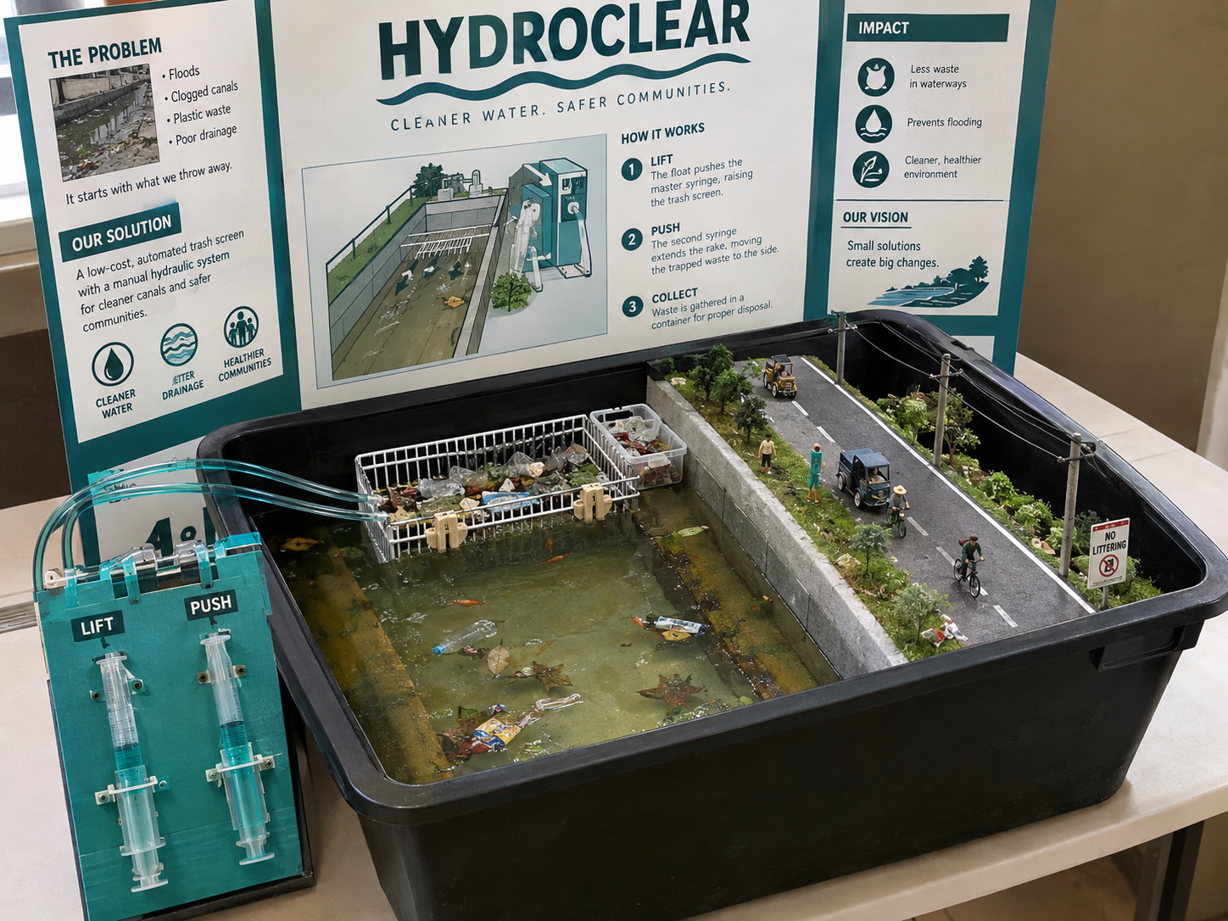
Figure 1. Final Design Visualization of the HYDROCLEAR Exhibit
Note. Visualization of the finished prototype with its display board and LIFT and PUSH control panel. The display board text shown is a layout placeholder, and the final placement of the parts follows Figure 2.
The diorama is built inside a 65 cm by 30 cm black storage box (Figure 2). From left to right, the box is divided into four strips that run its full 30 cm width. The left 10 cm is the truck loading bay, a 10 cm by 30 cm strip built like a road, with the model truck parked in reverse at its back end beside the bar screen. The next 10 cm is the canal, which is only as wide as the bar screen; its surface is made of tissue and glue, acrylic paint, and a coat of epoxy resin, and the bar screen and rake sit at its back end. The third 10 cm strip holds the pusher at the back, under a Sintra board cover, with the sloped concrete canal ramp (10 cm by 20 cm) south of it. The right 35 cm of the box is the roadside scene (35 cm by 30 cm). Everything sits on one platform raised about 15 cm off the bottom of the box by wood blocks, which leaves open space underneath for the lift syringe and its tubing.
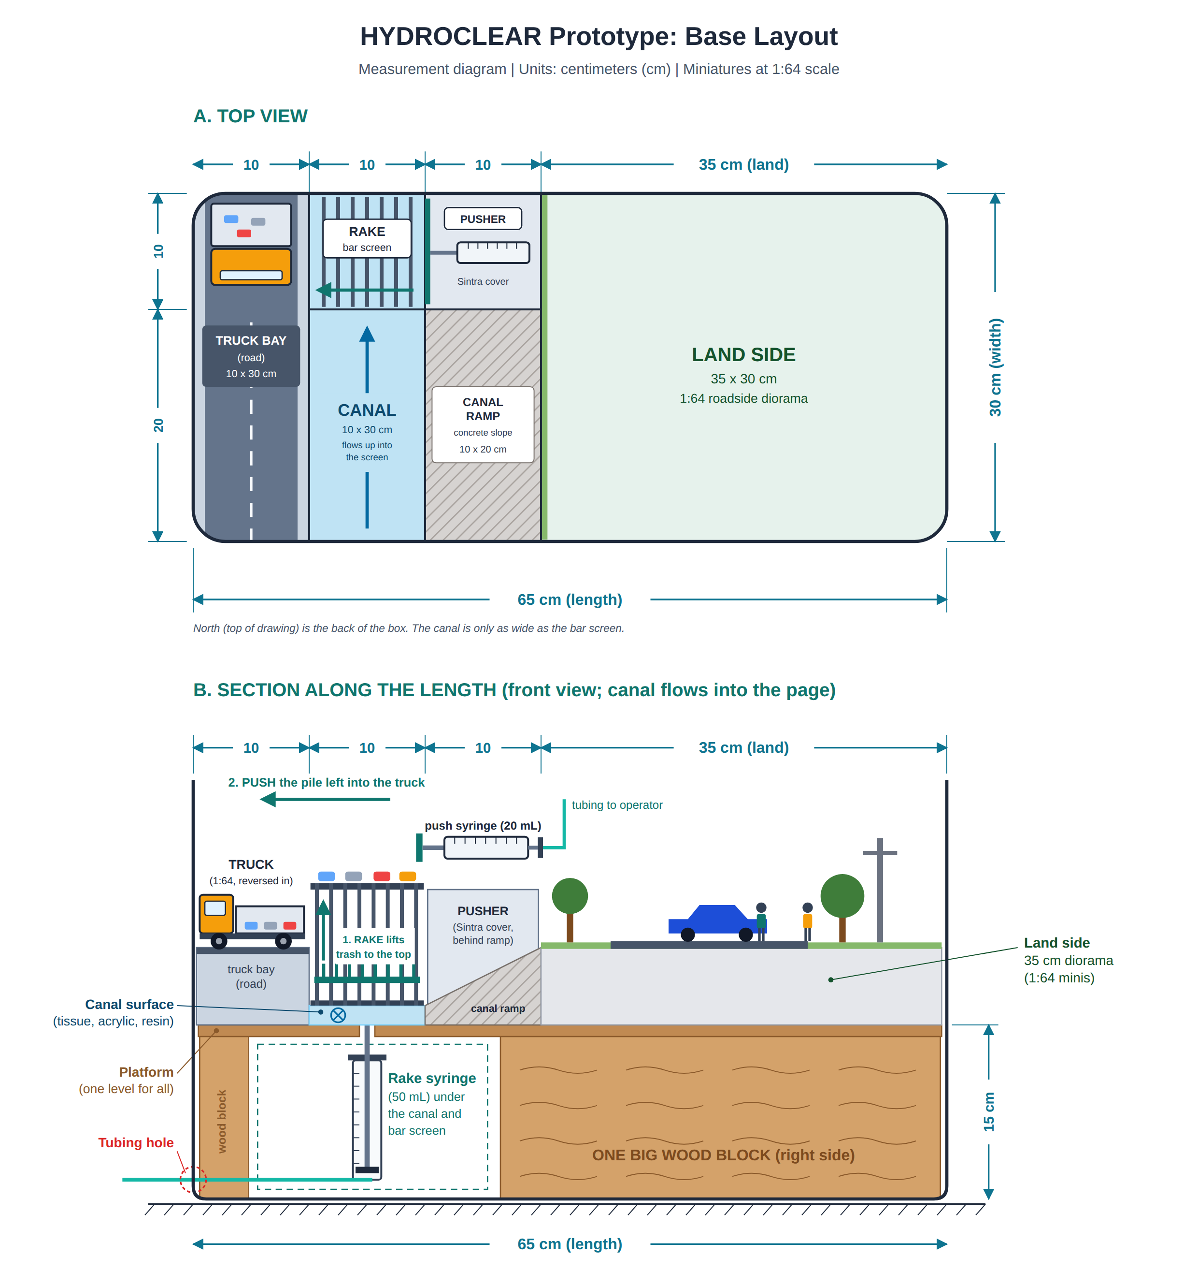
Figure 2. Base Layout of the HYDROCLEAR Prototype
Note. Top view (A) and front section view (B) of the diorama. Dimensions are in centimeters; heights and layer thicknesses are not to scale. Illustration by the group.
Parts of the Prototype
1.) Bar Screen.
A fixed grid of vertical bars, made from a bath metal basket, installed across the canal. The flow passes through the gaps between the bars, while debris larger than the gap spacing is retained on the upstream face. This concentrates debris at a single, fixed location that the lift and push mechanisms are positioned to act on.
2.) Lift Syringe (Slave 1) and Rake.
Mounted upright beneath the platform, below the middle third of the bar screen, with its plunger passing through a hole cut through the platform. The plunger is connected to a toothed rake whose teeth fit between the bars of the screen. Pressing the corresponding master syringe transmits hydraulic pressure through the tubing to this slave, extending its plunger. The extension raises the rake along the face of the bar screen, carrying the debris retained on the screen from the canal surface up to the top of the screen.
3.) Push Syringe (Slave 2) and Pusher Plate.
Mounted horizontally at the top of the screen, aligned toward the truck loading bay. Once debris has been raised to the top of the screen by the rake, pressing the corresponding master syringe extends this slave horizontally. The extension drives a pusher plate (Sintra board) across the top of the screen, displacing the debris off the edge and into the cargo bed of the waiting truck.
4.) Operator / Control Panel (2 Master Syringes).
Houses the two master syringes that provide manual input to the two independent hydraulic circuits: a 50 mL syringe for LIFT and a 20 mL syringe for PUSH. The panel is labeled LIFT and PUSH to indicate the required operating sequence: the lift circuit must be actuated first to raise debris to the top of the screen, followed by the push circuit to clear it into the truck.
5.) Clear Tubing.
Connects each master syringe to its own paired slave syringe, carrying the pressure of the enclosed air between them. The two circuits are entirely separate from each other, which is why the lift and the push can be, and must be, triggered one after the other rather than at the same time.
6.) Elevated Plywood Platform.
Raised about 15 cm above the bottom of the box by wood blocks, with a hole sized to the lift syringe's plunger and aligned to the bar screen. It holds the canal, screen, truck loading bay, and roadside diorama at one level, and the open space underneath holds the lift syringe. The platform height and hole placement determine the stroke length required of the lift syringe.
7.) Truck Loading Bay and Collection Truck.
A raised 10 cm by 30 cm loading bay, built like a road, beside the bar screen and at the end of the pusher's path. A 1:64 model truck is parked in reverse at the bay, with its open cargo bed just below the top of the screen, so that debris pushed off the screen drops straight into it. In real use, the truck backs up to the bay before the clearing cycle, receives the waste, and then drives away to deliver it to a disposal or recovery facility, so the collected waste never returns to the canal.
8.) Screen Cover.
Sintra board or cardboard placed over the part of the screen area that the rake does not reach. It hides the push syringe housing and keeps the debris on the working section of the screen.
Materials Used
Materials | Description
Mechanism
Syringes (4 total: two 50 mL and two 20 mL) | Two act as operator (master) syringes; one 50 mL slave drives the lift mechanism, and one 20 mL slave drives the push mechanism.
Clear tubing (oxygen mask tube) | Carries hydraulic pressure from each master syringe to its paired slave syringe, running from the operator panel to the mechanism.
Bath metal basket | Forms the bar screen and the toothed rake.
Hair clamp (1) | Holds the connected rake and pusher parts in place.
Sintra board | Forms the pusher plate.
Zip ties | Mount and secure the syringes in place.
Small wood board | Forms the operator panel, painted teal and labeled LIFT and PUSH.
Structure
Black plastic storage box (65 cm by 30 cm) | Houses the whole diorama and mechanism.
Plywood | Forms the elevated platform inside the box, cut to fit the box interior at platform height, with a hole for the lift syringe.
Wood blocks | Support legs under the platform, leaving clearance underneath for the syringes.
XPS foam | Shapes the road base of the diorama.
Sintra board or cardboard | Forms the truck loading bay and the screen cover.
Silicone sealant | Seals the tubing hole in the box and the joints of the hydraulic circuits to prevent leaks.
Decoration
Illustration board | Forms the base of the canal, cut to size with the corners rounded to match the box. Also forms the display board.
Tissue | Mixed with glue to create the canal surface and terrain texture.
Epoxy resin | Coats the canal surface for a glossy finish.
Acrylic paint (gray, white, green, brown, black, teal) | Paints the canal surface, concrete canal slope, road, terrain, structures, and mechanism housing.
Grass powder | Represents the grass verge and the top of the canal wall.
Barbecue sticks, toothpicks, black thread | Represent electricity poles, crossarms, and wires.
People figures | Represent pedestrians along the road, including at least one walking figure.
1:64 model truck (dump or garbage truck) | Represents the collection truck that backs up to the loading bay to receive the waste.
Cardboard | Forms the mountain side and small details, such as houses and signs.
Thin plastic | Represents plastic bag pieces (ice, bread, or sando bags) floating in the canal.
Snack wrappers and sachets | Cut small to represent floating solid waste in the canal.
Dried leaves | Crushed small to represent organic debris collecting on the screen.
Clear plastic packaging | Shaped into miniature bottles to add to the floating trash.
Photo paper | Prints the infographics, photos, and the NO LITTERING sign.
Illustration board or foam board | Mounts the printed infographic panels.
Double-sided tape and foam tape | Mounts the infographic panels to their backing.

PERFORMANCE CHECK 3
III. DISCUSSION OF THE PROTOTYPE
A. How Does the Project Work?
HYDROCLEAR is a proposed hydraulic screen-clearing system designed to remove accumulated debris from canals and drainage inlets. The system consists of a bar screen, a hydraulic rake mechanism, a hydraulic pusher mechanism, a ledge at the top of the screen, and a truck loading bay where a collection truck receives the waste. The system primarily applies Pascal's Principle to transmit the mechanical force required to remove debris from the screen.
During rainfall, stormwater enters the canal or drainage inlet and passes through the openings of the bar screen. Leaves, plastic, food packaging, and other solid waste are retained on the upstream face of the screen. As debris accumulates, the available openings through which water can pass become reduced, which can restrict the flow of stormwater into the drainage channel.
To clear the blockage, the first hydraulic mechanism is operated. A master syringe is connected to a slave syringe through flexible tubing containing an enclosed fluid (air). When force is applied to the master syringe, pressure is transmitted through the fluid to the slave syringe in accordance with Pascal's Principle. In our prototype, both syringes in each circuit have the same piston area, so the slave syringe produces an output force equal to the input force under ideal conditions. In a full-scale system, a slave cylinder with a larger piston area would produce a greater output force.
The slave syringe is positioned beneath the platform, below the canal, and is connected to a toothed rake. As the slave syringe moves, it raises the rake along the face of the bar screen. The teeth of the rake fit between the bars of the screen, allowing it to lift accumulated debris from the screen and carry it toward the ledge at the top.
Once the debris reaches the ledge, the second hydraulic mechanism is operated. A second master-and-slave syringe arrangement drives a horizontal pusher plate across the ledge. The pusher moves the collected debris away from the screen and into the cargo bed of a truck parked in reverse at the loading bay, preventing the debris from returning to the drainage channel.
After the clearing process, the hydraulic mechanisms are released and the rake and pusher return to their initial positions, and the loaded truck drives away to deliver the waste for proper disposal. The process therefore allows the accumulated debris to be removed from the screen and transferred to a designated collection area without requiring direct manual removal from the drainage opening. Figure 3 summarizes this four-step cycle.
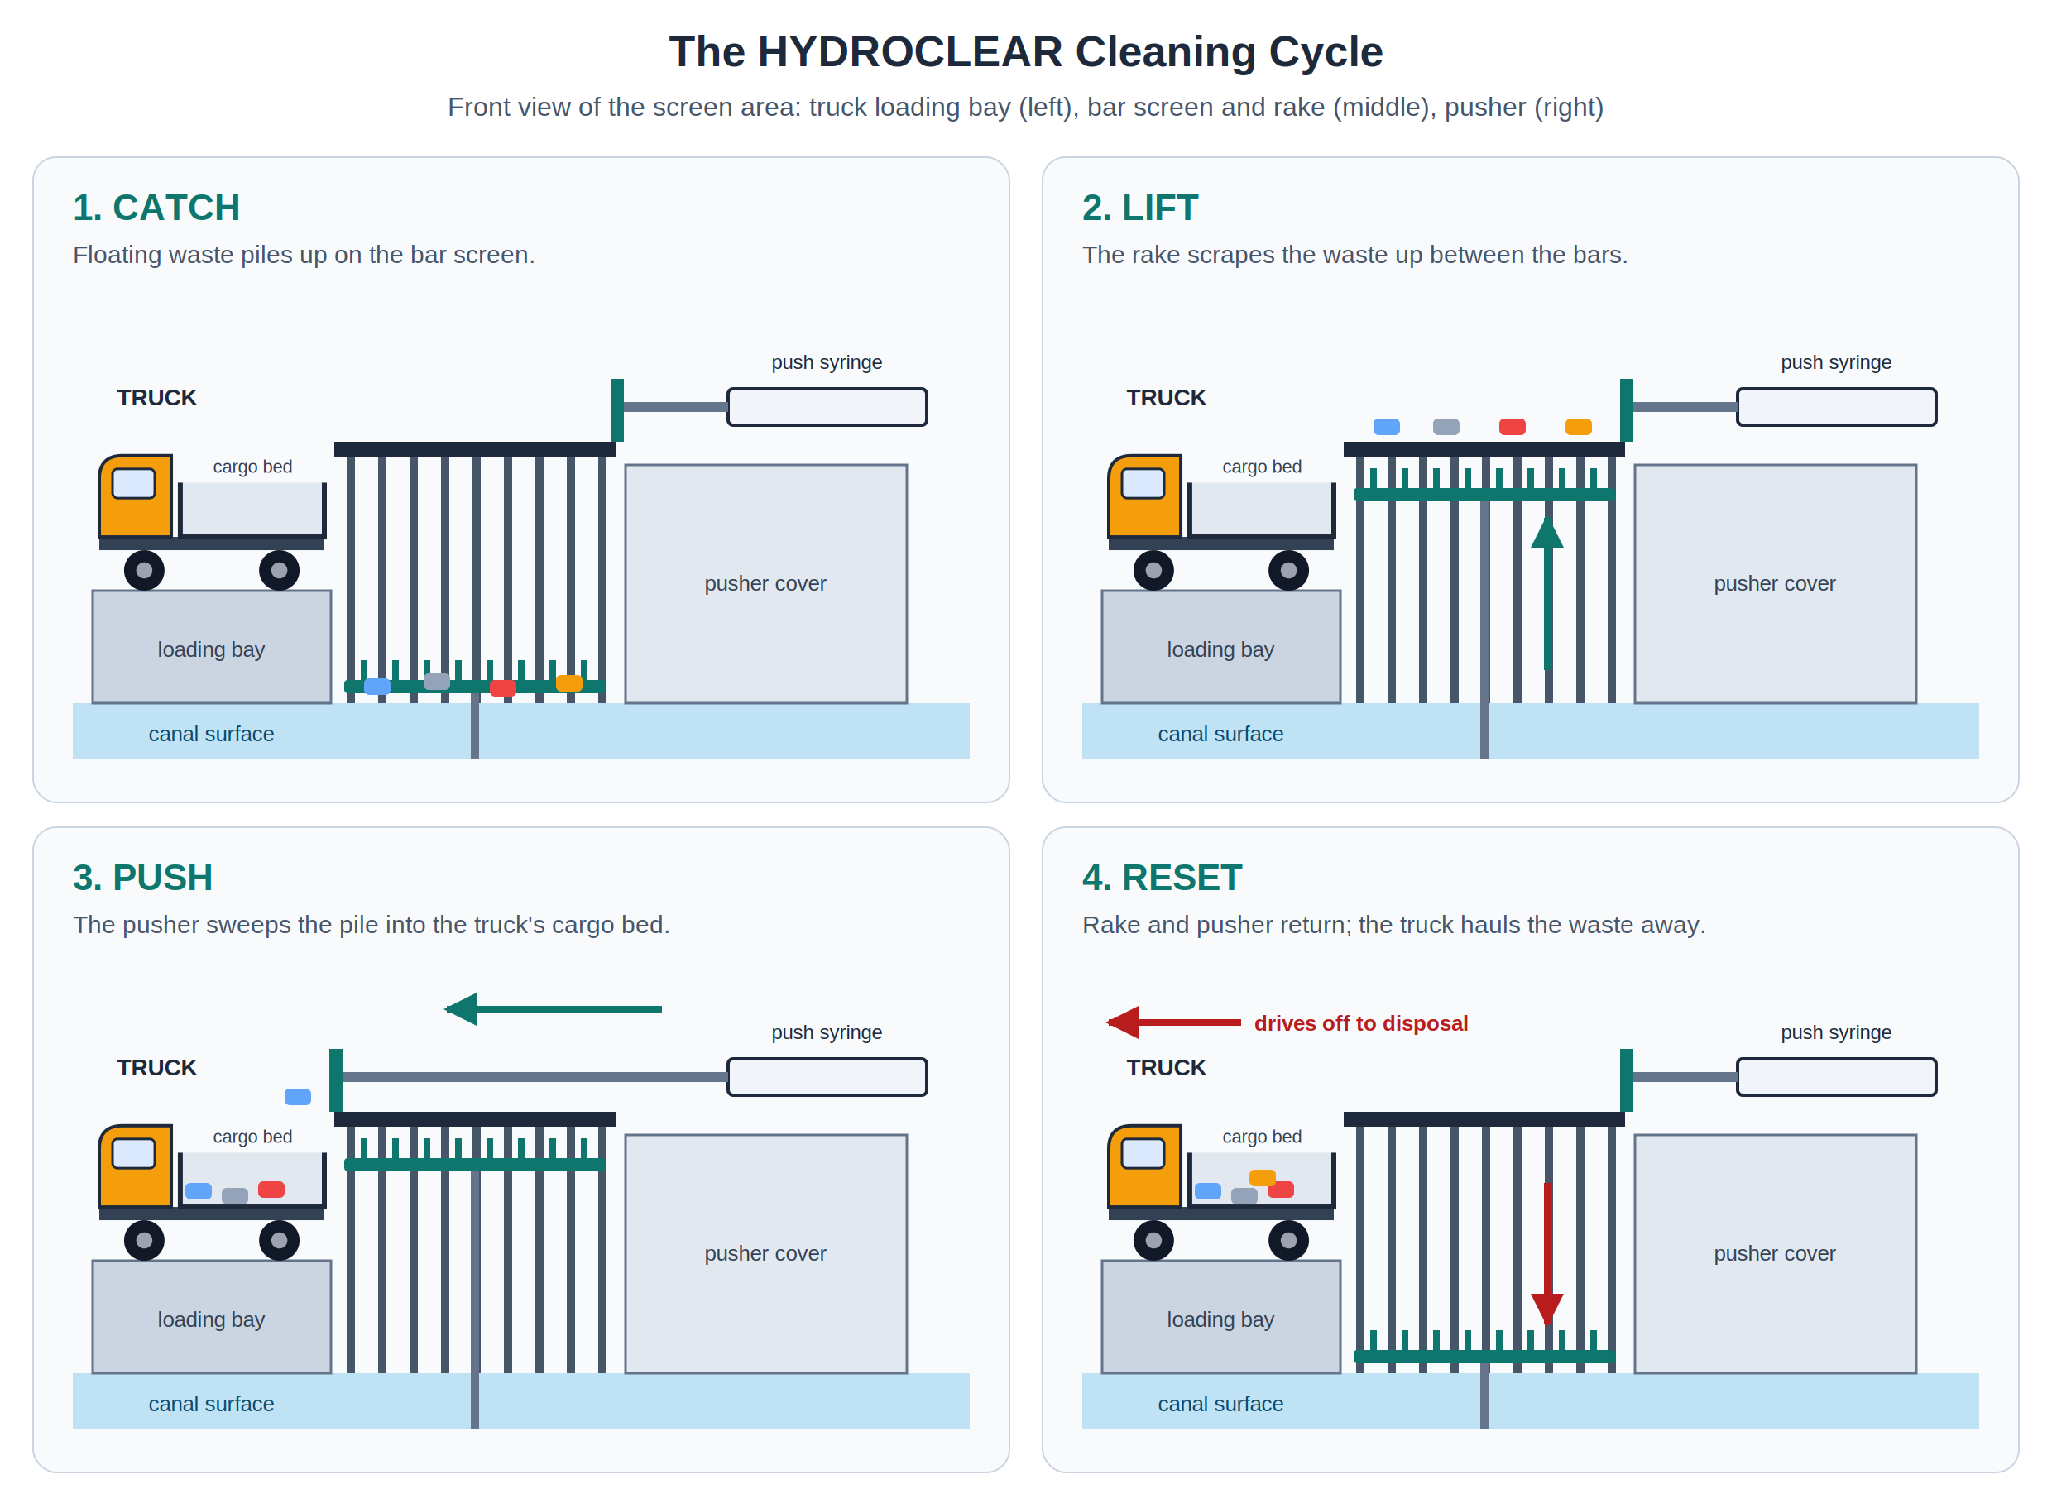
Figure 3. The HYDROCLEAR Cleaning Cycle
Note. Front view of the screen area in each step: catch, lift, push, and reset. Illustration by the group.
In the scaled prototype, the hydraulic mechanisms are operated manually through the master syringes. This allows the transmission of pressure and the movement of the rake and pusher to be directly observed during the demonstration.
B. Where Is It Used?
HYDROCLEAR is intended for use in canals and urban drainage inlets, particularly in low-lying communities where solid waste frequently accumulates and obstructs stormwater drainage. The proposed application of the project is Barangay Plaza Burgos, Guagua, Pampanga. Guagua was among the towns affected when floods reached 223 barangays and more than half a million residents in Pampanga in July 2025 (GMA Regional TV News, 2025b).
The project addresses the social issue of solid-waste accumulation in canals and drainage inlets and its potential contribution to localized street flooding. Leaves, plastic, food packaging, and other debris can accumulate on drainage screens and reduce the available area for stormwater to enter the drainage system. During rainfall, a restricted inlet may cause water to accumulate on the street, particularly when the amount of incoming water exceeds the reduced capacity of the blocked opening. This has been observed locally: the MMDA traced flooding in 49 areas to garbage-clogged drainage ("MMDA: Over 600 Tons," 2025), garbage at a blocked floodgate caused a creek in Santa Ana, Pampanga, to overflow (GMA Regional TV News, 2025a), and waste in the canals along Lazatin Boulevard in San Fernando was found to cut their drainage capacity (Gob et al., 2025).
HYDROCLEAR also addresses the safety concerns associated with manual drainage clearing. Conventional clearing may require residents or maintenance personnel to manually remove debris from or near the drainage inlet. This can expose them to contaminated water and potentially sharp or hazardous waste. HYDROCLEAR provides a mechanical method of lifting debris from the screen and loading it directly into a collection truck, reducing the need for direct contact with the accumulated waste. Because the waste goes straight into a truck, it can be hauled away at once instead of being piled on the canal bank, where the next rain could wash it back into the water.
The project is particularly relevant to communities where drainage inlets are frequently exposed to solid waste and where timely removal of debris is necessary to maintain the flow of stormwater. By integrating a bar screen with two hydraulic mechanisms, HYDROCLEAR demonstrates how principles of fluid mechanics can be applied to develop a practical approach to drainage maintenance. It also fits the local call for shared responsibility: MMDA Chairman Don Artes stressed that solving floods needs "the participation of everybody, especially on the aspect of garbage disposal" ("MMDA: Over 600 Tons," 2025), and Vice Governor Dennis Pineda suggested assigning the upkeep of waterway gates at the barangay level (GMA Regional TV News, 2025a). A simple hand-operated cleaner gives a barangay a practical tool for that duty.
The proposed system is intended to help maintain the flow capacity of drainage inlets and reduce the contribution of inlet blockage to localized flooding. It is not intended to eliminate flooding entirely, since flooding can also be affected by rainfall intensity, drainage capacity, downstream conditions, and other environmental factors.
C. Application and Relevance of the Concepts
HYDROCLEAR applies two physics concepts: Pascal's Principle and Work. Figure 4 shows how both concepts act in the two hydraulic circuits, and Table 1 summarizes where each concept appears in the prototype.
1. Pascal's Principle
HYDROCLEAR applies Pascal's Principle through its two hydraulic mechanisms. When force is applied to the master syringe, pressure is transmitted through the enclosed air to the corresponding slave syringe. This allows the system to produce the force needed to move the rake and pusher, demonstrating how hydraulic pressure can be applied to perform mechanical work. The air sealed inside each circuit acts as the fluid that transmits pressure through the tubing, since gases, like liquids, are fluids.
Definition. When you push on a fluid (a liquid or a gas) that is completely enclosed, the extra pressure you create does not stay where you pushed. It spreads equally to every part of the fluid and to every wall of its container. Since pressure is force divided by area ($P=\frac{F}{A}$), the same pressure acting on two pistons gives $P_{\text{inc}}=\frac{F_{1}}{A_{1}}=\frac{F_{2}}{A_{2}}$, so $F_{2}=F_{1}\left(\frac{A_{2}}{A_{1}}\right)$.
Application in the prototype.
- Each circuit is an enclosed fluid. The air is sealed inside the master syringe, the tubing, and the slave syringe, so the pressure created at the panel reaches the rake or pusher undiminished.
- Same-size syringes transmit the force. In each circuit, $A_{2}=A_{1}$, so $F_{2}=F_{1}$. The operator's push is carried to the mechanism without being multiplied (Sample Problem 3).
- Air compresses. Unlike a liquid, air squeezes into a smaller volume when pushed, so part of each push is used up compressing the air before the slave plunger moves. The slave therefore lags slightly behind the master, and the group keeps the tubing short and every joint sealed so the response stays firm.
- Syringe sizes match the job. The larger 50 mL syringes run the rake, which lifts trash against gravity over the full height of the screen. The smaller 20 mL syringes run the pusher, which moves trash sideways and fits the narrow space at the top of the screen.
Real-life examples. A car's brakes work the same way: pressing the pedal pushes on brake fluid in a master cylinder, and the pressure is transmitted through the brake lines to the cylinders at each wheel (Urone & Hinrichs, 2022). A hydraulic car lift in a repair shop uses a small piston and a large piston so that a mechanic can raise a whole car with a much smaller force.
Relevance. Without Pascal's Principle, the operator would have to reach into the canal to move the rake. The enclosed air lets the push travel around corners, under the platform, and through the box wall, which makes hands-free cleaning possible.
2. Work
The project also demonstrates Work and Energy, as the force applied by the operator is transferred through the hydraulic system and converted into mechanical movement of the rake and pusher. The force and displacement involved must be sufficient to lift and transfer the accumulated debris.
Definition. Work is done when a force makes an object move, and the force (or part of it) points along the direction of the motion. Work equals force times the distance moved, $W=Fd$, measured in joules (J). If nothing moves, no work is done, no matter how hard you push. When an object is lifted at a steady speed, the work done against gravity equals its weight times the height, $W=mgy$.
Application in the prototype.
- The rake does work on the trash. The rake pushes upward and the trash moves upward, so the force and the displacement are parallel ($θ=0^{∘}$) and the work is at its maximum, $W=Fd$. This work raises the trash against gravity to the top of the screen.
- The pusher does work on the trash. The pusher plate pushes sideways and the trash slides sideways, so it does work moving the pile across the top of the screen.
- Gravity does work as the trash drops into the truck. After the pusher moves the collected debris off the ledge, the trash falls into the truck's cargo bed. Its displacement is downward, parallel to its weight, so the work done by gravity is positive. This shows how gravity can work together with a mechanical mechanism to aid the movement of materials.
- The platform does no work. The platform and wood blocks hold up the weight of the canal and diorama, but nothing moves, so no work is done, just like carrying a book while standing still.
- Work in equals work out. The operator does work on the master syringe ($F_{1}d_{1}$). In an ideal hydraulic system, the slave cannot do more work than was done on it (Urone & Hinrichs, 2022), so $F_{1}d_{1}=F_{2}d_{2}$. Because our circuits use air, part of the operator's work goes into compressing the air, so the master plunger moves slightly farther than the slave and the work output is slightly less than the input. A larger slave cylinder would give a larger force but move a shorter distance, so the work stays the same (Sample Problems 1 and 2).
Real-life example. In car brakes, the force at the wheels is larger than the force on the pedal, but "the wheel cylinder moves through a smaller distance than the pedal cylinder" (Urone & Hinrichs, 2022, Section 11.5). A hydraulic jack shows the same trade-off: a person pumps the handle many times to raise a heavy car a short distance.
Relevance. Work tells us how much effort each press takes and how far each part must move. This helps us check that the cycle is easy enough to run by hand and that the rake travels far enough to bring the trash all the way to the top of the screen.
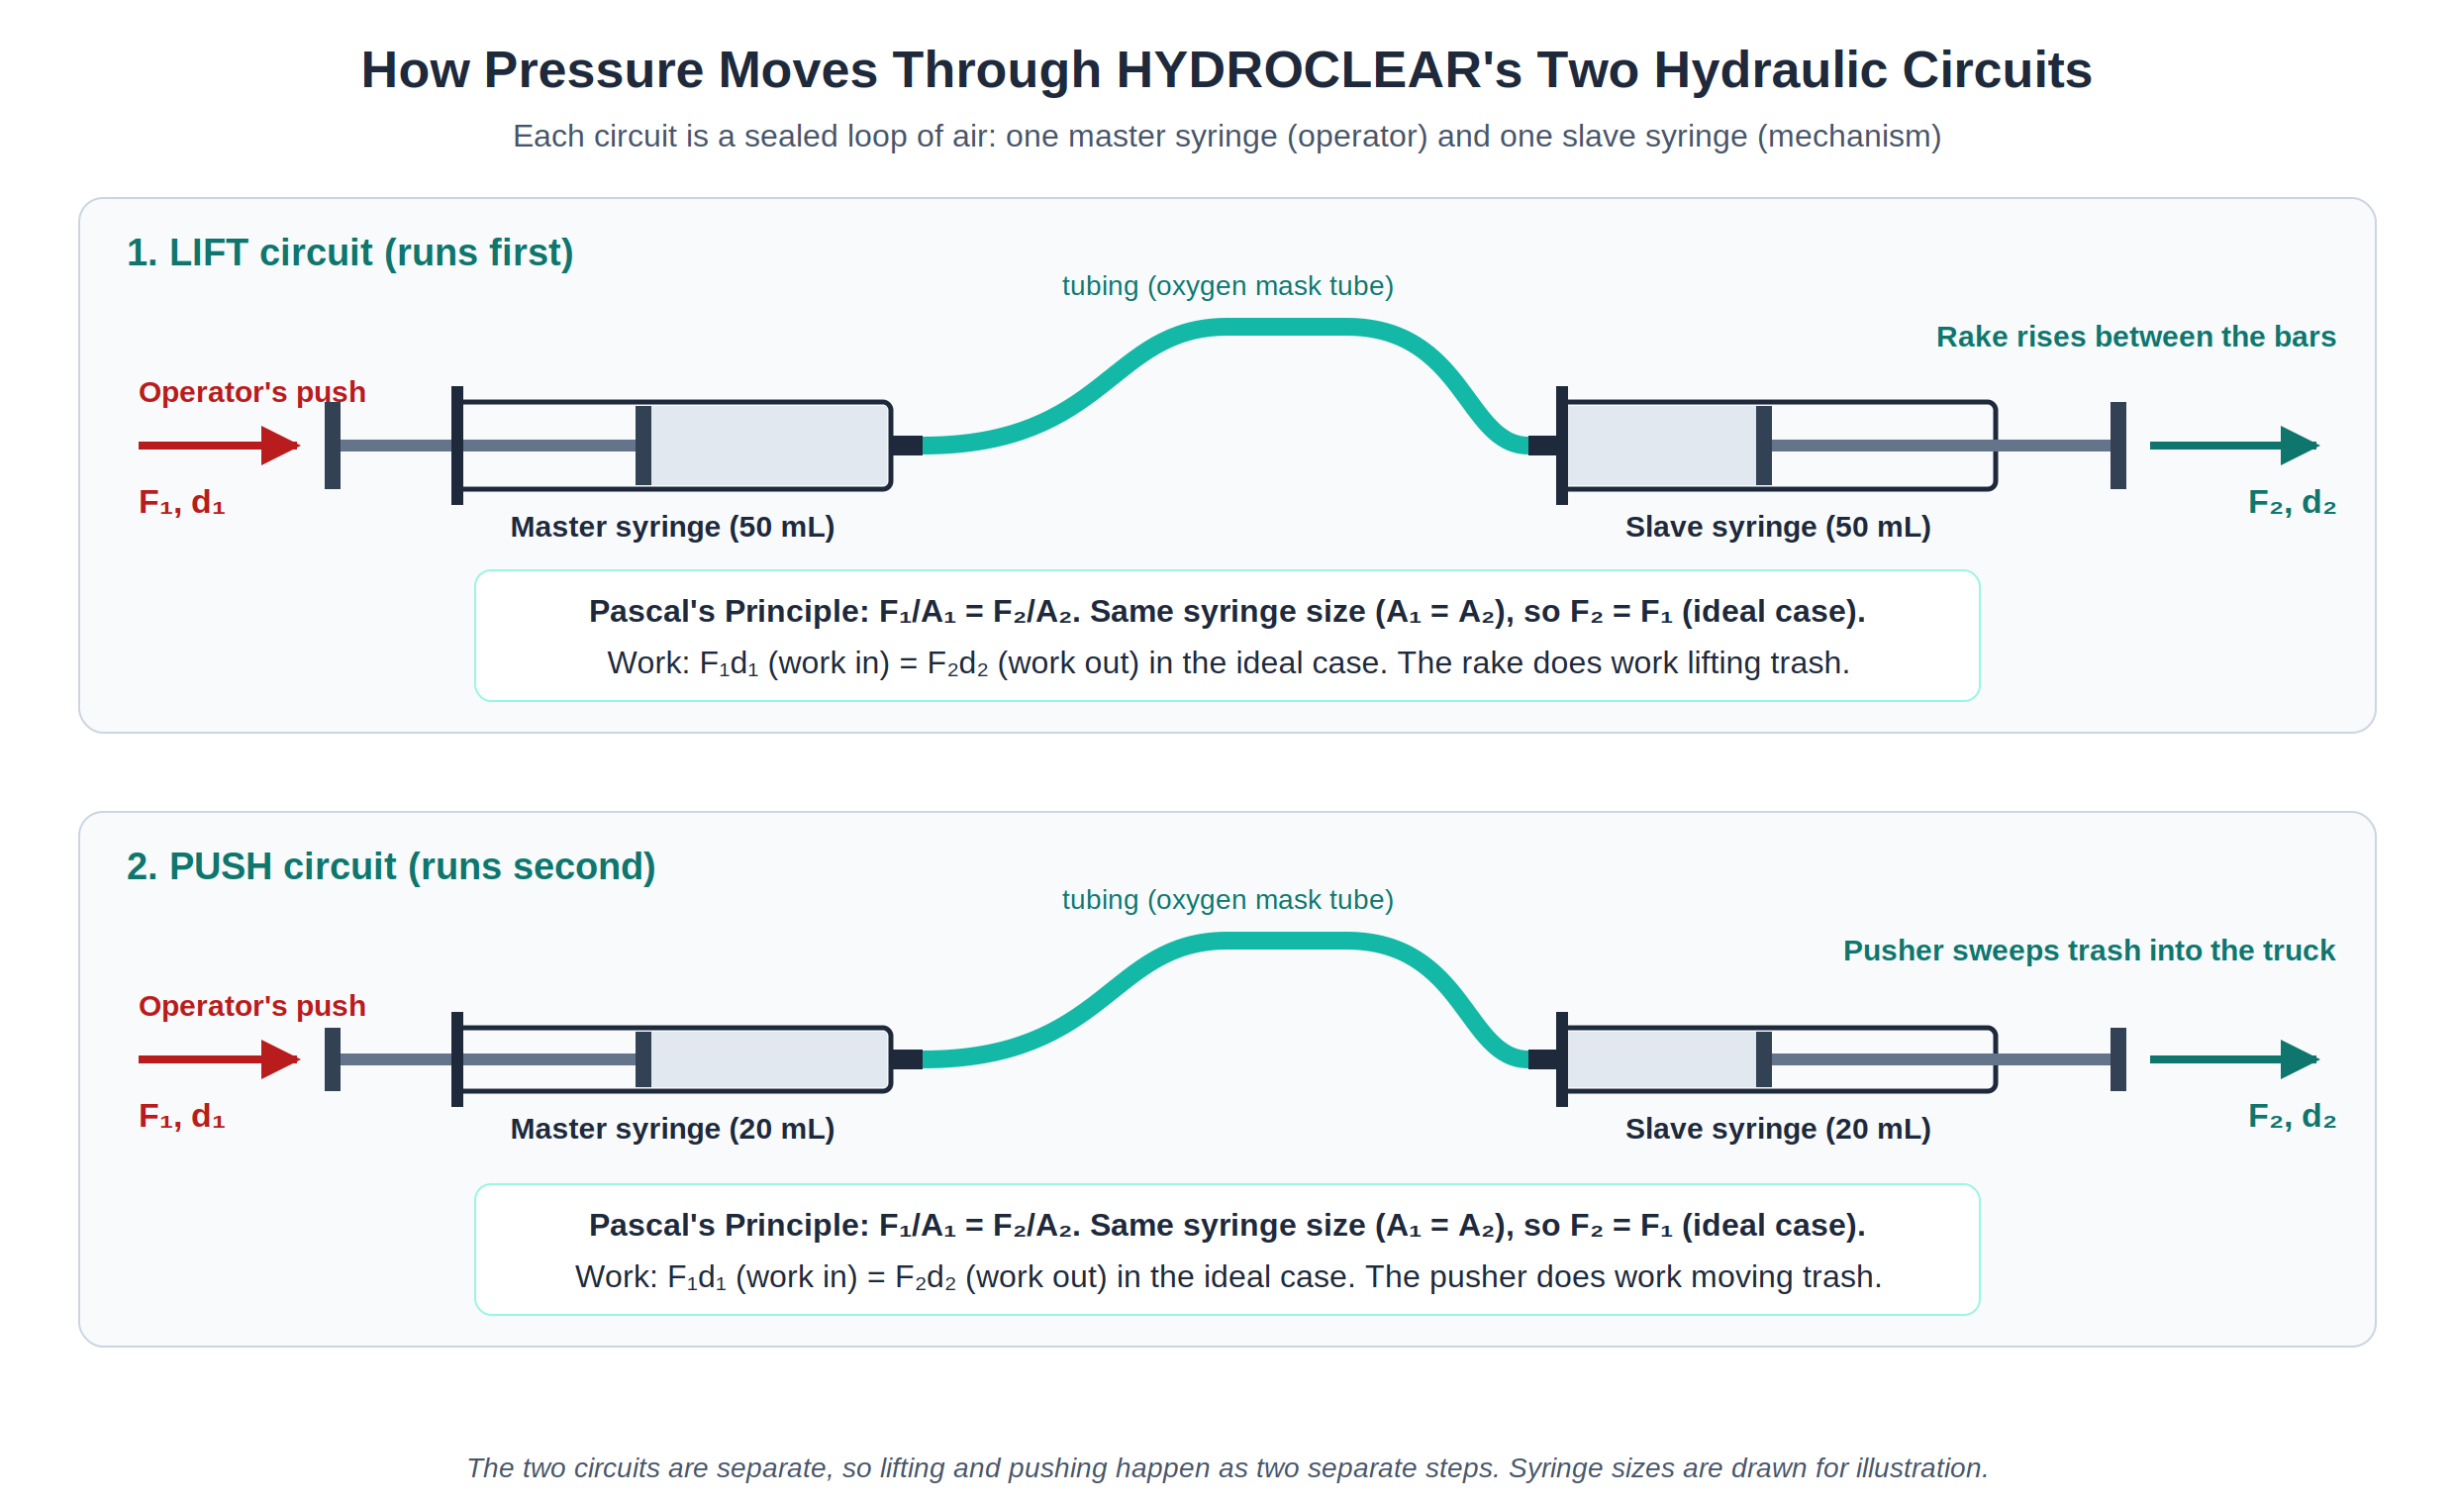
Figure 4. The Two Hydraulic Circuits of HYDROCLEAR
Note. Each circuit is sealed with air inside. Because both syringes in a circuit are the same size, the output force equals the input force. Illustration by the group.
Table 1
Where Pascal's Principle and Work Appear in HYDROCLEAR
Part | Pascal's Principle | Work
Master syringes (LIFT and PUSH) | The operator's push creates pressure in the enclosed air. | The operator does work on the air, $F_{1}d_{1}$.
Tubing | Carries the pressure equally to the slave syringe. | Transmits the push; it does no work of its own.
Lift syringe and rake | Receives the same pressure and pushes the rake up with $F_{2}=F_{1}$. | Does work lifting trash up the screen ($θ=0^{∘}$).
Push syringe and pusher | Receives the same pressure and pushes the plate sideways. | Does work sweeping the trash off the ledge.
Truck cargo bed | Not applied. | Gravity does positive work as the trash drops in.
Platform and wood blocks | Not applied. | No work: it holds weight, but nothing moves.

Overall, these concepts work together to make HYDROCLEAR functional. They demonstrate how fundamental principles of physics can be integrated into a practical system for removing waste from drainage inlets and helping maintain the flow of stormwater.
D. Sample Problems
To show how Pascal's Principle and the idea of work apply in a hydraulic system like HYDROCLEAR's, Sample Problems 1 and 2 use simple hydraulic systems with the same working principle: a small input force on a small piston produces a larger output force on a larger piston. Sample Problem 3 applies the same ideas to the actual LIFT circuit of our prototype. All solutions follow the GAFSA format (Given, Asked, Formula, Solution, Answer).
Sample Problem 1
A hydraulic lift has a small piston of area $10 {\text{cm}}^{2}$ and a large piston of area $250 {\text{cm}}^{2}$. It raises a 150 kg load at constant speed through a height of 0.20 m. Use $g=9.8 {\text{m/s}}^{2}$ and ignore friction.
a.) What is the minimum force needed on the small piston?
b.) How far must the small piston move?
c.) How much work is done on the load?
Given:
$A_{1}=10 {\text{cm}}^{2}$ {= $1.0×{10}^{−3} {\text{m}}^{2}$}
$A_{2}=250 {\text{cm}}^{2}$ {= $2.5×{10}^{−2} {\text{m}}^{2}$}
$$m=150 \text{kg}$$
$$d_{2}=0.20 \text{m}$$
$$g=9.8 {\text{m/s}}^{2}$$
Asked:
a.) I. weight of the load, $F_{2}$
II. force on the small piston, $F_{1}$
b.) distance moved by the small piston, $d_{1}$
c.) work done on the load, $W$
Formula:
a.) I. $F_{2}=mg$ {weight; constant speed}
II. $F_{1}=F_{2}\left(\frac{A_{1}}{A_{2}}\right)$ {Pascal's Principle; hydraulic lift}
b.) $d_{1}=d_{2}\left(\frac{A_{2}}{A_{1}}\right)$ {from $A_{1}d_{1}=A_{2}d_{2}$; same volume of fluid moves}
c.) $W=F_{2}d_{2}$ {Work}
Solution:
a.) I. $F_{2}=\left(150 \text{kg}\right)\left(9.8 {\text{m/s}}^{2}\right)=1470 \text{N}$
II. $F_{1}=\left(1470 \text{N}\right)\left(\frac{1.0×{10}^{−3} {\text{m}}^{2}}{2.5×{10}^{−2} {\text{m}}^{2}}\right)=58.8 \text{N}$
b.) $d_{1}=\left(0.20 \text{m}\right)\left(\frac{2.5×{10}^{−2} {\text{m}}^{2}}{1.0×{10}^{−3} {\text{m}}^{2}}\right)=5.0 \text{m}$
c.) $W=\left(1470 \text{N}\right)\left(0.20 \text{m}\right)=294 \text{J}$ {check: $F_{1}d_{1}=\left(58.8 \text{N}\right)\left(5.0 \text{m}\right)=294 \text{J}$}
Answer:
a.) The minimum force needed on the small piston is about 59 N (58.8 N).
b.) The small piston must move 5.0 m.
c.) The work done on the load is about $2.9×{10}^{2} \text{J}$ (294 J).
The large piston must push up with a force equal to the load's weight, 1,470 N. The fluid pressure needed is that weight divided by the large piston's area. Because pressure is transmitted equally throughout the confined fluid, the same pressure acts on the small piston. The small piston has 1/25 of the area, so it needs only 1/25 of the force to produce that pressure.
The small piston moves 25 times farther than the load rises (5.0 m compared with 0.20 m). With no friction, the work put in equals the work done on the load (294 J). You use a smaller force over a longer distance. The system does not create extra energy. (In real jacks, this long distance is covered by pumping repeatedly.)
The first problem shows that a small force on a small piston can support a much larger load, because the same pressure acts on both pistons, while the small piston moves farther. The second problem examines this trade-off directly by comparing force, distance, and work at both pistons.
Sample Problem 2
A hydraulic jack has a small piston of area $5.0 {\text{cm}}^{2}$ and a large piston of area $150 {\text{cm}}^{2}$. A person pushes the small piston down 30 cm with a force of 80 N. Assume no friction.
a.) What is the force on the large piston?
b.) How far does the large piston rise?
c.) How does the work done on the small piston compare with the work done by the large piston?
Given:
$A_{1}=5.0 {\text{cm}}^{2}$ {= $5.0×{10}^{−4} {\text{m}}^{2}$}
$A_{2}=150 {\text{cm}}^{2}$ {= $1.5×{10}^{−2} {\text{m}}^{2}$}
$$F_{1}=80 \text{N}$$
$d_{1}=30 \text{cm}$ {= $0.30 \text{m}$}
Asked:
a.) force on the large piston, $F_{2}$
b.) distance the large piston rises, $d_{2}$
c.) I. work done on the small piston, $W_{1}$
II. work done by the large piston, $W_{2}$
Formula:
a.) $F_{2}=F_{1}\left(\frac{A_{2}}{A_{1}}\right)$ {Pascal's Principle; hydraulic lift}
b.) $d_{2}=d_{1}\left(\frac{A_{1}}{A_{2}}\right)$ {from $A_{1}d_{1}=A_{2}d_{2}$; same volume of fluid moves}
c.) I. $W_{1}=F_{1}d_{1}$ {Work}
II. $W_{2}=F_{2}d_{2}$ {Work}
Solution:
a.) $F_{2}=\left(80 \text{N}\right)\left(\frac{1.5×{10}^{−2} {\text{m}}^{2}}{5.0×{10}^{−4} {\text{m}}^{2}}\right)=2400 \text{N}$
b.) $d_{2}=\left(0.30 \text{m}\right)\left(\frac{5.0×{10}^{−4} {\text{m}}^{2}}{1.5×{10}^{−2} {\text{m}}^{2}}\right)=0.010 \text{m}$
c.) I. $W_{1}=\left(80 \text{N}\right)\left(0.30 \text{m}\right)=24 \text{J}$
II. $W_{2}=\left(2400 \text{N}\right)\left(0.010 \text{m}\right)=24 \text{J}$
Answer:
a.) The force on the large piston is $2.4×{10}^{3} \text{N}$ (2,400 N).
b.) The large piston rises $1.0×{10}^{−2} \text{m}$ (1.0 cm).
c.) The work done on the small piston (24 J) equals the work done by the large piston (24 J).
Pushing the small piston forces a certain volume of fluid into the large cylinder. The fluid is incompressible, so the same volume must go under the large piston. That piston has 30 times the area, so it rises only 1/30 as far. The same pressure acts on both pistons, so the force on the large piston is 30 times greater.
The force is 30 times larger and the distance is 30 times smaller, so the work is the same at both ends (24 J). With no friction, a hydraulic system trades distance for force. It does not create extra energy.
Sample Problem 3: The LIFT Circuit of the Prototype
During a demonstration, the HYDROCLEAR rake and the trash it scrapes up have a combined mass of 0.25 kg. The LIFT circuit uses two identical 50 mL syringes, each with a plunger diameter of 2.9 cm. The slave syringe raises the rake at a steady speed, so it must push up with a force equal to the weight of the rake and trash. The rake travels 9.0 cm up the bar screen. Use $g=9.8 {\text{m/s}}^{2}$ and ignore friction.
a.) What pressure does the operator create in the air of the LIFT circuit?
b.) How much force must the operator apply to the master syringe?
c.) How much work does the slave syringe do on the rake and trash?
Given:
$$m=0.25 \text{kg}$$
$D_{1}=D_{2}=2.9 \text{cm}$ {= $0.029 \text{m}$; identical 50 mL syringes}
$d=9.0 \text{cm}$ {= $0.090 \text{m}$}
$$g=9.8 {\text{m/s}}^{2}$$
Asked:
a.) I. weight of the rake and trash, $w$ {equal to $F_{2}$}
II. plunger area, $A$
III. pressure transmitted, $P_{\text{inc}}$
b.) operator's force, $F_{1}$
c.) work done by the slave syringe, $W$
Formula:
a.) I. $w=mg; F_{2}=w$ {weight; steady lift}
II. $A=\frac{πD^{2}}{4}$ {area of a circle}
III. $P_{\text{inc}}=\frac{F_{2}}{A_{2}}$ {Pascal's Principle}
b.) $F_{1}=F_{2}\left(\frac{A_{1}}{A_{2}}\right)$ {Pascal's Principle; hydraulic lift}
c.) $W=Fd$ {Work; $θ=0^{∘}$}
Solution:
a.) I. $w=\left(0.25 \text{kg}\right)\left(9.8 {\text{m/s}}^{2}\right)=2.45 \text{N}$
II. $A=\frac{π{\left(0.029 \text{m}\right)}^{2}}{4}=6.61×{10}^{−4} {\text{m}}^{2}$
III. $P_{\text{inc}}=\frac{2.45 \text{N}}{6.61×{10}^{−4} {\text{m}}^{2}}=3.71×{10}^{3} \text{Pa}$
b.) $F_{1}=\left(2.45 \text{N}\right)\left(\frac{6.61×{10}^{−4} {\text{m}}^{2}}{6.61×{10}^{−4} {\text{m}}^{2}}\right)=2.45 \text{N}$
c.) $W=\left(2.45 \text{N}\right)\left(0.090 \text{m}\right)=0.22 \text{J}$
Answer:
a.) The operator creates a pressure of about $3.71×{10}^{3} \text{Pa}$ (3,710 Pa) in the air of the LIFT circuit.
b.) The operator must apply a force of 2.45 N to the master syringe, the same as the force on the rake, because both syringes have the same plunger area.
c.) The slave syringe does about 0.22 J of work on the rake and trash.
Sample Problems 1 and 2 show the idea that a full-scale HYDROCLEAR would use: pressure applied at a small master piston is transmitted through the fluid, giving a larger force at a larger slave piston while the slave moves a shorter distance. In our prototype, both syringes in each circuit are the same size, so the force is transmitted without being multiplied, as Sample Problem 3 shows. The value of the hydraulics in the prototype is that it carries the operator's push to the rake and pusher without the operator touching the waste.
PERFORMANCE CHECK 4
IV. CONCLUSION AND RECOMMENDATIONS
CONCLUSION
The development of HYDROCLEAR showcases how fundamental physics principles can address urban infrastructure challenges. This project has yielded several key insights.
Realizations from the Project
The group recognized that Pascal's principle, in which pressure applied to an enclosed fluid is transmitted equally throughout it, is not merely a theoretical concept but a powerful engineering tool. In our prototype, each hydraulic circuit pairs two syringes of the same size (50 mL for lifting and 20 mL for pushing), so the force the operator applies is transmitted rather than multiplied. This showed us that the main role of hydraulics in the prototype is to carry the operator's push through the tubing to the rake and pusher, which sit where a hand cannot easily reach. In a full-scale system, pairing a small master piston with a larger slave piston would multiply the input force, which is what would allow a real device to lift wet, debris-laden waste that would otherwise require dangerous hand contact with contaminated water.
The group also recognized that the system demonstrates work-energy conservation: in an ideal hydraulic system, the work put in equals the work done, so as force increases, the distance decreases proportionally (Urone & Hinrichs, 2022). This inverse relationship is not a limitation but a deliberate trade-off. A full-scale system would prioritize the force needed to clear a heavy, sticky screen over the distance traveled, which is appropriate for this application.
Another key realization was that Pascal's principle only works when the fluid is truly enclosed. A leak lets the pressure escape, and because air compresses, part of every push is spent squeezing the air before the rake moves, so a weak or leaky circuit may leave the rake halfway up the screen. Making the prototype work as expected meant sealing every joint, keeping the tubing short, and pressing the master syringes steadily.
Additionally, a crucial insight was that the two hydraulic mechanisms must operate in sequence: the rake must fully rise before the sweep begins. The group solved this not through electronic programming (which would require power and complexity in a deployed system) but through the physical independence of two separate hydraulic circuits. This demonstrates how proper mechanical design can embed logical control into the system itself, a principle relevant to fail-safe systems in engineering.
Relevance of Mathematical Analysis and Computations for Safety
Mathematical analysis and quantitative computations form the essential foundation of safety engineering, converting conceptual ideas into verifiable performance guarantees. In physical mechanisms like HYDROCLEAR, mathematical modeling replaces guesswork, ensuring that every mechanical component operates predictably under load and reducing hazards for human operators. By calculating cross-sectional bore ratios using Pascal's principle, engineers can confirm that input forces are large enough to overcome static friction and the gravitational weight of saturated waste. Without these force-balance calculations, hydraulic actuators risk stalling mid-stroke during heavy debris accumulation, leaving drainage channels obstructed and exposing maintenance personnel to danger.
Our own computations show this directly. In Sample Problem 3, the operator needs only about 2.45 N to lift the rake and its load, and the air in the LIFT circuit reaches about $3.71×{10}^{3} \text{Pa}$. Knowing these values tells us that the prototype can be run comfortably by hand, and that pushing much harder than needed would only raise the pressure in the tubing and the risk of a leak or a joint popping off during the demonstration. Sample Problem 1 shows how a full-scale design scales up: with a 25:1 area ratio, a worker pushing with about 59 N could lift a 1,470 N load, but the small piston must move 5.0 m in total. Without this analysis, a design might promise a lift it cannot deliver in one push, leaving trash hanging over the canal or forcing a worker to strain against a load the device was never sized for.
Furthermore, knowing the forces that the rake and pusher must exert allows designers to choose materials and sizes for the screen bars, rake teeth, and guide rails that will not bend or snap under heavy loads. Adding a factor of safety to these values ensures that components do not dislodge into downstream channels, preserving the long-term safety and stability of the surrounding drainage infrastructure. Work computations also check that each part travels far enough: the rake must rise the full height of the screen, or the trash will fall back into the canal when the pusher sweeps.
Ultimately, mathematical computations are needed to reduce human hazard exposure in maintenance as much as possible. Mathematical analysis ensures that safety is an inherent physical property of the system rather than an unpredictable variable.
Possible Improvements for Larger Scale and Greater Effectiveness
1. Scalability to Larger Drainage Infrastructure
- Modular Bore Design: The system can be scaled for larger drainage inlets by pairing a small master piston with a larger slave cylinder. Using the same 25:1 area ratio as Sample Problem 1, a worker pushing with about 59 N could lift a 1,470 N load. A hand pump with one-way valves would let the worker cover the longer input distance through repeated short strokes, as in a car jack.
- Multi-Rake Arrangements: For larger inlets, multiple rake-and-pusher units can operate in parallel from a single hand station or a small electric pump. By Pascal's principle, the same pressure reaches every slave cylinder on a shared line. This would also address a limit of our prototype, where the rake covers only the middle third of the screen.
- Truck Loading Bay Design: The loading bay can be sized for the barangay's garbage truck, so the truck can back up to the screen and be loaded directly, ready for hauling to a disposal site or materials recovery facility.
2. Enhancements to Reliability and Durability
- Automated Control Integration: Replace hand operation with a small pump and solenoid valves triggered by water-level sensors placed before and after the screen, enabling automatic clearing cycles. This would also allow for scheduled maintenance cycles and programmable response to multiple blockage events.
- Liquid-Filled Circuits: Fill the circuits with a liquid such as hydraulic oil instead of air. Liquids barely compress, so each push would reach the rake and pusher in full, with no lag, and a small master piston paired with a large slave cylinder could multiply the force as in Sample Problems 1 and 2.
- Self-Sealing Fittings: Upgrade plastic tubing connectors to quick-disconnect fittings to prevent leaks and pressure loss during maintenance or circuit separation.
- Wear-Resistant Materials: Replace the basket and plastic parts used in the demonstration with steel or reinforced composite screens rated for the expected debris load and abrasion from years of operation.
- Corrosion Resistance: In coastal or flood-prone environments (relevant to Guagua's low elevation), upgrade all wetted metal components (screen bars, rake teeth, pusher plate) to stainless steel or epoxy-coated steel.
3. Enhanced Debris Removal and Channel Protection
- Graduated Rake Teeth: Use closer tooth spacing near the channel edges to capture small debris and keep light materials from packing into corners where they resist lifting.
- Vibration Assist: Add a mechanical vibrator to the rake or pusher to dislodge sticky or partially compacted debris, increasing clearing effectiveness without increasing hydraulic force (which would make hand operation impractical).
- Pre-Filter Screen: Install a coarser mesh upstream of the main bar screen to capture large items (plastic bags, branches) before they reach the main blockage point, reducing debris load on the primary clearing mechanism.
- Coordinated Truck Schedule: Match the clearing cycle with the barangay's garbage collection schedule so that a truck is waiting at the bay during heavy rain, and the collected waste never piles up beside the canal.
4. Monitoring and Predictive Maintenance
- Pressure Sensors: Add transducers to measure hydraulic pressure during each cycle. A gradual increase in operating pressure (over weeks or months) signals plunger wear or seal degradation, allowing maintenance before failure.
- Stroke Time Monitoring: Measure the time required for each lift or sweep stroke. A marked increase in cycle time suggests trapped air or a leak, signaling that the circuit needs to be refilled or resealed.
- Data Logging: For automated systems, store blockage event timestamps and frequency to identify seasonal patterns and predict high-risk periods for preventive maintenance scheduling.
5. Transferability to Different Drainage Systems
- Adjustable Rake Tooth Pitch: Design the rake with replaceable tooth modules, allowing rapid reconfiguration for channels with different bar spacings (a common variation between municipalities).
6. Integration with Urban Resilience Planning
- Real-Time Notification: Connect the added water-level sensors to a municipal monitoring network that alerts maintenance personnel to blockages, enabling rapid response.
- Climate Adaptation: As rainfall intensity increases due to climate change, the system can be pre-staged during high-risk weather windows to reduce maximum blockage duration.
7. Community Operation
- Barangay-Level Responsibility: Following Vice Governor Pineda's suggestion to assign the upkeep of waterway gates at the barangay level (GMA Regional TV News, 2025a), a barangay team can run the clearing cycle after heavy rain and before typhoons.
- Proper Waste Disposal Campaign: HYDROCLEAR removes waste that has already reached the canal, but as MMDA Chairman Don Artes stressed, everyone must take part in proper garbage disposal ("MMDA: Over 600 Tons," 2025). An information campaign beside the device would keep less waste from reaching the screen in the first place.
FINAL REFLECTION
HYDROCLEAR demonstrates that physics education is not separate from real-world problem-solving, as it is foundational to it. The group's success in applying Pascal's principle, understanding the work done by each mechanism, and designing sequential mechanical logic shows that physics concepts can directly address community challenges. The mathematical rigor required to verify safety and performance is not a bureaucratic hurdle but an essential safeguard that bridges theory and practice.
As the system scales from a diorama to a deployed infrastructure solution, these same principles (accurate force calculations, proper cylinder sizing, material durability, and predictive maintenance) become increasingly critical. The improvements proposed above are not departures from the concept but natural extensions of the physics principles already embedded in HYDROCLEAR's design. Through iteration and collaboration with municipal engineers, this project has the potential to become an operational solution for towns like Guagua facing the intersection of urbanization, climate risk, and infrastructure maintenance.
V. REFERENCES
Darkwah, A. L. Y. (2026, June 1). Annual disaster: Resolving Accra's flooding crisis. MyJoyOnline. https://www.myjoyonline.com/annual-disaster-resolving-accras-flooding-crisis/
GMA Regional TV News. (2025a, September 3). Flood in Pampanga blamed on trash blocking creek. GMA News Online. https://www.gmanetwork.com/regionaltv/news/110020/flood-in-pampanga-blamed-on-trash-blocking-creek/story/
GMA Regional TV News. (2025b, July 23). Over half a million residents affected by floods in Pampanga. GMA News Online. https://www.gmanetwork.com/regionaltv/news/109294/over-half-a-million-residents-affected-by-floods-in-pampanga/story/
Gob, M. R. M., Labung, J. T. B., Ladrillo, L. J. B., Luna, J. P., Manasan, C. C., Santos, D. R. S., Malonzo, A. S., & Coronel, C. J. A. (2025). Assessing the waste accumulation effects on canals along Lazatin Boulevard in the City of San Fernando, Pampanga: As a basis for the proposed innovative drainage system design. International Journal of Scientific Research and Engineering Development, 8(3). https://www.ijsred.com/volume8/issue3/IJSRED-V8I3P559.pdf
Kaza, S., Yao, L. C., Bhada-Tata, P., & Van Woerden, F. (2018). What a waste 2.0: A global snapshot of solid waste management to 2050. World Bank. https://doi.org/10.1596/978-1-4648-1329-0
Mangaluz, J. (2025, October 9). 421 flood control projects found to be 'ghosts'. The Philippine Star. https://www.philstar.com/headlines/2025/10/09/2478643/421-flood-control-projects-found-be-ghosts
Meijer, L. J. J., van Emmerik, T., van der Ent, R., Schmidt, C., & Lebreton, L. (2021). More than 1000 rivers account for 80% of global riverine plastic emissions into the ocean. Science Advances, 7(18), Article eaaz5803. https://doi.org/10.1126/sciadv.aaz5803
MMDA: Over 600 tons of trash collected in pumping stations, flooded areas in Metro Manila since July 18. (2025, July 23). Manila Bulletin. https://mb.com.ph/2025/07/23/mmda-over-600-tons-of-trash-collected-in-pumping-stations-flooded-areas-in-metro-manila-since-july-18
United Nations Environment Programme. (2021, December 20). From birth to ban: A history of the plastic shopping bag. https://www.unep.org/news-and-stories/story/birth-ban-history-plastic-shopping-bag
Urone, P. P., & Hinrichs, R. (2022). College physics 2e. OpenStax. https://openstax.org/books/college-physics-2e/pages/11-5-pascals-principle

