PERFORMANCE CHECK 2
I. INTRODUCTION
Flooding is a common problem in many communities, especially during periods of heavy rain. While several factors can contribute to flooding, the accumulation of waste in canals and other waterways can interfere with the normal flow of water. Plastic bags, food wrappers, leaves, and other debris may collect along the sides or become trapped in certain sections of a waterway, particularly in roadside canals and drainage areas. During heavy rainfall, this buildup may further restrict the passage of water and contribute to flooding. Situations like these led us to focus on one specific and manageable aspect of the problem: the collection and removal of waste from canals before it becomes a larger obstruction.
Evidence and Testimonials: Waste-Clogged Waterways Worsen Flooding
Global Evidence
Around the world, poorly managed garbage is a recognized cause of urban flooding. The World Bank estimated that the world produced 2.01 billion tonnes of municipal solid waste in 2016 and projected that this would reach 3.40 billion tonnes by 2050 (Kaza et al., 2018). Waste that is not collected properly ends up in drains and waterways, where it blocks the flow of water.
Some countries have changed their laws because of this problem. Bangladesh became the first country in the world to ban thin plastic bags after it was found that they "played a key role in clogging drainage systems during disastrous flooding" (United Nations Environment Programme [UNEP], 2021). In Accra, Ghana, at least 150 people died during the flood of June 3, 2015, when a fire broke out in the flooded city, and witnesses afterward described "clogged drains filled with plastic waste, household refuse, and debris" (Darkwah, 2026).
The problem is especially serious for the Philippines. A global study of river plastic estimated that Philippine rivers carry about 356,371 metric tons of plastic into the ocean every year, roughly 36% of the world's riverine plastic emissions and the largest share of any country (Meijer et al., 2021). Much of this plastic passes through canals and drains on its way to the sea.
Local Evidence
In July 2025, continuous rain flooded 223 barangays across 18 local government units in Pampanga and affected 527,648 residents, including families in Guagua, Bacolor, Sasmuan, Candaba, and the City of San Fernando (GMA Regional TV News, 2025b). In the same month, the Metropolitan Manila Development Authority (MMDA) collected 603 tons of garbage from 71 pumping stations and flooded areas in just five days, and identified 49 areas where flooding was caused by garbage-clogged drainage ("MMDA: Over 600 Tons," 2025).
"Our drainage system is antiquated, more than 50 years old. So these drainage systems cannot accommodate sofas, refrigerators and other big garbage." "Addressing the flood problem is not the responsibility of the government alone. We have to work together, we need the participation of everybody, especially on the aspect of garbage disposal."
Don Artes, MMDA Chairman ("MMDA: Over 600 Tons," 2025)
Closer to home, heavy rain and piled-up garbage blocked a National Irrigation Administration (NIA) floodgate at Matubig Creek in Santa Ana, Pampanga, on September 1, 2025. The creek overflowed, broke the slope protection of its earth dike, and flooded nearby villages and rice fields. The municipal disaster office reported that about 30 truckloads of garbage had to be removed before the water returned to normal (GMA Regional TV News, 2025a).
Santa Ana Mayor Dinan Labung recalled that once the slope protection broke, water rushed into the rice fields, and the damage reached as far as San Pablo, which went underwater. Vice Governor Dennis Pineda pointed out that people often forget whose duty it is to look after the creek's check gates, and suggested meeting with the mayors and the NIA to assign that duty at the barangay and municipal levels.
Testimonies translated from Filipino and paraphrased (GMA Regional TV News, 2025a)
A 2025 study of the canals along Lazatin Boulevard in the City of San Fernando, Pampanga, found that waste washed into the canals took up about 20% of their drainage volume, and that their capacity to carry water dropped sharply as clogging increased. The researchers concluded that waste accumulation significantly affects the drainage system along the boulevard and leads to clogging and possible flooding (Gob et al., 2025). Large sums have also been spent on flood control, yet when government teams validated the first 8,000 flood control projects in 2025, 421 of them turned out to be "ghost" projects (Mangaluz, 2025). These findings show why communities need practical solutions they can build and maintain themselves.
Our project, HYDROCLEAR, is a hydraulic canal waste collection system presented through a roadside diorama. A bar screen is positioned across the canal to catch floating debris while allowing water to pass through. Once the waste has collected against the screen, two hydraulic mechanisms work in sequence to remove it. The first mechanism, a toothed rake, lifts the collected waste up the face of the screen to its top, while the second, a pusher, sweeps it from the top of the screen into the cargo bed of a waste collection truck that backs up beside the screen. Once loaded, the truck carries the waste away so it can be shipped for proper disposal.
The system operates through two separate hydraulic circuits made from syringes, clear tubing, and water. When a master syringe is pressed, the pressure exerted on the water is transferred through the tubing to its corresponding slave syringe, causing the plunger to extend. One circuit controls the lifting mechanism, while the other controls the pushing mechanism. This allows the collected waste to be transferred from the canal to the truck through manual hydraulic control.
The prototype applies two physics concepts in a practical application: Pascal's Principle, which explains how pressure applied to the enclosed water in one syringe is transmitted to the other, and Work, which describes the force and distance involved as the rake and pusher move the waste. Rather than addressing flooding as a whole, the project focuses on waste accumulation in waterways as one factor that can be addressed through mechanical collection. Through this project, we aim to show that addressing environmental problems does not always require expensive or complicated technology. By developing a low-cost and manually operated prototype, we hope to demonstrate a simple approach to reducing waste buildup in canals and explore how small-scale innovations can contribute to efforts toward reducing flooding in communities.
II. PRESENTATION OF THE PROTOTYPE
The final output is a roadside diorama depicting a canal-side street. A modeled canal runs alongside the road, holding floating trash against a bar screen. The scene includes terrain, roadside elements, and infographic panels presenting the social issue. Beside the canal sits the hydraulic mechanism, operated through a labeled control panel marked LIFT and PUSH.
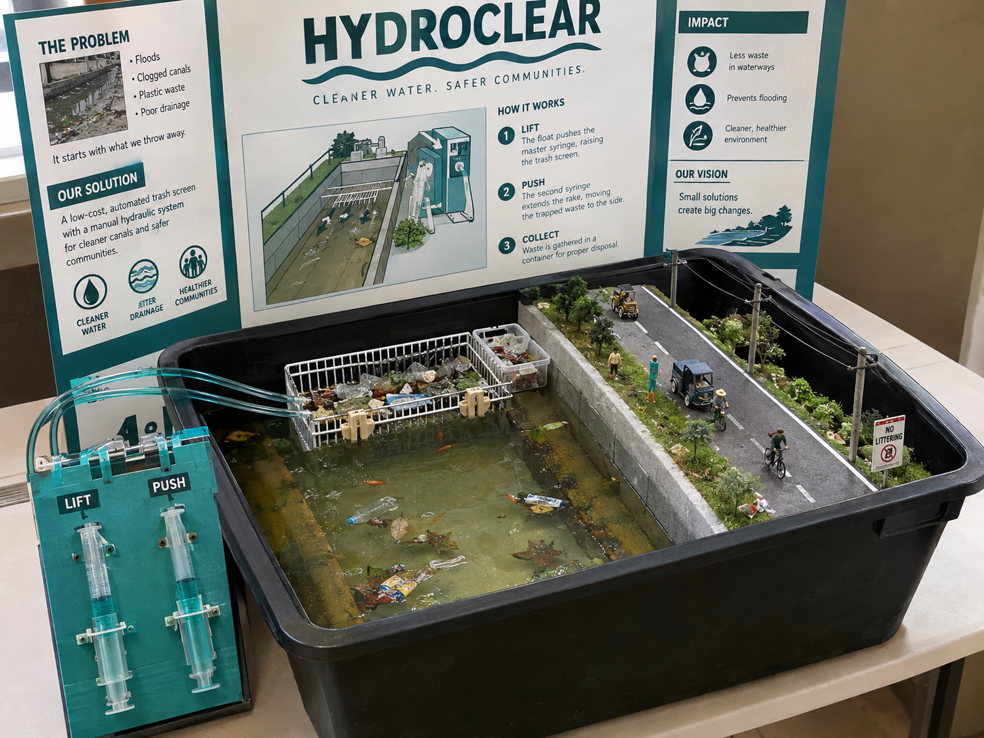
Figure 1. Final Design Visualization of the HYDROCLEAR Exhibit
Note. Visualization of the finished prototype with its display board and LIFT and PUSH control panel. The display board text shown is a layout placeholder, and the final placement of the parts follows Figure 2.
The diorama is built inside a 65 cm by 30 cm black storage box (Figure 2). From left to right, the box is divided into four strips that run its full 30 cm width. The left 10 cm is the truck loading bay, a 10 cm by 30 cm strip built like a road, with the model truck parked in reverse at its back end beside the bar screen. The next 10 cm is the canal, which is only as wide as the bar screen; its surface is made of fake water (a tissue and glue texture, acrylic paint, and a coat of epoxy resin), and the bar screen and rake sit at its back end. The third 10 cm strip holds the pusher at the back, under a Sintra board cover, with the sloped concrete canal ramp (10 cm by 20 cm) south of it. The right 35 cm of the box is the roadside scene (35 cm by 30 cm). Everything sits on one platform raised about 15 cm off the bottom of the box by wood blocks, which leaves open space underneath for the lift syringe and its tubing.
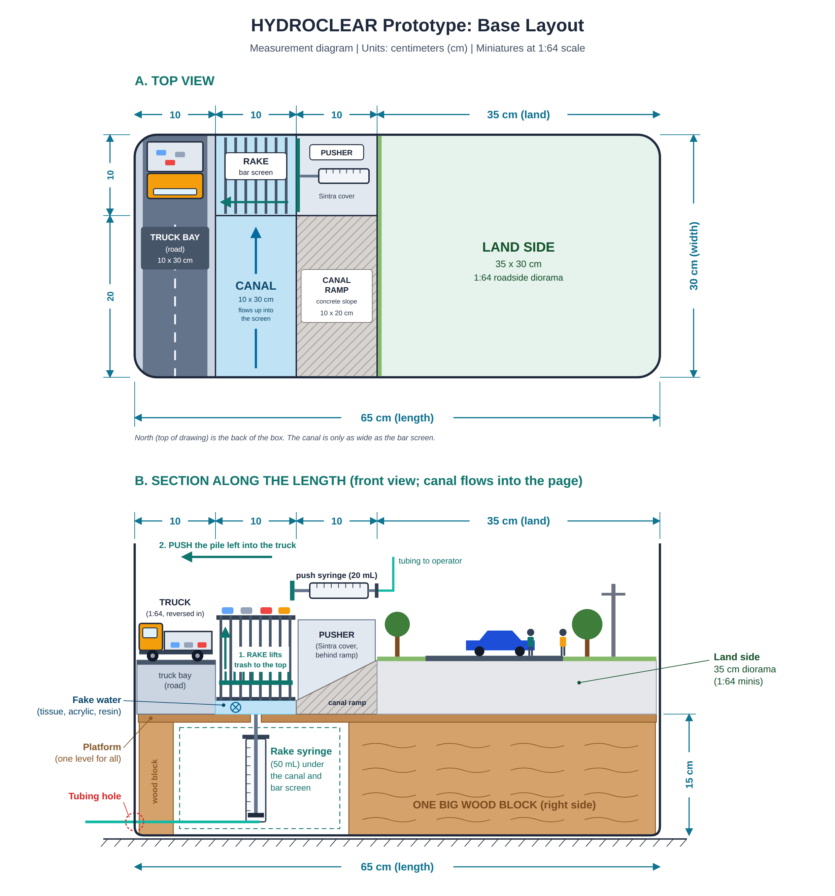
Figure 2. Base Layout of the HYDROCLEAR Prototype
Note. Top view (A) and front section view (B) of the diorama. Dimensions are in centimeters; heights and layer thicknesses are not to scale. Illustration by the group.
Parts of the Prototype
1.) Bar Screen.
A fixed grid of vertical bars, made from a bath metal basket, installed across the canal. Water passes through the gaps between the bars, while debris larger than the gap spacing is retained on the upstream face. This concentrates debris at a single, fixed location that the lift and push mechanisms are positioned to act on.
2.) Lift Syringe (Slave 1) and Rake.
Mounted upright beneath the platform, below the middle third of the bar screen, with its plunger passing through a hole cut through the platform. The plunger is connected to a toothed rake whose teeth fit between the bars of the screen. Pressing the corresponding master syringe transmits hydraulic pressure through the tubing to this slave, extending its plunger. The extension raises the rake along the face of the bar screen, carrying the debris retained on the screen from the water level up to the top of the screen.
3.) Push Syringe (Slave 2) and Pusher Plate.
Mounted horizontally at the top of the screen, aligned toward the truck loading bay. Once debris has been raised to the top of the screen by the rake, pressing the corresponding master syringe extends this slave horizontally. The extension drives a pusher plate (Sintra board) across the top of the screen, displacing the debris off the edge and into the cargo bed of the waiting truck.
4.) Operator / Control Panel (2 Master Syringes).
Houses the two master syringes that provide manual input to the two independent hydraulic circuits: a 50 mL syringe for LIFT and a 20 mL syringe for PUSH. The panel is labeled LIFT and PUSH to indicate the required operating sequence: the lift circuit must be actuated first to raise debris to the top of the screen, followed by the push circuit to clear it into the truck.
5.) Clear Tubing.
Connects each master syringe to its own paired slave syringe, carrying the pressurized hydraulic fluid (teal-colored water) between them. The two circuits are entirely separate from each other, which is why the lift and the push can be, and must be, triggered one after the other rather than at the same time.
6.) Elevated Plywood Platform.
Raised about 15 cm above the bottom of the box by wood blocks, with a hole sized to the lift syringe's plunger and aligned to the bar screen. It holds the canal, screen, truck loading bay, and roadside diorama at one level, and the open space underneath holds the lift syringe. The platform height and hole placement determine the stroke length required of the lift syringe.
7.) Truck Loading Bay and Collection Truck.
A raised 10 cm by 30 cm loading bay, built like a road, beside the bar screen and at the end of the pusher's path. A 1:64 model truck is parked in reverse at the bay, with its open cargo bed just below the top of the screen, so that debris pushed off the screen drops straight into it. In real use, the truck backs up to the bay before the clearing cycle, receives the waste, and then drives away to deliver it to a disposal or recovery facility, so the collected waste never returns to the canal.
8.) Screen Cover.
Sintra board or cardboard placed over the part of the screen area that the rake does not reach. It hides the push syringe housing and keeps the debris on the working section of the screen.
Materials Used
Materials | Description
Mechanism
Syringes (4 total: two 50 mL and two 20 mL) | Two act as operator (master) syringes; one 50 mL slave drives the lift mechanism, and one 20 mL slave drives the push mechanism.
Clear tubing (oxygen mask tube) | Carries hydraulic pressure from each master syringe to its paired slave syringe, running from the operator panel to the mechanism.
Food coloring | Colors the hydraulic fluid (water) so the fluid path is visible during operation.
Bath metal basket | Forms the bar screen and the toothed rake.
Hair clamp (1) | Holds the connected rake and pusher parts in place.
Sintra board | Forms the pusher plate.
Zip ties | Mount and secure the syringes in place.
Small wood board | Forms the operator panel, painted teal and labeled LIFT and PUSH.
Structure
Black plastic storage box (65 cm by 30 cm) | Houses the whole diorama and mechanism.
Plywood | Forms the elevated platform inside the box, cut to fit the box interior at platform height, with a hole for the lift syringe.
Wood blocks | Support legs under the platform, leaving clearance underneath for the syringes.
XPS foam | Shapes the road base of the diorama.
Sintra board or cardboard | Forms the truck loading bay and the screen cover.
Silicone sealant | Seals the tubing hole in the box and the joints of the hydraulic circuits to prevent leaks.
Decoration
Illustration board | Forms the base of the canal, cut to size with the corners rounded to match the box. Also forms the display board.
Tissue | Mixed with glue to create the water and terrain texture.
Epoxy resin | Coats the canal to give the fake water a wet, glossy look.
Acrylic paint (gray, white, green, brown, black, teal) | Paints the water, concrete canal slope, road, terrain, structures, and mechanism housing.
Grass powder | Represents the grass verge and the top of the canal wall.
Barbecue sticks, toothpicks, black thread | Represent electricity poles, crossarms, and wires.
People figures | Represent pedestrians along the road, including at least one walking figure.
1:64 model truck (dump or garbage truck) | Represents the collection truck that backs up to the loading bay to receive the waste.
Cardboard | Forms the mountain side and small details, such as houses and signs.
Thin plastic | Represents plastic bag pieces (ice, bread, or sando bags) floating in the canal.
Snack wrappers and sachets | Cut small to represent floating solid waste in the canal.
Dried leaves | Crushed small to represent organic debris collecting on the screen.
Clear plastic packaging | Shaped into miniature bottles to add to the floating trash.
Photo paper | Prints the infographics, photos, and the NO LITTERING sign.
Illustration board or foam board | Mounts the printed infographic panels.
Double-sided tape and foam tape | Mounts the infographic panels to their backing.

NAME | CONTRIBUTION/S
1) Chase | Consolidated Performance Check 2; wrote the evidence and testimonials section with APA 7 citations; drew the base layout diagram (Figure 2); sourced the syringes, tubing, bath basket, and hair clamps.
2) Matthew | Drafted the introduction (rationale, description of the prototype, and overview of the concepts); helped build the canal base.
3) Princess | Wrote the parts of the prototype; provided the clear plastic sheet, zip ties, and tissue.
4) Rinoa | Prepared the model trash (thin plastic, wrappers, sachets, and dried leaves) and described it in the materials table.
5) Michan | Organized the materials table; hosted the build session and provided masking tape and paintbrushes.
6) Michelle | Built the roadside base and the sloped concrete side of the canal; provided the epoxy resin and acrylic paint.
7) Leon | Designed the miniature bottle labels and the NO LITTERING sign; proofread the materials list.
8) Rhianna | Designed the HYDROCLEAR logo, LIFT and PUSH labels, and hazard stripes; prepared the final design visualization (Figure 1).
9) Wohan | Laid out the display board with the infographics; formatted Performance Check 2 for submission; provided scissors and a marker.

