PERFORMANCE CHECK 3
III. DISCUSSION OF THE PROTOTYPE
A. How Does the Project Work?
HYDROCLEAR is a proposed hydraulic screen-clearing system designed to remove accumulated debris from canals and drainage inlets. The system consists of a bar screen, a hydraulic rake mechanism, a hydraulic pusher mechanism, a ledge at the top of the screen, and a truck loading bay where a collection truck receives the waste. The system primarily applies Pascal's Principle to transmit the mechanical force required to remove debris from the screen.
During rainfall, stormwater enters the canal or drainage inlet and passes through the openings of the bar screen. Leaves, plastic, food packaging, and other solid waste are retained on the upstream face of the screen. As debris accumulates, the available openings through which water can pass become reduced, which can restrict the flow of stormwater into the drainage channel.
To clear the blockage, the first hydraulic mechanism is operated. A master syringe is connected to a slave syringe through flexible tubing containing an enclosed fluid. When force is applied to the master syringe, pressure is transmitted through the fluid to the slave syringe in accordance with Pascal's Principle. In our prototype, both syringes in each circuit have the same piston area, so the slave syringe produces an output force equal to the input force under ideal conditions. In a full-scale system, a slave cylinder with a larger piston area would produce a greater output force.
The slave syringe is positioned beneath the platform, below the canal, and is connected to a toothed rake. As the slave syringe moves, it raises the rake along the face of the bar screen. The teeth of the rake fit between the bars of the screen, allowing it to lift accumulated debris from the screen and carry it toward the ledge at the top.
Once the debris reaches the ledge, the second hydraulic mechanism is operated. A second master-and-slave syringe arrangement drives a horizontal pusher plate across the ledge. The pusher moves the collected debris away from the screen and into the cargo bed of a truck parked in reverse at the loading bay, preventing the debris from returning to the drainage channel.
After the clearing process, the hydraulic mechanisms are released and the rake and pusher return to their initial positions, and the loaded truck drives away to deliver the waste for proper disposal. The process therefore allows the accumulated debris to be removed from the screen and transferred to a designated collection area without requiring direct manual removal from the drainage opening. Figure 1 summarizes this four-step cycle.
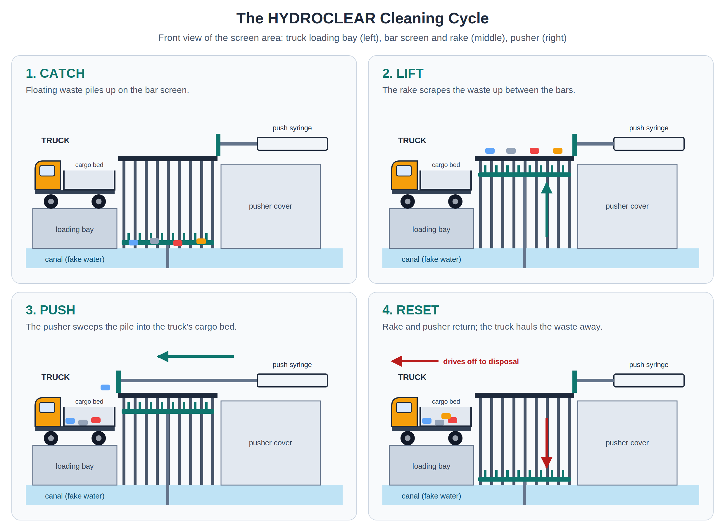
Figure 1. The HYDROCLEAR Cleaning Cycle
Note. Front view of the screen area in each step: catch, lift, push, and reset. Illustration by the group.
In the scaled prototype, the hydraulic mechanisms are operated manually through the master syringes. This allows the transmission of pressure and the movement of the rake and pusher to be directly observed during the demonstration.
B. Where Is It Used?
HYDROCLEAR is intended for use in canals and urban drainage inlets, particularly in low-lying communities where solid waste frequently accumulates and obstructs stormwater drainage. The proposed application of the project is Barangay Plaza Burgos, Guagua, Pampanga. Guagua was among the towns affected when floods reached 223 barangays and more than half a million residents in Pampanga in July 2025 (GMA Regional TV News, 2025b).
The project addresses the social issue of solid-waste accumulation in canals and drainage inlets and its potential contribution to localized street flooding. Leaves, plastic, food packaging, and other debris can accumulate on drainage screens and reduce the available area for stormwater to enter the drainage system. During rainfall, a restricted inlet may cause water to accumulate on the street, particularly when the amount of incoming water exceeds the reduced capacity of the blocked opening. This has been observed locally: the MMDA traced flooding in 49 areas to garbage-clogged drainage ("MMDA: Over 600 Tons," 2025), garbage at a blocked floodgate caused a creek in Santa Ana, Pampanga, to overflow (GMA Regional TV News, 2025a), and waste in the canals along Lazatin Boulevard in San Fernando was found to cut their drainage capacity (Gob et al., 2025).
HYDROCLEAR also addresses the safety concerns associated with manual drainage clearing. Conventional clearing may require residents or maintenance personnel to manually remove debris from or near the drainage inlet. This can expose them to contaminated water and potentially sharp or hazardous waste. HYDROCLEAR provides a mechanical method of lifting debris from the screen and loading it directly into a collection truck, reducing the need for direct contact with the accumulated waste. Because the waste goes straight into a truck, it can be hauled away at once instead of being piled on the canal bank, where the next rain could wash it back into the water.
The project is particularly relevant to communities where drainage inlets are frequently exposed to solid waste and where timely removal of debris is necessary to maintain the flow of stormwater. By integrating a bar screen with two hydraulic mechanisms, HYDROCLEAR demonstrates how principles of fluid mechanics can be applied to develop a practical approach to drainage maintenance. It also fits the local call for shared responsibility: MMDA Chairman Don Artes stressed that solving floods needs "the participation of everybody, especially on the aspect of garbage disposal" ("MMDA: Over 600 Tons," 2025), and Vice Governor Dennis Pineda suggested assigning the upkeep of waterway gates at the barangay level (GMA Regional TV News, 2025a). A simple hand-operated cleaner gives a barangay a practical tool for that duty.
The proposed system is intended to help maintain the flow capacity of drainage inlets and reduce the contribution of inlet blockage to localized flooding. It is not intended to eliminate flooding entirely, since flooding can also be affected by rainfall intensity, drainage capacity, downstream conditions, and other environmental factors.
C. Application and Relevance of the Concepts
HYDROCLEAR applies two physics concepts: Pascal's Principle and Work. Figure 2 shows how both concepts act in the two hydraulic circuits, and Table 1 summarizes where each concept appears in the prototype.
1. Pascal's Principle
HYDROCLEAR applies Pascal's Principle through its two hydraulic mechanisms. When force is applied to the master syringe, pressure is transmitted through the enclosed water to the corresponding slave syringe. This allows the system to produce the force needed to move the rake and pusher, demonstrating how hydraulic pressure can be applied to perform mechanical work. Water is used as the hydraulic fluid to transmit pressure through the tubing.
Definition. When you push on a liquid that is completely enclosed, the extra pressure you create does not stay where you pushed. It spreads equally to every part of the liquid and to every wall of its container. Since pressure is force divided by area ($P=\frac{F}{A}$), the same pressure acting on two pistons gives $P_{\text{inc}}=\frac{F_{1}}{A_{1}}=\frac{F_{2}}{A_{2}}$, so $F_{2}=F_{1}\left(\frac{A_{2}}{A_{1}}\right)$.
Application in the prototype.
- Each circuit is an enclosed fluid. The water is sealed inside the master syringe, the tubing, and the slave syringe, so the pressure created at the panel reaches the rake or pusher undiminished.
- Same-size syringes transmit the force. In each circuit, $A_{2}=A_{1}$, so $F_{2}=F_{1}$. The operator's push is carried to the mechanism without being multiplied (Sample Problem 3).
- Air must be removed. Air bubbles compress, so part of the operator's push would be used up squeezing air instead of reaching the slave syringe. Each circuit is filled completely with water and cleared of bubbles before the demonstration.
- Syringe sizes match the job. The larger 50 mL syringes run the rake, which lifts trash against gravity over the full height of the screen. The smaller 20 mL syringes run the pusher, which moves trash sideways and fits the narrow space at the top of the screen.
Real-life examples. A car's brakes work the same way: pressing the pedal pushes on brake fluid in a master cylinder, and the pressure is transmitted through the brake lines to the cylinders at each wheel (Urone & Hinrichs, 2022). A hydraulic car lift in a repair shop uses a small piston and a large piston so that a mechanic can raise a whole car with a much smaller force.
Relevance. Without Pascal's Principle, the operator would have to reach into the canal to move the rake. The enclosed water lets the push travel around corners, under the platform, and through the box wall, which makes hands-free cleaning possible.
2. Work
The project also demonstrates Work and Energy, as the force applied by the operator is transferred through the hydraulic system and converted into mechanical movement of the rake and pusher. The force and displacement involved must be sufficient to lift and transfer the accumulated debris.
Definition. Work is done when a force makes an object move, and the force (or part of it) points along the direction of the motion. Work equals force times the distance moved, $W=Fd$, measured in joules (J). If nothing moves, no work is done, no matter how hard you push. When an object is lifted at a steady speed, the work done against gravity equals its weight times the height, $W=mgy$.
Application in the prototype.
- The rake does work on the trash. The rake pushes upward and the trash moves upward, so the force and the displacement are parallel ($θ=0^{∘}$) and the work is at its maximum, $W=Fd$. This work raises the trash against gravity to the top of the screen.
- The pusher does work on the trash. The pusher plate pushes sideways and the trash slides sideways, so it does work moving the pile across the top of the screen.
- Gravity does work as the trash drops into the truck. After the pusher moves the collected debris off the ledge, the trash falls into the truck's cargo bed. Its displacement is downward, parallel to its weight, so the work done by gravity is positive. This shows how gravity can work together with a mechanical mechanism to aid the movement of materials.
- The platform does no work. The platform and wood blocks hold up the weight of the canal and diorama, but nothing moves, so no work is done, just like carrying a book while standing still.
- Work in equals work out. The operator does work on the master syringe ($F_{1}d_{1}$). In an ideal hydraulic system, the slave cannot do more work than was done on it (Urone & Hinrichs, 2022), so $F_{1}d_{1}=F_{2}d_{2}$. With same-size syringes, the force and the distance are both equal. A larger slave cylinder would give a larger force but move a shorter distance, so the work stays the same (Sample Problems 1 and 2).
Real-life example. In car brakes, the force at the wheels is larger than the force on the pedal, but "the wheel cylinder moves through a smaller distance than the pedal cylinder" (Urone & Hinrichs, 2022, Section 11.5). A hydraulic jack shows the same trade-off: a person pumps the handle many times to raise a heavy car a short distance.
Relevance. Work tells us how much effort each press takes and how far each part must move. This helps us check that the cycle is easy enough to run by hand and that the rake travels far enough to bring the trash all the way to the top of the screen.
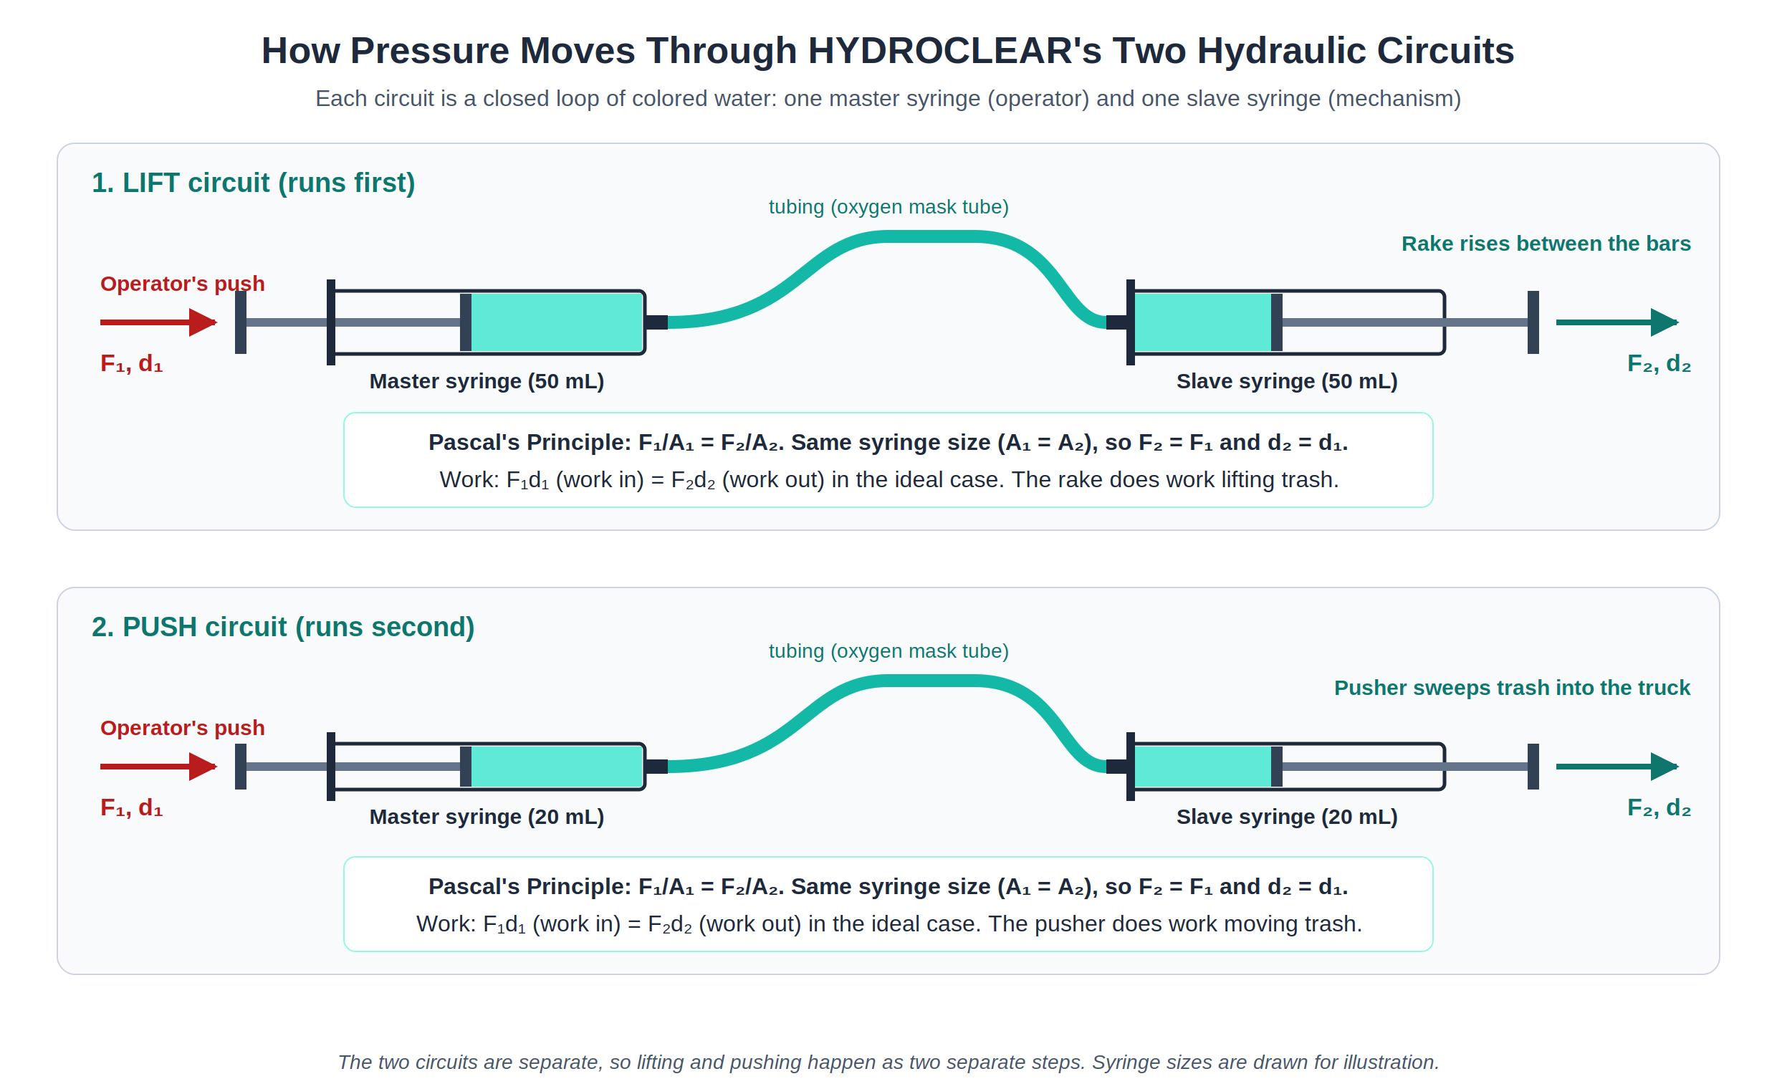
Figure 2. The Two Hydraulic Circuits of HYDROCLEAR
Note. Each circuit is sealed and filled with colored water. Because both syringes in a circuit are the same size, the output force equals the input force. Illustration by the group.
Table 1
Where Pascal's Principle and Work Appear in HYDROCLEAR
Part | Pascal's Principle | Work
Master syringes (LIFT and PUSH) | The operator's push creates pressure in the enclosed water. | The operator does work on the water, $F_{1}d_{1}$.
Tubing | Carries the pressure equally to the slave syringe. | Transmits the push; it does no work of its own.
Lift syringe and rake | Receives the same pressure and pushes the rake up with $F_{2}=F_{1}$. | Does work lifting trash up the screen ($θ=0^{∘}$).
Push syringe and pusher | Receives the same pressure and pushes the plate sideways. | Does work sweeping the trash off the ledge.
Truck cargo bed | Not applied. | Gravity does positive work as the trash drops in.
Platform and wood blocks | Not applied. | No work: it holds weight, but nothing moves.

Overall, these concepts work together to make HYDROCLEAR functional. They demonstrate how fundamental principles of physics can be integrated into a practical system for removing waste from drainage inlets and helping maintain the flow of stormwater.
D. Sample Problems
To show how Pascal's Principle and the idea of work apply in a hydraulic system like HYDROCLEAR's, Sample Problems 1 and 2 use simple hydraulic systems with the same working principle: a small input force on a small piston produces a larger output force on a larger piston. Sample Problem 3 applies the same ideas to the actual LIFT circuit of our prototype. All solutions follow the GAFSA format (Given, Asked, Formula, Solution, Answer).
Sample Problem 1
A hydraulic lift has a small piston of area $10 {\text{cm}}^{2}$ and a large piston of area $250 {\text{cm}}^{2}$. It raises a 150 kg load at constant speed through a height of 0.20 m. Use $g=9.8 {\text{m/s}}^{2}$ and ignore friction.
a.) What is the minimum force needed on the small piston?
b.) How far must the small piston move?
c.) How much work is done on the load?
Given:
$A_{1}=10 {\text{cm}}^{2}$ {= $1.0×{10}^{−3} {\text{m}}^{2}$}
$A_{2}=250 {\text{cm}}^{2}$ {= $2.5×{10}^{−2} {\text{m}}^{2}$}
$$m=150 \text{kg}$$
$$d_{2}=0.20 \text{m}$$
$$g=9.8 {\text{m/s}}^{2}$$
Asked:
a.) I. weight of the load, $F_{2}$
II. force on the small piston, $F_{1}$
b.) distance moved by the small piston, $d_{1}$
c.) work done on the load, $W$
Formula:
a.) I. $F_{2}=mg$ {weight; constant speed}
II. $F_{1}=F_{2}\left(\frac{A_{1}}{A_{2}}\right)$ {Pascal's Principle; hydraulic lift}
b.) $d_{1}=d_{2}\left(\frac{A_{2}}{A_{1}}\right)$ {from $A_{1}d_{1}=A_{2}d_{2}$; same volume of fluid moves}
c.) $W=F_{2}d_{2}$ {Work}
Solution:
a.) I. $F_{2}=\left(150 \text{kg}\right)\left(9.8 {\text{m/s}}^{2}\right)=1470 \text{N}$
II. $F_{1}=\left(1470 \text{N}\right)\left(\frac{1.0×{10}^{−3} {\text{m}}^{2}}{2.5×{10}^{−2} {\text{m}}^{2}}\right)=58.8 \text{N}$
b.) $d_{1}=\left(0.20 \text{m}\right)\left(\frac{2.5×{10}^{−2} {\text{m}}^{2}}{1.0×{10}^{−3} {\text{m}}^{2}}\right)=5.0 \text{m}$
c.) $W=\left(1470 \text{N}\right)\left(0.20 \text{m}\right)=294 \text{J}$ {check: $F_{1}d_{1}=\left(58.8 \text{N}\right)\left(5.0 \text{m}\right)=294 \text{J}$}
Answer:
a.) The minimum force needed on the small piston is about 59 N (58.8 N).
b.) The small piston must move 5.0 m.
c.) The work done on the load is about $2.9×{10}^{2} \text{J}$ (294 J).
The large piston must push up with a force equal to the load's weight, 1,470 N. The fluid pressure needed is that weight divided by the large piston's area. Because pressure is transmitted equally throughout the confined fluid, the same pressure acts on the small piston. The small piston has 1/25 of the area, so it needs only 1/25 of the force to produce that pressure.
The small piston moves 25 times farther than the load rises (5.0 m compared with 0.20 m). With no friction, the work put in equals the work done on the load (294 J). You use a smaller force over a longer distance. The system does not create extra energy. (In real jacks, this long distance is covered by pumping repeatedly.)
The first problem shows that a small force on a small piston can support a much larger load, because the same pressure acts on both pistons, while the small piston moves farther. The second problem examines this trade-off directly by comparing force, distance, and work at both pistons.
Sample Problem 2
A hydraulic jack has a small piston of area $5.0 {\text{cm}}^{2}$ and a large piston of area $150 {\text{cm}}^{2}$. A person pushes the small piston down 30 cm with a force of 80 N. Assume no friction.
a.) What is the force on the large piston?
b.) How far does the large piston rise?
c.) How does the work done on the small piston compare with the work done by the large piston?
Given:
$A_{1}=5.0 {\text{cm}}^{2}$ {= $5.0×{10}^{−4} {\text{m}}^{2}$}
$A_{2}=150 {\text{cm}}^{2}$ {= $1.5×{10}^{−2} {\text{m}}^{2}$}
$$F_{1}=80 \text{N}$$
$d_{1}=30 \text{cm}$ {= $0.30 \text{m}$}
Asked:
a.) force on the large piston, $F_{2}$
b.) distance the large piston rises, $d_{2}$
c.) I. work done on the small piston, $W_{1}$
II. work done by the large piston, $W_{2}$
Formula:
a.) $F_{2}=F_{1}\left(\frac{A_{2}}{A_{1}}\right)$ {Pascal's Principle; hydraulic lift}
b.) $d_{2}=d_{1}\left(\frac{A_{1}}{A_{2}}\right)$ {from $A_{1}d_{1}=A_{2}d_{2}$; same volume of fluid moves}
c.) I. $W_{1}=F_{1}d_{1}$ {Work}
II. $W_{2}=F_{2}d_{2}$ {Work}
Solution:
a.) $F_{2}=\left(80 \text{N}\right)\left(\frac{1.5×{10}^{−2} {\text{m}}^{2}}{5.0×{10}^{−4} {\text{m}}^{2}}\right)=2400 \text{N}$
b.) $d_{2}=\left(0.30 \text{m}\right)\left(\frac{5.0×{10}^{−4} {\text{m}}^{2}}{1.5×{10}^{−2} {\text{m}}^{2}}\right)=0.010 \text{m}$
c.) I. $W_{1}=\left(80 \text{N}\right)\left(0.30 \text{m}\right)=24 \text{J}$
II. $W_{2}=\left(2400 \text{N}\right)\left(0.010 \text{m}\right)=24 \text{J}$
Answer:
a.) The force on the large piston is $2.4×{10}^{3} \text{N}$ (2,400 N).
b.) The large piston rises $1.0×{10}^{−2} \text{m}$ (1.0 cm).
c.) The work done on the small piston (24 J) equals the work done by the large piston (24 J).
Pushing the small piston forces a certain volume of fluid into the large cylinder. The fluid is incompressible, so the same volume must go under the large piston. That piston has 30 times the area, so it rises only 1/30 as far. The same pressure acts on both pistons, so the force on the large piston is 30 times greater.
The force is 30 times larger and the distance is 30 times smaller, so the work is the same at both ends (24 J). With no friction, a hydraulic system trades distance for force. It does not create extra energy.
Sample Problem 3: The LIFT Circuit of the Prototype
During a demonstration, the HYDROCLEAR rake and the wet trash it scrapes up have a combined mass of 0.25 kg. The LIFT circuit uses two identical 50 mL syringes, each with a plunger diameter of 2.9 cm. The slave syringe raises the rake at a steady speed, so it must push up with a force equal to the weight of the rake and trash. The rake travels 9.0 cm up the bar screen. Use $g=9.8 {\text{m/s}}^{2}$ and ignore friction.
a.) What pressure does the operator create in the water of the LIFT circuit?
b.) How much force must the operator apply to the master syringe?
c.) How much work does the slave syringe do on the rake and trash?
Given:
$$m=0.25 \text{kg}$$
$D_{1}=D_{2}=2.9 \text{cm}$ {= $0.029 \text{m}$; identical 50 mL syringes}
$d=9.0 \text{cm}$ {= $0.090 \text{m}$}
$$g=9.8 {\text{m/s}}^{2}$$
Asked:
a.) I. weight of the rake and trash, $w$ {equal to $F_{2}$}
II. plunger area, $A$
III. pressure transmitted, $P_{\text{inc}}$
b.) operator's force, $F_{1}$
c.) work done by the slave syringe, $W$
Formula:
a.) I. $w=mg; F_{2}=w$ {weight; steady lift}
II. $A=\frac{πD^{2}}{4}$ {area of a circle}
III. $P_{\text{inc}}=\frac{F_{2}}{A_{2}}$ {Pascal's Principle}
b.) $F_{1}=F_{2}\left(\frac{A_{1}}{A_{2}}\right)$ {Pascal's Principle; hydraulic lift}
c.) $W=Fd$ {Work; $θ=0^{∘}$}
Solution:
a.) I. $w=\left(0.25 \text{kg}\right)\left(9.8 {\text{m/s}}^{2}\right)=2.45 \text{N}$
II. $A=\frac{π{\left(0.029 \text{m}\right)}^{2}}{4}=6.61×{10}^{−4} {\text{m}}^{2}$
III. $P_{\text{inc}}=\frac{2.45 \text{N}}{6.61×{10}^{−4} {\text{m}}^{2}}=3.71×{10}^{3} \text{Pa}$
b.) $F_{1}=\left(2.45 \text{N}\right)\left(\frac{6.61×{10}^{−4} {\text{m}}^{2}}{6.61×{10}^{−4} {\text{m}}^{2}}\right)=2.45 \text{N}$
c.) $W=\left(2.45 \text{N}\right)\left(0.090 \text{m}\right)=0.22 \text{J}$
Answer:
a.) The operator creates a pressure of about $3.71×{10}^{3} \text{Pa}$ (3,710 Pa) in the water of the LIFT circuit.
b.) The operator must apply a force of 2.45 N to the master syringe, the same as the force on the rake, because both syringes have the same plunger area.
c.) The slave syringe does about 0.22 J of work on the rake and trash.
Sample Problems 1 and 2 show the idea that a full-scale HYDROCLEAR would use: pressure applied at a small master piston is transmitted through the fluid, giving a larger force at a larger slave piston while the slave moves a shorter distance. In our prototype, both syringes in each circuit are the same size, so the force is transmitted without being multiplied, as Sample Problem 3 shows. The value of the hydraulics in the prototype is that it carries the operator's push to the rake and pusher without the operator touching the waste.

NAME | CONTRIBUTION/S
1) Chase | Consolidated Performance Check 3; created the cleaning cycle and hydraulic circuit diagrams (Figures 3 and 4); wrote Sample Problem 3 based on the prototype.
2) Matthew | Wrote how the project works, including the four-step cleaning cycle.
3) Princess | Wrote where the project is used and how it addresses the social issue.
4) Rinoa | Researched the local flood and waste reports used in the discussion of the social issue.
5) Michan | Wrote the application of Pascal's Principle, with its definition and real-life examples.
6) Michelle | Wrote the application of Work and prepared Table 1.
7) Leon | Solved Sample Problem 1 using the GAFSA format.
8) Rhianna | Solved Sample Problem 2 using the GAFSA format.
9) Wohan | Checked the computations and units in all sample problems; transferred the discussion to PowerPoint slides 4 to 6.

