|  |  |
| --- | --- |
| magical goods RENTAL STORE  COMP229 – Advanced Web Application Development | YESOL LEE  MIKANG KIM |

Table of Contents

Detailed description 2

Core functionality 2

Version History 3

GitHub commit history 4

Typography and Color 5

Wireframes 6

Screen Capture 7

# Detailed description

MAGICAL GODDS RENTAL STORE lets junior Witches and Wizards browse all the available Magical Items for their study in Magic school, and easily add them to users’ queue or share them with friends. Users can also find out more about each item. There are 3 easy steps using the website which are registering and signing in, searching perfect items, and using and returning them.

# Core functionality

* Witches and Wizards can rent magic items through: the Website
* To see if a magical item is available for rent, search the Website for that title and look for a Rent button
* To rent any item from the Website, users must Sign-up and Sign-in to the server
* Witches and Wizards can see some message boxes while they shop

# 

# Version History

* 1. Initial Setup
  2. Design Default Page
  3. Add Sign up Page
     1. Created Registration form on Sign up Page
  4. Connect Database
  5. Add Sign in Page
     1. Created Sign in form on Sign in Page
  6. Add Item Lists
     1. Added and sorted imges to match each item
     2. Modifed hover working for item images

# GitHub Commit History

# 

https://github.com/YesolLee3990/Comp229-TeamAssign1

# Typography and Color

Color: 

HEX #3a3a3c

RGB rgb(58, 58, 60)

HSV hsv(240°, 3%, 24%)

HSL hsl(240°, 2%, 23%)

CMYK cmyk(3%, 3%, 0%, 76%)

: Main Color of the Website

Color:

HEX #fefeff

RGB rgb(254, 254, 255)

HSV hsv(240°, 0%, 100%)

HSL hsl(240°, 100%, 100%)

CMYK cmyk(0%, 0%, 0%, 0%)

: Main Font / icon Color

Font: 

Font Name: TektonPro-Cond

# Wireframes

Main Page

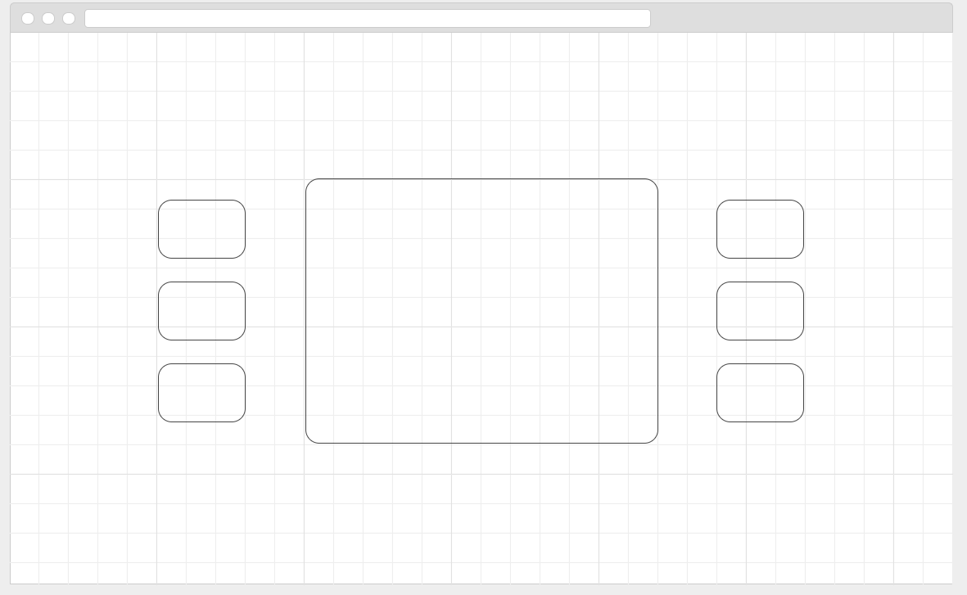

Main Page has png icons that guide other pages; Sign Up, Item List, and other additional pages. All the links are shown as an symbol.

Admin Page

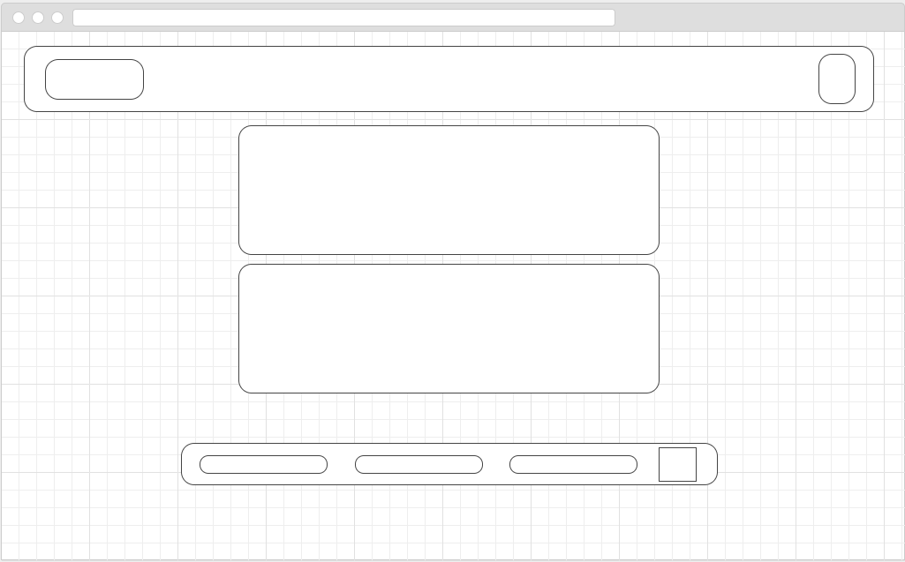

Cart Page

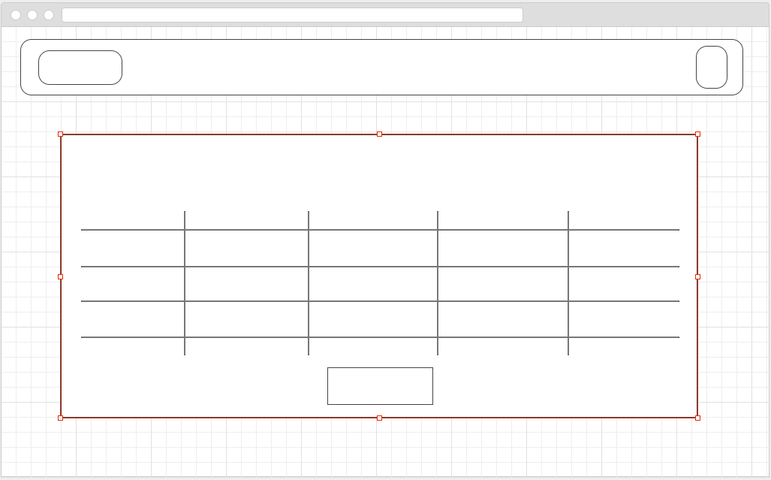

Item Pages

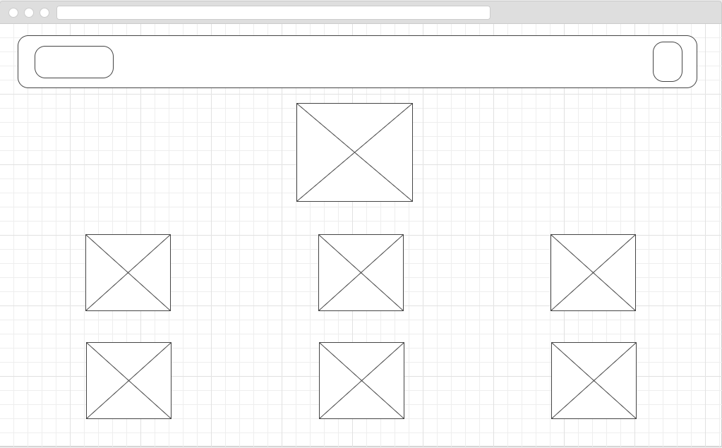

# Screen Shot

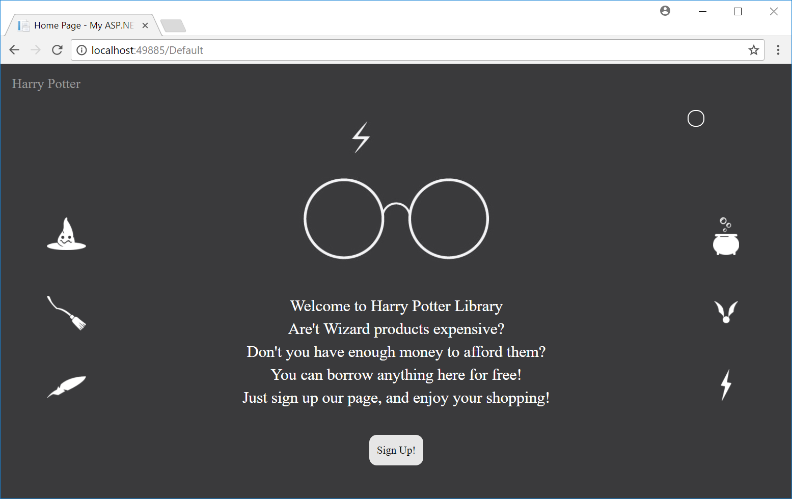

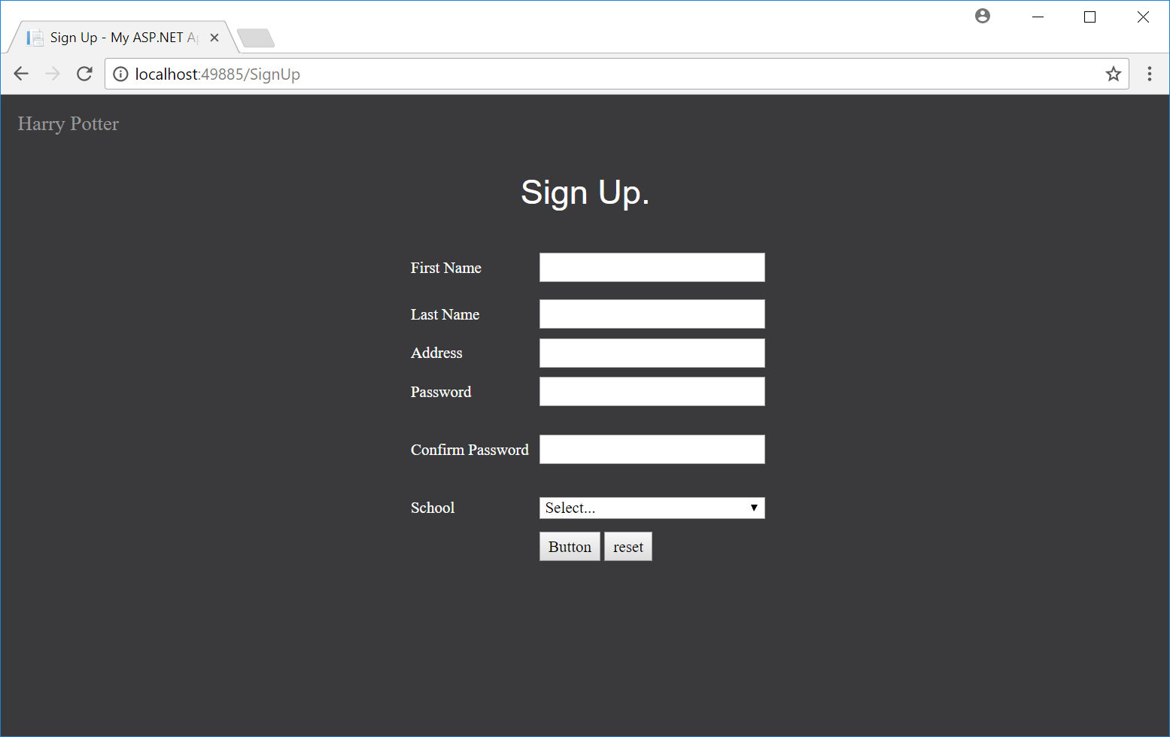

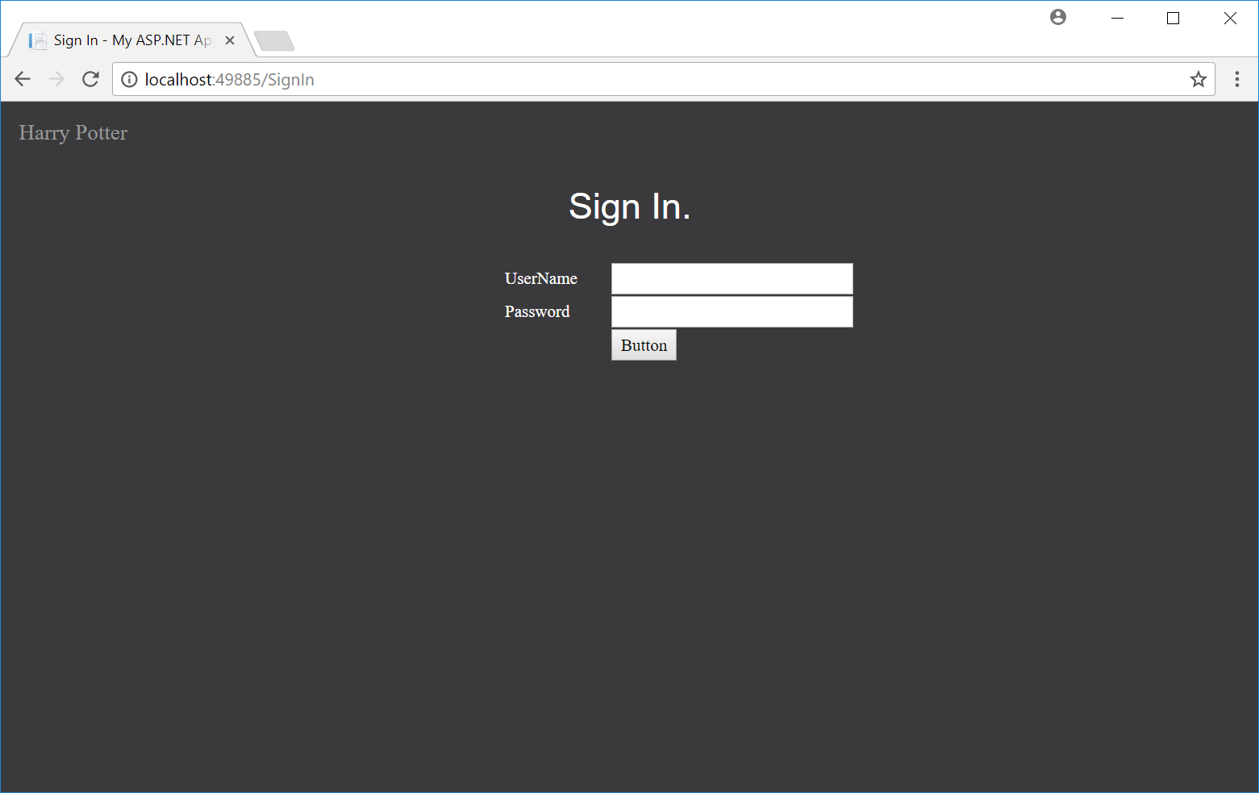

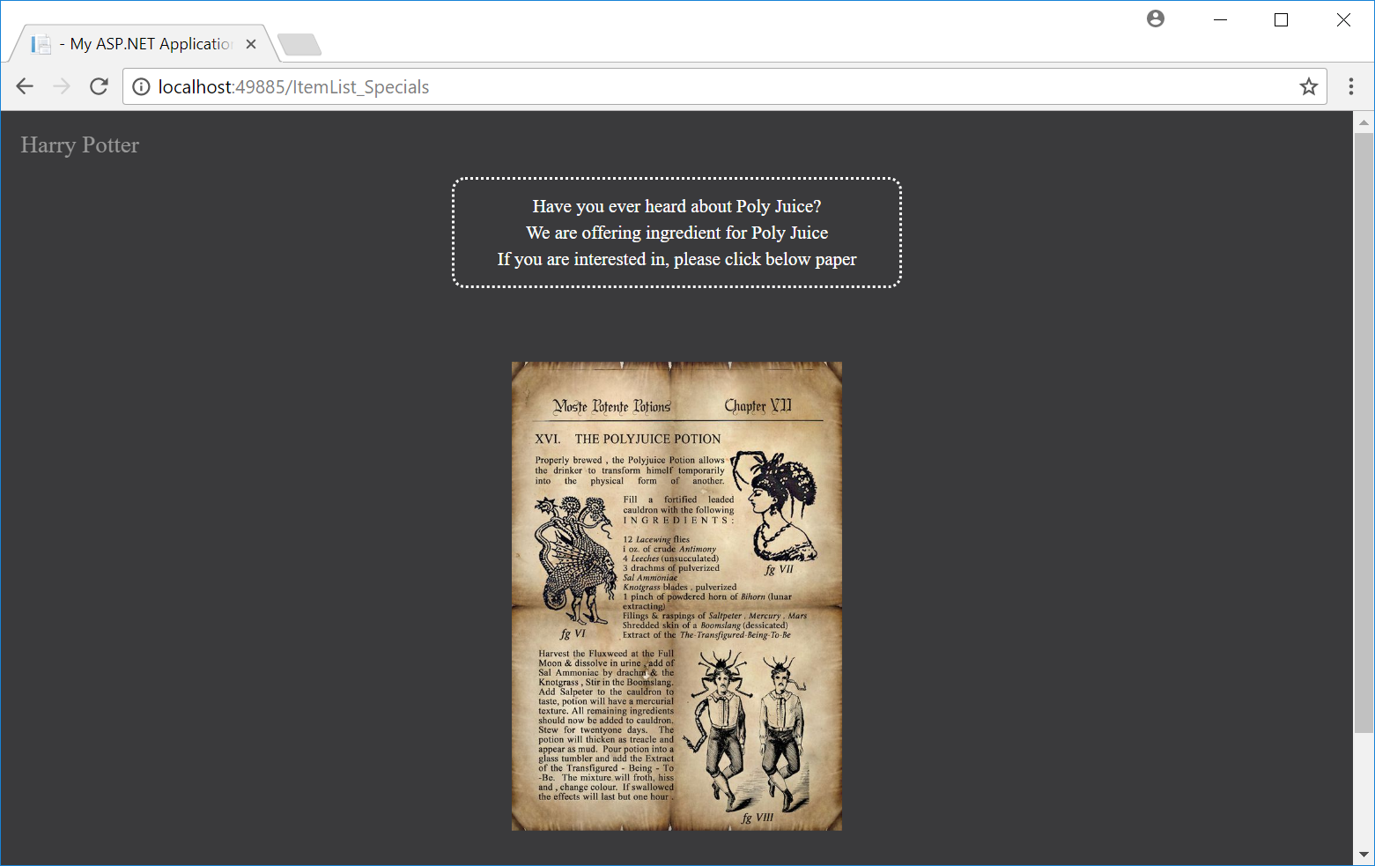

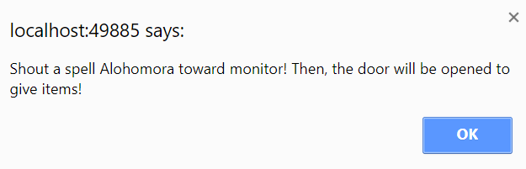

Special Message from the master