

Floss Solutions for Open Land Administration

(SOLA)

**Coded Lists**

Introduction

Coded lists values can be categorized in two types:

1. The type that is used also in code and business rules

2. The type that is not used

While the second type is not that important for a developer, during customization phase it might be needed to change the coded lists values.

If for some reason the first type has to be removed or cancelled, the code and business rules has also to be considered for review.

In the code there are methods actually that depend on these values and somewhere these values are also used in “if-then” conditions.

This document is meant for describing these kinds of coded list value tables (in data model) that are of the first type, in order to warn developers to search in the code for implications of changing the code of those values or removing them or adding new ones.

Data itself are described, with reference to the description fields they have in each of these reference tables (reported also in data model), as well as in which places they are used in code or business rules.

Coded Lists in the Code

|  |  |  |  |  |  |
| --- | --- | --- | --- | --- | --- |
| Project | Package | Class | Line | Value | Reference Table |
| **Common Rules** |
| org.sola.rules | RuleType.java | 37 | Sql,  Drools | system.br_technical_type.code |
| **Common Utilities** |
| org.sola.common | RolesConstants.java | 36 | all the  enum values | system.approle.coed  system.approle_appgroup.code |
| **Ejb Application** |  | | | | |
| org.sola.services.ejb.application.businesslogic | ApplicationEjb.java | 162 | naturalPerson | party.party_type.code |
| org.sola.services.ejb.application.repository.entities | Application.java | 124 | generate-application-nr | system.br.id |
| org.sola.services.ejb.application.repository.entities | ApplicationActionType.java | 47 | all the  public static final string values | application. application_action_type.code |
| ApplicationStatusType.java | 46 | all the  public static final string values | application. application_status_type.code |
| ApplicationCategoryType.java | 46 | informationServices | application. application_category_type.code |
| RequestType.java | 52 | cadastreChange | application. request_type.code |
| ServiceActionType.java | 46 | all the  public static final string values | application. service_action_type.code |
| ServiceStatusType.java | 46 | all the  public static final string values | application. service_status_type.code |
| **Ejb Administrative** |  | | | | |
| org.sola.services.ejb.administrative.businesslogic | AdministrativeEjb.java | 137 | pending | administrative.ba_unit.status_code |
| 138 | administrativeUnit | administrative.ba_unit_type.code |
| org.sola.services.ejb.administrative.repository.entities | BaUnit.java | 262 | generate-baunit-nr | system.br.id |
| BaUnitNotation.java | 91 | generate-notation-reference-nr | system.br.id |
| Rrr.java | 121 | generate-rrr-nr | system.br.id |
| **Ejb Cadastre** |  | | | | |
| org.sola.services.ejb.cadastre.repository.entities | CadastreObject.java | 51  55  58  63 | current | cadastre.cadastre_object.status_code |
| CadastreObjectNode.java | 35 | current |
| 35 | pending |
| **Ejb Party** |  | | | | |
| org.sola.services.ejb.party.repository.entities | Party.java | 54  55 | nonNaturalPerson  naturalPerson | party.party_type.code |
| **Ejb System** | org.sola.services.ejb.system.repository.entities | BrValidation.java | 59 | application | system.brvalidation.target_code |
| 62 | service |
| 66 | rrr |
| org.sola.services.ejb.system.businesslogic | SystemEjb.java | 172 | drools  sql | system.br_current.technical_type_code |
| **Ejb Source** |  | | | | |
| org.sola.services.ejb.source.repository.entities | Source.java | 105 | generate-source-nr | system.br.id |
| **Ejb Search** |  | | | | |
| org.sola.services.ejb.search.repository.entities | ApplicationSearchResult.java | 63 | lodged  approved | application.application.status_code |
| CadastreObjectSearchResult.java | 52  66  81  87  98 | current | Cadastre.cadastre_object.status_code |
| PropertyVerifier.java | 54 | basicPropertyUnit | administrative.ba_unit_type.code |
| Setting.java | 47 | map-srid | public.spatial_ref_sys.name |
| **Ejb Transaction** |  | | | | |
| org.sola.services.ejb. repository.entities | RegistrationStatusType.java | 46  47  48 | current  historic  pending | transaction.reg_status_type.code |
| TransactionStatusType.java | 46  47  48  49 | current  approved  cancelled  completed | transaction.transaction  _status_type.code |
| TransactionType.java | 39  |  45 | cadastreChange  redefineCadastre  newDigitalTitle  newDigitalProperty  newApartment  newState  newFreehold | cadastre.cadastre_object.status_code |
| **Client Desktop** |  | | | | |
| org.sola.clients.swing.desktop.administrative | CreateParcelForm.java | 129 | pending | cadastre.cadastre_object.status_code |
| **Client Beans** |  | | | | |
| org.sola.clients.beans.administrative | BaUnitBean.java | 114  115 | ownership  apartment | administrative.rrr_type.code |
| RrrBean.java | 66-69 | ownership  apartment  stateOwnership  mortgage | administrative.rrr_type.code |
| org.sola.clients.beans.referencedata | ApplicationActionTypeBean.java | 42-56 | addDocument  approve  archive  despatch  withdraw  cancel  requisition  validate  lapse  lodge  assign  unAssign  resubmit  validateFailed  validatePassed | application. application_action_type. |
| BaUnitRelTypeListBean.java | 90 | priorTitle | administrative.ba_unit_rel_type.code |
| RequestTypeBean.java | 49-61 | cadastrePrint  cadastreChange  redefineCadastre  regnPowerOfAttorney  regnStandardDocument  newApartment  newFreehold  newOwnership  newState  newDigitalTitle  titleSearch  documentCopy  serviceEnquiry | application. request_type.code |
| RrrTypeActionConstants.java | 34-36 | new  cancel  vary | application.type_action.code |
| StatusConstants.java | 34-48 | pending  current  cancelled  completed  lodged  historic  approved  previous  requisitioned  NO IN TABLE:  loaded  unassigned  assigned  rejected  dead  archived | application.application_status_type.code  application.service_status_type.code  application.reg_status_type.code |
| TypeActionBean.java | 39-41 | new  cancel  vary | application.type_action.code |
| org.sola.clients.beans.system.validation | BrValidationBeanValidator.java | 55  65  66  76  85  95 | Application  Service  rrr | System.br_validation_target_type.code |
|  |  |  |  |  |  |
| **Clients Gis** | org.sola.clients.swing.gis.beans | SpatialValueAreaBean.java | 42  43 | officialArea  calculatedArea | cadastre.area_type.code |

Coded Lists in the Business rules

|  |  |  |
| --- | --- | --- |
| BR | Value | Reference Table |
| **app-area-comparison** | cadastre.cadastre_object.type_code = 'parcel'  administrative.ba_unit_area.type_code = 'officialArea'  cadastre.spatial_value_area.type_code = 'officialArea' | cadastre.cadastre_object.type_code  administrative.ba_unit_area.type_code  cadastre.spatial_value_area.type_code |
| **app-current-caveat-and-no-withdrawal-or-waiver** | administrative.rrr.type_code = 'caveat'  administrative.rrr.status_code != 'cancelled'  application.application.status_code = 'pending'  source.source.type_code = 'waiver' | administrative.rrr.type_  administrative.rrr.status_  application.application.status_  source.source.type_code |
| **app-current-caveat-check** | administrative.rrr.type_code = 'caveat'  administrative.rrr.status_code != 'cancelled' | administrative.rrr.type_code  administrative.rrr.status_code |
| **app-for-title-with-mortgage** | administrative.rrr.type_code= 'mortgage'  administrative.rrr.status_code!= 'cancelled'  administrative.rrr.status_code= 'pending' | administrative.rrr.type_code  administrative.rrr.status_code |
| **app-has-title-several-mortgages-with-same-rank** | administrative.rrr.type_code= 'mortgage'  administrative.rrr.status_code= 'pending' | administrative.rrr.type_code  administrative.rrr.status_code |
| **applicant-name-to-owner-name-check** | party.party_role.type_code = 'applicant' | party.party_role_type.code |
| **application-baunit-check-area** | administrative.ba_unit_area. type_code = 'officialArea'  cadastre.spatial_value_area. type_code = 'officialArea' | administrative.ba_unit_area. type_code  cadastre.spatial_value_area. type_code |
| **application-br3-check-properties-are-not-historic** | administrative.ba_unit.status_code in ('historic') | administrative.ba_unit.status_code |
| **application-br5-check-there-are-front-desk-services** | application.service.request_type_code in ('serviceEnquiry', 'documentCopy', 'cadastrePrint', 'surveyPlanCopy', 'titleSearch') | application.service.request_type_code |
| **application-br6-check-new-title-service-is-needed** | application.service.request_type_code = 'newFreehold' | application.service.request_type_code |
| **application-on-approve-check-services-status** | application.service.status_code not in ('completed', 'cancelled') | application.service.status_code |
| **application-on-approve-check-services-without-transaction** | application.service.status_code='cancelled' | application.service.status_code |
| **app-shares-total-check** | administrative.rrr.status_code != 'cancelled' | administrative.rrr.status_code |
| **app-title-has-compatible-cadastre-object** | administrative.ba_unit.type_code = 'basicPropertyUnit'  administrative.rrr.type_code = 'ownership'  cadastre.cadastre_object.type_code = 'parcel' | administrative.ba_unit.type_code  administrative.rrr.type_code  cadastre.cadastre_object.type_code |
| **app-title-has-primary-right** | rrr.status_code != 'historic' | rrr.status_code |
| **area-check-percentage-newareas-oldareas** | cadastre.spatial_value_area.type_code = 'officialArea' | cadastre.spatial_value_area.type_code |
| **area-check-percentage-newofficialarea-calculatednewarea** | cadastre.spatial_value_area.type_code ='calculatedArea'  cadastre.spatial_value_area.type_code ='officialArea' | cadastre.spatial_value_area.type_code  cadastre.spatial_value_area.type_code |
| **baunit-area-compares-to-related-parcel-area** | cadastre.cadastre_object.type_code = 'parcel'  administrative.ba_unit_area.type_code = 'officialArea'  cadastre.spatial_value_area.type_code = 'officialArea' | cadastre.cadastre_object.type_code  administrative.ba_unit_area.type_code  cadastre.spatial_value_area.type_code |
| **baunit-has-compatible-cadastre-object** | administrative.ba_unit.type_code = 'basicPropertyUnit'  administrative.rrr.type_code = 'ownership'  cadastre.cadastre_object.type_code = 'parcel' | administrative.ba_unit.type_code  administrative.rrr.type_code  cadastre.cadastre_object.type_code |
| **baunit-has-multiple-mortgages** | administrative.rrr.type_code = 'mortgage'  administrative.rrr.status_code != 'cancelled'  administrative.rrr. status_code = 'pending' | administrative.rrr.type_code  administrative.rrr.status_code |
| **baunit-has-primary-right** | administrative.rrr.status_code != 'cancelled' | administrative.rrr.status_code |
| **baunit-has-several-mortgages-with-same-rank** | administrative.rrr.type_code = 'mortgage'  administrative.rrr.status_code != 'cancelled'  administrative.rrr. status_code = 'pending' | administrative.rrr.type_code  administrative.rrr.status_code |
| **ba_unit_shares-total-check** | administrative.rrr.status_code != 'cancelled' | administrative.rrr.status_code |
| **cadastre-object-check-name** | cadastre.cadastre_object type_code =’parcel’ | cadastre.cadastre_object.type_code |
| **current-caveat-and-no-withdrawal-or-waiver** | administrative.rrr.type_code = 'caveat'  administrative.rrr.status_code != 'cancelled'  application.application.status_code = 'pending'  source.source.type_code = 'waiver' | administrative.rrr.type_code  administrative.rrr.status_code  application.application.status_code  source.source.type_code |
| **current-caveat-check** | administrative.rrr.type_code = 'caveat'  administrative.rrr.status_code != 'cancelled' | administrative.rrr.type_code  administrative.rrr.status_code |
| **current-rrr-for-variation-or-cancellation-check** | administrative.rrr.status_code = 'current' | administrative.rrr.status_code |
| **newtitle-br23-check-share-100%** | administrative.rrr.status_code != 'cancelled' | administrative.rrr.status_code |
| **newtitle-br24-check-rrr-accounted** | administrative.rrr.status_code != 'cancelled' | administrative.rrr.status_code |
| **newtitle-brNew-check-pending-transaction** | transaction.transaction.status_code='pending' | transaction.transaction.status_code |
| **request-newfreehold-br1-check-title-source-not-old** | source.source.type_code in ('title') | source.source.type_code |
| **source-attach-in-transaction-no-pendings** | source.source.status_code in ('pending') | source.source.status_code |
| **target-parcels-check-nopending** | transaction.transaction.status_code not in ('approved') | transaction.transaction.status_code |
|  |  |  |
|  |  |  |
|  |  |  |

Reference Data Tables

# br_technical_type

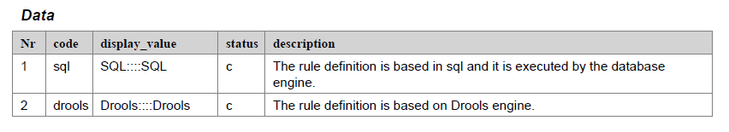

# approle

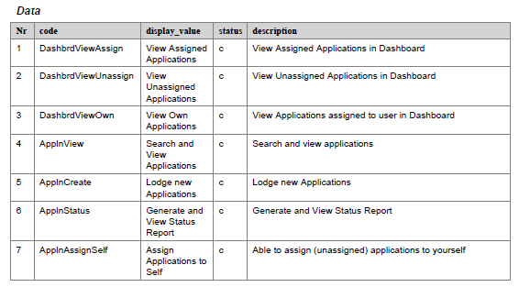

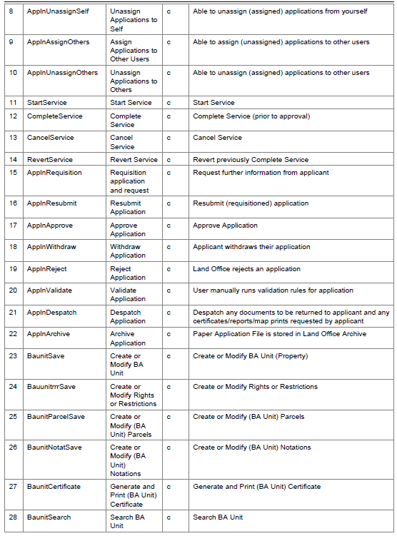

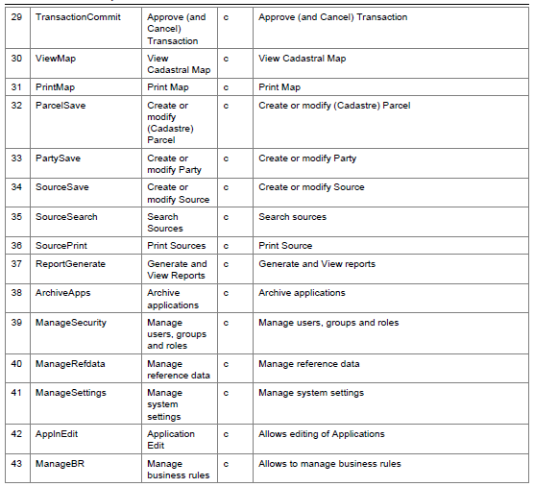

# approle_appgroup

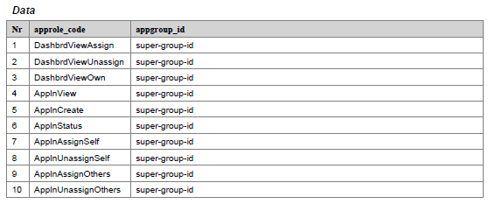

# administrative.ba_unit_type

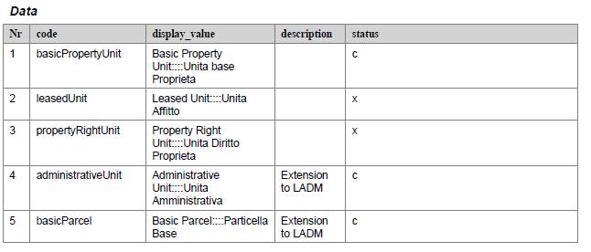

# administrative.rrr_type

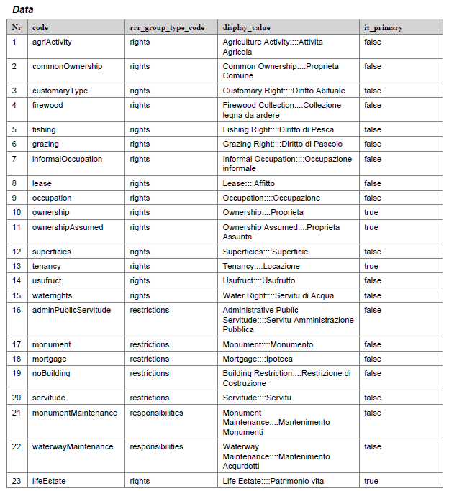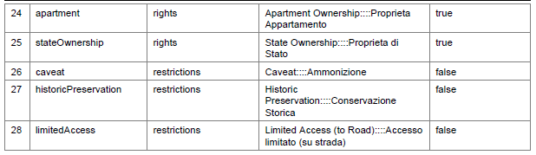

# administrative.ba_unit_rel_type

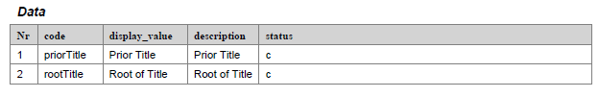

# cadastre.area_type

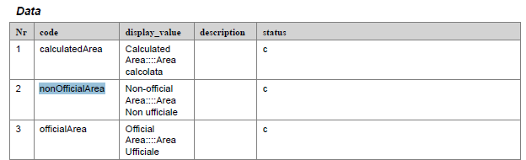

# cadastre.cadastre_object_type

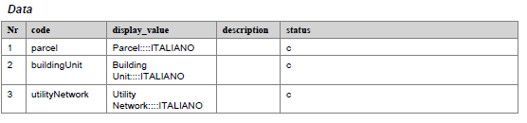

# application.application_status_type

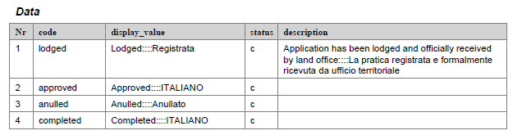

# application.service_status_type

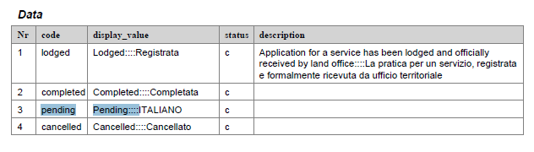

# application.application_action_type

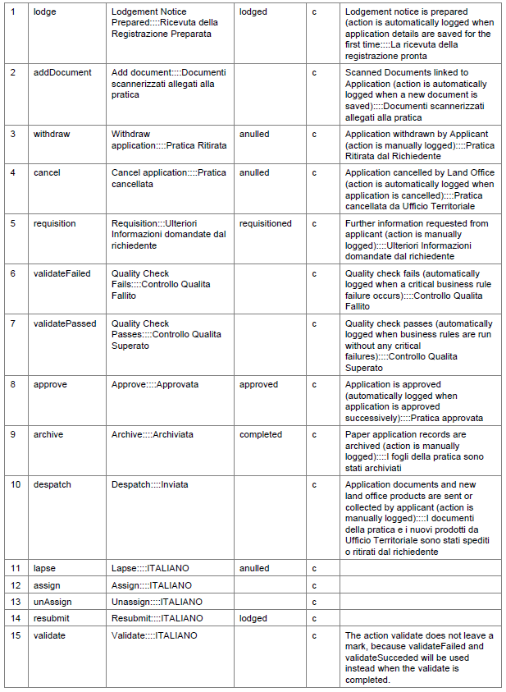

# application.request_type

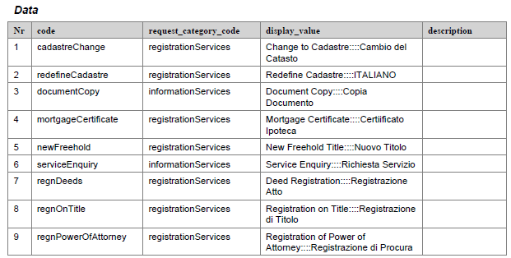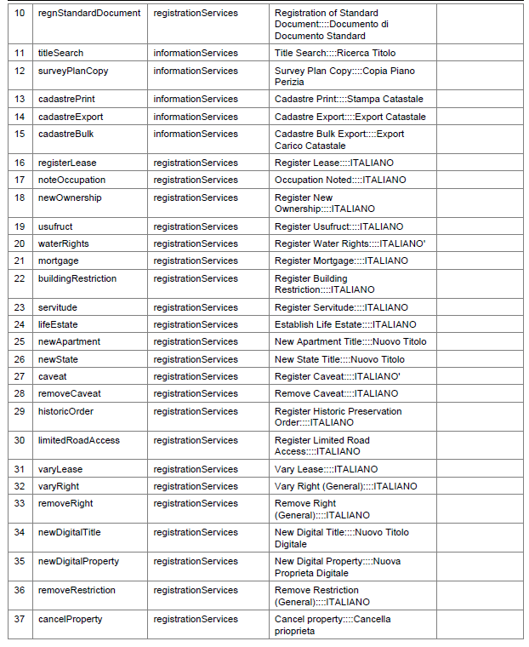

# application.request_category_type

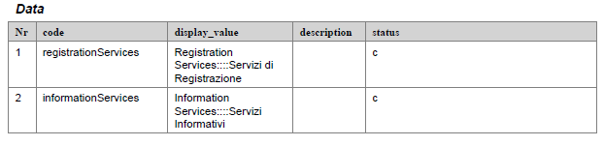

# application.service_action_type

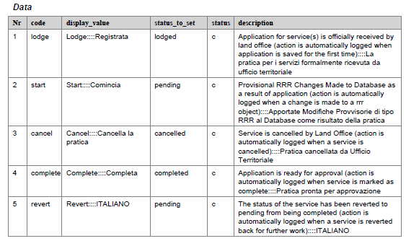

# application.type_action

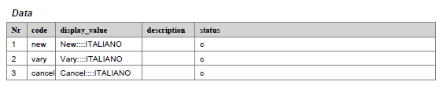

# party_role_type

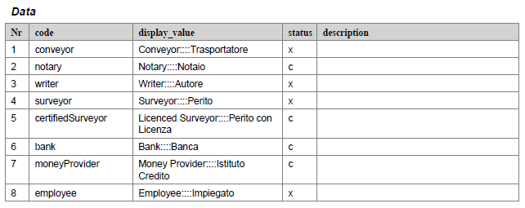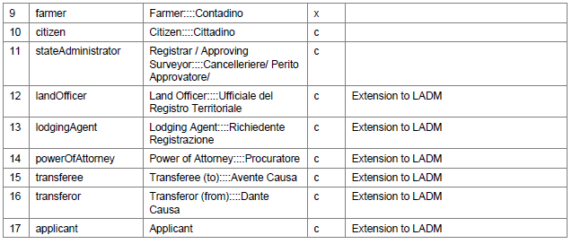

# party_type

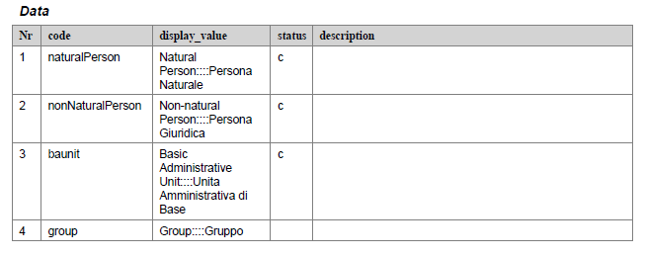

# transaction.reg_status_type

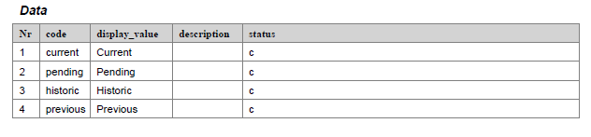

# transaction.transaction_status_type

