Second Generation of Adjusted Precipitation for Canada
Update to December 2017

Attention: A much larger adjusted precipitation dataset – The Adjusted Daily Rainfall and Snowfall Dataset, which contains 3346 stations across Canada, is available at the Government of Canada’s Open Data Portal: http://open.canada.ca/data/en/dataset/d8616c52-a812-44ad-8754-7bcc0d8de305. This dataset was produced with the same adjustments/corrections as the AHCCD precipitation data but with no joining of stations.
As shown below, due to station automation, the number of the AHCCD stations with precipitation data (manual stations) has been decreasing rapidly since 2001. We are working on alleviating this problem by joining data from manual and automatic stations.
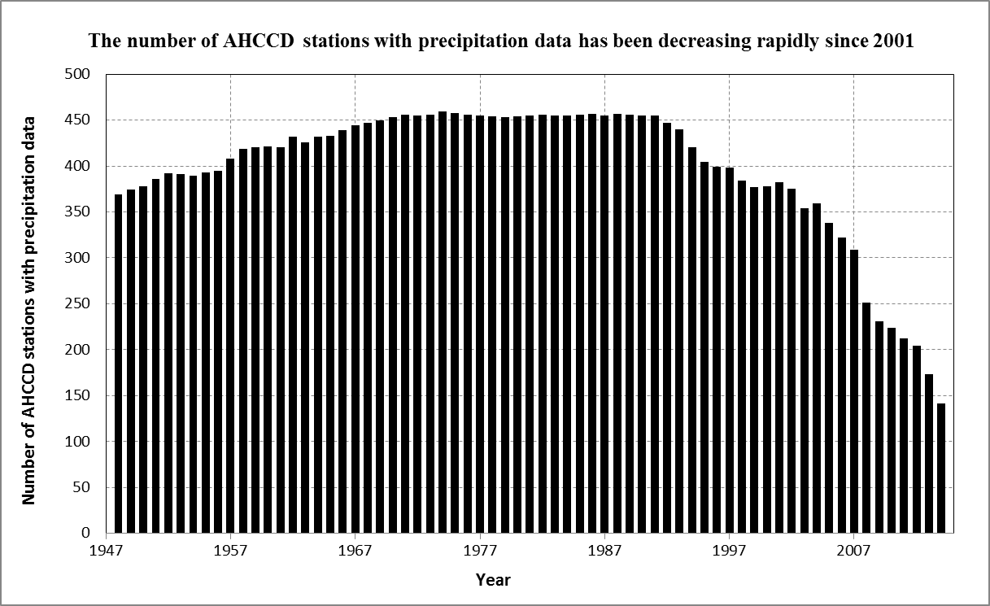

Background
In the mid-1990s, the first generation Adjusted Precipitation for Canada (APC1) dataset was prepared to provide a more accurate estimate of the precipitation amount for the analysis of climate trends (Mekis and Hogg, 1999). A number of improvements were introduced since then. The station list was revised to include stations with longer periods of observations covering as much of the last two decades as possible. The second generation Adjusted Precipitation for Canada (APC2) dataset provides adjusted daily rainfall, snowfall and total precipitation for over 450 locations. Series extend back as much as possible: however, data availability over most of the Canadian Arctic is restricted to the mid-1940s to present.
The methods to adjust daily rainfall and snowfall are described in Mekis and Vincent (2011). Daily rainfall gauge and snowfall ruler data were extracted directly from the National Climate Data Archive of Environment Canada. For each rain gauge type, corrections to account for wind undercatch, evaporation, and gauge specific wetting losses were implemented. The complete description of gauges can be found in Metcalfe et al (1997) and Devine and Mekis (2008). For snowfall, density corrections based upon coincident ruler and Nipher measurements were applied to all snow ruler measurements (Mekis and Brown, 2010). Trace precipitation is important over vast parts of Canada with the highest impact on the Canadian Arctic. Detailed description of trace related issues and the applied adjustments for trace observations are given in Mekis (2005) and Mekis and Vincent (2011). The accumulated rain or snow amounts were distributed over the effected days in order to minimize the impact on extreme values.
In Canada, when a station is relocated, a new identification number is often given to the new location and the two station’s observations can be combined in order to create longer time series. Adjustments obtained from standardized ratios between the tested site and neighbours or overlapping observations were applied for the joining of observations (Vincent and Mekis, 2009). To receive the list of the joined segments by stations along with the joining dates and applied adjustments please contact Eva Mekis at Eva.Mekis@ec.gc.ca.
Daily total precipitation was calculated by adding the station’s adjusted daily rain gauge and snow ruler observations together. Monthly rain, snow and total precipitation were calculated by adding the station’s daily rain gauge, snow ruler and total precipitation observations, over the month. A monthly value is missing if more than 3 consecutive days or more than 5 random days are missing in the month; a seasonal/annual value is missing if at least one month is missing in the respective season/year. The adjusted precipitation datasets will continue to be updated every year. The impact of the adjustments on rainfall and snowfall total amounts and trends was examined in detail in Mekis and Vincent, 2011.
Homogenized precipitation were used in a number of climate trends studies including the trends in annual and seasonal temperature and precipitation in Canada (Zhang et al. 2000), changes in temperature and precipitation daily indices (Vincent and Mekis, 2006 and Mekis and Vincent, 2011) and in global changes in daily and extremes temperature and precipitation (Alexander et al. 2006).
For more information, please contact Eva Mekis at Eva.Mekis@ec.gc.ca.
Naming convention and file format
Filenames defined as mr9999999.txt, ms9999999.txt and mt9999999.txt for monthly rain, snow and total precipitation respectively where 9999999 represents the 7-digits station identification number.
Within each file, the first two lines provide the station characteristics (identification number, name, province, station joined or not, element, unit, last update). The next two lines identify the content of each column (Year, January to December, annual, winter, spring, summer, autumn). Winter represents the total of December of the previous year, January and February; spring is the total of March, April and May; summer is the total of June, July and August; autumn is the total of September, October and November. Since the monthly value is the total of the daily adjusted values, no flag displayed to indicate monthly adjusted values: the flags are displayed in the daily dataset. The record format is: i4,1x,17(f8.1,1x,a1,1x). The data are in a comma-delimited format, which can easily be retrieved by packages such as Excel. Missing values are identified as "-9999.9" with the flag "M".

Reference to the second generation Adjusted Precipitation for Canada (APC2) dataset
Mekis, É and L.A. Vincent, 2011: An overview of the second generation adjusted daily precipitation dataset for trend analysis in Canada. Atmosphere-Ocean 49(2), 163-177.
Further references
Alexander, L.V., et al. 2006: Global observed changes in daily climate extremes of temperature and precipitation. Journal of Geophysical Research, vol. 111, D05109, doi:10.1029/2005JD006290.
Devine, K.A. and É. Mekis, 2008: Field accuracy of Canadian rain measurements. Atmosphere-Ocean 46 (2), 213–227.
Mekis, É and R. Brown, 2010: Derivation of an adjustment factor map for the estimation of the water equivalent of snowfall from ruler measurements in Canada. Atmosphere-Ocean 48 (4), 284–293 doi:10.3137/AO1104.2010
Mekis, É., 2005: J3.7 Adjustments for trace measurements in Canada. 15th Conference on Applied Climatology, Savannah, Georgia, USA, 20-24 June 2005.
Mekis, É. and W.D. Hogg, 1999: Rehabilitation and analysis of Canadian daily precipitation time series. Atmosphere-Ocean 37(1), 53-85.
Metcalfe, J.R., B. Routledge, and K. Devine, 1997: Rainfall measurement in Canada: Changing observational methods and archive adjustment procedures. J. Clim. 10: 92-101.
Vincent, L.A. and É. Mekis, 2009: Discontinuities due to joining precipitation station observations in Canada, Journal of Applied Meteorology and Climatology, Vol. 48, No. 1, 156–166. DOI: 10.1175/2008JAMC2031.1
Vincent, L.A. and É. Mekis, 2006: Changes in daily and extreme temperature and precipitation indices for Canada over the twentieth century. Atmosphere-Ocean, 44(2), 177-193.
Zhang, X., L.A. Vincent, W.D. Hogg and Ain Niitsoo, 2000: Temperature and precipitation trends in Canada during the 20th Century. Atmosphere and Ocean, 38, 395-429.

