Simple Example of an Automated Report in Word

June 04, 2023

## Overview

This is a very basic illustration of the kind of automated reports you can generate with R markdown. In this set-up, you have limited options for formatting (e.g., page breaks or figure captions require workarounds), but it shows the key benefit: every time you source data is updated you can quickly generate an updated report with all the updated figures and tables.

This document was generated following the steps from this [worked example](https://rmarkdown.rstudio.com/articles_docx.html). For an in-depth description of many possibilities for markdown reports (pdf, html, word, powerpoint), start with [this guide](https://epirhandbook.com/en/reports-with-r-markdown.html). For a properly formatted technical report, consider the versatile [bookdown package](https://bookdown.org/yihui/rmarkdown/) or the [csasdown extension](https://github.com/pbs-assess/csasdown) specifically for DFO technical reports and research documents.

*Important*: It is easy to get lost in the beautiful intricacies of generating perfectly-formatted reports using these more powerful tools for generating reports from markdown. However, the real bottleneck is getting a streamlined workflow up and running, from the individual data contributors to a basic summary of available information. Until that step works smoothly, a very basic report like this example should be sufficient. All the packages you need are already part of your RStudio install, so no additional setup is required. *Don’t procrastinate on the hard part by spending your time on the flashy stuff!*

## Example of Automated Summary Text

*The values in the text below are calculated from the data summaries and update automatically when the source data changes*

The current data set covers 11 assessment projects. Survey types include Aerial, MR, Sonar, Weir. The earliest record is from 1961.

## Example of A Summary Plot

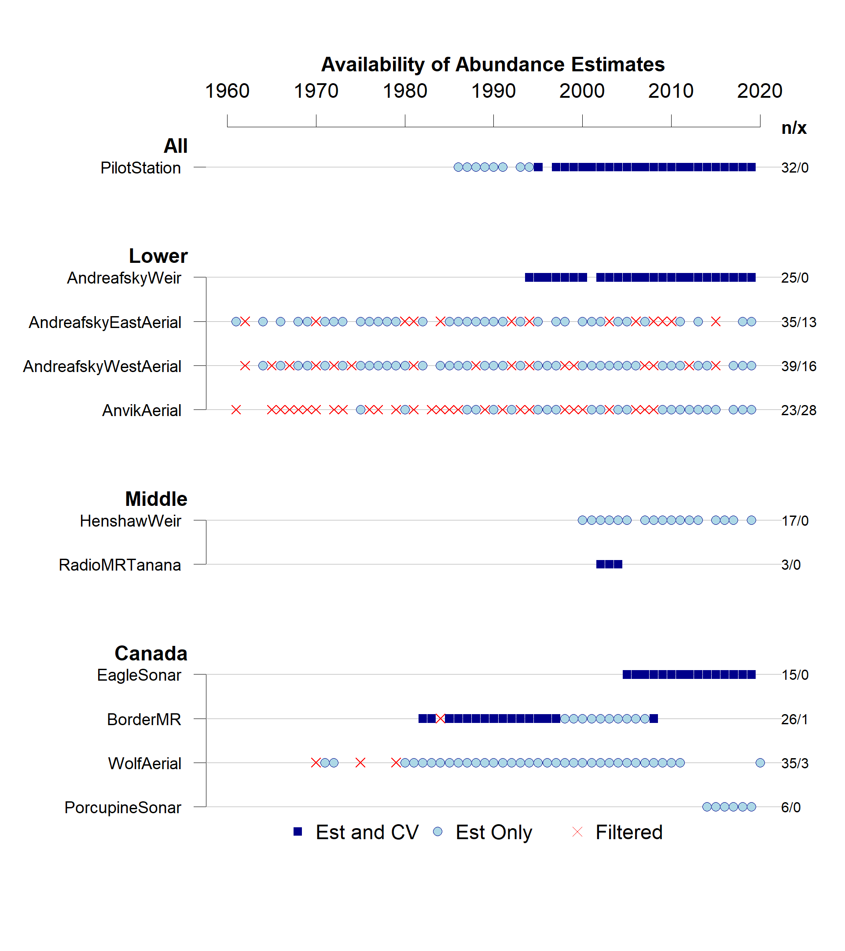

**Figure 1:** Overview of available data. For each assessment project, the timeline shows available estimates, categorized into three types: records for which uncertainty has been quantified (i.e., a coefficient of variation, CV, is available as well), records for which only a point estimate is available, and records that have been excluded due to data quality concerns (e.g., poor visibility during aerial survey).

## Another Example of A Summary Plot

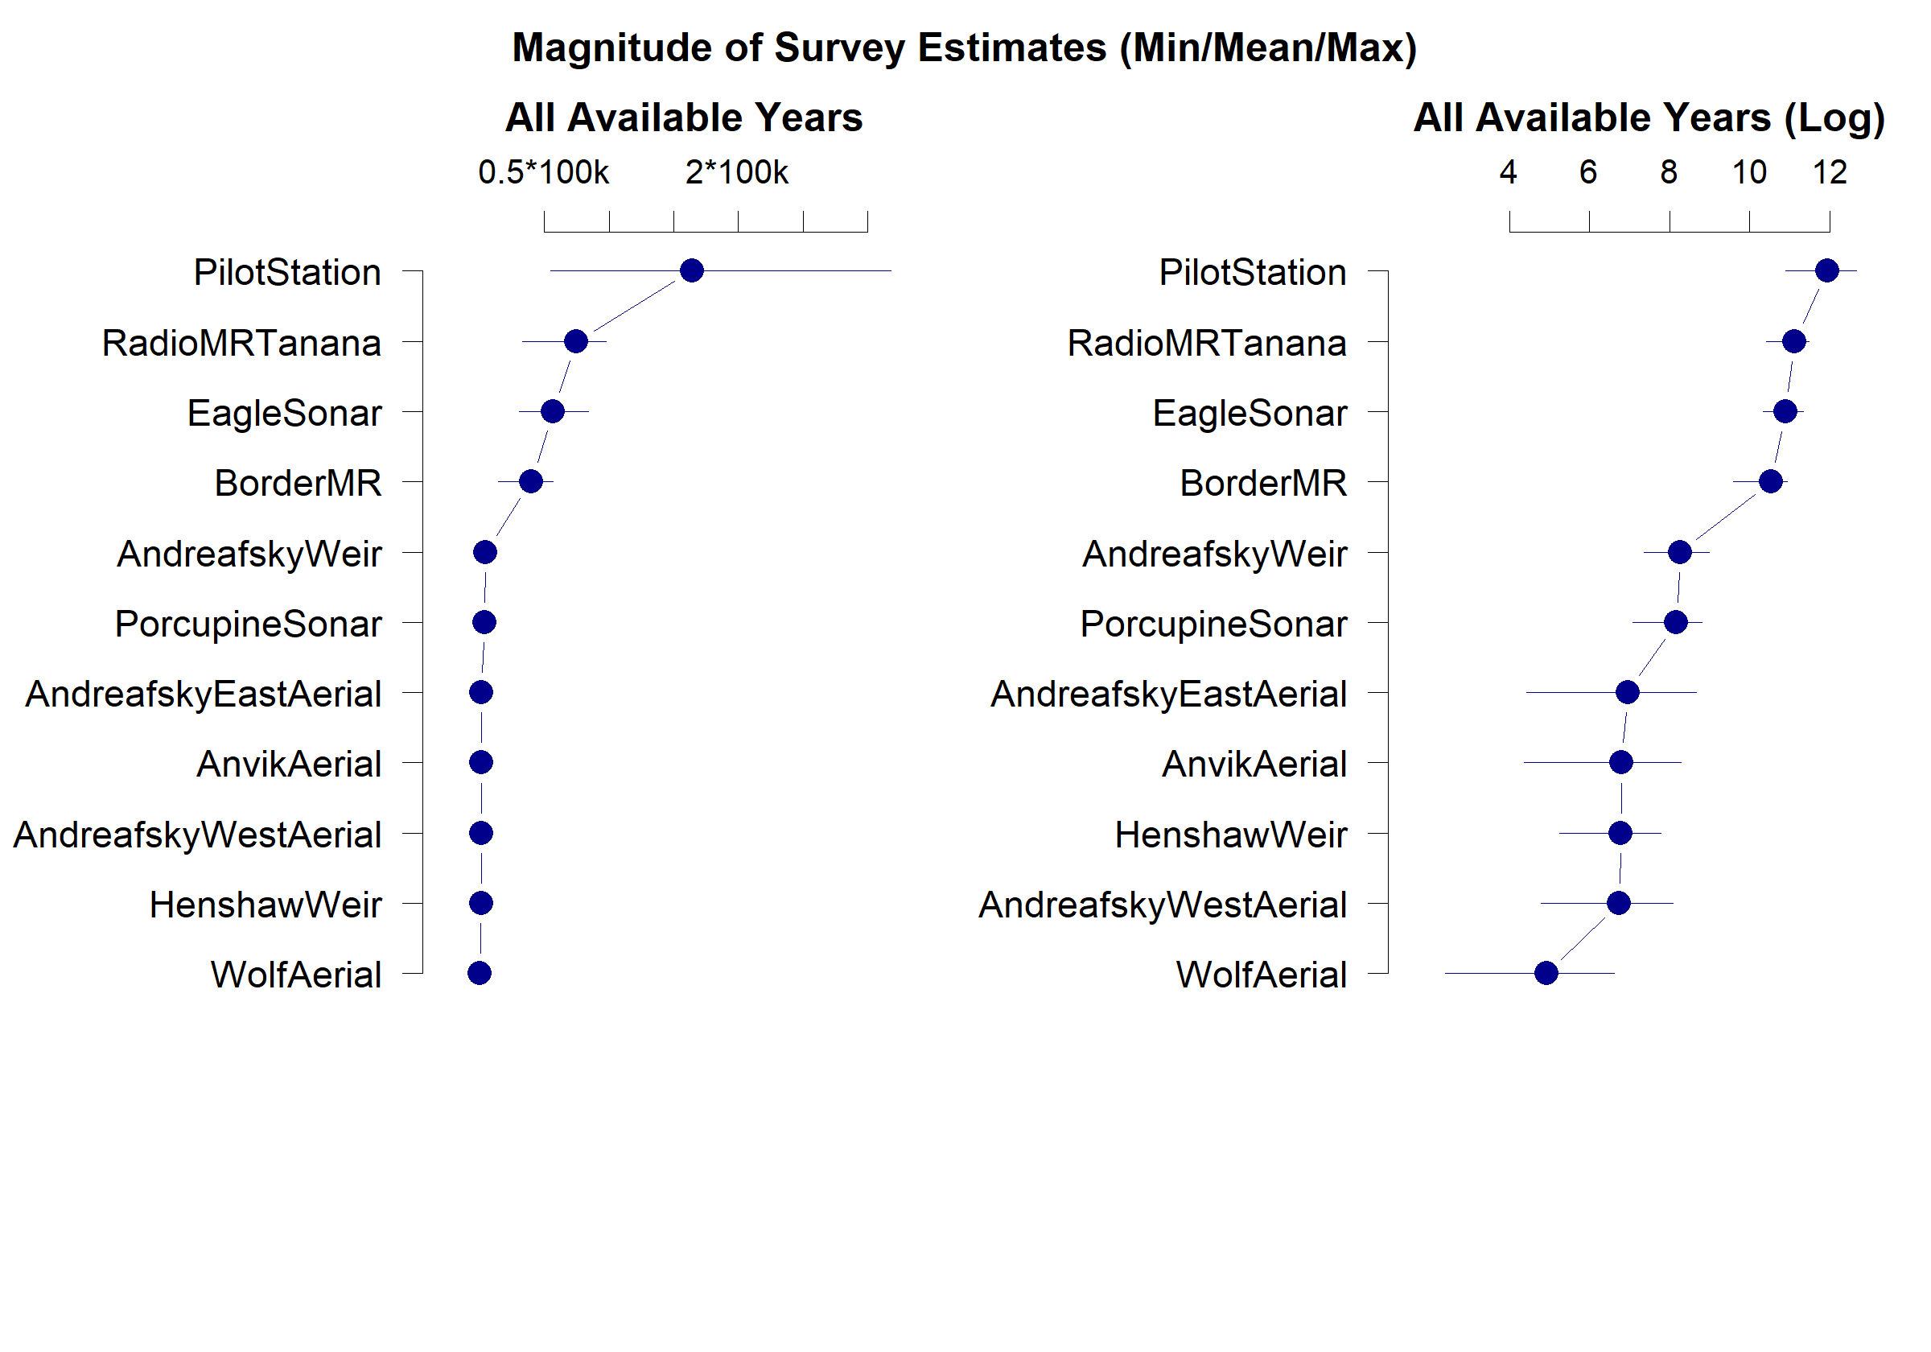

**Figure 2:** Comparison of abundance estimates across project. Figure shows the smallest, mean, and largest abundance estimate. Projects are ranked by mean estimate.

## Example of a Summary Table

**Table 1:** Project inventory.

| Stock | Watershed | SurveyType | NumEst | NumCV | FirstYr | LastYr |
| --- | --- | --- | --- | --- | --- | --- |
| All | Mainstem | Sonar | 32 | 24 | 1986 | 2019 |
| Lower | Andreafsky | Weir | 25 | 25 | 1994 | 2019 |
| Lower | Andreafsky | Aerial | 48 | 0 | 1961 | 2019 |
| Lower | Andreafsky | Aerial | 55 | 0 | 1962 | 2019 |
| Lower | Anvik | Aerial | 51 | 0 | 1961 | 2019 |
| Middle | Koyukuk | Weir | 17 | 0 | 2000 | 2019 |
| Middle | Tanana | MR | 3 | 3 | 2002 | 2004 |
| Canada | Mainstem | Sonar | 15 | 15 | 2005 | 2019 |
| Canada | Mainstem | MR | 27 | 16 | 1982 | 2008 |
| Canada | Teslin Headwaters | Aerial | 38 | 0 | 1970 | 2020 |
| Canada | Porcupine | Sonar | 6 | 0 | 2014 | 2019 |

## Example of Appendix Section With Project Details - Pilot Station Sonar

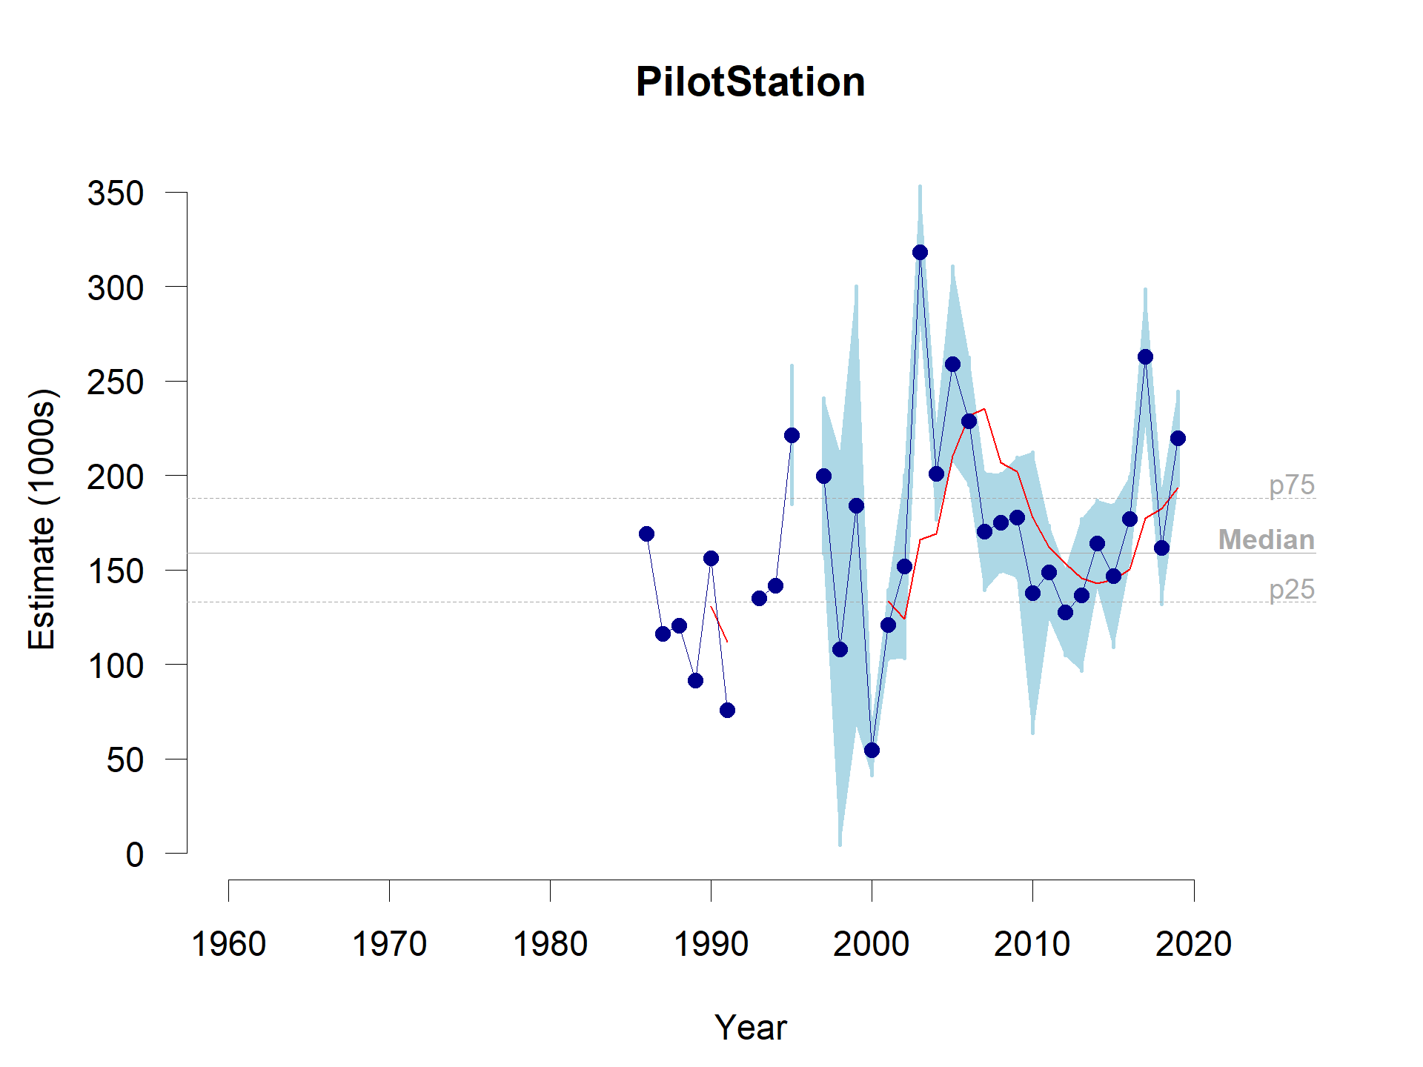

**Figure A.1:** Time series of abundance estimates - Pilot Station Sonar.

**Table A.1:** Annual estimates - Pilot Station Sonar

| Year | Estimate | SE | CV | Lower | Upper |
| --- | --- | --- | --- | --- | --- |
| 1986 | 169067 | NA | NA | NA | NA |
| 1987 | 116126 | NA | NA | NA | NA |
| 1988 | 120656 | NA | NA | NA | NA |
| 1989 | 91545 | NA | NA | NA | NA |
| 1990 | 156097 | NA | NA | NA | NA |
| 1991 | 75676 | NA | NA | NA | NA |
| 1993 | 134854 | NA | NA | NA | NA |
| 1994 | 141795 | NA | NA | NA | NA |
| 1995 | 221357 | 18313 | 0.0827306 | 184731 | 257983 |
| 1997 | 199763 | 20535 | 0.1027968 | 158693 | 240833 |
| 1998 | 108038 | 51703 | 0.4785631 | 4632 | 211444 |
| 1999 | 184218 | 57953 | 0.3145892 | 68312 | 300124 |
| 2000 | 54560 | 6601 | 0.1209861 | 41358 | 67762 |
| 2001 | 121089 | 9106 | 0.0752009 | 102877 | 139301 |
| 2002 | 151713 | 24298 | 0.1601577 | 103117 | 200309 |
| 2003 | 318088 | 17359 | 0.0545729 | 283370 | 352806 |
| 2004 | 200761 | 12145 | 0.0604948 | 176471 | 225051 |
| 2005 | 259014 | 25807 | 0.0996355 | 207400 | 310628 |
| 2006 | 228763 | 16836 | 0.0735958 | 195091 | 262435 |
| 2007 | 170246 | 15523 | 0.0911798 | 139200 | 201292 |
| 2008 | 175046 | 12989 | 0.0742034 | 149068 | 201024 |
| 2009 | 177796 | 15885 | 0.0893440 | 146026 | 209566 |
| 2010 | 137899 | 37156 | 0.2694436 | 63587 | 212211 |
| 2011 | 148797 | 12264 | 0.0824210 | 124269 | 173325 |
| 2012 | 127555 | 11339 | 0.0888950 | 104877 | 150233 |
| 2013 | 136805 | 20001 | 0.1462008 | 96803 | 176807 |
| 2014 | 163895 | 11389 | 0.0694896 | 141117 | 186673 |
| 2015 | 146859 | 18820 | 0.1281501 | 109219 | 184499 |
| 2016 | 176898 | 11226 | 0.0634603 | 154446 | 199350 |
| 2017 | 263014 | 17696 | 0.0672816 | 227622 | 298406 |
| 2018 | 161831 | 14917 | 0.0921764 | 131997 | 191665 |
| 2019 | 219624 | 12448 | 0.0566787 | 194728 | 244520 |

**Table A.2:** Inventory of Operational Changes - Pilot Station Sonar

| Years | Component | Change_Event |
| --- | --- | --- |
| 1980-1983 | All | Project feasibility studies conducted. |
| 1985 | Sonar | Initial set up using BioSonics 420 kHz with 20 min sampling duration with a -32 dB detection threshold. Report periods were 3-9 days to obtain minimum sample of 120 fish at each site. Transducers were aimed 15 deg downstream to determine direction of travel. Counts within sectors were expanded for the proportion of the water column covered. Left bank strata required 2 transducers deployed at different ranges. |
| 1985 | Test Fishery | Used 4 mesh sizes: 101.6 mm (4.0 in), 139.7 mm (5.5 in), 162.0 mm (6.38 in), and 215.9 mm (8.5 in) 45.7 m (150 ft) . Sampled 4 strata, (left bank nearshore, left bank offshore, right bank bottom, right bank surface), |
| 1986 | Test Fishery | 6 Mesh sizes utilized 101.6 mm (4.0 in), 127.0 mm (5.0 in), 139.7 mm (5.5 in), 165.1 mm (6.5 in), 190.5 mm (7.5 in), and 215.9 mm (8.5 in). All were 45.7 m (150 ft) long and 7.6 m (25 ft) deep. |
| 1988 | Test Fishery | Did not adjust catches for selectivity (this was 1988 only). |
| 1989 | Test Fishery | Methodology consistent with 1986. |
| 1990 | Test Fishery | Spatial expansion based on the proportion of the water column ensonified was discontinued. 8.5in and 7.5indrifted twice per bank per period, other nets drifted once per bank. Stopped fishing 8.5in and 7.5in nets after July 25. Net selectivity methodology improved from previous, used McCombie and Fry method (1960) for Chinook and chum salmon and Holt (Peterson 1966) for coho salmon, pink salmon, and whitefish. Began computing sample variance for the estimates. SAS used to generate estimates. |
| 1991 | Test Fishery | First year 70 mm (2.75 in) net fished |
| 1992 | Sonar | Project only operated a partial season and savings used to purchase 120kHz equipment |
| 1993 | Sonar | Sonar frequency changed from 420 kHz to 120 kHz to detect fish at greater ranges. Individual sonar stratum were sampled in 15 min periods (was 20 min previously). Sonar operated 24 hrs/day 4 times during the season. No expansion for fish beyond the counting range using down looking fathometer Log-normal curves used to describe selectivity. |
| 1995 | Test Fishery | Utilized a single stratum on the right bank. The project has always utilized a single stratum (or test fish zone) for the apportionment of the sonar counts on the right bank. Although there were a couple years (2008 and 2009) where another test fish zone was fished to bolster Chinook catches for GSI, this data was not used in the apportionment of sonar counts. |
| 1995 | Sonar | No longer used the angle of traces to distinguish downstream from upstream fish. All traces were considered upstream. |
| 1996 | Sonar and TF | Project did not produce estimates and operated for training purposes only. |
| 1997 | Test Fishery | 140 mm (5.5 in) mesh added in the fall when 7.5 in and 8.5 in discontinued. |
| 1998 | Sonar | Sampled 3 sonar strata on right bank. |
| 1998 | Test Fishery | Discontinued the 127.0 mm (5.0 in) and 165.1 mm (5.5 in) nets, used 133 mm (5.25 in). |
| 1999 | Test Fishery | In the fall season, discontinued 215.0 mm (8.5 in) and 133 mm (5.25 in) nets and added 146 mm (5.75 in) and 127 mm (5.0 in). |
| 2001 | Sonar | Transitioned to HTI split-beam equipment. Frequency kept at 120 kHz and still marked fish using paper charts. |
| 2004 | Sonar | Changed selectivity model to use Pearson-T curve. |
| 2005 | Sonar | Incorporated the DIDSON into left bank sampling for the first 20 m. |
| 2009 | Sonar | Transitioned from marking fish on paper charts to electronic echograms. |
| 2010 | Test Fishery | Tested 50 fathom nets during summer season. Alternated 25 fathom and 50 fathom by test fishing period. |
| 2010 | Sonar | Preliminary testing of side-scan sonar for use offshore during periods of extreme turbidity. |
| 2011 | Test Fishery | Discontinued the 50 fathom nets and resumed normal test fishing operations. |
| 2011 | Sonar | Final year of side-scan testing. |
| 2015 | Sonar | Switched from DIDSON to ARIS on the left bank sampling the entire stratum 3 (0-50 m). |
| 2016 | Sonar | Updated selectivity parameters for all species and implemented a minimum selectivity threshold of 0.1. |

**Table A.3:** Inventory of Data Concerns - Pilot Station Sonar

| Years_Affected | Potential_Issue |
| --- | --- |
| 1980-1994 | Prior to 1993, the project used dual-beam sonar equipment that operated at 420 kHz. Prior to 1995, the project attempted to identify direction of travel of detected targets by aiming transducers at an upstream or downstream oblique angle relative to fish travel. Because of these changes, data collected from 1995 to current are not directly compatible to previous years. |
| Mid 1990s | Sandbar issue on the right bank plagued the project for several years. Detection through the silt band created by the bar while depositing or vacating made counts difficult in those years. |
| 1996 | The Pilot Station sonar project did not operate at full capacity in 1996 and there are no passage estimates for this year. |
| 2001 | High water levels were experienced at Pilot Station therefore, passage estimates are considered conservative. Extreme high water during the bulk of the summer season (May, all of June and part of July). Water remained slightly above average throughout the fall. |
| 2005 | Estimates include extrapolations for the dates June 10 to June 18 to account for the time before the DIDSON was deployed. Otherwise, the estimates should be good. |
| 2009 | High water levels were experienced at Pilot Station therefore which limited detection. Passage estimates are considered conservative. Extremely high in May but then just above average the rest of the summer season. In the fall, water dropped to record low causing all kinds of unique issues for those species. |