Status Report

Table of contents

## 1 Introduction

### 1.1 Background

This report summarizes data, status metrics, and rapid status status results for INSERT LABEL.

### 1.2 WSP Status Methods

put some brief text here with links to publications

## 2 CU Status

Put some brief text that describes the dashboards

### 2.1 Chinook_CU_1 (Case1, WorkedExample)

Add description in spec file

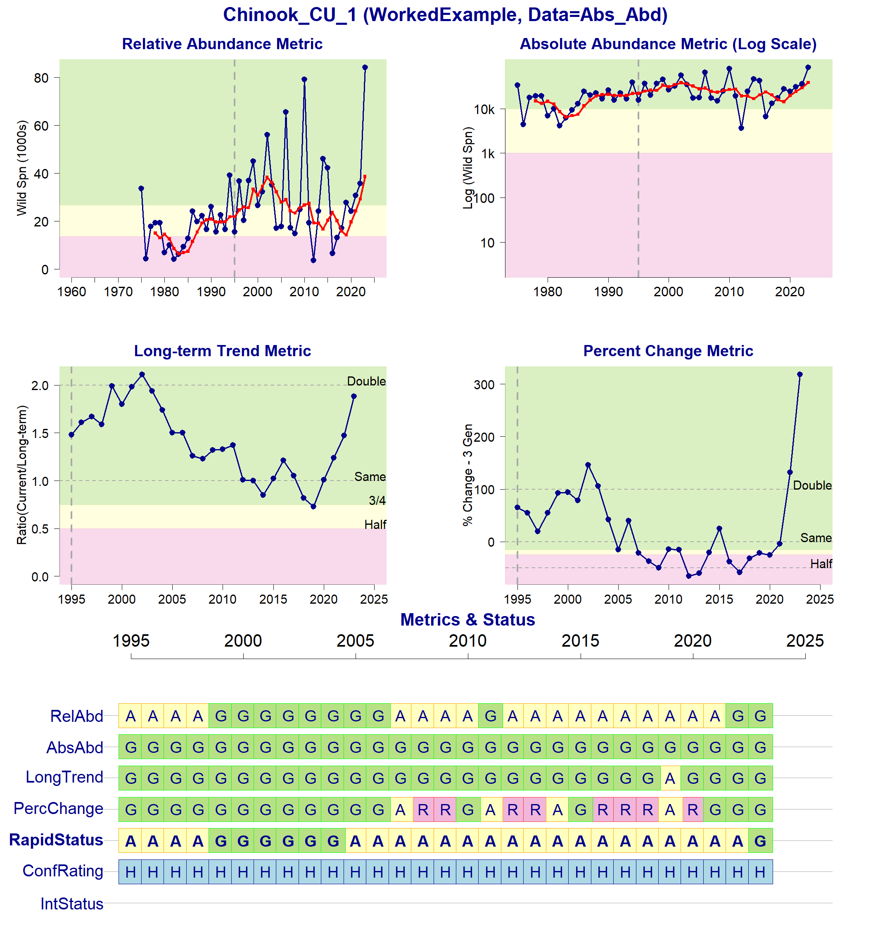

Status Metrics and Rapid Status for Chinook_CU_1

### 2.2 Sockeye_CU_2 (Case2, WorkedExample)

Add description in spec file

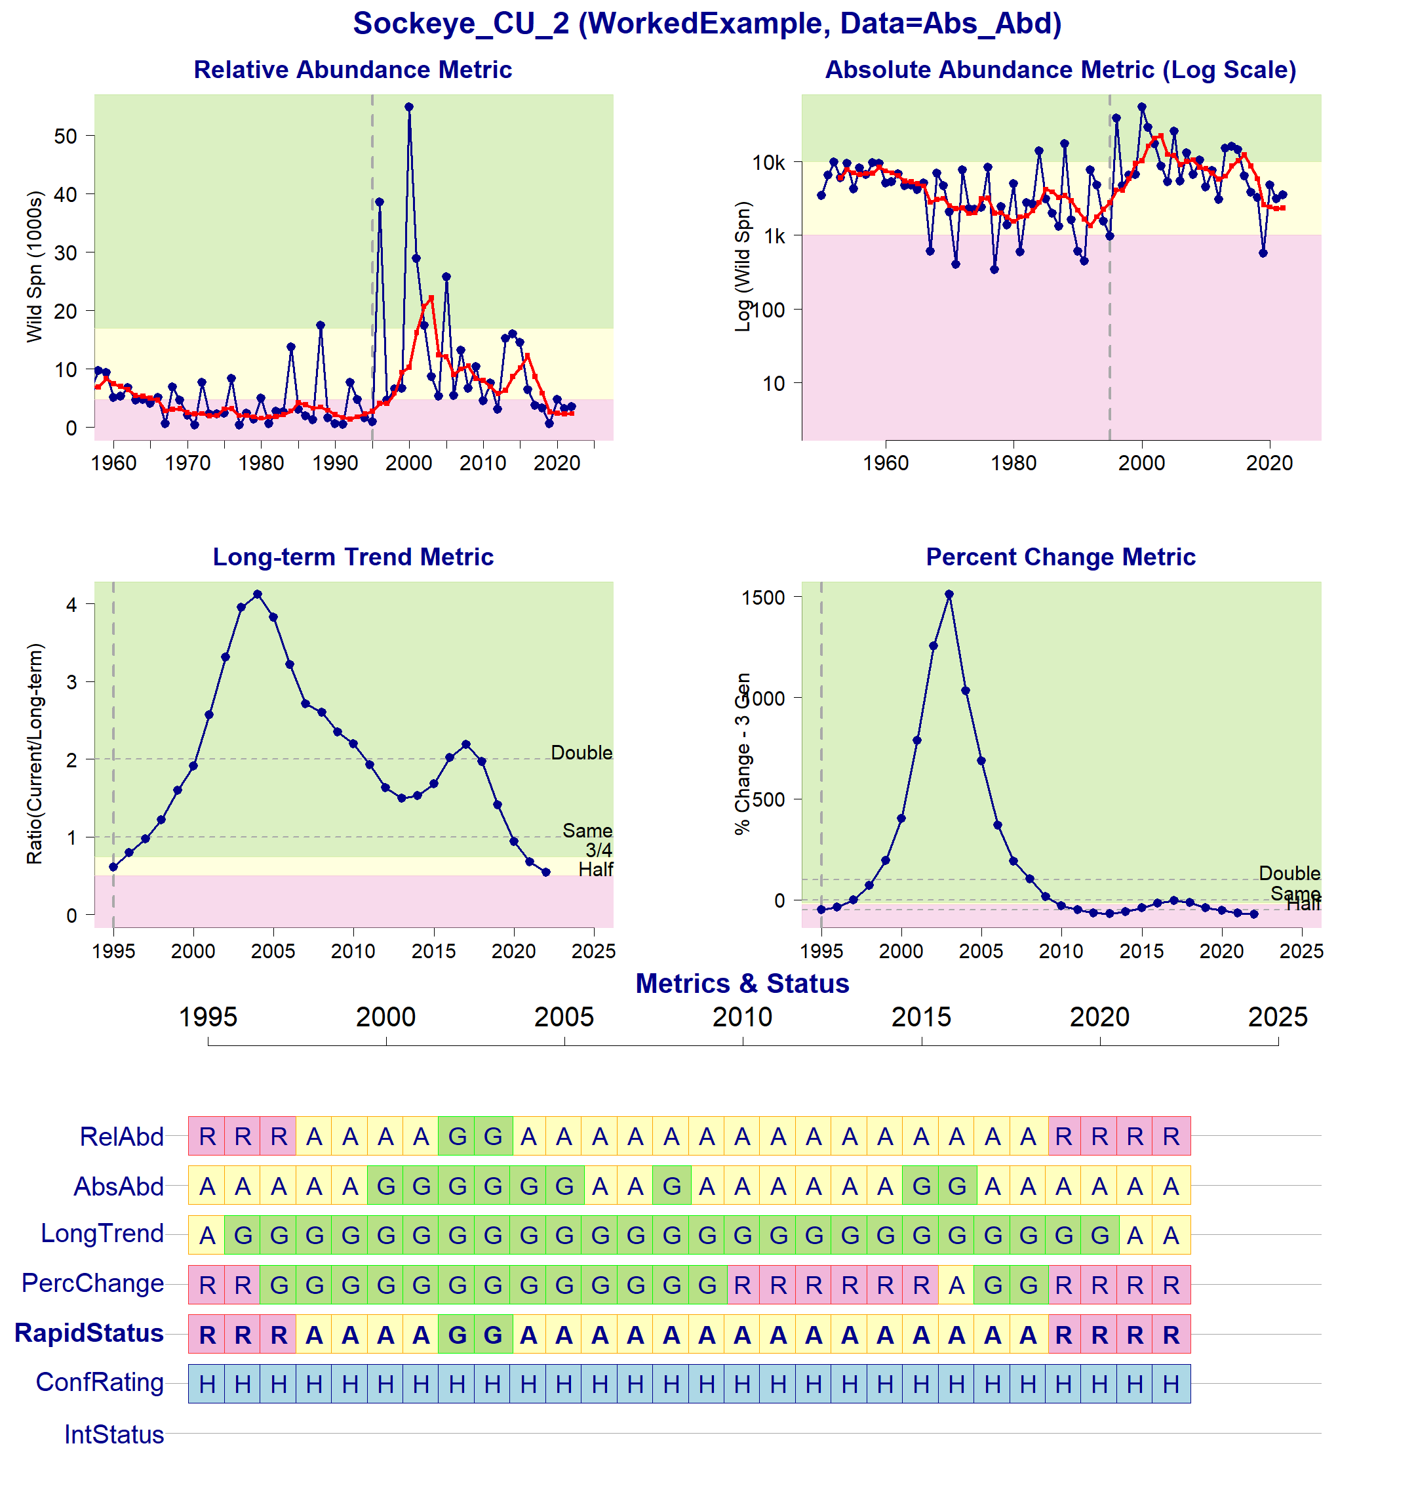

Status Metrics and Rapid Status for Sockeye_CU_2

### 2.3 Chinook_CU_3 (Case3, WorkedExample)

Add description in spec file

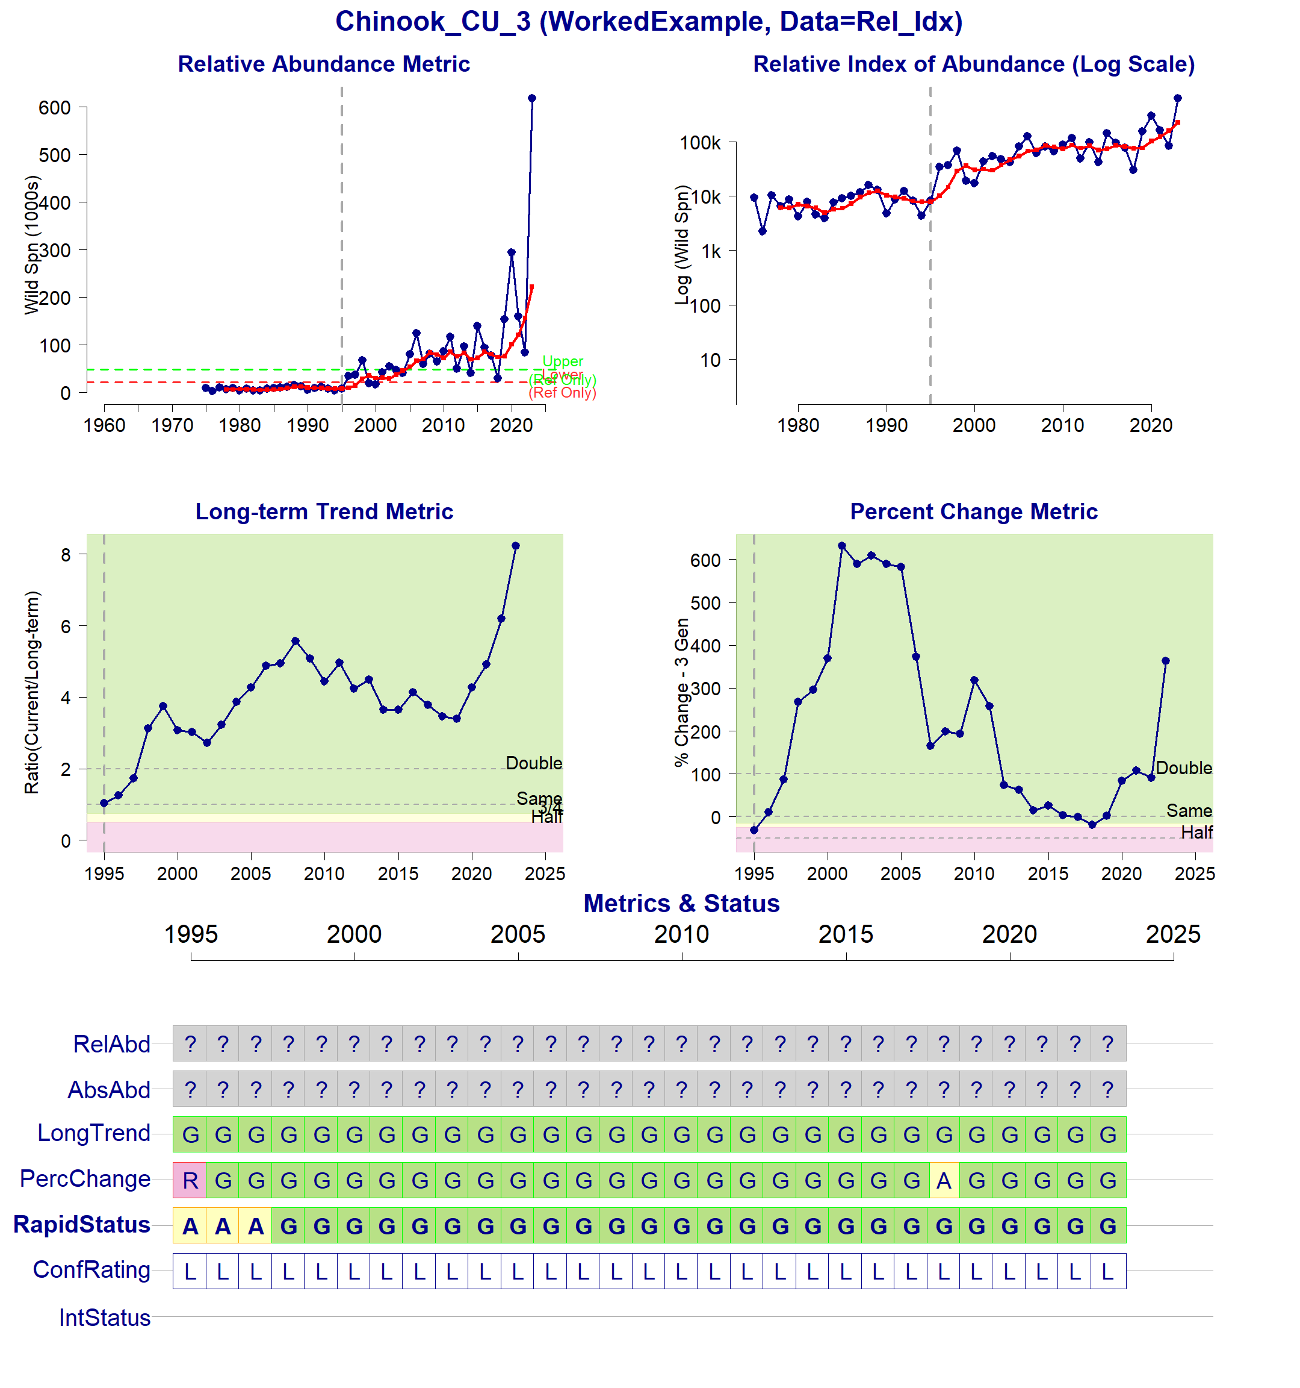

Status Metrics and Rapid Status for Chinook_CU_3

### 2.4 Sockeye_CU_4 (Case4, WorkedExample)

Add description in spec file

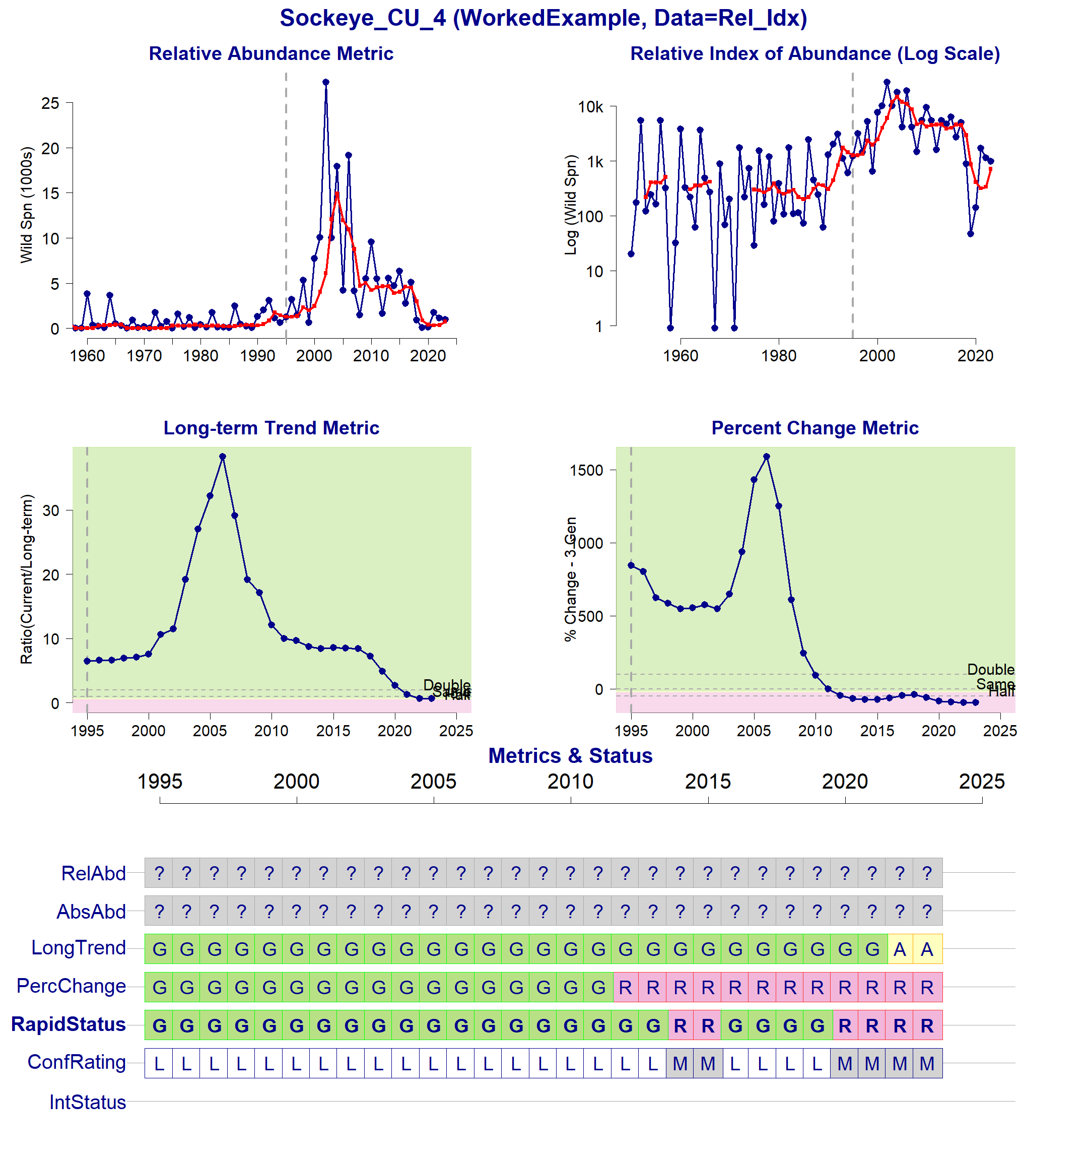

Status Metrics and Rapid Status for Sockeye_CU_4

### 2.5 Chinook_CU_5 (Case5, WorkedExample)

Add description in spec file

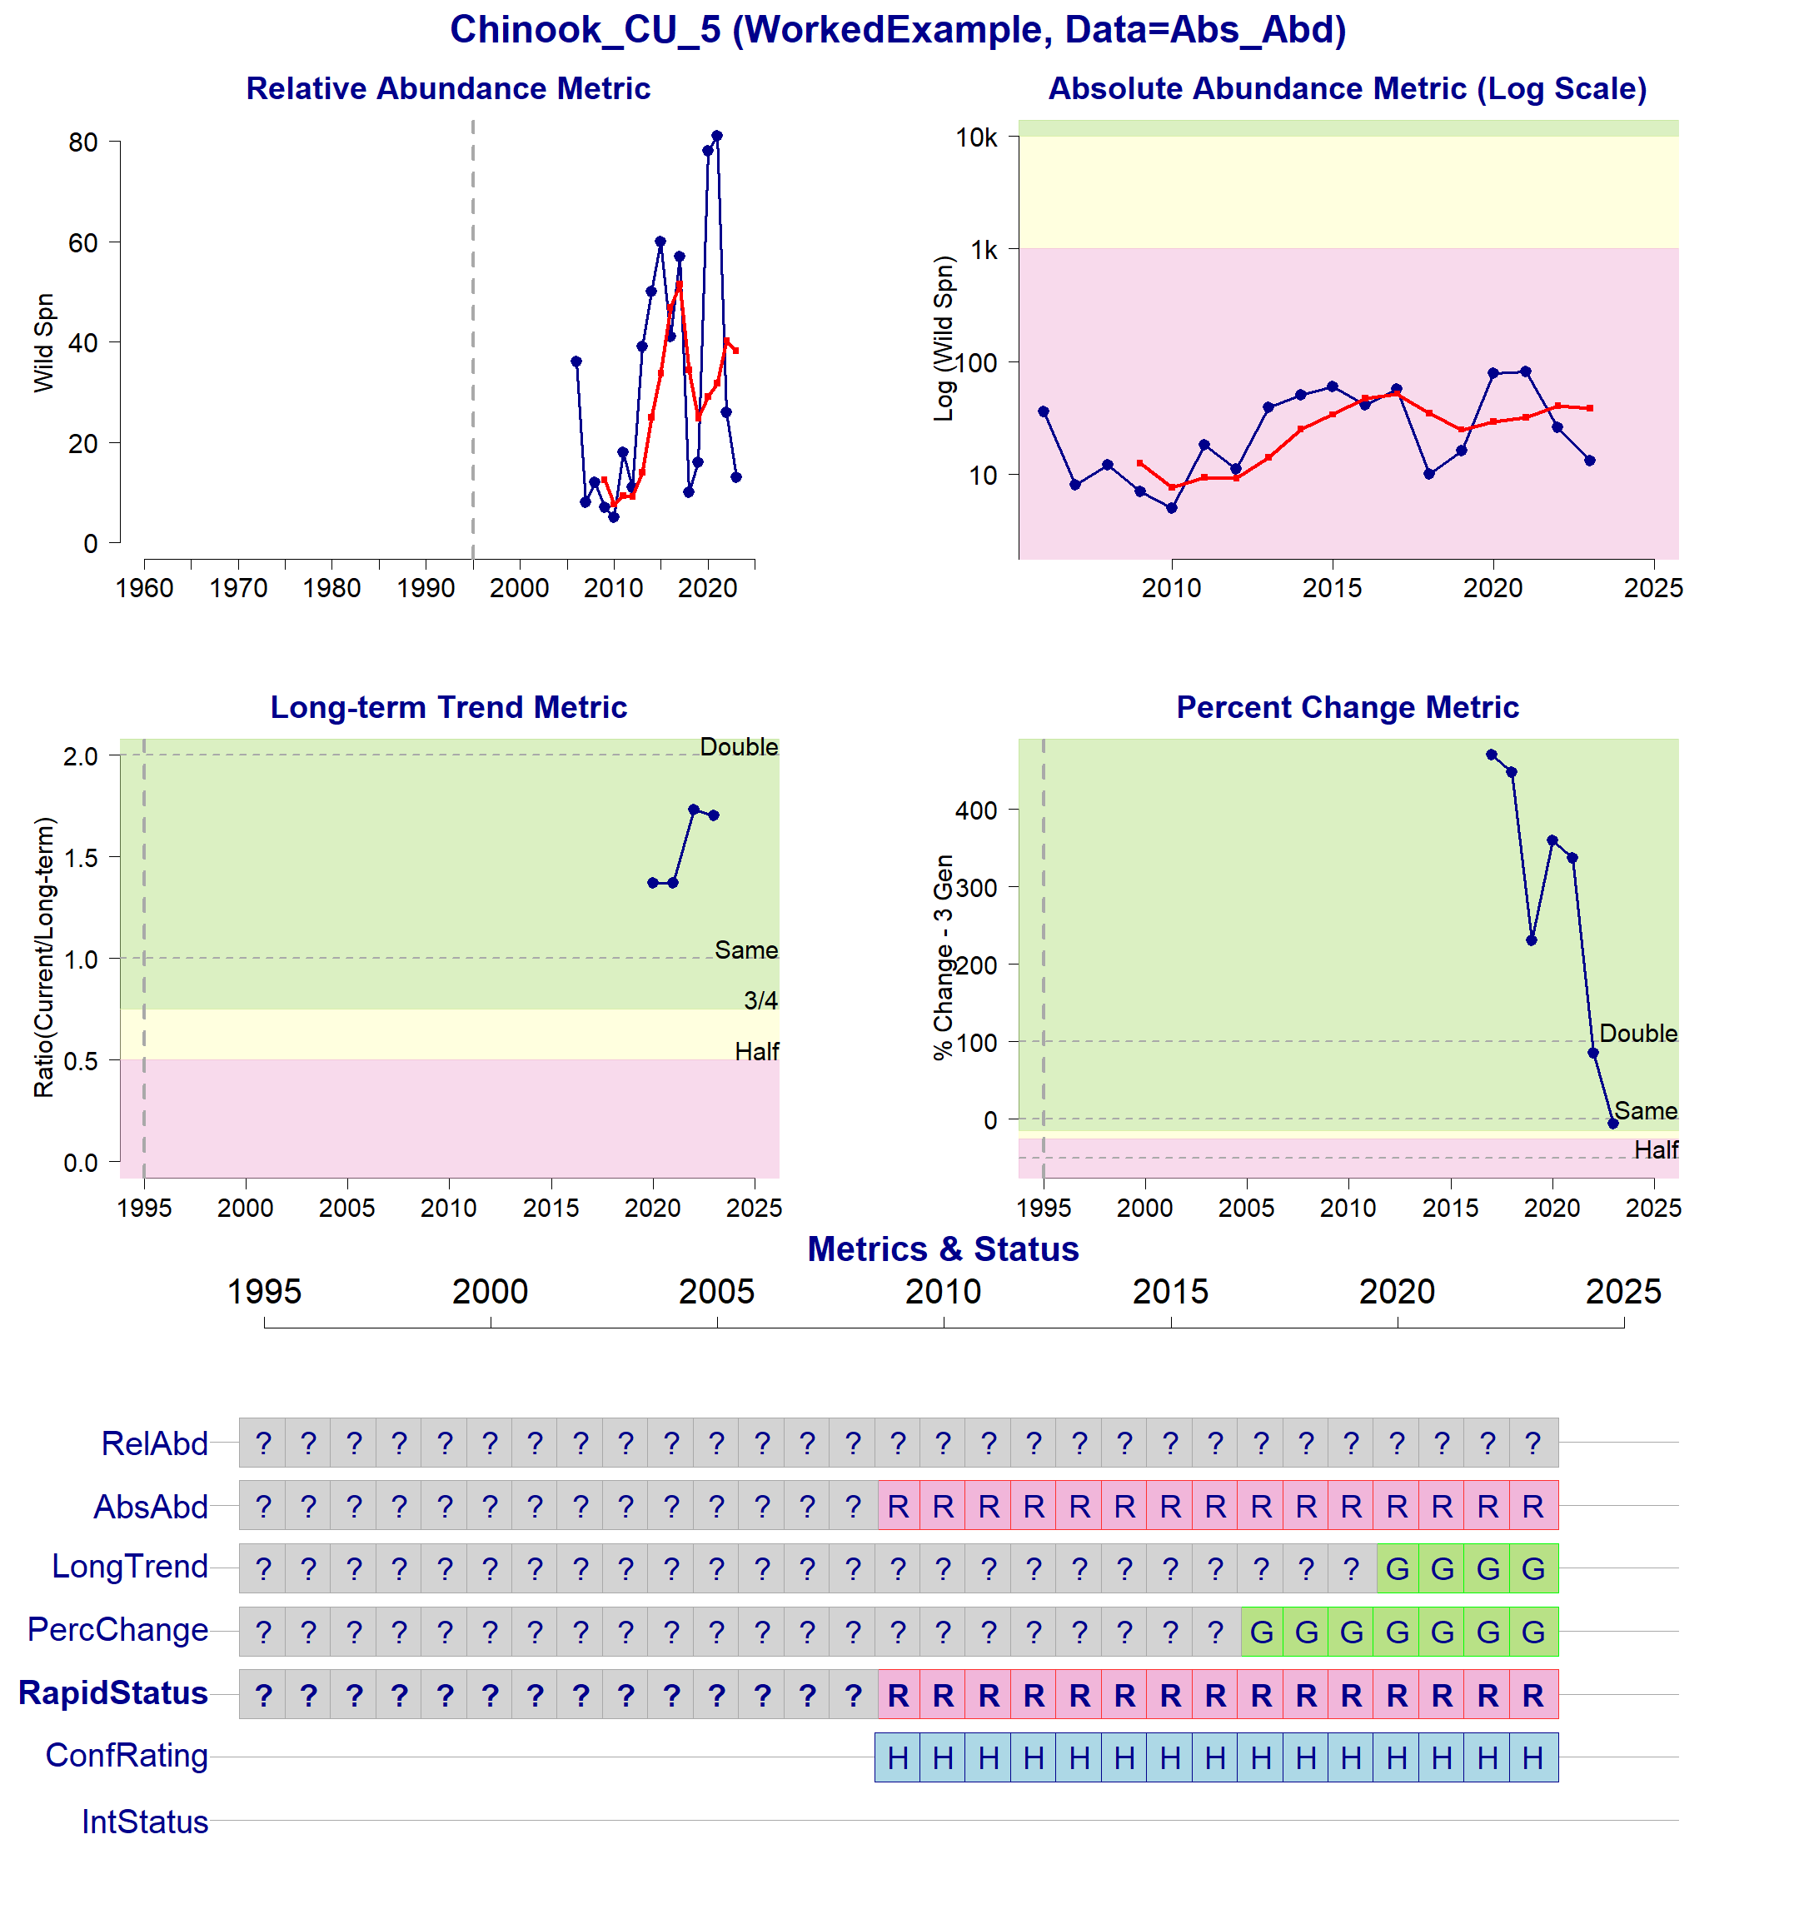

Status Metrics and Rapid Status for Chinook_CU_5