Solutions Report

Table of contents

# 1. SOLUTIONS FOR THE EXAMPLES

## 1.1 Conservation Unit 1 (Chinook)

Rapid status for 2023 is Green with High Confidence (Node 36 in the decision tree).

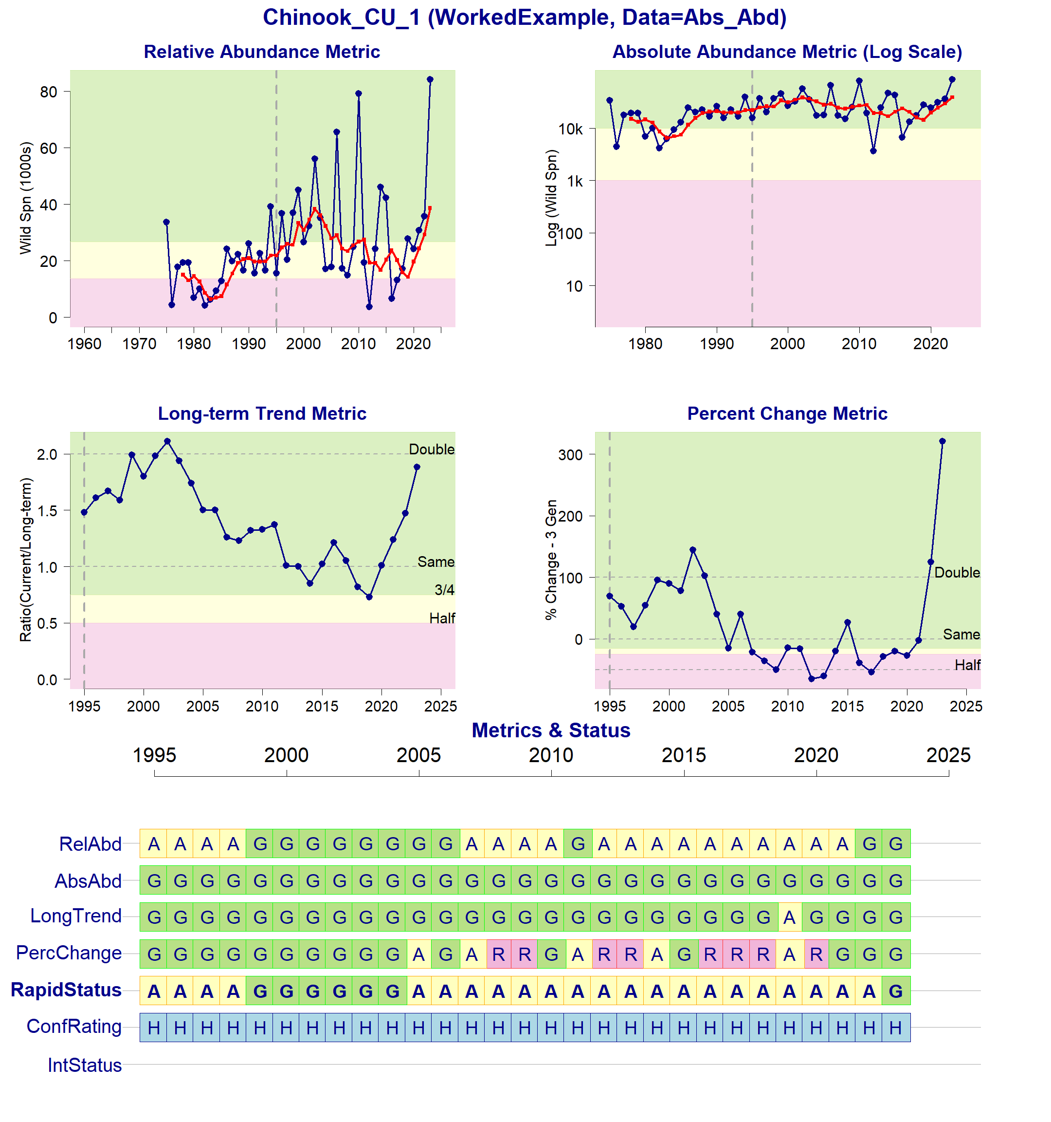

Status Metrics and Rapid Status for Chinook_CU_1

## 1.2 Conservation Unit 2 (Sockeye)

Rapid status for 2022 is Red with High Confidence (Node 23 in the decision tree).

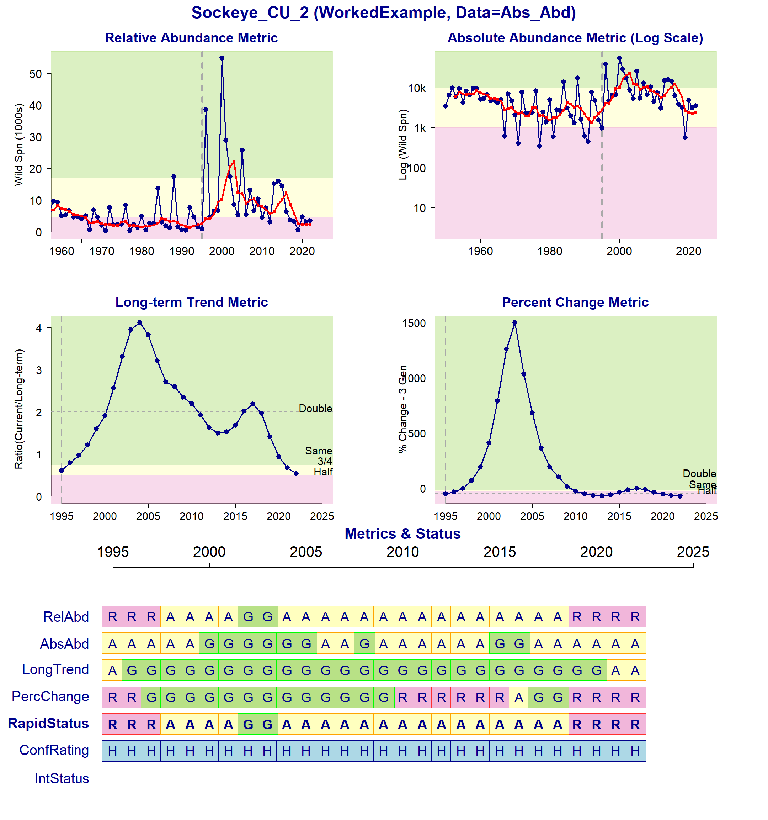

Status Metrics and Rapid Status for Sockeye_CU_2

## 1.3 Conservation Unit 3 (Chinook)

Rapid status for 2023 is Green with Low Confidence (Node 64 in the decision tree).

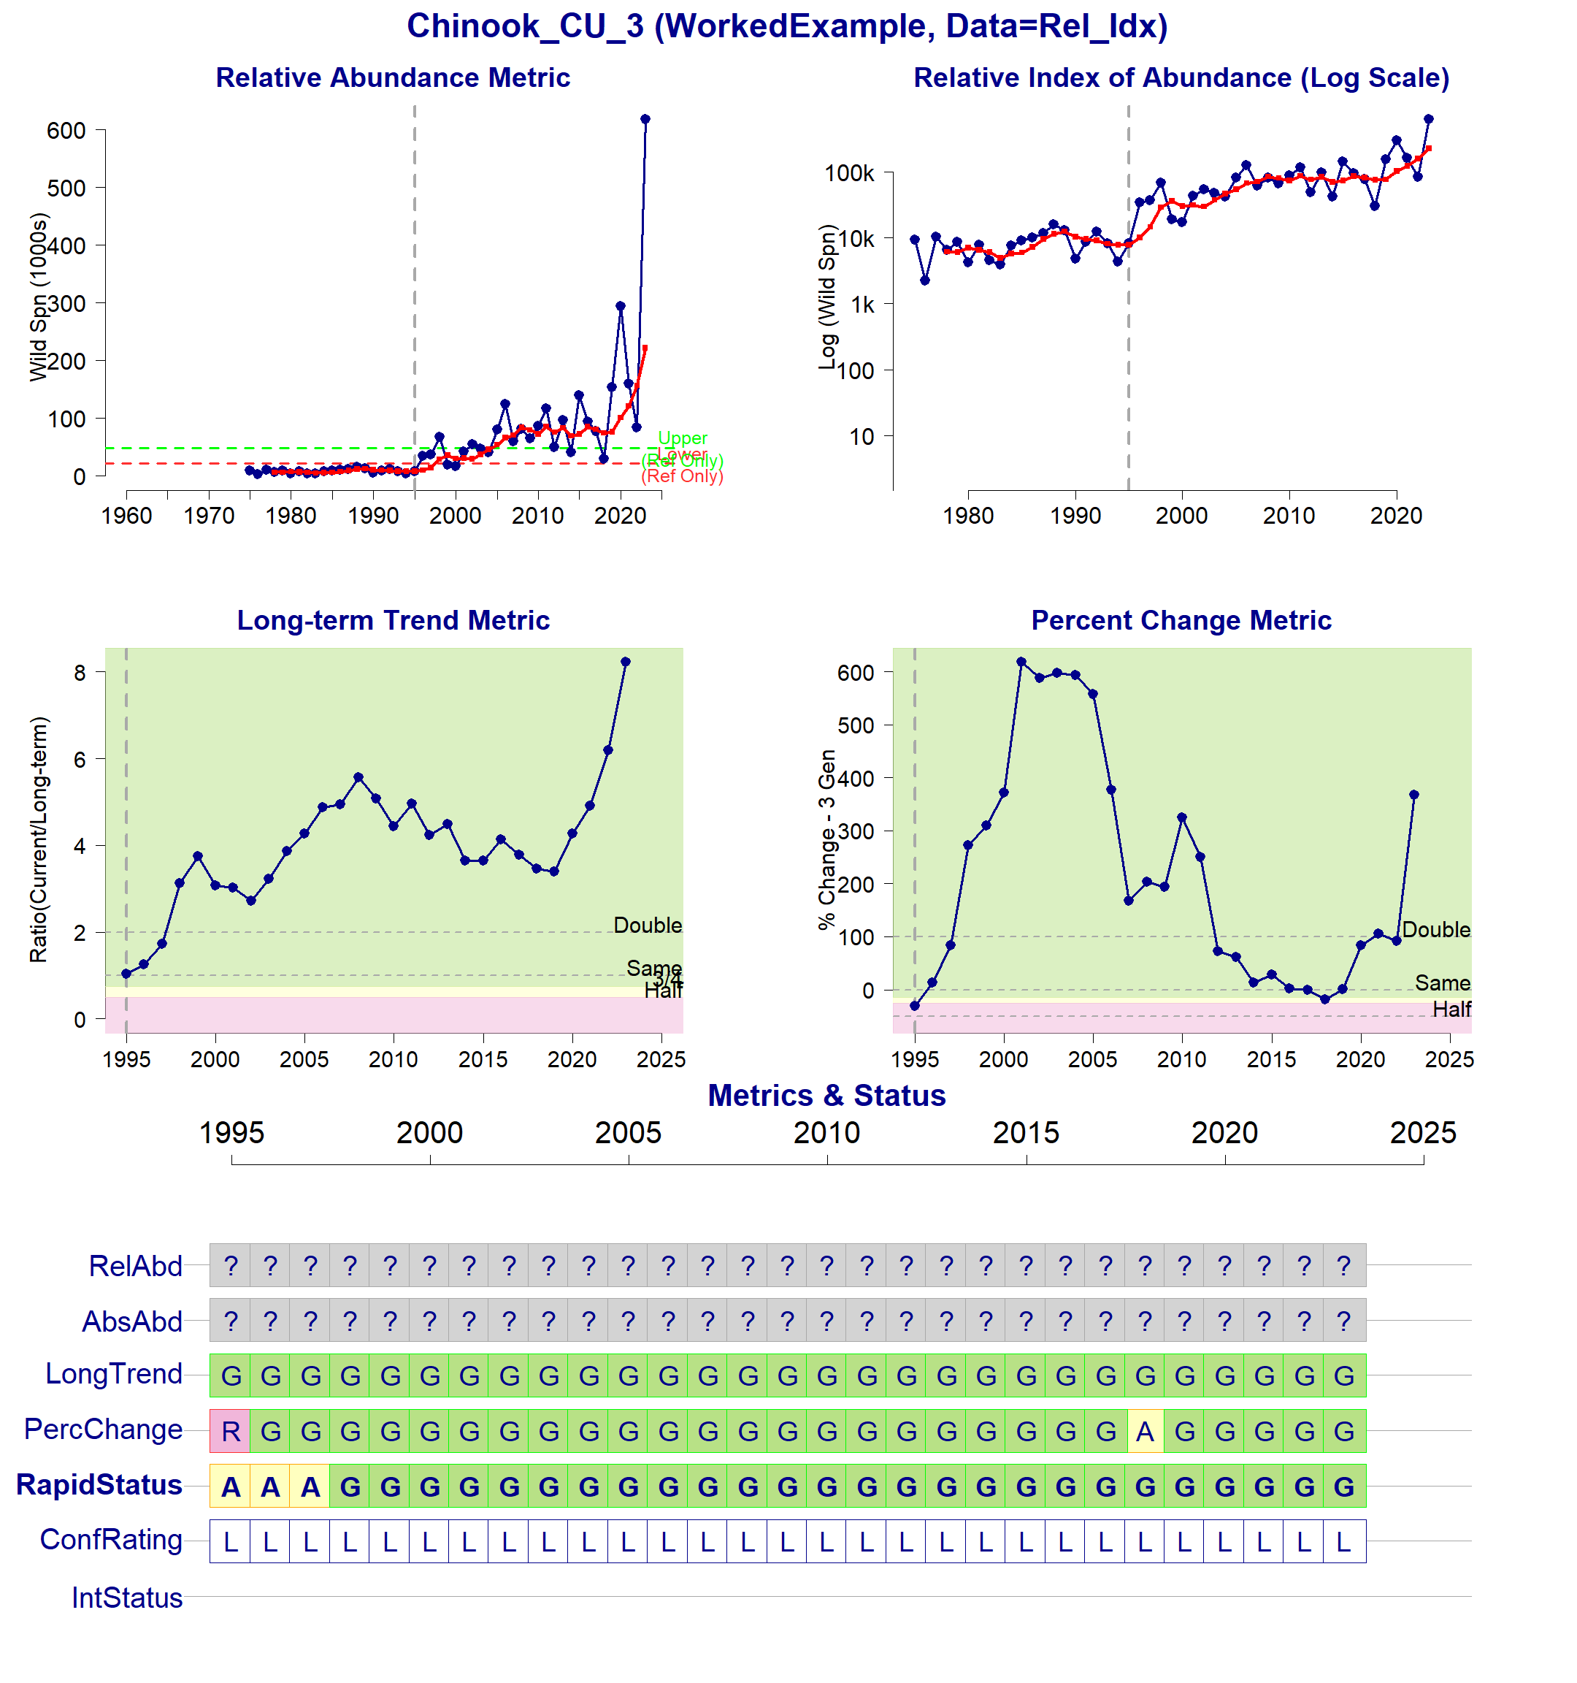

Status Metrics and Rapid Status for Chinook_CU_3

## 1.4 Conservation Unit 4 (Sockeye)

Rapid status for 2023 is Red with Medium Confidence (Node 33 in the decision tree)

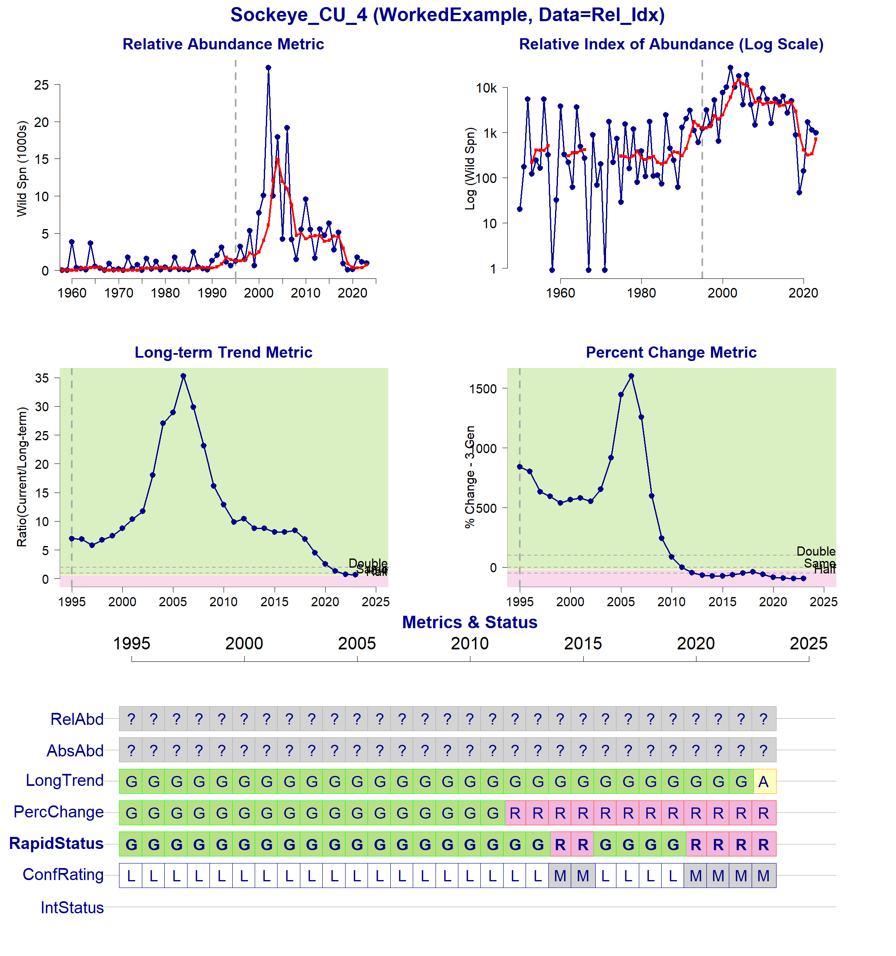

Status Metrics and Rapid Status for Sockeye_CU_4

## 1.5 Conservation Unit 5 (Chinook)

Rapid status for 2023 is Red with High Confidence (Node 3 in the decision tree).

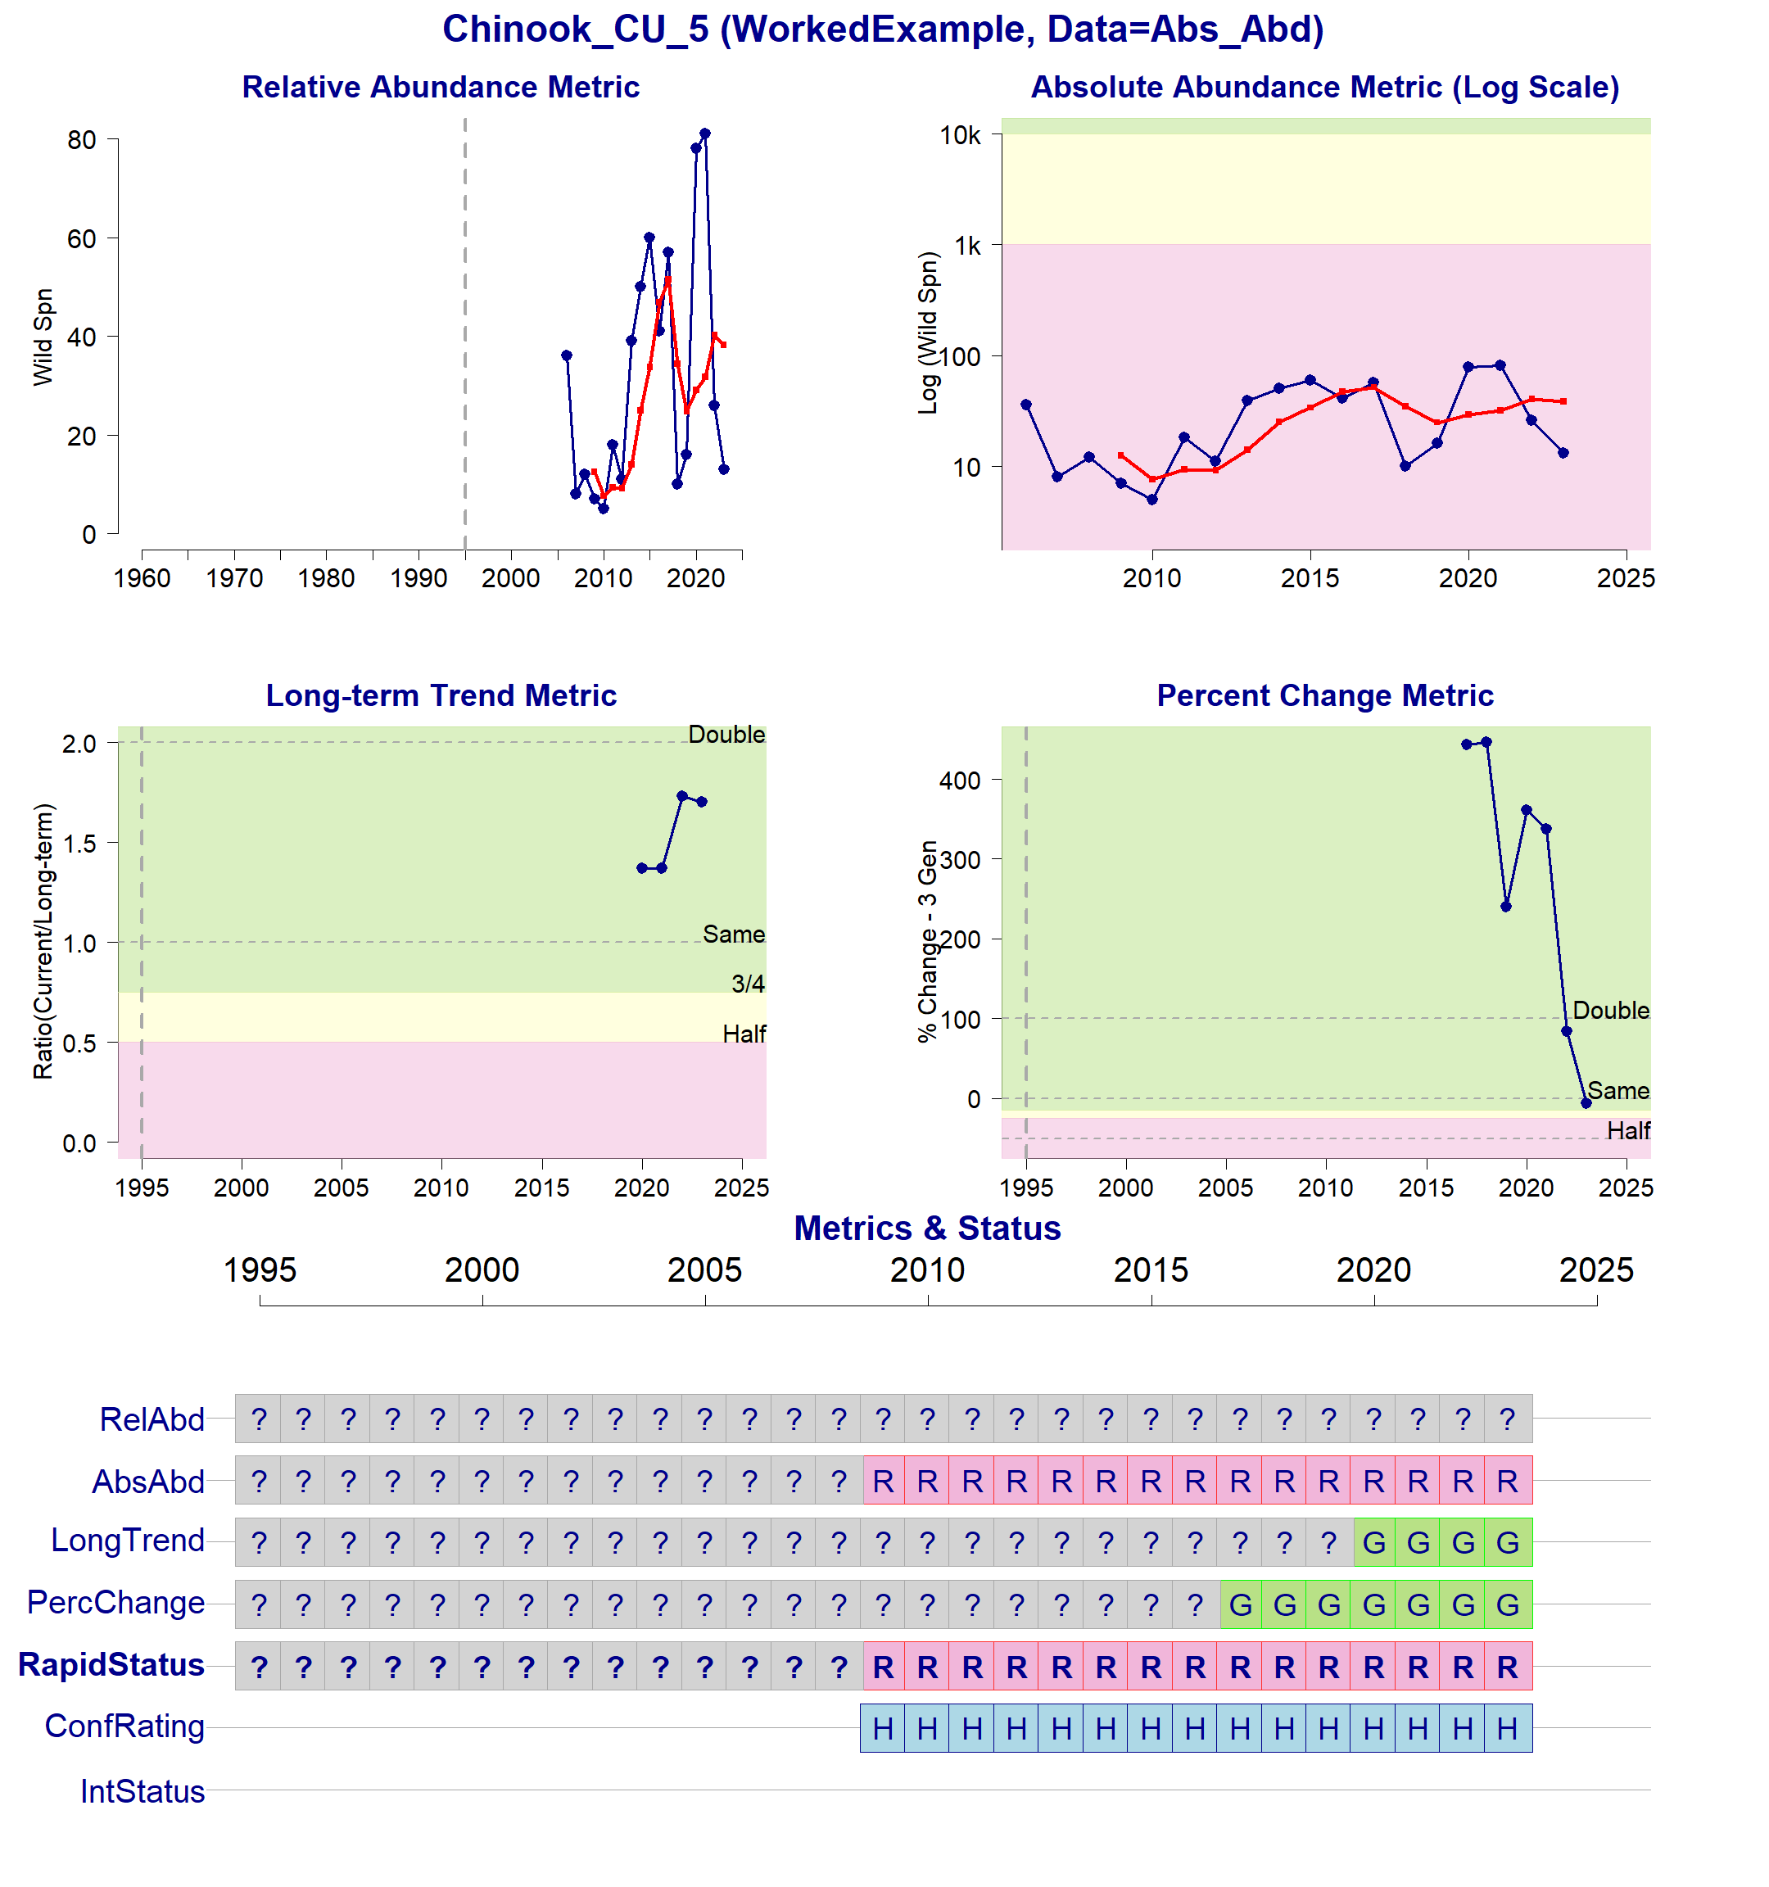

Status Metrics and Rapid Status for Chinook_CU_5

## 1.6 Conservation Unit 6 (Coho)

Rapid status for 2023 is Amber with High Confidence (Node 22 in the decision tree).

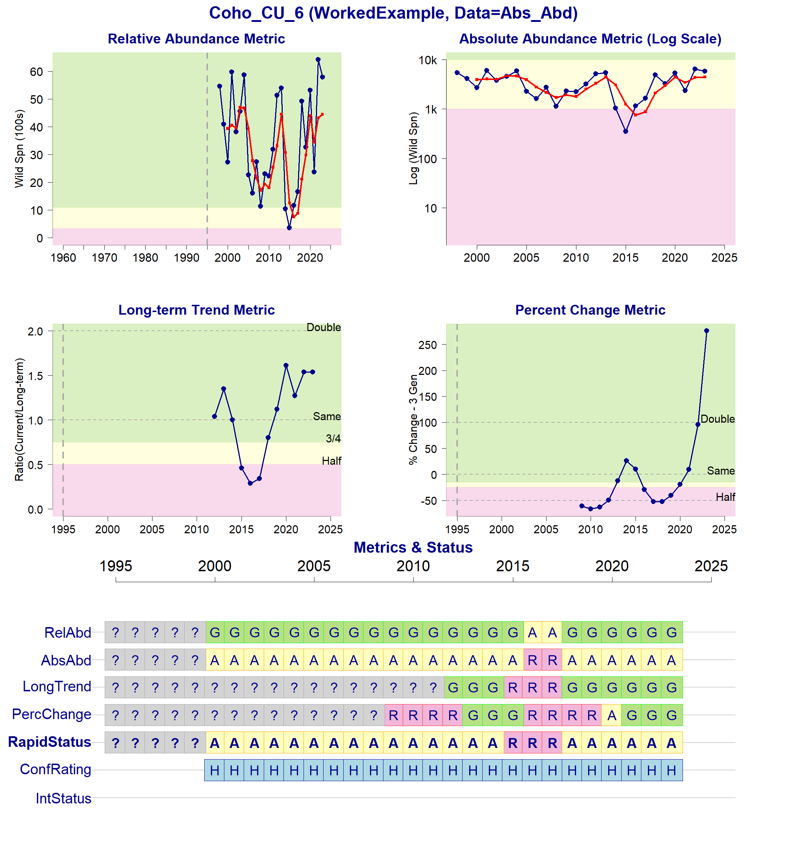

Status Metrics and Rapid Status for Coho_CU_6