Project Report
1. Introduction
The Iris dataset is a well-known benchmark dataset in machine learning that contains measurements of three different species of Iris flowers. Each sample in the dataset is described by four numerical features that capture physical characteristics of the flower. The task associated with this dataset is to classify each flower into its correct species based on these measurements.
This project addresses a multi-class classification problem using the Iris dataset. Although classification problems are typically solved using classification algorithms such as logistic regression or decision trees, this project intentionally applies linear regression to perform classification. The motivation behind this approach is to explore how a regression model can be adapted to solve a classification task when combined with an appropriate decision strategy.
The objective of this project is to implement linear regression from scratch, train the model using gradient descent, and classify Iris samples by mapping continuous regression outputs to discrete class labels. The project also emphasizes understanding the full learning pipeline, including data preprocessing, model training, visualization, and evaluation.
2. Dataset Description
The dataset used in this project is the Iris dataset obtained from the UCI Machine Learning Repository. The dataset consists of 150 samples, each representing a flower from one of three Iris species: Iris-setosa, Iris-versicolor, and Iris-virginica.
Each sample contains four numerical features: sepal length, sepal width, petal length, and petal width. These features describe the physical characteristics of the flowers and are used as inputs to the model.
The original class labels are provided as strings. For applying linear regression, the class labels were mapped to numeric values as follows: Iris-setosa to −1, Iris-versicolor to 0, and Iris-virginica to 1.
The dataset was split into a training set of 120 samples and a testing set of 30 samples. A stratified split was used to ensure that each class was equally represented in both the training and testing datasets.
set of 120 samples and a testing set of 30 samples. A stratified split was used so that each class was equally represented in both sets.
3. Data Preprocessing
Before training the model, several preprocessing steps were applied to the dataset. First, all class labels were converted from strings to numeric values. This conversion was required because linear regression operates on numerical targets.
Next, feature normalization was applied using Min-Max normalization to scale each feature to the range [0, 1]. Normalization improves the stability and convergence speed of gradient descent by ensuring that all features contribute proportionally to the learning process.
$$x'=\frac{\left(x - x_{\left\{min\right\}}\right)}{(x_\{max\} - x_\{min\} )}$$
4. Methodology Overview
The overall methodology followed a structured pipeline:
- Load and parse the Iris dataset
- Map class labels to numeric values
- Split the data into training and testing sets
- Normalize features using training statistics
- Train a linear regression model using gradient descent
- Convert regression outputs into class labels
- Evaluate the model using classification accuracy
- Test the trained model on manually selected samples
This pipeline ensured a clear separation between training and evaluation while maintaining a simple and interpretable approach.
5. Linear Regression Model
Linear regression was used as the underlying model in this project. The model computes a linear combination of the input features along with a bias term to produce a continuous output.
$$\hat{y} = Xw + b$$

6. Loss Function and Training
The model was trained using batch gradient descent to minimize the Mean Squared Error between predicted outputs and true numeric labels. The loss (cost) function is:
$$J\left(w,b\right)=\frac{1}{2m} \sum_{i=1}^{m}{{\left({\hat{y}}_{i}-y_{i} \right)}^{2}}$$
During each iteration of training, the gradients of the loss function with respect to the model parameters were computed manually, and the weights were updated using a fixed learning rate. Training was performed for a fixed number of iterations, and the loss value was recorded at each step to observe convergence.

7. Classification Strategy
Because linear regression produces continuous outputs, an additional decision rule was required to perform classification. Each regression output was mapped to a discrete class label using a nearest-label strategy.
The set of valid class labels was defined as {−1, 0, 1}. For each prediction, the label with the smallest absolute difference from the regression output was selected as the final class. The numeric labels were then mapped back to their corresponding Iris species names for interpretability.

8. Visualizations
This section contains all figures generated during the project.
Figure 1 shows a scatter plot of petal length versus petal width for the entire dataset. This plot illustrates how the three Iris classes are distributed in feature space and highlights the separability of the classes.
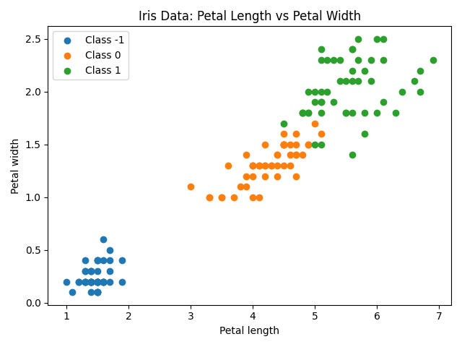
Figure 2 shows a one-dimensional slice of the linear regression model before training. Petal length is varied while the remaining features are held at their mean values. This plot represents the initial, untrained model.
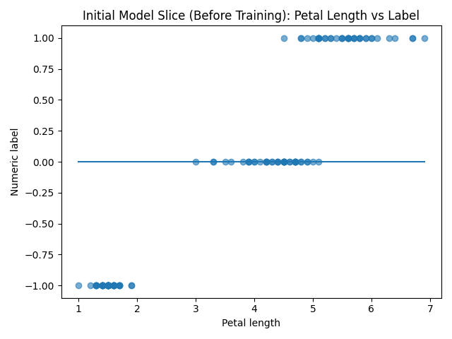
Figure 3 shows the same one-dimensional slice after training using gradient descent. The learned regression line reflects how the model has adapted to fit the data.
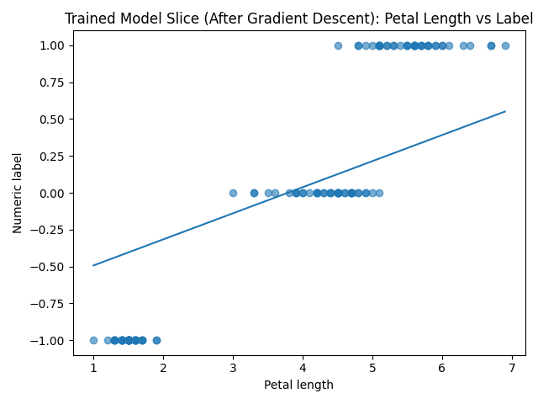
Figure 4 shows the training loss versus the number of iterations. The decreasing curve demonstrates stable convergence of the gradient descent algorithm.
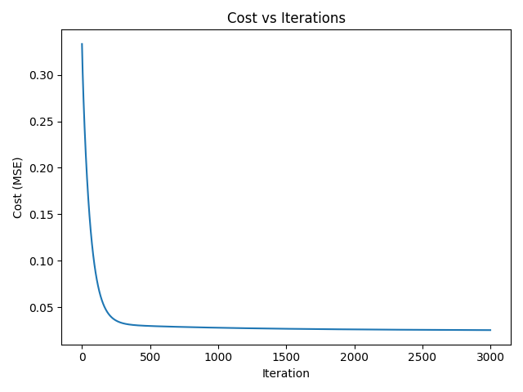

9. Results
The model was trained on 120 samples and evaluated on a test set of 30 samples. The final training cost achieved was 0.0253.
The classification accuracy on the test dataset was 96.67%, indicating that the regression-based approach successfully separated the three classes.
In addition to quantitative evaluation, several manual test samples were passed through the trained model. Samples resembling Iris-setosa, Iris-versicolor, and Iris-virginica were correctly classified. Screenshots of the console output showing accuracy and manual test predictions are included for reference.

