🔐 Cloudflare Security Integration
jauntsolutions.com • Hostinger • Free Plan

🌐 Website Information
Field | Details
Website | jauntsolutions.com
Host | Hostinger
CDN / Security | Cloudflare (Free Plan)
Protocol | HTTPS (SSL Enabled)

🎯 Purpose
Cloudflare is being integrated with jauntsolutions.com for the following reasons:
- 🛡️ Security — Protect the website from DDoS attacks, bots, and malicious traffic
- ⚡ Performance — Deliver content faster worldwide through Cloudflare's global CDN network
- 🔒 SSL/TLS — Enable HTTPS with automatic SSL certificate management
- 🤖 Bot Protection — Filter out automated threats before they reach the server
- 🌍 CDN — Cache static assets globally to reduce load time for all visitors

🪜 Step-by-Step Setup Guide

Step 1 — Add Your Site to Cloudflare
- Go to https://cloudflare.com and create a free account
- Click "Add a Site" from your dashboard
- Enter your domain: jauntsolutions.com
- Click "Add Site" to proceed

Step 2 — Choose the Free Plan
- Scroll down and select the Free plan
- Click "Continue" to move to the DNS scan step
- The free plan includes DDoS protection, CDN, SSL, and basic firewall rules

Step 3 — DNS Scan Process
- Cloudflare will automatically scan your existing DNS records
- Wait for the scan to complete (usually takes 10–30 seconds)
- Review the records shown — make sure your A, CNAME, and MX records are all listed
- If any records are missing, add them manually before continuing

Step 4 — Update Nameservers in Hostinger
Cloudflare will provide you with 2 custom nameservers, for example:
📋 ada.ns.cloudflare.com
bob.ns.cloudflare.com

To update in Hostinger:
- Log in to your Hostinger control panel
- Go to Domains → Select jauntsolutions.com
- Click on Nameservers or DNS Settings
- Replace the existing nameservers with the two Cloudflare nameservers provided
- Save your changes

Step 5 — Wait for DNS Propagation
- DNS propagation typically takes 1 to 24 hours
- In most cases, it completes within 1–2 hours
- You can check propagation status at https://dnschecker.org
- Cloudflare will send you an email once your domain is active

Step 6 — Verify DNS Records
Once active, verify the following records in your Cloudflare DNS dashboard:

Record Type | Name | Value / Points To | Proxy Status
A | jauntsolutions.com | Your server IP | 🟠 Proxied
CNAME | www | jauntsolutions.com | 🟠 Proxied
MX | @ | Your mail server | ⚫ DNS Only

⚠️ Make sure the orange cloud icon (Proxied) is enabled for A and CNAME records to activate Cloudflare's protection and CDN.

Step 7 — Enable Security Features
Bot Protection:
- Go to Security → Bots
- Enable Bot Fight Mode to automatically challenge suspicious bots
Under Attack Mode (Use During Active Attacks Only):
- Go to Security → Settings
- Set Security Level to "Under Attack" if you're experiencing a DDoS attack
- Set it back to "Medium" or "High" under normal conditions
Firewall Rules (Optional but Recommended):
- Go to Security → WAF
- Enable Managed Rules to protect against common web vulnerabilities

Step 8 — Configure SSL / TLS
Navigate to SSL/TLS in your Cloudflare dashboard:

Mode | Description
Flexible | Cloudflare uses HTTPS with visitors, HTTP to your server (less secure)
Full | Cloudflare uses HTTPS to your server (self-signed cert OK)
Full (Strict) ✅ | Recommended — requires a valid SSL cert on your origin server

Recommended Settings:
- Set SSL mode to Full (Strict)
- Enable Always Use HTTPS (under Edge Certificates)
- Enable Automatic HTTPS Rewrites

📸 Cloudflare in Action — Real Example
The screenshot below shows Cloudflare's bot verification challenge page actively working on celltel.com.gh. This is exactly what visitors see when Cloudflare detects suspicious access patterns — it verifies the user is human before allowing entry to the site.

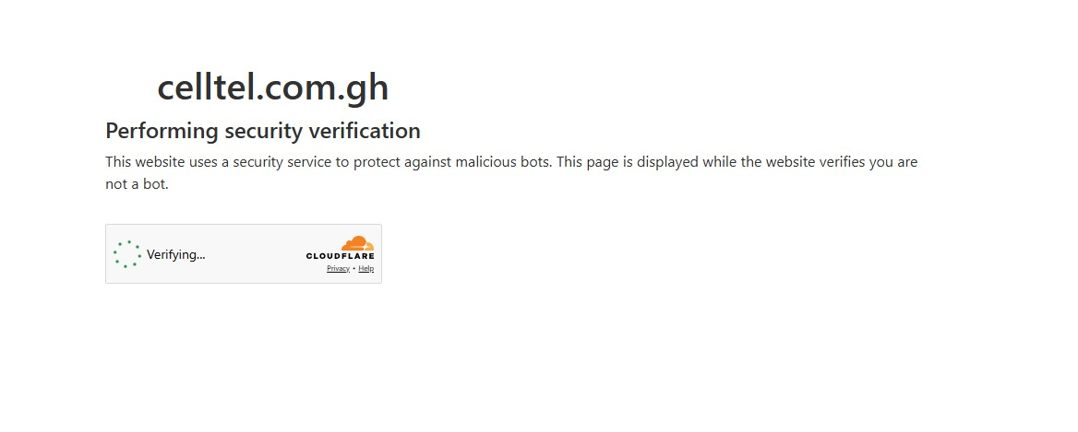
↑ Cloudflare bot verification challenge — celltel.com.gh (Live Example)
✅ This "Performing security verification" screen means Cloudflare is actively protecting the site — bots and suspicious traffic are blocked before reaching your server.

✅ Final Result
After completing the setup, jauntsolutions.com will have the following protections and improvements active:

Feature | Status | Description
🛡️ DDoS Protection | ✅ Active | Cloudflare absorbs and filters large-scale attacks
🤖 Bot Filtering | ✅ Active | Malicious bots are automatically challenged or blocked
🔒 SSL Enabled (HTTPS) | ✅ Active | All traffic is encrypted with an SSL certificate
⚡ Faster Load via CDN | ✅ Active | Static assets are cached globally for faster delivery
🔐 Improved Security Layer | ✅ Active | WAF and firewall rules filter malicious requests

⚠️ Important Notes
- Do not change nameservers after setup is complete — this will break Cloudflare's integration
- DNS propagation can take up to 24 hours, though it usually completes much sooner
- DNSSEC is recommended — enable it under DNS → Settings → DNSSEC in Cloudflare
- Email records (MX) should remain set to DNS Only (grey cloud), not proxied, to avoid mail delivery issues
- Hostinger's SSL can be disabled once Cloudflare SSL is active to avoid conflicts

📋 Summary
This integration connects jauntsolutions.com to Cloudflare's global network, providing enterprise-grade security and performance at no cost. By routing all traffic through Cloudflare, the website benefits from automatic DDoS mitigation, bot filtering, a globally distributed CDN, and enforced HTTPS — all managed from a single, easy-to-use dashboard. The setup requires only a nameserver update in Hostinger and takes less than 30 minutes to configure, with full propagation completing within 24 hours.

README prepared for: jauntsolutions.com | Integration: Cloudflare Free Plan | Host: Hostinger

