**CURRICULUM VITAE**

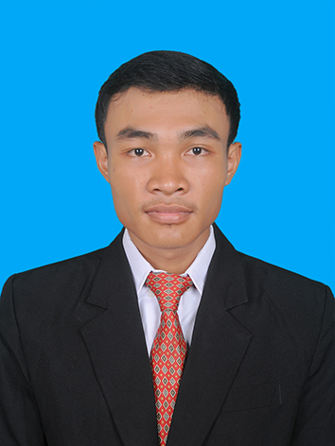

**🙞🙜**

**Soum Som On**

#WF88, St5, Sang Kat Toul Songke,

Khan Russey Keo, Phnom Penh.

(+855)969405840

[somonmel07@gmail.com](mailto:somonmel07@gmail.com)

**PERSONAL DATA**

Nationality : Cambodian

Sex : Male   
 Date of Birth : March 16 1996

Place of Birth : Svay Rieng, Cambodia

Marital Status : Single

Height : 175 cm

Health : Good

**EDUCATION AND QUALIFICATION**

2013-Present : Institute of Technology of Cambodia(ITC)

Department of Information and Communication

Engineering(DICE)

2010-2013 : Hun Sen Kompong Ro High School

2007-2010 : Thmey Secondary School

2001-2007 : Chup Preng Primary School

**TECHNICAL SKILL**

Computer Administrator : Microsoft office Word, Excel, PowerPoint,

Programming : C, C++, Java

Web : HTML, CSS, JavaScript, Bootstrap, Angular, Typescript, PHP, Laravel.

Mobile : Ionic/Cordova Framework

Database : MySQL

OS : Window, Linux, Mac OS

Other : Software Engineering, UML, Algorithm, MATLAB,

Object-Oriented Programming(OOP), VCS(Git)

**ACCOMPLISHMENT AND EXPERIENCES**

Mathematics Tutor : I had been teaching in Math for grade 12 since

2014 in Phnom Penh

Calculator : C language to build up the program within console

not GUI

Project 1 : C language to build up a game within GUI called

Flappy Bird

Project 2 : A simple E-commerce Web with HTM, CSS, and

Bootstrap.

Project 3 : Chat Application (Android and iOS) with Ionic 3 Framework and Firebase.

**LANGUAGE SKILLS**

Khmer : Native Language

English : Good “Speaking, Listening, Writing, and Reading”

French : Fair “Speaking, Listening, Writing, and Reading”

**PERSONAL STRENGTH**

: Hard working and challenging

: Have high self-discipline and responsibility

: Honest and Sincere

: Willing to learn new things

: Have a strong commitment and can work long term

: Good in both work as independence and work as

Team

: Friendly and outgoing

: Kind and generous

: Neat and tidy

**HOBBIES**

Reading : Newspaper, Khmer Culture and Business Book,

Magazines, etc.

Listening : Book Audio, Music, etc.

Computer : Internet, E-Mail, English and Khmer Typing,

Researching other information on internet that’s

useful for my studies

Other : Learning foreign languages, Teaching math, Self-study, etc.

**REFERENCE**

Mr. Muth Sphoeur : Computer Teacher at [Sovannaphumi Schoo](https://www.facebook.com/Sovannaphumischool/?hc_ref=PAGES_TIMELINE&fref=nf)l,

Administration and Accountant at Christadelphian

Bethezer Fund Cambodia Organization

Mobile : (+855)97947776

E-mail : [sophoeur.kh8899@gmail.com](mailto:sophoeur.kh8899@gmail.com)