1.MOVEZEROS
Code:
import java.util.*;
public class Movzeros {
public static void main(String[] args) {
Scanner s=new Scanner(System.in);
System.out.print("N:");
int n=s.nextInt();
int index=0;
int [] a=new int[n];
System.out.print("Elements:");
for(int i=0;i<n;i++){
a[i]=s.nextInt();
}
for(int i=0;i<n;i++){
if(a[i]!=0){
a[index]=a[i];
index++;
}
}
while(index<a.length){
a[index]=0;
index++;
}
for(int i=0;i<n;i++){
System.out.print(a[i] + " ");
}
}
}

Output:
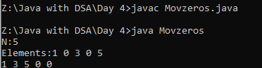
2.MOVEZEROS USING TWO POINTERS
Code:
import java.util.*;
public class Zerosptr {
public static void moveZeroes(int[] arr) {
int left = 0;
int right = 0;
while (right < arr.length) {
if (arr[right] != 0) {
int temp = arr[left];
arr[left] = arr[right];
arr[right] = temp;
left++;
}
right++;
}
}
public static void main(String[] args) {
Scanner s=new Scanner(System.in);
System.out.print("N:");
int n=s.nextInt();
int[] arr = new int[n];
System.out.print("Elements:");
for(int i=0;i<n;i++){
arr[i]=s.nextInt();
}
moveZeroes(arr);
System.out.println(Arrays.toString(arr));
}
}
Output:
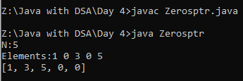
3.MAXIMUM SUM OF THE SUB ARRAY(BRUTE FORCE METHOD)
Code:
import java.util.*;
public class subarrmaxsum {
public static void main(String[] args) {
Scanner s=new Scanner(System.in);
System.out.print("N:");
int n=s.nextInt();
int maxsum=0;
int [] a=new int[n];
System.out.print("Elements:");
for(int i=0;i<n;i++){
a[i]=s.nextInt();
}
for(int i=0;i<n;i++){
int sum=a[i];
maxsum=Math.max(maxsum,sum);
for(int j=i+1;j<n;j++){
sum+=a[j];
maxsum=Math.max(maxsum,sum);
}
}
System.out.print(maxsum);
}
}
Output:
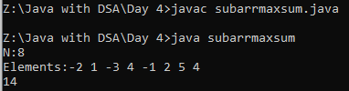
4.MAXIMUM SUM OF THE SUB ARRAY(OPTIMIZED USING KDENS ALGORITHM)
Code:
import java.util.*;
public class subarrmaxsum1 {
public static void main(String[] args) {
Scanner s=new Scanner(System.in);
System.out.print("N:");
int n=s.nextInt();
int maxsum=0;
int [] a=new int[n];
System.out.print("Elements:");
for(int i=0;i<n;i++){
a[i]=s.nextInt();
}
for(int i=0;i<n;i++){
int sum=a[i];
maxsum=Math.max(maxsum,sum);
for(int j=i+1;j<n;j++){
sum+=a[j];
maxsum=Math.max(maxsum,sum);
}
}
System.out.print(maxsum);
}
}
Output:
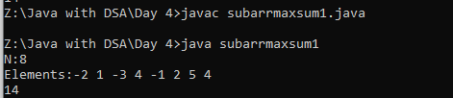
5.SLIDING WINDOW(BRUTE FORCE)
Code:
import java.util.*;
class SlidingWindow{
public static void main(String [] args){
Scanner s=new Scanner(System.in);
System.out.print("N:");
int n=s.nextInt();
int max=0;
int k=3;
int [] a=new int[n];
System.out.print("Elements:");
for(int i=0;i<n;i++){
a[i]=s.nextInt();
}
for(int i=0;i<=n-k;i++){
int sum=0;
for(int j=i;j<i+k;j++){
sum+=a[j];
}
max=Math.max(sum,max);
}

System.out.print(max);
}
}
Output:
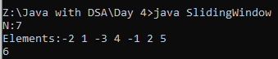
6.SLIDING WINDOW(OPTIMIZED)
Code:
import java.util.*;
class Sliding{
public static void main(String [] args){
Scanner s=new Scanner(System.in);
System.out.print("N:");
int n=s.nextInt();
int max=0;
int k=3;
int sum=0;
int [] a=new int[n];
System.out.print("Elements:");
for(int i=0;i<n;i++){
a[i]=s.nextInt();
}
for(int i=0;i<k;i++){
sum+=a[i];
}
for(int j=k;j<n;j++){
sum=(sum-a[j-k])+a[j];
max=Math.max(max,sum);
}
System.out.print(max);
}
}
Output:
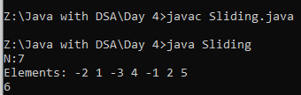
7.PRINT THE LENGTH OF LAST STRING
Code:
import java.util.*;
class StrLength{
public static void main(String [] args){
Scanner s=new Scanner(System.in);
String str=s.nextLine().trim();
String [] words=str.split("\\s+");
System.out.print(words[words.length-1].length());
}
}
Output:
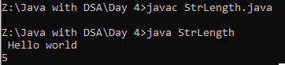
8.PRINT THE CHARACTER BASED ON THE DIGITS
Code:
import java.util.*;
class Strcount{
public static void main(String [] args){
Scanner s=new Scanner(System.in);
System.out.print("Enter str:");
String str=s.nextLine();
StringBuilder result=new StringBuilder();
for(int i=0;i<str.length();i+=2){
char ch=str.charAt(i);
int count=str.charAt(i+1)-'0';
for(int j=0;j<count;j++){
result.append(ch);
}
}
System.out.println(result);
}
}
Output:
