DOM高级

运动原理--->匀速运动--->加减速运动----->缓冲运动

抛物线运动--->圆周运动

1.运动原理

运动原理：JavaScript 实现运动的原理，就是通过定时器不断改变元素的位置，直至到达目标点后停止运动。通常，要让元素动起来，我们会通过改变元素的 left 和 top 值来改变元素的相对位置。

方法：

     1.运动的物体使用绝对定位

     2.通过改变定位物体的属性（left、right、top、bottom）值来使物体移动。例如向右或左移动可以使用offsetLeft（offsetRight）来控制左右移动。

步骤：

     1、开始运动前，先清除已有定时器 （因为：是连续点击按钮，物体会运动越来越快,造成运动混乱）

     2、开启定时器，计算速度

     3、把运动和停止隔开（if/else),判断停止条件，执行运动

2.匀速运动

<!DOCTYPE html>

<html>

    <head>

        <meta charset="utf-8" />

        <title></title>

        <style>

            *{

                margin: 0;

            }

            #box{

                height: 100px;

                width: 100px;

                background: red;

                position: absolute;

                top: 200px;

            }

        </style>

    </head>

    <body>

        <button id="btn1" onclick="startMove()">开始</button>

        <div id="box"></div>

    </body>

</html>

<script>

    let box = document.getElementById("box");

    let time = null;

    function startMove(){

        clearInterval(time);

         time = setInterval(function(){

            box.style.left = box.offsetLeft + 5 + "px";

            if(box.offsetLeft > 300){

                box.style.left = "300px";//注意边界问题

                clearInterval(time);

            }

        },50);

    }

</script>

    //问题 频繁点击按钮 由于每次点击 都要重新启动定时器 相当于加速

    //解决 每次启动定时器时,将上一个定时器清除

3.匀速运动的优化：往返运动

<!DOCTYPE html>

<html>

    <head>

        <meta charset="utf-8">

        <title></title>

        <style>

            *{

                margin: 0;

            }

            #box{

                height: 100px;

                width: 100px;

                background: red;

                position: absolute;

                top: 200px;

            }

        </style>

    </head>

    <body>

        <button id="btn1" onclick="startMove(300)">开始</button>

        <button id="btn2" onclick="startMove(0)">开始</button>

        <div id="box"></div>

    </body>

</html>

<script>

    let box = document.getElementById("box");

    let time = null;

    function startMove(targat){

        clearInterval(time);

        time = setInterval(function(){

            let speed = targat - box.offsetLeft > 0 ? 5:-5;

            box.style.left = box.offsetLeft + speed + "px";

            if(box.offsetLeft >= 300 || box.offsetLeft <=0){

                clearInterval(time);

            }

        },50);

    }

</script>

    //问题 频繁点击按钮 由于每次启动 都要重新启动定时器 相当于加速

    //解决 每次启动定时器时,将上一个定时器清除

</script>

4.匀速透明运动

<!DOCTYPE html>

<html>

    <head>

        <meta charset="utf-8">

        <title></title>

        <style>

            *{

                margin: 0;

            }

            #box{

                height: 100px;

                width: 100px;

                background: red;

                position: absolute;

                top: 200px;

                left: 200px;

                opacity: 0.3;

            }

        </style>

    </head>

    <body>

        <div id="box" onmouseover="startMove(0.1)"  onmouseout="startMove(1)">

        </div>

    </body>

</html>

<script>

    function getStyle(obj,attr){    //获取非行间样式，obj是对象，attr是值

        if(obj.currentStyle){       //针对ie获取非行间样式

            return obj.currentStyle[attr];

        }else{

            return getComputedStyle(obj,false)[attr];   //针对非ie

        };

    };

    let box = document.getElementById("box");

    let opa = getStyle(box,"opacity");//这货的返回值为字符串

    let time = null;

    function startMove(target){

        clearInterval(time);

        time = setInterval(function(){

            let speed = target-opa>0?0.01:-0.01;

            //                  字符串相加结果不是数字而是字符串

            box.style.opacity = Number(getStyle(box,"opacity"))+speed;

            if(getStyle(box,"opacity") == 1 || getStyle(box,"opacity") == 0){

                clearInterval(time);

            }

        },50);

    }

</script>

5.缓冲运动与封装

原理：//缓冲运动原理

     var speed = (target-obj.offsetLeft)/10;

     speed =  speed>0 ? Math.ceil(speed) : Math.floor(speed);//核心算法

<!DOCTYPE html>

<html>

    <head>

        <meta charset="utf-8">

        <title></title>

        <style>

            #box{

                height: 100px;

                width: 100px;

                background: red;

                position: absolute;

                top: 200px;

                left: 0px;

            }

        </style>

    </head>

    <body>

        <button id = "btn">起飞</button>

        <div id="box">

        </div>

    </body>

</html>

<script>

    let box = document.getElementById("box");

    box.time = null;

    function startMove(obj,target){

        clearInterval(obj.time);

        obj.time = setInterval(function(){

            let speed = (target-obj.offsetLeft)/10;

            speed = speed>0?Math.ceil(speed):Math.floor(speed);

            obj.style.left = obj.offsetLeft + speed + "px";

        },50);

    }

    let btn = document.getElementById("btn");

    btn.onclick = function(){

        startMove(box,300);

    }

</script>

6.反弹运动

<!DOCTYPE html>

<html>

    <head>

        <meta charset="utf-8">

        <title></title>

        <style>

            #box{

                height: 25px;

                width: 25px;

                position: absolute;

                border-radius: 50%;

                background: red;

                top: 50%;

            }

        </style>

    </head>

    <body>

        <button onclick="startMove()">点击</button>

        <div id="box">

        </div>

    </body>

</html>

<script>

    var box = document.getElementById("box");

    var time = null;

    var speedX = 5;

    var speedY = 5;

    function startMove(){

        clearInterval(time);

        time = setInterval(function(){

            box.style.left = box.offsetLeft + speedX + "px";

            box.style.top = box.offsetTop + speedY + "px";

            if(box.offsetLeft<0){

                speedX *= -1;

            }

            var maxX = window.innerWidth-box.offsetWidth;

            if(box.offsetLeft>maxX){

                speedX *= -1;

            }

            if(box.offsetTop<0){

                speedY *= -1;

            }

            var maxY = window.innerHeight-box.offsetHeight;

            if(box.offsetTop>maxY){

                speedY *= -1;

            }

        },50);

    }

</script>

7.*圆周运动

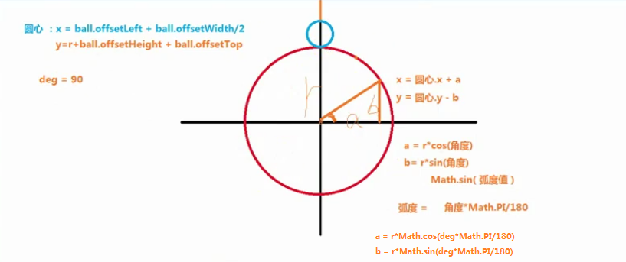

**必须已知大圆r以及角度,否则没法玩**

然后将算法照抄

<!DOCTYPE html>

<html>

    <head>

        <meta charset="utf-8">

        <title></title>

        <style>

            *{

                margin: 0;

                padding: 0;

            }

            #ball{

                height: 30px;

                width: 30px;

                background: red;

                position: absolute;

                left: 400px;

                top:100px;

                border-radius: 50%;

            }

        </style>

    </head>

    <body>

        <div id="ball"></div>

    </body>

</html>

<script>

    let r = 200;

    //角度

    let deg = 90;

    let time = null;

    let ball = document.getElementById("ball");

    //圆心坐标

    let circleCenter = {

        x:ball.offsetLeft + ball.offsetWidth/2,

        y:r+ball.offsetHeight+ball.offsetTop

    }

    time = setInterval(function(){

        ball.style.left = circleCenter.x + r*Math.cos(deg*Math.PI/180) + "px";

        ball.style.top = circleCenter.y - r*Math.sin(deg*Math.PI/180) + "px";

        deg--;

    },30);

</script>