Student Performance Prediction System
Machine Learning Capstone Project Report
Submitted by: Soham Mukherjee
Domain- Machine Learning
Internship Training Project - SkillOrbit

Abstract
Student performance is shaped by a mix of academic and non-academic factors - how much a student studies, how regularly they attend class, how involved their parents are, and even how well they sleep. This project builds a machine learning pipeline that takes a dataset of these factors and turns it into two useful outputs: a predicted exam score, and a Low/Average/High performance category, along with a short list of personalized suggestions for each student. The pipeline covers the full workflow expected of an applied data science project - cleaning and preparing the data, exploring it to understand what actually drives performance, training and comparing multiple models, and finally presenting the results through an interactive dashboard.

1. Project Overview
The Student Performance Prediction System is a machine learning application built to analyze student academic data and predict performance outcomes. Rather than just building a single model, the goal was to understand which factors matter most for a student's exam score and to package that understanding into something a teacher or student could actually use - a dashboard and a set of recommendations, not just a number.
This project mirrors how performance-prediction systems work inside real EdTech platforms, learning management systems, and academic analytics tools - collecting data on a student, running it through a model, and surfacing insights that support a decision (whether that decision is made by a teacher, a parent, or the student themselves).

1.1 Objectives
- Analyze student academic data to identify patterns.
- Predict student performance levels (Low / Average / High).
- Identify the key factors that most affect performance.
- Generate actionable performance insights.
- Visualize student analytics through an interactive dashboard.

2. Dataset
The dataset used is StudentPerformanceFactors.csv, containing 6,607 student records with 20 columns spanning study habits (Hours_Studied, Attendance, Tutoring_Sessions), the home environment (Parental_Involvement, Family_Income, Parental_Education_Level, Distance_from_Home), personal factors (Sleep_Hours, Motivation_Level, Physical_Activity, Learning_Disabilities), and the target variable, Exam_Score.

3. Data Collection & Preprocessing
We started by loading the CSV and checking its shape and structure. There were no duplicate rows, but three categorical columns - Teacher_Quality, Parental_Education_Level, and Distance_from_Home - had a small number of missing values (between 67 and 90 rows out of 6,607). Rather than dropping those rows outright, which would have thrown away otherwise-usable data, we filled them in with the mode (most frequent value) of each column.
Most of the categorical columns in this dataset are naturally ordered - for example Parental_Involvement is Low/Medium/High, not an unordered category. So instead of one-hot encoding everything, we mapped these ordinal columns to integers (0/1/2) that preserve their order, which also keeps the feature set compact. Binary Yes/No columns (Extracurricular_Activities, Internet_Access, Learning_Disabilities) were mapped to 1/0, and the remaining nominal columns (Gender, School_Type) were label-encoded since they only have two categories each.
Finally, we scaled the numeric features (Hours_Studied, Attendance, Sleep_Hours, Previous_Scores, Tutoring_Sessions, Physical_Activity) using StandardScaler for use with the Linear Regression model - the tree-based models don't need this since they split on raw feature values, but Linear Regression is sensitive to differences in scale.

4. Exploratory Data Analysis
With the data cleaned, we looked at how each factor relates to Exam_Score. The score distribution is fairly tight and roughly bell-shaped, centered around 67, with a handful of high-scoring outliers above 90.
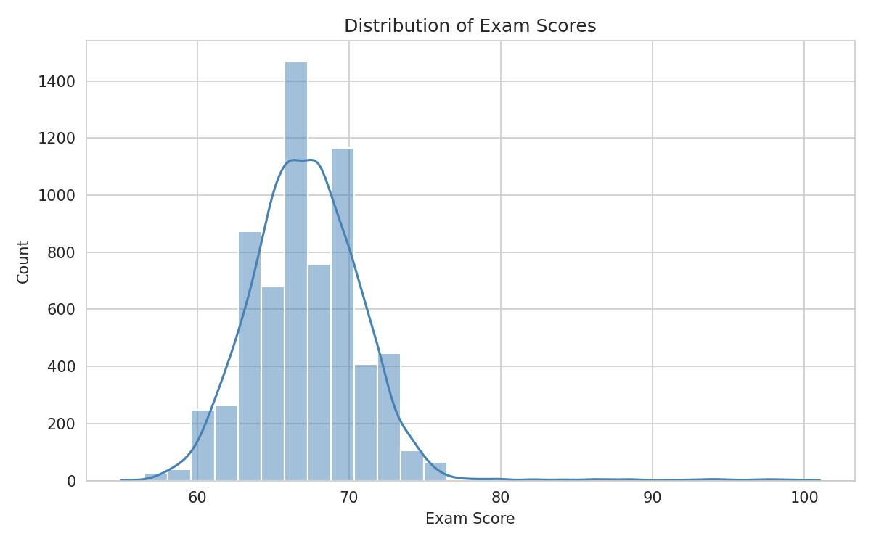
Figure 1: Distribution of Exam Scores
Attendance and study hours both show a clear positive relationship with exam score, though attendance is the tighter, more consistent relationship of the two.
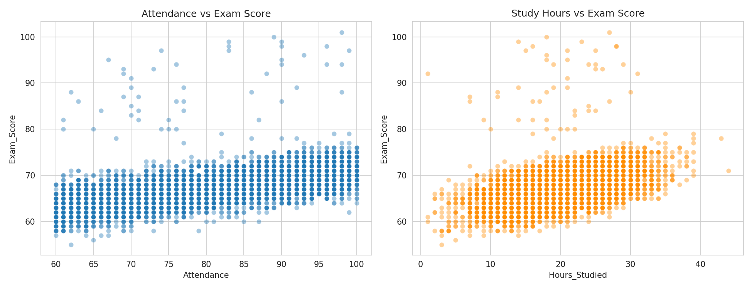
Figure 2: Attendance and Study Hours vs Exam Score
The correlation heatmap below confirms this - Attendance, Hours_Studied, and Previous_Scores are the three features most correlated with the final exam score, while most of the categorical/lifestyle factors have a smaller (but still present) effect.
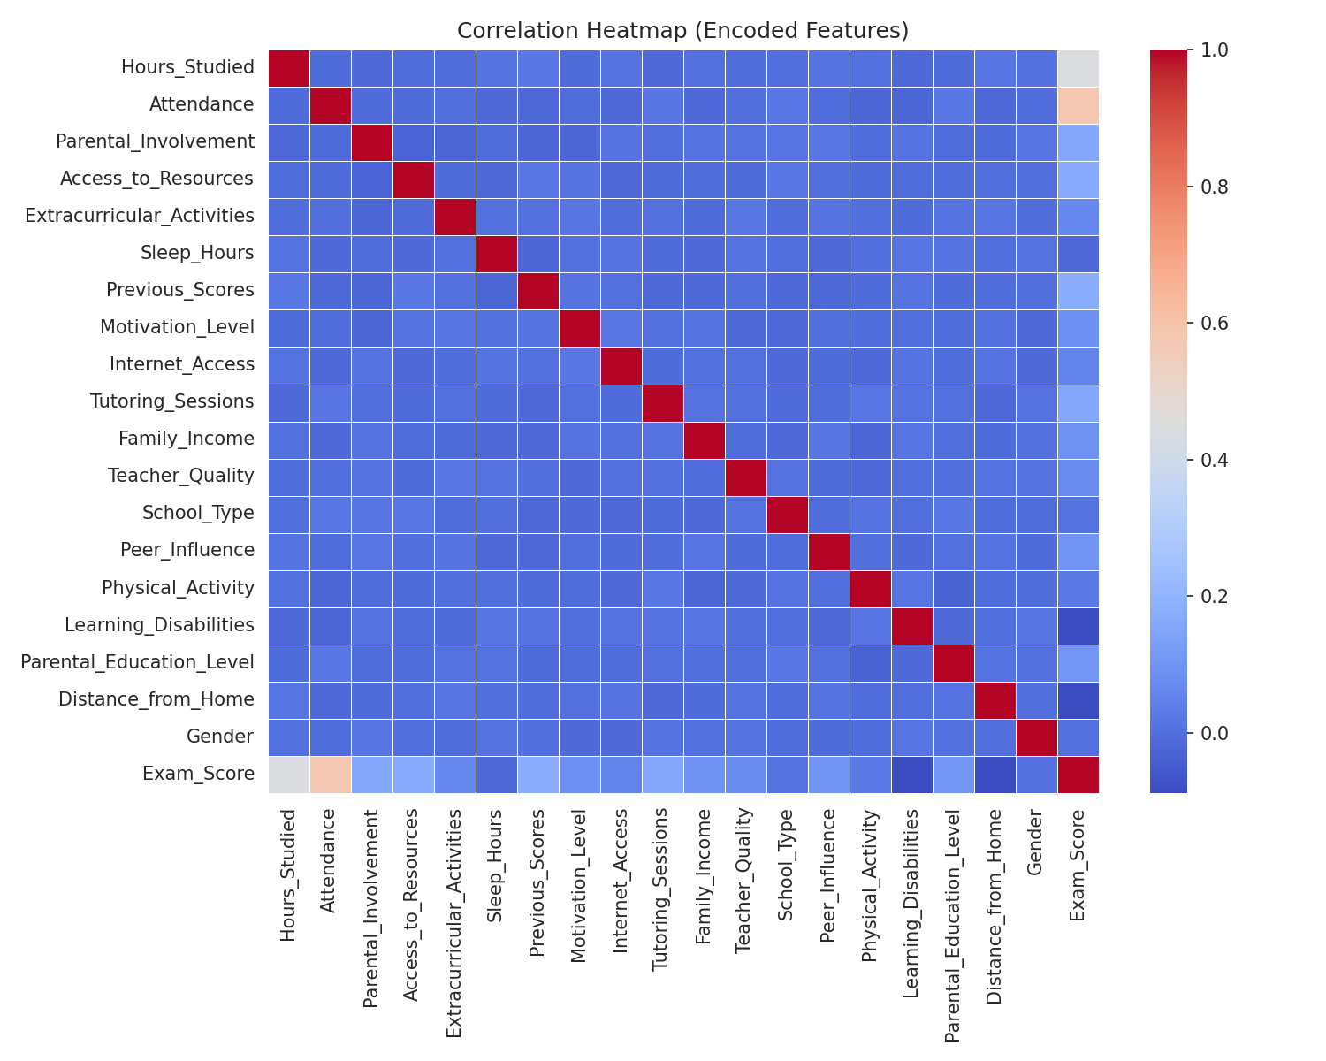
Figure 3: Correlation Heatmap of Encoded Features
We also compared exam score across categories of parental involvement and peer influence. Students with higher parental involvement and more positive peer influence tend to score a little higher on average, though the spread within each group is still large - these factors nudge performance rather than determine it outright.
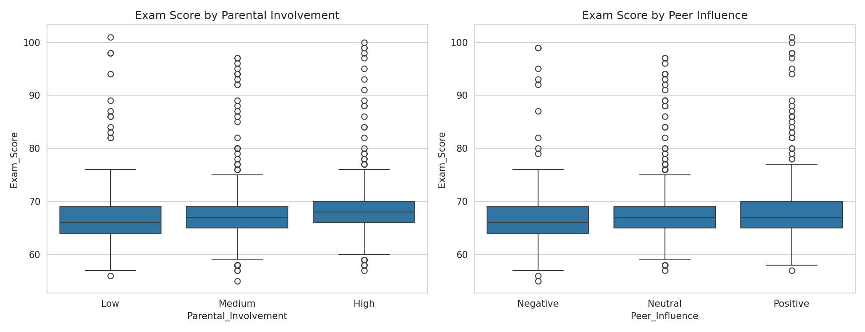
Figure 4: Exam Score by Parental Involvement and Peer Influence

5. Performance Prediction Model
We approached prediction two ways, matching the project's dual goal of predicting both a score and a performance level:
- Regression - predicting the exact Exam_Score using Linear Regression, a Decision Tree Regressor, and a Random Forest Regressor.
- Classification - bucketing students into Low / Average / High performance (using tertiles of Exam_Score, to keep the three classes roughly balanced) and predicting that category with a Decision Tree Classifier and a Random Forest Classifier.
Both tasks used an 80/20 train-test split. Here's how the regression models compared:
Model | MAE | RMSE | R2 Score
Linear Regression | 0.444 | 1.799 | 0.771
Random Forest | 1.228 | 2.243 | 0.644
Decision Tree | 1.645 | 2.676 | 0.493
Linear Regression came out ahead here, which was a bit surprising at first but makes sense once you look at the correlation heatmap - the relationship between the top features and Exam_Score is close to linear, so the extra flexibility of the tree-based models didn't add value and led them to overfit slightly on the training data.
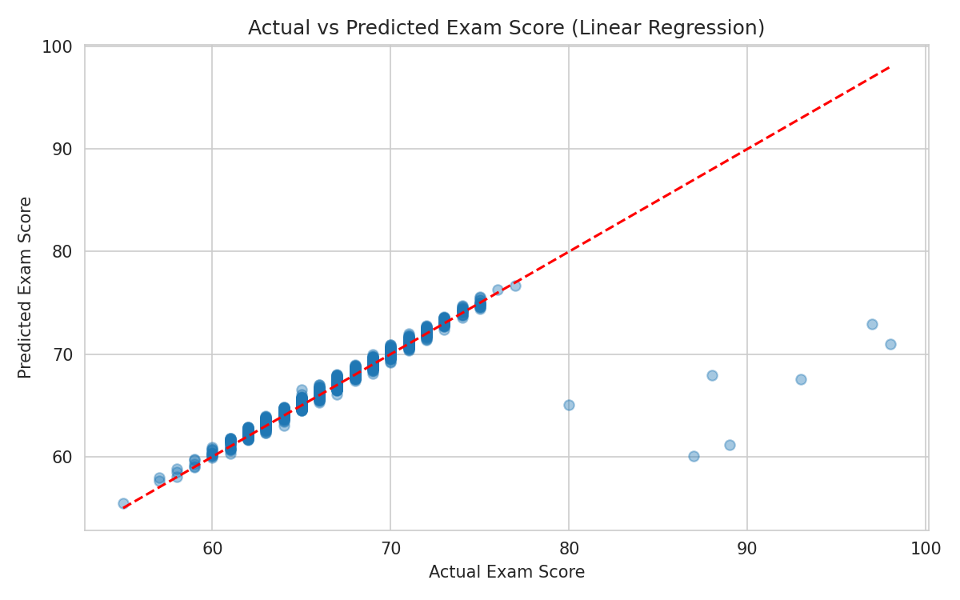
Figure 5: Actual vs Predicted Exam Score (Linear Regression)
For the classification task, Random Forest performed better than a single Decision Tree, which is what we'd expect since it averages over many trees and generalizes better:
Model | Accuracy
Random Forest | 78.97%
Decision Tree | 71.94%
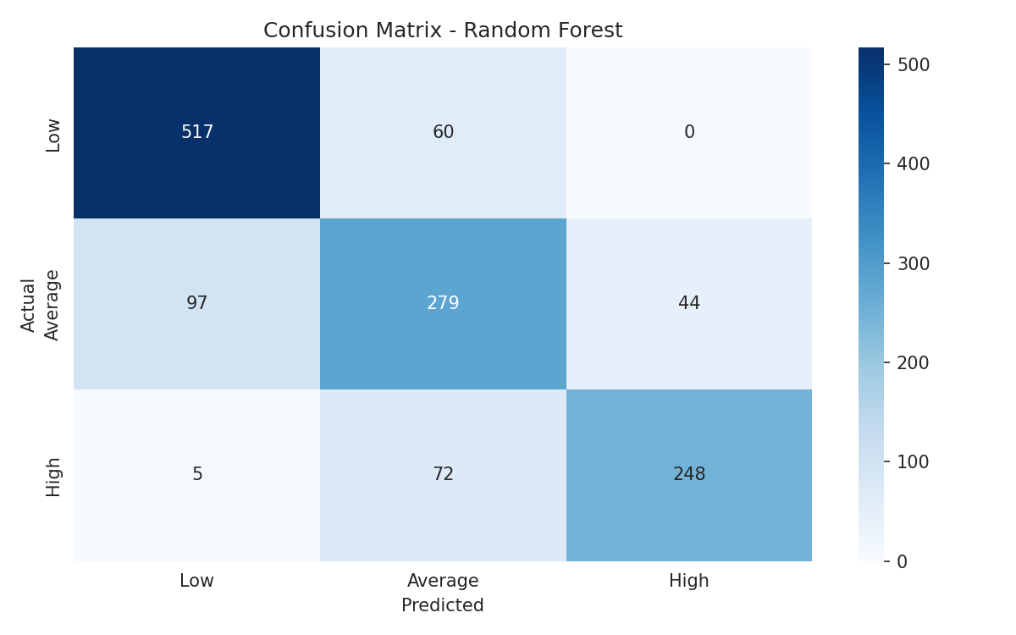
Figure 6: Confusion Matrix - Random Forest Classifier
Most of the misclassifications happen between adjacent classes (Low predicted as Average, or Average predicted as High) rather than jumping from Low to High, which is a reasonable failure mode for this kind of ordinal target.
The feature importance chart from the Random Forest classifier lines up with the EDA - Attendance, Hours_Studied, and Previous_Scores dominate, with the remaining lifestyle and demographic factors contributing smaller amounts.
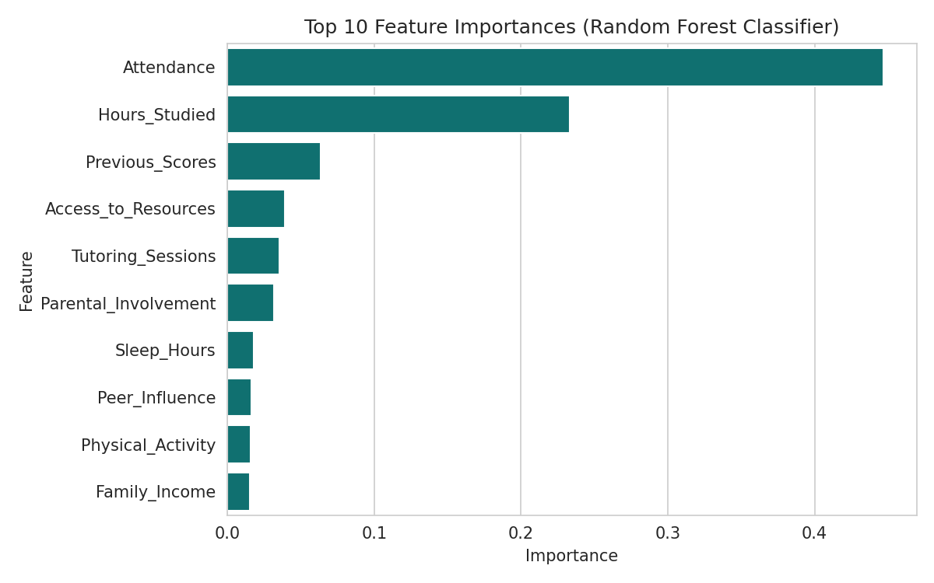
Figure 7: Top 10 Feature Importances (Random Forest Classifier)

6. Performance Dashboard
To satisfy the visualization/dashboard requirement, we built an interactive Streamlit dashboard (dashboard.py) that lets a user pick any student and instantly see their predicted score, predicted performance level, how they compare to the class average on key factors, and where they sit on the attendance/study-hours trend lines. It's meant to be run locally (streamlit run dashboard.py) or deployed to Streamlit Cloud.
Below is a static preview built from the same models and data, covering the same four views the live dashboard shows: predicted vs actual scores, the performance-level breakdown across all students, average score by motivation level, and the performance trend against study hours.
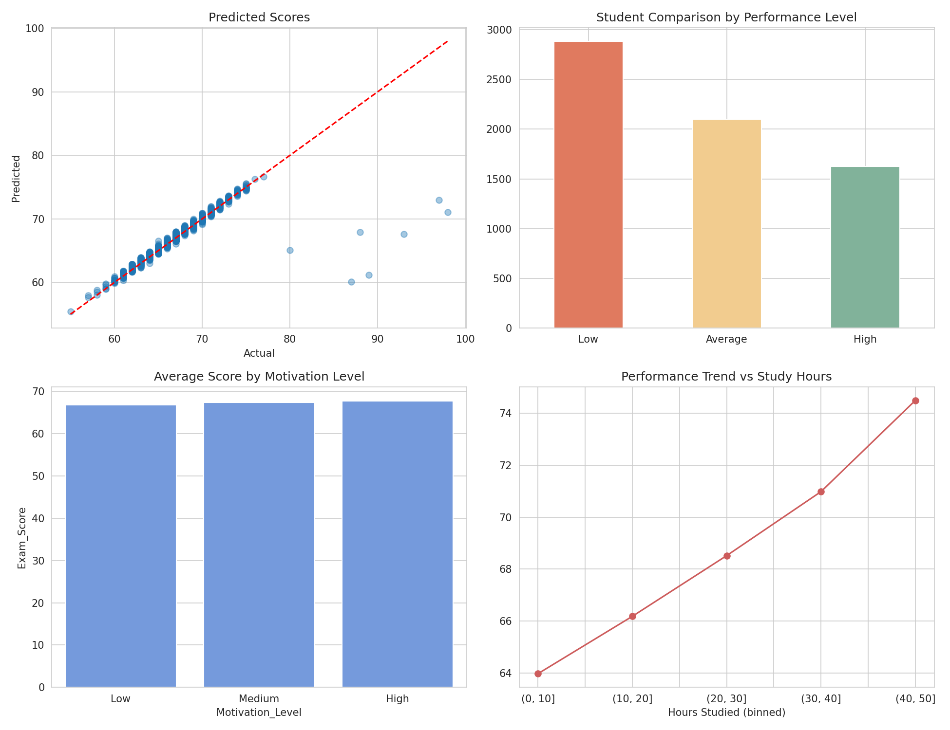
Figure 8: Dashboard Preview - Predictions, Comparisons, and Trends

7. Recommendation System
The last piece is a simple rule-based recommendation engine - it compares a student's Hours_Studied, Attendance, Previous_Scores, Tutoring_Sessions, Sleep_Hours, and Motivation_Level against the class medians and returns a short list of targeted suggestions (e.g. "Increase weekly study hours", "Improve class attendance", "Attend more tutoring/practice sessions"). We didn't use a machine learning model for this part on purpose - the thresholds are directly interpretable, which matters more than raw predictive power when the output is meant to be read and acted on by a student or teacher.

8. Tech Stack
- Programming: Python
- Libraries: Pandas, NumPy, Scikit-learn, Matplotlib, Seaborn
- Dashboard: Streamlit
- Deployment: Streamlit Cloud

9. Conclusion & Future Scope
This project walks through a complete, small-scale machine learning workflow - from raw CSV to a working dashboard - while staying within the intended scope (no deep learning or complex architectures, per the project brief). The main finding is that attendance, study hours, and prior academic performance are by far the strongest predictors of exam score, which held true across every stage of the analysis: correlation, regression, and feature importance.
If extended further, this system could be improved with hyperparameter tuning (GridSearchCV), gradient boosting models like XGBoost, and - most usefully - subject-wise marks instead of a single aggregate score, which would let the recommendation engine point to specific weak subjects rather than general study habits.

10. Deliverables
- Source Code - Jupyter Notebook (Student_Performance_Prediction_System.ipynb)
- Project Report - this document
- PPT Presentation - Student_Performance_Prediction_System.pptx
- GitHub Repository - source code, dashboard, and this report pushed to a public repo
- Dashboard Screenshots - included in Section 6 above
- Deployment Link - Streamlit Cloud link, added after deployment
- Demo Video - short walkthrough recorded after deployment

