The BaghSim model ODD (Version 1)

Simulating Habitat and Ecology of Royal Bengal Tiger

Indushree Banerjee¹, Volker Grimm^{2,3}, Qamar Qureshi⁴, Maurits Ertsen¹

¹ Delft University of Technology – TU Delft, Department Water System Engineering, CiTG, Delft, The Netherlands

² Helmholtz Centre for Environmental Research - UFZ, Department of Ecological Modelling, Leipzig, Germany

³ University of Potsdam, Plant Ecology and Nature Conservation, Potsdam, Germany

⁴ Wildlife Trust of India, New Delhi, India
The model description follows the ODD (Overview, Design concepts, Details) protocol for describing individual- and agent-based models (Grimm et al. 2006), as updated by Grimm et al. (2020). This model description focuses on the technical details of the model, with the particular purpose to enable full transparency of how the model works and to enable independent replication of the model. A narrative description of the model and its rationale is provided in the main text. The model's design, of the tiger's behavior, is based on input from a participatory workshop, where a group of tiger experts and park managers were asked to answer and discuss more than 80 questions regarding tiger behavior. This workshop is described and summarized here (https://zenodo.org/records/18731319).
The model is implemented in NetLogo 6.4.0 (Wilensky 1999); the program and its input files are available at https://github.com/SOSbanerjee/BaghSim.

1. Purpose and Patterns
The purpose of this model is to simulate tiger behavior, movement, and population dynamics in a spatially explicit environment that represents National parks. The model aims to simulate individual tigers and their spatial movement as they explore their environment to fulfil their survival requirements. The model aims to capture how tigers adapt to environment and make decisions about meeting their needs (hunger, thirst, fatigue, exploration, mating, fear of competitors, and fear of humans) (Veasey, 2020), how they interact with their environment and with each other, and how these individual behaviors generate emergent patterns at the population level. Specifically, the model addresses the question:
Can individual-based tiger behavior based on resource needs, spatial memory, and social interactions produce realistic population dynamics and spatial patterns in a national park?
The model focuses on understanding how resource distributions (water, prey, shade) and social interactions (competition, mating, mother-cub relationships) together influence both tiger spatial use patterns and population dynamics, and how various environmental scenarios affect tiger population viability. Ultimately, the purpose of the model is to support tiger conservation, allowing the study of impact of policies (such as fencing, buffer zone creation, waterhole creation) in silico.
Patterns used as criteria for evaluating the model's suitability for its purpose
The model is designed to reproduce the following patterns observed in tiger ecology. These patterns will not be imposed via model assumptions but should emerge from the adaptive behaviour of the tigers in response to their biotic and abiotic environment, and their own states:
- Spatial distribution patterns: Tiger territories should show realistic size and location patterns, sex-specific home range sizes comparable to those generated by analysis of national parks published in tiger reports (Simcharoen et al., 2014; Goodrich et al., 2010).
- Dispersal and daily walking distances: The model must produce male-biased dispersal distances , natal philopatry in females (Smith, 1993; Greenwood, 1980). Daily walking distribution should reflect age, and gender of tigers, for example increased daily walking for transient tigers in comparison to resident tigers.
- Demographic structure: adult sex ratios, and reproductive timing (age at first reproduction, interbirth-interval) consistent with field observations published in literature for tiger populations in national parks (Smith and McDougal, 1991; Sadhu et al., 2017).
- Population growth rate: The growth rate (λ) should reach levels consistent with observed densities in national park.
- Social structure: polygynous breeding units with males encompassing 1–5 female territories as observed in tigers social structure (Goodrich et al., 2010).

2. Entities, State Variables, and Scales

Entities
The model contains two types of entities:
- Tigers: Mobile agents that represent individual tigers. These are the primary entities as the model focuses on individual tiger behavior and how it scales up to population dynamics.
- Patches: Spatial grid cells that represent habitat features (100m × 100m areas). These represent spatial variation in environmental conditions and resources.

State Variables
Tigers have the following state variables:
- Position (x and y coordinate of the center of a patch)
- Demographic/physical attributes: female (1=female, 0=male), age (years), age-days (total days old), tiger-id (unique numerical identifier for individual tracking)
- Movement/budget variables: base-speed (baseline movement steps allocated as per age of a tiger in the first process ), total-speed (next the base-speed is adjusted as per the environment due to presence or absence of heat ), energy (the final daily movement steps allocated to each tiger as per need urgency), steps-taken (actual steps taken )
- Needs (quantified by scores ranging from 0, no need at all, to a maximum need): hunger (0-15), thirst (0-15), fatigue (0-15), fear-of-competitors (0-15), fear-of-humans (0-15), mate (0-12 for females during estrus, 0-10 for males), exploration (fixed at 2.0), cub-hunger, cub-thirst (sum of hunger/thirst levels of dependent cubs, used by mothers; capped at 15 only when calculating energy scaling, not when summing needs)
- Decision-making variables: total-needs (sum of all needs), current-need (string indicating focus of current action), current-need-met? (status flag)
- Memory variables: water-memory-locations, shade-memory-locations, food-memory-locations, female-memory-locations, male-memory-locations, human-memory-locations. Tigers select patches from these memory sets using distance-based criteria (nearest patch), with the exception of cubs seeking their mother (selected by highest thirst need rather than distance). Memory sets have no maximum size - tigers can remember unlimited resource locations.
- Reproductive variables: pregnant?, gestation-timer (days), fertility-age?, estrus-day (cycle day 0-40 within 41-day cycle), nursing?, nursing-timer (nursing status and duration counter)
- Family variables: is-mother?, cubs (list of cub IDs), mother (ID of mother), father (ID of cub's father)
- Development variables: is-cub?, self-reliance (0-1 development measure), transient? (Boolean status for cubs who are independent but haven't established territory), time-away-from-mother (counter for consecutive days spent independently)
- Social recognition variables: litter-ids (list of identifiers for kin recognition to prevent inbreeding among siblings), female-litter-ids (identifiers from female marking tigers for kin recognition), male-litter-ids (identifiers from male marking tigers for kin recognition)
Patches have the following state variables:
- Resource attributes: prey (amount of available prey), pcolor (NetLogo built-in patch color indicating habitat type: green=grasslands, blue=water, black=dense forests, brown=open dirt areas, white=buffer zone/human settlements)
- Territorial markers: male-marking, female-marking (ID numbers of the male and female tigers currently marking this patch; 9999 indicates unmarked; each sex can have one marking per patch simultaneously), male-marking-fading-clock, female-marking-fading-clock (duration timers for markings), female-litter-ids, male-litter-ids (kin recognition markers from territorial markings)

Scales
Spatial scale: Space is represented as grid of square grid cells, or patches. Spatial scale: Each patch represents a 100m × 100m area. The model world consists of 384 × 384 patches (procedurally generated), covering approximately 1,475 km² representing a generic tiger habitat with national park, buffer zone, and surrounding areas.
Temporal scale: Each time step (tick) represents one day. Within each day, tigers perform multiple activities in sequence based on need prioritization, with energy expenditure limiting total daily activity.
Scale selection rationale: The 100m × 100m patch size was chosen to balance computational efficiency with biological realism - large enough to avoid excessive computational overhead while small enough to capture meaningful habitat heterogeneity and tiger movement decisions (Banejee & Ertsen, 2025). The daily time step reflects the natural cycle of tiger activity patterns and allows modeling of need accumulation and fulfillment over realistic timeframes.

3. Process Overview and Scheduling
The model follows a sequential scheduling approach where processes occur in the following order each time step (day):

Global environmental updates
- Increment day-of-year and update temperature based on seasonal cycle (update-temperature)
- Age all tigers by 1 day and check for death from old age (18+ years)
- Increment marking fading timers on all marked patches and remove faded markings (increment-male-marking-fading, increment-female-marking-fading,
remove-male-marking, remove-female-marking)
- Remove faded markings (remove-female-marking, remove-male-marking)
- Monthly prey regeneration (conditional, inline code)

Individual tiger physiological updates
- Update tiger daily speed based on base speed, age, gender, and temperature (update-tiger-daily-speed)
- Update fertility status and handle pregnancy progression (update-fertility-status, handle-gestation). Fertility status affects mating availability and reproductive behavior. Females are fertile ages 3-15 when not pregnant; males are fertile ages 4-17.
- Increment needs: hunger +1, thirst +3.5, fatigue +0.5, fear-of-competitors -2, fear-of-humans -2 (increment-needs)
- Adjust mating need: males’ mating drive increases by +0.5/day (capped at 10) year-round with no seasonal variation; females exhibit cyclical patterns with mating drive = 12 during estrus days 0-4 of a 41-day cycle, otherwise zero (increment-needs)
- Sum all needs and checks for death conditions (sum-needs)
- Scale energy budget based on relative need levels (scale-energy-by-needs)
Tiger behavioral actions
Tiger agents are subdivided into three groups as per their age and reproductive stage. The model processes sequentially: adult tigers (males, and adult females without cubs), female tigers with cubs, and cubs.
Adult tigers (first males, then females without cubs) execute in sequence, with energy allocated proportionally to each need:
- Run away from same-sex competitors (run-away-from-males, run-away-from-females)
- Run away from human areas (run-away-from-humans)
- Run towards opposite-sex for mating (run-towards-males, run-towards-females)
- Go towards water (go-towards-water)
- Mark territory (mark-territory-male, mark-territory-female)
- Go towards dense forest for shade (go-towards-shade)
- Go towards food for hunting (go-towards-food)
- Explore surrounding (go-forward)
Opportunistically, they might engage in
- Territorial competition with same-sex (fighting-strength, prob-winning procedures) Infanticide behavior by only males toward unrelated cubs
Then, female tigers with cubs follow the same activity sequence but exhibit maternal checking behavior: after each major activity (for example: hunting, resting, etc.), mothers return to cubs to assess their safety and needs before proceeding to the next activity. This is done by calling the procedure run-towards-cubs, this helps in including cub needs in total-needs calculations.
Cub development (for tigers with is-cub?= true)
- Develop self-reliance gradually (grow-cub-behaviors)
- Update time away from mother and assess independence readiness(update-time-away)
- Set transient status if self-reliant but lacking safe territory (separate-from-mother)
- Transition to independence if age, self-reliance, and resource conditions met

Rationale for scheduling
Environmental updates occur first because subsequent tiger actions depend on current environmental conditions. Tigers are processed by age for physiological updates to ensure consistent aging effects. Illustrated in figure 1, behavioral actions follow a sequence reflecting biological urgency (Veasey, 2020): immediate survival threats (fear) are addressed first, followed by time-sensitive reproductive opportunities, then critical survival resources, and finally general maintenance activities. Territory marking occurs as a behavioral action separate from need fulfillment. Behavioral actions are grouped by demographic category because different tiger types (males, females without cubs, mothers) follow different behavioral sequences reflecting their distinct biological roles.
Figure 1: The Tiger activity framework showing the daily sequence of procedures simulated in the model as need-fulfilment cycle. There are seven needs that are processed sequentially shown in clockwise direction. Each tiger starts by ensuring safety from competitors(shown here in yellow) by moving away from the closest competitor fulfilling first need. This is followed by ensuring safety from humans (shown in navy blue) by moving towards dense forested areas, the second need. Next, the tiger addresses reproductive need (shown in purple), which vary for males and females: the tiger moves to a nearby opposite-sex tiger (within 500 meters) or moves to the nearest memorized opposite-sex location, fulfilling the third need (shown in purple) if mating occurs. This is followed by thirst, moving to the nearest water patch representing water, fulfilling the fourth need (shown in sky blue). The next need is to move to the nearest dense forested area due to fatigue, as rest is the fifth need. This is followed by hunting to fulfil hunger (shown in green), moving to the nearest memorized prey location to hunt, with the goal of attempting to hunt once; if opportunities for hunting arise during movement, these present additional hunting attempts on top of this.

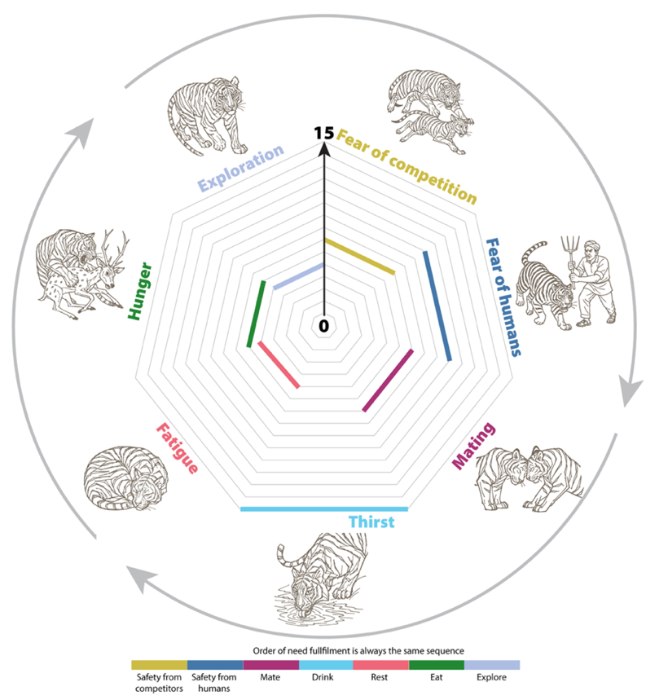
The last activity is exploration (shown in grey), in which the tiger wanders, randomly turning left and right throughout, coming across possible new locations to memorize and fulfill needs opportunistically. If a tiger has no way of fulfilling a particular need because it is somehow lacking any memory of its location, they will also allocate these needs to their exploration phase; the exploration activity is therefore called directionless need fulfillment, as it subsumes any activity for which the direction is undefined. The heptagon represents need prioritization: low needs appear close to the center (minimal urgency, if fulfilled the weighted line disappears because it is 0), while the most pressing needs extend toward the outer edges. The length of each thick colored line represents need intensity, with larger outer edges indicating the most urgent needs that the tigers proportionally allocate the most of their energy to.

4. Design Concepts

Basic principles:
The model is grounded in need-based behavioral prioritization (Veasey, 2020) (tigers allocate limited daily energy proportionally to urgent survival requirements), territorial behavior theory as tigers establish territories through marking (Ranc et al., 2022; Maher & Lott, 2000), resource selection theory as tigers remember and return to resource locations (Manly et al., 2002), landscape of fear concepts as tigers avoid areas with threats and exhibit faster, more directional movement in human-dominated areas (Hussain et al., 2025; Laundré et al., 2001).

Emergence:
Territory formation emerges from individual marking behaviors and competitor avoidance. Population dynamics emerge from individual survival, reproduction, and mortality. Spatial distribution patterns emerge from resource availability, competition, and memory-based movement. Resource use patterns emerge from individual foraging decisions.

Adaptation:
The tiger’s behaviour is implicitly adaptive: Tigers are modeled with need-based prioritization (allocating energy based on relative urgency), memory-based movement (using spatial memory of resources), avoidance behavior (moving away from competitors and humans), and kin recognition and mating asymmetry (males cannot mate with mothers, driving male-biased dispersal). Tiger behaviour is not, though, emerging from tigers explicitly choosing between options, based on some objective measure.

Objectives:
The model imposes behavioral rules that prioritize survival (maintaining needs within survivable thresholds), safety (avoiding competitors and humans), reproduction (finding unrelated mates), and parental care (for mothers, ensuring cubs' survival). Tigers are modeled as allocating energy proportionally to need urgency, which implicitly serves these survival and reproductive objectives.

Learning:
Tigers exhibit spatial memory formation (Fagan et al., 2013) (memorizing resource locations), memory updating (removing locations when resources absent), and gradual cub learning (cubs build memories while following mothers).

Prediction:
Tigers use implicit prediction by traveling to remembered resource locations (Sunquist 2010) (predicting resources remain present) and avoiding competitor markings (predicting danger). Mothers regularly return to cubs (predicting cubs need care).

Sensing:
Tigers sense their internal state (hunger, thirst, fatigue levels), local environment (patch characteristics), nearby tigers within 5 patches (500 meters), territorial markings including kin recognition markers, and cubs' needs (for mothers).

Interaction:
Tigers interact through territorial competition (direct encounters with probabilistic outcomes), indirect competition for prey, mating (between unrelated fertile individuals), mother-cub relationships (care provision and protection), kin recognition, and infanticide (males may kill unrelated cubs) (Smith and McDoughal,1991).
Stochasticity:
Random processes include initial tiger placement, gender assignment (58.7% female)(Sadhu et al., 2017), hunting success (1/6 chance when hunger > 3) (Sunquist, 2010), competition outcomes (logistic probability based on relative strength), reproduction (random litter size 2-4 cubs).

Collectives:
Family groups form temporary collectives where mothers and cubs coordinate movement (Liu et al., 2024). Mothers regularly run toward cubs. This persists until cubs develop sufficient independence.

Observation:
The model tracks population demographics (male-female ratios, age structure), causes of mortality, population stability, individual movement patterns (daily displacement, territory formation), spatial memory accumulation (water, food, shade location sets), territorial marking patterns (patch-level male/female markings), reproductive success (pregnancy rates, cub survival), behavioral state transitions (hunting success, competition outcomes). Additional tracking includes individual position histories and tiger-specific behavioral metrics for model testing and validation purposes.

5. Initialization
The model world is initialized to represent approximately 1,475 km² covering a generic tiger habitat with national park, buffer zone, and surrounding areas. The world consists of 384 × 384 patches (procedurally generated), each representing 100m × 100m areas. The world has non-wrapping boundaries, meaning tigers cannot cross edges and immigration/emigration is not possible.

Environmental initialization
Patches are assigned habitat types and resource characteristics through procedural generation. The model supports three landscape scenarios configurable via the interface of which the accompanying article used the default scenario:
In this scenario, patches representing the national park core are colored green, buffer zone patches (edges beyond coordinate 160) are colored white. Brown patches representing open dirt areas are distributed randomly. Dense forests (black patches) providing shade habitat are distributed within park boundaries through seed-and-expand clustering. Rivers can be configured as central or boundary with configurable number of water channels (None/One/Two/Many where Many = 6-8 channels). Additionally, 50 waterholes are placed, and 1000 single-cell water patches are sprinkled across green patches to represent basic puddles. . In this setup prey density was held constant (prey-situation = "Prey unaffected”).
Prey is distributed based on chital (90%) and sambar (10%) habitat preferences. Chital prefer riverine habitat within 6 patches (~600m) of water, placed in herds of 2-14 animals at a density of 50 per km² in suitable habitat. Sambar prefer forest habitat, with 52% solitary and the rest in groups of 2-4, at a density of 5 per km². This creates a realistic heterogeneous prey distribution based on documented ungulate ecology (Moe & Wegge 1994; Karanth & Sunquist 1992/1995).

Tiger initialization

Tigers are created according to the specified total tiger count. Each tiger is assigned gender with 58.7% probability of being female. Age is assigned as 3-15 years for initial adults (cubs are not created during initialization). Initial needs are set to zero. Movement speed is calculated based on age and gender. Memory sets are initialized as empty. Each tiger is assigned a unique genetic identity through distinct initial litter IDs. Tigers are placed randomly on non-human settlement patches.

Memory initialization Phase
An optional initialization phase allows tigers to explore and build initial memory of their surroundings. During this phase, tigers begin with zero needs but exploration need set to 25. As the phase progresses, hunger, thirst, and fatigue increase to motivate resource-seeking behavior, guiding tigers to find water, shade, and food locations. Tigers explore until all have found at least three patches for each resource type. During this phase, tigers do not die from unmet needs and do not reduce prey when hunting. After initialization, all needs are reset to zero and exploration is reduced to normal levels. This memory initialization helps the model population to survive the initial years and reach a quasi-stationary state. Without this initialization, most tigers will die and those surviving take a long time to reach the quasi-stationary state.

Rationale
Initial adults (no cubs) simplify model startup while allowing realistic population development. The 58.7% female ratio reflects observed tiger demographics (Sadhu et al., 2017). Random spatial placement avoids imposing artificial territory patterns. The optional memory initialization ensures tigers begin with basic environmental knowledge, preventing unrealistic early mortality from lack of spatial information while allowing emergent territory formation.

6. Input Data
The model does not use any external input data. All environmental changes (such as seasonal temperature fluctuations) are generated internally through mathematical functions. The landscape, including habitat boundaries, water bodies, and resource distributions, is generated procedurally during initialization. No external data files are required to run the model.

7. Submodels
This section describes the submodels called during model execution. Each submodel represents a specific process or decision mechanism.

Temperature Update
Daily temperature follows a sinusoidal annual cycle: temperature = 25 + 5 × cos(day-of-year × 360/365), where 25°C is the average annual temperature and the range is ±5°C. This creates seasonal variation with Since cos(0) = 1, peak temperature (30°C) occurs at day 0 (start of simulation year), with minimum temperature (20°C) at mid-year. Temperature affects tiger movement speed, with hot weather (>25°C) reducing speed by 20%; there is no speed bonus during cool weather (Hussain et al., 2025).

Need Increment
Tiger needs increase daily: hunger +1, thirst +3.5, fatigue +0.5 (bounded 0-15). Fear variables decrease by 2 daily (bounded 0-15) unless reinforced by encounters. During movement on white (buffer zone/human) patches, fear-of-humans increases by +0.25 per step. The faster thirst increment reflects tigers’ greater vulnerability to dehydration than starvation. Tigers die of dehydration after approximately 5 days (when thirst exceeds 15) and of starvation after 15 days (when hunger exceeds 15, i.e., death on day 16).
Mating Drive Adjustment
Males’ mating drive increases by +0.5 per day, capped at 10, with no seasonal variation—males are receptive to mating year-round. Mating drive resets to 0 upon successful mating. Females exhibit cyclical mating patterns with mating drive peaking at 12 during estrus days 0-4, otherwise zero. Pregnant or nursing females have mating drive of 0. Estrus cycles every 41 days (days 0-40 inclusive).

Energy Budget Scaling
Tigers determine how much energy they will expend, proportionally to their top 2 needs (Veasey, 2020) using the scale-energy-by-needs procedure detailed with an illustration in figure 2. This procedure calculates available energy as: total-speed × (sum-of-highest-two-needs / 30), where the scaling factor represents the maximum possible need urgencies of two needs. Total speed available is determined by age, gender, and temperature-adjusted movement capacity given in table 1.
Energy allocation to each activity equals: available-energy × (specific-need / sum-of-all-needs).This ensures tigers prioritize their most urgent requirements while maintaining realistic movement constraints.
Age-specific movement parameters are supported by empirical telemetry data from tiger populations. Hussain et al. (2025) documented peak mobility during dispersal phases (mean travelling step lengths 1,387m per 2-hour interval) compared to pre-dispersal (751m) and post-dispersal phases (867m). This pattern aligns with our sub-adult speed assignment of 130 steps/day (~13 km/day) representing peak movement capacity during territory-seeking phases. Empirical data also supports reduced mobility in established adults, with post-dispersal individuals allocating 36.28% of time to resting compared to 27.42% in pre-dispersal phases, consistent with our speed reductions for older tigers (Hussain et al., 2025).
Table 1: Base speed of simulated tiger with respect to age and gender; each step covers 100 meters.
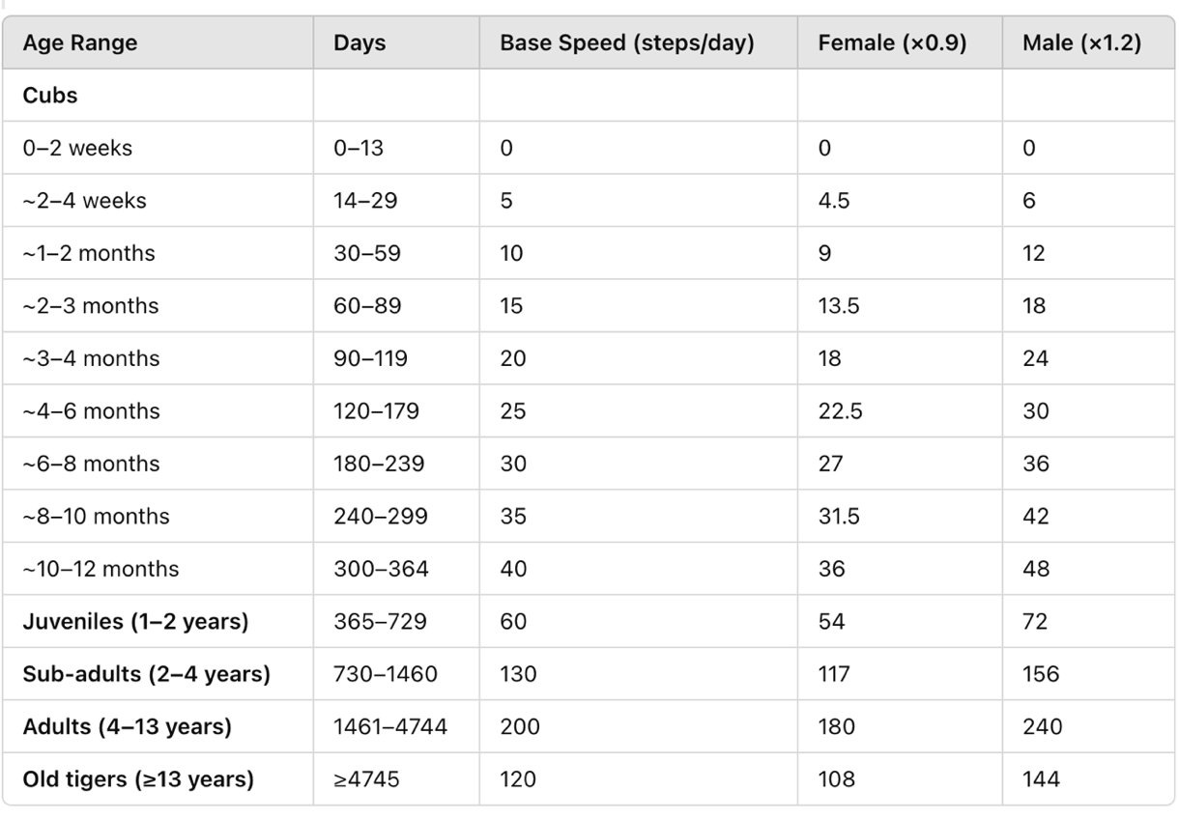

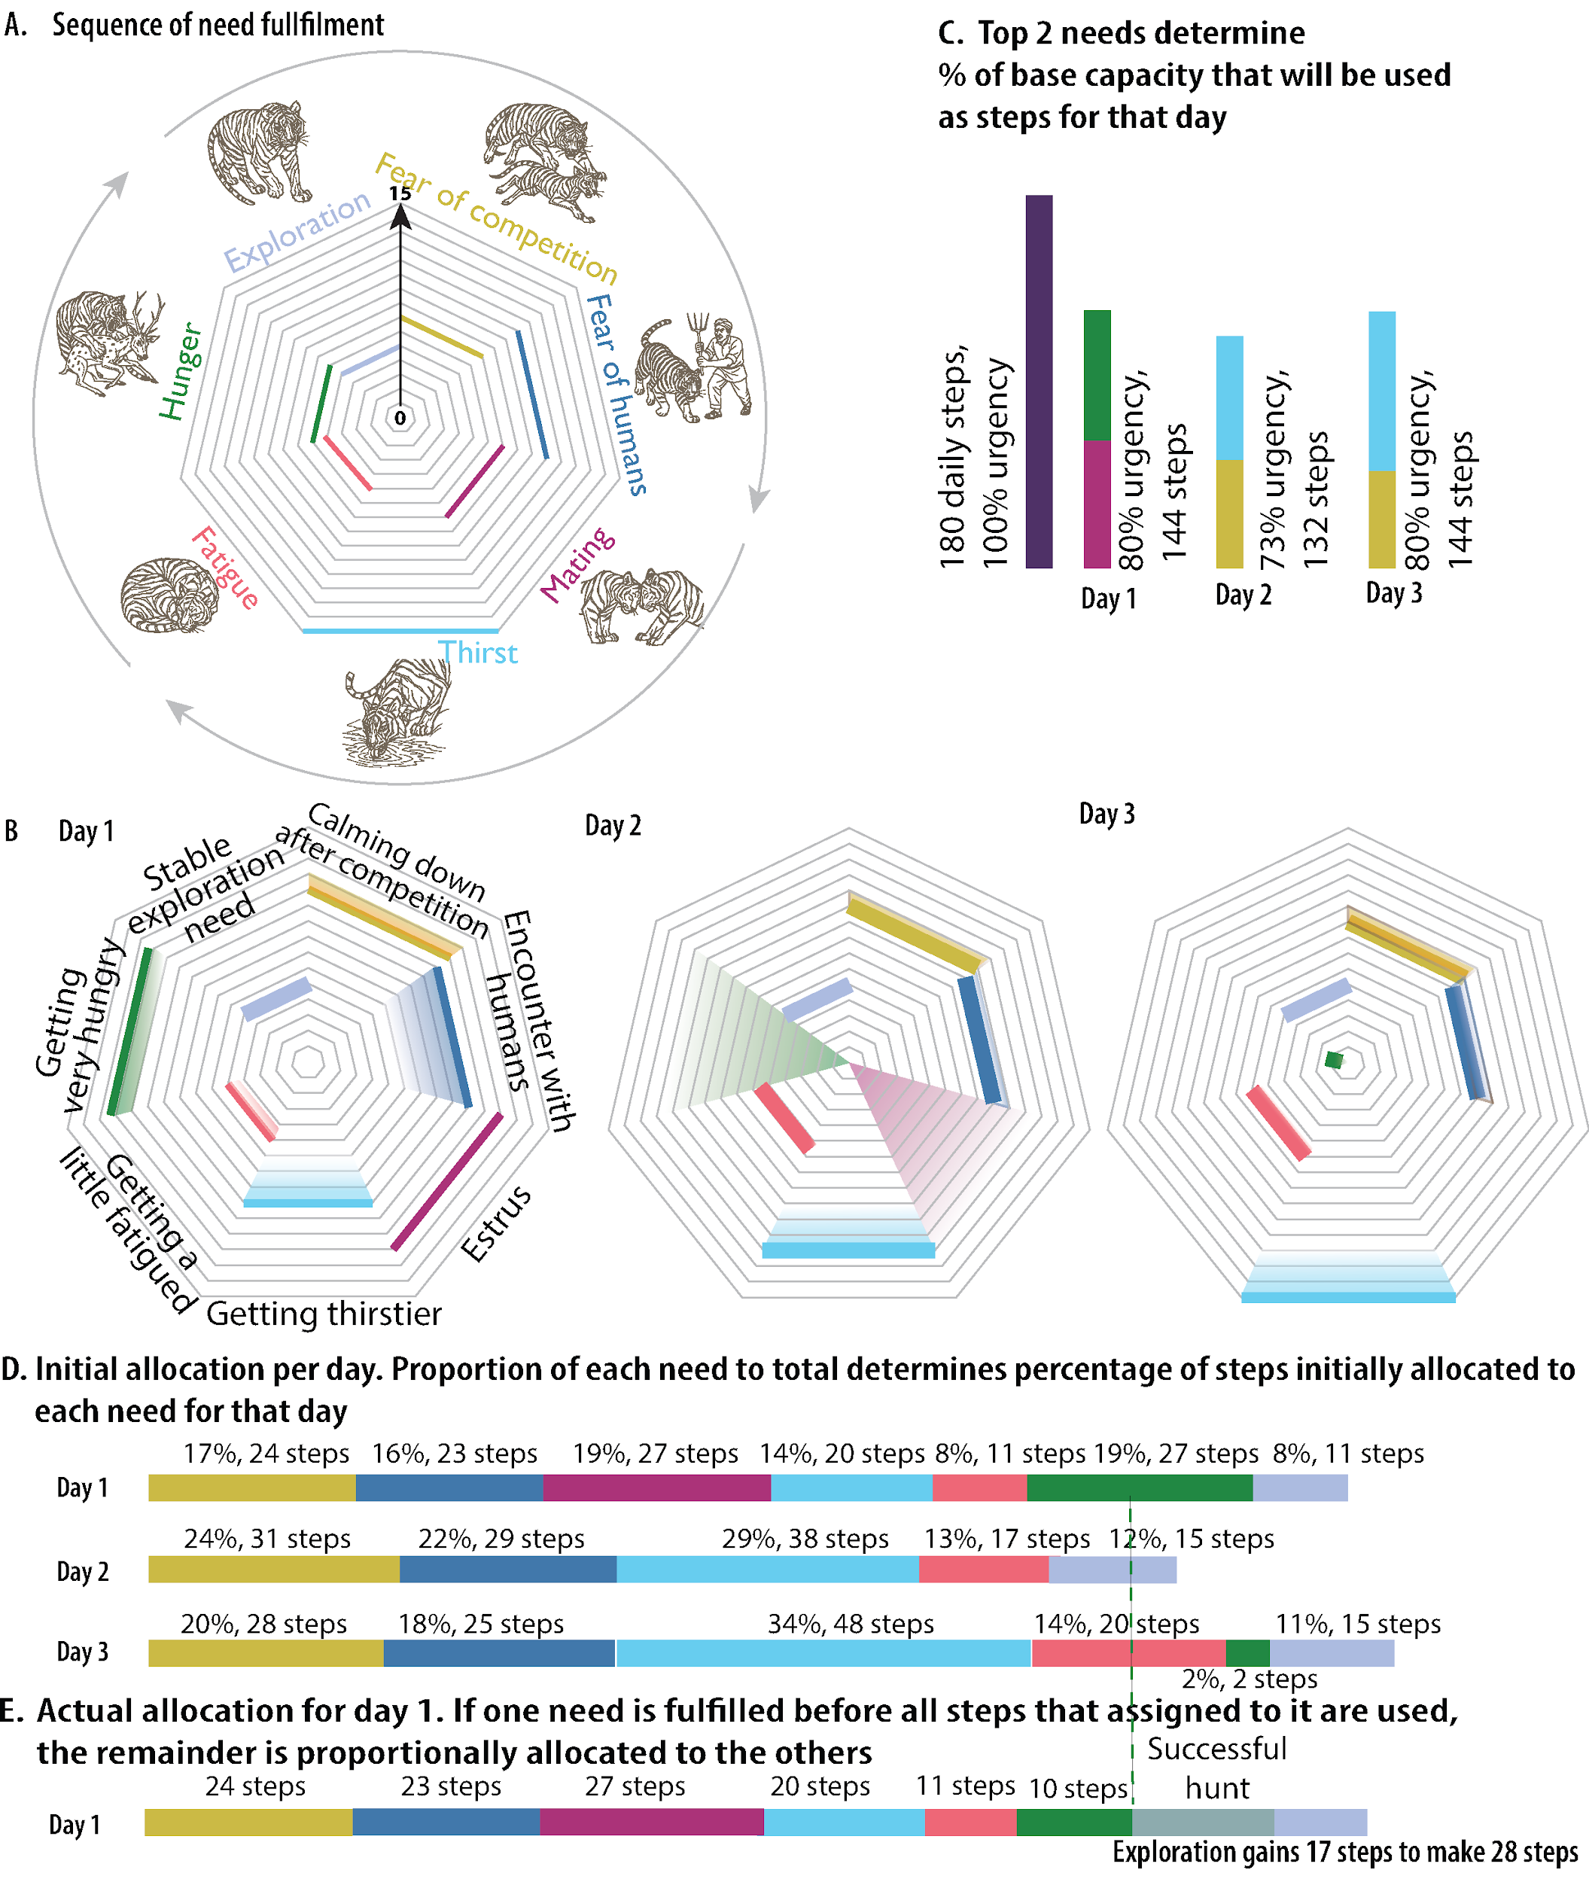

Figure 2: Energy allocation mechanism across three consecutive days for an adult female tiger in estrus. Panels A,B show daily need profiles where distance from center indicates need intensity. Panel C shows percentage of maximum movement capacity utilized each day based on the sum of the two highest needs. Panel D shows initial proportional allocation of movement units among active needs for each day. Panel E illustrates dynamic reallocation for Day 1: when hunting succeeds early, the 27 movement units originally allocated to eating redistribute proportionally among remaining needs, increasing exploration from 27 to 45 total units. Note the dramatic shifts in allocation patterns: Day 1 shows high mating allocation (19%) during estrus, Day 2 eliminates mating needs entirely while thirst intensifies (29%), and Day 3 shows critical thirst dominating allocation (34%) despite persistent other needs. This demonstrates how stochastic resource encounters and dynamic need states create emergent movement patterns from identical maximum capacities.

Movement, Opportunistic Need Fulfillment and Conflict Avoidance
Tigers move step-by-step toward target locations rather than teleporting directly, allowing opportunistic encounters with resources while being on their way. Mating and fighting occur opportunistically during any movement activity when eligible tigers share a patch via the update-status procedure, rather than as separate behavioral phases (alt-fd). During movement, tigers memorize newly encountered resources, update their status based on current patch characteristics, interact with other tigers present, and consume energy proportional to distance traveled. Tigers exhibit two levels of avoidance behavior (Riotte-Lambert et al. 2015). Major avoidance behaviors receive dedicated energy allocation based on fear levels: tigers flee from same-sex competitors within a 5-patch (500m) detection range by facing directly away (180-degree turn) and moving with allocated energy, or if no competitors are present, they flee from remembered competitor locations (run-away-from-males, run-away-from-females). Tigers with fear-of-humans move toward remembered shade locations (safe refuges) rather than simply fleeing (run-away-from-humans), reflecting the need for protective cover from human threats. Importantly, competitor avoidance only triggers for tigers of reproductive age (fertility-age? = true); pre-fertile tigers (males <4 years, females <3 years) do not trigger avoidance behavior in others. Minor avoidance behaviors occur during other activities: tigers turn away from human settlements (white patches) during exploration with large random turns (100-260 degrees)(alt-fd) and increase fear (+2 fear-of-competitors) when encountering competitor scent markings (update-status). These habitat-dependent movement patterns align with empirical observations where tigers in non-forest habitats demonstrate faster, more directional movements compared to more localized movements in forested areas (Hussain et al., 2025).
Opportunistic need fulfillment occurs regardless of current activity (Seidensticker and McDougal, 1993) (alt-fd): water patches (blue) reset thirst to zero, patches with prey > 0 trigger probabilistic hunting (1/6 success rate when hunger >3) resetting hunger to zero on success, and shade patches (black) reset fatigue to zero. When needs are fulfilled before allocated energy is consumed, remaining energy is redistributed proportionally among remaining needs, often resulting in increased exploration that helps prevent future resource crises.

Spatial Memory
Tigers maintain spatial memory of encountered resource locations organized by type (water, shade, food, competitors). Memory accumulates throughout individual lifespans as tigers explore their environment (Fagan et al., 2013) (memorize-water-locations, memorize-shade-locations, memorize-human-locations, memorize-food-locations, memorize-female-locations, memorize-male-locations). Memory is updated continuously (Spencer, 2012) (alt-fd): new resources are added when encountered, and resources are removed when tigers revisit locations where resources are no longer present. This memory system guides future movement decisions and allows efficient resource acquisition.

Territorial Marking
Tigers mark territory by placing their individual ID and litter IDs on patches. Male (mark-territory-male) and female (mark-territory-female) markings are tracked separately. Marking clocks start at 15 and decrement by 1 each day; markings are removed when the clock falls below 1, meaning markings fade after 15 days (Smith et al., 1989; Liu et al., 2024) through daily decrements of fading timers (increment-female-marking-fading, increment-male-marking-fading). Only unmarked patches can be newly marked. Tigers must be at least 700 days old (~1.9 years) to mark territory. This creates temporary territorial boundaries that emerge from individual marking behavior and influence other tigers' movement decisions.

Competition and Fighting
When tigers encounter competitors of the same gender, fighting occurs with outcomes determined by relative strength (fighting-strength). Fighting strength equals
total-speed × (1 - (hunger + thirst + fatigue)/45),
representing how age, gender, and physical condition affect competitive ability.
This formulation gives advantages to resident tigers with nearby resources over transient tigers who have been traveling and are more likely to be hungry, thirsty, or fatigued (Stamps and Krishnan, 1999).
Probability of winning follows a logistic function:
1/(1 + exp(-0.05 × strength-difference)) (prob-winning).
The stochastic outcome reflects the inherent unpredictability of animal contests while incorporating realistic factors affecting success as demonstrated in figure 3.
The coefficient -0.05 creates competitive dynamics where strength differences of 20 units correspond to ~73% win probability. Losers either die (10% probability) or flee with maximum fear (fear-of-competitors = 15); actual fleeing movement occurs at the start of the next day’s avoidance behavior cycle, not immediately. This reflects that most territorial conflicts end with displacement rather than mortality (Smith, 1993). Males may kill unrelated cubs (50% probability) if mothers are absent (not within 10 patches) or lose defensive fights. Infanticide kin recognition uses the father ID check (comparing the male’s ID to the cub’s father variable), which differs from the litter-id system used for mating and sibling recognition (Smith and McDougal, 1991).
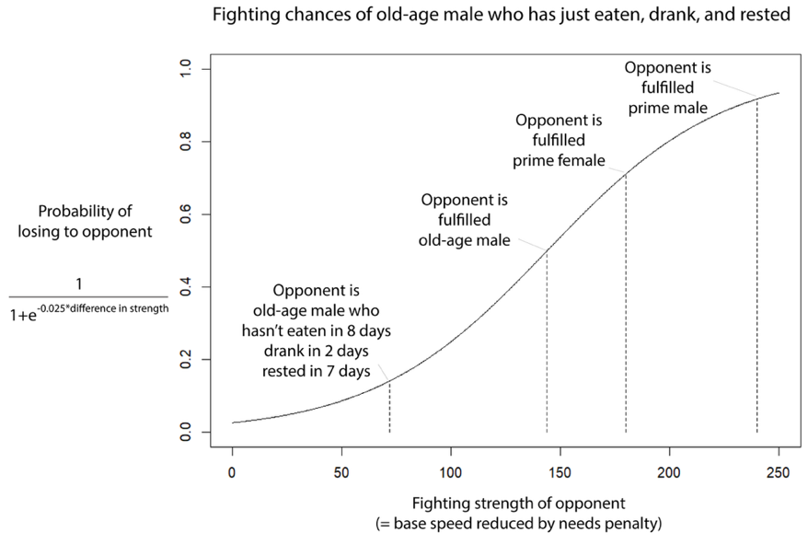
Figure 3: The stochastic outcome of competitive fights.
The X-axis represents the fighting strength of a challenged tiger.
The Y axis shows the probability of winning which follows a logistic function. The needs penalty is defined as multiplication by
(1 – ((hunger + thirst + fatigue) / 45)).

Reproduction and Cub Development
Mating occurs opportunistically between fertile, unrelated tigers occupying the same patch during any movement activity (via update-status). There is no probability gate—mating always succeeds if conditions are met. Relatedness is determined by shared litter IDs, which captures full siblings (shared mother and father) but not half-siblings. Pregnant females experience reduced mobility (up to 30% speed reduction proportional to gestation progress) and increased fatigue (+0.2/day). Safe birthing locations require: shade (pcolor = black), water memory within 5 patches (500m), AND food memory within 10 patches (1km). Birth occurs after a minimum 100-day gestation, once a safe location has been found (give-birth). Litter size ranges 2-4 cubs. New cubs receive only the newly-generated shared litter-id (not the mother’s full historical litter-ids), plus the father’s ID for infanticide kin recognition. Cubs initialize with zero needs and dependencies. Mother-specific behavior: Mothers check on cubs first thing each day before other activities, and return to cubs after each major activity (8 times per day cycle). When seeking food, mothers allocate energy based on both their own hunger and cub-hunger combined; on a successful hunt, all dependent cubs’ hunger also resets to zero. Cubs without resource memories face toward their mother as a fallback behavior when seeking water or food, allowing them to follow her. Cubs develop self-reliance gradually (+0.01 daily). Cubs separate from mothers when they achieve high self-reliance (≥0.9), spend 15 consecutive days more than 500 meters away from their mother after having built some knowledge of unmarked shade, water and food locations (2, 3, 5 patches respectively), and are at least 2 years old (730 days) (grow-cub-behaviors, update-time-away, separate-from-mother).

Rationale
The proportional energy allocation reflects optimal foraging principles while remaining computationally tractable. Probabilistic elements (hunting success, competition outcomes) introduce realistic variability without requiring detailed mechanistic models. The step-by-step movement system enables opportunistic resource use while maintaining directed behavior. The territorial marking system creates emergent spatial patterns without imposing fixed territories.

References
[1] Banerjee, I., and Ertsen, M.W., 2025. Scale choices shape species adaptation predictions: Improving conservation modeling under global change. Conservation Science and Practice, e70193
[2] Laundré, J.W., Hernández, L. and Altendorf, K.B., 2001. Wolves, elk, and bison: reestablishing the" landscape of fear" in Yellowstone National Park, USA. Canadian Journal of Zoology, 79(8), pp.1401-1409.
[3] Ranc, N., Cagnacci, F. & Moorcroft, P.R., 2022. Memory drives the formation of animal home ranges: evidence from a reintroduction. Ecology Letters, 25, 716–728.
[4] Manly, B.F., McDonald, L.L., Thomas, D.L., McDonald, T.L. and Erickson, W.P., 2002. Resource selection by animals: statistical design and analysis for field studies. Dordrecht: Springer Netherlands.
[5] Johnson, D.H., 1980. The comparison of usage and availability measurements for evaluating resource preference. Ecology, 61(1), pp.65-71.
[6] Adams, E.S., 2001. Approaches to the study of territory size and shape. Annual review of ecology and systematics, 32(1), pp.277-303.
[7] Maher, C.R. and Lott, D.F., 2000. A review of ecological determinants of territoriality within vertebrate species. The American Midland Naturalist, 143(1), pp.1-29.
[8] Hussain, Z., Kay, W., Börger, L., Ghaskadbi, P., Nigam, P., & Habib, B. (2025). Rest to roam: behavioural adaptations of tigers in anthropogenically altered landscapes. Movement Ecology, 13(1), 61.
[9] McNamara, J.M. and Houston, A.I., 1986. The common currency for behavioral decisions. The American Naturalist, 127(3), pp.358-378.
[10] Grimm, V., Railsback, S.F., Vincenot, C.E., Berger, U., Gallagher, C., DeAngelis, D.L., Edmonds, B., Ge, J., Giske, J., Groeneveld, J. and Johnston, A.S., 2020. The ODD protocol for describing agent-based and other simulation models: A second update to improve clarity, replication, and structural realism. Journal of Artificial Societies and Social Simulation, 23(2).
[11] Grimm, V., Berger, U., Bastiansen, F., Eliassen, S., Ginot, V., Giske, J., Goss-Custard, J., Grand, T., Heinz, S.K., Huse, G. and Huth, A., 2006. A standard protocol for describing individual-based and agent-based models. Ecological modelling, 198(1-2), pp.115-126.
[12] Veasey, J.S., 2020. Assessing the psychological priorities for optimising captive Asian elephant (Elephas maximus) welfare. Animals, 10(1), p.39.
[13] Wilensky, U. and Reisman, K., 2006. Thinking like a wolf, a sheep, or a firefly: Learning biology through constructing and testing computational theories—an embodied modeling approach. Cognition and instruction, 24(2), pp.171-209.
[14] Simcharoen, A.C.H.A.R.A., Savini, T., Gale, G.A., Simcharoen, S., Duangchantrasiri, S., Pakpien, S. and Smith, J.L., 2014. Female tiger Panthera tigris home range size and prey abundance: important metrics for management. Oryx, 48(3), pp.370-377.
[15] Goodrich, J.M., Miquelle, D.G., Smirnov, E.N., Kerley, L.L., Quigley, H.B. and Hornocker, M.G., 2010. Spatial structure of Amur (Siberian) tigers (Panthera tigris altaica) on Sikhote-Alin Biosphere Zapovednik, Russia. Journal of Mammalogy, 91(3), pp.737-748.
[16] Smith, J.L.D., 1993. The role of dispersal in structuring the Chitwan tiger population. Behaviour, 124(3-4), pp.165-195.
[17] Greenwood, P.J., 1980. Mating systems, philopatry and dispersal in birds and mammals. Animal Behaviour, 28(4), pp.1140-1162.
[18] Fagan, W.F., Lewis, M.A., Auger-Méthé, M., Avgar, T., Benhamou, S., Breed, G., LaDage, L., Schlägel, U.E., Tang, W., Papastamatiou, Y.P. and Forester, J., 2013. Spatial memory and animal movement. Ecology Letters, 16(10), pp.1316-1329.
[19] Sunquist, M., 2010. What is a tiger? Ecology and behavior. In: Tilson, R. and Nyhus, P.J. (eds.), Tigers of the World: The Science, Politics, and Conservation of Panthera tigris, 2nd ed. Elsevier, pp.19-33.
[20] Smith, J.L.D., McDougal, C. and Miquelle, D., 1989. Scent marking in free-ranging tigers, Panthera tigris. Animal Behaviour, 37, pp.1-10.
[21] Liu, Y., Dodge, S., Simcharoen, A., Ahearn, S.C. and Smith, J.L.D., 2024. Analyzing tiger interaction and home range shifts using a time-geographic approach. Movement Ecology, 12, p.13.
[22] Sadhu, A., Jayam, P.P.C., Qureshi, Q., Shekhawat, R.S., Sharma, S. and Jhala, Y.V., 2017. Demography of a small, isolated tiger (Panthera tigris tigris) population in a semi-arid region of western India. BMC Zoology, 2, p.16.
[23] Riotte-Lambert, L., Benhamou, S. and Chamaillé-Jammes, S., 2015. How memory-based movement leads to nonterritorial spatial segregation. The American Naturalist, 185(4), pp.E103-E116.
[24] Seidensticker, J. and McDougal, C., 1993. Tiger predatory behaviour, ecology and conservation. Symposia of the Zoological Society of London, 65, pp.105-125.
[25] Spencer, W.D., 2012. Home ranges and the value of spatial information. Journal of Mammalogy, 93(4), pp.929-947.
[26] Stamps, J.A. and Krishnan, V.V., 1999. A learning-based model of territory establishment. The Quarterly Review of Biology, 74(3), pp.291-318.

