- Introduction
To actually use the control methods I learned in ECE515, I decided to control a drone because its mechanics are simple enough to model with a single equation. I consider the control methods necessary for drones to move smoothly. The process of this project consists of the following steps.
The object of this project is to control a drone as it gets horizontal against the ground.

- Set up the equations of the mechanics of a drone with four wings.
- Transform the equations into matrix form.
- Consider the const function and find the optimal control.
- Make a simulator for this model.

- Mechanics and Transform into a matrix
  - Assumption
- Neglect the translational motion and only consider rotational motion.
- Neglect the disturbance.
- The distances between the center of mass and the propellers are the same. $(l)$
- For simplicity, let the moment of inertia $J_{x}=J_{y}=0.5ml^{2}$
- Assume that the rotation angle can be observable.

  - Equation of motion
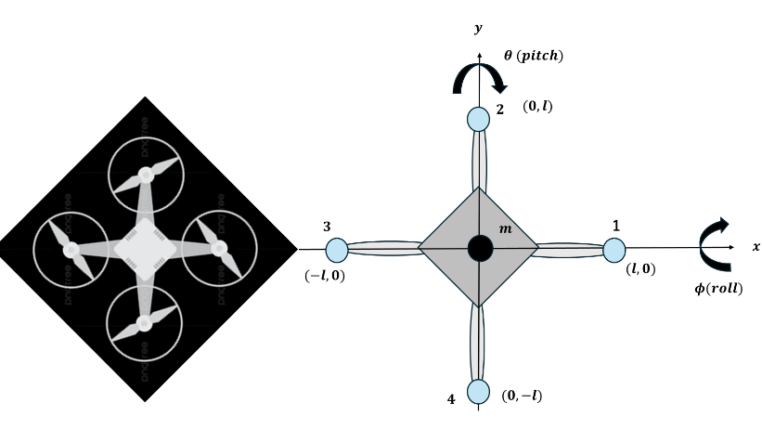
Fig.1 The model of a drone
Set the position of the wings and define the angle, like Fig.1
$$r_{1}={\left(l,0,0\right)}^{T}, r_{2}={\left(0,l,0\right)}^{T}, r_{3}={\left(-l,0,0\right)}^{T}, r_{4}={\left(0,-l,0\right)}^{T}$$
$$ϕ:angle around x-axis, θ:angle around y-axis$$
And let the thrust power
$$F_{i}={\left(0,0,f_{i}\right)}^{T}$$
And, the torques are
$$τ_{i}=F_{i}×r_{i}$$
$$τ_{1}={\left(0,-lf_{1},0\right)}^{T}, τ_{2}={\left(lf_{2},0,0\right)}^{T}, τ_{3}={\left(0,lf_{3},0\right)}^{T}, τ_{4}={\left(-lf_{4},0,0\right)}^{T}$$
$$τ=\sum{τ_{i}=}{[l(f_{2}-f_{4}), l\left(f_{3}-f_{1}\right),0]}^{T}$$
Consider the equation of motion for rotation and neglect the term of $\left(J_{i}-J_{j}\right)\dot{ϕ_{i}}\dot{ϕ_{j}}$ because we assume the angular velocity is small enough, so
$$τ_{x}=J_{x}\ddot{ϕ}, τ_{y}=J_{y}\ddot{θ}$$
$$J_{x}\ddot{ϕ}=l\left(f_{2}-f_{4}\right), J_{y}\ddot{θ}= l\left(f_{3}-f_{1}\right)$$
For simplicity, let the moment of inertia
$$J_{x}=J_{y}=0.5ml^{2}$$
Here, define p and q as
$$p=\dot{ϕ}, q=\dot{θ}$$
And, let the control
$$u_{ϕ}=\dot{p}, u_{θ}=\dot{q}$$
We can easily calculate the torque from the control
$$τ_{x}=J_{x}u_{ϕ}, τ_{y}=J_{y}u_{θ}$$

  - Transform the equation into matrices
Let
$$x=\left[\begin{matrix}ϕ \\ θ \\ p \\ q\end{matrix}\right], u=\left[\begin{matrix}u_{ϕ} \\ u_{θ}\end{matrix}\right], y=\left[\begin{matrix}ϕ \\ θ\end{matrix}\right]$$
The equation is
$$x=Ax+Bu, y=Cx$$
$$A=\left[\begin{matrix}0_{2} & I_{2} \\ 0_{2} & 0_{2}\end{matrix}\right], B=\left[\begin{matrix}0_{2} \\ I_{2}\end{matrix}\right], C=\left(I_{2},0_{2}\right)$$

- Cost function and optimal control
Define the infinite horizon cost function as
$$J\left(u\right)=\int_{t_{0}}^{∞}{\left\{h_{1}^{2}\left(ϕ^{2}+θ^{2}\right)+h_{2}^{2}\left(p^{2}+q^{2}\right)+r^{2}\left(u_{ϕ}^{2}+u_{θ}^{2}\right)\right\}dτ}$$

$$h_{1}^{2}\left(ϕ^{2}+θ^{2}\right):the cost associated with the convergence speed \\ h_{2}^{2}\left(p^{2}+q^{2}\right):the cost associated with the change of the angular velocity \\ r^{2}\left(u_{ϕ}^{2}+u_{θ}^{2}\right):the cost associated with the magnitude of torque$$

Calculate P from the Riccati equation
$$A^{T}P+PA-PBR^{-1}B^{T}P+Q=0$$

$$P=\left[\begin{matrix}S & 0 \\ 0 & S\end{matrix}\right], S=\left[\begin{matrix}h_{1}\sqrt{h_{2}^{2}+2h_{1}r} & h_{1}r \\ h_{1}r & r\sqrt{h_{2}^{2}+2h_{1}r}\end{matrix}\right]$$
The optimal control and cost are
$$u^{°}=-Kx=R^{-1}B^{T}Px$$
$$K=\left[\begin{matrix}\frac{h_{1}}{r} & 0 & \frac{\sqrt{h_{2}^{2}+2h_{1}r}}{r} & 0 \\ 0 & \frac{h_{1}}{r} & 0 & \frac{\sqrt{h_{2}^{2}+2h_{1}r}}{r}\end{matrix}\right]$$

$$V^{°}\left(x_{0}\right)=x_{0}^{T}Px_{0}$$
Here, I suppose the drone is stationary.

- Make a simulator for this model

I made a simulator using ChatGPT. First, I set the bars to easily change the parameters, such as mass, length, the initial angle, and cost coefficient.
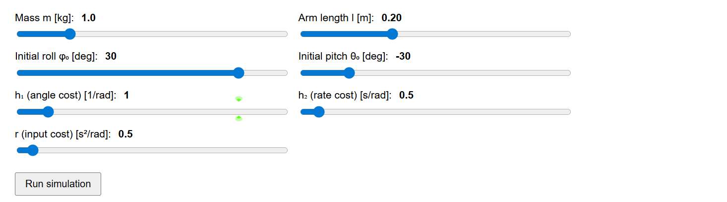

Furthermore, we can see the results of the angle, control, and the force.
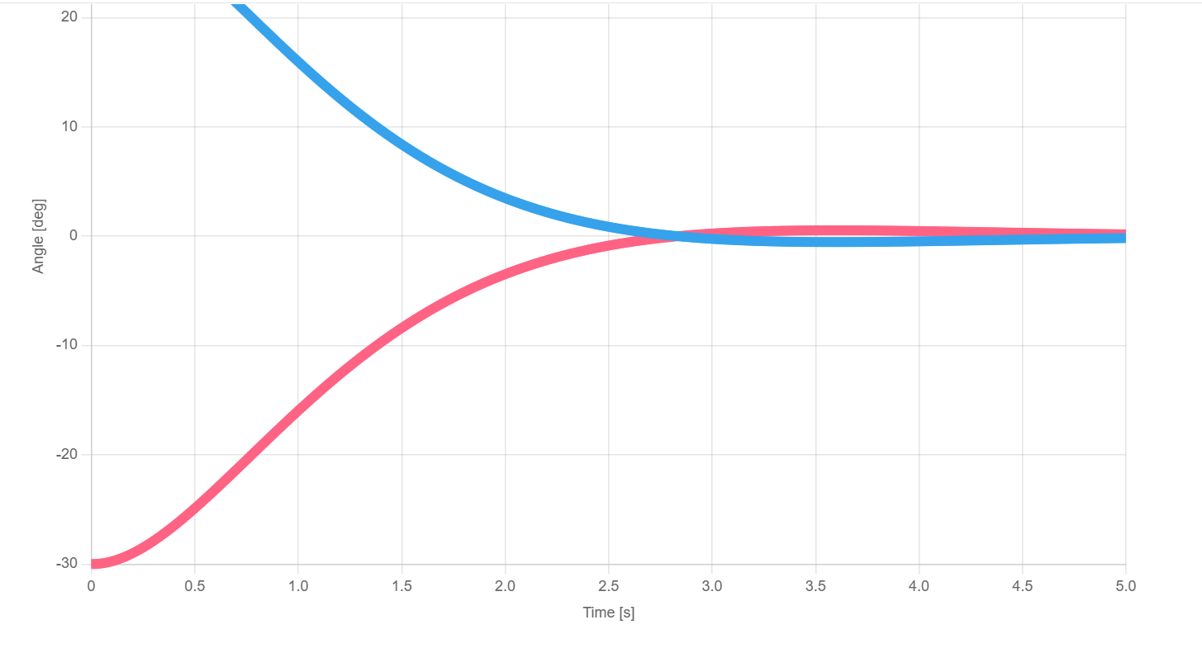
Moreover, you can see the animation of this control
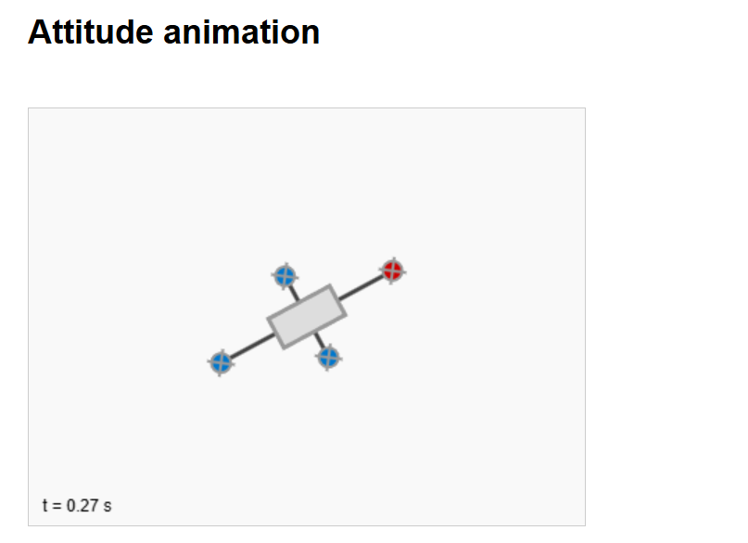

- Interpretation of the result
  - High angle cost $h_{1}$
- Faster reduction of the angle $θ, ϕ$
- A higher chance of overshooting
- Larger torque
  - High angular rate cost $h_{2}$
- Avoids rapid changes in angle
- The response becomes slower but smoother

  - High control cost r
- Smaller control and smaller torque
- Slower convergence of angle

  - Change the mass m and the length l
- These parameters do not affect the control, so the shape of the control does not change.
- However, the torque becomes bigger if the mass and the length become bigger.

- Future works
In this model, I only consider rotation, so next I’m going to include position and yaw angle. Furthermore, I neglect the disturbance, such as wind. Hence, I would like to tackle the control of the disturbance.

