|  |  |
| --- | --- |
|  | Application for the management and operation of schools |
|  |  |
|  | Student ID: 19045454  [Course title]: SOFT7011 BIGDATA AND THE CLOUD  [Date] |

Contents

Project Summary: 2

Introduction: 3

Analysis and Specification of Quality Requirements: 5

Performance Requirements: 5

Scalability Requirements: 6

Reliability Requirements: 6

Security and Privacy Requirements: 6

Usability Requirements: 7

PLES Aspects: 7

1. Professional Issues: 7

2. Legal Issues: 7

3. Ethical Issues: 8

4. Social Issues: 8

System Architecture Design: 8

# Project Summary:

The Project aims to design a school management system using Cloud Computing Features. The report discusses the non-functional requirements that are required for efficient and reliable system design and development. Professional, Ethical, Social, and Legal issues have been discussed from a software development point of view. Also, the detailed architectural design of the system has been designed that shows how the system will interact with the other system components and resources.

# Introduction:

The traditional file management system has many issues as they cause issues like data redundancy, security, storage, and privacy. Web, Mobile, and cloud technologies has enables organizations to shift their manual system to computerized. Most of the schools have their computerized management system, the goal of this project is to use cloud computing features to enhance the scope of the system. Like the system would be accessible by the users anywhere.

The project focuses on the development of Desktop and Mobile application systems depending on the type of user, using Cloud computing services, the main actors of the system are administration staff, students, teachers, and parents. the administration staff is responsible for managing all the records of students, teachers, and other staff members. Also, they will update the school website and enter basic information about the school. For teachers, a desktop system will be developed that will allow them to manage student activities e.g. attendance marks, homework upload, and marking, etc. while students and parents will use mobile as well as web systems to communicate with the schools.

The report focuses on the development and design of a Desktop Application subsystem for teachers. The desktop system will allow teachers to:

1. Login into the system using their names and Password.
2. The system will enable teachers to set up homework online and offline.
3. The teachers will be able to mark the homework and send feedback to the student.
4. The system will enable teachers to assess student performance, they can also share the performance with school administration and parents.
5. The system will enable teachers to manage their classes e.g. adding or removing a student from the class.

The system will use cloud services to store and retrieve data. Google Cloud platform provides a facility to store data and ensures data privacy and security. The use of standard connectors and interfaces will enable the system to connect with the cloud database where all the data is stored.

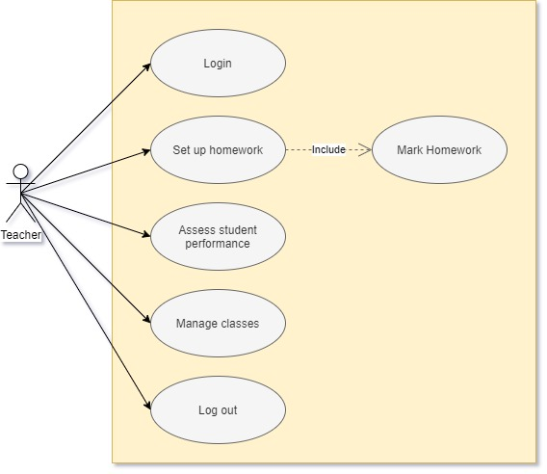

Figure 1 Use case Diagram

# Analysis and Specification of Quality Requirements:

For any system development, it's important to consider both the functional and non-functional system requirements. The functional requirements focus on the user’s requirements and features, while the non-function is related to the system development, that how the system will work. The non-functional requirements highlight systems’, security, reliability, performance, and usability requirements. As our goal is to develop a desktop application system for teachers. So, the specification and quality requirements of our system are:

## Performance Requirements:

* the system is expected to have a minimum response time.
* Easy uploading, deleting, and insertion of records on the cloud.
* Easy tracking of records, and efficient use of cloud database.
* The teacher will be able to Login into the system by providing his name and password, the one that is stored in the database.
* The system will be able to set up homework for the student online and offline.
* The homework of the student will be marked, and performance records can be shared with management and parents.
* The system will enable teachers to communicate with students’ parents and management staff members.
* The system will also mark the attendance of the student as well as will allow the teacher to accept or delete enrolment requests of any student.
* The system can add and delete any student enrolled in a particular class.

## Scalability Requirements:

* The system will be only used by the School Teachers, whose Login credentials are stored in the School database system.
* Use of MySQL Server for handling database on Google Cloud.
* The database will hold all the ACID (Atomicity, Consistency, Isolation, and Durability) properties.
* Use of C sharp language for system Development. The code will be written with the proper use of arrays, string, and database. Also, will be commented properly for later use.

## Reliability Requirements:

* The system does not to be connected to a cloud database while uploading assignments offline.
* For the online setting and marking of the assignment, the system must be connected to the local server to update the database on the cloud.
* The system needs to be updated from time to time depending on the requirements.

## Security and Privacy Requirements:

* To prevent the system from unauthorized access, the Login system is created that will allow only those users to access the system whose data is stored in the database.
* The use of Cloud storage will serve as a backup storage unit in case of data loss.
* In case of a system crash, the user must shut down the system and all connections.

## Usability Requirements:

* The system must be User friendly so that one can easily learn how to use it.
* Reduce system response time and latency rate.
* The system should be efficient and be able to handle all the errors.
* Errors must be handled properly, easy error messages must be displayed, that is simple to understand.
* Buttons, link labels, text fields, etc must be used properly and efficiently.
* Efficient use of cloud storage and database.

# PLES Aspects:

## Professional Issues:

The professional issues that are associated with the development of this project are the lack of knowledge of software tools and language. For the development of desktop applications, it is important to have skills related to code and database design. one must have prior knowledge of C sharp language, cloud database handling, Query handling in the database, etc.

## Legal Issues:

* Members should agree with the software development procedure.
* Modifications in the system design and development mythology will be made with the consent of all parties.
* All the test dates, results, and time must be documented properly.

## Ethical Issues:

* The only authorized user must be provided access to the data.
* The data must be handled and used properly.
* The development team must collaborate to handle Bugs and other issues.

## Social Issues:

* The system must provide and interactive interface that is easy to use and learn.
* A training session must be held to train users regarding the use of the software.
* All the functional requirements must be documented properly.

# System Architecture Design:

The system that we are going to develop will implement all the functionals that are required for the teachers’ section. The system will use Google Cloud Platform for the accessibility of data. As we have already discussed the functional requirements of our user type here are the details that how these functional requirements will be impanated.

1. For user Login, the Teacher will use the Desktop Application system along with the Local database server where his/ Login Credentials will be stored. In case f any issue the teachers must contact the administration.
2. To set up Homework, access to local and cloud database server is required. as soon as the homework will be uploaded updated record will be shown to the Students which means that this section must also interact with the student system.
3. Enrolment request of the student can be accepted or rejected based on the conditions, for this each student must be an authorized user of the system, and teacher must be able to see his Biodata information for this we have provided access to the student system where all the information related to the student is stored and will be accessed by the teacher per requirements.
4. Student performance can be shared with the parents and the administration staff, for this we have provided access to their accounts, as the performance will only be shared with the authorized user of the system. Also, the teacher can only communicate with the parents of those students who are currently enrolled in his class.

The below image shows the architecture design of our system as you can see that the User in this case Teacher will be connected to our Desktop Application and database Server which will be cloud and local. Local server to use offline features and cloud for accessing online features of the system. The central administration site is responsible for the management of records and other features. For each type of functional requirements, the system is further connected to its user type. All the operations will be performed dynamically, as the database of all the parties associated with the current functional requirements will be updated.

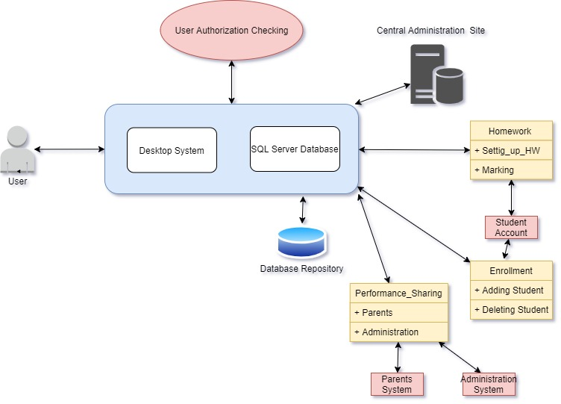

Figure 2 Architecture Design