
IPBeja - Instituto Politécnico de Beja
FACULTY OF TECHNOLOGY AND MANAGEMENT
SOUFIANE ACHOUCH
(Erasmus Student)
T2 ANO LEI S2
Software Engineering

U-bike IPBeja Management Platform

PR. Isabel Sofia Brito

Table of Contents
1. Project Information
2. Development Plan
2.1 Development Model
2.2 Activity Schedule
2.3 CASE Tools
3. Analysis
3.1 Information Gathering
3.2 System Actors
3.3 Functional Requirements
3.4 Non-Functional Requirements
3.5 Requirements Traceability
3.6 Use Case Diagram
UC01 — Register
UC03 — Check Availability
UC04 — Reserve Bicycle
UC06 — Record Trip
UC10 — Manage Fleet
UC12 — Log Maintenance
4. Design
4.1 Architectural Pattern / MVC (Three-Tier)
4.2 Class Diagram
4.3 Sequence Diagrams
4.3.1 Reserve Bicycle
4.3.2 Record Trip
4.4 Activity Diagram
4.5 State Diagram — Bicycle Lifecycle
4.6 Design Patterns
4.6.1 Observer Pattern
4.6.2 Strategy Pattern
4.6.3 Singleton Pattern
5. Innovation
6. Conclusion
References
Appendix A — Use of Generative AI Tools
A.1 Prompts Used
A.2 Verification Actions

1. Project Information
Field | Detail
Course Unit | Software Engineering , Computer Engineering, IPBeja 2025/2026
Project | U-bike IPBeja Management Platform
Goal | Monitor bicycle usage, measure energy efficiency, promote healthy habits
Team | Individual project (1 member)
Author | Soufiane Achouch , Student No. 28638
GitHub URL | SOUFIANEASH/Ubike_Ipbeja

2. Development Plan

2.1 Development Model
The Incremental Development Model was chosen for this project. It divides the system into distinct modules, each developed and validated in sequence. This suits an individual project where complexity must be managed incrementally and requirements may be refined as the system is built.

Increment | Scope
1 | User registration and authentication
2 | Bicycle fleet management and reservations
3 | Trip recording and health / energy indicators
4 | Maintenance, notifications and reports

2.2 Activity Schedule
Activity | Tools | Deadline
Development plan + GitHub URL | Word, GitHub | 30 Apr 2026
Information gathering | Browser, Word | 5 May 2026
Requirements identification | Word, Visual Paradigm | 8 May 2026
Use case diagram + specifications | Visual Paradigm, Word | 12 May 2026
Class diagram | Visual Paradigm | 18 May 2026
Sequence diagrams | Visual Paradigm | 22 May 2026
Activity & state diagrams | Visual Paradigm | 25 May 2026
Design patterns (pseudocode) | Word, Visual Paradigm | 28 May 2026
Final report compilation | Word | Jun 2026
Submission + defence | Moodle | TBC

2.3 CASE Tools
Tool | Purpose | Phase
Visual Paradigm | All UML diagrams | Analysis & Design
GitHub | Version control, issues | All phases
Microsoft Word | Technical report | All phases

3. Analysis

3.1 Information Gathering
Information was gathered through two complementary methods:

Method 1 / Similar Systems Research:
- U-bike IPLeiria (https://www.ipleiria.pt) main functional reference
- U-bike IPBeja (https://www.ipbeja.pt/sas/gaad/U-Bike/) institutional context
- Bika4 (https://bika4.webnode.pt/) soft mobility in academic setting
- Commercial platforms (Lime, Gira Lisboa) UX and feature reference

Method 2 / User Interviews:
- IPBeja Students : primary users: bicycle reservation and trip recording needs
- SAS Staff service managers: fleet management and reporting needs
- Maintenance Technicians : bicycle upkeep and fault tracking

3.2 System Actors
Actor | Type | Description
Student | Primary | Registers, reserves and uses bicycles; views statistics
SAS Manager | Primary | Manages fleet, validates users, views reports
Maintenance Technician | Primary | Records and tracks maintenance interventions
Administrator | Primary | Manages users, permissions and system settings
Email System | External | Sends notifications and confirmations

3.3 Functional Requirements
ID | Requirement | Priority
FR01 | System allows new users (students/staff) to register | High
FR02 | System authenticates users with IPBeja institutional credentials | High
FR03 | Users can check bicycle availability in real time | High
FR04 | Users can reserve a bicycle for a defined period | High
FR05 | Users can cancel an existing reservation | High
FR06 | System records start and end of each trip (check-in / check-out) | High
FR07 | System calculates distance travelled and calories burned per trip | Medium
FR08 | System calculates CO2 saved per trip vs car | Medium
FR09 | Users can view their full usage history | Medium
FR10 | Users can view personal health and environmental statistics | Medium
FR11 | Manager can register and manage the bicycle fleet | High
FR12 | Manager can log maintenance events | High
FR13 | Manager can view fleet usage reports | High
FR14 | System sends reservation confirmation by email | Medium
FR15 | System alerts manager when a bicycle needs maintenance | Medium
FR16 | System shows a leaderboard of most active users | Low
FR17 | Administrator can manage users and permissions | High
FR18 | Users can report a bicycle fault | High

3.4 Non-Functional Requirements
ID | Requirement | Category
NFR01 | System responds to any request in under 2 seconds under normal load | Performance
NFR02 | System maintains 99% uptime (max ~7h downtime/month) | Availability
NFR03 | System supports up to 500 concurrent users | Scalability
NFR04 | All communications encrypted with HTTPS | Security
NFR05 | Passwords stored with bcrypt hashing | Security
NFR06 | System complies with GDPR for personal data | Compliance
NFR07 | Interface is responsive on mobile and desktop | Usability
NFR08 | Interface is intuitive without technical training | Usability
NFR09 | Codebase follows good practices and is documented | Maintainability
NFR10 | Modular architecture to allow future expansion | Maintainability
NFR11 | System available in Portuguese (PT) | Localisation

3.5 Requirements Traceability
The table below maps each functional requirement to its corresponding use case(s), ensuring full coverage and consistency between requirements and design.

FR ID | Requirement (short) | Use Case(s)
FR01 | User registration | UC01
FR02 | User authentication | UC02
FR03 | Check availability | UC03
FR04 | Reserve bicycle | UC04
FR05 | Cancel reservation | UC05
FR06 | Record trip (check-in/out) | UC06
FR07 | Calculate calories | UC06
FR08 | Calculate CO2 saved | UC06
FR09 | View usage history | UC07
FR10 | View personal statistics | UC07
FR11 | Manage fleet | UC10
FR12 | Log maintenance | UC12
FR13 | View fleet reports | UC11
FR14 | Reservation confirmation email | UC04, UC13
FR15 | Maintenance alert | UC12, UC13
FR16 | Leaderboard | UC07
FR17 | Manage users/permissions | UC09
FR18 | Report fault | UC08

3.6 Use Case Diagram
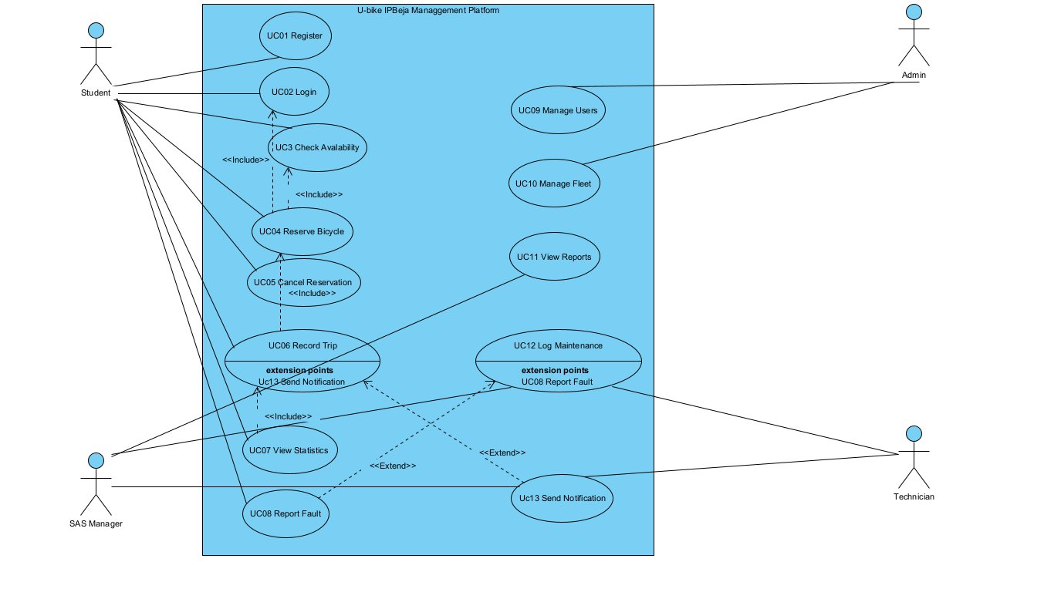
Figure 1 — Use Case Diagram (with include and extend relationships)

3.7 Use Case Specifications
All thirteen use cases were identified (UC01-UC13). Full specifications for the six most critical are provided below.

UC01 / Register
ID | UC01
Primary Actor | Student / Staff
Pre-conditions | User is not yet registered in the system
Post-conditions | New user account created; welcome email sent
Main Flow | 1. User opens registration page 2. Fills in name, email, institutional number, role 3. Submits form 4. System validates data 5. Account created 6. Welcome email sent
Alt. Flow A | 4a. Email already exists / system shows error and asks for different email
Exception | 3a. Required field missing / system highlights field and blocks submission
Priority | High

UC03 / Check Availability
ID | UC03
Primary Actor | Student
Pre-conditions | Student is authenticated
Post-conditions | Student sees real-time list of available bicycles
Main Flow | 1. Student opens availability section 2. Optionally selects date/time 3. System queries database 4. System displays available bicycles with type and location
Alt. Flow A | 3a. No bicycles available — system shows message and suggests other times
Priority | High

UC04 / Reserve Bicycle
ID | UC04
Primary Actor | Student
Pre-conditions | Student is authenticated; at least one bicycle is available
Post-conditions | Bicycle is reserved; confirmation email is sent
Main Flow | 1. Student opens reservations section 2. Checks availability 3. Selects bicycle 4. Sets date/time and duration 5. Confirms 6. System saves and sends confirmation email
Alt. Flow A | 3a. No bicycle available — system informs user and suggests other time slots
Exception | 5a. Communication error — system shows error message, invites retry
Priority | High

UC06 / Record Trip
ID | UC06
Primary Actor | Student
Pre-conditions | Student has an active reservation and is authenticated
Post-conditions | Trip saved with distance, calories and CO2 indicators; statistics updated
Main Flow | 1. Student checks in when picking up bicycle 2. System records start time 3. Student rides 4. Student checks out on return 5. System calculates distance, calories, CO2 6. System updates statistics and leaderboard
Alt. Flow | 4a. Student exceeds reservation time — system sends overdue notification to student and manager
Priority | High

UC10 / Manage Fleet
ID | UC10
Primary Actor | SAS Manager
Pre-conditions | Manager is authenticated with manager-level permissions
Post-conditions | Fleet record updated in the system
Main Flow | 1. Manager opens fleet management section 2. Chooses action: add / edit / remove 3. Enters bicycle details (code, type, location) 4. Confirms 5. System saves updated record
Alt. Flow | 3a. Bicycle code already exists — system warns manager and requests unique code
Priority | High

UC12 / Log Maintenance
ID | UC12
Primary Actor | Maintenance Technician
Pre-conditions | Technician is authenticated; bicycle exists in system
Post-conditions | Maintenance event saved; bicycle status updated
Main Flow | 1. Technician opens maintenance section 2. Selects bicycle by code 3. Selects maintenance type (routine / repair / fault) 4. Adds description and date 5. Confirms 6. System saves event and updates bicycle status
Alt. Flow | 4a. Bicycle in active reservation — system warns technician and flags conflict
Priority | High

4. Design

4.1 Architectural Pattern MVC (Three-Tier)
The MVC (Model-View-Controller) pattern combined with a three-tier architecture was adopted:
- Presentation Layer (View): Responsive web interface + admin dashboard
- Business Logic Layer (Controller/Service): Reservations, indicator calculation, notifications
- Data Layer (Model/Repository): Relational database access, domain entities

Justifications:
- Clear separation of responsibilities easier to maintain and test each layer independently
- Each layer can be scaled independently (e.g. add a caching layer without touching the UI)
- Supports future REST API for a native mobile application

4.2 Class Diagram
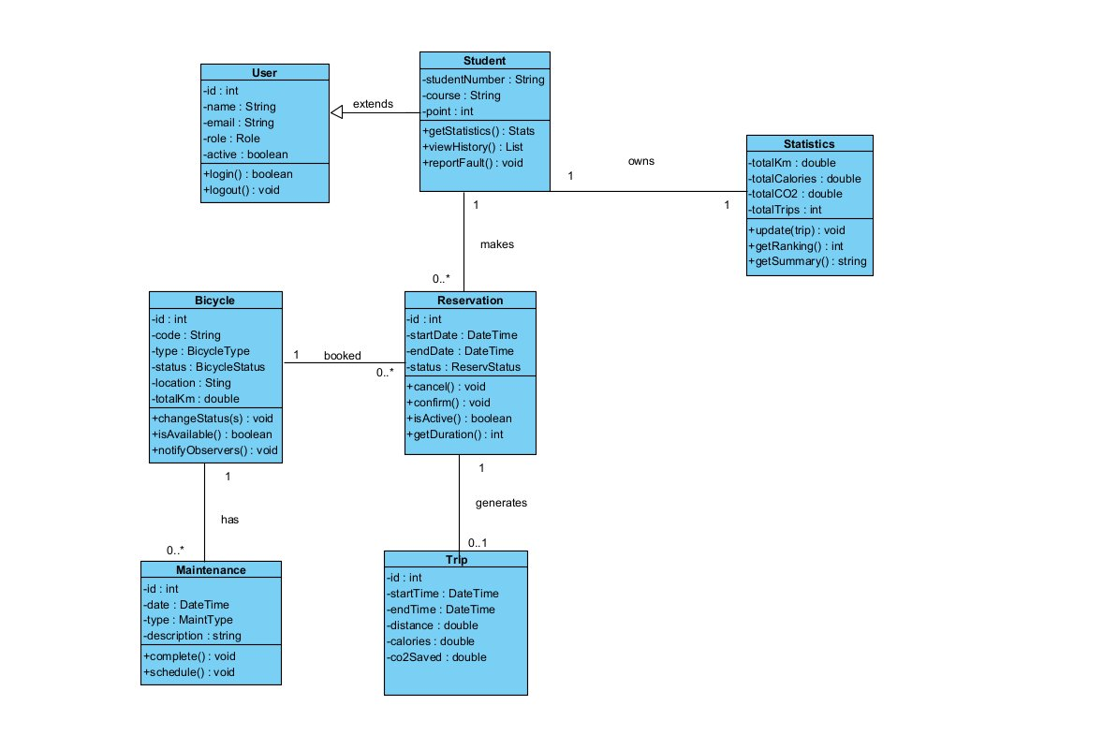
Figure 2 — Class Diagram
Class | Key Attributes | Role
User | id, name, email, password, role, active | Base class for all system users
Student | studentNumber, course, points | Extends User / bicycle user
Bicycle | id, code, type, status, location, totalKm | Central entity / one physical bicycle
Reservation | id, startDate, endDate, status | Links student to bicycle for a time slot
Trip | id, startTime, endTime, distance, calories, co2Saved | Records one actual trip
Maintenance | id, date, type, description, technician | Records a maintenance event
Statistics | totalKm, totalCalories, totalCO2, totalTrips | Aggregated stats per student

4.3 Sequence Diagrams

4.3.1 Reserve Bicycle
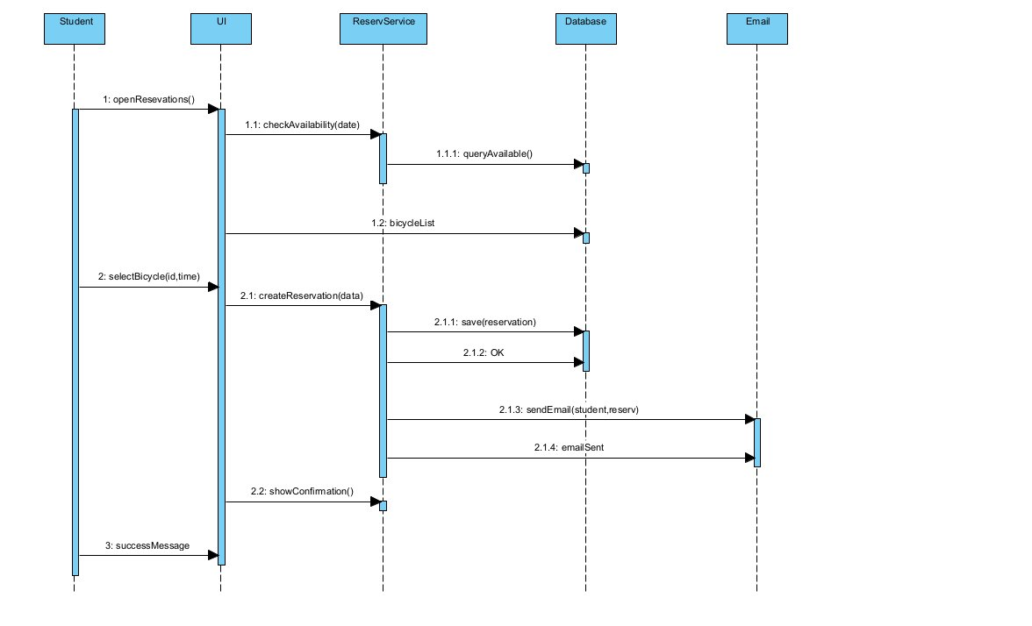
Figure 3 — Sequence Diagram: Reserve Bicycle

4.3.2 Record Trip
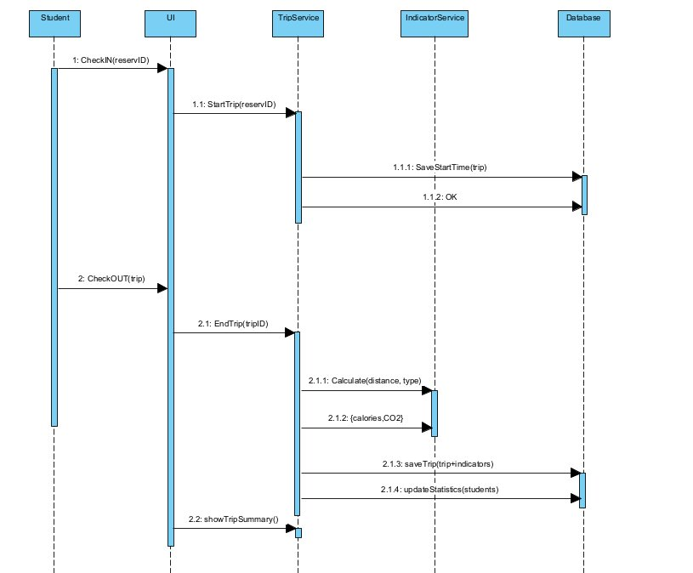
Figure 4 — Sequence Diagram: Record Trip

4.4 Activity Diagram
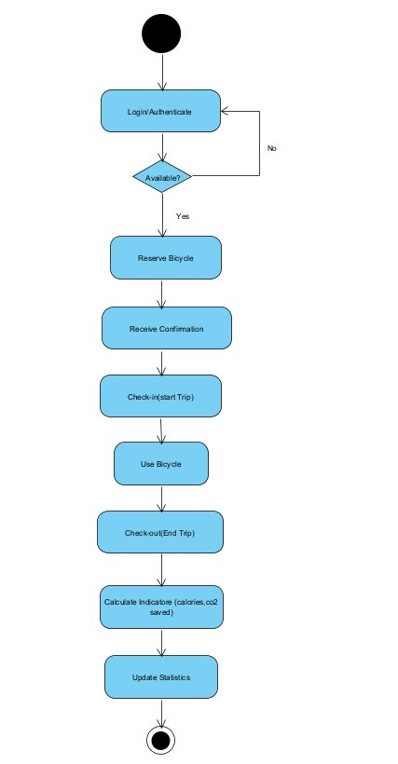
Figure 5 — Activity Diagram: Full Trip Flow

4.5 State Diagram / Bicycle Lifecycle
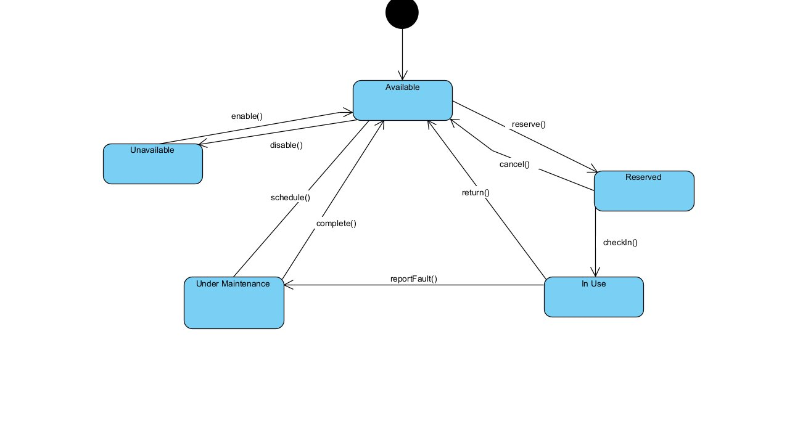
Figure 6 — State Diagram: Bicycle
State | Description | Transitions
Available | Ready to be reserved or used | → Reserved, → Under Maintenance, → Unavailable
Reserved | Active reservation, not yet collected | → In Use, → Available (cancel)
In Use | Currently being used by a student | → Available (return), → Under Maintenance (fault)
Under Maintenance | Being serviced by technician | → Available (after maintenance)
Unavailable | Temporarily out of service | → Available, → Under Maintenance

4.6 Design Patterns

4.6.1 Observer Pattern
Applied to: Bicycle status changes notify multiple services automatically.
Why: When a bicycle changes state, multiple components must react without tight coupling. The Observer pattern decouples the subject (BicycleService) from its dependents (NotificationObserver, StatisticsObserver).

interface Observer { void update(Bicycle bicycle, String newStatus); }

class NotificationObserver implements Observer {
void update(Bicycle b, String status) {
if (status.equals("Under Maintenance"))
sendEmailToManager("Bicycle " + b.getCode() + " needs maintenance.");
}
}

class BicycleService {
List<Observer> observers = new ArrayList<>();
void addObserver(Observer o) { observers.add(o); }
void changeStatus(Bicycle b, String status) {
b.setStatus(status);
for (Observer o : observers) o.update(b, status);
}
}

4.6.2 Strategy Pattern
Applied to: Indicator calculation (calories, CO2) varies by bicycle type.
Why: Electric and manual bicycles require different algorithms. Strategy allows the calculation method to be selected at runtime without changing the caller.

interface IndicatorCalculation {
double calculateCalories(double distance);
double calculateCO2(double distance);
}

class ManualBicycle implements IndicatorCalculation {
double calculateCalories(double d) { return d * 40; } // 40 kcal/km
double calculateCO2(double d) { return d * 0.21; }
}

class ElectricBicycle implements IndicatorCalculation {
double calculateCalories(double d) { return d * 20; }
double calculateCO2(double d) { return d * 0.16; }
}

class IndicatorService {
IndicatorCalculation strategy;
void setStrategy(IndicatorCalculation s) { this.strategy = s; }
double getCalories(double d) { return strategy.calculateCalories(d); }
}

4.6.3 Singleton Pattern
Applied to: Database connection only one instance should exist across the application.
Why: Prevents multiple unnecessary database connections and resource waste; ensures consistency of connection state.

class DatabaseManager {
private static DatabaseManager instance = null;
private Connection connection;

private DatabaseManager() {
connection = createConnection("jdbc:mysql://localhost/ubike");
}
public static DatabaseManager getInstance() {
if (instance == null) instance = new DatabaseManager();
return instance;
}
public Connection getConnection() { return connection; }
}

6. Innovation
This platform goes beyond basic bike-sharing management in the following innovative ways:

- Dual health and environmental indicators: each trip automatically calculates calories burned and CO2 saved compared to an equivalent car journey, directly supporting the project goals of energy efficiency and healthy habits.
- Gamification through a leaderboard (FR16): students earn points per km ridden, displayed on a public leaderboard. This incentivises consistent bicycle use and friendly competition within the academic community.
- Smart maintenance alerts: the Observer pattern drives automatic notifications to the SAS Manager when a bicycle is reported faulty or exceeds a usage threshold, reducing downtime without manual monitoring.
- GDPR-compliant data model: personal data and trip data are explicitly separated in the class model; users can request data deletion, supporting legal compliance from the design phase.
- Modular architecture for extensibility: the three-tier MVC structure and Strategy pattern for indicator calculation allow future expansion for example, adding GPS sensors or new bicycle types (cargo, adaptive) without changing existing code.7.

7. Conclusion

This report presents the analysis and design of the U-bike IPBeja Management Platform, developed individually for the Software Engineering course at IPBeja 2025/2026.
The project adopted an Incremental Development Model across four modules, covering user management, reservations, trip recording and maintenance. Eighteen functional and eleven non-functional requirements were identified and traced to thirteen use cases, with six fully specified using the standard template.
The design follows an MVC three-tier architecture, supported by a complete UML model and three design patterns Observer, Strategy and Singleton. The platform adds innovative features including automatic CO2 and calorie indicators, a student leaderboard and smart maintenance alerts.
Future work includes a mobile app with GPS tracking and an expanded gamification system.

References
[1] U-bike IPBeja — https://www.ipbeja.pt/sas/gaad/U-Bike/Paginas/ComoFunciona.aspx
[2] U-bike IPLeiria — https://www.ipleiria.pt/arquivo/candidaturas-u-bike-ate-11-de-novembro/
[3] Bika4 — https://bika4.webnode.pt/
[4] Portal Alentejano — https://www.portalalentejano.com/projeto-u-bike-ipbeja/
[5] Gamma, E., Helm, R., Johnson, R., Vlissides, J. (1994). Design Patterns: Elements of Reusable Object-Oriented Software. Addison-Wesley.
[6] Sommerville, I. (2016). Software Engineering, 10th ed. Pearson.
[7] Larman, C. (2004). Applying UML and Patterns, 3rd ed. Prentice Hall.
[8] OMG. (2017). Unified Modeling Language Specification Version 2.5.1. Object Management Group.

Appendix A Use of Generative AI Tools
Tool used: ChatGPT

A.1 Prompts Used

"Generate functional requirements for a university bicycle management system."

"Create non-functional requirements for a web-based bicycle reservation platform."

"Provide a use case specification for reserving a bicycle."

"Suggest UML class diagram entities for a bike-sharing management system."

"Explain how the Observer, Strategy, and Singleton design patterns can be applied in a software engineering project."

"Improve the academic writing and grammar of this report section."

A.2 Verification Actions

- Reviewed and edited all generated content to ensure consistency with the project requirements.
- Compared functional and non-functional requirements with course materials and software engineering principles.
- Validated UML diagrams and use case descriptions using Visual Paradigm.
- Checked design pattern implementations against references from software engineering textbooks, including the work of and colleagues.
- Confirmed that all project-specific information, diagrams, and conclusions accurately reflected the designed U-bike IPBeja Management Platform.
- Corrected any inaccuracies and adapted generated suggestions to fit the project scope and academic standards.

