⚙ [**Stock-Market-Trend-Predictor**](https://github.com/SOUHAM23/Stock-Market-Trend-Predictor-using-Python-ML)⚙

**By Machine Learning**

Project Report

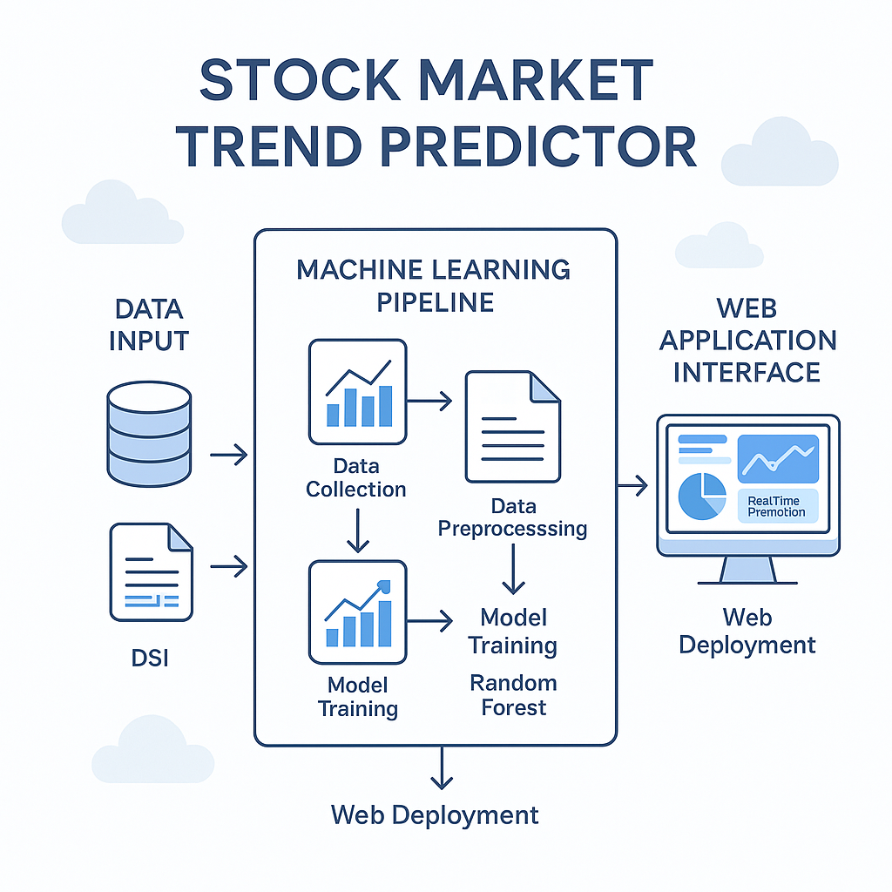

**CERTIFICATION**

This is to certify that the dissertation/project report entitled **“**[**Stock-Market-Trend-Predictor**](https://github.com/SOUHAM23/Stock-Market-Trend-Predictor-using-Python-ML)**”** has been carried out solely by me as an authentic piece of work for the partial fulfilment of the requirements for the award of the Diploma in **Computer Science and Technology (CST)** degree under the guidance of **Raihan Mistry Sir**. I hereby declare that I am fully aware of the guidelines stated in the “Diploma CST Project Report.”

**A Project Report**

**Submitted By**

**Name: Souham Dutta**

**Roll No: DJSPCSTS3**

**Registration Number: D232432668**

**ACKNOWLEDGEMENT**

I would like to express my deepest gratitude to my mentors, colleagues, and family for their unwavering support, encouragement, and guidance during the development of this project. Their valuable insights and constructive feedback have been essential in achieving the objectives of this project.

**INDEX**

|  |  |  |
| --- | --- | --- |
| **SL NO.** | **Table of Contents** | **PAGE NO.** |
| 1. | Scope of the Project | 1 |
| 2. | Abstract | 2 |
| 3. | Introduction | 3 |
| 4. | Literature Survey | 4 |
| 5. | Data Set & Importing Libraries | 5 |
| 6. | Data Analysis | 6-9 |
| 6.1 | Model Implementation & Training | 10 |
| 6.2 | Web Application & Interface | 11 |
| 6.3 | Deployment | 12-13 |
| 6.4 | Conclusion | 14 |
| 7. | References | 15 |

**SCOPE OF PROJECT**

The **Stock Market Trend Predictor** project is designed to forecast market movements by classifying trends as Bullish, Bearish, or Stable based on historical market data and technical indicators. The project aims to provide:

* **Real-Time Predictions:** An interactive tool that dynamically predicts stock market trends.
* **Machine Learning Integration:** Utilization of Python-based machine learning libraries for feature extraction, model training, and prediction.
* **Web Interface:** A user-friendly Django web application for inputting data and visualizing prediction outcomes.

* **Deployment Ready:** A modular structure that supports cloud deployment ensuring scalability and ease of maintenance.

**ABSTRACT**

The Stock Market Trend Predictor leverages historical market data and technical indicators to forecast future market trends with the classification of Bullish, Bearish, or Stable conditions. The project uses a combination of data pre-processing, feature engineering, and machine learning algorithms (such as Random Forest) implemented using Python’s scikit-learn library. The trained model is integrated into a Django web application that not only provides interactive predictions but also visualizes key metrics and trend analyses in real time. This approach aids investors and analysts in making informed decisions based on dynamic market conditions. The document details each stage of the project—from initial data analysis to deployment—ensuring the system is robust, maintainable, and ready for production use.

**INTRODUCTION**

In today’s volatile financial markets, predicting stock market trends is essential for minimizing risk and capitalizing on emerging opportunities. Traditional analytical methods have been supplemented by machine learning techniques that can capture complex patterns in historical data. The “**Stock Market Trend Predictor”** project addresses this challenge by:

* **Combining Multiple Data Sources:** Using historical price data, moving averages, volume, and other technical indicators.
* **Implementing Advanced Algorithms:** Applying classification algorithms that categorize market conditions as Bullish, Bearish, or Stable.
* **Providing an End-to-End Solution:** From data ingestion and model training to a real-time web-based interface for predictions.

By offering a comprehensive tool that automates market trend predictions, this project intends to assist financial analysts, traders, and investors in making data-driven decisions.

**LITERATURE SURVEY**

Extensive research has been carried out in the field of financial time-series analysis and stock trend prediction. The literature highlights:

* **Technical Analysis Methods:** Studies that explain the efficacy of technical indicators like Moving Averages, RSI, and MACD in predicting market behavior.
* **Machine Learning Applications:** Research demonstrating the advantages of ensemble methods (e.g., Random Forest) over traditional statistical models for financial forecasting.
* **Integration of ML with Web Technologies:** Various projects that illustrate how the synergy between machine learning and modern web frameworks (like Django) facilitates real-time predictions and interactive visualizations.

The insights gathered from these studies have shaped the design of this project, guiding the selection of features, pre-processing strategies, and model parameters.

**DATA SET & IMPORTING LIBRARIES**

### Data Set

The project uses historical stock market data which can include:

* **Price Metrics:** Open, High, Low, and Close values.
* **Volume Data:** Trading volumes for each time period.
* **Technical Indicators:** Derived features such as moving averages, relative strength index (RSI), and others.

Note: Ensure you update the data source path or API details as required.

### Importing Libraries

Key Python libraries used in the project:

* **NumPy:** For numerical operations and array handling.
* **Pandas:** To process and analyze structured data.
* **Matplotlib/Seaborn:** For visualizing data patterns and trends.
* **Scikit-learn:** For implementing and training machine learning algorithms.
* **Joblib:** For model serialization (saving and loading trained models).
* **Django:** To develop the web application interface for real-time predictions.

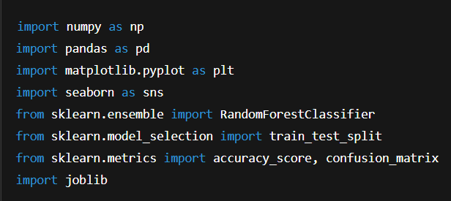Example of importing libraries

Fig.1 Examples of imported liberies

## **Data Analysis**

Data analysis is vital for uncovering underlying patterns in historical stock data and selecting the most relevant features for the predictive model. The visualizations below provide insights into key aspects of the data:

### **1. Stock Price Trend Analysis**

Observation:  
This chart illustrates the time-series behaviour of stock closing prices. The visualization helps identify long-term trends, sudden fluctuations, and cyclical patterns. Insights from this analysis guide further feature engineering—for instance, by suggesting moving average windows to capture momentum.

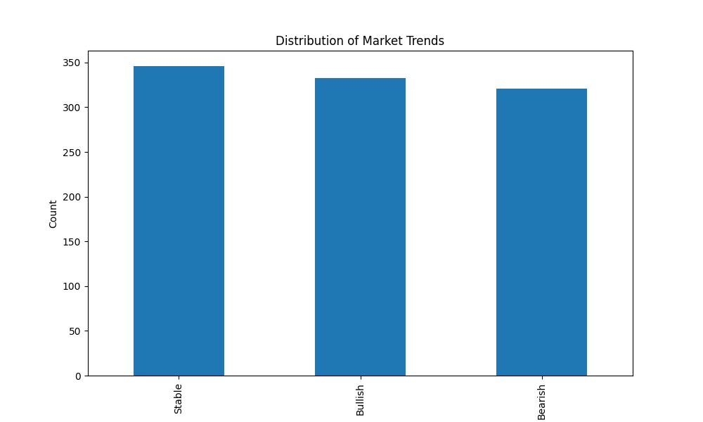

Fig.2 Distribution of Market Trend

### **2. Correlation Heat map**

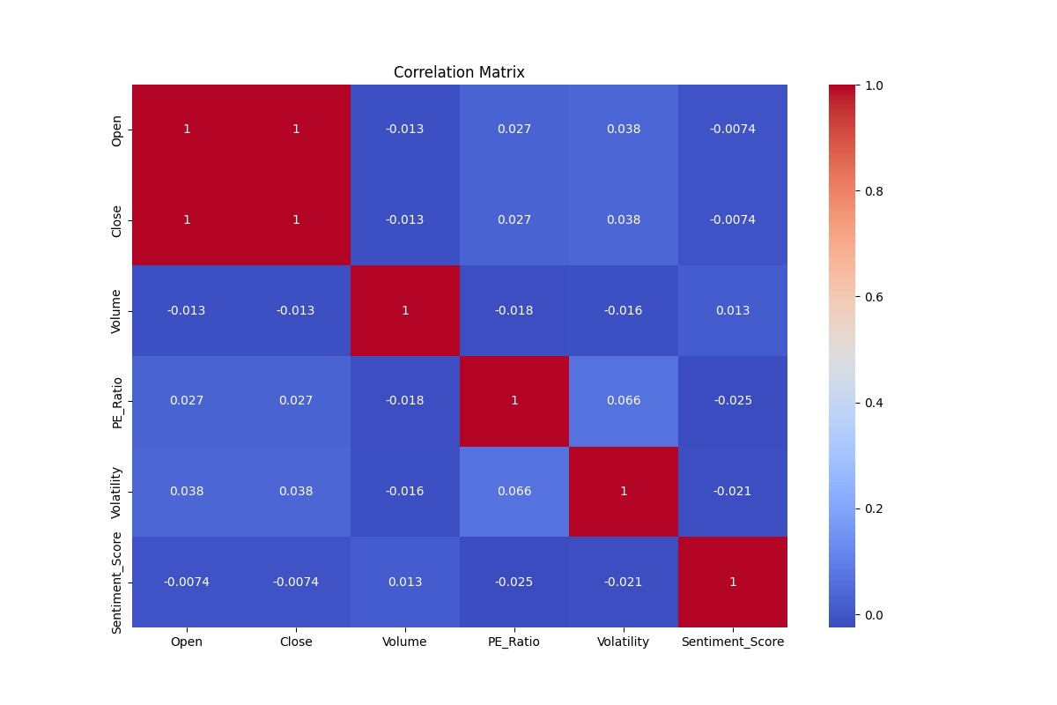Observation:  
The correlation heat map highlights the relationships between multiple market indicators. Strong correlations indicate redundant information, while lower correlations suggest unique contributions to the prediction of market trends. This analysis assists in determining which features to retain or discard before model training.

Fig.3 Heat Map

### 3. Feature Importance Plot

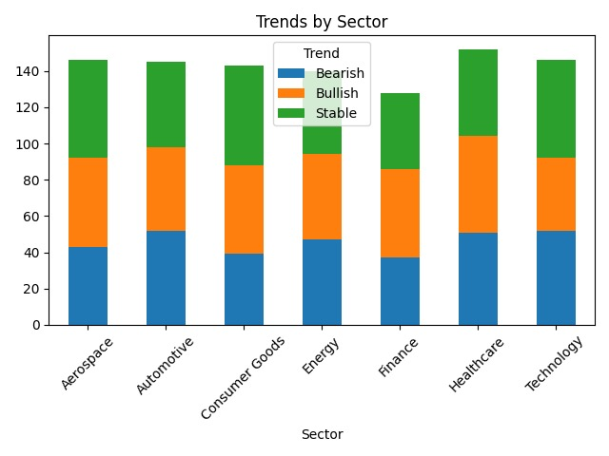Observation:  
The feature importance plot shows the relative impact of various features on the predictive model. Features with higher importance scores are critical for forecasting trends, and this insight is used to fine-tune both the model and subsequent feature engineering processes. It may also highlight areas where additional data could strengthen the model performance.

Fig.4 Trends by Sector

### 4. Trading Volume Distribution

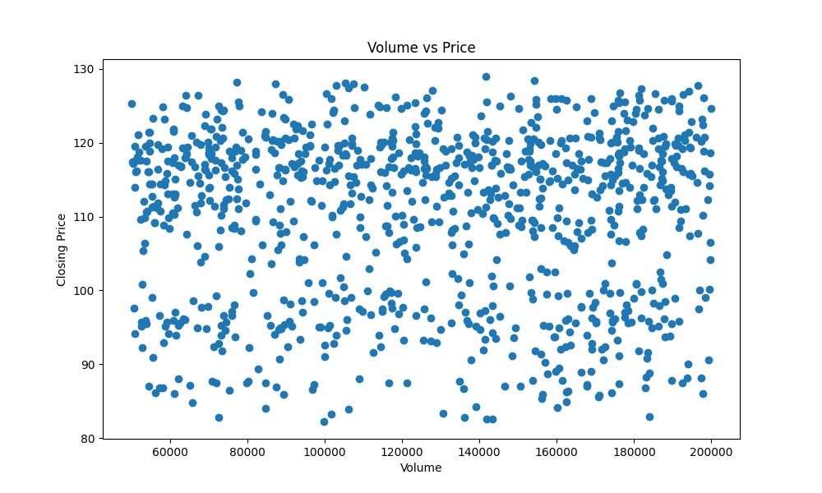Observation:  
This histogram displays the distribution of trading volumes over time. Analyzing volume distribution is key to understanding market liquidity and investor behavior. Outliers or skewed distributions can indicate periods of high market activity, which may coincide with significant trend shifts.

Fig.5 Examples of Volume Distribution

## **Model Implementation & Training**

### Model Implementation

The model implementation involves:

1. **Data Pre-processing:** Cleaning data, handling missing values, and normalizing numerical features.
2. **Feature Engineering:** Creating technical indicators from raw data.
3. **Model Selection:** Choosing the Random Forest classifier due to its robustness in handling non-linear data distributions.
4. **Training and Evaluation:** Splitting the dataset into training and test sets, training the model, and evaluating performance using metrics like accuracy, precision, recall, and F1-score.
5. **Serialization:** Saving the trained model (market_model.pkl) and scaler (scaler.pkl) using joblib for later use in the web application.

Example snippet for training:

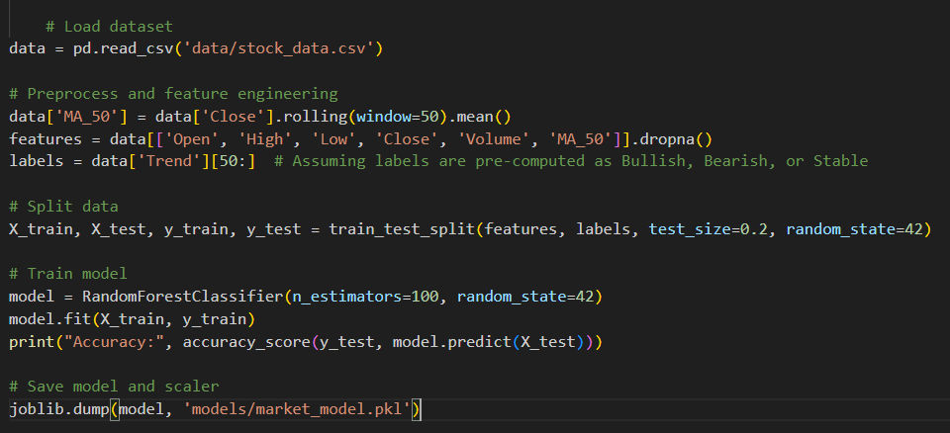Fig.6 Example of snippet for training

## **Web Application & Interface**

The web application is developed using Django and offers an interactive interface for:

* **User Inputs:** A form for users to enter market data.
* **Real-Time Prediction:** The integrated machine learning model processes inputs and returns market trend predictions.
* **Visual Feedback:** Dynamic charts display prediction analytics and probability distributions.
* **Responsive Design:** Frontend components are built using HTML and CSS (with optional Tailwind CSS enhancements) to ensure the application works well on multiple devices.

The project structure is organized to clearly separate business logic, templates, and static files, ensuring maintainability.

## **Deployment**

Deploying the Stock Market Trend Predictor involves setting up the environment, running migrations, and ensuring that the model is properly integrated with the Django application. Follow these steps:

### Deployment Steps

1. 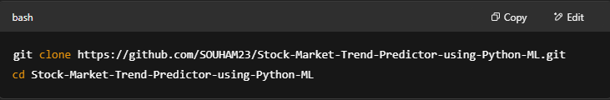**Clone the Repository**
2. **Set Up Virtual Environment**

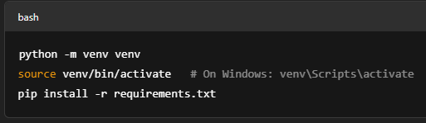

1. **Model Preparation**

Ensure your trained model and scaler files (market_model.pkl and scaler.pkl) are present in the designated models folder.

1. **Django Configuration**

* Update the settings.py to configure the database, static file paths, and allowed hosts (e.g., add your domain or server IP).
* Configure environment-specific variables such as the SECRET_KEY and DEBUG settings.

5. **Migrations and Static Files**

Run database migrations and collect static assets:

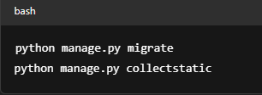

1. **Launch the Application**

Start the Django server using a production-ready command (e.g., via Gunicorn or your cloud provider's deployment commands):

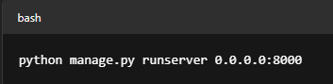

1. **Access the Application**
   1. **Web Interface:** Visit http://<your-domain-or-ip>:8000 in your browser.
   2. **Admin Panel:** Visit http://<your-domain-or-ip>:8000/admin for administrative access.

### **Deployment Environment**

For production deployments, consider cloud platforms such as:

* **Heroku**
* **PythonAnywhere**
* **AWS Elastic Beanstalk**

Ensure proper logging, security configurations, and environment settings are applied as per your selected provider’s guidelines.

## **Conclusion**

The Stock Market Trend Predictor project demonstrates a full-cycle machine learning application that combines advanced data analysis with an interactive web interface. By classifying market trends in real time, the project assists traders and financial analysts in making informed decisions. The modular design, scalable deployment architecture, and robust machine learning integration pave the way for future enhancements and broader applications in financial forecasting.

## References

* GitHub Repository: [SOUHAM23/Stock-Market-Trend-Predictor-using-Python-ML](https://github.com/SOUHAM23/Stock-Market-Trend-Predictor-using-Python-ML.git)
* Scikit-learn Documentation: [Random Forest Classifier](https://scikit-learn.org/stable/modules/generated/sklearn.ensemble.RandomForestClassifier.html)
* Django Documentation: [Django Web Framework](https://docs.djangoproject.com/)
* Additional deployment and cloud integration guides as applicable.