
An Internship Report
on
AI DEPLOYMENT & AUTOMATION
AICTE – EduSkills Virtual Internship Program (8 Weeks)
Submitted in partial fulfilment of the requirements for the award of the degree of
Bachelor of Technology
in Cloud Computing
Submitted by
Soumoya Majumdar
Enrollment No.: 2410031597
B.Tech Cloud Computing, 5th Semester
Internship Organization
EduSkills Foundation (under the patronage of AICTE)
IILM UNIVERSITY, GREATER NOIDA
Session 2026–27

DECLARATION
I, Soumoya Majumdar, a student of B.Tech Cloud Computing (5th Semester), Enrollment No. 2410031597, IILM University, Greater Noida, hereby declare that this internship report titled “AI Deployment & Automation” is a record of the work I did during the AICTE – EduSkills Virtual Internship Program from August 2026 to October 2026.
Everything written here is based on my own learning and the assignments and project I completed during the internship. This report has not been submitted to any other university or institution for the award of any degree or diploma.
Place: Greater Noida
Date:
(Signature)
Soumoya Majumdar
Enrollment No.: 2410031597

CERTIFICATE
This is to certify that the internship report titled “AI Deployment & Automation”, submitted by Soumoya Majumdar (Enrollment No. 2410031597), B.Tech Cloud Computing, 5th Semester, is a bonafide record of the internship carried out under the AICTE – EduSkills Virtual Internship Program between August 2026 and October 2026.
The report is submitted in partial fulfilment of the requirements for the award of the degree of Bachelor of Technology at IILM University, Greater Noida.

ACKNOWLEDGEMENT
I’d like to thank EduSkills Foundation and AICTE for running this virtual internship and giving students like me a structured way to learn skills that are actually used in the industry. Special thanks to Mr. Bibek Ranjan, Director, EduSkills, and the whole team behind the course content and assessments.
I’m grateful to my faculty guide for their support and for helping me stay on track, and to the Head of the Department for encouraging us to take up internships like this one.
I also want to thank IILM University, Greater Noida, for making internships a part of our curriculum, and my friends and family for putting up with me during the weeks when a Docker build just would not work.
Soumoya Majumdar

ABSTRACT
Most machine learning courses stop once a model is trained and shows good accuracy. In the real world, that is only half the job. The model still has to be put behind an API, packaged, deployed somewhere it can scale, and watched so that someone notices when it starts giving bad results. This area is usually called MLOps, and it is what this internship was about.
This report covers my 8-week AICTE – EduSkills Virtual Internship in AI Deployment & Automation (August–October 2026). Each week focused on one part of the deployment process: serving models with FastAPI, containerizing with Docker and setting up CI/CD, deploying on cloud platforms such as Amazon SageMaker, Google Vertex AI and Azure ML, building AI agents with LangChain, LlamaIndex and LangGraph, securing AI systems, orchestrating with Kubernetes, monitoring with Prometheus and Grafana, and detecting model drift with Evidently AI.
The internship ended with a capstone project: a Retrieval-Augmented Generation (RAG) application with a FastAPI backend and a simple frontend, packaged in Docker, deployed through a CI/CD pipeline and monitored in production. The report explains what I learned each week, how the capstone was put together, the problems I ran into, and how this experience connects to my B.Tech specialisation in Cloud Computing.
Keywords: MLOps, FastAPI, Docker, CI/CD, Kubernetes, Cloud AI, RAG, AI Agents, Model Monitoring

TABLE OF CONTENTS
Declaration i
Certificate ii
Acknowledgement iii
Abstract iv
1. Introduction 1
1.1 Background 1
1.2 Internship Details 1
1.3 Scope of the Report 1
2. About the Organization 2
2.1 EduSkills Foundation 2
2.2 AICTE and the National Internship Portal 2
2.3 How the Program Works 2
3. Objectives of the Internship 3
4. Week-wise Work Done 4
4.1 Week 1: AI Deployment Foundations & FastAPI Model Serving 4
4.2 Week 2: Containerization & CI/CD for MLOps 4
4.3 Week 3: Cloud AI Deployment & Generative AI Serving 5
4.4 Week 4: AI Agents & Automation Workflows 5
4.5 Week 5: AI Integration, Security & Compliance 5
4.6 Week 6: Kubernetes & Observability in Production AI 5
4.7 Week 7: Performance Optimization, Drift & Advanced RAG 6
4.8 Week 8: Applied AI Projects & Capstone 6
5. Capstone Project 7
5.1 Problem Statement 7
5.2 System Architecture 7
5.3 How It Works 7
5.4 Closing the Loop 8
5.5 Outcome 8
6. Tools and Technologies Used 9
7. Learning Outcomes 10
7.1 Technical Skills 10
7.2 Professional Skills 10
7.3 Relevance to My Degree 10
8. Challenges Faced 11
9. Conclusion and Future Scope 12
9.1 Conclusion 12
9.2 Future Scope 12
References 13
Appendix 14

1. Introduction

1.1 Background
Over the last few years, AI has moved out of research labs and into everyday products such as chatbots, recommendation systems and document search. Companies no longer just need people who can train models; they need people who can get those models running reliably, cheaply and safely. That gap between a working notebook and a working product is where most AI projects struggle.
As a Cloud Computing student, I was already learning about virtual machines, containers and cloud services. What I didn’t have was a clear picture of how all of that connects to machine learning. This internship seemed like the right way to fill that gap.

1.2 Internship Details
Particular | Details
Student Name | Soumoya Majumdar
Enrollment Number | 2410031597
Program & Semester | B.Tech Cloud Computing, 5th Semester
Institute | IILM University, Greater Noida
Organization | EduSkills Foundation
Program | AICTE – EduSkills Virtual Internship Program
Internship Domain | AI Deployment & Automation
Duration | August 2026 – October 2026 (8 weeks)
Mode | Virtual (online, self-paced with weekly deadlines)
AICTE Student ID | STU6a02cf6813a201778569064
Offer Letter Ref. No. | C18Y2026M091567121
Stipend | None
Table 1.1: Internship details

1.3 Scope of the Report
This report covers the organization (Chapter 2), my objectives (Chapter 3), the week-by-week work (Chapter 4), the capstone project (Chapter 5), the tools I used (Chapter 6), what I learned (Chapter 7), the difficulties I faced (Chapter 8), and my conclusions and plans (Chapter 9).

2. About the Organization

2.1 EduSkills Foundation
EduSkills Foundation is a non-profit organization that works with AICTE (All India Council for Technical Education) to run industry-oriented virtual internships for engineering students across India. Its tagline is “Nation Building Through Skills”, and the idea is to give students practical exposure that regular coursework often doesn’t cover.
The internship programs are designed with technology companies, so the content follows tools and practices that are used in real jobs. The organization is ISO-certified and has been recognised as a Great Place To Work.

2.2 AICTE and the National Internship Portal
The program runs under the patronage of AICTE and is listed on the AICTE National Internship Portal, which is where I applied. Each student gets an AICTE Student ID, and after successfully completing the program, a Virtual Internship Certificate is issued that can be verified online.

2.3 How the Program Works
The internship is fully online. Every week a new module is opened with video lessons, reading material and hands-on labs. At the end of each week there is an assessment, some modules require assignments and project documentation, and there is a final assessment test in the last week. The final grade depends on overall performance across all of these.

3. Objectives of the Internship
Going in, these were the things I wanted to be able to do by the end:
- Put a model behind an API: turn a trained model into a service that other applications can call, using FastAPI.
- Package and automate deployments: use Docker so the app runs the same everywhere, and set up CI/CD so deployments happen automatically.
- Use the cloud properly for AI: understand how managed platforms such as SageMaker, Vertex AI and Azure ML host models. This ties in directly with my Cloud Computing specialisation.
- Understand AI agents and RAG: learn how tools such as LangChain, LlamaIndex and LangGraph are used to build agents and question-answering systems over documents.
- Monitor models after deployment: learn how to tell when a live model is slowing down, failing or drifting, using Prometheus, Grafana and Evidently AI.
- Think about security and fairness: understand the risks that come with AI systems, from prompt injection to biased outputs.

4. Week-wise Work Done
The internship followed a fixed week-by-week plan. Table 4.1 gives a summary, and the sections after it describe what I did in each week.
Week | Module | Main Topics
1 | AI Deployment Foundations & FastAPI Model Serving | AI lifecycle, production readiness, MLOps terms, environment setup, FastAPI, async APIs
2 | Containerization & CI/CD for MLOps | Docker architecture, Dockerfiles, networking, volumes, MLOps principles, CI/CD pipelines
3 | Cloud AI Deployment & Generative AI Serving | SageMaker, Vertex AI, Azure ML, LLM challenges, vLLM, quantization
4 | AI Agents & Automation Workflows | LangChain, LlamaIndex, LangGraph, hyper-automation
5 | AI Integration, Security & Compliance | Streamlit, Gradio, AI security threats, privacy, bias mitigation
6 | Kubernetes & Observability in Production AI | Pods, Deployments, Services, Prometheus, Grafana
7 | Performance Optimization, Drift & Advanced RAG | Performance tuning, cost optimization, Evidently AI, retraining, vector databases
8 | Applied AI Projects & Capstone | E-commerce and healthcare case studies, full-stack RAG app, business automation agent
Table 4.1: Week-wise structure of the internship

4.1 Week 1: AI Deployment Foundations & FastAPI Model Serving
The first week started with the big picture: what happens to a model after it is trained, and what “production-ready” actually means. I learned the common MLOps vocabulary (model registry, serving, inference, versioning) and set up my development environment.
The hands-on part was building a REST API with FastAPI that loads a trained model and returns predictions. I liked how FastAPI automatically generates interactive documentation, which made testing much easier. I also made the endpoints asynchronous so that the service could handle several requests at once instead of one after another.

4.2 Week 2: Containerization & CI/CD for MLOps
This week was about making the Week 1 API portable. I learned how Docker works (images, containers, layers, networking and volumes) and wrote a Dockerfile to package my FastAPI service. For the first time, the “it works on my machine” problem made sense, because the container carries everything the app needs.
I then set up a basic CI/CD pipeline that runs tests and builds the Docker image every time code is pushed. The module also covered core MLOps principles, especially why data and models need versioning just like code.

4.3 Week 3: Cloud AI Deployment & Generative AI Serving
This was the week I was most looking forward to, given my specialisation. The module compared the three major managed ML platforms: Amazon SageMaker, Google Vertex AI and Azure Machine Learning. They all solve the same problem, which is hosting and scaling a model without managing servers yourself, but differ in setup and pricing.
The second half moved to large language models. I learned why LLMs are harder to deploy than regular models (they are big, slow and expensive, and can produce confident but wrong answers), how vLLM speeds up LLM serving, and how quantization reduces a model’s memory use so it can run on smaller hardware.

4.4 Week 4: AI Agents & Automation Workflows
In Week 4 I built simple AI agents using LangChain and LlamaIndex. An agent is an LLM that can decide which tool to use (for example, a search function or a calculator) instead of only producing text. With LangGraph I connected several steps into a workflow where the output of one step feeds into the next.
The module also discussed hyper-automation, where these agents take over repetitive business tasks such as sorting emails or summarising documents.

4.5 Week 5: AI Integration, Security & Compliance
This week covered two different things. First, building quick front-ends for AI models with Streamlit and Gradio, which let you put together a working demo in a few lines of Python. Second, the risks: attacks like prompt injection and data leakage, how to handle user data privately, and how to detect and reduce bias in model outputs. This part changed how I think about AI. A model that is accurate but unsafe or unfair is not ready for users.

4.6 Week 6: Kubernetes & Observability in Production AI
Week 6 built on Docker by introducing Kubernetes for running containers at scale. I worked with Pods, Deployments and Services, and saw how Kubernetes can run multiple copies of the API and restart them if they crash.
For observability, I used Prometheus to collect metrics such as request count, latency and error rate, and Grafana to show them on a dashboard. Seeing live graphs of my own service was one of the more satisfying moments of the internship.

4.7 Week 7: Performance Optimization, Drift & Advanced RAG
This module was about keeping a deployed model healthy over time. It covered performance tuning and ways to keep cloud costs under control. The key new idea was drift: the real-world data a model sees slowly changes, and its performance drops without any code changing. I used Evidently AI to detect drift and looked at strategies for deciding when to retrain.
The week also went deeper into Retrieval-Augmented Generation (RAG), including vector databases and LlamaIndex agents, which set things up for the capstone.

4.8 Week 8: Applied AI Projects & Capstone
The final week started with case studies from e-commerce and healthcare, showing how the same deployment ideas apply in very different industries. Most of the week went into the capstone project, described in Chapter 5, followed by the final assessment test.

5. Capstone Project

5.1 Problem Statement
The goal of the capstone was to build a complete, production-style AI application that brings together everything from the previous seven weeks. I built a Retrieval-Augmented Generation (RAG) application that lets a user ask questions about a set of documents and get answers based on those documents, rather than on whatever the LLM happens to remember.

5.2 System Architecture
Figure 5.1 shows the overall pipeline. Each stage maps to one or more weeks of the internship.
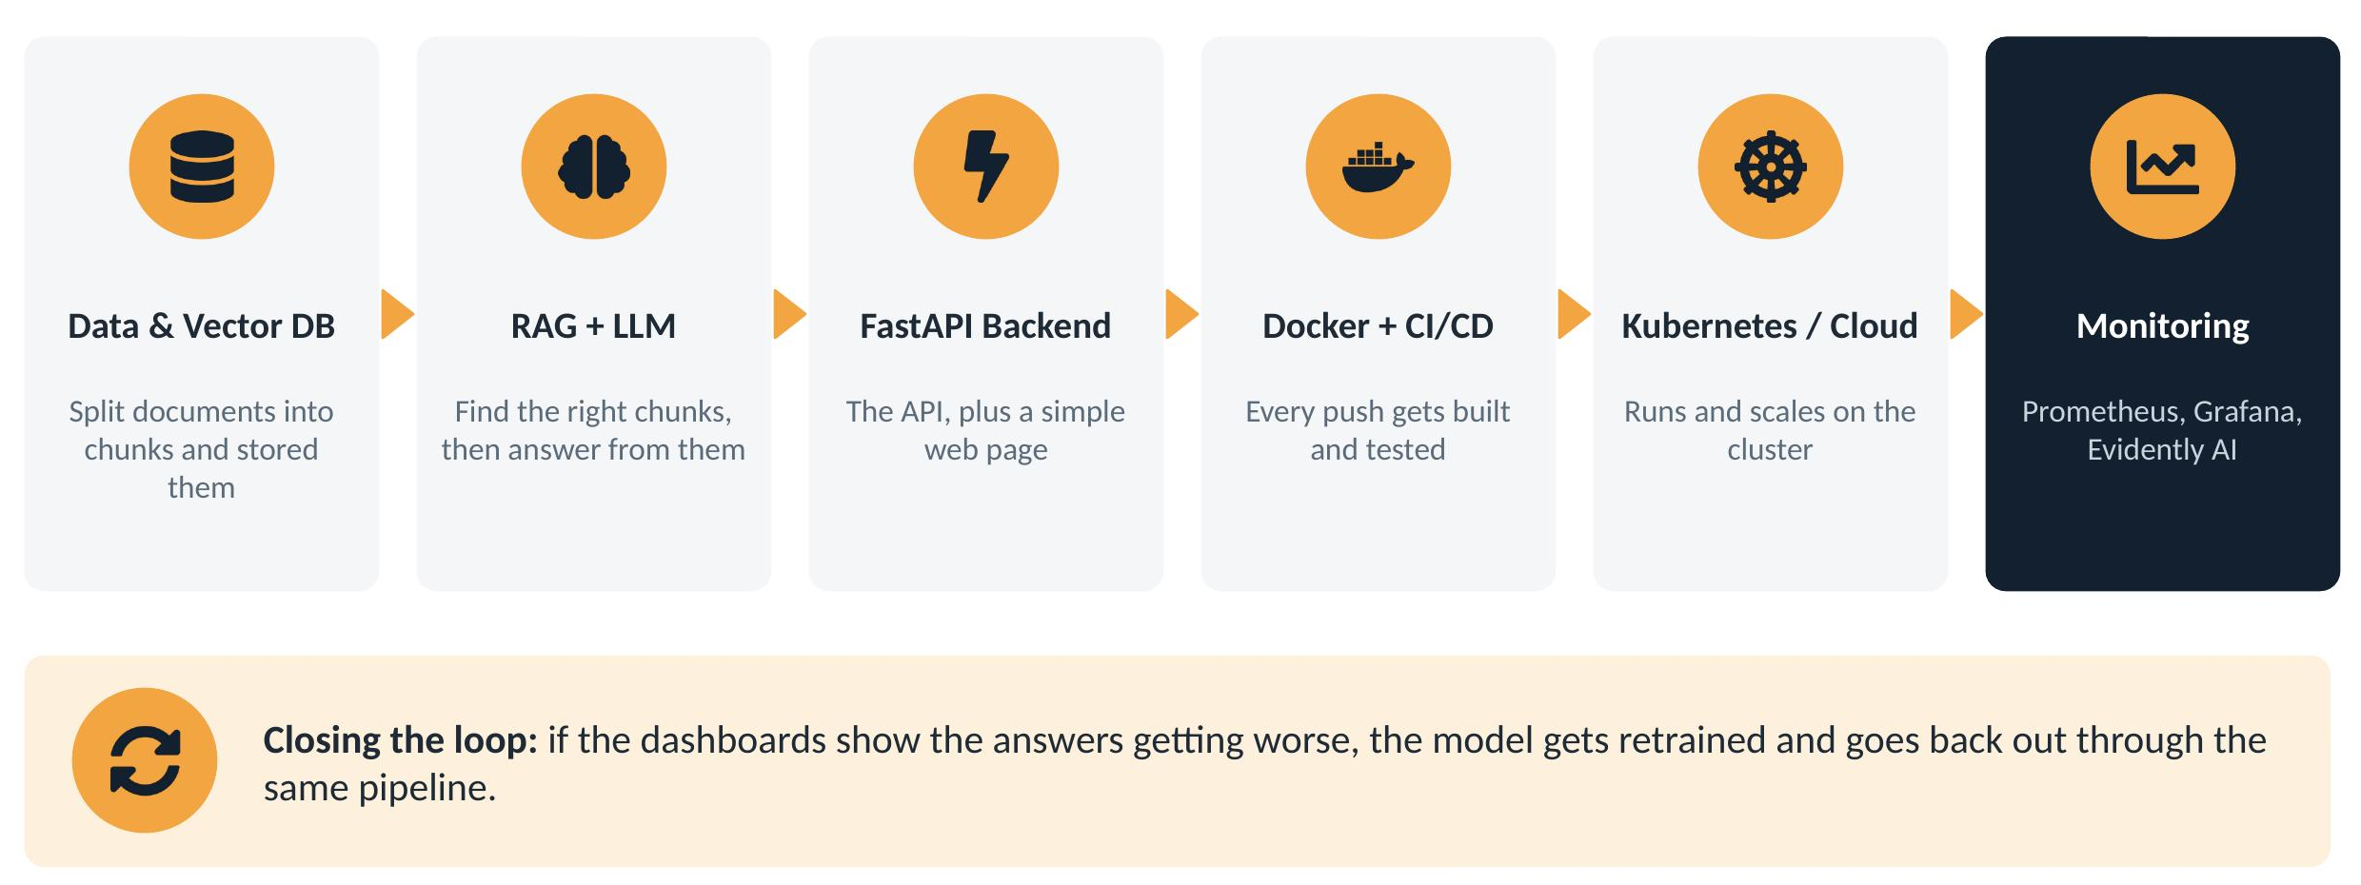
Figure 5.1: Architecture of the capstone RAG application

5.3 How It Works
- Data and vector database: documents are split into smaller chunks, converted into embeddings (numerical representations of meaning), and stored in a vector database.
- Retrieval and generation: when a user asks a question, the system finds the most relevant chunks and passes them to the LLM along with the question, so the answer is grounded in real content.
- FastAPI backend and frontend: the RAG logic sits behind a FastAPI endpoint, with a simple web page for users to type questions.
- Docker and CI/CD: the application is containerized, and every push to the repository triggers an automatic build and test.
- Kubernetes / cloud deployment: the container runs on a Kubernetes cluster / cloud platform, which lets it scale when traffic increases.
- Monitoring: Prometheus and Grafana track latency and errors, while Evidently AI watches for drift.

5.4 Closing the Loop
The most important idea in the design is that deployment isn’t the end. If the dashboards show answer quality dropping or the input data changing, the model or the document index is updated and goes back out through the same CI/CD pipeline. This makes the system maintainable instead of a one-time demo.

5.5 Outcome
The finished application could answer questions over the chosen documents through a web interface, with the full build, deployment and monitoring setup in place.

6. Tools and Technologies Used
Category | Tools | What I used them for
Language | Python | All code, scripts and model handling
API & UI | FastAPI, Streamlit, Gradio | Serving models and building quick front-ends
Containers | Docker | Packaging apps into portable images
Orchestration | Kubernetes | Running and scaling containers
Automation | CI/CD pipelines, Git / GitHub | Version control, automatic testing and builds
Cloud ML | Amazon SageMaker, Google Vertex AI, Azure ML | Managed model hosting
LLM Serving | vLLM, quantization | Faster, lighter LLM inference
Agents & RAG | LangChain, LlamaIndex, LangGraph, vector databases | Building agents and document Q&A
Monitoring | Prometheus, Grafana | Metrics collection and dashboards
Model Quality | Evidently AI | Drift detection
Table 6.1: Tools and technologies used during the internship

7. Learning Outcomes

7.1 Technical Skills
- A model in a notebook is maybe half the job. I now understand the other half: turning it into an API, packaging it, deploying it and keeping it running.
- I can write a Dockerfile, build and run containers, and set up a basic CI/CD pipeline without being scared of it anymore.
- I understand how Kubernetes runs and scales services, and how the major cloud platforms host ML models.
- I know how RAG and AI agents actually work under the hood, not just as buzzwords.
- I can set up monitoring for a live service and understand why drift detection matters.

7.2 Professional Skills
- Time management: the internship was self-paced, so nobody was chasing me about deadlines. I had to plan my own weeks.
- Documentation: writing up assignments clearly enough that someone else could follow them.
- A wider view of “good” AI: accuracy is not everything; cost, reliability, security and fairness matter just as much.
- Independent problem-solving: sitting with an error message and working it out instead of giving up.

7.3 Relevance to My Degree
A lot of what I learned connects directly to my Cloud Computing coursework. Containers, orchestration, managed services and cost optimization are core cloud topics, and this internship showed me how they are used for one of the fastest-growing kinds of workload: AI.

8. Challenges Faced
Challenge | Why it was hard | What I did
Too many tools in too little time | Docker, Kubernetes, three cloud platforms and several agent frameworks, all in 8 weeks. | Kept reusing the same small API every week, so each new tool built on the last one instead of starting fresh.
Setup kept breaking | Library versions clashed and container builds failed. | Fixed exact versions in requirements.txt and switched to smaller, cleaner base images.
LLMs are heavy | My laptop couldn’t comfortably run a large model. | Used quantized models, served them with vLLM, and relied on free cloud tiers.
Self-paced schedule | Easy to fall behind alongside regular college work. | Set fixed hours each week for the internship and finished quizzes before the deadline.
Table 8.1: Challenges faced and how they were handled

9. Conclusion and Future Scope

9.1 Conclusion
Before this internship, I knew how to train a model. Now I know how to actually put one out there and keep it running. Over eight weeks I went from serving a single model with FastAPI to building a complete RAG application that is containerized, deployed through CI/CD, running on Kubernetes and monitored for drift.
The biggest takeaway for me is that deploying AI is really an engineering and cloud problem as much as a data science one, which makes it a very natural fit with my specialisation. The internship gave me both the practical skills and the confidence to take on these kinds of projects on my own.

9.2 Future Scope
- Get a cloud certification: probably in AWS or Google Cloud machine learning, now that the basics make sense.
- Keep building the capstone: add user login, autoscaling based on traffic, and automatic retraining when drift is detected.
- Use it in my own projects: bring Docker, CI/CD and monitoring into college projects instead of leaving them as notebooks.

References
[1] AICTE – EduSkills Virtual Internship Program, Internship Offer Letter, Ref. No. C18Y2026M091567121, EduSkills Foundation, 2026.
[2] EduSkills Foundation, official website. https://eduskillsfoundation.org
[3] AICTE National Internship Portal. https://internship.aicte-india.org
[4] FastAPI documentation. https://fastapi.tiangolo.com
[5] Docker documentation. https://docs.docker.com
[6] Kubernetes documentation. https://kubernetes.io/docs
[7] LangChain documentation. https://python.langchain.com
[8] LlamaIndex documentation. https://docs.llamaindex.ai
[9] Prometheus documentation. https://prometheus.io/docs
[10] Evidently AI documentation. https://docs.evidentlyai.com

Appendix

Internship Offer Letter
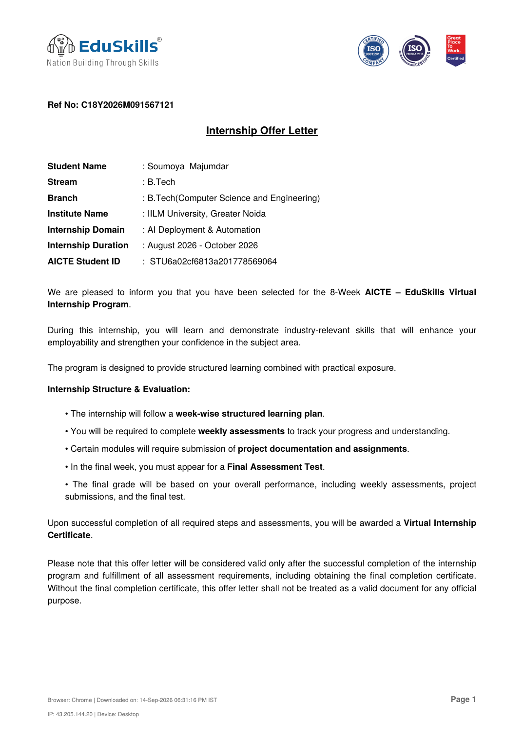
Offer letter, page 1
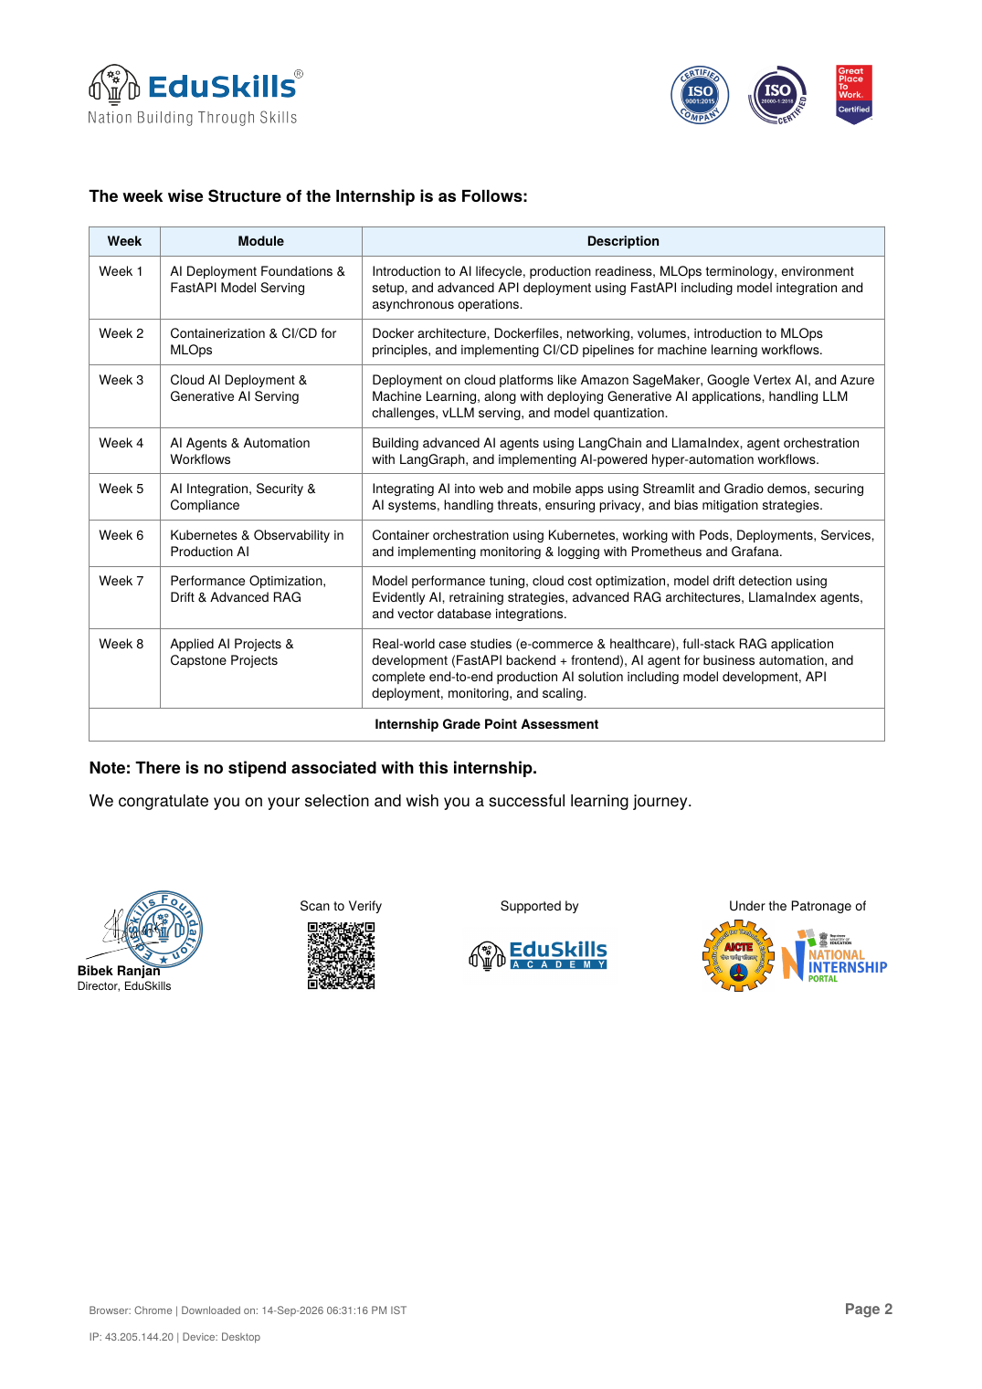
Offer letter, page 2

