COURSE PROJECT REPORT
HYBRID DEEP LEARNING NETWORK INTRUSION DETECTION SYSTEM
Benign-Only Anomaly Detection, Latent Clustering, and Day-Specific Attack Classification
Course: BCSE209L - Machine Learning
Submitted by
Sushant Kumar (23BDS0128)
Soumyadeep Dasgupta (23BDS0134)
Udit Vashisht (23BDS0172)
Faculty: Dega Nagaraju

Academic Year 2026-27

CONTENTS
Abstract
Chapter 1 Introduction
Chapter 2 Literature Review
Chapter 3 Methodology
Chapter 4 Results and Discussion
Chapter 5 Conclusion and Future Work
References
Appendix A Project Artifacts

ABSTRACT
This project develops and evaluates a hybrid network intrusion detection system (NIDS) using CICIDS2017 network-flow data. The system combines three complementary components: Engine A, a benign-only FT-Transformer autoencoder that flags flows with high reconstruction error; Engine B, an unsupervised clustering stage that profiles anomalous latent embeddings; and Engine C, day-specific supervised classifiers that identify known attack labels using a feature-tokenization/Transformer and temporal convolutional network (TCN) design. Preprocessing removes identifier and leakage-prone fields, handles missing and infinite values, scales numeric features, and selects a compact feature set. The saved results show that clustering separates some DDoS and PortScan groups, while supervised specialist performance is strong for several common classes on Tuesday, Wednesday, and Friday. Performance is weak for rare classes and for the 5,000-window Thursday and Friday runs' minority labels. Engine A's recall depends strongly on the percentile threshold, and attack medians above a threshold do not by themselves establish flow-level detection rates. The project therefore demonstrates a useful hybrid prototype while highlighting the need for threshold calibration, rare-class evaluation, and carefully audited chronological testing.
Keywords: network intrusion detection, CICIDS2017, FT-Transformer, autoencoder, anomaly detection, clustering, TCN, temporal generalization
CHAPTER 1 INTRODUCTION
1.1 Background and Problem
Network intrusion detection examines network traffic to identify activity that may threaten confidentiality, integrity, or availability. Signature and supervised classifiers can recognize attack patterns represented in training data, but they may not identify new or changed behavior. Anomaly detection offers another route: learn a baseline of ordinary traffic and alert when observed traffic differs from it. In practice, anomaly systems can also raise false alarms, and labeled traffic is often imbalanced, with a few attack types represented by very few flows.
CICIDS2017 provides labeled flow records across multiple weekdays, with benign traffic and attack scenarios such as brute-force login attempts, denial-of-service, web attacks, infiltration, bot activity, and port scanning [1], [2]. The daily structure creates an opportunity to study both attack classification and changes in traffic distribution over time. It also requires care: a random split within one day measures interpolation within that day's distribution, whereas a chronological split asks whether a model trained earlier can handle later traffic.
1.2 Aim and Objectives
The aim is to build a modular NIDS prototype that uses benign-only learning to flag unusual flows, clusters anomaly representations for exploratory profiling, and applies supervised specialists to known attack classes. The objectives are to audit and preprocess CICIDS2017, use leakage-conscious feature preparation, calibrate reconstruction thresholds on benign validation data, inspect clusters without using labels during fitting, train per-day classifiers, and compare performance using class-aware and threshold-based metrics.
1.3 Scope and Contributions
The project is an offline research prototype using CICIDS2017 flow features. It does not claim a production deployment or a single end-to-end score for all three engines. Engine A and Engine B are evaluated as an anomaly detection and profiling path; Engine C is evaluated as a separate known-class classification path. The main contribution is the combination of complementary detection tasks with saved preprocessing objects, reports, model artifacts, and a dashboard for inspection.
1.4 Report Organization
Chapter 2 reviews intrusion detection, anomaly detection, feature learning, temporal modeling, class imbalance, and dataset evaluation. Chapter 3 describes the system architecture and methodology. Chapter 4 summarizes saved clustering, anomaly, and specialist results with limitations. Chapter 5 concludes and gives next steps.

CHAPTER 2 LITERATURE REVIEW
2.1 Network Intrusion Detection and Benchmarking
Machine-learning-based NIDS research spans binary detection, multiclass attack recognition, anomaly detection, and hybrid systems. Survey work describes the breadth of algorithms and the difficulty of comparing systems when datasets, class composition, and evaluation protocols differ [2]-[5]. CICIDS2017 was introduced as a more contemporary labeled benchmark with benign and attack traffic and flow-level features [1]. Subsequent analyses point out that dataset construction, duplicated or problematic records, feature leakage, and preprocessing decisions can change reported results [6]-[8]. This supports documenting the split protocol and the train-only fitting of transformations rather than relying on accuracy alone.
2.2 Autoencoders and Unsupervised Anomaly Detection
Autoencoders learn a compressed representation by reconstructing their input. When trained on normal-only data, reconstruction error can serve as an anomaly score. Deep anomaly detection work has explored robust autoencoders and representation-based approaches [9], while network-specific systems such as Kitsune use online unsupervised learning to detect anomalous traffic [10]. These approaches motivate Engine A's benign-only objective. Their practical performance, however, depends on how normal training data represents deployment traffic and how the threshold balances missed attacks against false alerts. A percentile threshold is a calibration rule, not a guarantee of the corresponding false-positive rate on a shifted target day.
2.3 Feature Learning and Temporal Models
Feature selection reduces redundant or noisy dimensions and can lower training cost. Prior intrusion detection work uses information gain and other ranking approaches for CICIDS2017 features [11]. Attention-based models learn interactions among input features; Transformer architectures established self-attention as a general sequence modeling mechanism [12], while later studies adapted Transformer encoders to tabular data [13]. Temporal convolutional networks use causal and dilated convolutions to model sequence context [14]. Engine C combines a feature-tokenization/attention encoder with TCN blocks over short flow windows, aiming to represent both within-flow feature interactions and local temporal patterns.
2.4 Imbalance, Metrics, and Temporal Generalization
Intrusion datasets are often highly imbalanced. Cost-sensitive learning and class weighting can increase the contribution of rare classes, but very small supports still make estimates unstable [15], [16]. Precision-recall analysis is especially informative when positive events are rare; ROC-AUC and accuracy should be interpreted alongside attack recall, precision, F1, and benign false-positive rate [17], [18]. In operational traffic, distributions can drift. Concept-drift surveys describe the need to evaluate models as data changes over time [19], [20]. Therefore, a random within-day split and a chronological split answer different questions and should not be conflated.
Related methods also inform this design: oversampling and imbalanced-learning research provide alternatives to class weighting [25]-[27]; feature-selection and Random Forest work motivates compact flow representations [28], [29]; DBSCAN-family clustering and silhouette analysis inform anomaly grouping and its evaluation [30]-[32]. Benchmark research on KDD Cup and UNSW-NB15 and broader deep-learning surveys provide additional context for the limits of single-dataset claims [33]-[35].
2.5 Research Gap and Project Position
Many studies focus on one task or report a single benchmark score. This project explores a modular combination: normal-only anomaly learning, unsupervised grouping of anomaly embeddings, and day-wise supervised classification. Its saved results also expose the limits of this combination: threshold choices change detection, unsupervised clusters may contain benign flows, rare labels provide little evidence, and random-split performance may not transfer to later traffic. The prototype is positioned as an empirical study of complementary methods rather than a claim of solved zero-day detection.

CHAPTER 3 METHODOLOGY
3.1 Overall System Architecture
The workflow begins with flow-level CICIDS2017 records and a shared preprocessing stage. The prepared features feed two analysis tracks. Engine A learns benign traffic and scores each flow by reconstruction error; Engine B groups suspicious latent representations for post-hoc behavioral inspection. In parallel, Engine C trains a supervised specialist for each attack day. Engine C is not simply a downstream classifier of Engine A's flags: it is a separate classification path, so results are reported independently.
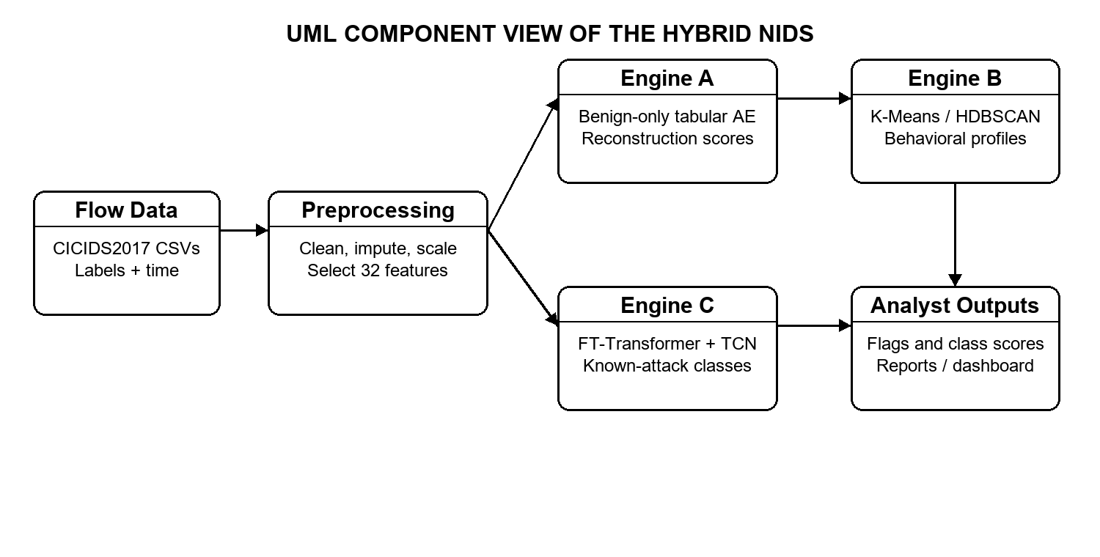
Figure 1. UML component view of the implemented NIDS modules and their data products.
3.2 Data Preparation and Feature Selection
The project audits raw daily CSV files, normalizes labels and columns, removes identifiers and metadata such as flow IDs, IP addresses, ports, protocol, timestamp, and label from model inputs, converts candidate fields to numeric values, and replaces infinities with missing values. Imputation statistics, scaling parameters, and feature ranking are learned from the training data and reused for validation or test data. The saved Engine A feature set contains 32 flow-statistical features. The specialist pipelines also use training-fold feature ranking based on Random Forest importance and mutual information, followed by scaling. Signed log transformation is used in the production scripts to reduce the effect of extreme magnitudes.
This procedure reduces direct label and identifier leakage, but does not remove all benchmark limitations. CICIDS2017 can contain duplicated, mislabeled, or temporally correlated observations, so split design and duplicate auditing remain important [6]-[8]. The report treats saved model outputs as experimental results on the available dataset rather than evidence of deployment readiness.
3.3 Engine A: Benign-Only Autoencoder
Engine A is a flow-level tabular FT-Transformer autoencoder. Each numeric feature is tokenized into a learned embedding; self-attention and feed-forward blocks form a latent representation; a decoder reconstructs the feature vector. Training uses benign Monday flows only, with a 20% benign validation split. The saved threshold file records percentile cutoffs for mean MSE, top-3 MSE, and maximum feature error. In this report, top-3 MSE means the average squared reconstruction error of the three highest-error features in one flow. The p95 top-3 threshold is 0.04595, calibrated from Monday benign validation data.
At inference, the model produces a reconstruction score per flow. A flow is flagged when its selected score exceeds its calibrated threshold. Choosing p90, p95, p97, p99, or p99.5 changes the detection/false-alarm trade-off; each operating point must be measured on held-out benign and attack flows. Labels are used only to evaluate the score, not to train the benign-only autoencoder or set the Monday percentile threshold.
3.4 Engine B: Clustering Anomalous Embeddings
Engine B extracts the autoencoder's 64-dimensional bottleneck representation for flows selected as anomalous and applies K-Means and HDBSCAN. K-Means produces a fixed number of groups for a chosen run; HDBSCAN can discover density-based groups and mark some observations as noise. Silhouette, Calinski-Harabasz, and Davies-Bouldin scores summarize geometric separation. Class labels are used after clustering to audit cluster composition; they do not supervise the clustering step. Two-dimensional PCA projections are visual aids and do not replace the original embedding-space analysis.
3.5 Engine C: Day-Specific Supervised Specialists
Engine C creates separate multiclass classifiers for Tuesday, Wednesday, Thursday, and Friday. Each model combines a feature tokenizer and multi-head self-attention encoder with temporal convolutional blocks over a configurable short lookback window. The output layer assigns probabilities to the day-specific labels. Training uses a stratified 70/30 within-day split in the saved specialist reports, with preprocessing fitted on training data and class-weighted loss to address imbalance. The saved Thursday and Friday result files contain 5,000 training windows and 5,000 test windows each; Tuesday and Wednesday use substantially larger splits. Results across these days are therefore not directly comparable without considering sample size and class support.
3.6 Evaluation Design
Engine A is assessed using ROC-AUC, average precision, recall at calibrated thresholds, and benign false-positive rate. Engine B uses internal clustering metrics and post-hoc dominant-label composition. Engine C uses per-class precision, recall, F1, weighted and macro averages, accuracy, attack-versus-benign average precision, and ROC-AUC. A separate temporal experiment orders flows by timestamp, trains on the first 70%, and evaluates on the final 30%. This chronological evaluation is essential for deployment-oriented interpretation but requires class-presence and metric checks when labels appear only in particular time windows.
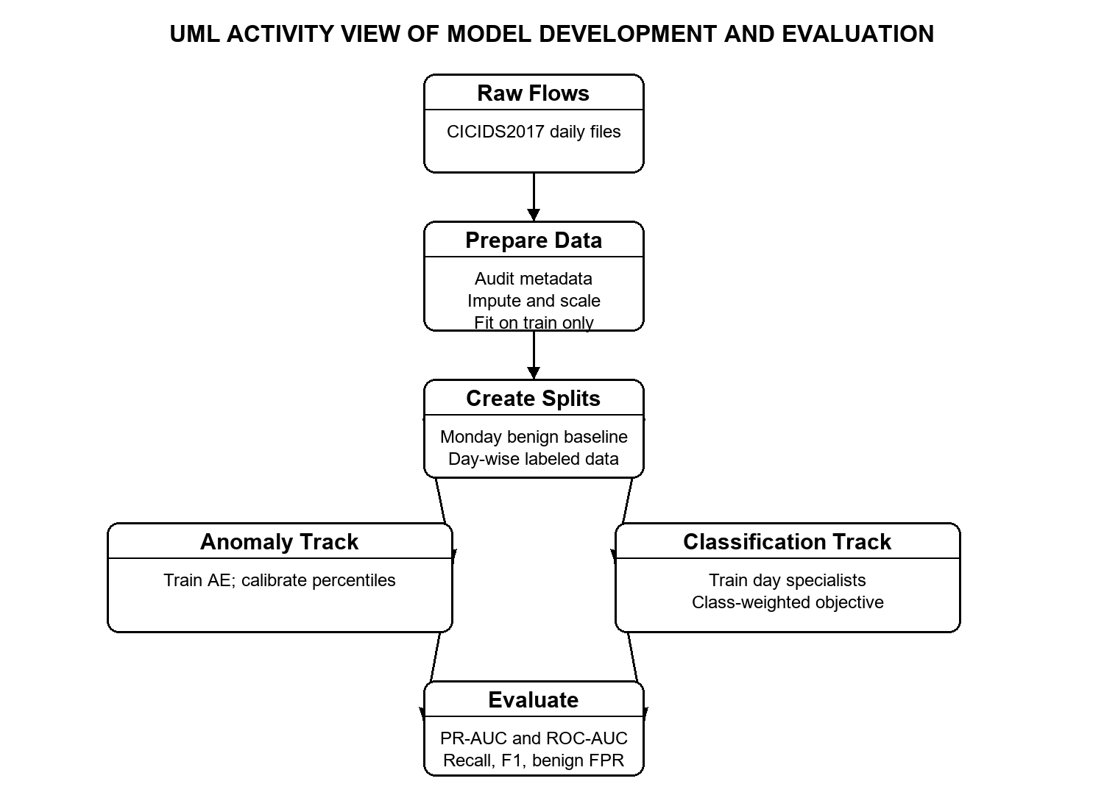
Figure 2. UML activity view of data preparation, model training, and evaluation paths.
3.7 Dataset Summary
Traffic day | Role in this project | Examples of labels
Monday | Benign baseline for Engine A | BENIGN
Tuesday | Supervised specialist | BENIGN, FTP-Patator, SSH-Patator
Wednesday | Supervised specialist | BENIGN, DoS variants, Heartbleed
Thursday | Supervised specialist and unseen-attack evaluation | BENIGN, Infiltration, Web attacks
Friday | Supervised specialist and unseen-attack evaluation | BENIGN, Bot, DDoS, PortScan

CHAPTER 4 RESULTS AND DISCUSSION
4.1 Engine A Thresholds and Anomaly Results
The saved Monday benign calibration gives a top-3 MSE p95 threshold of 0.04595 and a p99 threshold of 0.12192. The Thursday and Friday family-level median top-3 MSE values provide a descriptive comparison with the p95 cutoff. These medians suggest that many flows in some attack families may score above the cutoff, but a group median alone cannot establish attack recall or count the exact flows flagged.
Day and label | Attack flows in evaluated sample | Median top-3 MSE | Compared with p95 = 0.04595
Thursday Infiltration | 3 | 0.17031 | Above
Thursday Web Brute Force | 156 | 0.05449 | Above
Thursday SQL Injection | 1 | 0.02530 | Below
Thursday XSS | 73 | 0.05335 | Above
Friday Bot | 206 | 0.01551 | Below
Friday DDoS | 12,658 | 0.11834 | Above
Friday PortScan | 15,702 | 0.05567 | Above

At the saved p99 operating point, Engine A's top-3 score reports 4.72% overall attack recall on the evaluated Thursday sample and 20.89% on Friday, with benign false-positive rates of 1.10% and 7.57%, respectively. The per-family p99 breakdown reports 100% recall for the three Infiltration examples, 3.85% for Web Brute Force, 0% for the single SQL Injection example, and 2.74% for XSS. On Friday it reports 0.97% for Bot, 47.02% for DDoS, and 0.09% for PortScan. These percentages are tied to the saved evaluation and threshold definitions; rare-class rates based on one to three flows are highly uncertain.
The comparison at p95 should be presented as a threshold comparison only. Exact p95 recall requires applying 0.04595 to every saved flow-level top-3 score and counting flagged attack and benign flows. A sound operating point should be selected from a validation sweep over percentiles and reported with both attack recall and benign false-positive rate. Raising recall by lowering the threshold may increase analyst alert volume.
4.2 Engine B Clustering Results
The saved clustering evaluation contains 21,158 flows. The K-Means run used five clusters and reports a silhouette score of 0.594, Calinski-Harabasz index of 12,578.50, and Davies-Bouldin index of 0.991. The HDBSCAN summary reports 74 clusters and 19.30% noise. In the post-hoc audit, one cluster is 98.44% DDoS, another is 91.69% DDoS, and one is 85.73% PortScan. A web-attack-heavy cluster has 61.85% Brute Force labels, while a mixed cluster is 62.20% benign and also contains DDoS. This illustrates both the value and limitation of clustering: some anomalous behavior is grouped clearly, but cluster identity is not a reliable class prediction and some groups mix benign and malicious flows.
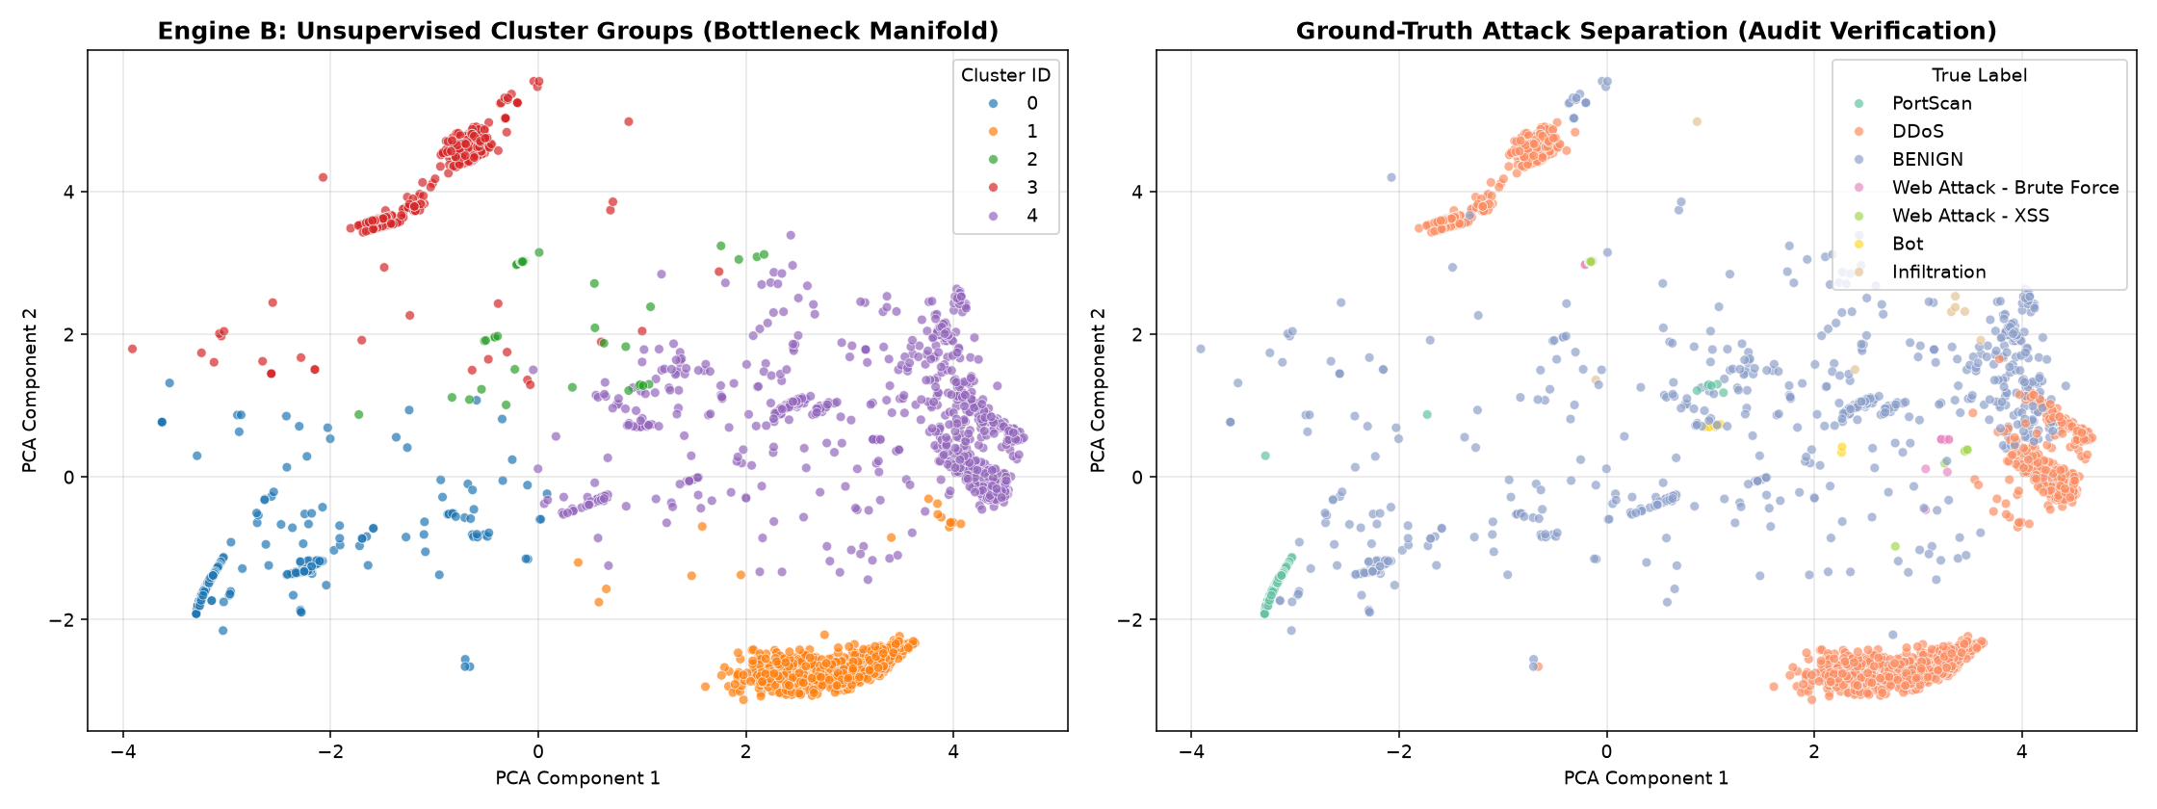
Figure 3. Engine B PCA projection of the K-Means groups and a separate label audit. Labels in the right panel are post-hoc evaluation only.
4.3 Engine C Specialist Results
Tuesday's specialist reports 98.34% accuracy and 0.985 weighted F1. FTP-Patator recall is 99.83% and SSH-Patator recall is 95.93%, with precision of 67.62% and 62.48%; this means many predicted attack windows are false positives even though attack recall is high. Wednesday reports 97.93% accuracy and 0.981 weighted F1. Common DoS classes have high recall, but the three Heartbleed test examples were all missed, so no dependable Heartbleed conclusion can be drawn.
Friday's 5,000-window test reports 96.02% accuracy and 0.963 weighted F1. DDoS recall is 98.77% and PortScan recall is 98.39%. The test contained only 13 Bot windows and the model missed all 13. Thursday's 5,000-window test reports 21.06% accuracy and 0.343 weighted F1; it contains 17 Brute Force and 8 XSS attack examples, with no test support for Infiltration or SQL Injection, and the confusion matrix shows the test attack examples predicted as Brute Force. Those results are not evidence of successful Thursday multiclass detection.
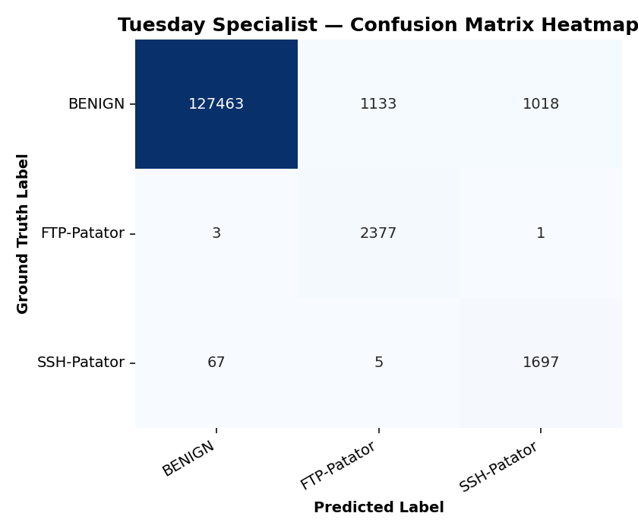
Figure 4. Tuesday specialist confusion matrix. The model detects most FTP-Patator and SSH-Patator windows, while attack precision is lower than recall.
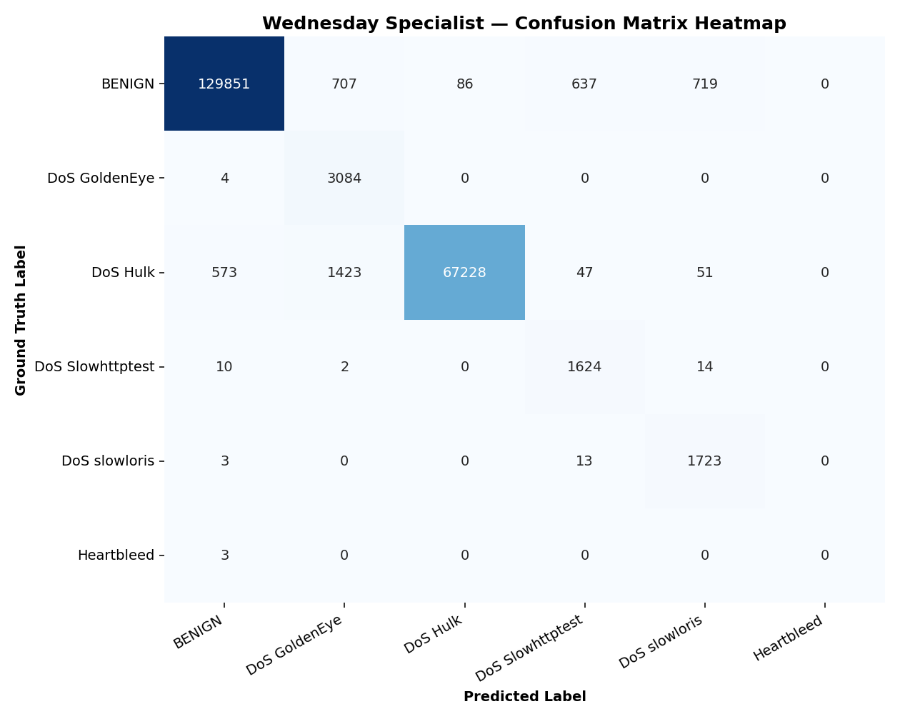
Figure 5. Wednesday specialist confusion matrix. The rare Heartbleed test examples are all predicted as benign.
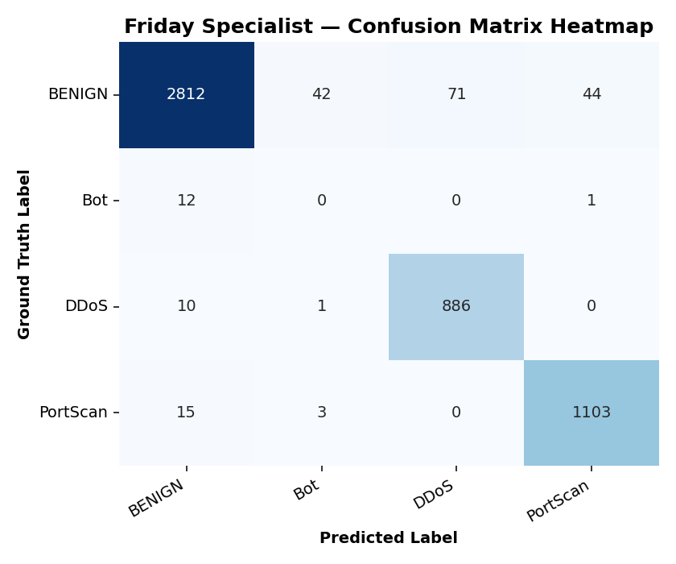
Figure 6. Friday specialist confusion matrix. DDoS and PortScan are classified well in this sampled test; all 13 Bot samples are missed.
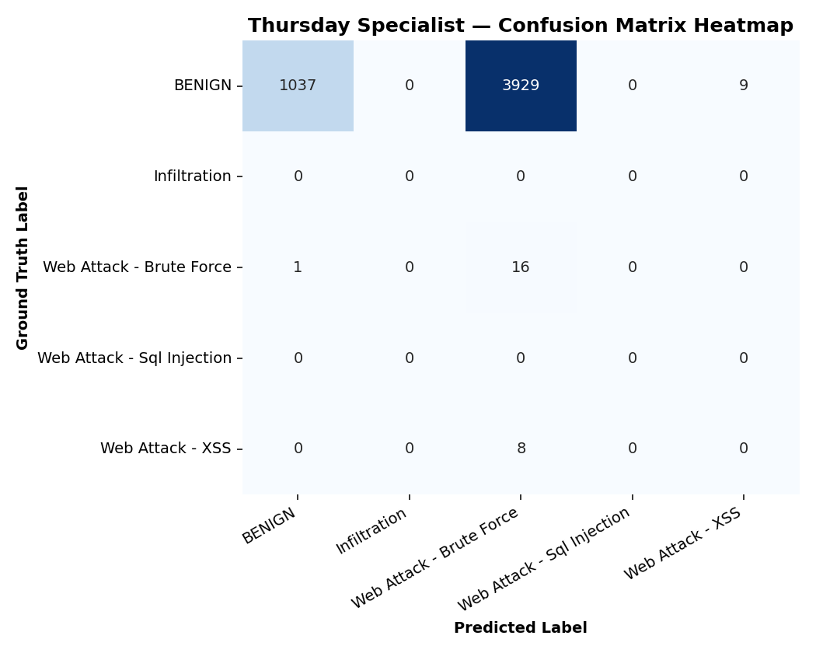
Figure 7. Thursday specialist confusion matrix. This 5,000-window test has only 25 attack examples and weak overall multiclass performance.
ROC and Precision-Recall Curves
The saved Engine C evaluation reports include one-vs-rest ROC and precision-recall curves for Tuesday, Wednesday, and Friday. These plots show ranking performance across thresholds and complement fixed operating-point classification metrics. A Thursday curve is not shown because the sampled test contains very few attacks, making class-level estimates especially unstable.
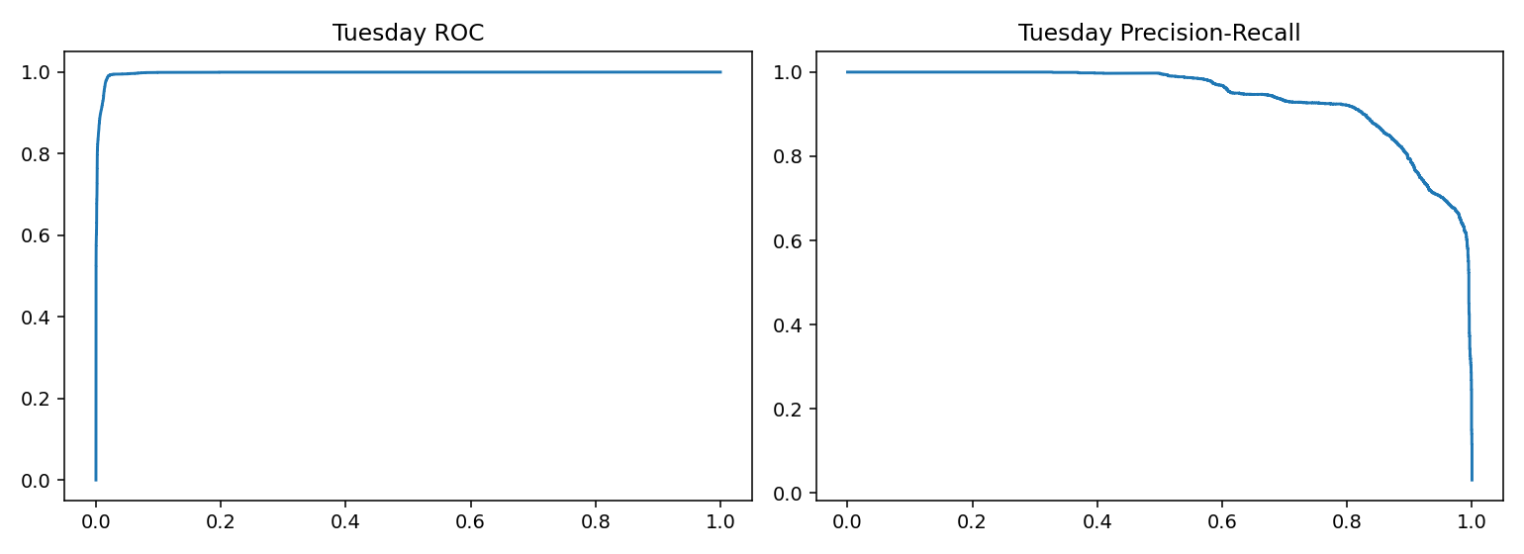
Figure 8. Engine C Tuesday specialist ROC and precision-recall curves.
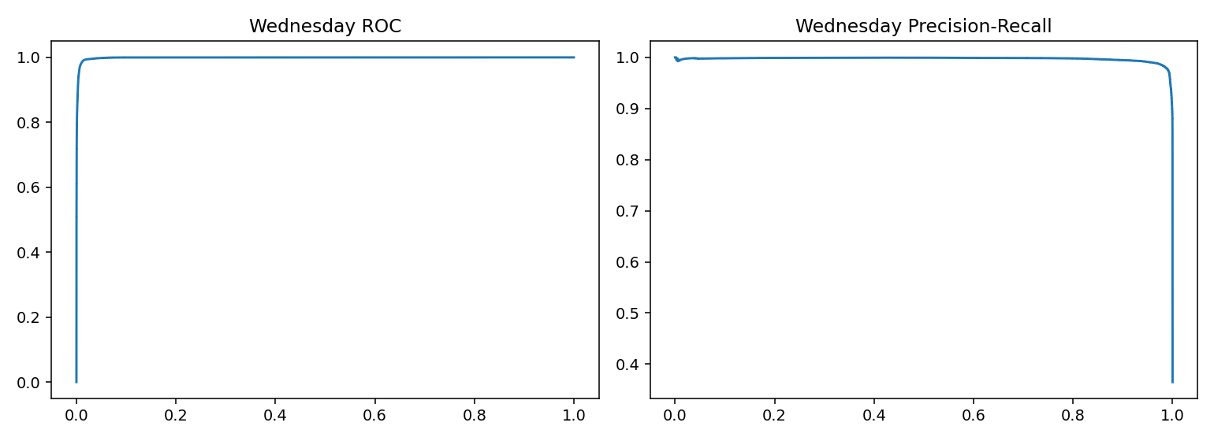
Figure 9. Engine C Wednesday specialist ROC and precision-recall curves.
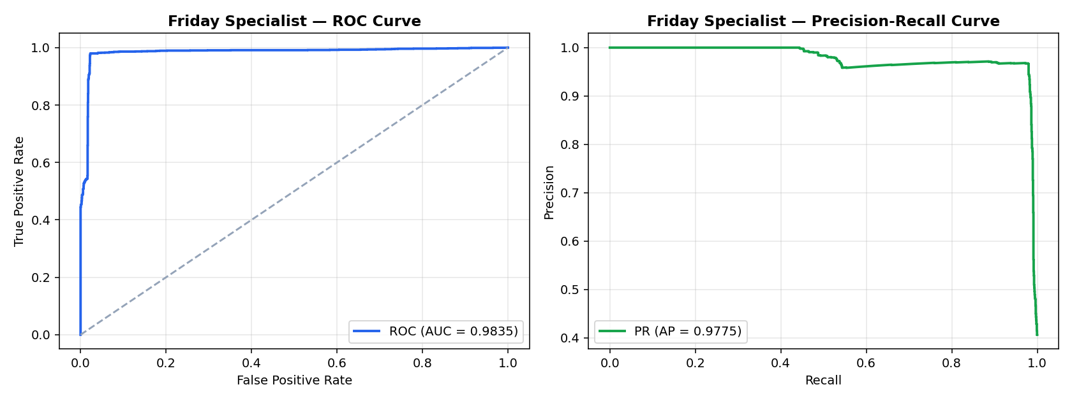
Figure 10. Engine C Friday specialist ROC and precision-recall curves.
4.4 Random and Chronological Evaluation
The specialist reports use stratified random 70/30 splits within each day. This benchmarks same-day traffic, not later-time performance. The separate chronological report has irregular results, including near-zero scores for Wednesday and Friday and near-perfect weighted F1 for Thursday. Before interpreting these as temporal generalization, audit class support, unseen labels, binary-score construction, and aggregation. The chronological table should remain provisional until that review is complete.
4.5 Overall Interpretation and Limitations
Overall, Engine B groups some attack-heavy traffic; Engine C recognizes common DDoS, PortScan, and DoS classes in sampled random splits; Engine A's p99 results still miss many PortScan and Thursday web-attack flows. Rare classes remain uncertain. The engines were evaluated separately, with no validated fusion rule or combined-system score. Small class supports, different sample sizes, temporal dependence, dataset quality, threshold sensitivity, and inconsistent metric naming limit the conclusions. Report macro F1, per-class recall, and benign false-positive rate alongside accuracy and weighted F1, and reconcile saved metrics with the evaluation code before publication.

CHAPTER 5 CONCLUSION AND FUTURE WORK
5.1 Conclusion
This project implemented a hybrid CICIDS2017 NIDS consisting of a benign-only FT-Transformer autoencoder, latent-space anomaly clustering, and day-specific supervised classifiers that combine feature attention with temporal convolution. The workflow includes data auditing, train-fitted preprocessing, threshold calibration, cluster profiling, class-weighted learning, and saved visual reports. The empirical results show useful separation for some clusters and strong same-day recognition for common DDoS, PortScan, and DoS classes. They also reveal important weaknesses in rare-class detection and threshold-dependent anomaly recall.
The appropriate conclusion is that the project demonstrates a modular hybrid approach and a set of informative experiments, not a deployment-ready detector. A high attack median above the Engine A p95 threshold is a preliminary signal only; flow-level recall and benign false-positive rates must be measured at that exact threshold. Engine C results must be interpreted with their random split, subset size, and per-class test support in view.
5.2 Future Work
Future work should (1) recompute and verify Engine A score metrics directly from saved flow-level scores for p90, p95, p97, p99, and p99.5; (2) choose thresholds using a validation objective that constrains false-positive rate; (3) retrain and test each Engine C specialist on full data with repeated seeds and class-aware confidence intervals; (4) audit and repair chronological evaluation, including label availability and score aggregation; (5) test group-wise or strict chronological splits that prevent overlapping windows from crossing train/test boundaries; (6) evaluate the complete system with a clearly defined fusion policy; and (7) validate on another dataset or later collection period before making deployment claims. Explainability, analyst workload, and inference cost should also be measured.

REFERENCES
[1] I. Sharafaldin, A. H. Lashkari, and A. A. Ghorbani, “Toward generating a new intrusion detection dataset and intrusion traffic characterization,” in Proc. ICISSP, 2018, pp. 108-116.
[2] I. Sharafaldin, A. H. Lashkari, and A. A. Ghorbani, “A detailed analysis of the CICIDS2017 data set,” in Information Systems Security and Privacy, 2018, pp. 172-188.
[3] M. Ring, S. Wunderlich, D. Scheuring, D. Landes, and A. Hotho, “A survey of network-based intrusion detection data sets,” Computers & Security, vol. 86, pp. 147-167, 2019.
[4] A. L. Buczak and E. Guven, “A survey of data mining and machine learning methods for cyber security intrusion detection,” IEEE Communications Surveys & Tutorials, vol. 18, no. 2, pp. 1153-1176, 2016.
[5] A. Khraisat, I. Gondal, P. Vamplew, and J. Kamruzzaman, “Survey of intrusion detection systems: Techniques, datasets and challenges,” Cybersecurity, vol. 2, art. 20, 2019.
[6] G. Engelen, V. Rimmer, and W. Joosen, “Troubleshooting an intrusion detection dataset: The CICIDS2017 case study,” in Proc. IEEE Security and Privacy Workshops, 2021, pp. 7-12, doi: 10.1109/SPW53761.2021.00009.
[7] M. Lanvin, A. H. Lashkari, and M. Burrage, “Errors in CICIDS2017 dataset,” arXiv:2301.04401, 2023.
[8] A. Rosay, L. Carlier, R. Fontugne, and G. Culotta, “CIC-IDS2017 to LYCOS-IDS2017: A corrected dataset,” Computer Networks, vol. 196, 2021.
[9] N. Shone, T. N. Ngoc, V. D. Phai, and Q. Shi, “A deep learning approach to network intrusion detection,” IEEE Transactions on Emerging Topics in Computational Intelligence, vol. 2, no. 1, pp. 41-50, 2018.
[10] Y. Mirsky, T. Doitshman, Y. Elovici, and A. Shabtai, “Kitsune: An ensemble of autoencoders for online network intrusion detection,” in Proc. NDSS, 2018.
[11] R. Vinayakumar et al., “Deep learning approach for intelligent intrusion detection system,” IEEE Access, vol. 7, pp. 41525-41550, 2019.
[12] C. Yin, Y. Zhu, J. Fei, and X. He, “A deep learning approach for intrusion detection using recurrent neural networks,” IEEE Access, vol. 5, pp. 21954-21961, 2017.
[13] H. Zhou and R. Paffenroth, “Anomaly detection with robust deep autoencoders,” in Proc. ACM SIGKDD, 2017, pp. 665-674.
[14] A. Vaswani et al., “Attention is all you need,” in Advances in Neural Information Processing Systems, 2017.
[15] Y. Gorishniy, I. Rubachev, V. Khrulkov, and A. Babenko, “Revisiting deep learning models for tabular data,” in Advances in Neural Information Processing Systems, 2021.
[16] X. Huang, A. Khetan, M. Cvitkovic, and Z. Karnin, “TabTransformer: Tabular data modeling using contextual embeddings,” arXiv:2012.06678, 2020.
[17] S. Bai, J. Z. Kolter, and V. Koltun, “An empirical evaluation of generic convolutional and recurrent networks for sequence modeling,” arXiv:1803.01271, 2018.
[18] A. Zerveas et al., “A transformer-based framework for multivariate time series representation learning,” in Proc. ACM SIGKDD, 2021, pp. 2114-2124.
[19] J. Gama, I. Zliobaite, A. Bifet, M. Pechenizkiy, and A. Bouchachia, “A survey on concept drift adaptation,” ACM Computing Surveys, vol. 46, no. 4, art. 44, 2014.
[20] J. Lu, A. Liu, F. Dong, F. Gu, J. Gama, and G. Zhang, “Learning under concept drift: A review,” IEEE Transactions on Knowledge and Data Engineering, vol. 31, no. 12, pp. 2346-2363, 2019.
[21] M. S. Milosevic and V. M. Ciric, “Extreme minority class detection in imbalanced data for network intrusion,” Computers & Security, vol. 123, art. 102940, 2022.
[22] N. Gupta, V. Jindal, and P. Bedi, “CSE-IDS: Using cost-sensitive deep learning and ensemble algorithms to handle class imbalance in network-based intrusion detection systems,” Computers & Security, vol. 112, art. 102499, 2022, doi: 10.1016/j.cose.2021.102499.
[23] T. Saito and M. Rehmsmeier, “The precision-recall plot is more informative than the ROC plot when evaluating binary classifiers on imbalanced datasets,” PLoS ONE, vol. 10, no. 3, e0118432, 2015.
[24] J. Davis and M. Goadrich, “The relationship between precision-recall and ROC curves,” in Proc. ICML, 2006, pp. 233-240.
[25] N. V. Chawla, K. W. Bowyer, L. O. Hall, and W. P. Kegelmeyer, “SMOTE: Synthetic minority over-sampling technique,” Journal of Artificial Intelligence Research, vol. 16, pp. 321-357, 2002.
[26] H. He and E. A. Garcia, “Learning from imbalanced data,” IEEE Transactions on Knowledge and Data Engineering, vol. 21, no. 9, pp. 1263-1284, 2009.
[27] B. Krawczyk, “Learning from imbalanced data: Open challenges and future directions,” Progress in Artificial Intelligence, vol. 5, pp. 221-232, 2016.
[28] I. Guyon and A. Elisseeff, “An introduction to variable and feature selection,” Journal of Machine Learning Research, vol. 3, pp. 1157-1182, 2003.
[29] L. Breiman, “Random forests,” Machine Learning, vol. 45, pp. 5-32, 2001.
[30] M. Ester, H.-P. Kriegel, J. Sander, and X. Xu, “A density-based algorithm for discovering clusters in large spatial databases with noise,” in Proc. KDD, 1996, pp. 226-231.
[31] R. C. Campello, D. Moulavi, and J. Sander, “Density-based clustering based on hierarchical density estimates,” in Advances in Knowledge Discovery and Data Mining, 2013, pp. 160-172.
[32] P. J. Rousseeuw, “Silhouettes: A graphical aid to the interpretation and validation of cluster analysis,” Journal of Computational and Applied Mathematics, vol. 20, pp. 53-65, 1987.
[33] M. Tavallaee, E. Bagheri, W. Lu, and A. A. Ghorbani, “A detailed analysis of the KDD CUP 99 data set,” in Proc. IEEE CISDA, 2009, pp. 1-6.
[34] N. Moustafa and J. Slay, “UNSW-NB15: A comprehensive data set for network intrusion detection systems,” in Proc. Military Communications and Information Systems Conference, 2015.
[35] M. A. Ferrag, L. Maglaras, S. Moschoyiannis, and H. Janicke, “Deep learning for cyber security intrusion detection: Approaches, datasets, and comparative study,” Journal of Information Security and Applications, vol. 50, art. 102419, 2020.

APPENDIX A PROJECT ARTIFACTS
The project includes source modules for the Engine A autoencoder, Engine B clustering, Engine C specialists, and temporal-generalization experiment. Evaluation figures, metric summaries, model files, and feature pipelines are stored in the production project folders. A Streamlit dashboard displays saved artifacts and supports Engine A scoring for uploaded flow CSV files.
Source code and project artifacts: https://github.com/SOUMYADEEP-rgb/NIDS

